Tittle:Cryptography

Problem-In the computing industry, standards are established to facilitate information interchanges among American coders. Unfortunately, I've made communication a little bit more difficult. Can you figure this one out? 41 42 43 54 46 7B 34 35 43 31 31 5F 31 35 5F 55 35 33 46 55 4C 7D

Initial Analysis:Firstly i can see the numbers but there i can also see some characters like A,C,D,F from there i assumed that it could be a HEX. It means the plaintext is HEXED.

Tools Used:https://gchq.github.io/CyberChef/

Solution:Firstly i went to my browser and opened CyberChef , there I pasted the HEXED text and and Used the From Hex option and then i decoded the HEXED text.

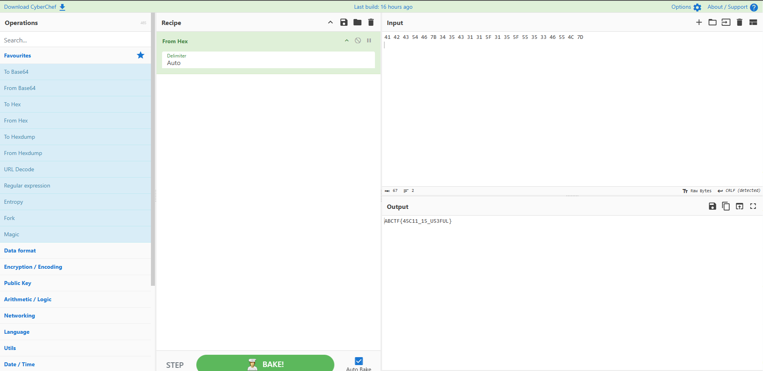

Flag: ABCTF{45C11_15_U53FUL}

Takeaways: Pattern Recognition: Hexadecimal strings are easily identifiable by their 0-9 and A-F character set. When you see pairs of characters in this range, ASCII encoding should be your first guess.Tooling is Everything:CyberChef (the "Swiss Army Knife") is the industry standard for rapid prototyping of decodings. The "Magic" ingredient can also help if you're unsure of the format.

Problem-At 1pm I called my uncle who was 64 years old 10 months ago, but I heard only that. Later I started thinking about the 24 hour clock.

I hope you will help me solve this problem. Got a wav audio file.

Initial Analysis:Firstly when I opened the audio file I heard the number typing sound. It was
following a pattern and it hid the massage in the number typing thing. First i needed to decode the number pattern

Tools Used:DTMF Decoder, CyberChef

Solution:First i put the audio file in the DTMF Decoder and it decoded the string and i got this string Decoded: 67847010810197110123678289808479718265807289125. Then it seemed like an ASCII value to me so I went straight to the cyberchef and put that value in there but cyberchef was struggling but I had to add spaces to make the Ascii values more accurate after that i got my desired flag from there.
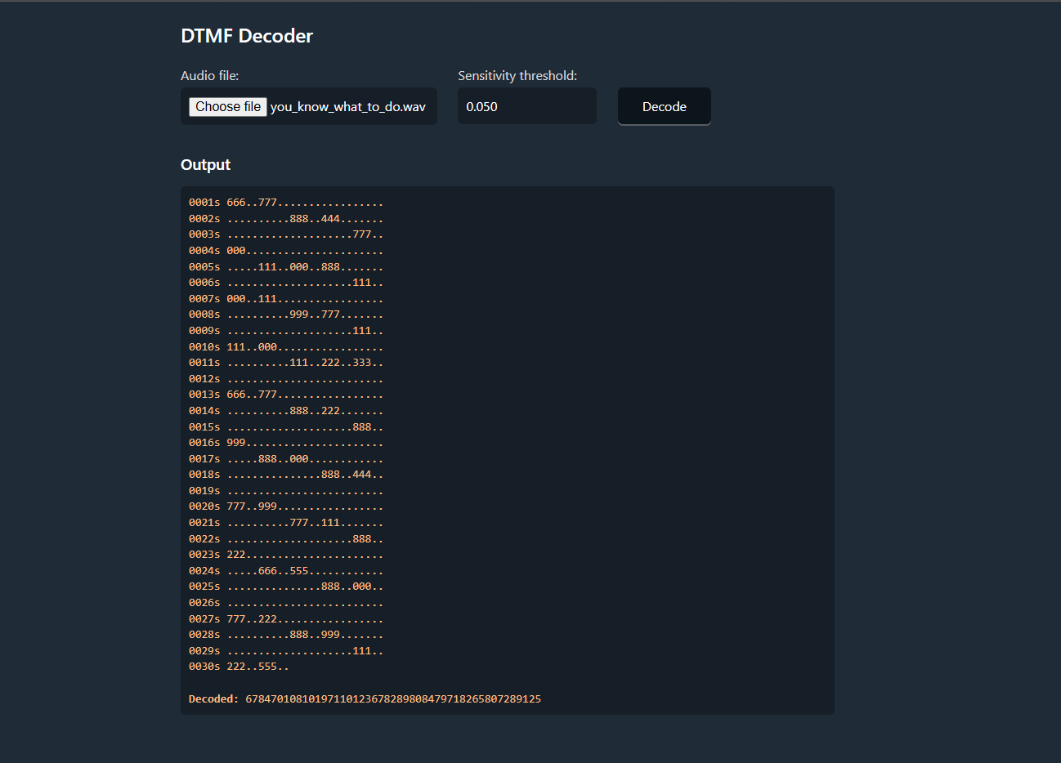

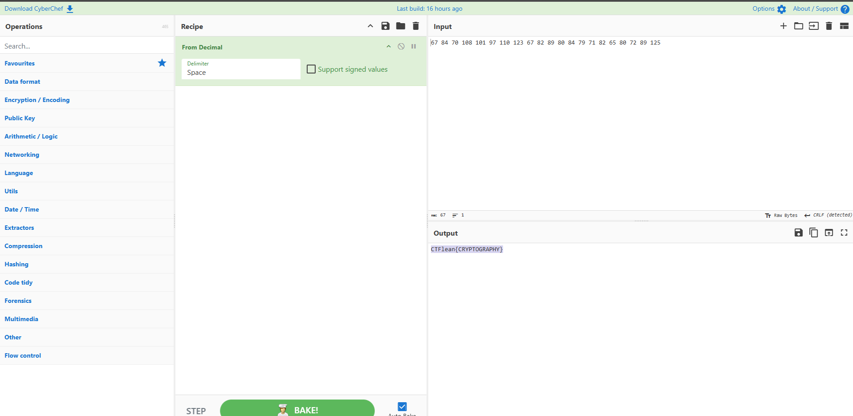

Flag: CTFlearn{h4ck3d}
Takeaways:Decimal Squashing: When a DTMF decoder gives you a giant wall of numbers with no spaces, it’s usually Decimal ASCII. Look for "anchor" numbers like 123 ({) and 125 (}) to confirm.Manual Splitting: If tools fail because of the lack of spaces, look for the $1xx$ values (like 108, 110, 123) first, then the 2-digit values around them.
CTF Archetype: If you hear "telephone beeps," think: DTMF rightarrow Decimal rightarrow ASCII.

Problem-Hello! My friend Fari sent me this suspecious message: 'MQDzqdor{Ix4Oa41W_1F_B00h_m1YlqPpPP}' and photo.png. Help me decrypt this!

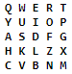

Initial Analysis: I couldn't understand what type of cipher it was but after reading some blogs i got to know that it is a playfair-cipher.

Tools Used:https://www.boxentriq.com/ciphers/playfair-cipher

Solution:I went to the website and entered the cipher text MQDzqdor{Ix4Oa41W_1F_B00h_m1YlqPpPP} and for the key i placed the images writing QWERTYUIOPASDFGHKLZXCVBNM and it was decoded in no time.

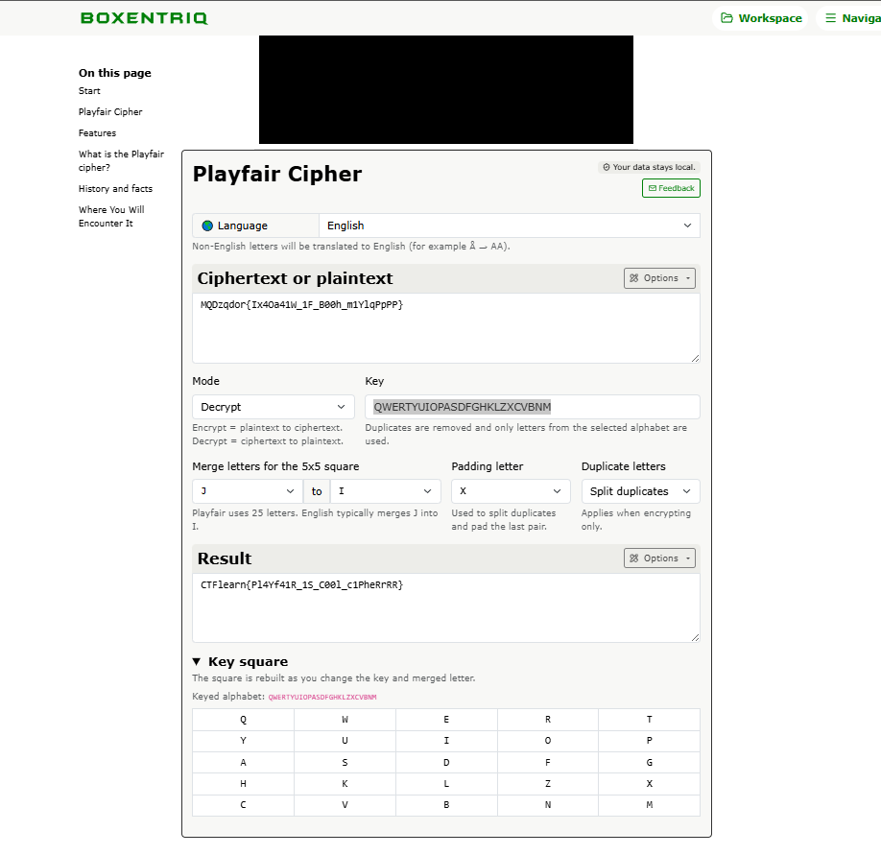

Flag:CTFlearn{Pl4Yf41R_1S_C00l_c1PheRrRR}

Takeaways:The 5*5 Grid: Playfair uses a 5*5 matrix based on a keyword. Because 5*5 = 25, one letter is always omitted or combined (usually I and J are treated as the same character).
Digraph substitution: Unlike Caesar or Vigenère, Playfair encrypts pairs of letters (digraphs). This means the ciphertext length will almost always be even.
No Double Letters: A major "tell" for Playfair is that a pair of letters in the ciphertext will never consist of the same letter (e.g., you’ll never see LL or EE as a pair).
The "X" Padding: If you see a lot of 'X's or 'Q's scattered in the plaintext, they were likely used as "fillers" to separate double letters (like HELXLO) or to complete an odd-numbered string.
Geometric Rules:
- Same Row: Shift left to decrypt.
- Same Column: Shift up to decrypt.
- Rectangle: Swap corners.

Problem-One of the easiest and earliest known ciphers but with XXI century twist! Nobody uses Alphabet nowadays, right? Why should you when you have your keyboard?

BUH'tdy,|Bim5y~Bdt76yQ

Initial Analysis: Why should you when you have your keyboard? This was a hint I got when I first read the story and after some research I got to know that it is indeed a keyboard shift cipher.

Tools Used:https://www.dcode.fr

Solution:First i went to the dcode.fr website and searched for keyboard shift cipher and pasted the cipher and hit decode that gave me the flag for this problem.
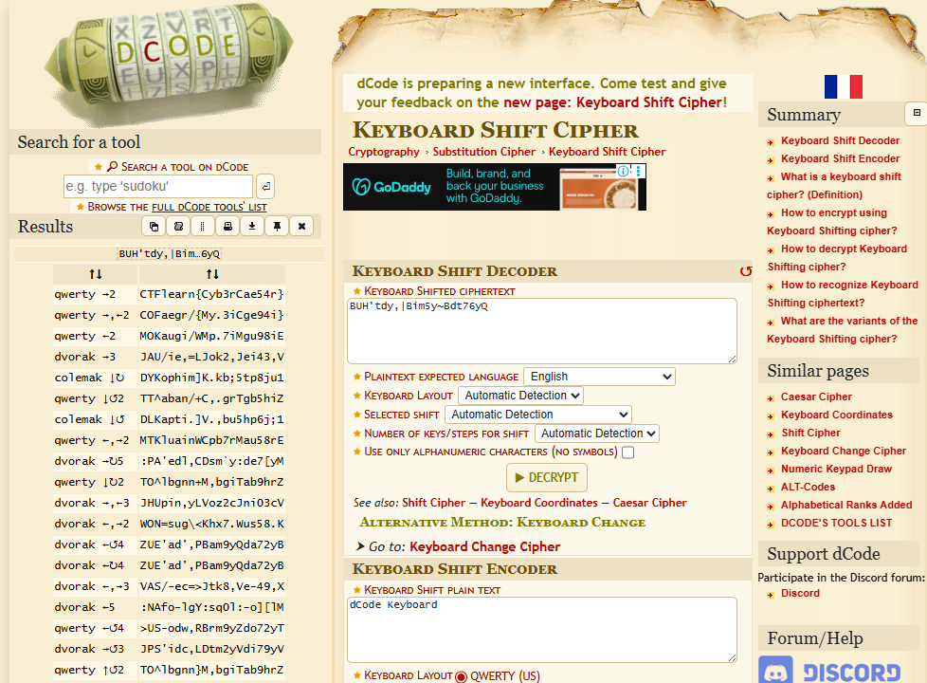

Flag:CTFlearn{Cyb3r_Cae54r}
Takeaways:The "QWERTY" Clue: If the ciphertext looks like gibberish but follows a physical path on your keyboard (e.g., rdgh instead of tfgh), suspect a keyboard shift.
Directional Offsets: Letters are typically shifted left, right, up, or down from their original position. For example, a "shift right" would turn H into J or E into R.
The "I" and "O" Edge Case: Remember that shifts wrap around or hit the "edge" of the keyboard (like P shifting right into nothing, or wrapping back to Q).

Problem-I love the smell of bacon in the morning! ABAAAABABAABBABBAABBAABAAAAAABAAAAAAAABAABBABABBAAAAABBABBABABBAABAABABABBAABBABBAABB

Initial Analysis:First its a mix of A’s and B’s and we can find the hint in the line I love the smell of bacon in the morning! So I will think of the bacon cipher.

Tools Used:https://cryptii.com

Solution: I went to the crypti website and selected the Bacon cipher and changed the mode to DECODE and in the cipher text and pasted the text and changed the letters to A and B and it decoded the cipher in no time.

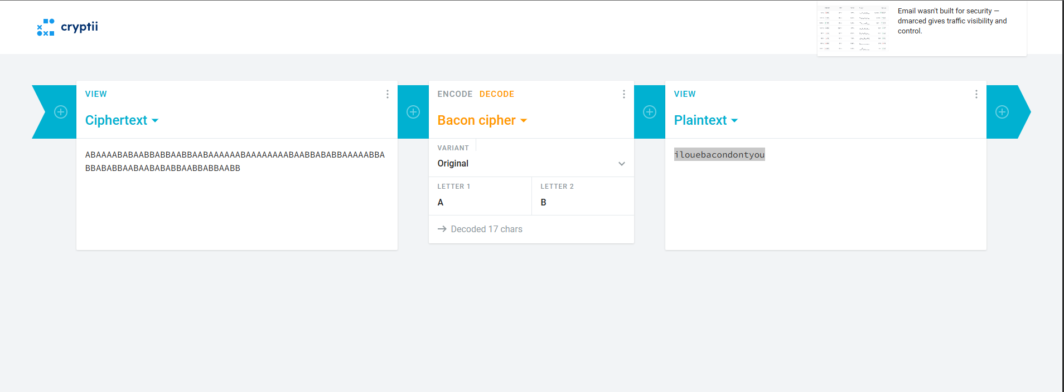

Flag:CTFlearn{ilouebacondontyou}

Takeaways:Binary in Disguise: At its core, it’s a substitution cipher where every letter is replaced by a string of five characters using only two options (usually A and B).
The "Rule of 5": If your ciphertext length is a multiple of 5 (e.g., 25, 50, 100 characters), Bacon is a prime suspect.

Problem:Meet ROXy, a coder obsessed with being exclusively the worlds best hacker. She specializes in short cryptic hard to decipher secret codes. The below hex values for example, she did something with them to generate a secret code, can you figure out what? Your answer should start with 0x.

0xc4115 0x4cf8

Initial Analysis:We can see how ROXy has been named. This is a clue to use XOR operation to generate a secret Code.

Tools Used:https://xor.pw/#

Solution: I went to the XOR calculator I mentioned above then put those input values in the input and I got the calculated XOR value.After that I built the flag.
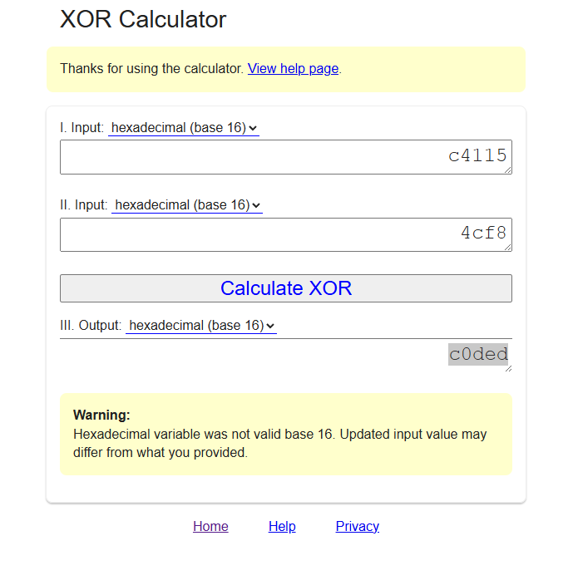

Flag:CTFlearn{0xc0ded}

Takeaway:The Reversibility Trick: XOR is its own inverse. If A XOR B = C, then C XOR B = A. You use the exact same key/process to both encrypt and decrypt.

Problem:I got a new hard drive just to hold my flag, but I'm afraid that it rotted. What do I do? The only thing I could get off of it was this: 01000011010101000100011001111011010000100110100101110100010111110100011001101100011010010111000001110000011010010110111001111101

Initial Analysis: It's clearly visible that it is a binary encoding.

Tools Used:CyberChef

Solution: So I went to the cyberchef online tool and I pasted the binary string in the input and selected the From binary and it decoded the string.
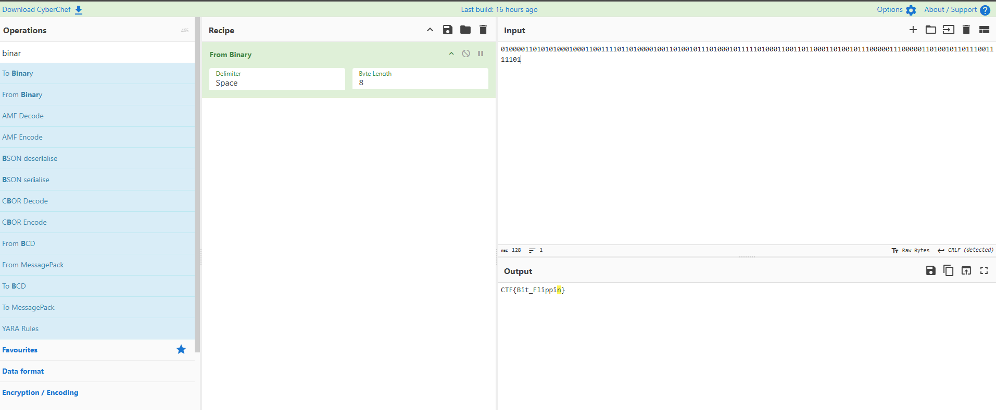

Flag:CTF{Bit_Flippin}

Takeaway:The Rule of 8: Standard ASCII characters are 8 bits (1 byte). If your string length isn't a multiple of 8, check for missing leading zeros or see if it's 7-bit ASCII.
The "01" Tell: In the ASCII table, most printable English characters start with 01 (uppercase starts with 010, lowercase with 011). If you see that pattern repeating every 8 bits, you're on the right track.
Non-Standard Binary: Binary isn't always 0s and 1s. It can be hidden as any two opposites: Short/Long sounds, High/Low voltages, or Even/Odd numbers.
Bit Inversion: If "From Binary" gives you garbage, try a NOT operation (flipping all 0s to 1s) before decoding. Sometimes the logic is simply reversed.
Problem:There is a technique called bruteforce. Message: q{vpln'bH_varHuebcrqxetrHOXEj No key! Just brute .. brute .. brute ... :D

Initial Analysis: The problem name gives a hint BruXOR so i will do this.

Tools Used:CyberChef

Solution: I went to the cyberchef and selected XOR BRUTE FORCE and pasted the string in the input. It gave me a lot of output and I grabbed the flag from the output box.

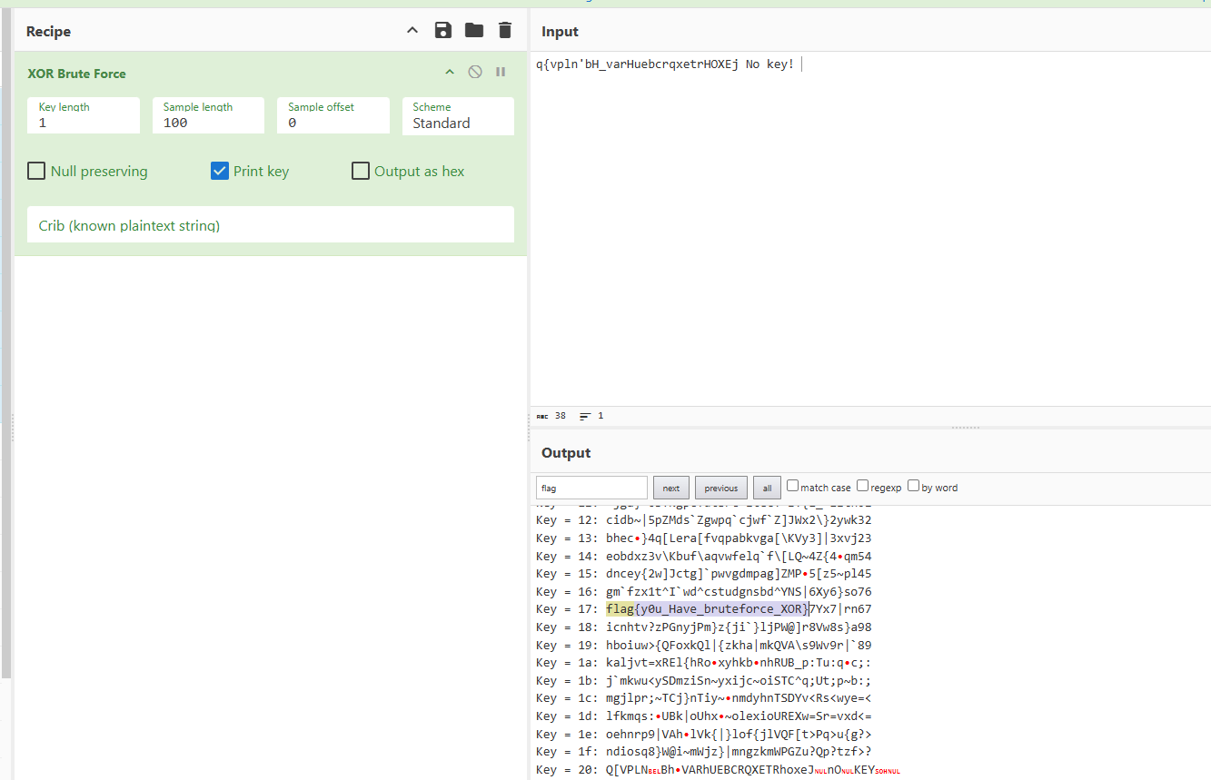

Flag:CTFlearn{y0u_Have_bruteforce_XOR}

Takeaway:The 256-Key Limit: A single-byte XOR key only has 256 possibilities (0x00 to 0xFF). This makes it the "low-hanging fruit" of CTF crypto; always try this first if you suspect XOR.
Search for "Anchors": Don't read through all 256 results manually. Use a "Find" or "Grep" for known flag formats like flag{, CTF, or even just the { character.
The CyberChef "Sample" Trick: When using the XOR Brute Force recipe, you can set a "Search String." This filters the output and only shows you the keys that produce your specific keyword (like "flag").
Beyond the Single Byte: If a single-byte brute force fails, the key might be 2 or 3 bytes. The "keyspace" grows exponentially, but for small keys (up to 4 bytes), tools like xortool can still crack it by looking for the most frequent character (usually a space or null byte).

Problem:The vignere cipher is a method of encrypting alphabetic text by using a series of interwoven Caesar ciphers based on the letters of a keyword.<br />

I’m not sure what this means, but it was left lying around: blorpy

gwox{RgqssihYspOntqpxs}

Initial Analysis: It tells us about the vigenere cipher and blorpy is the key for the cipher to decrypt so I will try that.

Tools Used:Cryptii

Solution: I went to the website and selected vigenere cipher and pasted the string and also pasted the key and it gave me the plain text.

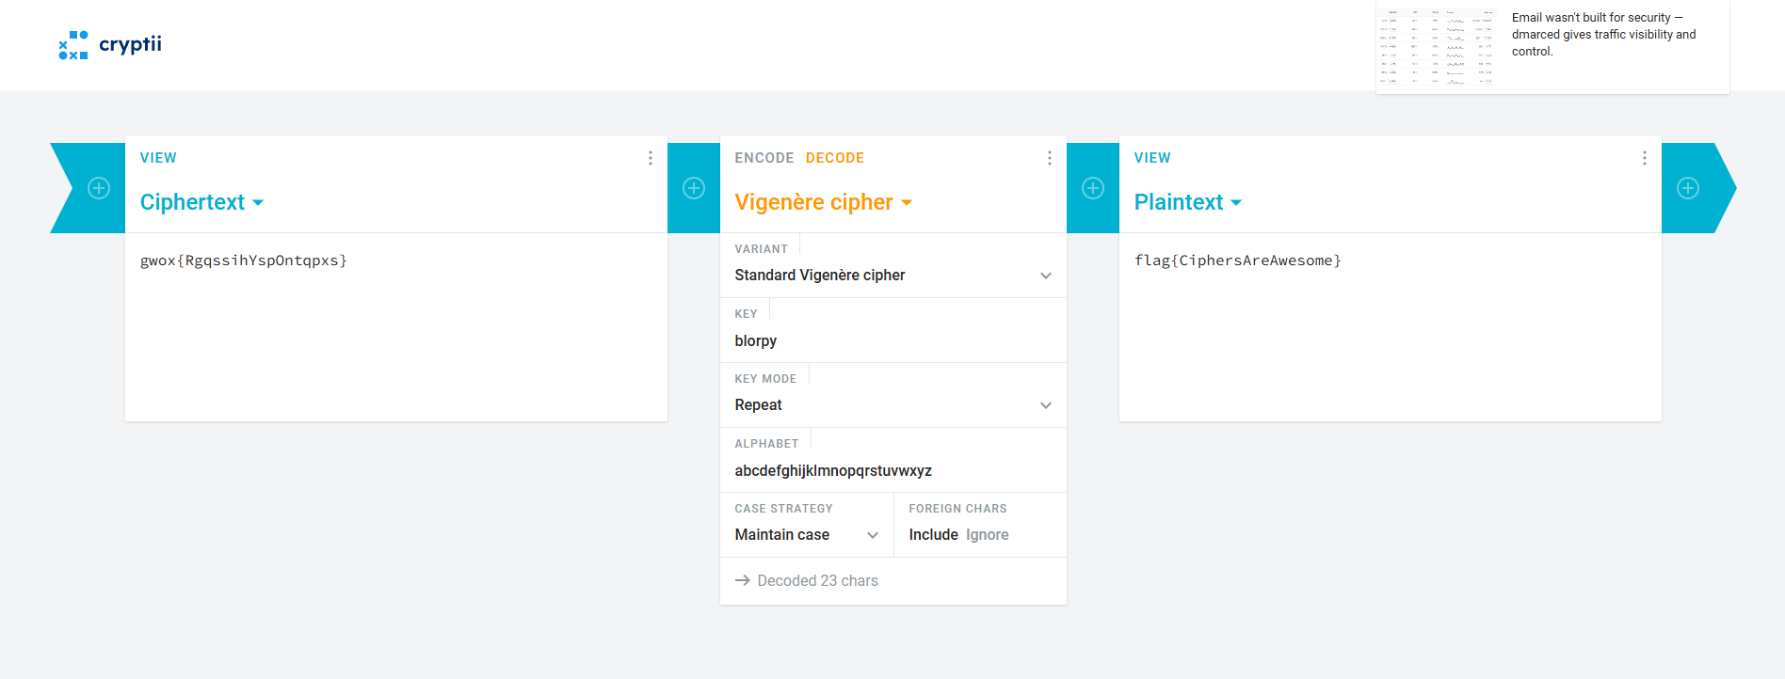

Flag:flag{CiphersAreAwesome}

Takeaway:The Polyalphabetic Shift: Unlike Caesar, which uses one shift, Vigenère uses a keyword to apply different shifts to each letter. It's essentially multiple Caesar ciphers layered together.
Key Repetition: The keyword repeats over the length of the plaintext. If the key is DOG and the text is HELLO, the shifts are based on DOGDO.
The "Index of Coincidence" (IC): This is the statistical "smoking gun." A high IC suggests a repeating key rather than random gibberish.
Kasiski Examination: If you see repeating patterns in the ciphertext (e.g., "VNH" appearing twice), the distance between those repetitions is usually a multiple of the key length.
Known Plaintext: If you know the flag starts with CTF{, you can subtract CTF{ from the ciphertext to instantly reveal the first four letters of the keyword.

Problem:..-. .-.. .- --. ... .- -- ..- . .-.. -- --- .-. ... . .. ... -.-. --- --- .-.. -... -.-- - .... . .-- .- -.-- .. .-.. .. -.- . -.-. .... . . …

Initial Analysis: It is morse code.

Tools Used:Cryptii

Solution: I went to the cryptii website and pasted the morse code and it decoded the code and gave me the flag.
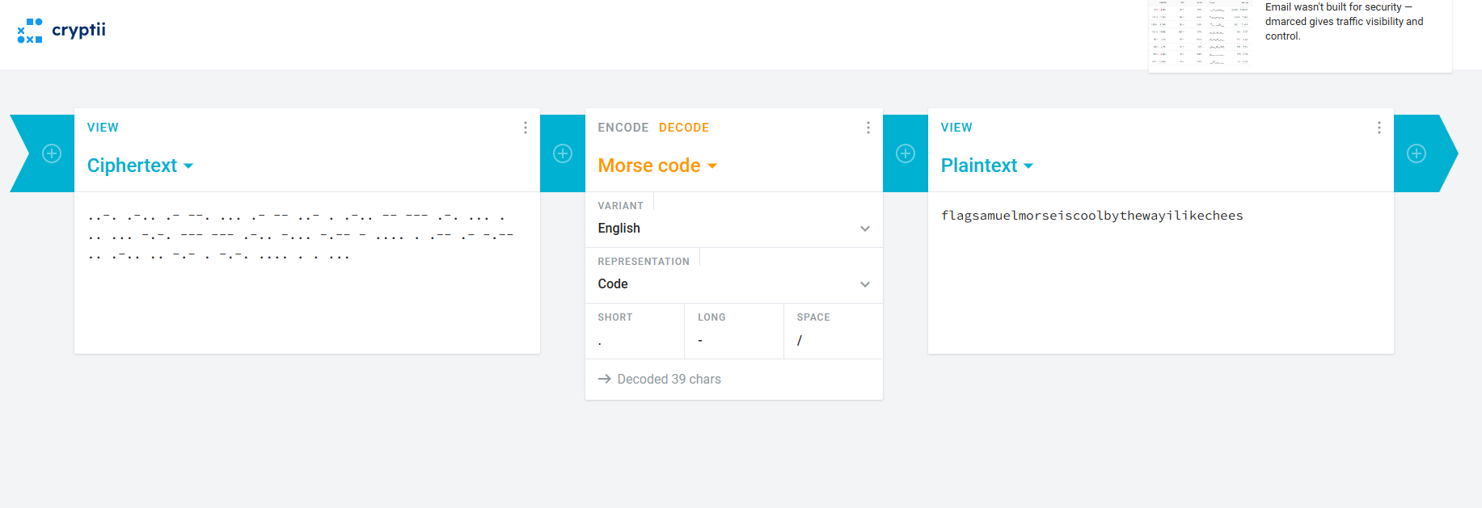

Flag:flag{samuelmorseiscoolbythewayilikechees}

Takeaway:The Binary Nature: Look for any two-symbol system (dots/dashes, 0/1, short/long, or even two different colors). If it’s rhythmic or separated by spaces, it’s likely Morse.
Delimiters are Key: Standard Morse uses a single space between letters and a forward slash / or triple space between words. If there are no spaces, it becomes a "Fractionated Morse" challenge harder.

Problem:There are so many different ways of encoding and decoding information nowadays... One of them will work! Q1RGe0ZsYWdneVdhZ2d5UmFnZ3l9

Initial Analysis: The problems name Base 2 2 the 6 is Base64 so this was the hint to decode it.

Tools Used:CyberChef

Solution: I went to the cyberchef website and selected from BASE64 and pasted the cipher and it gave me the flag.
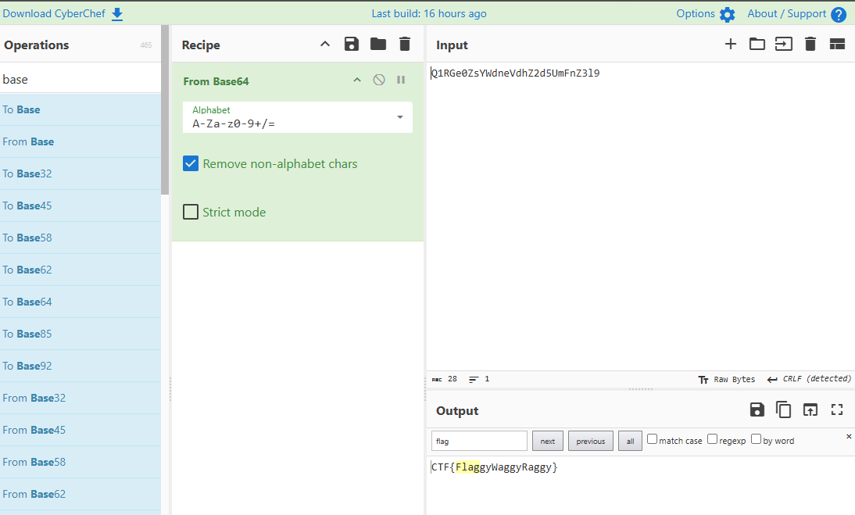

Flag:CTF{FlaggyWaggyRaggy}

Takeaway:The Character Set: Easily spotted by the use of A–Z, a–z, 0–9, and the + and / symbols.The Padding "Tell": The most iconic feature is the trailing equals signs (= or ==). These are used as padding to ensure the data aligns to a multiple of 4 characters.
Not Encryption: Base64 is encoding, not encryption. It’s used to transport binary data (like images or files) as plain text. It offers zero security; anyone can decode it instantly.

Problem:A company stored a secret message on a server which got breached due to the admin using weakly hashed passwords. Can you gain access to the secret stored within the server?

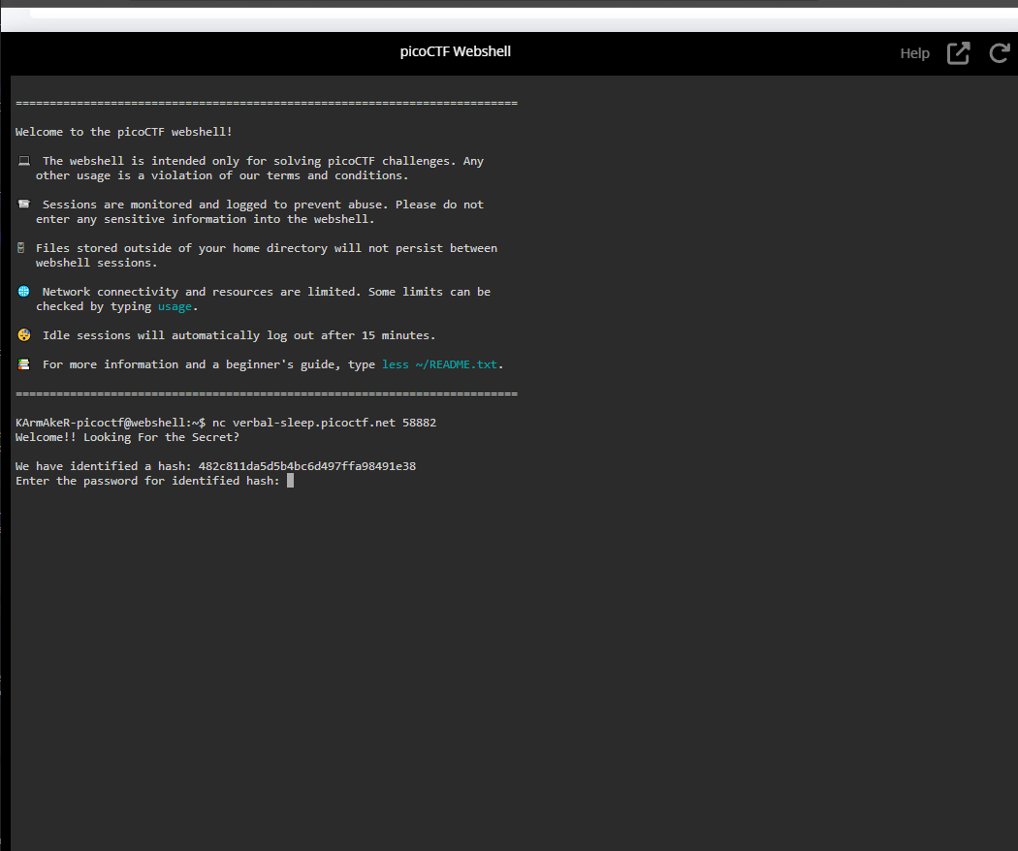

Tools Used:Crackstation,Hashes.com

Solution: First i ran the pico instance then it gave me a hash i went to hashes and pasted that hash and i got a md5 detection and then went to crack station and cracked the hash the password was password123 and then another hash i followed the same approach and it was SHA-1 hash and cracked it its password was letmein and after that another hash it was SHA-256 and the password was qwerty098 after that i got the flag.

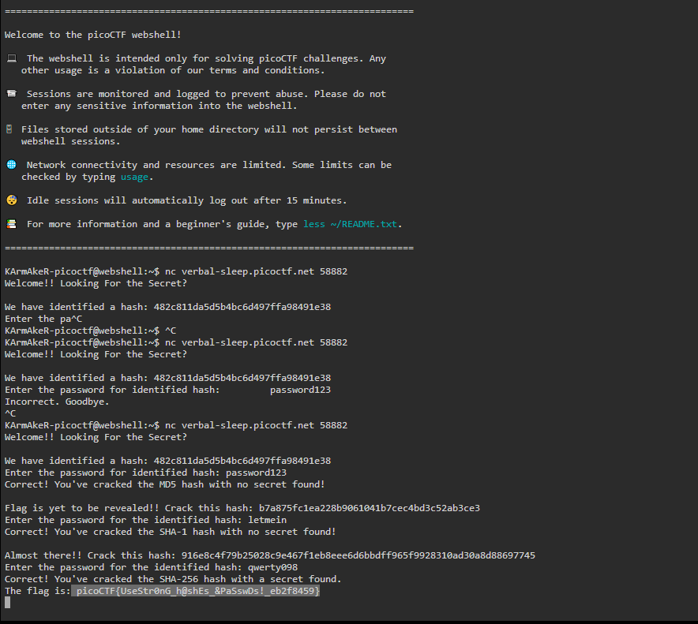

Flag: picoCTF{UseStr0nG_h@shEs_&PaSswDs!_eb2f8459}

Problem:This service provides you an encrypted flag. Can you decrypt it with just N & e?
Source code i got.
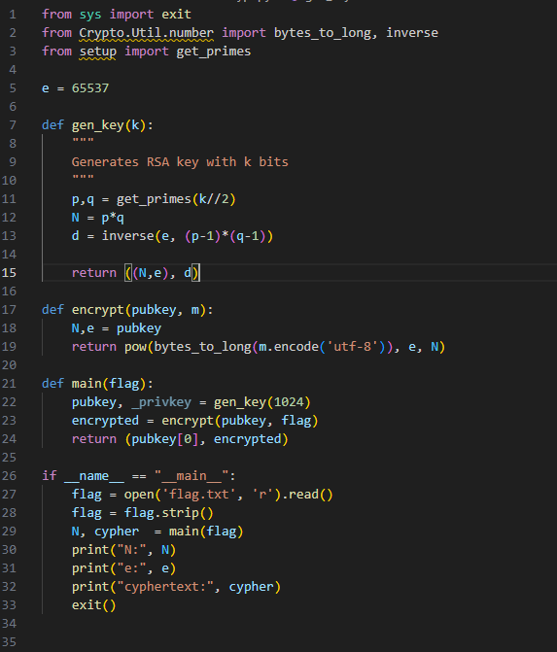

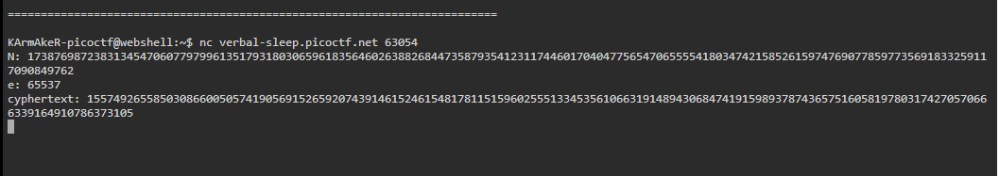

Tools used:https://www.dcode.fr/rsa-cipher
Solution: I went to the dcode.fr and searched for rsa cipher and put those values in the respective places and got the Flag.
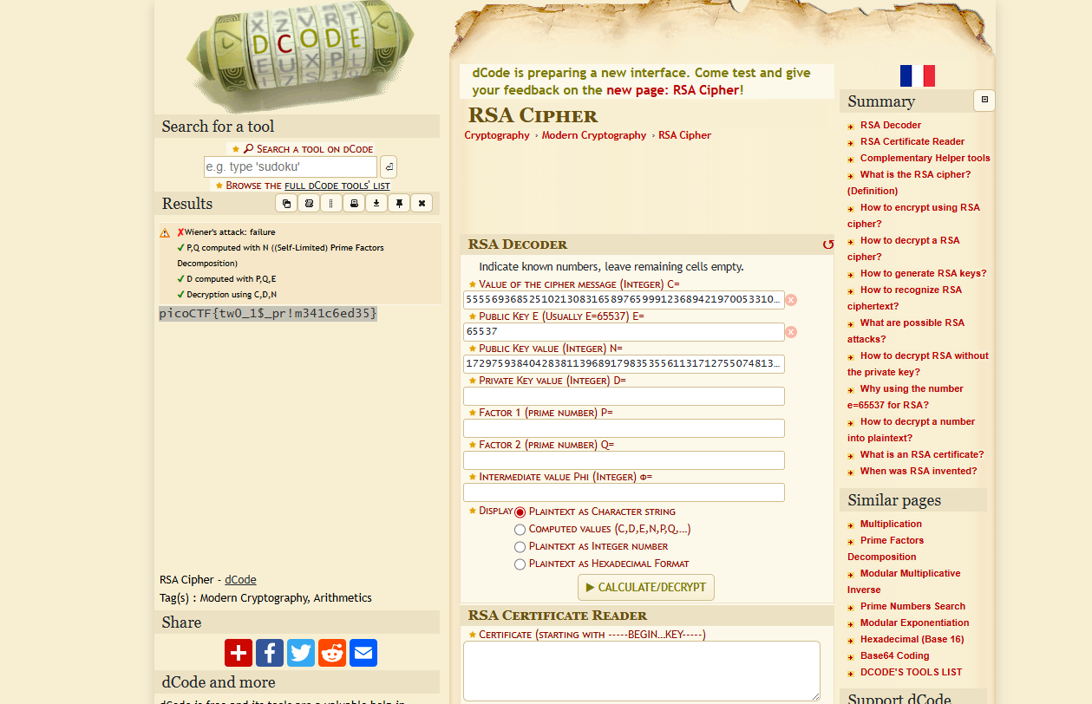

Flag:picoCTF{tw0_1$_pr!m341c6ed35}

Problem:Can you get the real meaning from this file?

File consisted this: YidkM0JxZGtwQlRYdHFhR3g2YUhsZmF6TnFlVGwzWVROclgya3lNRFJvYTJvMmZRPT0nCg==

Initial Analysis: It seems like a base64 the last two equal sign points kinda that.

Tools Used:CyberChef,Cryptii

Solution:Once i applied the base64 and i got this one b'd3BqdkpBTXtqaGx6aHlfazNqeTl3YTNrX2kyMDRoa2o2fQ=='
Then again i applied the base64 and deleted the b and ‘ and it kinda shaped like my flag. Then i went to the cryptii website and pasted it and selected the caesar cipher and i go the flag.

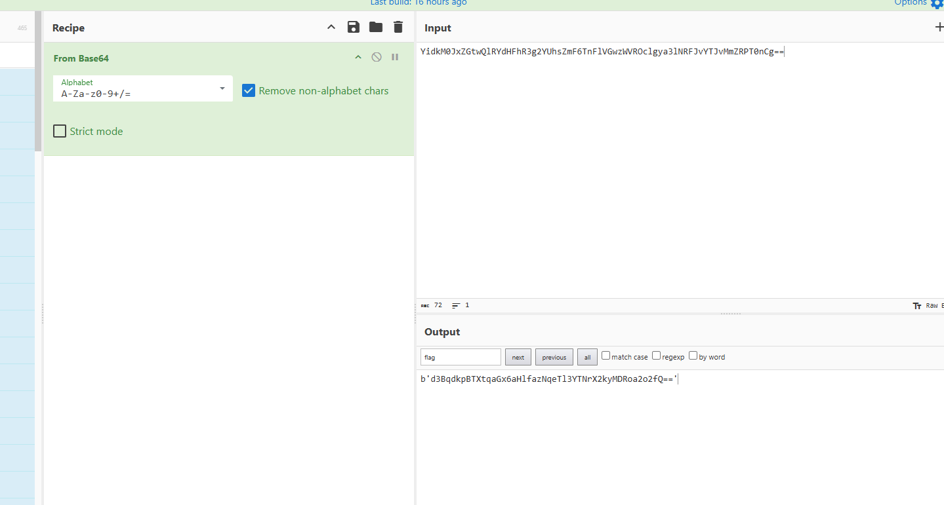

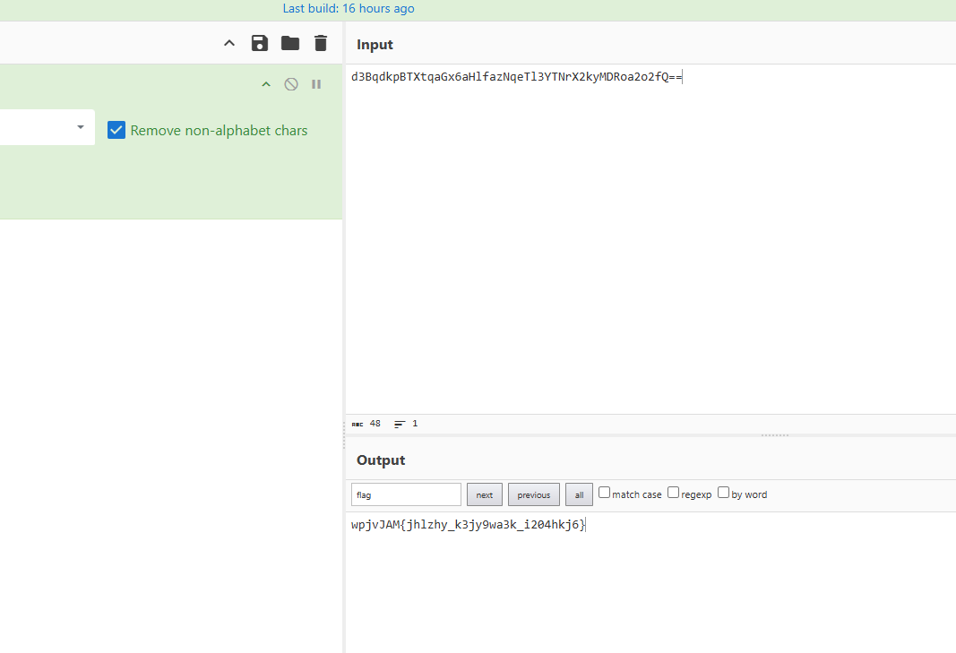
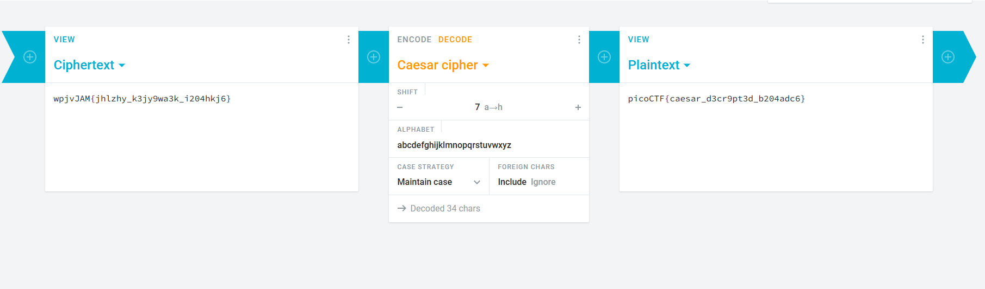

Flag:picoCTF{caesar_d3cr9pt3d_b204adc6}

Problem:Cryptography can be easy, do you know what ROT13 is?

Values.txt file contains:cvpbPGS{arkg_gvzr_V'yy_gel_2_ebhaqf_bs_ebg13_45559noq}

Initial Analysis:ROT13 is our hint here. I'm gonna use it to decipher it.

Tools used:Cryptii

Solution: I went to the cryptii website and selected decode and ROT13 and pasted the cipher text and it decoded the cipher and I got my flag.
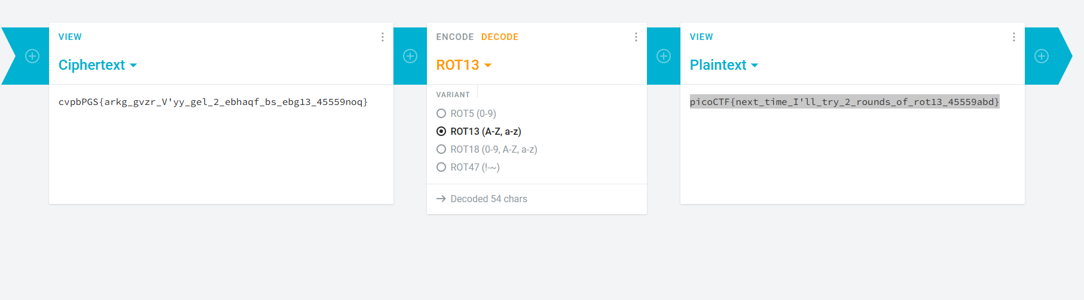

Flag:picoCTF{next_time_I'll_try_2_rounds_of_rot13_45559abd}

Problem:The numbers... what do they mean?
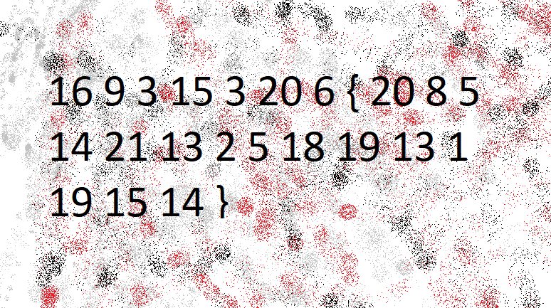

Initial Analysis: after close inspection we can see these are alphabet numbers so it could be a letter number cipher.

Tools Used:https://www.dcode.fr/letter-number-cipher

Solution: I went to the dcode.fr website and pasted the number and it revealed the flag.
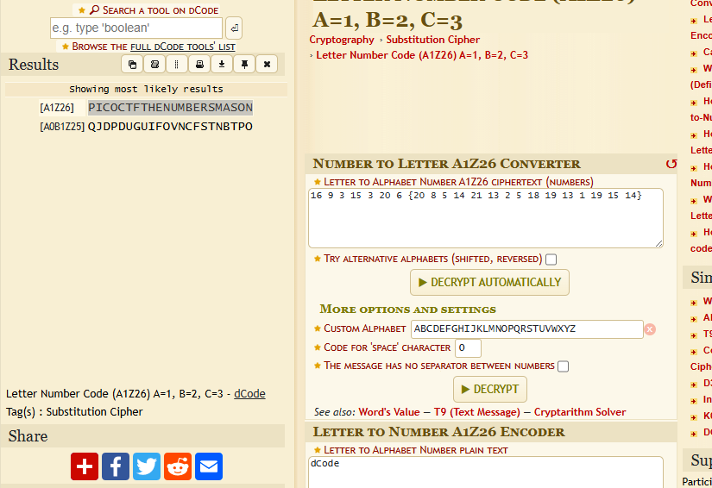
Flag:PICOCTF{THENUMBERSMASON}
Problem:Cryptography can be easy, do you know what ROT13 is? cvpbPGS{abg_gbb_onq_bs_n_ceboyrz}

Initial Analysis:There is the hint ROT13, i will go with that.

Tools Used:Cryptii

Solution:I went to the cryptii website and selected the ROT13 and pasted the cipher text and got the flag.

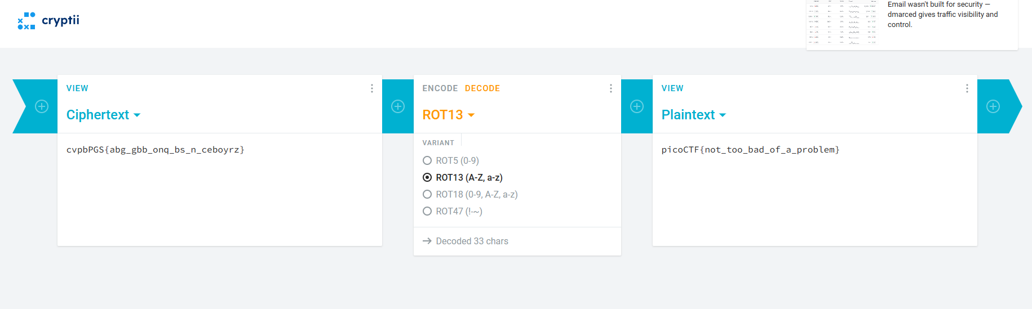

Flag:picoCTF{not_too_bad_of_a_problem}

Problem:Try to decrypt the secret cheese password to prove you're not the imposter!

Tools Used:Dcode.fr

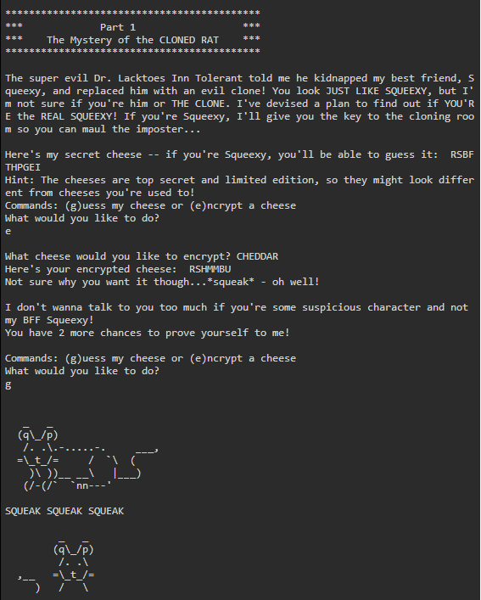

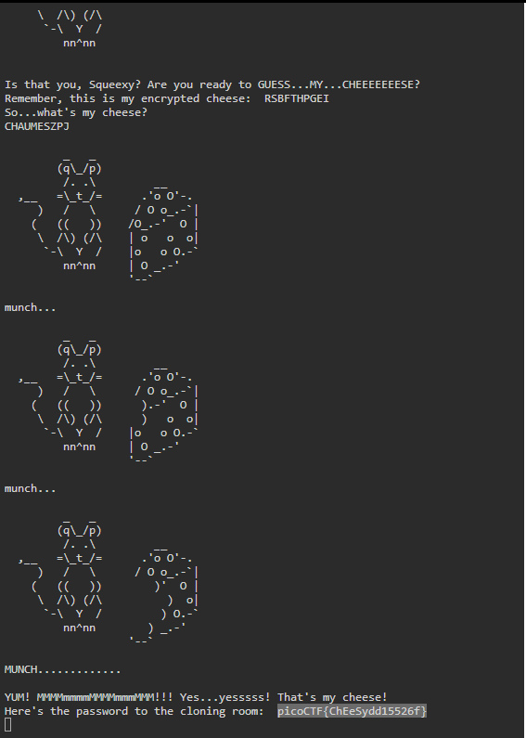

Solution:This is an affine cipher and it actually calculates the values and encrypts it. I used dcode.fr to get the A and B coefficients to get the exact values to decipher it.
Flag:picoCTF{ChEeSydd15526f}

