DEBORAH VANLALDUATI

1937030



2nd SEMESTER MASTERS IN APPLIED ECONOMICS

DEPARTMENT OF ECONOMICS

DEANERY OF HUMANITIES AND SOCIAL SCIENCES

1. SELECT

passenger_count

FROM `bigquery-public-data.new_york_taxi_trips.tlc_green_trips_2014`

Where

passenger_count > 3

LIMIT

30

**RESULTS**

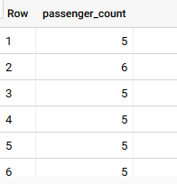

**2.** **S**ELECT

place_name,

rooms,

ROUND(AVG(surface_covered_in_m2)) AS avg_surface_covered_m2

FROM

`properati-data-public.properties_co.properties_sell_201706`

WHERE

property_type = "apartment"

AND operation = "sell"

AND rooms > 0

AND surface_covered_in_m2 > 0

GROUP BY

place_name,

rooms

ORDER BY

place_name,

rooms

RESULT:

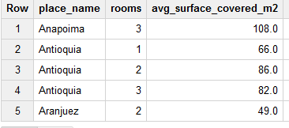

3. SELECT

se.cause_code

,COUNT(r.id) as number_of_tsunami

FROM

`bigquery-public-data.noaa_tsunami.historical_runups` r

INNER JOIN `bigquery-public-data.noaa_tsunami.historical_source_event` se

ON r.tsevent_id=se.id

WHERE se.cause_code != 0

GROUP BY 1

LIMIT 1000

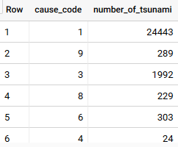

4. SELECT

COUNT(date_local) AS NUM_OF_DAYS,

CASE

WHEN aqi < 51 THEN "Good (green)"

WHEN aqi <101 THEN "Moderate (yellow)"

WHEN aqi <151 THEN "Unhealthy for sensitive groups (orange)"

WHEN aqi <201 THEN "Unhealthy (red)"

WHEN aqi <301 THEN "Very unhealthy (purple)"

WHEN aqi <501 THEN "Hazardous (maroon)"

ELSE "unexpected data"

END AS AQ_RATING

FROM

`bigquery-public-data.epa_historical_air_quality.pm25_frm_daily_summary`

WHERE

city_name = "Los Angeles"

AND state_name = "California"

AND sample_duration = "24 HOUR"

AND poc = 1

AND EXTRACT(YEAR FROM date_local) = 2015

GROUP BY

2

ORDER BY

1 DESC RESULTS:

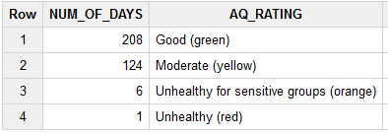

5.SELECT

COUNT(DISTINCT(fdic_certificate_number)) AS count_banks,

city,

state_name

FROM

`bigquery-public-data.fdic_banks.institutions`

GROUP BY

city,

state_name

ORDER BY

count_banks desc

**Results**

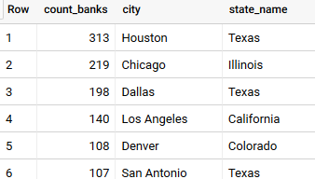

**6.** SELECT

place_name,

rooms,

ROUND(AVG(surface_covered_in_m2)) AS avg_surface_covered_m2

FROM

`properati-data-public.properties_br.properties_sell_201706`

WHERE

property_type = "apartment"

AND operation = "sell"

AND rooms > 0

AND surface_covered_in_m2 > 0

GROUP BY

place_name,

rooms

ORDER BY

place_name,

rooms

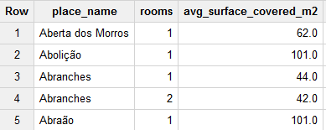

7. SELECT

COUNT(DISTINCT(fdic_certificate_number)) AS count_banks,

city,

state_name

FROM

`bigquery-public-data.fdic_banks.institutions`

GROUP BY

city,

state_name

ORDER BY

count_banks desc

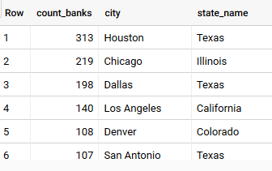

8. SELECT

(SUM (total_transactions_per_user) / COUNT(fullVisitorId) ) AS avg_total_transactions_per_user

FROM (

SELECT

fullVisitorId,

SUM (totals.transactions) AS total_transactions_per_user

FROM

`bigquery-public-data.google_analytics_sample.ga_sessions_*`

WHERE

_TABLE_SUFFIX BETWEEN '20170701'

AND '20170731'

AND totals.transactions IS NOT NULL

GROUP BY

fullVisitorId )

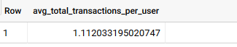

9. SELECT

device.browser,

SUM ( totals.transactions ) AS total_transactions

FROM

`bigquery-public-data.google_analytics_sample.ga_sessions_*`

WHERE

_TABLE_SUFFIX BETWEEN '20170701'

AND '20170731'

GROUP BY

device.browser

ORDER BY

total_transactions DESC

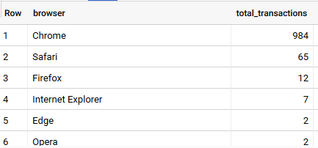

10. SELECT

EXTRACT(YEAR FROM creation_date) AS Year,

COUNT(*) AS Number_of_Questions,

ROUND(100 * SUM(IF(answer_count > 0, 1, 0)) / COUNT(*), 1) AS Percent_Questions_with_Answers

FROM `bigquery-public-data.stackoverflow.posts_questions`

GROUP BY Year

HAVING

Year = 2015

# Use to query a range of years (warning this query processes all records)

# Year > 2009 AND Year < 2016 ORDER BY Year

