Dados 2019 – Sem as estações ruins
time_step = X_train.shape[1] # Quantidade de coordenada para equivaler a 1 espaço de tempo
input_dim = X_train.shape[2] #qtd colunas (features)
out = Y_train.shape[2]

# LSTM
start = time.time()
model = Sequential()
model.add(Masking(mask_value=-1.,input_shape=(time_step, input_dim,))) #camada de entrada
model.add(LSTM(32,activation='elu', input_shape=(time_step, input_dim,),return_sequences=True, go_backwards=True, kernel_regularizer=l2(0.01), recurrent_regularizer=l2(0.01), bias_regularizer=l2(0.01))) # camada escondida
model.add(Dense(out, activation='sigmoid')) #camada saida

opt = tf.keras.optimizers.Adam(learning_rate=0.01)

model.compile(loss = tf.keras.losses.BinaryCrossentropy(from_logits=False) #https://keras.io/api/losses/probabilistic_losses/
, optimizer= opt #'adam'
, weighted_metrics=[tf.keras.losses.BinaryCrossentropy(from_logits=False),'accuracy'
, tf.keras.metrics.Precision()
, tf.keras.metrics.Recall()]
, sample_weight_mode="temporal") #Weights
model.summary()
hist = model.fit(X_train
, Y_train
, epochs=100
, validation_split=.2
# ,validation_data=(X_val, Y_val)
, verbose=1, batch_size=64
, sample_weight=sample_weight_transformado
#(samples, sequence_length)
)
end = time.time()
print("Total compile time: --------", end - start, 's')
Peso: 5600
Resultados:
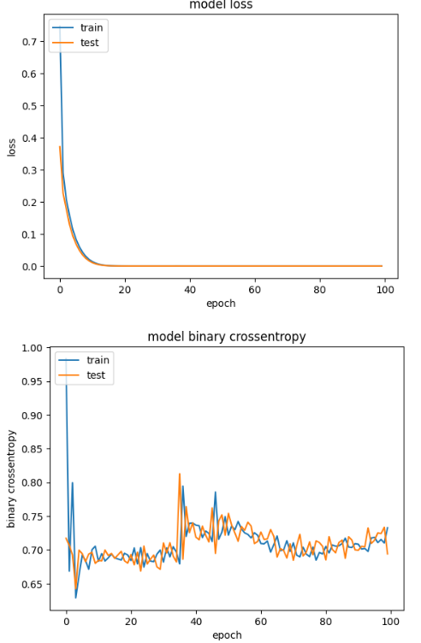
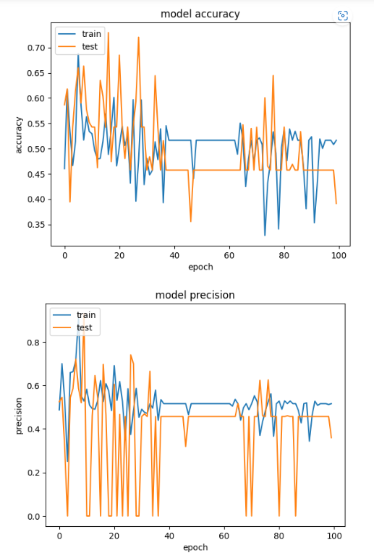

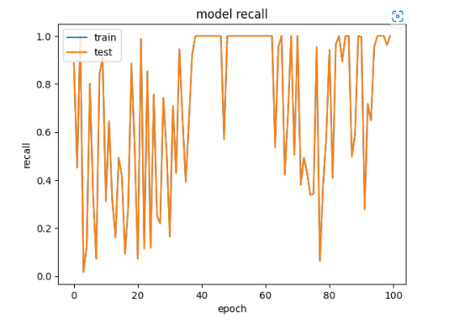

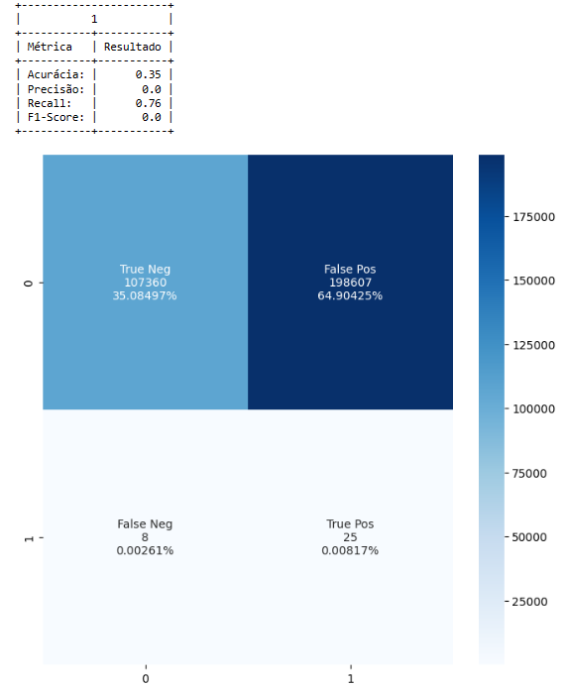

Modelo 2:
time_step = X_train.shape[1] # Quantidade de coordenada para equivaler a 1 espaço de tempo
input_dim = X_train.shape[2] #qtd colunas (features)
out = Y_train.shape[2]

# LSTM
start = time.time()
model = Sequential()
model.add(Masking(mask_value=-1.,input_shape=(time_step, input_dim,))) #camada de entrada
model.add(LSTM(32,activation='elu', input_shape=(time_step, input_dim,),return_sequences=True, go_backwards=True, kernel_regularizer=l2(0.01), recurrent_regularizer=l2(0.01), bias_regularizer=l2(0.01))) # camada escondida
model.add(Dense(out, activation='sigmoid')) #camada saida

opt = tf.keras.optimizers.Adam(learning_rate=0.01)

model.compile(loss = tf.keras.losses.BinaryCrossentropy(from_logits=False) #https://keras.io/api/losses/probabilistic_losses/
, optimizer= opt #'adam'
, weighted_metrics=[tf.keras.losses.BinaryCrossentropy(from_logits=False),'accuracy'
, tf.keras.metrics.Precision()
, tf.keras.metrics.Recall()]
, sample_weight_mode="temporal") #Weights
model.summary()
hist = model.fit(X_train
, Y_train
, epochs=100
# , validation_split=.2
,validation_data=(X_val, Y_val)
, verbose=1, batch_size=64
, sample_weight=sample_weight_transformado
#(samples, sequence_length)
)
end = time.time()
print("Total compile time: --------", end - start, 's')

