SOUTH CAROLINA DAY BY DAY
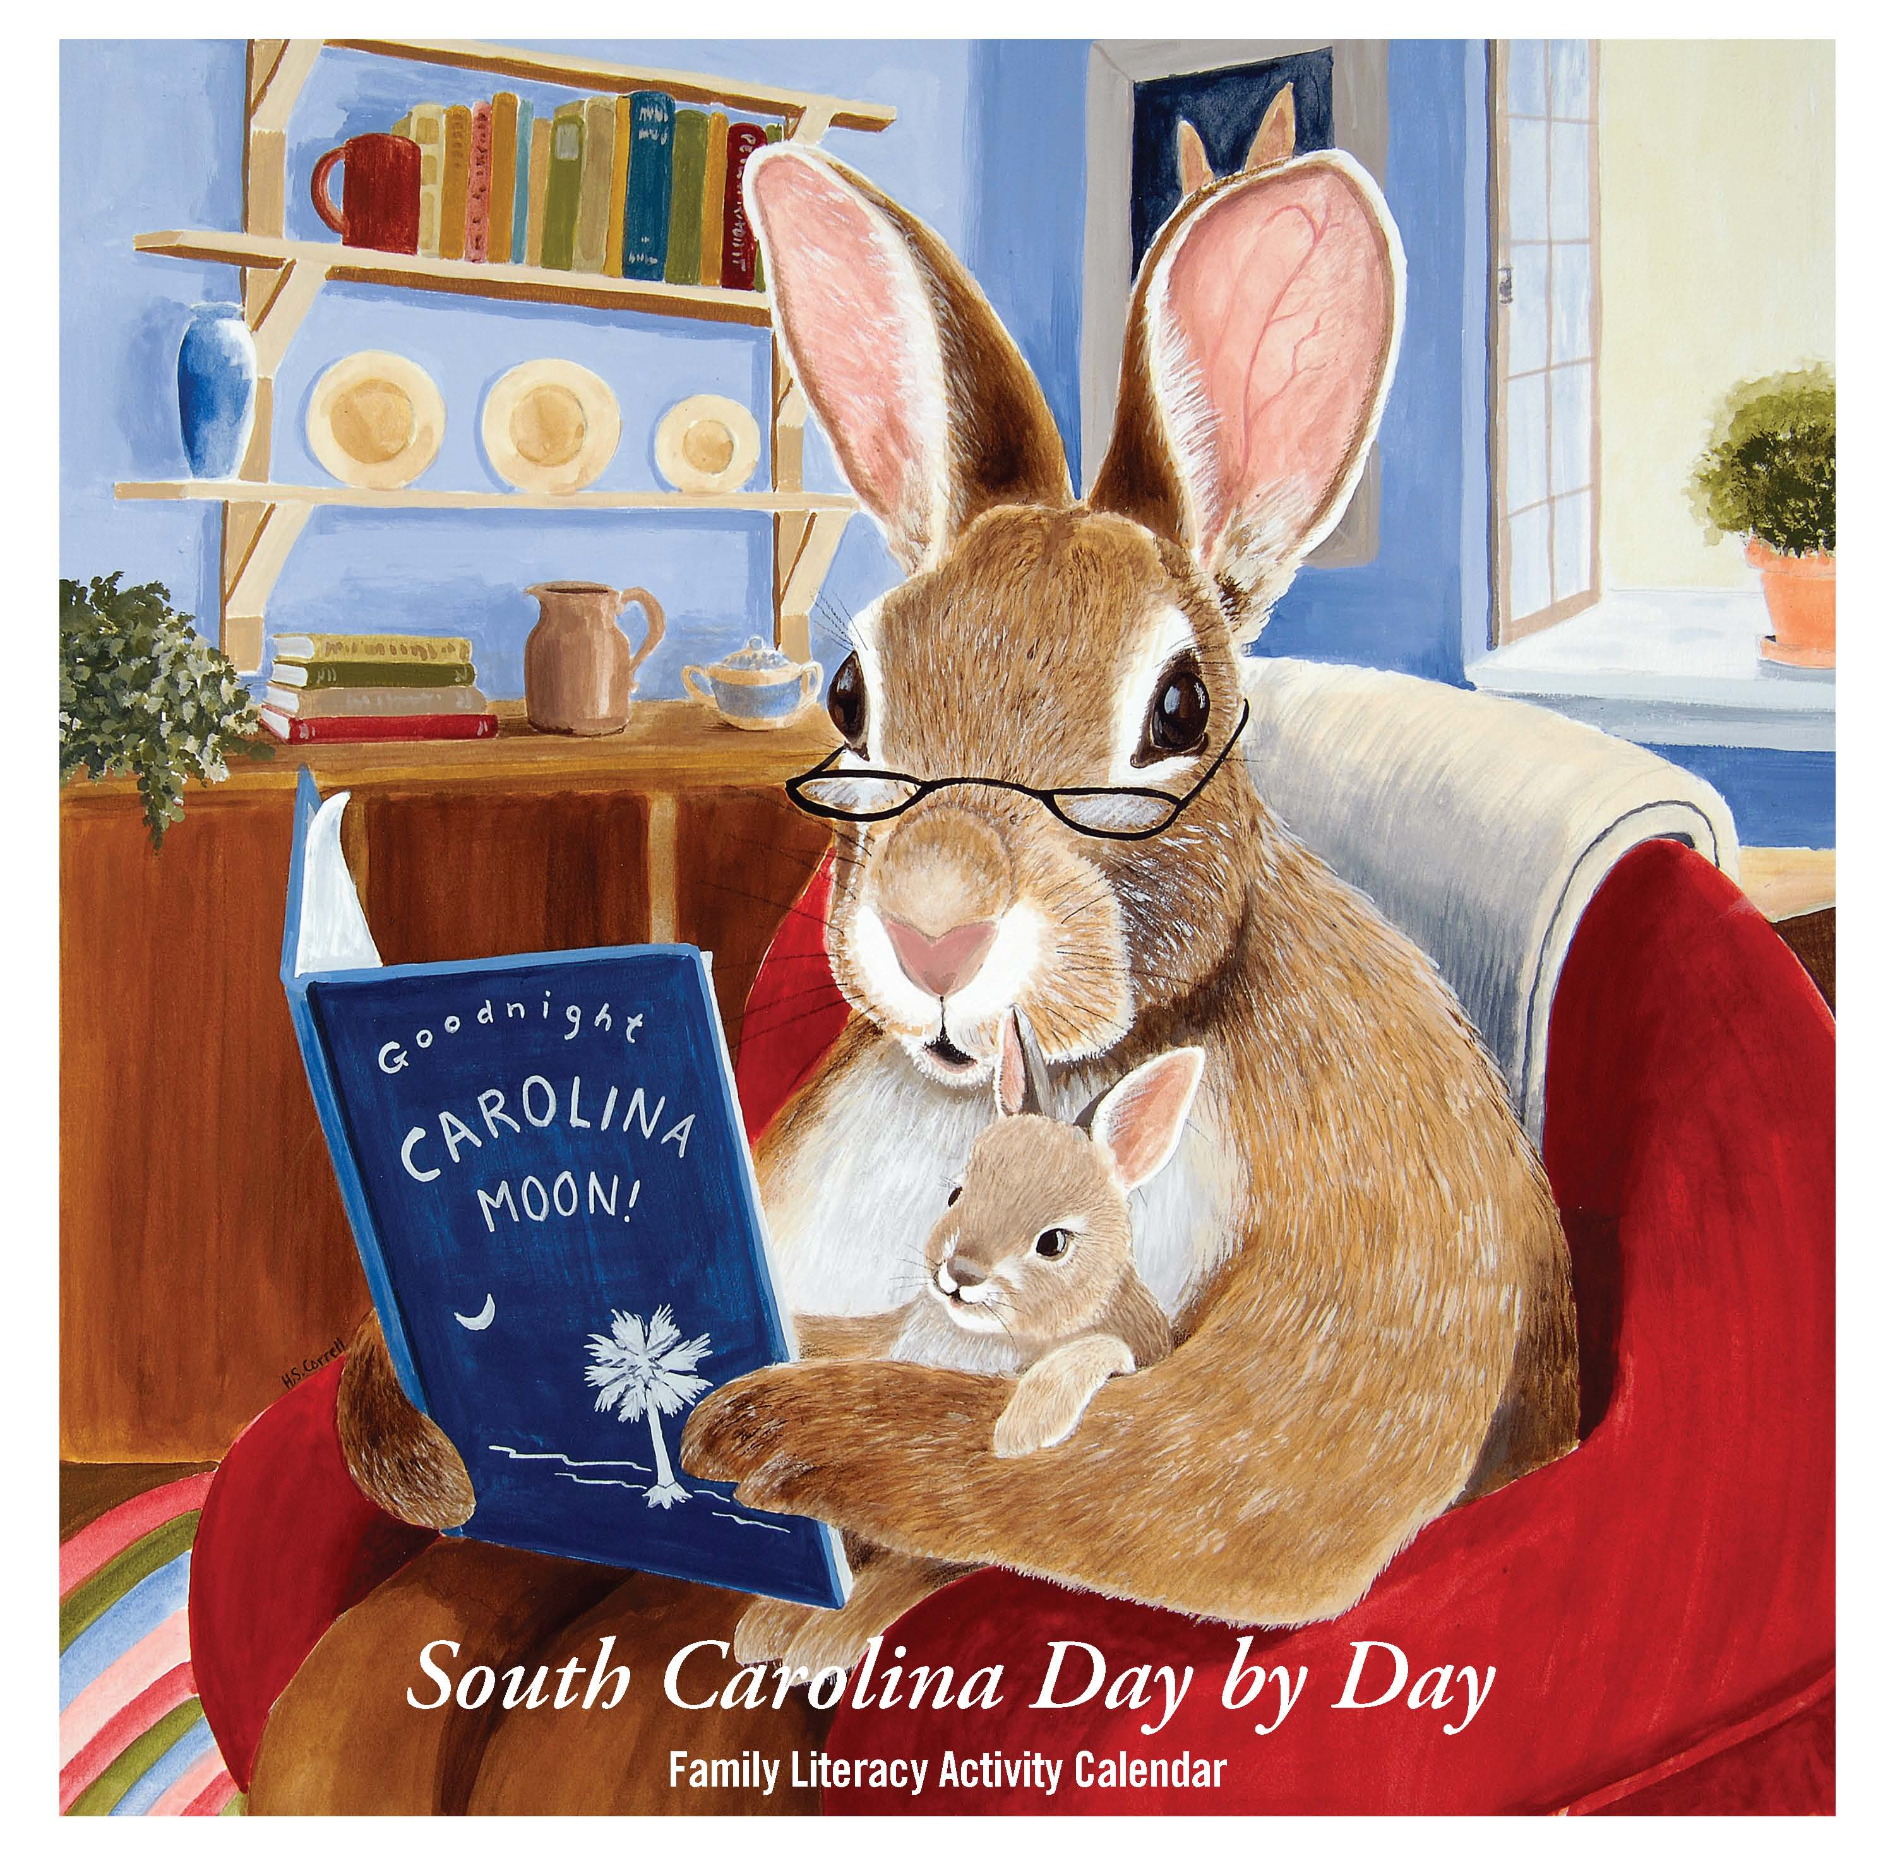
FAMILY LITERACY ACTIVITY CALENDAR FAQ’S

What is a perpetual calendar?
A perpetual calendar is an undated calendar with no time-sensitive content. The South Carolina Day by Day family literacy activity calendar is designed to be a perpetual calendar for two reasons. Families and caregivers can take time together each month and write in the numbers of the days. This is a skill-building activity: it helps with counting skills, number recognition, and learning about days and time. Second, the calendar is not dated for any particular year, so it can be used year after year. You can pencil in the dates and erase them when the New Year starts, or you can obtain a blank calendar and write in the new dates. This design will allow the flexibility to provide a useful tool for many years.

Who will receive the Day by Day Calendar? Is there an associated cost?
Calendar will be given free of charge to families who meet the guidelines for the targeted audience: Families with one or more children under the age of 7, who come from low income or low literacy backgrounds, or who have very limited resources in their community. This is done through an organizational request, such as school/preschool, childcare center, literacy center, nonprofit agency, library or similar agencies that serve the educational needs of young children and families. Please contact Flora at fdubose@statelibrary.sc.gov for an order form. While we would like to be able to give a calendar to every family in South Carolina, we regret it is not possible with current funding. The Calendar is intended to stimulate family reading activities and increase skills for emerging readers, for those who are currently disadvantaged in this regard. Libraries and partners need to work with the SC State Library to discuss programs which may qualify.

Who is responsible for the Day by Day Calendar?
The Calendar is a project of the South Carolina State Library, working in partnership with many agencies, and primarily funded by a Library Services and Technology grant from the U.S. Institute of Museum and Library Services (IMLS). For information, contact Denise Lyons, dlyons@statelibrary.sc.gov or 803.734.6061.

Will you ever create a new, differently-designed calendar or calendars in other languages?
We will continue to produce the current design of the calendar without dates so that we can print more copies throughout the year and distribute them to more South Carolina families. We have completed one revision, the fifth year anniversary edition in 2015. The Spanish version is available online to print in PDF. We have explored printing in Braille for our visually impaired patrons, but the amount of text makes it too difficult to reproduce. However, we will increase our audio and video companion pieces through the online site, www.daybydaysc.org to assist with those of varying abilities.

I would love to order a personal copy of the Day by Day Calendar – can they be purchased?
They are available for purchase for $10 each plus shipping. Order forms are available at http://daybydaysc.org/sites/default/files/docs/orderform.pdf or through the SC State Library Foundation who helps coordinate the sales: http://www.scslfoundation.org. The bottom of each page on the www.daybydaysc.org site has helpful information for navigating the calendar.

Who are the partners in the Day by Day Calendar Project?
The South Carolina State Library is grateful to the many agencies and individuals who came on board to support the project. Agency logos are reproduced on the final page of the calendar. IMLS was the primary funder for the first design and printing and the South Carolina State Library Foundation continues to coordinate the sales and support of the project. If you would like to assist in these efforts, please contact Denise Lyons at dlyons@statelibrary.sc.gov or 803.734.6061.

