Game Design Document

Fill up the following document

1. Write the title of your project.

The Coin Hunter.

1. What is the goal of the game?

The goal of the game is to collect as many coins possible without being encountered with the enemy.

1. Write a brief story of your game.

Amy is lost in the forest and she suddenly noticed coins dropped on

the ground. In order to survive, she needs to collect as many coins

possible and not being attacked by the enemy.

1. Which are the playing characters of this game?

* Playing characters are the ones who respond to the user based on the input from the user.
* Cars, monkeys, dinos, wizards, etc., are the playing characters in the game.

|  |  |  |
| --- | --- | --- |
| Number | Character Name | What can this character do? |
| 1 | Amy | Collect coins and run from the enemy |
| 2 |  |  |
| 3 |  |  |
| 4 |  |  |
| 5 |  |  |
| 6 |  |  |
| 7 |  |  |
| 8 |  |  |

1. Which are the Non-Playing Characters of this game?

* Non-Playing characters are the ones that don't have an action or behavior when the user interacts with the game.
* Hurdles, stones, bananas, coins, etc., are non-playing characters in the game.

|  |  |  |
| --- | --- | --- |
| Number | Character Name | What can this character do? |
| 1 | coins | Can get collected by the playing character |
| 2 | enemy | Can attack the playing character |
| 3 |  |  |
| 4 |  |  |
| 5 |  |  |
| 6 |  |  |
| 7 |  |  |
| 8 |  |  |

Draw your imagination of this game. What does this game look like?

* Draw the game either on your computer or on paper.
* Add images of the game scenes to show each of the playing and non-playing characters at least once.

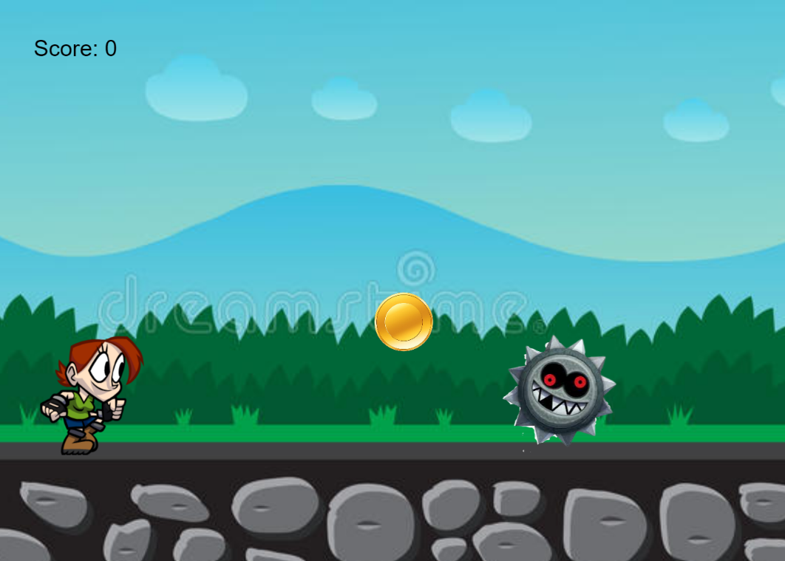

How do you plan to make your game engaging?

To make the user engaged, the game contains sound effects for every

move the playing character is making. While collecting the coins, the user

also has to check if the enemy is near or not.