Assignment1_Deborah

Deborah

2025-10-18

## Introduction

plot(cars)

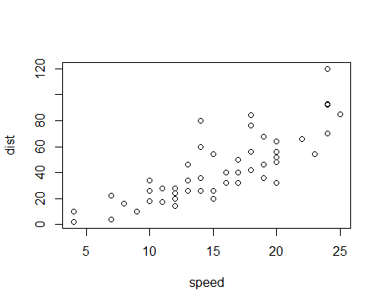 This is a scatter plot of distance vs speed

## apt gender admit fses  
## 1 8 1 1 3  
## 2 7 1 1 1  
## 3 5 0 1 2  
## 4 3 0 0 1  
## 5 3 1 0 2  
## 6 5 1 1 2

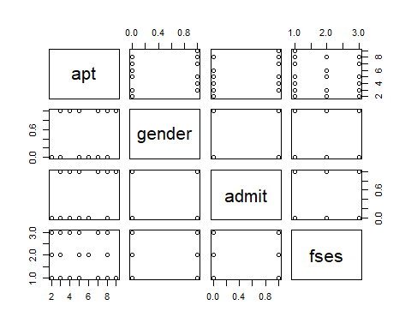

## Temperature Cola  
## 1 1 1  
## 2 2 1  
## 3 3 1  
## 4 4 1  
## 5 5 1  
## 6 6 1

