**Representation of a Process**

Program under execution usually known as process.

|  |
| --- |
| Stack  (local variables, function parameters,  Return address) |
| ⬇️    ⬆️ |
| Heap  (Dynamic allocation) |
| Data area  (Public or static variables) |
| Code or text  Area  (Instructions) |

Program Control Block(PCB):

PCB also known as program descriptor

1. Process id

2. Program counter

3. General purpose register content(GPR)

4. List of devices

5. Type

6. Size

7. Memory Limits

8. Priority

9. state

10. List of files

Context Switch

1. Context save (cpu to memory)

2. Context Load (memory to cpu)

Context switching is done by dispatcher in os.

Process State

Ready

Running

Terminated

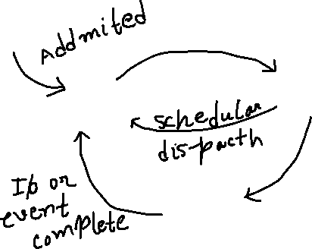

Wait

New



**Process Scheduling**

Non preemptive processes(One the process gets the cpu it can not me replaced with another process)

**First come first serve**

Process 1: 24 ms

Process 2: 3 ms

Process 3: 3 ms

All came at 0 sec

|  |  |  |
| --- | --- | --- |
| P1 | P2 | P3 |

0 24 27 30

Turned around time:

For process 1: completion time – arrival time

24 – 0 = 24

For process 2: completion time – arrival time

27 – 0 = 27

For process 3: completion time – arrival time

30 – 0 = 30

Average TAT = (24 + 27 + 30 ) / 3 = 27 ms

Wait time for process 1: | arrival time – the time when got cpu |

|0 – 0 | = 0 ms

Wait time for process 2: | arrival time – the time when got cpu |

|0 – 24 | = 24 ms

Wait time for process 3: | arrival time – the time when got cpu |

| 0 – 27 | = 27 ms

Therefore total waiting time: ( 0 + 24 + 27 ) / 3

= 51 / 3 ms

= 17 ms

**Shortest job first**

Process1: 24 ms

Process2: 3 ms

Process3: 3ms

All jobs came at 0 ms

|  |  |  |
| --- | --- | --- |
| P2 | P3 | P1 |

0 3 6 30

Turned around time:

For process 1: completion time – arrival time

30 – 0 = 30

For process 2: completion time – arrival time

3 – 0 = 3

For process 3: completion time – arrival time

6 – 0 = 6

Average TAT = (30 + 3 + 6 ) / 3 = 13 ms

Wait time for process 1: | arrival time – the time when got cpu |

|0 – 6 | = 6 ms

Wait time for process 2: | arrival time – the time when got cpu |

|0 – 0 | = 0 ms

Wait time for process 3: | arrival time – the time when got cpu |

| 0 – 3 | = 3 ms

Therefore total waiting time: ( 6 + 0 + 3 ) / 3

= 9 / 3 ms

= 3 ms

/