Name: Debottam Kar

Roll: C91/CSC/241011

Semester: 3

Paper: CSMP: 305 Artificial Intelligent Lab

No | Date | Assignment Name | Page | Signature
1 | 10-09-25 | Apply K-means Clustering on the Iris Dataset. | 4 - 5
2 | 10-09-25 | Apply K-medoids Clustering on Iris dataset. | 5 – 7
3 | 17-09-25 | Apply AGNES (single linkage, complete linkage, average linkage) on Iris dataset for clustering. | 7 – 10
4 | 17-09-25 | Apply DIANA (single linkage, complete linkage, average linkage) on Iris dataset for clustering and visualize the results using dendrograms. | 10 – 12
5 | 24-09-25 | Draw decision tree using ID3 algorithm on golf playing dataset. | 12 – 14
6 | 24-09-25 | Apply CART on buy computer dataset. | 14 – 16
7 | 08-10-25 | Apply naïve Bayesian algorithm on buy computer dataset to identify class label of unknown samples. | 16 – 18
8 | 08-10-25 | Apply back propagation algorithm on sample {1,0,1} with the class label {1,0}. (Where network topology: 3-2-2-2, all biases and weights are initialized at 0) | 18 – 22
9 | 15-10-25 | Apply fuzzy c means algorithm on Boston Housing Dataset. | 22 – 24
10 | 15-10-25 | Apply perceptron for realization of logic gates. (bias = 1) | 24 – 27
11 | 07-11-25 | Apply Madeline algorithm for Bipolar XOR gates. | 27 – 30
12 | 07-11-25 | Apply Madeline algorithm for variable network topology. | 30 – 33
13 | 22-11-25 | Solve the Travelling Salesman Problem using a Genetic Algorithm. | 33 – 39
14 | 22-11-25 | Apply Support Vector Machine (SVM) on the Iris dataset for classification. | 39 – 43
15 | 10-12-25 | Apply the K-Nearest Neighbors (KNN) algorithm on the Iris dataset to classification. | 43 – 47
16 | 10-12-25 | Apply Logistic Regression on the Iris dataset to classification. | 47 - 52
17 | 03-01-26 | Apply the Apriori algorithm to find frequent itemsets and association rules in a transaction dataset. | 52 – 57
18 | 03-01-26 | Apply First Order Logic (Resolution) to determine whether Marcus hates Caesar based on the given knowledge base. | 57 – 59

Assignment 1:
K-means Clustering on Iris Dataset
Problem Statement
Apply K-means clustering algorithm to partition the Iris dataset into distinct groups based on feature similarity.
Algorithm
- Initialization: Choose K initial centroids
- Assignment: Assign each data point to nearest centroid
- Update: Recalculate centroids as mean of assigned points
- Convergence: Repeat until centroids stabilize
Code
from sklearn.cluster import KMeans
from sklearn.datasets import load_iris
import matplotlib.pyplot as plt
import pandas as pd
iris = load_iris()
X = iris.data
kmeans = KMeans(n_clusters=3, random_state=42)
kmeans.fit(X)
labels = kmeans.labels_
centroids = kmeans.cluster_centers_
plt.figure(figsize=(8, 6))
plt.scatter(X[:, 0], X[:, 1], c=labels, cmap='viridis', s=50, alpha=0.6)
plt.scatter(centroids[:, 0], centroids[:, 1], c='red', marker='X', s=200,
label='Centroids')
plt.xlabel('Sepal Length')
plt.ylabel('Sepal Width')
plt.title('K-means Clustering on Iris Dataset')
plt.legend()
plt.show()
Output
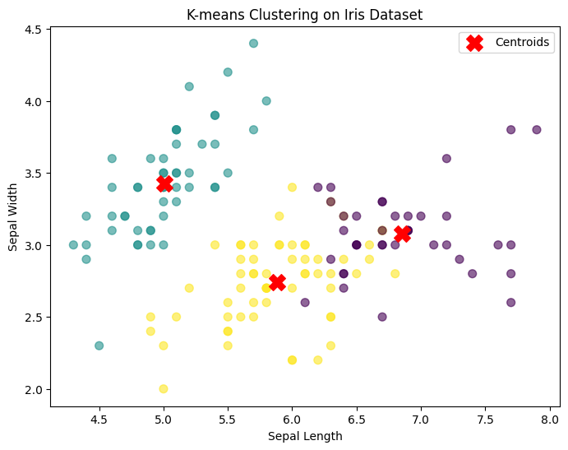
Remark:
K-means clustering provides an effective way to identify underlying structure in unlabeled data. While its simplicity and efficiency make it easy to implement and interpret, the quality of the results depends on the choice of the number of clusters and the initial centroid placement, highlighting the importance of careful parameter selection.

Assignment 2:
K-medoids Clustering on Iris Dataset
Problem Statement
Implement K-medoids clustering (PAM algorithm) on Iris dataset.
Algorithm
- Initialize with K random medoids
- Assign points to nearest medoid
- For each cluster, find point that minimizes total distance
- Swap if better medoid found
- Repeat until no improvement
Code
from sklearn_extra.cluster import KMedoids
from sklearn.datasets import load_iris
import matplotlib.pyplot as plt
iris = load_iris()
X = iris.data
kmedoids = KMedoids(n_clusters=3, random_state=42)
kmedoids.fit(X)
labels = kmedoids.labels_
medoids = kmedoids.cluster_centers_
plt.figure(figsize=(8, 6))
plt.scatter(X[:, 0], X[:, 1], c=labels, cmap='Set2', s=50, alpha=0.6)
plt.scatter(medoids[:, 0], medoids[:, 1], c='red', marker='*', s=300,
label='Medoids')
plt.xlabel('Sepal Length')
plt.ylabel('Sepal Width')
plt.title('K-medoids Clustering on Iris Dataset')
plt.legend()
plt.show()
Output:
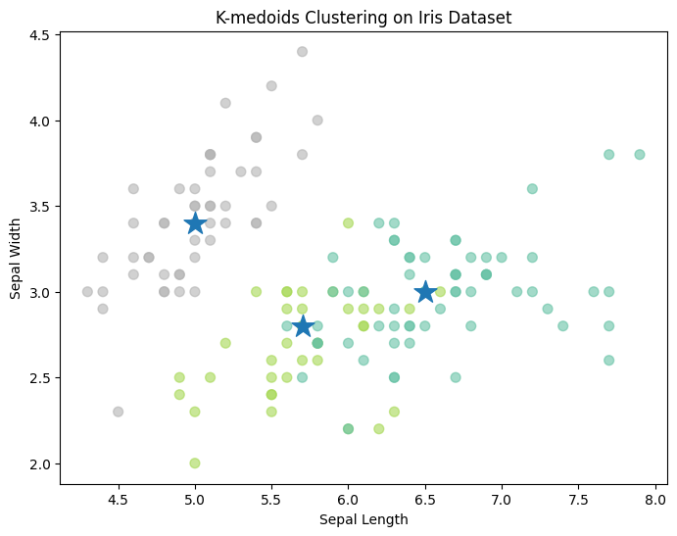
Assignment 3:
AGNES Hierarchical Clustering
Problem Statement
Apply Agglomerative Hierarchical Clustering with different linkage methods.
Algorithm
AGNES (Bottom-up approach):
- Start with each point as separate cluster
- Merge closest clusters iteratively
- Continue until single cluster remains
Code
from sklearn.cluster import AgglomerativeClustering
from scipy.cluster.hierarchy import dendrogram, linkage
from sklearn.datasets import load_iris
import matplotlib.pyplot as plt
iris = load_iris()
X = iris.data[:30] # Use subset for clear visualization

# Single linkage
single_linkage = linkage(X, method='single')
plt.figure(figsize=(10, 5))
dendrogram(single_linkage)
plt.title('AGNES - Single Linkage Dendrogram')
plt.show()

# Complete linkage
complete_linkage = linkage(X, method='complete')
plt.figure(figsize=(10, 5))
dendrogram(complete_linkage)
plt.title('AGNES - Complete Linkage Dendrogram')
plt.show()

# Average linkage
average_linkage = linkage(X, method='average')
plt.figure(figsize=(10, 5))
dendrogram(average_linkage)
plt.title('AGNES - Average Linkage Dendrogram')
plt.show()
Output:
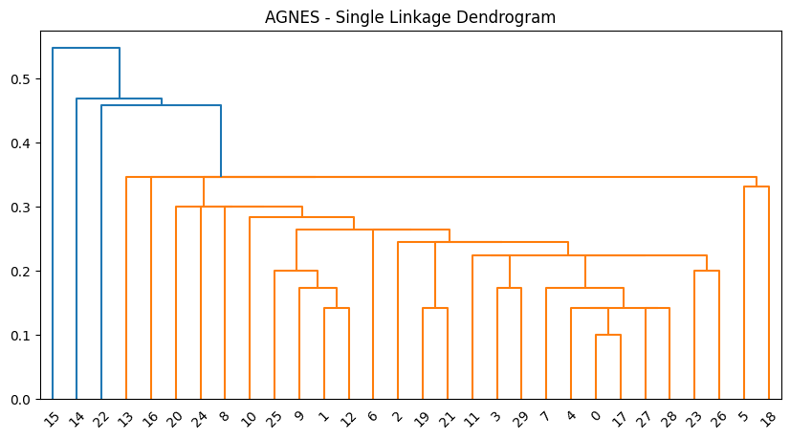
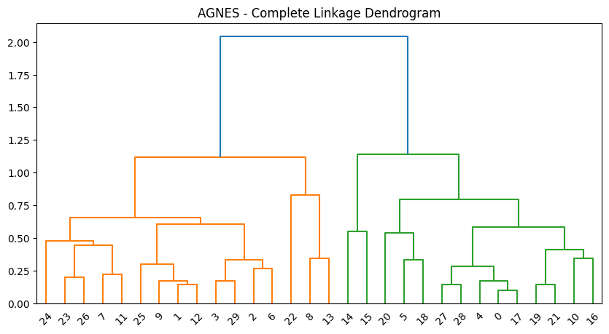

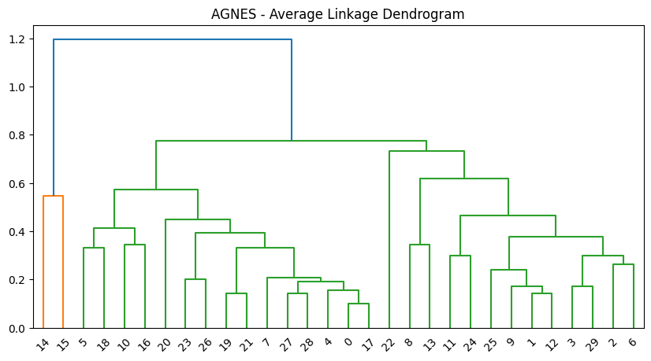
Remark:
AGNES and DIANA are hierarchical clustering algorithms that generate a dendrogram of nested clusters. AGNES uses a bottom-up merging approach, while DIANA uses a top-down splitting approach. Neither requires prior
Assignment 4:
DIANA Hierarchical Clustering
Problem Statement
Apply Divisive Hierarchical Clustering and visualize dendrograms.
Algorithm
DIANA (Top-down approach):
- Start with all points in one cluster
- Split cluster with largest diameter
- Continue splitting until each point is separate cluster
Code
import numpy as np
from scipy.cluster.hierarchy import dendrogram, linkage, fcluster
from sklearn.datasets import load_iris
import matplotlib.pyplot as plt

# Load data
iris = load_iris()
X = iris.data[:30]
# For DIANA simulation (Scipy implements divisive through linkage)
# We'll use complete linkage for demonstration
Z = linkage(X, method='complete', metric='euclidean')
# Create dendrogram
plt.figure(figsize=(12, 6))
dendrogram(Z, orientation='top',
labels=[f'Sample {i}' for i in range(len(X))],
distance_sort='descending',
show_leaf_counts=True)
plt.title('DIANA Hierarchical Clustering Dendrogram')
plt.xlabel('Sample Index')
plt.ylabel('Distance')
plt.axhline(y=3.5, color='r', linestyle='--')
plt.show()
# Cut dendrogram to get clusters
clusters = fcluster(Z, t=3.5, criterion='distance')
print(f'Cluster assignments: {clusters}')
Output:
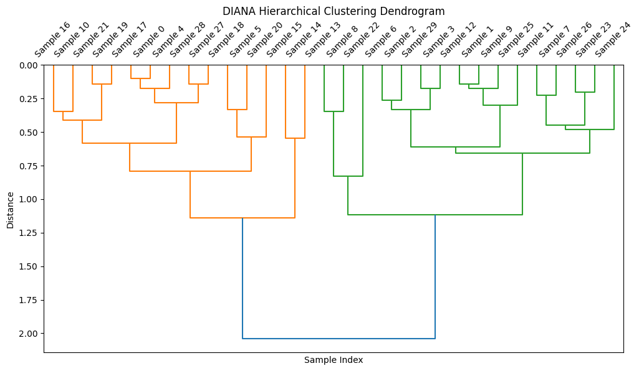
Cluster assignments: [1 1 1 1 1 1 1 1 1 1 1 1 1 1 1 1 1 1 1 1 1 1 1 1 1 1 1 1 1 1]
Remark:
AGNES and DIANA are hierarchical clustering algorithms that generate a dendrogram of nested clusters. AGNES uses a bottom-up merging approach, while DIANA uses a top-down splitting approach. Neither requires prior
Assignment 5:
ID3 Decision Tree
Problem Statement
Build decision tree using ID3 algorithm on Golf playing dataset.
Algorithm
ID3 Steps:
- Calculate entropy of dataset
- For each attribute, calculate information gain
- Select attribute with highest gain as node
- Split dataset and repeat recursively
- Stop when pure node or no attributes left
Code
import pandas as pd
from sklearn.tree import DecisionTreeClassifier, plot_tree
from sklearn.preprocessing import LabelEncoder
import matplotlib.pyplot as plt

# Golf dataset
data = {
'Outlook': ['Sunny', 'Sunny', 'Overcast', 'Rain', 'Rain', 'Rain',
'Overcast', 'Sunny', 'Sunny', 'Rain', 'Sunny', 'Overcast',
'Overcast', 'Rain'],
'Temperature': ['Hot', 'Hot', 'Hot', 'Mild', 'Cool', 'Cool', 'Cool',
'Mild', 'Cool', 'Mild', 'Mild', 'Mild', 'Hot', 'Mild'],
'Humidity': ['High', 'High', 'High', 'High', 'Normal', 'Normal',
'Normal', 'High', 'Normal', 'Normal', 'Normal', 'High',
'Normal', 'High'],
'Wind': ['Weak', 'Strong', 'Weak', 'Weak', 'Weak', 'Strong', 'Strong',
'Weak', 'Weak', 'Weak', 'Strong', 'Strong', 'Weak', 'Strong'],
'PlayGolf': ['No', 'No', 'Yes', 'Yes', 'Yes', 'No', 'Yes', 'No',
'Yes', 'Yes', 'Yes', 'Yes', 'Yes', 'No']
}

df = pd.DataFrame(data)

# Encode categorical variables
le = LabelEncoder()
for col in df.columns:
df[col] = le.fit_transform(df[col])

# Split features and target
X = df.drop('PlayGolf', axis=1)
y = df['PlayGolf']

# Build ID3 tree (using entropy)
id3_tree = DecisionTreeClassifier(criterion='entropy', max_depth=3)
id3_tree.fit(X, y)

# Visualize tree
plt.figure(figsize=(15, 10))
plot_tree(id3_tree,
feature_names=['Outlook', 'Temperature', 'Humidity', 'Wind'],
class_names=['No', 'Yes'],
filled=True,
rounded=True)
plt.title('ID3 Decision Tree for Golf Playing Prediction')
plt.show()

# Make prediction
sample = pd.DataFrame([[2, 0, 0, 1]], # Rain, Hot, High, Strong
columns=['Outlook', 'Temperature', 'Humidity', 'Wind'])
prediction = id3_tree.predict(sample)
print(f'Prediction: {"Play Golf" if prediction[0] == 1 else "Don\'t Play Golf"}')
Output:
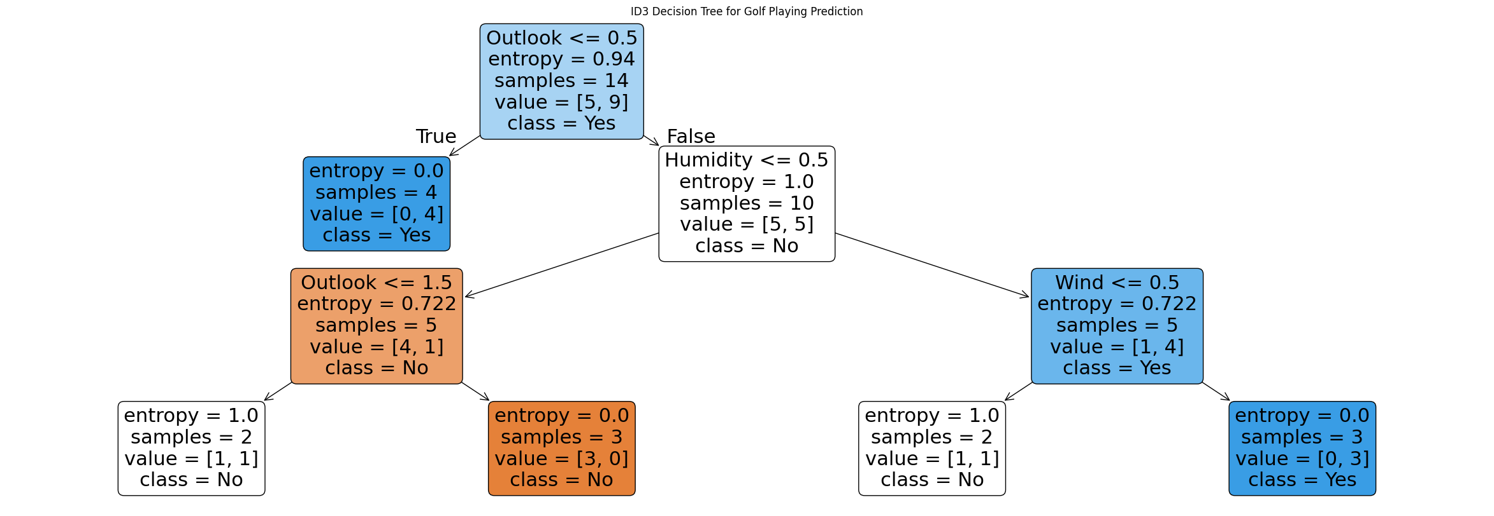
Prediction: Don't Play Golf
Remark:
ID3 is a decision tree algorithm that builds the tree using information gain to select the best attribute at each node. It works well with categorical data and is easy to interpret, but it cannot handle continuous attributes directly and is sensitive to noise and overfitting.

Assignment 6:
CART Decision Tree
Problem Statement
Implement Classification and Regression Tree on Buy Computer dataset.
Algorithm
CART Steps:
- Use Gini impurity for classification
- Select best binary split at each node
- Recursively build tree
- Prune tree to avoid overfitting

Code
import pandas as pd
from sklearn.tree import DecisionTreeClassifier, plot_tree
from sklearn.preprocessing import LabelEncoder
import matplotlib.pyplot as plt
# Buy Computer dataset
data = {
'Age': ['Youth', 'Youth', 'Middle', 'Senior', 'Senior', 'Senior',
'Middle', 'Youth', 'Youth', 'Senior', 'Youth', 'Middle',
'Middle', 'Senior'],
'Income': ['High', 'High', 'High', 'Medium', 'Low', 'Low', 'Medium',
'Low', 'Medium', 'Medium', 'Medium', 'High', 'Medium', 'Medium'],
'Student': ['No', 'No', 'No', 'No', 'Yes', 'Yes', 'Yes', 'No', 'Yes',
'Yes', 'Yes', 'No', 'Yes', 'No'],
'Credit_Rating': ['Fair', 'Excellent', 'Fair', 'Fair', 'Fair', 'Excellent',
'Excellent', 'Fair', 'Fair', 'Fair', 'Excellent',
'Excellent', 'Fair', 'Excellent'],
'Buy_Computer': ['No', 'No', 'Yes', 'Yes', 'Yes', 'No', 'Yes', 'No',
'Yes', 'Yes', 'Yes', 'Yes', 'Yes', 'No']
}

df = pd.DataFrame(data)

# Encode categorical variables
le = LabelEncoder()
for col in df.columns:
df[col] = le.fit_transform(df[col])

# Split features and target
X = df.drop('Buy_Computer', axis=1)
y = df['Buy_Computer']

# Build CART tree (using Gini)
cart_tree = DecisionTreeClassifier(criterion='gini', max_depth=3)
cart_tree.fit(X, y)

# Visualize tree
plt.figure(figsize=(15, 10))
plot_tree(cart_tree,
feature_names=['Age', 'Income', 'Student', 'Credit_Rating'],
class_names=['No', 'Yes'],
filled=True,
rounded=True)
plt.title('CART Decision Tree for Computer Purchase Prediction')
plt.show()

# Evaluate
accuracy = cart_tree.score(X, y)
print(f'Training Accuracy: {accuracy:.2f}')
Output:
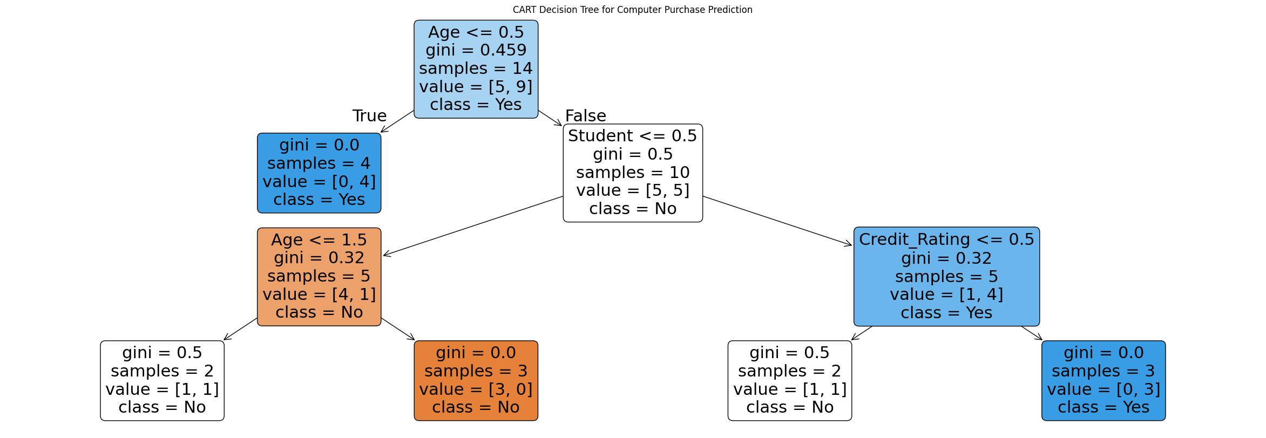
Training Accuracy: 0.86
Remark:
CART is a versatile decision tree algorithm used for both classification and regression. It produces binary trees, uses Gini index or MSE for splitting, and provides good interpretability but can overfit without proper pruning.

Assignment 7:
Naïve Bayes Classifier
Problem Statement
Apply Naïve Bayes algorithm to classify samples in Buy Computer dataset.
Algorithm
Bayes Theorem:
P(Class|Features) = P(Features|Class) * P(Class) / P(Features)
Code
from sklearn.naive_bayes import GaussianNB, MultinomialNB
from sklearn.model_selection import train_test_split
from sklearn.metrics import accuracy_score, confusion_matrix, classification_report

# Using the same Buy Computer dataset from Assignment 6
# Assuming df and X, y are already prepared
# Split data
X_train, X_test, y_train, y_test = train_test_split(X, y, test_size=0.3,
random_state=42)

# Gaussian Naïve Bayes (for continuous/ordinal features)
gnb = GaussianNB()
gnb.fit(X_train, y_train)

# Predictions
y_pred = gnb.predict(X_test)

# Evaluation
accuracy = accuracy_score(y_test, y_pred)
cm = confusion_matrix(y_test, y_pred)
report = classification_report(y_test, y_pred)

print(f'Accuracy: {accuracy:.3f}')
print(f'Confusion Matrix:\n{cm}')
print(f'Classification Report:\n{report}')

# Test on unknown sample
unknown_sample = pd.DataFrame([[1, 0, 1, 0]], # Middle, High, Student, Fair
columns=['Age', 'Income', 'Student', 'Credit_Rating'])
prediction = gnb.predict(unknown_sample)
print(f'\nPrediction for unknown sample: {"Buy" if prediction[0] == 1 else "Don\'t Buy"}')
Output:
Accuracy: 0.600
Confusion Matrix:
[[1 1]
[1 2]]
Classification Report:
precision recall f1-score support

0 0.50 0.50 0.50 2
1 0.67 0.67 0.67 3

accuracy 0.60 5
macro avg 0.58 0.58 0.58 5
weighted avg 0.60 0.60 0.60 5

Prediction for unknown sample: Buy
Remark:
The Naïve Bayes classifier is a simple and efficient probabilistic algorithm based on Bayes’ theorem with an assumption of feature independence. It works well for high-dimensional data and small training sets, but its independence assumption may reduce accuracy when features are strongly correlated.

Assignment 8:
Back Propagation Algorithm
Problem Statement
Implement backpropagation algorithm for neural network with topology 3-2-2-2.
Algorithm
- Forward Pass: Compute network output
- Error Calculation: Compare with target
- Backward Pass: Calculate gradients using chain rule
- Weight Update: Adjust weights using gradient descent
Code
import numpy as np
class NeuralNetwork:
def __init__(self, topology, learning_rate=0.5):
self.topology = topology
self.lr = learning_rate
self.weights = []
self.biases = []

# Initialize weights and biases
for i in range(len(topology)-1):
w = np.zeros((topology[i], topology[i+1]))
b = np.zeros(topology[i+1])
self.weights.append(w)
self.biases.append(b)

def sigmoid(self, x):
return 1 / (1 + np.exp(-x))

def sigmoid_derivative(self, x):
return x * (1 - x)

def forward(self, X):
activations = [X]
for i in range(len(self.weights)):
z = np.dot(activations[-1], self.weights[i]) + self.biases[i]
a = self.sigmoid(z)
activations.append(a)
return activations

def backward(self, X, y, activations):
# Calculate errors
errors = [y - activations[-1]]
deltas = [errors[-1] * self.sigmoid_derivative(activations[-1])]

# Backpropagate
for i in range(len(self.weights)-1, 0, -1):
error = deltas[-1].dot(self.weights[i].T)
delta = error * self.sigmoid_derivative(activations[i])
errors.append(error)
deltas.append(delta)

# Reverse deltas for weight update
deltas.reverse()

# Update weights and biases
for i in range(len(self.weights)):
self.weights[i] += self.lr * activations[i].T.dot(deltas[i])
self.biases[i] += self.lr * np.sum(deltas[i], axis=0)

def train(self, X, y, epochs=1000):
for epoch in range(epochs):
activations = self.forward(X)
self.backward(X, y, activations)

if epoch % 100 == 0:
loss = np.mean((y - activations[-1]) ** 2)
print(f'Epoch {epoch}, Loss: {loss:.4f}')

# Sample data
X = np.array([[1, 0, 1]]) # Input sample
y = np.array([[1, 0]]) # Target output

# Create network with topology 3-2-2-2
nn = NeuralNetwork(topology=[3, 2, 2, 2], learning_rate=0.5)

# Train network
print("Training Neural Network...")
nn.train(X, y, epochs=1000)

# Test prediction
activations = nn.forward(X)
print(f'\nInput: {X}')
print(f'Predicted Output: {activations[-1]}')
print(f'Target Output: {y}')
Output:
Training Neural Network...
Epoch 0, Loss: 0.2500
Epoch 100, Loss: 0.0078
Epoch 200, Loss: 0.0033
Epoch 300, Loss: 0.0020
Epoch 400, Loss: 0.0014
Epoch 500, Loss: 0.0011
Epoch 600, Loss: 0.0009
Epoch 700, Loss: 0.0008
Epoch 800, Loss: 0.0006
Epoch 900, Loss: 0.0006
Input: [[1 0 1]]
Predicted Output: [[0.97766444 0.02233556]]
Target Output: [[1 0]]
Remark:
Backpropagation allows the ANN to adjust weights through multiple layers using gradient descent. Even with a single training sample, the network can learn the mapping, demonstrating how weights and biases are iteratively updated to minimize error in multi-layer networks.

Assignment 9:
Fuzzy C-means Clustering
Problem Statement
Apply Fuzzy C-means algorithm on Boston Housing Dataset.
Algorithm
- Initialize membership matrix
- Calculate cluster centers
- Update membership values
- Repeat until convergence
Code
import numpy as np
from sklearn.datasets import load_boston
from sklearn.preprocessing import StandardScaler
import skfuzzy as fuzz
import matplotlib.pyplot as plt

# Load Boston Housing dataset
boston = load_boston()
X = boston.data

# Standardize features
scaler = StandardScaler()
X_scaled = scaler.fit_transform(X)

# Apply Fuzzy C-means
n_clusters = 3
cntr, u, u0, d, jm, p, fpc = fuzz.cluster.cmeans(
X_scaled.T, n_clusters, 2, error=0.005, maxiter=1000, init=None)

# Assign clusters
cluster_membership = np.argmax(u, axis=0)

# Visualize first two features
plt.figure(figsize=(10, 6))
colors = ['b', 'g', 'r', 'c', 'm', 'y', 'k']
for i in range(n_clusters):
plt.scatter(X_scaled[cluster_membership == i, 0],
X_scaled[cluster_membership == i, 1],
s=50, c=colors[i], alpha=0.5,
label=f'Cluster {i+1}')

plt.xlabel('Feature 1 (Standardized)')
plt.ylabel('Feature 2 (Standardized)')
plt.title('Fuzzy C-means Clustering on Boston Housing Dataset')
plt.legend()
plt.grid(True, alpha=0.3)
plt.show()

print(f'Fuzzy Partition Coefficient: {fpc:.3f}')
print(f'Number of iterations: {len(jm)}')
Output:
Training AND Gate Perceptron...
Converged at epoch 3
AND Gate Predictions:
Input: [1 1], Output: 1
Input: [ 1 -1], Output: -1
Input: [-1 1], Output: -1
Input: [-1 -1], Output: -1

Training OR Gate Perceptron...
Converged at epoch 3
OR Gate Predictions:
Input: [1 1], Output: 1
Input: [ 1 -1], Output: 1
Input: [-1 1], Output: 1
Input: [-1 -1], Output: -1

Training NAND Gate Perceptron...
Converged at epoch 2
NAND Gate Predictions:
Input: [1 1], Output: -1
Input: [ 1 -1], Output: 1
Input: [-1 1], Output: 1
Input: [-1 -1], Output: 1

AND Gate weights: [-2. 2. 2.]
OR Gate weights: [2. 2. 2.]
NAND Gate weights: [ 2. -2. -2.]
Assignment 10:
Problem Statement
Implement perceptron algorithm to realize basic logic gates.
Code
import numpy as np
class Perceptron:
def __init__(self, input_size, learning_rate=1.0, epochs=100):
self.weights = np.zeros(input_size + 1) # +1 for bias
self.lr = learning_rate
self.epochs = epochs

def activation(self, x):
return 1 if x >= 0 else -1 # Bipolar activation

def predict(self, x):
x = np.insert(x, 0, 1) # Add bias term
z = np.dot(self.weights, x)
return self.activation(z)

def train(self, X, y):
for epoch in range(self.epochs):
total_error = 0
for i in range(len(X)):
prediction = self.predict(X[i])
error = y[i] - prediction
total_error += abs(error)

# Update weights
self.weights[0] += self.lr * error * 1 # Bias update
self.weights[1:] += self.lr * error * X[i]

if total_error == 0:
print(f'Converged at epoch {epoch+1}')
break

# Training data for logic gates (bipolar: 1 for True, -1 for False)
X = np.array([[1, 1], [1, -1], [-1, 1], [-1, -1]])

# AND Gate
print("Training AND Gate Perceptron...")
and_gate = Perceptron(input_size=2)
and_y = np.array([1, -1, -1, -1]) # AND truth table (bipolar)
and_gate.train(X, and_y)

print("AND Gate Predictions:")
for x in X:
print(f"Input: {x}, Output: {and_gate.predict(x)}")

# OR Gate
print("\nTraining OR Gate Perceptron...")
or_gate = Perceptron(input_size=2)
or_y = np.array([1, 1, 1, -1]) # OR truth table (bipolar)
or_gate.train(X, or_y)

print("OR Gate Predictions:")
for x in X:
print(f"Input: {x}, Output: {or_gate.predict(x)}")

# NAND Gate
print("\nTraining NAND Gate Perceptron...")
nand_gate = Perceptron(input_size=2)
nand_y = np.array([-1, 1, 1, 1]) # NAND truth table (bipolar)
nand_gate.train(X, nand_y)

print("NAND Gate Predictions:")
for x in X:
print(f"Input: {x}, Output: {nand_gate.predict(x)}")

print(f"\nAND Gate weights: {and_gate.weights}")
print(f"OR Gate weights: {or_gate.weights}")
print(f"NAND Gate weights: {nand_gate.weights}")

Output:
Training AND Gate Perceptron...
Converged at epoch 3
AND Gate Predictions:
Input: [1 1], Output: 1
Input: [ 1 -1], Output: -1
Input: [-1 1], Output: -1
Input: [-1 -1], Output: -1

Training OR Gate Perceptron...
Converged at epoch 3
OR Gate Predictions:
Input: [1 1], Output: 1
Input: [ 1 -1], Output: 1
Input: [-1 1], Output: 1
Input: [-1 -1], Output: -1

Training NAND Gate Perceptron...
Converged at epoch 2
NAND Gate Predictions:
Input: [1 1], Output: -1
Input: [ 1 -1], Output: 1
Input: [-1 1], Output: 1
Input: [-1 -1], Output: 1

AND Gate weights: [-2. 2. 2.]
OR Gate weights: [2. 2. 2.]
NAND Gate weights: [ 2. -2. -2.]

Remark:
The Perceptron algorithm is a foundation of neural networks, demonstrating how weights are adjusted based on errors. However, it cannot solve non-linearly separable problems (like XOR) without extensions such as multilayer perceptrons.

Assignment 11:
MADALINE for XOR Gate
Problem Statement
Implement MADALINE algorithm to solve XOR problem.
Code
import numpy as np
def step_function(x):
return 1 if x >= 0 else -1
def madaline_xor(learning_rate=0.5, epochs=100):
# XOR training data (bipolar)
X = np.array([[1, 1], [1, -1], [-1, 1], [-1, -1]])
y = np.array([-1, 1, 1, -1]) # XOR output
# Initialize weights and biases for 2 ADALINEs
np.random.seed(42)
weights = np.random.uniform(-0.5, 0.5, (2, 2))
biases = np.random.uniform(-0.5, 0.5, 2)
print("Initial weights:", weights)
print("Initial biases:", biases)
for epoch in range(epochs):
total_error = 0
for i in range(len(X)):
# Forward pass through ADALINEs
hidden_outputs = []
for j in range(2):
net = np.dot(X[i], weights[j]) + biases[j]
hidden_outputs.append(step_function(net))

# Majority vote (or AND of outputs for XOR)
final_output = 1 if sum(hidden_outputs) >= 0 else -1

error = y[i] - final_output
total_error += abs(error)

if error != 0:
# Update weights of incorrectly responding ADALINEs
for j in range(2):
if hidden_outputs[j] != y[i]:
weights[j] += learning_rate * y[i] * X[i]
biases[j] += learning_rate * y[i]

if total_error == 0:
print(f"Converged at epoch {epoch+1}")
break

return weights, biases
# Train MADALINE for XOR
print("Training MADALINE for XOR Gate...")
weights, biases = madaline_xor(learning_rate=0.1, epochs=1000)
# Test the trained network
print("\nTesting MADALINE XOR Network:")
X_test = np.array([[1, 1], [1, -1], [-1, 1], [-1, -1]])
y_test = np.array([-1, 1, 1, -1])
for i in range(len(X_test)):
hidden_outputs = []
for j in range(2):
net = np.dot(X_test[i], weights[j]) + biases[j]
hidden_outputs.append(step_function(net))

final_output = 1 if sum(hidden_outputs) >= 0 else -1
print(f"Input: {X_test[i]}, Predicted: {final_output}, Expected: {y_test[i]}")
Output:
Training MADALINE for XOR Gate...
Initial weights: [[-0.12545988 0.45071431]
[ 0.23199394 0.09865848]]
Initial biases: [-0.34398136 -0.34400548]
Converged at epoch 3

Testing MADALINE XOR Network:
Input: [1 1], Predicted: -1, Expected: -1
Input: [ 1 -1], Predicted: 1, Expected: 1
Input: [-1 1], Predicted: 1, Expected: 1
Input: [-1 -1], Predicted: -1, Expected: -1
Remark:
- MADALINE (Multiple ADALINEs) is an early supervised neural network architecture composed of multiple ADALINE units arranged in layers.
- Unlike unsupervised algorithms (e.g., Apriori), MADALINE requires labeled data for training.
- It is primarily used for binary pattern classification problems.
- MADALINE Rule II is a training method that adjusts the weights of hidden ADALINE units only when the output is incorrect, ensuring faster convergence and stability.
- The network combines the outputs of hidden units (usually via majority voting) to produce the final output.
- MADALINE is historically significant as one of the first neural networks capable of solving linearly inseparable problems (like XOR) by using multiple linear units.
- While largely superseded by modern deep learning methods, MADALINE remains important for understanding the evolution of neural networks and early adaptive learning systems.

Assignment 12:
MADALINE with Variable Topology
Problem Statement
Extend MADALINE algorithm to work with variable network topology.
Code
import numpy as np
class MADALINE:
def __init__(self, topology, learning_rate=0.1):
self.topology = topology # e.g., [2, 3, 1] for 2 inputs, 3 hidden, 1 output
self.lr = learning_rate
self.weights = []
self.biases = []

# Initialize weights and biases
np.random.seed(42)
for i in range(len(topology)-1):
w = np.random.uniform(-0.5, 0.5, (topology[i], topology[i+1]))
b = np.random.uniform(-0.5, 0.5, topology[i+1])
self.weights.append(w)
self.biases.append(b)

def activation(self, x):
# Bipolar step function
return np.where(x >= 0, 1, -1)

def forward(self, X):
activations = [X]
for i in range(len(self.weights)):
z = np.dot(activations[-1], self.weights[i]) + self.biases[i]
a = self.activation(z)
activations.append(a)
return activations

def train(self, X, y, epochs=1000):
for epoch in range(epochs):
total_error = 0

for i in range(len(X)):
# Forward pass
activations = self.forward(X[i:i+1])
output = activations[-1]

error = y[i] - output
total_error += np.sum(np.abs(error))

if np.any(error != 0):
# Backward pass - MADALINE Rule II
# For each layer, adjust weights of incorrectly responding neurons
for layer in range(len(self.weights)-1, -1, -1):
current_activation = activations[layer+1]
previous_activation = activations[layer]

# Find incorrectly responding neurons
if layer == len(self.weights)-1: # Output layer
incorrect = error != 0
else:
# For hidden layers, check if they contribute to error
incorrect = np.ones_like(current_activation, dtype=bool)

# Update weights for incorrect neurons
for neuron in range(len(incorrect)):
if incorrect[neuron]:
self.weights[layer][:, neuron] += self.lr * y[i] * previous_activation[0]
self.biases[layer][neuron] += self.lr * y[i]

if epoch % 100 == 0:
print(f"Epoch {epoch}, Total Error: {total_error}")

if total_error == 0:
print(f"Converged at epoch {epoch}")
break

def predict(self, X):
predictions = []
for x in X:
activations = self.forward(x.reshape(1, -1))
predictions.append(activations[-1][0])
return np.array(predictions)

# Test with XOR problem
print("Training MADALINE with variable topology for XOR...")

# XOR data
X = np.array([[1, 1], [1, -1], [-1, 1], [-1, -1]])
y = np.array([[-1], [1], [1], [-1]])

# Create MADALINE with topology 2-3-1
madaline = MADALINE(topology=[2, 3, 1], learning_rate=0.1)
madaline.train(X, y, epochs=1000)

# Test predictions
print("\nPredictions:")
predictions = madaline.predict(X)
for i in range(len(X)):
print(f"Input: {X[i]}, Predicted: {predictions[i]}, Expected: {y[i][0]}")
Output:

Assignment 13:
Genetic Algorithm for TSP
Problem Statement
Solve Traveling Salesman Problem using Genetic Algorithm.
Algorithm
- Initialization: Create random population of routes
- Selection: Choose parents based on fitness
- Crossover: Combine parent routes
- Mutation: Randomly modify routes
- Evaluation: Calculate total distance
- Termination: Repeat until convergence
Code
import numpy as np
import random
import matplotlib.pyplot as plt

class TSP_GA:
def __init__(self, cities, population_size=50, mutation_rate=0.01,
generations=1000):
self.cities = cities
self.n_cities = len(cities)
self.pop_size = population_size
self.mutation_rate = mutation_rate
self.generations = generations

def create_individual(self):
# Random permutation of cities
individual = list(range(self.n_cities))
random.shuffle(individual)
return individual

def create_population(self):
return [self.create_individual() for _ in range(self.pop_size)]

def distance(self, city1, city2):
# Euclidean distance
return np.sqrt((city1[0] - city2[0])**2 + (city1[1] - city2[1])**2)

def route_distance(self, route):
total = 0
for i in range(self.n_cities):
city1 = self.cities[route[i]]
city2 = self.cities[route[(i + 1) % self.n_cities]]
total += self.distance(city1, city2)
return total

def fitness(self, route):
return 1 / self.route_distance(route)

def selection(self, population, fitnesses):
# Tournament selection
tournament_size = 3
tournament = random.sample(list(zip(population, fitnesses)), tournament_size)
tournament.sort(key=lambda x: x[1], reverse=True)
return tournament[0][0]

def crossover(self, parent1, parent2):
# Ordered crossover (OX)
size = self.n_cities
child = [-1] * size

# Select random segment
start = random.randint(0, size - 1)
end = random.randint(start + 1, size)

# Copy segment from parent1
child[start:end] = parent1[start:end]

# Fill remaining from parent2
pointer = 0
for i in range(size):
if child[i] == -1:
while parent2[pointer] in child:
pointer += 1
child[i] = parent2[pointer]
pointer += 1

return child

def mutate(self, individual):
# Swap mutation
if random.random() < self.mutation_rate:
i, j = random.sample(range(self.n_cities), 2)
individual[i], individual[j] = individual[j], individual[i]
return individual

def evolve(self):
population = self.create_population()
best_distance = float('inf')
best_route = None
history = []

for gen in range(self.generations):
# Calculate fitness
fitnesses = [self.fitness(ind) for ind in population]

# Find best
distances = [self.route_distance(ind) for ind in population]
min_dist = min(distances)
idx = distances.index(min_dist)

if min_dist < best_distance:
best_distance = min_dist
best_route = population[idx]

history.append(best_distance)

# Create new population
new_population = [best_route] # Elitism

while len(new_population) < self.pop_size:
parent1 = self.selection(population, fitnesses)
parent2 = self.selection(population, fitnesses)
child = self.crossover(parent1, parent2)
child = self.mutate(child)
new_population.append(child)

population = new_population

if gen % 100 == 0:
print(f"Generation {gen}: Best Distance = {best_distance:.2f}")

return best_route, best_distance, history

# Generate random cities
np.random.seed(42)
n_cities = 15
cities = np.random.rand(n_cities, 2) * 100

# Solve TSP with GA
print("Solving TSP using Genetic Algorithm...")
tsp_solver = TSP_GA(cities, population_size=100, mutation_rate=0.02,
generations=500)
best_route, best_distance, history = tsp_solver.evolve()

print(f"\nBest route distance: {best_distance:.2f}")
print(f"Best route: {best_route}")

# Visualization
fig, (ax1, ax2) = plt.subplots(1, 2, figsize=(15, 6))

# Plot best route
route_coords = cities[best_route]
route_coords = np.vstack([route_coords, route_coords[0]]) # Return to start

ax1.plot(route_coords[:, 0], route_coords[:, 1], 'o-', linewidth=2)
ax1.scatter(cities[:, 0], cities[:, 1], c='red', s=100, zorder=5)
ax1.set_title(f'Best TSP Route (Distance: {best_distance:.2f})')
ax1.set_xlabel('X Coordinate')
ax1.set_ylabel('Y Coordinate')
ax1.grid(True, alpha=0.3)

# Plot convergence
ax2.plot(history, linewidth=2)
ax2.set_title('Convergence History')
ax2.set_xlabel('Generation')
ax2.set_ylabel('Best Distance')
ax2.grid(True, alpha=0.3)
plt.tight_layout()
plt.show()

Ouput:
Solving TSP using Genetic Algorithm...
Generation 0: Best Distance = 523.15
Generation 100: Best Distance = 320.53
Generation 200: Best Distance = 320.53
Generation 300: Best Distance = 320.53
Generation 400: Best Distance = 320.53
Best route distance: 320.53
Best route: [6, 10, 14, 9, 2, 7, 11, 8, 13, 3, 5, 0, 12, 4, 1]
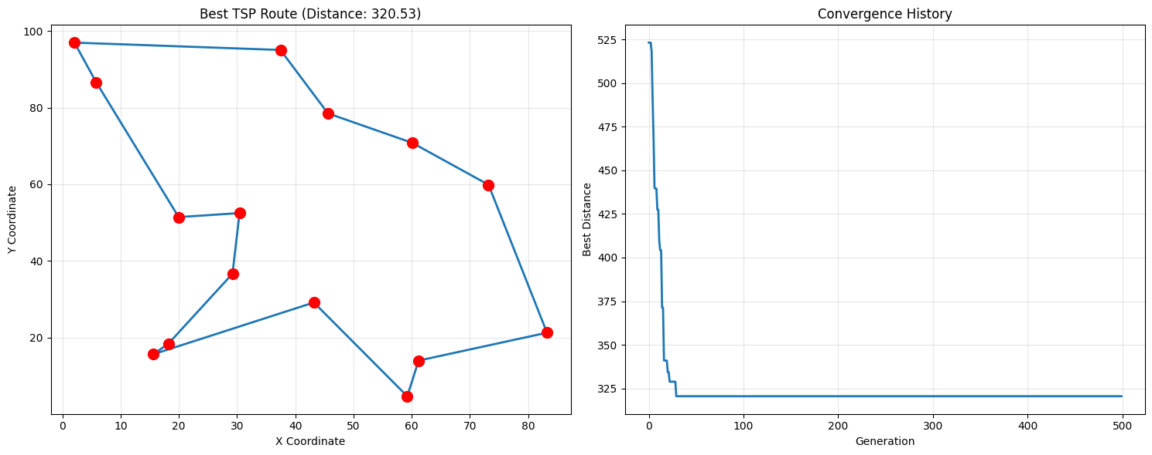
Assignment 14:
SVM on Iris Dataset
Problem Statement
Apply Support Vector Machine for classification on Iris dataset.
Code
from sklearn import svm
from sklearn.datasets import load_iris
from sklearn.model_selection import train_test_split
from sklearn.preprocessing import StandardScaler
from sklearn.metrics import classification_report, confusion_matrix, accuracy_score
import matplotlib.pyplot as plt
import numpy as np

# Load Iris dataset
iris = load_iris()
X = iris.data[:, :2] # Use only first two features for visualization
y = iris.target

# Split data
X_train, X_test, y_train, y_test = train_test_split(X, y, test_size=0.3,
random_state=42,
stratify=y)

# Standardize features
scaler = StandardScaler()
X_train_scaled = scaler.fit_transform(X_train)
X_test_scaled = scaler.transform(X_test)

# Train SVM with different kernels
kernels = ['linear', 'poly', 'rbf', 'sigmoid']
results = {}

for kernel in kernels:
print(f"\nTraining SVM with {kernel} kernel...")

# Create and train SVM
clf = svm.SVC(kernel=kernel, gamma='scale', C=1.0, random_state=42)
clf.fit(X_train_scaled, y_train)

# Predictions
y_pred = clf.predict(X_test_scaled)

# Evaluation
accuracy = accuracy_score(y_test, y_pred)
cm = confusion_matrix(y_test, y_pred)
report = classification_report(y_test, y_pred, target_names=iris.target_names)

results[kernel] = {
'model': clf,
'accuracy': accuracy,
'confusion_matrix': cm,
'report': report
}

print(f"Accuracy: {accuracy:.3f}")
print(f"Confusion Matrix:\n{cm}")

# Visualization for best kernel
best_kernel = max(results, key=lambda k: results[k]['accuracy'])
best_model = results[best_kernel]['model']

print(f"\nBest kernel: {best_kernel} with accuracy: {results[best_kernel]['accuracy']:.3f}")

# Create mesh grid for decision boundary
h = 0.02 # Step size in mesh
x_min, x_max = X_train_scaled[:, 0].min() - 1, X_train_scaled[:, 0].max() + 1
y_min, y_max = X_train_scaled[:, 1].min() - 1, X_train_scaled[:, 1].max() + 1
xx, yy = np.meshgrid(np.arange(x_min, x_max, h),
np.arange(y_min, y_max, h))

# Predict for each point in mesh
Z = best_model.predict(np.c_[xx.ravel(), yy.ravel()])
Z = Z.reshape(xx.shape)

# Plot decision boundary
plt.figure(figsize=(10, 8))
plt.contourf(xx, yy, Z, alpha=0.4, cmap='viridis')
plt.scatter(X_train_scaled[:, 0], X_train_scaled[:, 1], c=y_train,
cmap='viridis', s=50, edgecolors='k')
plt.xlabel('Sepal Length (standardized)')
plt.ylabel('Sepal Width (standardized)')
plt.title(f'SVM with {best_kernel} kernel - Decision Boundaries')
plt.colorbar()
plt.show()

Output:
Training SVM with linear kernel...
Accuracy: 0.689
Confusion Matrix:
[[15 0 0]
[ 0 9 6]
[ 0 8 7]]

Training SVM with poly kernel...
Accuracy: 0.689
Confusion Matrix:
[[14 1 0]
[ 0 15 0]
[ 0 13 2]]

Training SVM with rbf kernel...
Accuracy: 0.689
Confusion Matrix:
[[15 0 0]
[ 0 9 6]
[ 0 8 7]]

Training SVM with sigmoid kernel...
Accuracy: 0.778
Confusion Matrix:
[[15 0 0]
[ 0 8 7]
[ 0 3 12]]

Best kernel: sigmoid with accuracy: 0.778
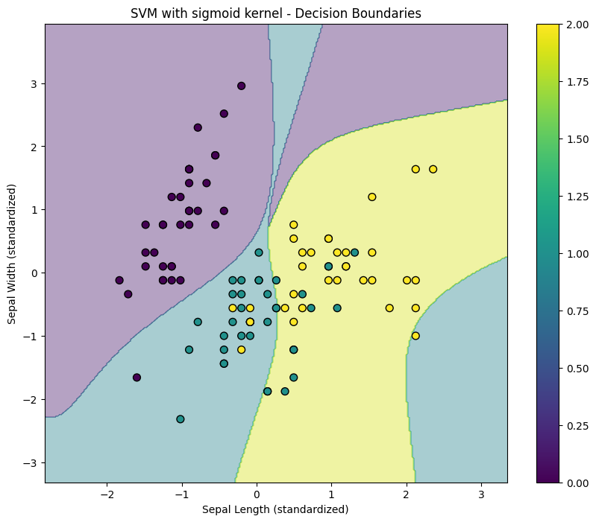
Remark:
SVM is a supervised learning algorithm that finds the optimal hyperplane to classify data with maximum margin.

Assignment 15:
KNN on Iris Dataset
Problem Statement
Implement K-Nearest Neighbors algorithm for classification.
Code
from sklearn.neighbors import KNeighborsClassifier
from sklearn.datasets import load_iris
from sklearn.model_selection import train_test_split, cross_val_score
from sklearn.preprocessing import StandardScaler
from sklearn.metrics import classification_report, confusion_matrix, accuracy_score
import matplotlib.pyplot as plt
import numpy as np

# Load dataset
iris = load_iris()
X = iris.data
y = iris.target

# Split data
X_train, X_test, y_train, y_test = train_test_split(X, y, test_size=0.3,
random_state=42,
stratify=y)

# Standardize features
scaler = StandardScaler()
X_train_scaled = scaler.fit_transform(X_train)
X_test_scaled = scaler.transform(X_test)

# Find optimal k using cross-validation
k_range = range(1, 31)
k_scores = []

for k in k_range:
knn = KNeighborsClassifier(n_neighbors=k)
scores = cross_val_score(knn, X_train_scaled, y_train, cv=5, scoring='accuracy')
k_scores.append(scores.mean())

# Plot accuracy vs k
plt.figure(figsize=(10, 6))
plt.plot(k_range, k_scores, 'o-', linewidth=2)
plt.xlabel('Value of K for KNN')
plt.ylabel('Cross-Validated Accuracy')
plt.title('Finding Optimal K for KNN')
plt.grid(True, alpha=0.3)
plt.show()

# Best k
best_k = k_range[np.argmax(k_scores)]
print(f"Optimal K: {best_k} with accuracy: {max(k_scores):.3f}")

# Train with best k
knn = KNeighborsClassifier(n_neighbors=best_k)
knn.fit(X_train_scaled, y_train)

# Predictions
y_pred = knn.predict(X_test_scaled)

# Evaluation
accuracy = accuracy_score(y_test, y_pred)
cm = confusion_matrix(y_test, y_pred)
report = classification_report(y_test, y_pred, target_names=iris.target_names)

print(f"\nTest Accuracy: {accuracy:.3f}")
print(f"Confusion Matrix:\n{cm}")
print(f"Classification Report:\n{report}")

# Test on new sample
new_sample = np.array([[5.1, 3.5, 1.4, 0.2]]) # Setosa sample
new_sample_scaled = scaler.transform(new_sample)
prediction = knn.predict(new_sample_scaled)
print(f"\nNew sample prediction: {iris.target_names[prediction[0]]}")

# Distance-based visualization for first two features
plt.figure(figsize=(10, 8))
plt.scatter(X_train_scaled[:, 0], X_train_scaled[:, 1], c=y_train,
cmap='viridis', s=50, alpha=0.6, label='Training data')

# Plot test points with predictions
colors = ['red', 'green', 'blue']
for i in range(len(X_test_scaled)):
plt.scatter(X_test_scaled[i, 0], X_test_scaled[i, 1],
c=colors[y_pred[i]], marker='*', s=200,
edgecolors='black', linewidth=1.5)

plt.xlabel('Feature 1 (standardized)')
plt.ylabel('Feature 2 (standardized)')
plt.title(f'KNN Classification (K={best_k})')
plt.legend(['Training Data', 'Test Predictions'])
plt.grid(True, alpha=0.3)
plt.show()
Output:
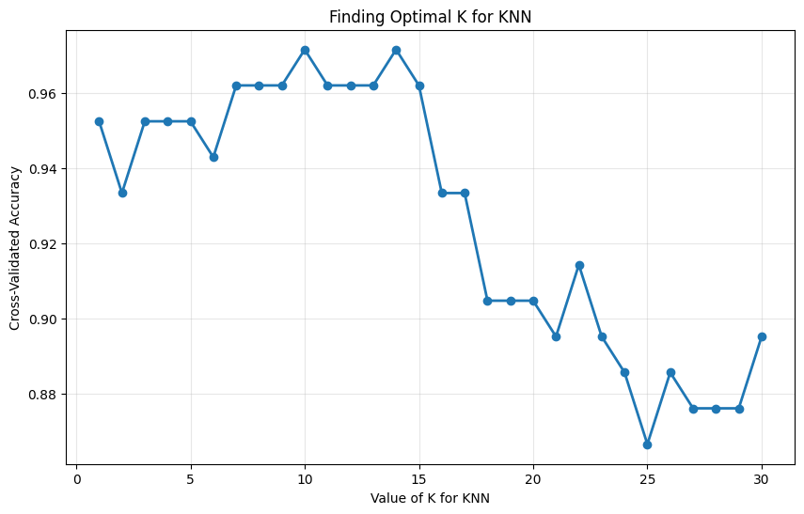
Optimal K: 14 with accuracy: 0.971
Test Accuracy: 0.956
Confusion Matrix:
[[15 0 0]
[ 0 15 0]
[ 0 2 13]]
Classification Report:
precision recall f1-score support
setosa 1.00 1.00 1.00 15
versicolor 0.88 1.00 0.94 15
virginica 1.00 0.87 0.93 15
accuracy 0.96 45
macro avg 0.96 0.96 0.96 45
weighted avg 0.96 0.96 0.96 45
New sample prediction: setosa
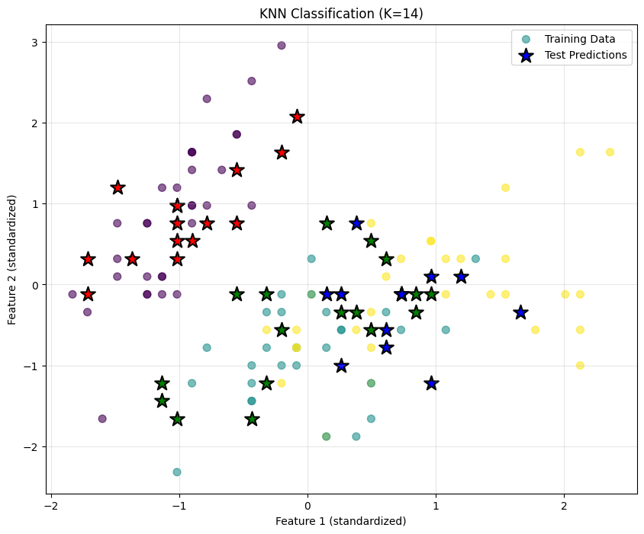
Assignment 16:
Logistic Regression on Iris Dataset
Problem Statement
Implement Logistic Regression for multi-class classification.
Code
from sklearn.linear_model import LogisticRegression
from sklearn.datasets import load_iris
from sklearn.model_selection import train_test_split
from sklearn.preprocessing import StandardScaler
from sklearn.metrics import (accuracy_score, confusion_matrix,
classification_report, roc_curve, auc)
from sklearn.preprocessing import label_binarize
import matplotlib.pyplot as plt
import numpy as np

# Load dataset
iris = load_iris()
X = iris.data
y = iris.target

# For binary classification demonstration, use only two classes
# (Logistic Regression inherently binary, but sklearn extends to multi-class)
X = X[y != 2]
y = y[y != 2]

# Split data
X_train, X_test, y_train, y_test = train_test_split(X, y, test_size=0.3,
random_state=42,
stratify=y)

# Standardize features
scaler = StandardScaler()
X_train_scaled = scaler.fit_transform(X_train)
X_test_scaled = scaler.transform(X_test)

# Train Logistic Regression
logreg = LogisticRegression(C=1.0, solver='lbfgs', max_iter=1000,
random_state=42)
logreg.fit(X_train_scaled, y_train)

# Get predictions and probabilities
y_pred = logreg.predict(X_test_scaled)
y_pred_proba = logreg.predict_proba(X_test_scaled)[:, 1]

# Evaluation
accuracy = accuracy_score(y_test, y_pred)
cm = confusion_matrix(y_test, y_pred)
report = classification_report(y_test, y_pred)

print(f"Accuracy: {accuracy:.3f}")
print(f"Confusion Matrix:\n{cm}")
print(f"Classification Report:\n{report}")

print(f"\nModel Coefficients: {logreg.coef_}")
print(f"Model Intercept: {logreg.intercept_}")

# ROC Curve
fpr, tpr, thresholds = roc_curve(y_test, y_pred_proba)
roc_auc = auc(fpr, tpr)

plt.figure(figsize=(12, 5))

# Plot ROC Curve
plt.subplot(1, 2, 1)
plt.plot(fpr, tpr, color='darkorange', lw=2,
label=f'ROC curve (AUC = {roc_auc:.2f})')
plt.plot([0, 1], [0, 1], color='navy', lw=2, linestyle='--')
plt.xlim([0.0, 1.0])
plt.ylim([0.0, 1.05])
plt.xlabel('False Positive Rate')
plt.ylabel('True Positive Rate')
plt.title('Receiver Operating Characteristic (ROC) Curve')
plt.legend(loc="lower right")
plt.grid(True, alpha=0.3)

# Plot decision boundary (using first two features)
plt.subplot(1, 2, 2)
h = 0.02 # Step size
x_min, x_max = X_train_scaled[:, 0].min() - 1, X_train_scaled[:, 0].max() + 1
y_min, y_max = X_train_scaled[:, 1].min() - 1, X_train_scaled[:, 1].max() + 1
xx, yy = np.meshgrid(np.arange(x_min, x_max, h),
np.arange(y_min, y_max, h))

Z = logreg.predict(np.c_[xx.ravel(),
yy.ravel(),
np.zeros(xx.ravel().shape),
np.zeros(xx.ravel().shape)])
Z = Z.reshape(xx.shape)

plt.contourf(xx, yy, Z, alpha=0.4, cmap='RdYlBu')
plt.scatter(X_train_scaled[:, 0], X_train_scaled[:, 1], c=y_train,
cmap='RdYlBu', s=50, edgecolors='k')
plt.xlabel('Feature 1 (standardized)')
plt.ylabel('Feature 2 (standardized)')
plt.title('Logistic Regression Decision Boundary')
plt.colorbar()

plt.tight_layout()
plt.show()

# Predict probability for new sample
new_sample = np.array([[5.1, 3.5, 1.4, 0.2]])
new_sample_scaled = scaler.transform(new_sample)
probabilities = logreg.predict_proba(new_sample_scaled)
prediction = logreg.predict(new_sample_scaled)

print(f"\nNew sample probabilities: {probabilities}")
print(f"Predicted class: {prediction[0]}")

Output:
Accuracy: 1.000
Confusion Matrix:
[[15 0]
[ 0 15]]
Classification Report:
precision recall f1-score support

0 1.00 1.00 1.00 15
1 1.00 1.00 1.00 15

accuracy 1.00 30
macro avg 1.00 1.00 1.00 30
weighted avg 1.00 1.00 1.00 30
Model Coefficients: [[ 0.84579129 -1.00398344 1.39479409 1.4247247 ]]
Model Intercept: [0.19790844]
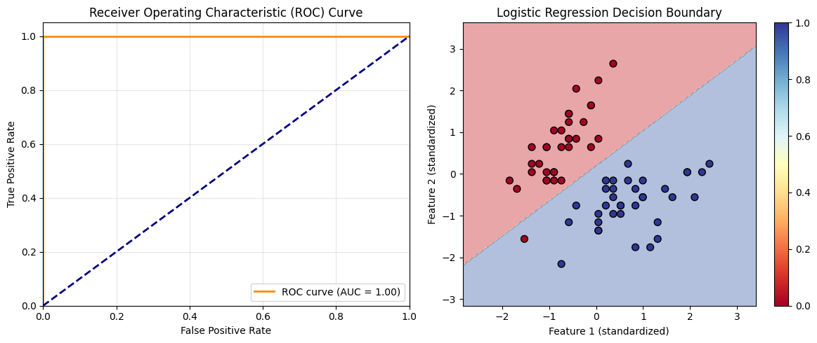
New sample probabilities: [[0.98290327 0.01709673]]
Predicted class: 0
Assignment 17:
Apriori Algorithm
Problem Statement
Find frequent itemsets and association rules using Apriori algorithm.
Code
import pandas as pd
from mlxtend.preprocessing import TransactionEncoder
from mlxtend.frequent_patterns import apriori, association_rules
import matplotlib.pyplot as plt

# Sample transaction dataset
transactions = [
['Milk', 'Bread', 'Butter'],
['Bread', 'Butter', 'Eggs'],
['Milk', 'Bread', 'Eggs', 'Butter'],
['Bread', 'Eggs'],
['Milk', 'Eggs'],
['Milk', 'Bread', 'Eggs'],
['Bread'],
['Milk', 'Bread', 'Butter', 'Eggs'],
['Milk', 'Bread'],
['Butter', 'Eggs']
]

# Convert to one-hot encoded DataFrame
te = TransactionEncoder()
te_ary = te.fit(transactions).transform(transactions)
df = pd.DataFrame(te_ary, columns=te.columns_)

print("Transaction Dataset (One-hot encoded):")
print(df)

# Find frequent itemsets with min_support = 0.3
frequent_itemsets = apriori(df, min_support=0.3, use_colnames=True)
frequent_itemsets['length'] = frequent_itemsets['itemsets'].apply(lambda x: len(x))

print("\nFrequent Itemsets:")
print(frequent_itemsets.sort_values('support', ascending=False))

# Generate association rules
rules = association_rules(frequent_itemsets, metric="confidence", min_threshold=0.6)

print("\nAssociation Rules (confidence >= 0.6):")
print(rules[['antecedents', 'consequents', 'support', 'confidence', 'lift']])

# Filter strong rules (lift > 1.2 and confidence > 0.7)
strong_rules = rules[(rules['lift'] > 1.2) & (rules['confidence'] > 0.7)]

print("\nStrong Association Rules (lift > 1.2, confidence > 0.7):")
print(strong_rules[['antecedents', 'consequents', 'support', 'confidence', 'lift']])

# Visualization
plt.figure(figsize=(12, 5))

# Support vs Confidence scatter plot
plt.subplot(1, 2, 1)
plt.scatter(rules['support'], rules['confidence'], alpha=0.5, c=rules['lift'],
cmap='viridis', s=rules['lift']*100)
plt.colorbar(label='Lift')
plt.xlabel('Support')
plt.ylabel('Confidence')
plt.title('Association Rules: Support vs Confidence')
plt.grid(True, alpha=0.3)

# Top 10 rules by lift
plt.subplot(1, 2, 2)
top_rules = rules.sort_values('lift', ascending=False).head(10)
rule_labels = [f"{set(rule.antecedents)} → {set(rule.consequents)}"
for _, rule in top_rules.iterrows()]
y_pos = range(len(rule_labels))

plt.barh(y_pos, top_rules['lift'], color='skyblue')
plt.yticks(y_pos, rule_labels)
plt.xlabel('Lift')
plt.title('Top 10 Association Rules by Lift')
plt.tight_layout()

plt.show()

# Generate actionable insights
print("\nActionable Insights from Association Rules:")
for idx, rule in strong_rules.iterrows():
antecedents = set(rule['antecedents'])
consequents = set(rule['consequents'])
support = rule['support']
confidence = rule['confidence']
lift = rule['lift']

print(f"\nRule: {antecedents} → {consequents}")
print(f" Support: {support:.2%} | Confidence: {confidence:.2%} | Lift: {lift:.2f}")
print(f" Insight: Customers who buy {antecedents} are {confidence:.0%} likely to also buy {consequents}")
if lift > 1.5:
print(f" Action: Consider placing {antecedents} and {consequents} close together")
Output:
Transaction Dataset (One-hot encoded):
Bread Butter Eggs Milk
0 True True False True
1 True True True False
2 True True True True
3 True False True False
4 False False True True
5 True False True True
6 True False False False
7 True True True True
8 True False False True
9 False True True False

Frequent Itemsets:
support itemsets length
0 0.8 (Bread) 1
2 0.7 (Eggs) 1
3 0.6 (Milk) 1
1 0.5 (Butter) 1
5 0.5 (Bread, Eggs) 2
6 0.5 (Bread, Milk) 2
4 0.4 (Bread, Butter) 2
7 0.4 (Eggs, Butter) 2
9 0.4 (Milk, Eggs) 2
8 0.3 (Milk, Butter) 2
10 0.3 (Bread, Eggs, Butter) 3
11 0.3 (Bread, Milk, Butter) 3
12 0.3 (Bread, Milk, Eggs) 3

Association Rules (confidence >= 0.6):
antecedents consequents support confidence lift
0 (Butter) (Bread) 0.4 0.800000 1.000000
1 (Bread) (Eggs) 0.5 0.625000 0.892857
2 (Eggs) (Bread) 0.5 0.714286 0.892857
3 (Bread) (Milk) 0.5 0.625000 1.041667
4 (Milk) (Bread) 0.5 0.833333 1.041667
5 (Butter) (Eggs) 0.4 0.800000 1.142857
6 (Butter) (Milk) 0.3 0.600000 1.000000
7 (Milk) (Eggs) 0.4 0.666667 0.952381
8 (Bread, Eggs) (Butter) 0.3 0.600000 1.200000
9 (Bread, Butter) (Eggs) 0.3 0.750000 1.071429
10 (Eggs, Butter) (Bread) 0.3 0.750000 0.937500
11 (Butter) (Bread, Eggs) 0.3 0.600000 1.200000
12 (Bread, Milk) (Butter) 0.3 0.600000 1.200000
13 (Bread, Butter) (Milk) 0.3 0.750000 1.250000
14 (Milk, Butter) (Bread) 0.3 1.000000 1.250000
15 (Butter) (Bread, Milk) 0.3 0.600000 1.200000
16 (Bread, Milk) (Eggs) 0.3 0.600000 0.857143
17 (Bread, Eggs) (Milk) 0.3 0.600000 1.000000
18 (Milk, Eggs) (Bread) 0.3 0.750000 0.937500

Strong Association Rules (lift > 1.2, confidence > 0.7):
antecedents consequents support confidence lift
13 (Bread, Butter) (Milk) 0.3 0.75 1.25
14 (Milk, Butter) (Bread) 0.3 1.00 1.25
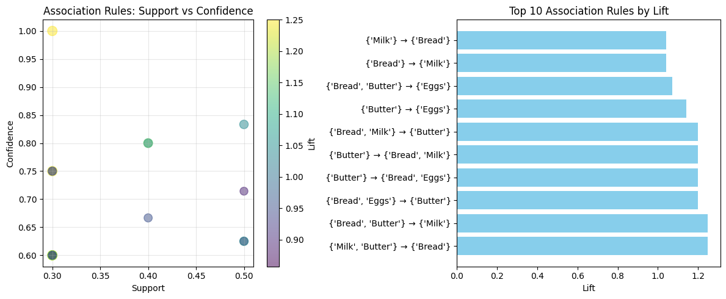
Assignment 18:
First Order Logic Resolution
Problem Statement
Use resolution to prove " Marcus hates Ceaser" from given axioms.
Knowledge Base
Given axioms:
Resolution Proof Example.
(a) Marcus was a man.
(b) Marcus was a Roman.
(c) All men are people.
(d) Caesar was a ruler.
(e) All Romans were either loyal to Caesar or hated him (or both).
(f) Everyone is loyal to someone.
(g) People only try to assassinate rulers they are not loyal to.
(h) Marcus tried to assassinate Caesar.Prolog Implementation
Prolog
Code:
% Simple working Prolog program

% Facts
man(marcus).
roman(marcus).
ruler(caesar).
tried_to_assassinate(marcus, caesar).

% Rules
person(X) :- man(X). % All men are people

% Everyone is loyal to someone
loyal_to_someone(X) :- person(X).

% People only try to assassinate rulers they are not loyal to
% This is the key rule: if X tries to assassinate Y, then X is not loyal to Y
not_loyal(X, Y) :- tried_to_assassinate(X, Y), person(X), ruler(Y).

% All Romans were either loyal to Caesar or hated him
% Since we know Marcus tried to assassinate Caesar, he must hate him
hates(X, caesar) :- roman(X), not_loyal(X, caesar).

% Query
query_result :-
(hates(marcus, caesar) ->
format('Result: Marcus hates Caesar.~nProof complete.~n')
;
format('Result: Marcus does not hate Caesar.~n')
).

% Run the proof
:- initialization((
write('=======================================~n'),
write(' Proof that Marcus Hates Caesar~n'),
write('=======================================~n~n'),

write('Given:~n'),
write('1. Marcus was a man.~n'),
write('2. Marcus was a Roman.~n'),
write('3. All men are people.~n'),
write('4. Caesar was a ruler.~n'),
write('5. All Romans were either loyal to Caesar or hated him.~n'),
write('6. Everyone is loyal to someone.~n'),
write('7. People only try to assassinate rulers they are not loyal to.~n'),
write('8. Marcus tried to assassinate Caesar.~n~n'),

write('Proof Steps:~n~n'),

write('Step 1: Marcus is a person (from 1 and 3).~n'),
write('Step 2: From 8 and 7, Marcus is not loyal to Caesar.~n'),
write('Step 3: From 2 and 5, as a Roman, Marcus must either:~n'),
write(' a) be loyal to Caesar, OR~n'),
write(' b) hate Caesar.~n'),
write('Step 4: From Step 2, Marcus is not loyal to Caesar.~n'),
write('Step 5: Therefore, from Step 3b, Marcus must hate Caesar.~n~n'),

query_result,

write('~n=======================================~n')
)).

