Business Requirement Document
For
Change in Agent and Suplier Contact information
Prepared by – Akash sharma

Confidentiality
Confidentiality
This document contains confidential information of DeBox Global IT Solutions Pvt Ltd. which is provided for the sole purpose of permitting the recipient to evaluate the information submitted herewith. In consideration of receipt of this document, the recipient agrees to maintain such information in confidence and to not reproduce or otherwise disclose this information to any person outside the group or the evaluation committee directly responsible for evaluation of its contents, except that there is no obligation to maintain the confidentiality of any information which was known to the recipient prior to receipt of such information from DeBox Global IT Solutions Pvt Ltd., or becomes publicly known through no fault of recipient, or DeBox Global IT Solutions Pvt Ltd. or is received without obligation of confidentiality from a third party owing no obligation of confidentiality to DeBox Global IT Solutions Pvt Ltd.
Security
The information contained herein is proprietary to DeBox Global IT Solutions Pvt Ltd. and may not be used, reproduced or disclosed to others except as specifically permitted in writing by DeBox Global IT Solutions Pvt Ltd.. The recipient of this document, by its retention and use, agrees to protect the same and the information contained therein from loss or theft.
Revision | Document No. | Date | Changes/Remarks
Version 1.0 | 2021-10 | 11- OCT - 2021 | Office Use

Objective
- Till add more fields in agent and Supplier contact details & provision to upload business card.
- Need option to mention agent/Supplier website URL

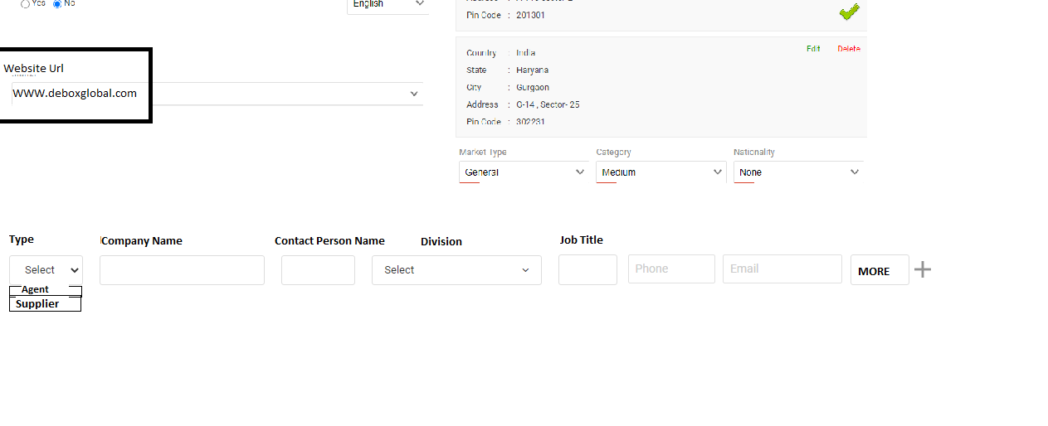

Information is to be added in the contact person section:-
- Type – Agent/Supplier
- Company Name
- Contact Person Name
- Division
- Job Title
- Phone Number
- E mail- ID
- More Button
- Status
- Incase, user click on “More Button”, he can enter following information
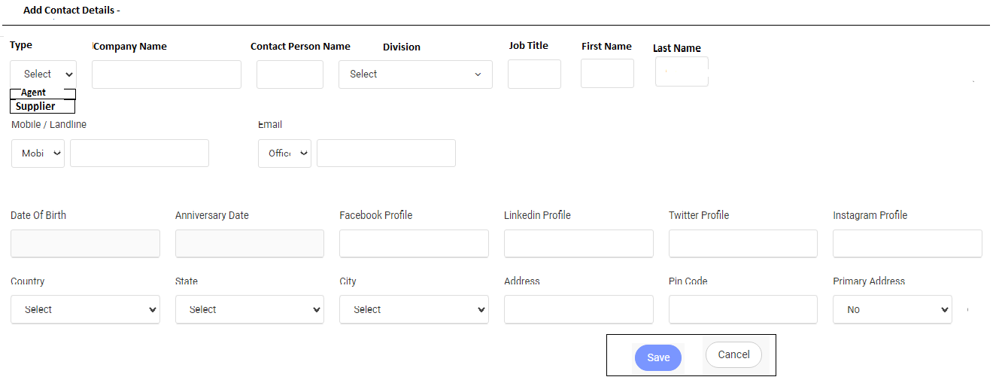

- Type – Agent/Supplier
- Company Name
- Contact Person Name
- Division Dropdown
- Job title
- Firstname , Last name
- Mobile
- Email
- Date of Birth
- Anniversary Date
- Facebook Profile
- Linkedlin profile
- Twitter Profile
- Instagram Profile
- Country
- State
- City
- Address
- Pin code
- Primary Address
Points :
- Need this option and Agent – Creation and Edit
- Need this option to supplier - Creation and Edit

Supplier Screen –

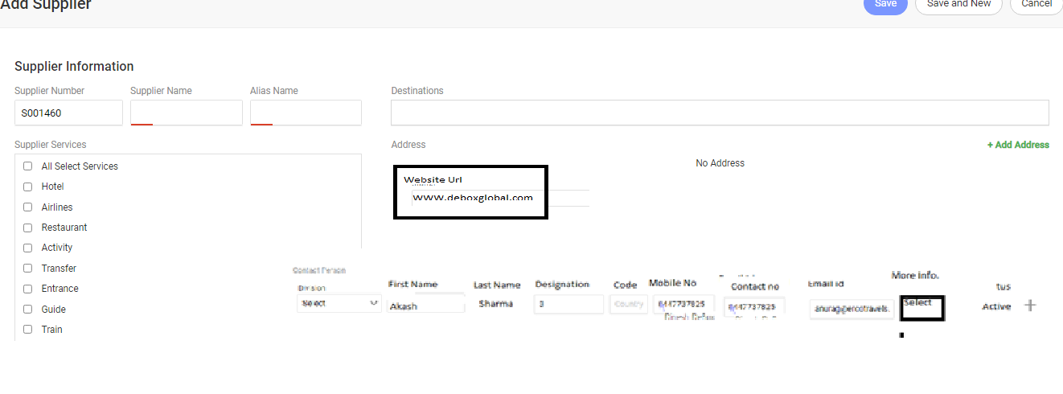
Note – Due to impact of hotel master this change .
B2C Screen –
New button Added Download Data –
- User click on Download Data System will ask to select date range after post Selecting post range system will download an Excel Sheet Record
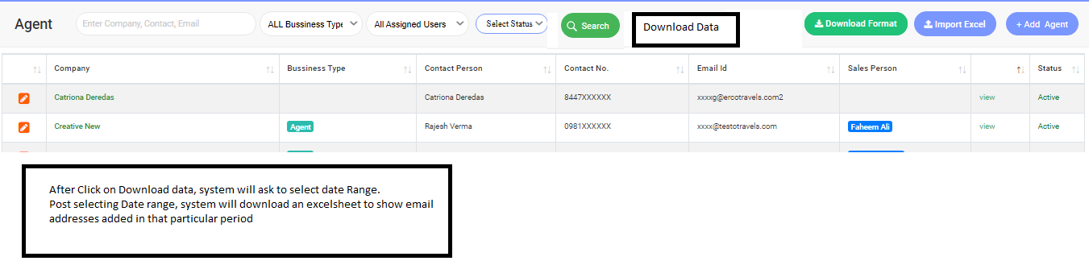
Same options Need to Agent master -
- User click on Download Data System will ask to select date range after post Selecting post range system will download an Excel Sheet Record

