ADVANCED COMPUTER VISION
22424620
CALVIN DEBRAH AMPADU

Coin Segmentation and Measurement: A Comparison of Thresholding, Region Growing, and K-means

1. Introduction
Automatically locating and measuring coins in a photograph is a small but complete computer vision problem: it requires turning a colour image into a clean binary map of coin versus not-coin, extracting the boundary of each coin, and then reading off basic geometric properties such as area, perimeter, and position. This report implements and compares three classical segmentation approaches for that task -- global thresholding, region growing, and k-means clustering -- and evaluates each of them against manually labelled ground truth on a set of 24 photographs taken specifically to stress-test the pipeline.
The 24 images were captured under six deliberately different conditions: a baseline set of well-lit coins on a plain background (A1-A4), a set of illumination changes covering dim light, harsh sunlight, side-lighting, warm artificial light, and camera flash (B1-B5), a set of background changes covering wood grain, patterned cloth, a dark surface, and a printed page (C1-C4), a set of touching or overlapping coins (D1-D4), a set of scale changes from close-up to far away (E1-E3), and a set of adversarial conditions covering defocus blur, motion blur, a cluttered background, and very low light (F1-F4). Because none of these categories directly test sensitivity to sensor noise, synthetic Gaussian noise was additionally added to two of the baseline images to complete that part of the comparison.
The full pipeline follows the same structure regardless of which segmentation method is used: an input photograph is resized and denoised, segmented into a binary foreground mask, the boundary of each detected object is extracted and drawn on the original image alongside its measurements, and finally the mask is compared against a hand-drawn ground truth using Intersection over Union, precision, recall, and F1 score.

2. Methodology

2.1 Data Acquisition
All 24 photographs were taken on a phone camera and originally saved in HEIC format. They were converted to JPEG and renamed to a consistent <Category><Number>_<label>.jpg scheme (for example B2_harsh.jpg for the harsh-sunlight illumination test).

2.2 Preprocessing
Every image is resized so its longest side is 900 pixels before any further processing takes place. This is a practical necessity: the original photographs are typically 3000-4000 pixels along their longest side, and the region-growing method in particular becomes prohibitively slow at that resolution. After resizing, the image is converted to grayscale and a 5x5 Gaussian blur is applied to suppress fine sensor noise and JPEG compression artefacts.

2.3 Segmentation Method 1: Thresholding
The thresholding method uses Otsu's algorithm to automatically choose a single global grayscale intensity value that best separates the image into two classes, then applies a morphological opening followed by a closing operation to remove small speckles of noise. Because Otsu's method does not know in advance whether the coins are lighter or darker than the background, the resulting binary mask is passed through a heuristic that treats whichever class dominates the image border as the background.

2.4 Segmentation Method 2: Region Growing
Seeds were generated automatically rather than clicked by hand: the same Otsu threshold is computed, the resulting rough foreground mask is eroded to shrink each coin-shaped blob down to a small core, and the centroid of each surviving core becomes one seed point. From each seed, OpenCV's floodFill function grows the region outward, accepting a candidate pixel if its intensity is within a fixed tolerance of the original seed's intensity value.
This last detail was arrived at empirically. The initial implementation used floodFill's default floating-range comparison mode, in which each new candidate pixel is compared to its already-accepted neighbour rather than to the seed. This produced a serious failure: because the blurred boundary between a coin and its background contains a short run of intermediate pixel values, the flood fill was able to take a series of small steps across that blurred edge and leak into the surrounding background, in one test case filling more than 99% of the entire image from a single seed. Switching to fixed-range mode, which always compares a candidate pixel back to the original seed value, fixed this drift. A tolerance of 40 grey levels was chosen after testing values between 10 and 100 and picking the value that best balanced under-segmentation against over-segmentation.

2.5 Segmentation Method 3: K-means Clustering
The k-means method clusters pixels purely on their grayscale intensity value, ignoring spatial position. The number of clusters, K, was tested at 2, 3, and 4, with K=2 used as the representative result in the main three-way method comparison. As with thresholding, the same border heuristic is used to decide which cluster represents the background.

2.6 Boundary Visualisation and Object Measurement
Once a binary foreground mask has been produced, connected-component analysis separates it into individual candidate objects, discarding any component smaller than 80 pixels as noise. For each surviving object, the pipeline extracts its contour and draws it in green on a copy of the original colour image, along with a blue bounding box and a red dot marking its centroid. For each object the pipeline records its pixel area, perimeter, centroid coordinates, and bounding box.

2.7 Testing Conditions
The pipeline was run across all 24 images without modification. Sensitivity to noise, which none of the 24 photographs directly test, was assessed separately by adding synthetic Gaussian noise at standard deviations of 0, 10, 20, 30, and 40 grey levels to two baseline images and re-running all three methods at each noise level.

3. Experimental Results
Before comparing methods numerically, Figure 1 shows every stage of the pipeline for a single representative image (A2_baseline, five coins): the original photograph, the grayscale conversion, the Gaussian-blurred version used for segmentation, the resulting binary mask, and the final boundary overlay with per-object measurements.
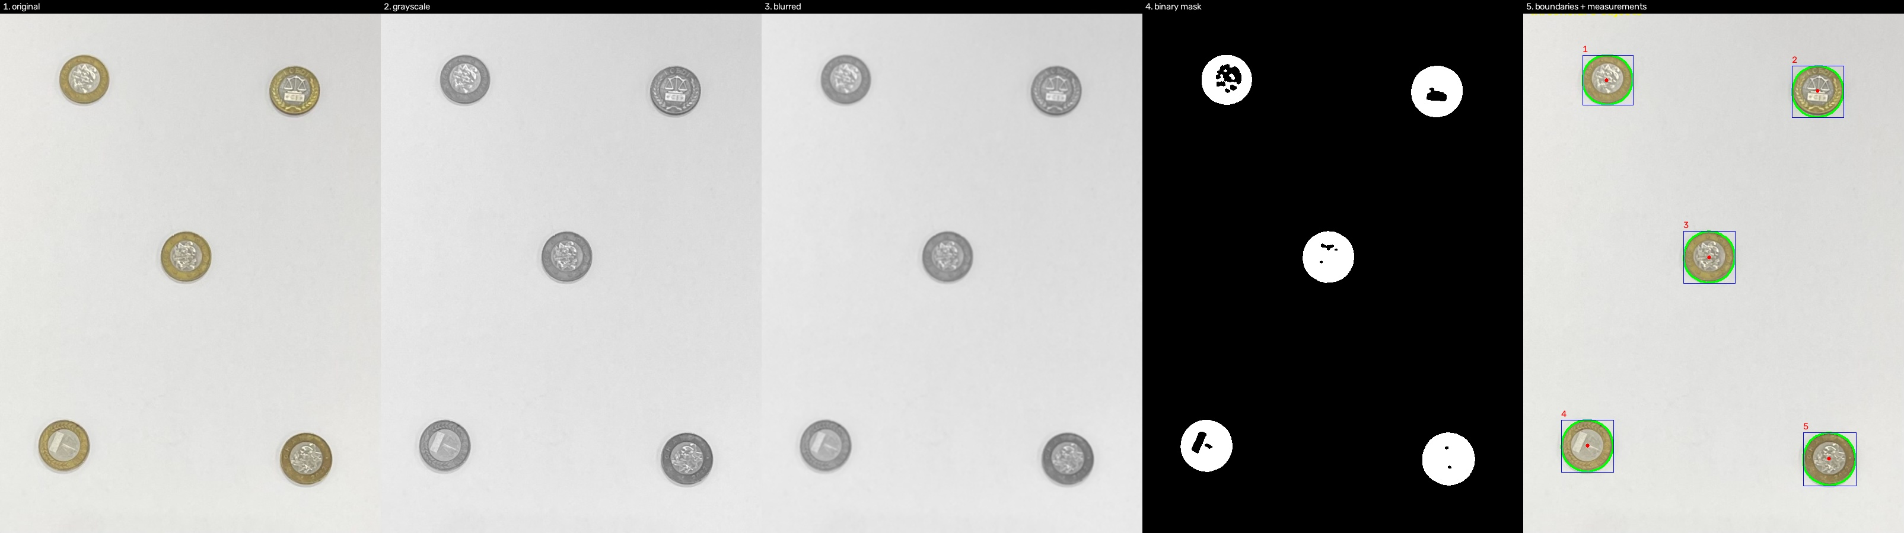
Figure 1. The five pipeline stages applied to A2_baseline: original, grayscale, blurred, binary mask (Thresholding), and final boundaries with measurements. All five coins are correctly separated and measured.

3.1 Method Comparison
Eight of the 24 images were selected for manual ground-truth annotation, covering one or two images from every category: A1_baseline, A4_baseline, B2_harsh, B5_flash, C2_cloth, D3_touch, E2_normal, and F4_verydark. Ground truth was drawn by hand as a set of circles, one per visible coin.
Method | Mean IoU | Mean Precision | Mean Recall | Mean F1 | Avg. Time
Thresholding | 0.695 | 0.727 | 0.952 | 0.776 | 0.0016 s
Region Growing | 0.609 | 0.775 | 0.798 | 0.719 | 0.0057 s
K-means (K=2) | 0.704 | 0.737 | 0.951 | 0.789 | 0.108 s

Per-image IoU scores tell a more detailed story than the averages alone:
Image | Thresholding | Region Growing | K-means (K=2)
A1_baseline | 0.895 | 0.47 | 0.895
A4_baseline | 0.827 | 0.711 | 0.827
B2_harsh | 0.829 | 0.494 | 0.829
B5_flash | 0.887 | 0.693 | 0.887
C2_cloth | 0.232 | 0.837 | 0.27
D3_touch | 0.166 | 0.057 | 0.201
E2_normal | 0.897 | 0.887 | 0.897
F4_verydark | 0.828 | 0.723 | 0.828

Two patterns stand out. First, thresholding and k-means with K=2 produce near-identical IoU scores on every image except the two hardest cases (patterned cloth and touching coins) -- unsurprising, since Otsu's method is effectively already solving a one-dimensional two-cluster grouping problem on the intensity histogram, so k-means with K=2 on that same feature converges to almost the same decision boundary. Second, region growing, despite the lowest mean IoU of the three methods, produced by far the best result on the patterned cloth background (C2_cloth, IoU 0.837 versus 0.232 and 0.270).
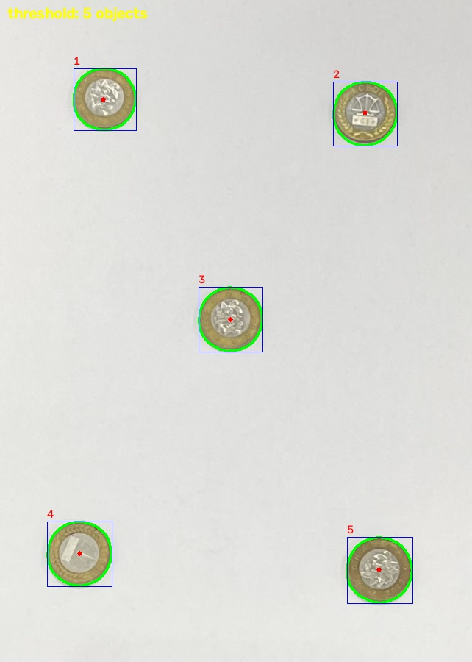
Figure 2. Correct segmentation of all 5 coins on a clean baseline image (Thresholding, A2_baseline).

3.2 Effect of K in K-means
Sweeping K across 2, 3, and 4 shows that K=2 was consistently the most stable choice for this data set. On A2_baseline, which contains five coins, K=2 correctly separated all five with plausible areas (roughly 4,500-6,200 pixels each), while K=3 and K=4 fragmented the image into seven objects, one of which was a single 238,076-pixel blob covering a large fraction of the background. The effect was more severe under harsh direct sunlight: on B2_harsh, K=2 gave four clean objects, while K=3 and K=4 both fragmented the image into 24 separate components, most of them tiny false positives generated by strong shadow and highlight contrast.

3.3 Sensitivity to Noise
Thresholding and k-means (K=2) held their object counts essentially constant across the full range of synthetic noise tested (standard deviation 0-40). Region growing degraded sharply: its object count on A1_baseline fell to zero by a noise standard deviation of 30, and on A4_baseline it collapsed to zero by a standard deviation of 40, since its seed-finding step depends on locating small, coherent eroded blobs that noise breaks apart.

3.4 Qualitative Failure Cases
On D3_touch.jpg, two coins overlap directly. All three methods place a single connected contour around the merged pair rather than detecting two separate coins, which is why every method scores its lowest IoU of the whole test set on this image. Thresholding and k-means also picked up an unrelated shadow line as a large false-positive object, explaining the very high recall but low precision (0.166) on this image.
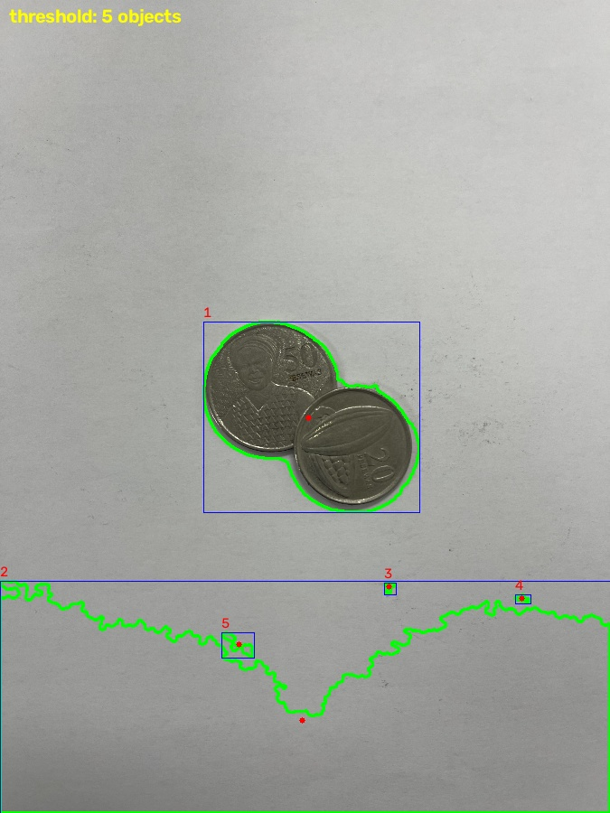
Figure 3. Two overlapping coins merged into one blob, plus a shadow line misread as an extra object (Thresholding, D3_touch).
On C4_newspaper.jpg, thresholding detected 140 separate objects where only four coins are actually present, because the printed calibration chart used as a background contains high-contrast text and ruled lines that fall on the coin side of the Otsu threshold.
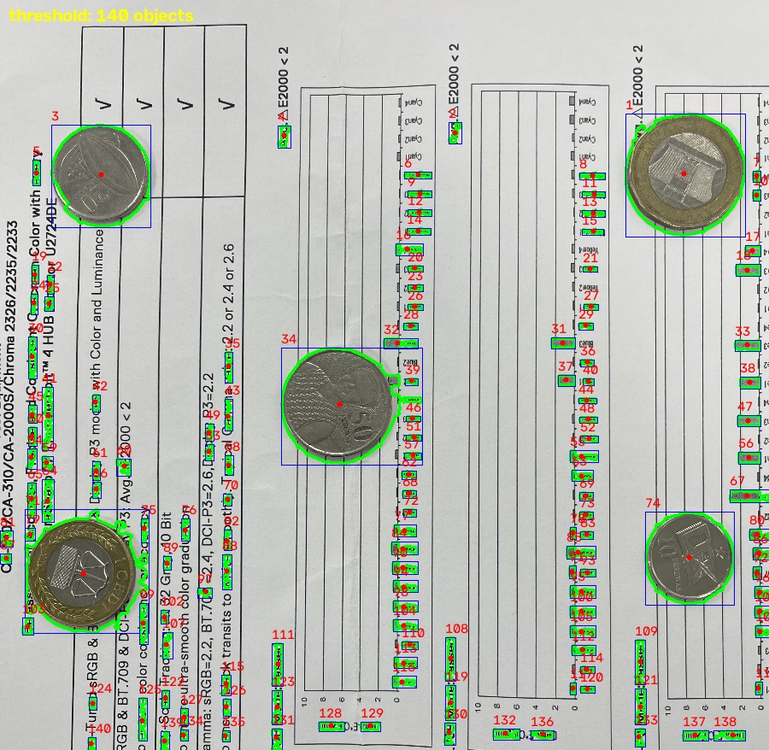
Figure 4. Over-segmentation caused by printed background text (Thresholding, C4_newspaper) -- the four real coins are correctly outlined, but the text generates many additional false objects.
By contrast, on the patterned cloth background, region growing's local, seed-based approach coped far better than the two global methods:
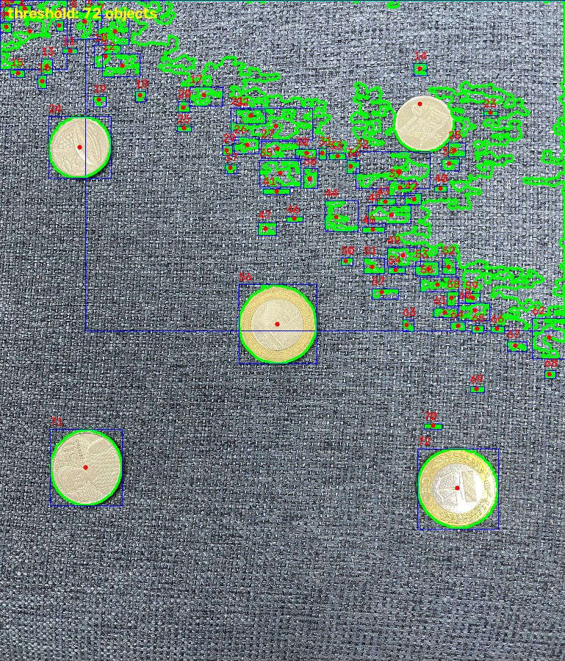
Figure 5a. Thresholding on patterned cloth (C2_cloth) -- the background pattern overlaps the coins' intensity range and heavily distorts the mask.
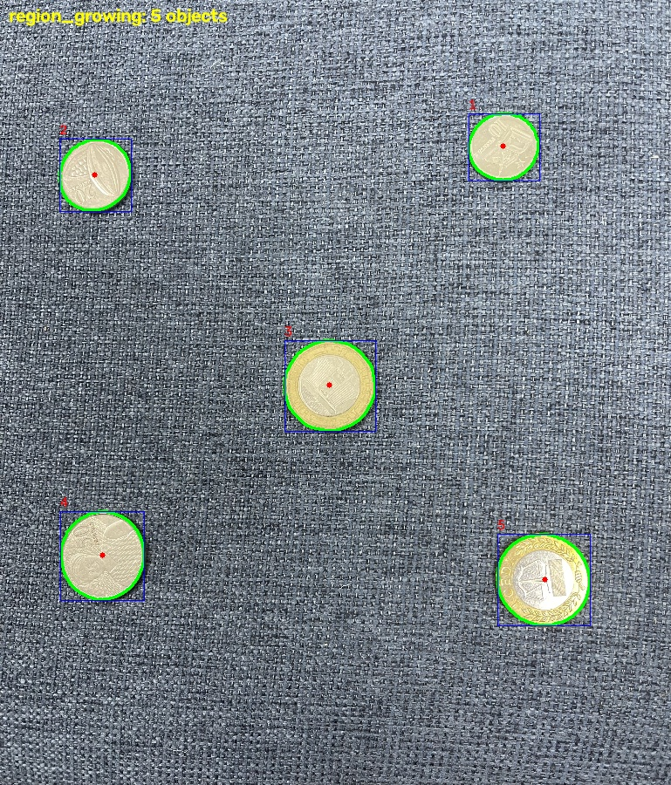
Figure 5b. Region growing on the same image -- the local, seed-based growth is not misled by the busy background pattern.

4. Critical Analysis

Which segmentation method produced the best results, and why?
By mean IoU across the eight ground-truth images, k-means with K=2 was marginally ahead (0.704) of thresholding (0.695), with region growing clearly behind (0.609). In practice, though, thresholding and k-means are solving almost the same underlying one-dimensional separation problem, so their near-identical scores are expected rather than a genuine methodological advantage for one over the other. Given that k-means took roughly 68 times longer to run for essentially the same result, thresholding is the more practical choice of the two. Region growing's lower average is driven almost entirely by its failures on textured and dark backgrounds; on the one image with a strongly patterned background, it was in fact the best method by a wide margin, which suggests that no single method is uniformly best -- the right choice depends on what the background looks like.

How did illumination changes affect thresholding?
Across the five dedicated illumination tests, thresholding's object counts stayed correct and its IoU on the two illumination images with ground truth remained high (0.829 and 0.887). Its clearer failure came from surface darkness rather than illumination direction: on the dark-surface background image, the coin and background intensities were close enough that Otsu's single global threshold could not cleanly separate them, and a shadow line was misread as an extra object. This suggests thresholding is reasonably robust to changes in overall brightness as long as there remains a clear intensity gap between coin and background, but it has no way to recover once that gap narrows.

How did seed-point selection influence region-growing performance?
Seeds were placed automatically by eroding a rough Otsu mask down to one small core per coin and using its centroid, which worked reliably for locating a starting point inside each coin on plain backgrounds. The performance problems were not really failures of seed placement -- the seeds were consistently found in the right locations -- but of what happened after growth started. On textured or dark backgrounds, the seed correctly landed inside a coin, but the fixed intensity tolerance was wide enough that the fill leaked through the coin's edge into a background of similar brightness. The single fixed tolerance of 40, chosen as a compromise across all 24 images, was too generous for dark or low-contrast backgrounds. This is the clearest limitation of using one global parameter across a varied data set.

What effect did changing K have on K-means segmentation?
Moving from K=2 to K=3 or K=4 consistently made results worse: with only pixel intensity as a feature, adding an extra cluster gives k-means a way to split the background itself into two groups whenever there is any lighting gradient across it, rather than describing the coins more precisely. The clearest example was B2_harsh, where the exaggerated contrast of harsh direct sunlight caused K=3 and K=4 to fragment the image into 24 small components, compared to 4 clean objects at K=2. K=2 was the more reliable setting throughout this data set specifically because the underlying scene genuinely only contains two classes of surface as far as a single-channel intensity feature can tell.

Which method was most computationally efficient?
Thresholding was clearly the fastest, averaging 0.0016 seconds per image, because Otsu's algorithm only needs to compute and scan a 256-bin histogram. Region growing was roughly 3.5 times slower on average (0.0057 seconds), the extra cost coming from running a separate flood-fill operation per detected seed. K-means was by far the slowest, averaging 0.108 seconds -- around 68 times slower than thresholding -- because it must run an iterative clustering procedure that repeatedly reassigns every pixel and recomputes cluster centres until convergence.

Under what conditions did each method fail?
Thresholding failed most clearly on patterned or printed backgrounds, where background texture overlaps the coin's intensity range. Region growing failed on dark and low-contrast backgrounds, where its fixed tolerance either fragmented coins into disconnected arcs or leaked into the background; it also failed outright once synthetic noise reached a standard deviation of around 30. K-means failed under uneven lighting once K was increased beyond 2. All three methods shared one common failure: none of them could separate two coins that were touching or overlapping, since all three operate purely on pixel classification rather than on any notion of individual object shape.

How could techniques studied in earlier weeks improve the segmentation results?
The most direct improvement would target the shared touching-coins failure: a distance transform followed by a watershed transform, seeded from the local maxima of that distance transform, is the standard way to split a single connected blob containing multiple round objects into its constituent parts. Adaptive or local thresholding, rather than a single global Otsu value, would likely help with the dark-surface and shadow-line failures. For the patterned-background failures, a simple background-subtraction step would remove most of the interference seen on the newspaper and cloth backgrounds. Finally, a Canny edge map could be used as an independent cross-check on the boundaries produced by any of the three region-based methods.

5. Conclusion
Across 24 test images and eight manually annotated ground-truth masks, thresholding and k-means with K=2 performed almost identically and clearly outperformed region growing on average, while remaining far cheaper to compute than k-means. Region growing's weaker average score conceals a genuine strength on textured backgrounds, where its local, seed-based approach avoided the sharp accuracy drop that affected both global methods. The one failure mode common to all three methods was the inability to separate touching or overlapping coins, which points clearly to a distance-transform/watershed step as the highest-value addition to this pipeline if it were to be extended further. Overall, for a typical single-object-per-region scene with a reasonably uniform background, simple Otsu thresholding offers the best balance of accuracy and speed of the three methods tested here; its main weaknesses -- patterned backgrounds and touching objects -- are also the weaknesses shared by the more expensive alternatives, and are better addressed with a targeted preprocessing or post-processing step than by switching segmentation method entirely.

Source Code
Screenshots of the pipeline scripts follow. Full code is included in the separate zip submission.

prepare_data.py
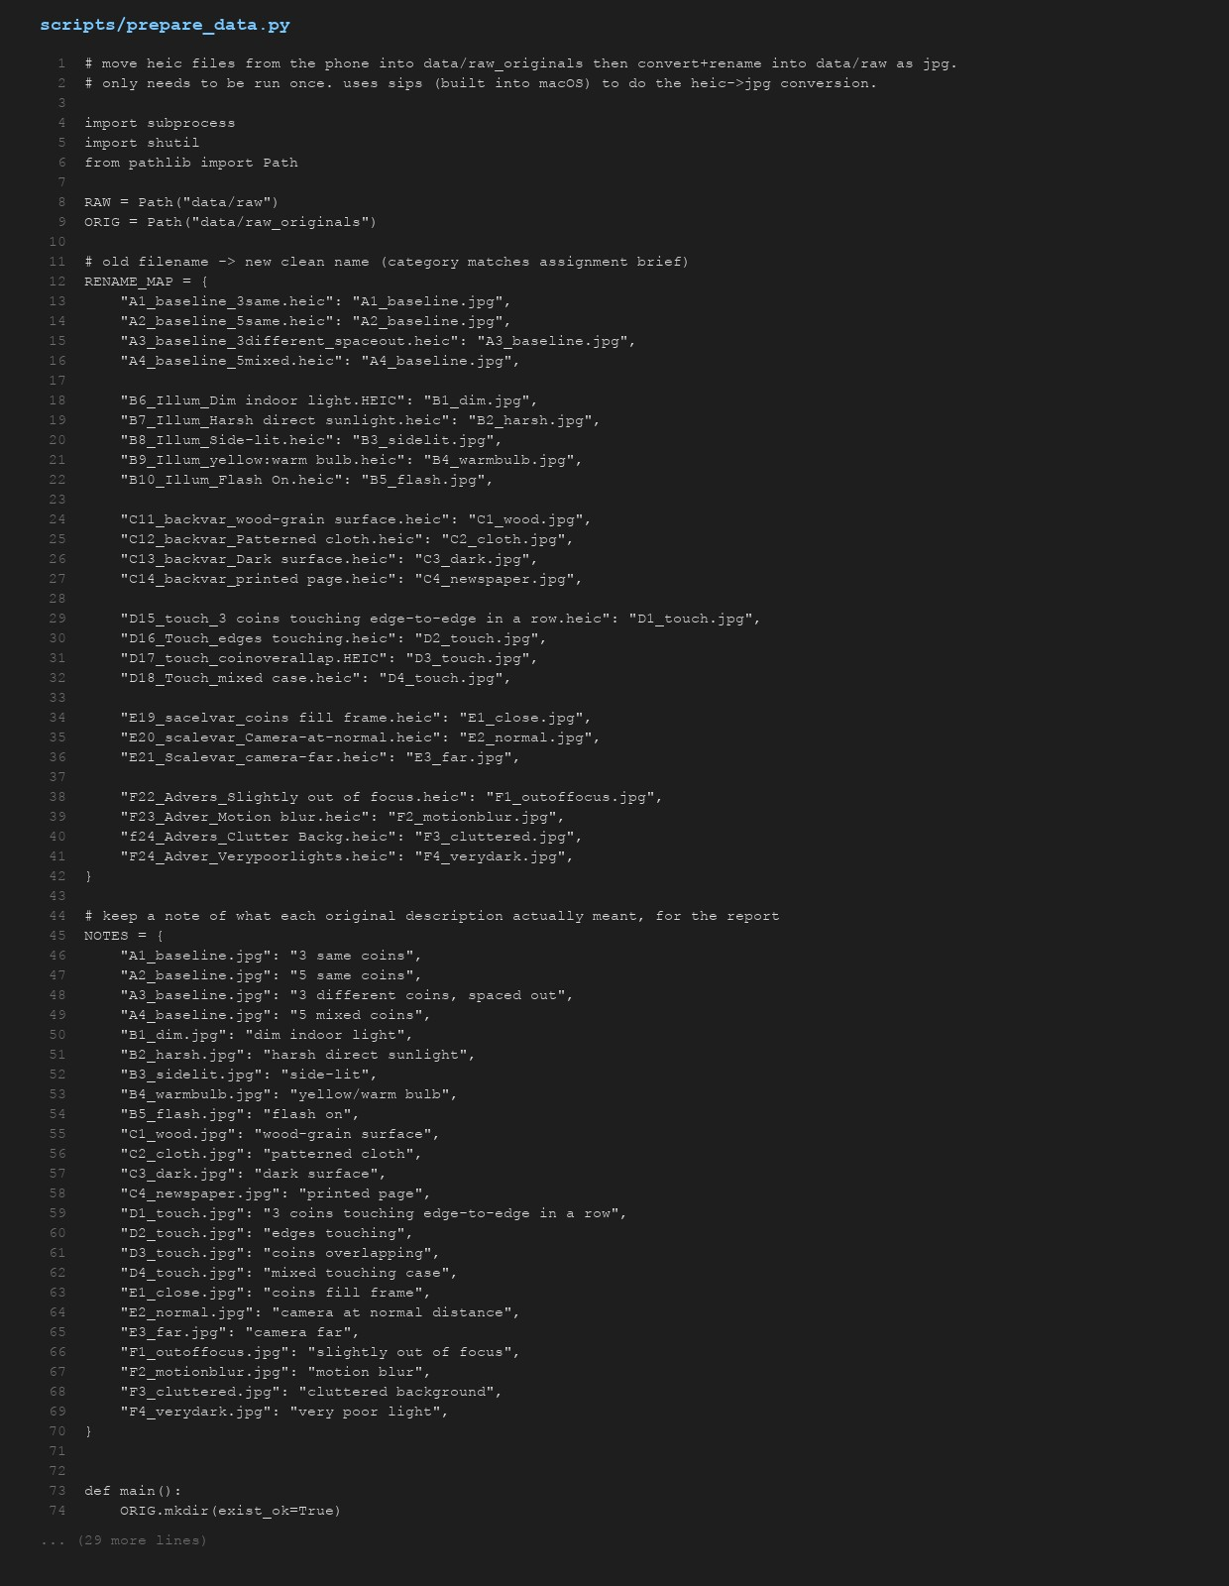

utils.py
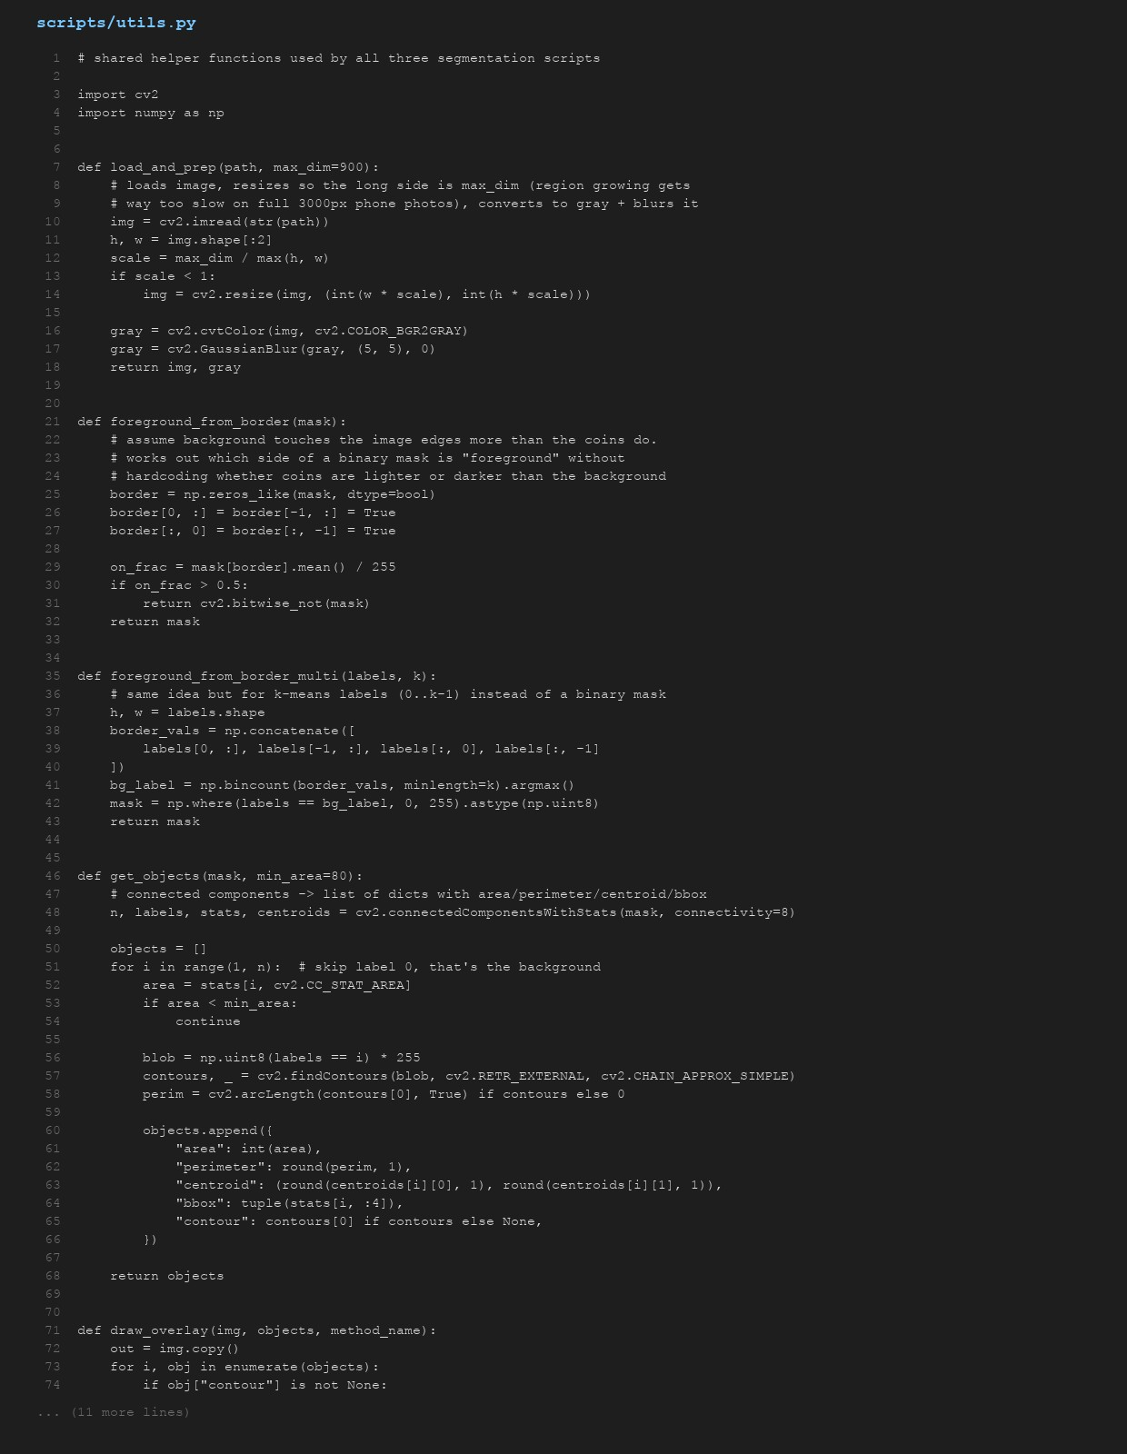

segment_threshold.py


segment_region_growing.py
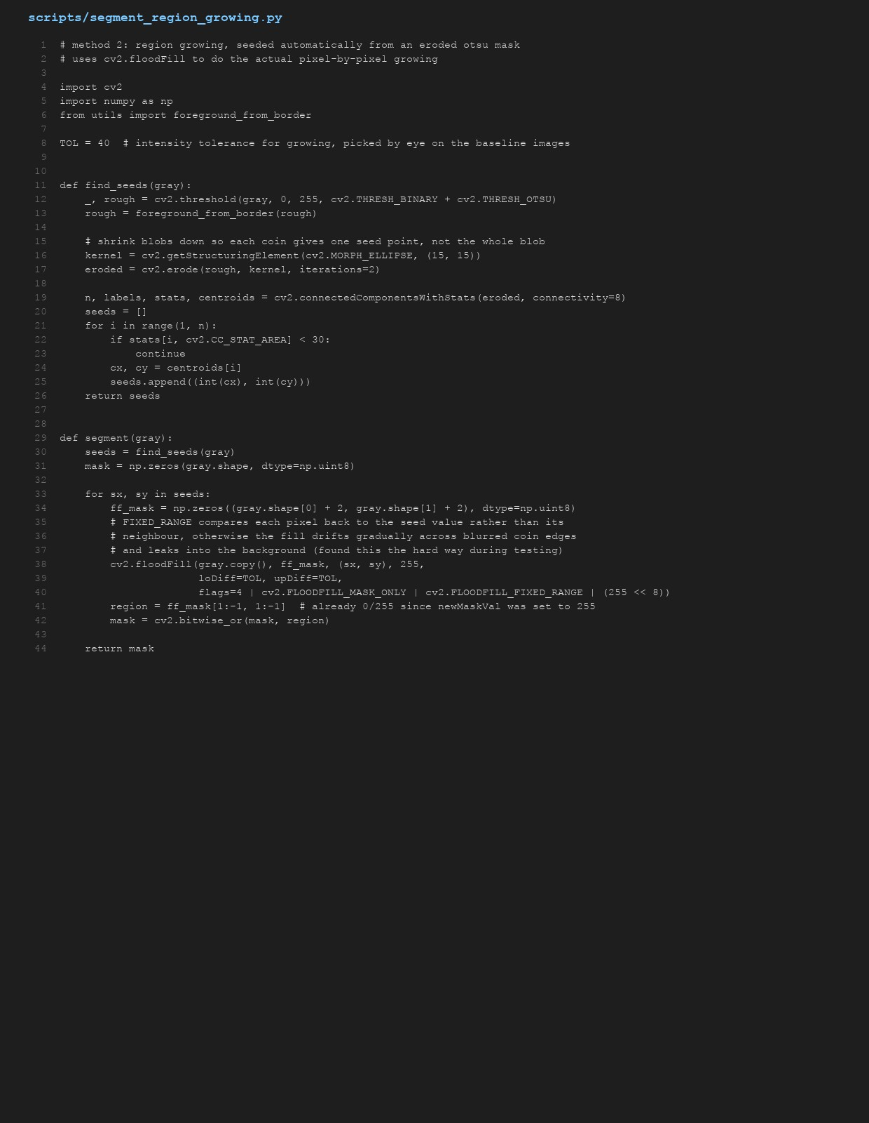

segment_kmeans.py
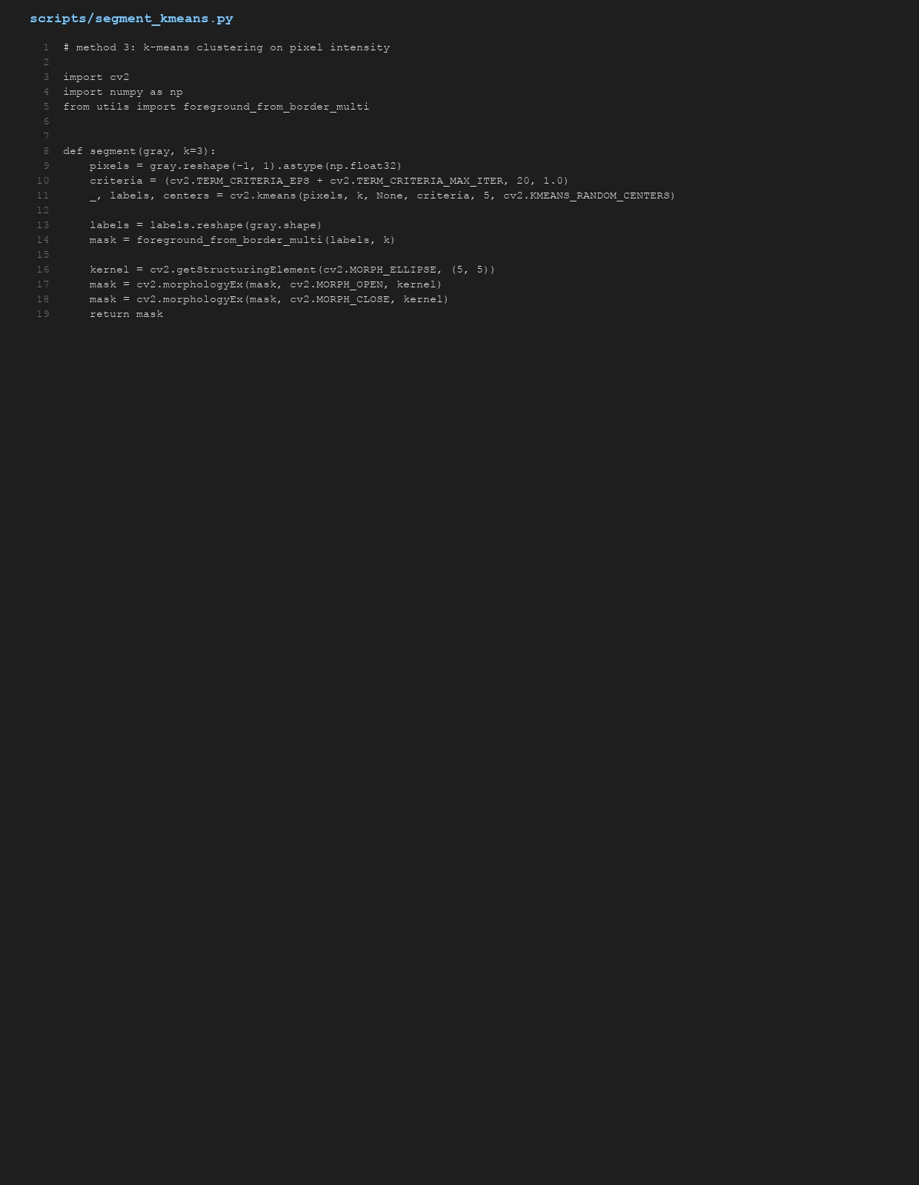

run_all.py
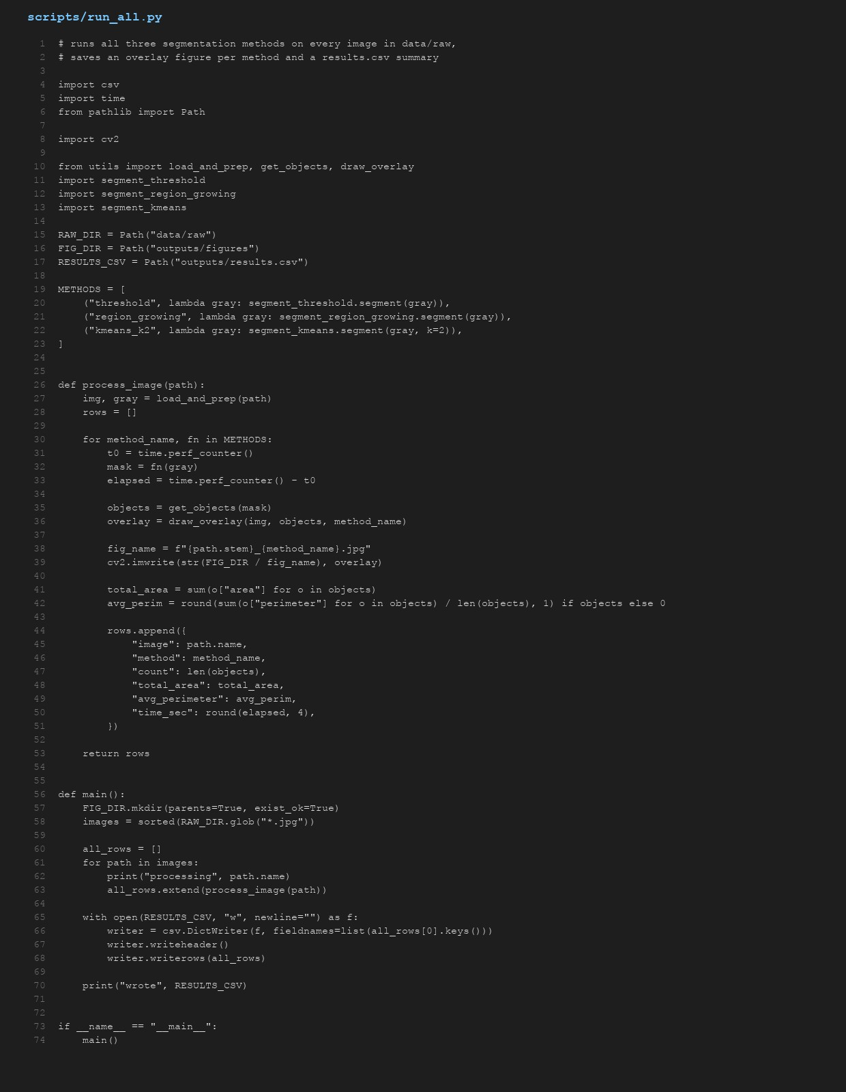

kmeans_sweep.py
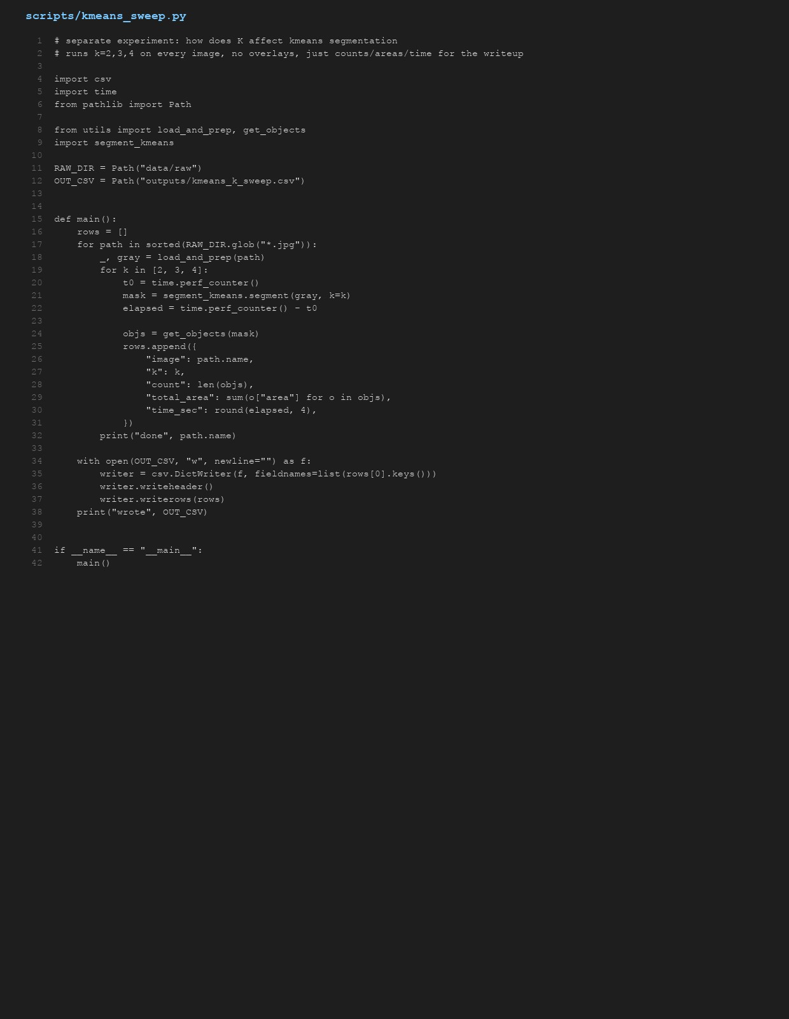

noise_test.py
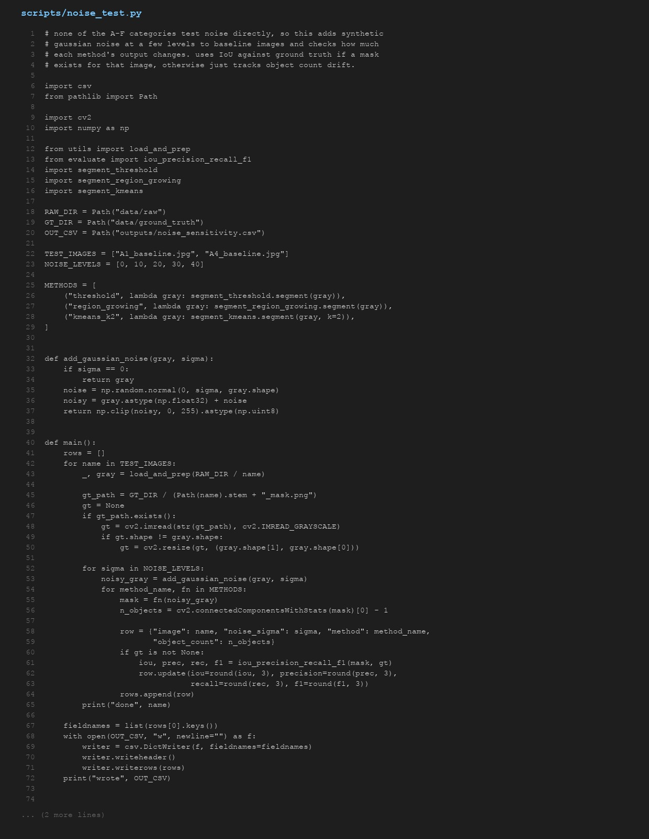

evaluate.py
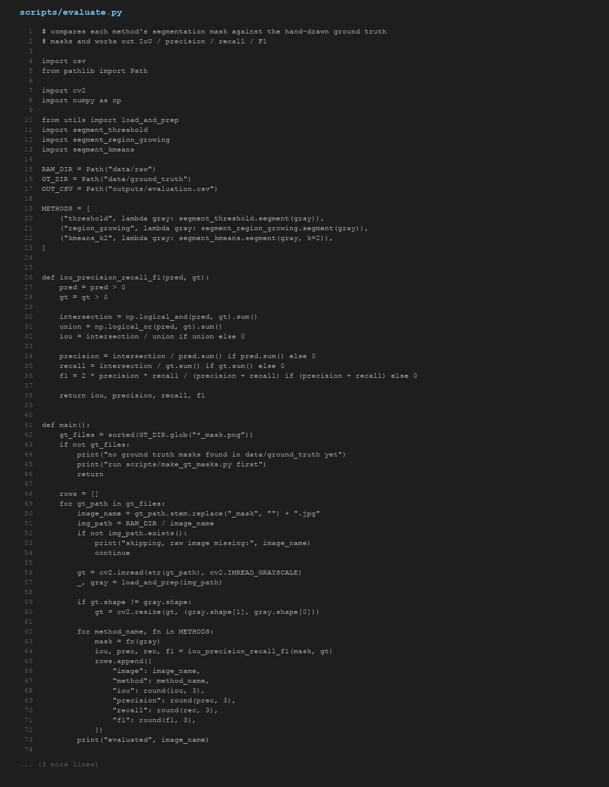

make_gt_masks.py
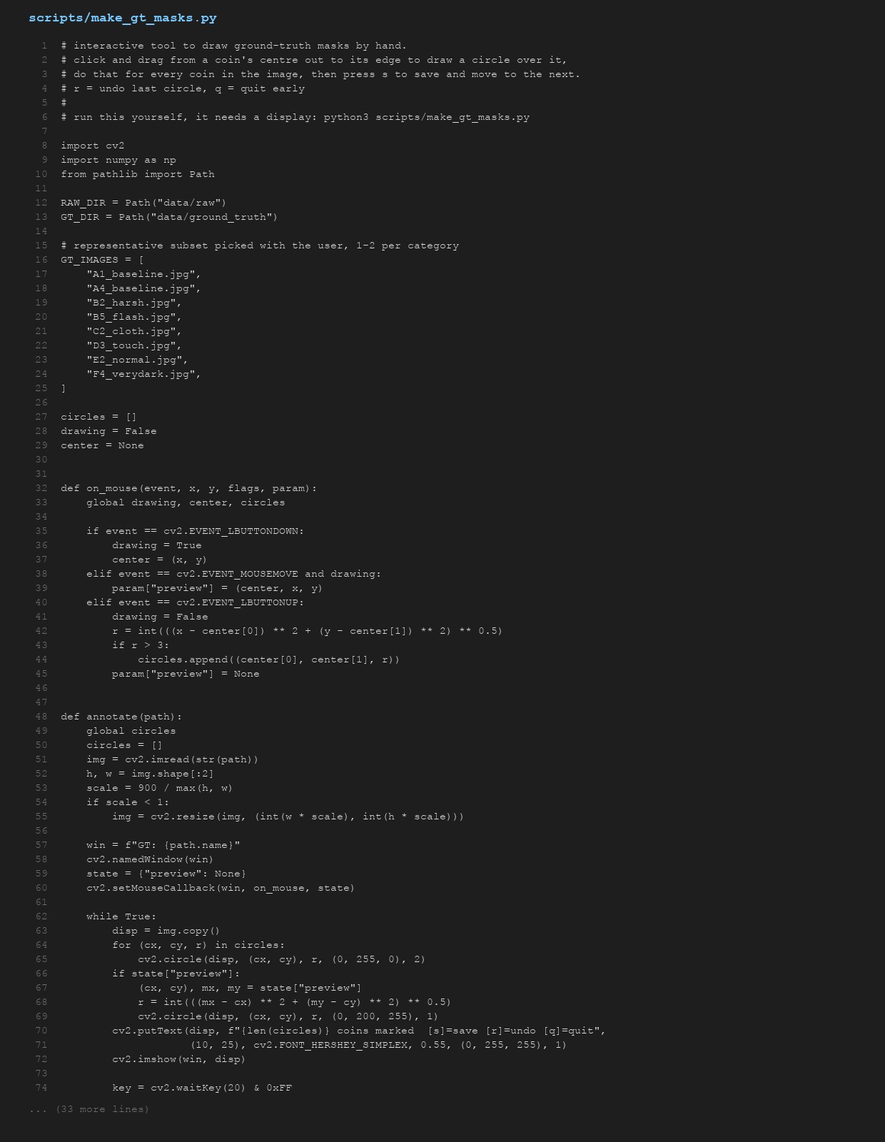

make_pipeline_figure.py
