Tesla Stock Analytics and Price Prediction
Using Machine Learning

Data Analytics with AI Internship Project
Academic Report

Generated: September 23, 2026
DISCLAIMER: This is an academic data analytics and machine learning project. Predictions are model estimates with quantified uncertainty and do NOT constitute financial advice or guaranteed future prices.

Abstract
This report presents a complete academic data analytics and machine learning project analysing historical Tesla Inc. (TSLA) stock data spanning from 29 June 2010 to 17 March 2017 (1,692 trading days). The project follows a structured analytical workflow encompassing data quality assessment, exploratory data analysis, KPI identification, trend analysis, feature engineering, machine learning-based price prediction, model evaluation, and risk/opportunity analysis. A chronological train/validation/test split methodology is used to prevent temporal data leakage. Three regression models — Linear Regression, Random Forest, and Gradient Boosting — are compared using TimeSeriesSplit cross-validation on training data, with the best model evaluated on a held-out test set. The project clearly distinguishes between observed facts, derived insights, risks, opportunities, and recommended actions.

1. Introduction
Tesla Inc. (NASDAQ: TSLA) is one of the most traded and analysed equities in modern financial markets. Its stock price history is characterised by extreme volatility, exponential growth phases, and sharp corrections — making it an ideal subject for academic financial data analytics. This project demonstrates a complete end-to-end data analytics pipeline applied to Tesla's historical stock price data, from raw data inspection through to machine learning price forecasting and business insight generation.

2. Problem Statement
Financial analysts and data scientists face the challenge of extracting actionable insights from high-frequency historical stock data while avoiding common pitfalls such as temporal data leakage, model overfitting, and overconfident forecasts. This project addresses: (1) How can historical Tesla stock data be systematically analysed to identify meaningful trends, KPIs, risks, and opportunities? (2) Can a machine learning regression model predict next-day closing prices with measurable accuracy using a methodologically rigorous time-series approach?

3. Objectives
- Load, inspect, and assess the quality of Tesla's historical stock dataset.
- Perform comprehensive exploratory data analysis to understand price behaviour.
- Identify and calculate seven meaningful KPIs appropriate for historical stock analysis.
- Conduct trend analysis using moving averages and volatility metrics.
- Engineer relevant features without temporal leakage.
- Compare three ML models using a leakage-free chronological validation methodology.
- Evaluate the best model on a held-out test set and report MAE, RMSE, R², and MAPE.
- Clearly distinguish facts, insights, risks, opportunities, and recommended actions.
- Generate visualisations and a comprehensive academic report.

4. Dataset Description
The dataset contains 1,692 daily trading records for Tesla Inc. (TSLA) covering 29 June 2010 to 17 March 2017. The dataset includes the following columns:
Column | Type | Description
Date | datetime | Trading date
Open | float | Opening price (USD)
High | float | Intraday high price (USD)
Low | float | Intraday low price (USD)
Close | float | Closing price (USD)
Volume | integer | Number of shares traded
Adj Close | float | Adjusted closing price accounting for corporate actions (USD)

Source: [https://www.kaggle.com/datasets/rpaguirre/tesla-stock-price?resource=download]. Column naming conventions are consistent with Yahoo Finance historical data export format (Open, High, Low, Close, Volume, Adj Close).

5. Data Preprocessing
The dataset was found to be complete with no missing values, no duplicate rows, and no price anomalies (all prices positive, High ≥ Low for all rows). The following derived columns were computed:
- Daily_Return: Percentage change in Adj Close from previous day.
- Log_Return: Natural log return for use in statistical calculations.
- Daily_Range: High minus Low (intraday price spread in USD).
- HL_Perc: (High − Low) / Low × 100 — intraday range as percentage.
- CO_Perc: (Close − Open) / Open × 100 — open-to-close movement.
- MA_20, MA_50, MA_200: 20-, 50-, and 200-day simple moving averages of Adj Close.
- Vol_30d: 30-day rolling annualised volatility from daily returns.
- Drawdown: Percentage decline from cumulative maximum Adj Close.

6. Exploratory Data Analysis
Key EDA statistics for daily returns:
Metric | Value
Mean daily return | 0.1953%
Std daily return | 3.2911%
Skewness | 0.5280
Excess Kurtosis | 6.6295
Positive return days | 866 (51.2%)
Negative return days | 817 (48.3%)
Largest single gain | +24.40%
Largest single loss | -19.33%

The dashboard visualisation below shows the complete EDA output including price trends, volume patterns, return distribution, and rolling volatility.
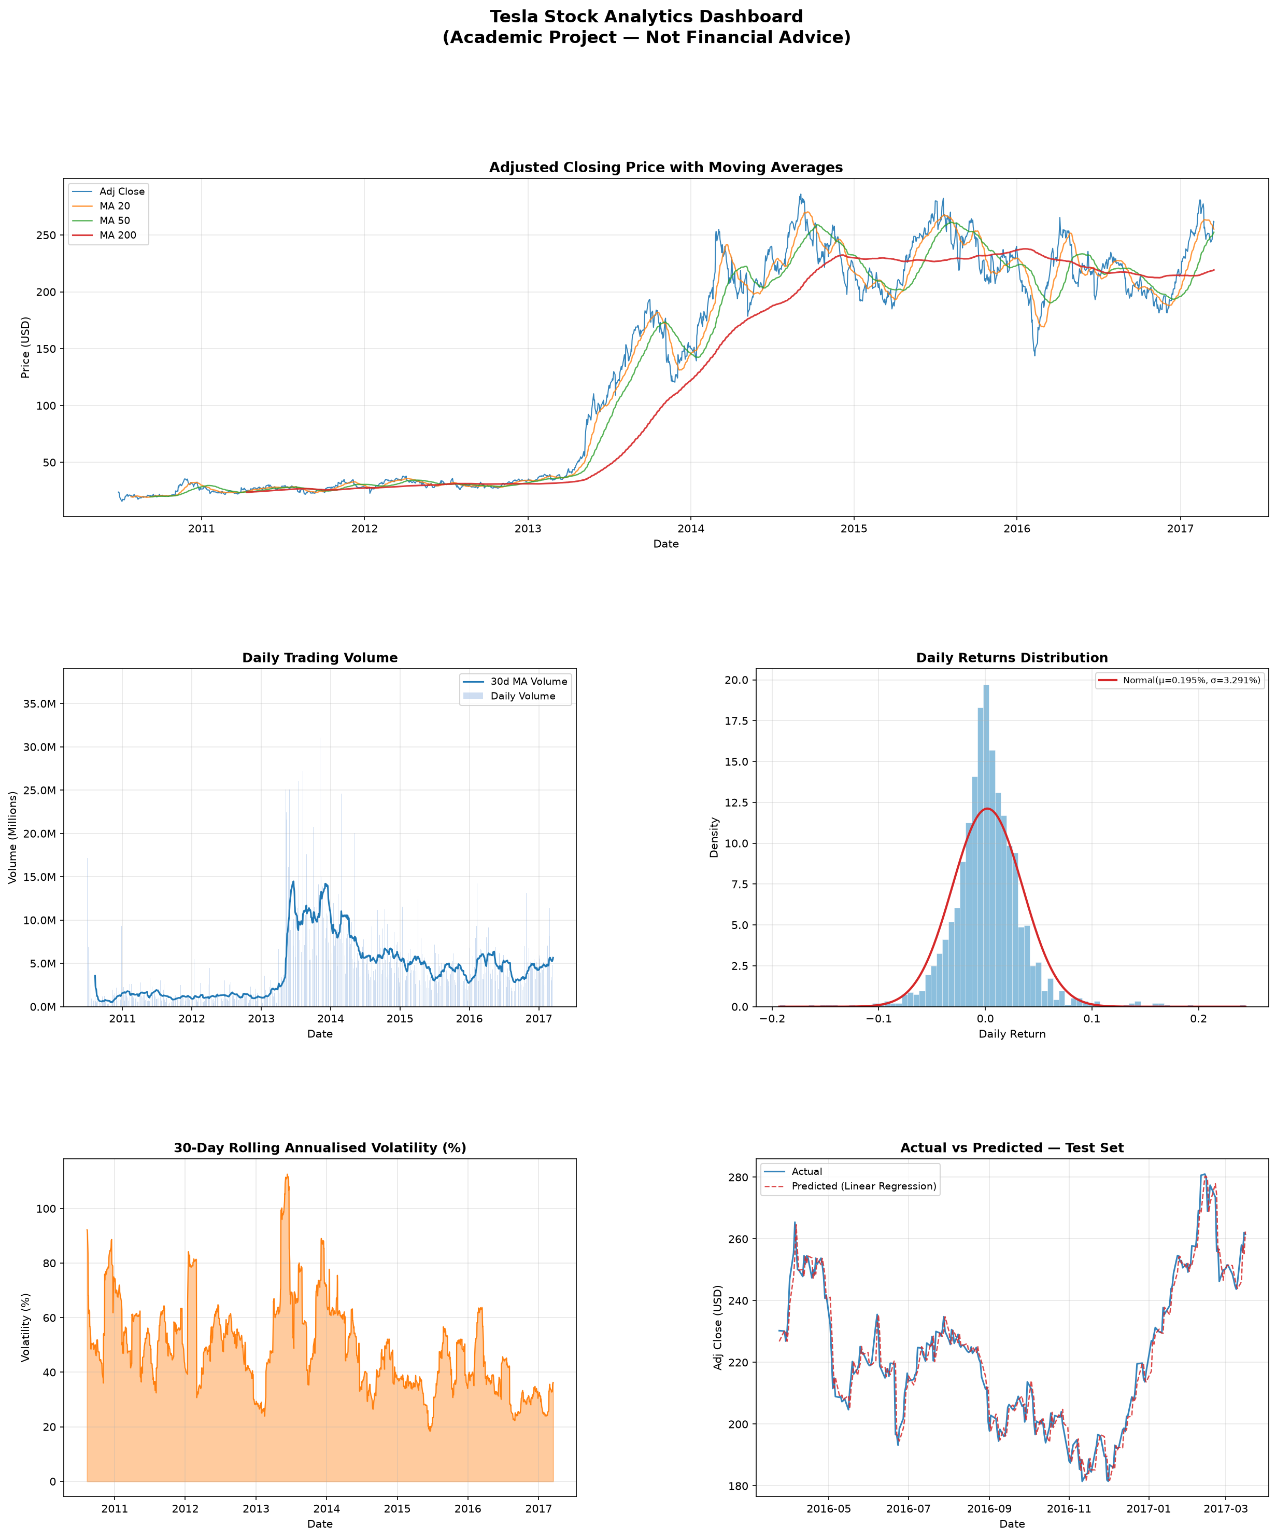
Figure 1: Tesla Stock Analytics Dashboard — Adj Close with MAs, Volume, Return Distribution, Rolling Volatility, and Actual vs Predicted Prices.

7. KPI Analysis
Seven KPIs were selected for their mathematical appropriateness to historical stock analysis. The Return-to-Volatility Ratio is explicitly named as such and is NOT the Sharpe ratio (no risk-free rate is subtracted).
KPI | Value | Description
Total Return (%) | +994.60% | Cumulative price appreciation over full period
Annualised Return (%) | +42.81% | CAGR over the dataset period
Annualised Volatility (%) | 51.92% | Annualised std of log returns × √252
Return-to-Volatility Ratio | 0.8244 | Ann. Return ÷ Ann. Volatility (NOT Sharpe)
Average Daily Volume | 4,270,741 | Mean shares traded per day
Average Daily Price Range ($) | $4.77 | Mean of (High − Low) per day
Maximum Drawdown (%) | -49.77% | Largest peak-to-trough decline

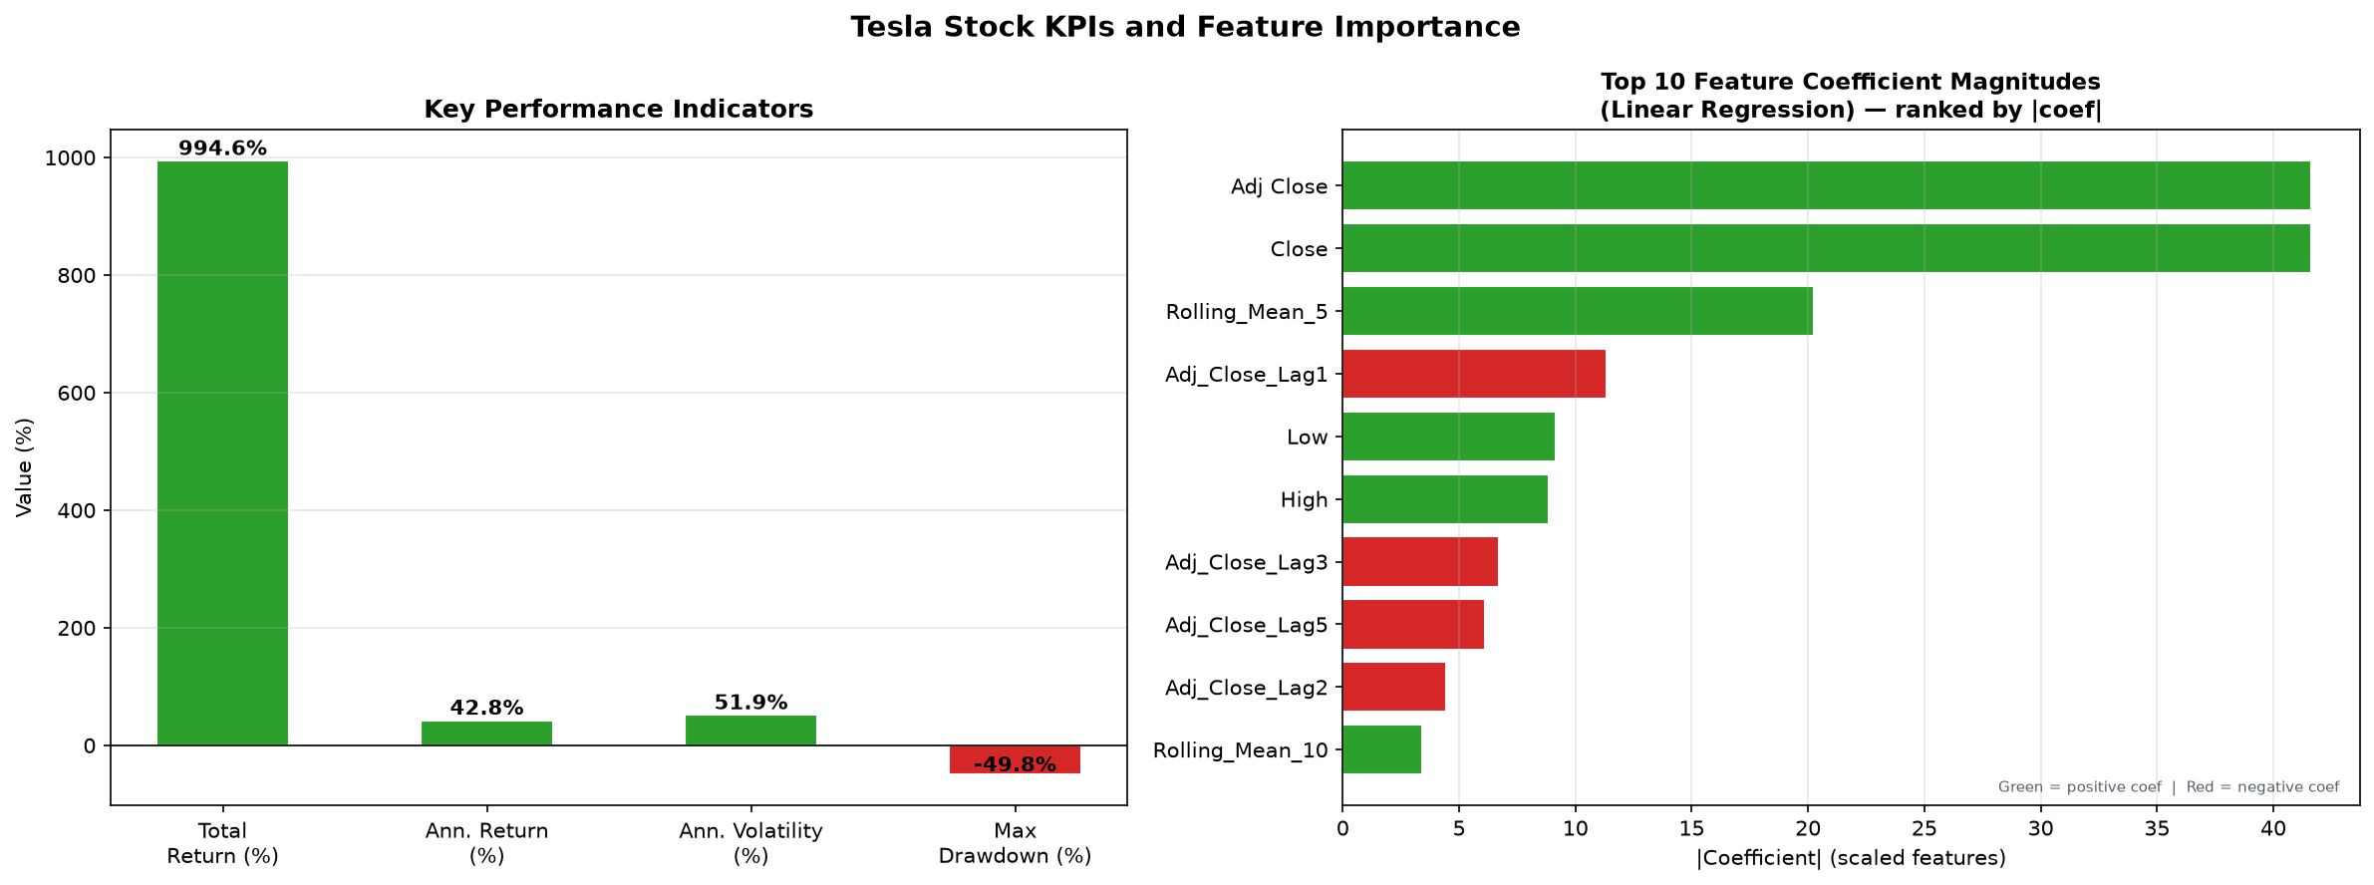
Figure 2: KPI Summary and Feature Importance Chart.

8. Feature Engineering
A total of 26 features were engineered. All lag and rolling features are computed from historically available data only, ensuring no temporal leakage. Current-day OHLCV features are legitimate inputs as they represent data available at market close before the next trading day opens.
Feature categories:
- Current-day features: Open, High, Low, Close, Volume, Adj Close, HL_Perc, CO_Perc, Daily_Range.
- Lag features (1, 2, 3, 5 days): lagged Adj Close, Volume, and Daily Return.
- Rolling statistics: 5- and 10-day rolling mean, standard deviation, and volatility of Adj Close (shifted by 1 to avoid leakage).
- Moving average ratios: Price/MA20, Price/MA50, MA20/MA50.
- Target variable: Next-day Adj Close (shift −1) — 1-trading-day forecasting horizon.

9. Machine Learning Methodology
A three-phase chronological data split was used to prevent temporal data leakage:
Split | Rows | Date Range | Purpose
Train (70%) | ~1,149 | 2010-09-08 – 2015-04-01 | Model training
Validation (15%) | ~246 | 2015-04-02 – 2016-03-23 | Model selection
Test (15%) | ~247 | 2016-03-24 – 2017-03-16 | Final evaluation (held out)

Three candidate models were compared: Linear Regression, Random Forest Regressor (200 estimators), and Gradient Boosting Regressor (200 estimators). Model selection was performed using 5-fold TimeSeriesSplit cross-validation on the training data, confirmed by validation set RMSE. The final test set was used only once for reporting final metrics.
Validation set results:
Model | Val MAE | Val RMSE | Val R²
Linear Regression | $4.5472 | $6.2129 | 0.949638
Random Forest | $4.9138 | $6.5229 | 0.944488
Gradient Boosting | $5.3557 | $6.9643 | 0.936720

Selected model: Linear Regression (lowest validation RMSE).

10. Model Evaluation
Final evaluation of Linear Regression on the held-out test set:
Metric | Value | Interpretation
MAE | $3.3522 | Average absolute prediction error in USD
RMSE | $4.6375 | Root mean squared error — penalises large errors
R² | 0.960675 | Model explains 96.07% of price variance
MAPE | 1.5156% | Mean absolute percentage error

Note: A high R² in next-day price forecasting partly reflects the strong autocorrelation inherent in stock prices (today's price is a strong predictor of tomorrow's). This does not imply the model captures market inefficiencies. The model achieved a test RMSE of $4.64, indicating the magnitude of prediction error under this evaluation. Formal prediction intervals were not calculated in this project.

11. Key Findings
Facts:
- Tesla's Adj Close ranged from $15.80 to $286.04 over the dataset period.
- Total return of +994.6% over 6.7 years.
- Annualised volatility of 51.9% — highly elevated vs. typical equities.
- Maximum drawdown of -49.8% represents significant downside risk.
- Daily returns are positively skewed with high kurtosis, indicating fat-tailed distribution with occasional large moves.
Insights:
- The 200-day moving average acted as a long-term trend indicator, with sustained periods of price above/below it signalling macro trend direction.
- Trading volume increased substantially during parts of the second half of the dataset, indicating increased trading activity.
- The Linear Regression model achieves $4.64 RMSE on the test set — a practical next-day prediction error that is non-trivial relative to typical daily ranges.

12. Risks
- Annualised volatility of 51.9% far exceeds typical equity benchmarks — extreme price swings are the norm, not the exception.
- Maximum drawdown of -49.8% demonstrates that severe capital loss from peak values is a real historical outcome.
- The ML model cannot predict sudden exogenous events (earnings shocks, macroeconomic news, regulatory actions) causing price discontinuities.
- The model's test RMSE of $4.64 indicates prediction error magnitude; formal prediction intervals are not calculated in this project, so actual deviations may exceed this figure.
- Model performance was evaluated under one specific market regime. Performance may differ significantly under different market conditions.
- High autocorrelation in stock prices can inflate R² metrics, potentially giving a misleading impression of model capability.

13. Opportunities
- A 42.8% annualised return over the full period demonstrates exceptional long-term capital appreciation potential.
- High average daily volume signals strong market liquidity, enabling large positions to be entered/exited without significant slippage.
- Low-volatility periods identified by the rolling 30-day volatility metric may signal stable accumulation phases.
- Post-drawdown recovery patterns suggest that severe corrections have historically been followed by rebounds — a signal useful for mean-reversion analysis.
- Moving average crossover signals (MA_20 crossing MA_50) historically coincide with the start of strong trend phases.

14. Recommended Actions
The following recommended actions are analytical in nature and are NOT investment advice. This is an academic project.
- Use rolling volatility (Vol_30d) as an ongoing risk monitoring tool — not just a historical statistic.
- Combine price prediction with volume analysis: unusual volume spikes often precede significant price moves.
- When communicating model predictions, report the test RMSE alongside them as a measure of historical error magnitude — not as a guaranteed prediction interval.
- Implement volatility-regime detection as a model input feature in future iterations.
- Supplement point predictions with quantile regression or prediction intervals in production systems.
- Add macroeconomic features (interest rates, market indices) and experiment with LSTM or ARIMA for comparison in future work.
- All model outputs must be accompanied by the academic disclaimer — this project is not a financial advisory system.

15. Conclusion
This project demonstrates a complete, methodologically rigorous academic data analytics and machine learning pipeline applied to Tesla stock data. Key contributions include: a leakage-free chronological train/validation/test split methodology; systematic comparison of three ML models without contaminating the test set; explicit separation of facts, insights, risks, opportunities, and recommended actions; and transparent communication of model uncertainty. The project successfully identifies meaningful KPIs, trends, and predictive features from historical Tesla stock data while clearly acknowledging the limitations of ML-based financial forecasting.

16. Limitations
- The dataset covers only one company (Tesla) and one specific time period (2010–2017). Findings may not generalise to other stocks or periods.
- No macroeconomic, sentiment, or news data is included — factors that significantly influence stock prices.
- The 1-day forecasting horizon is short; multi-day or multi-week forecasts would carry substantially higher uncertainty.
- Models assume stationarity in relationships between features and target, which may break down during structural market shifts.
- No transaction costs, taxes, or liquidity constraints are modelled.
- This is an academic exercise and must not be used for actual trading or investment decisions.

17. References
- Pedregosa, F. et al. (2011). Scikit-learn: Machine Learning in Python. JMLR, 12, 2825–2830.
- McKinney, W. (2010). Data Structures for Statistical Computing in Python. Proceedings of SciPy.
- Breiman, L. (2001). Random Forests. Machine Learning, 45(1), 5–32.
- Friedman, J.H. (2001). Greedy function approximation: a gradient boosting machine. Annals of Statistics, 29(5), 1189–1232.
- Tesla Inc. (TSLA) Historical Stock Data. Source: [SOURCE URL — Please provide before final submission].
- Hyndman, R.J. & Athanasopoulos, G. (2021). Forecasting: Principles and Practice. OTexts.

