**GROUP 1W1.**

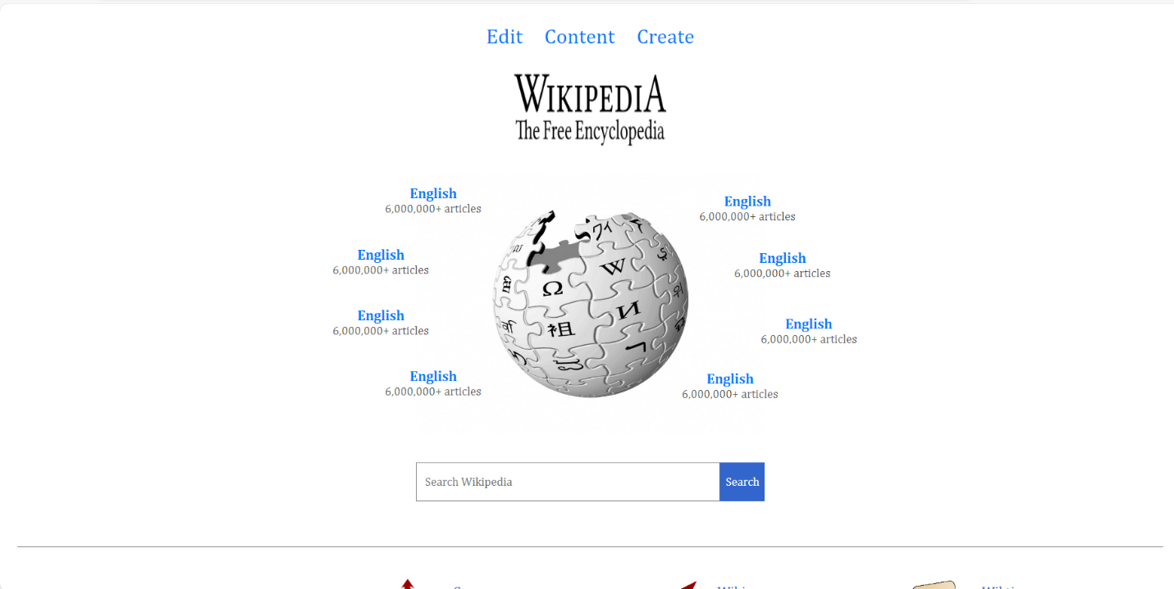Index or home page

[1/2]

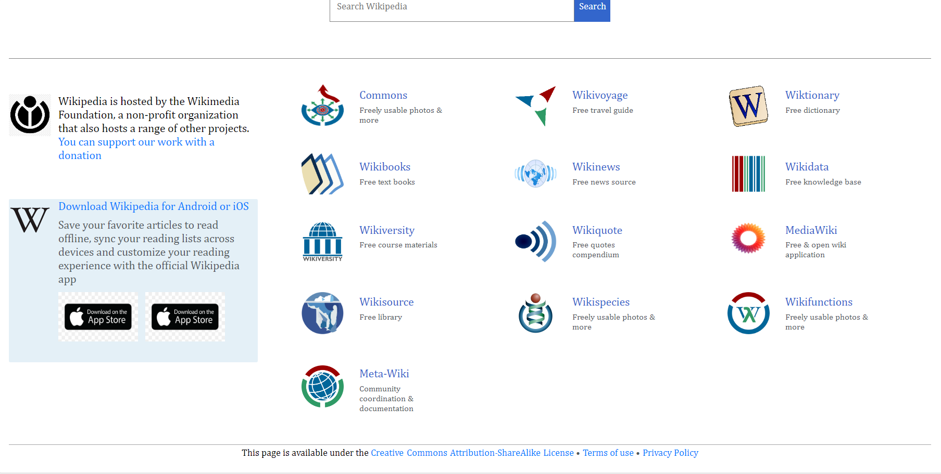

[2/2]

New Page

Edit Page

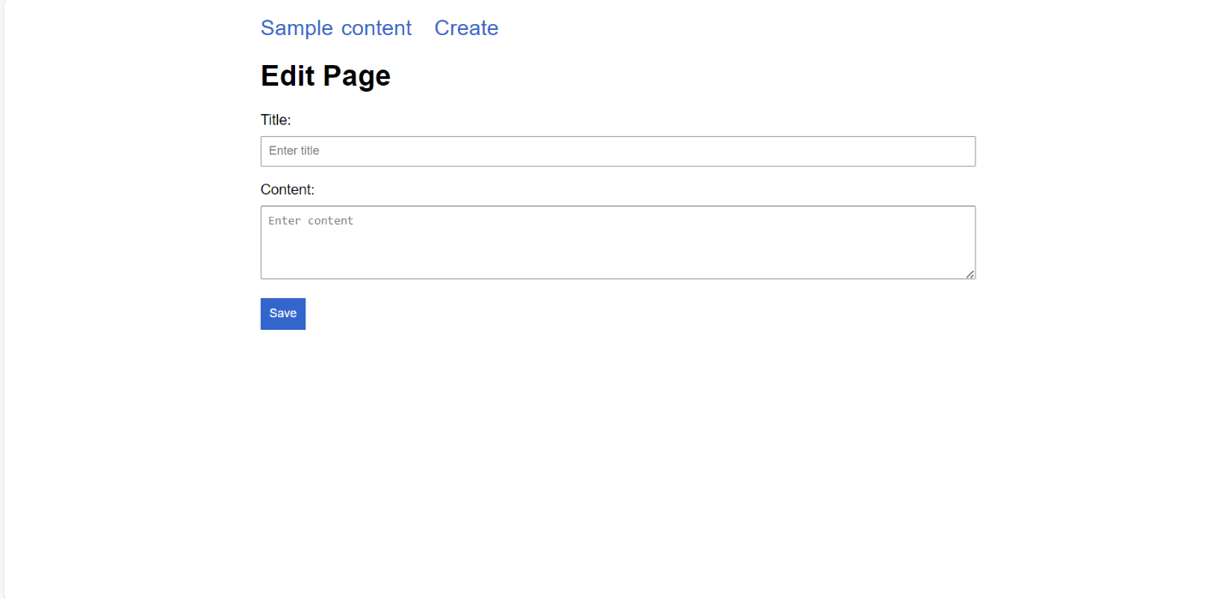

Random page

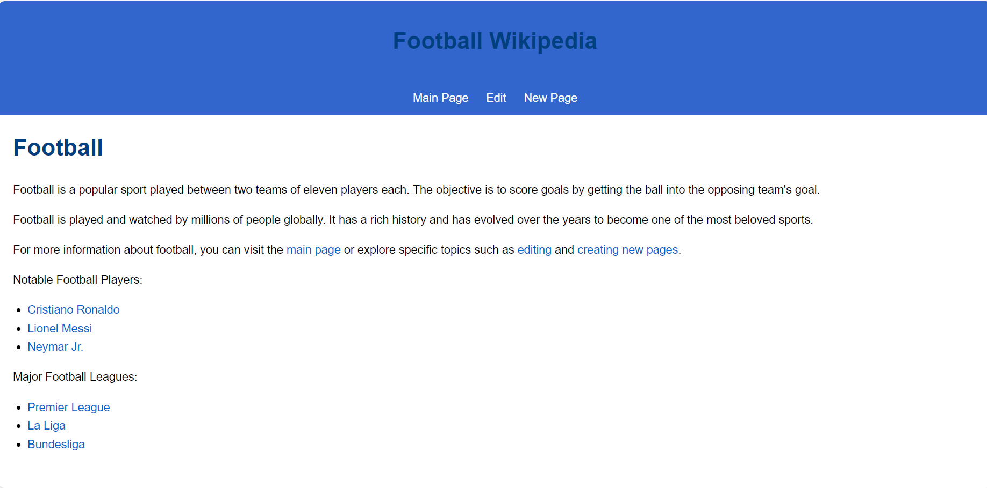

**MEMBERS WHO PARTICIPATED**

1. Kevin Mireku Asante 8537621
2. Othman Mohammed-Hanan 8564121
3. Williams Brien Solomon 8571121
4. Cecil Joojo Graham 8549921
5. Otchereh Japheth Wilson 8564021
6. Bryan-Sackey Nan Ekow 8544121
7. Boison Leslie 8543321