

**BUSINESS CASES WITH DATA SCIENCE**

**MASTER DEGREE PROGRAM IN DATA SCIENCE AND ADVANCED ANALYTICS – MAJOR IN BUSINESS ANALYTICS**

**Business Case #4 – Recommender System**



Data4Business Consulting

Débora Santos, number: 20200748

Pedro Henrique Medeiros, number: 20200742

Rebeca Pinheiro, number: 20201096

May, 2021

INDEX

1. INTRODUCTION 1

2. BUSINESS UNDERSTANDING 1

2.1. Background 1

2.2. Business Objectives 1

2.3. Business Success criteria 2

2.4. Situation assessment 2

2.4.1. Inventory of resources 2

2.4.2. Requirements, assumptions, and constraints 2

2.4.3. Risks and contingencies 2

2.5. Determine Data Mining goals 3

2.6. Project Plan 3

3. Predictive Analysis 4

3.1. Data understanding 4

3.2. Data preparation 5

3.3. modelling and evaluation 6

4. RESULTS EVALUATION 8

5. DEPLOYMENT AND MAINTENANCE PLANS 9

6. CONCLUSIONS 9

7. REFERENCES 9

# 

# INTRODUCTION

Thank you for choosing **Data4Business Consulting (D4B)** to help you with the challenge of better understanding your customers preferences. Our main objective is helping **ManyGiftsUK** to build a recommender system that is able to facilitate user choices and suggest relevant items to customers.

The world is experiencing a great technological and digital revolution where understanding business data, customers and their needs is essential for the business success. Taking advantage of that, e-commerce is growing daily and now it is a fundamental strategy for any business to gain value, market share and to stay relevant in the market. Consequently, the competition between sellers leads to a constant search for the improvement of their business models and decisions. One of the important challenges is helping customers sort through a large variety of offered products to easily find the ones they will enjoy the most. *[1]*

Through innovative technological programs, well-referenced data mining methods and insights of digital marketing, the present report intends to provide an overview of the process behind the analysis, presents the results and insights you need to be successful in this new era.

In addition to the present report, the following deliverables will be submitted:

* Outcomes presentation to ManyGifts.
* Jupyter Notebook with the code of the entire process.

All files can be accessed in Github:

*https://github.com/Debs86/Business_Cases_Projects/tree/main/BC2*

We are excited to take part of this challenge.

# BUSINESS UNDERSTANDING

## Background

**ManyGiftsUK (MGUK)** is non-store online retailer with some 80 members of staff. The company was established in 1981, with the focus on selling unique all-occasion gifts. The company is based on UK, but it has customers in many countries on the world.

In the past, the merchant relied heavily on direct mailing catalogues, and orders were taken over phone calls. Two years ago, the company launched its own website and shifted completely online. The company also uses Amazon.co.uk to market and sell its products.

Given the number of possible product choices available, having some extra guidance on these choices can improve the customerexperience and lead to an increase in sales. Recommender systems are an essential feature in our digital world, as users are often overwhelmed by choice and need help finding what they are looking for. *[3]* These systems have become a very important part of the retail industries, by providing users personalized recommendations for products or services which hopefully suit their unique taste and needs.

On the past years, MGUK has accumulated a huge amount of data about many customers.

Now, they expect to build a recommender system, therefore they have reached D4B.

## Business Objectives

The customer’s primary objective is to build models to answer the follow problems:

* Implement a recommender system.
* Cold star problem: offer relevant products to new customers.

## Business Success criteria

The main expected outcome will be implementing a recommendation system that appears in MGUK website home page and offers a wide range of relevant products to both, new and old customers. The success of the proposed task will be evaluated by MGUK management director and, if needed, we will go back to the model until we get an outcome that matches with their expectation.

Also, another success criteria would be an increase on sales. For example, 35% of Amazon sales come from recommendations. We believe that implementing a recommender system the sales would increase.

Finally, recommender systems would improve customers satisfaction providing them good recommendations and consequently easy choices.

## Situation assessment

### Inventory of resources

This project was made following the CRISP-DM reference model (Cross Industry Standard Process for Data Mining). CRISP-DM is a standard process built in the end of 90’s and it was built by more than 200 members lead by a consortium of big companies. *CRISP-DM succeeds because it is soundly based on the practical, real-world experience of how people conduct data mining projects.*[2]

This project has the support of MGUK’s Management and staff.

On the D4B Consulting side, this project will be conducted by a team of 3 Data Scientists and Business Analysts.

We have been provided by the MGUK team with a dataset with transactions of customers occurring between December 1, 2010 and December 09, 2012. Along with this dataset, we were also provided with its metadata file.

The main technology used to achieve the objectives of this report was Python. Python is one of most important and commonly used program languages in data science projects. The main packages for recommender systems are mlxtend and AlgorithmX for network visualizations. We also used Plotly and Dash packages to produce visualizations and a final application.

### Requirements, assumptions, and constraints

The completion date of the present phase of the project is May 03, 2021, but we expect to continue giving support and helping MGUK to achieve the next goals for the growth of the business.

Recommendation systems are divided in two main categories:

1. Collaborative filtering utilizes the past data of user’s interactions as well similar choices made by other users. “Similarity” is measured against the similarity of users. *[3]*
2. Content based filtering uses the knowledge about each product to recommend items with similar properties.  “Similarity” is measured against product attributes*. [3]*

In collaborative filter, the system can find similarity based on purchase history, but also based on demographic data. One of the constraints of this project is the lack of demographic data. It is not a mandatory requirement, but it would improve the quality of the recommendations. Examples of demographic data are genre, age, and location.

In addition, it would also not be possible to find similarity based on products attributes as the data does not provide details of products, only code and name.

### Risks and contingencies

Table 2.1 identifies a list of risks and contingency proposed.

|  |  |
| --- | --- |
| **Risk** | **Contingency** |
| Insufficient features of customers’ behaviors/ characteristics | Work with remaining features |
| Insufficient product attributes | Work with remaining features or ask for different variables |
| Only one year of transaction data | Ask for more observations (transactions) |

Table 2.1 - Risks and contingency.

#### Terminology

***Business glossary***

Recommender systems usually make use of two types of data:

* Explicit data: Considered as most common feedback type, explicit data has common rating type, where users directly input their feedback regarding product or service. From this rating is possible to understand the like or dislike user level in a intuitive way. From explicit data is possible to calculate similarity and provides recommendations according to the users ratings.
* Implicit data: Attached to users behaviors, implicit data is collected based in a indirectly way of users shows preferences. An example of implicit data is how long the user spent in a website, which clicks were made in a webpage by an user, show many times a songs were played and so on. Implicit feedback can be used to solve a common recommendation system challenges which is the sparsity(when the users’ preference is not available all time).

***Data mining glossary***

* Recommendation system problem: System which make suggestions for users about items based on their preferences. This system is usually classified according to the rating estimation technique, which has three main ways:
  + Collaborative Filtering Process: Collects user feedback in rating format for items and explore similarities in rating behaviour among several users.
  + Content based Process: System which recommends an item for a user based on the item description and user profile
  + Hybrid process: Recommendation system which combine multiple recommendations techniques together in order to achieve synergy between all.
* Precision: measure how precise the model is out of those predicted positives. The proportion of correctly predicted cancelations against the proportion of total correctly predictions.  
   𝑃𝑟𝑒𝑐𝑖𝑠𝑖𝑜𝑛 = $\frac{True positive}{True positives+ True Negatives}$
* Recall: how many actual positives, the model captures as being positive. The proportion of correctly predicted cancelations against the total of actual cancelations.

Recall = $\frac{True positive}{True positives+ False negatives}$

## Determine Data Mining goals

The data mining goals states project objectives in technical terms:

1. Create a model that will be able to predict good recommendations for the users.

*Success criteria*: Higher percenteges of precision.

1. Implement a recommendation system.

*Success criteria*: Implement the recommender system on the website homepage.

## Project Plan

Figure 2.1 - Project’s timeline.

Resources wise, for the business understanding we plan to use all the information provided in the kickoff meeting’s presentation. For the core stages of the project, we plan to use Python to work the data provided. To present the results, we expect to use Word for the report and Power point for the presentation.

The performance of the model will be directly connected with the quality of the input data. For this reason, we identify the Modelling stage as dependent of the Data preparation stage. During the project, we must go and back between Data preparation and Modelling many times, repeat this iteratively until we get the desired outcome.

For the Modelling stage we aim to build a supervised model (predictive) using Random Forecast classifier algorithm. We opted for this model because it presented the best results compared with other algorithms. Further details will be presented in section 3.3 – Modelling and evaluation. The model evaluation will be made using accuracy, precision and F1 score metrics. The accuracy metric is good to see the overall performance of the model. Precision to measure how good the model is predicting the cancellations. Finally, F1 to check the balance between recall and precision. It will also be presented a confusion matrix and an ROC curve.

# Predictive Analysis

In this section we go through the process of understanding and preparing the data for modelling, the modelling itself, the different algorithms used and, finally, the results evaluation.

## Data understanding

At this stage we analyzed the dataset to understand its potential and limitations. We have used the Pandas profiling to have an overview of the dataset: what variables are in the dataset, what they mean, number of variables (31 features, from which 13 categorical and 18 numerical as shown on Table 3.1) and observations (79.330 customers), how the variables are distributed (there are some skewed variables) , if there is noise, if there are missing values (28 missing entries) and/or duplicated values (none) , which of these features are relevant for the final goal and which features are redundant.

We have also looked at the metadata file provided to understand the meaning of each feature to understand their relevancy in the project.

|  |  |
| --- | --- |
| **Numeric** | **Categorical** |
| *ADR*, *Adults,Babies*, *BookingChanges,Children, DaysInWaitingList, LeadTime, PreviousBookingsNotCanceled, PreviousCancellations RequiredCardParkingSpaces, StaysInWeekendNights, StaysInWeekNights, TotalOfSpecialRequests* | *Agent, ArrivalDateDayOfMonth, ArrivalDateMonth, ArrivalDateWeekNumber, ArrivalDateYear, AssignedRoomType, Company, Country, CustomerType, DepositType, DistributionChannel, IsCanceled, IsRepeatedGuest, MarketSegment, Meal, ReservationStatus, ReservationStatusDate, ReservedRoomType,* |

Table 3.1 - Numerical and categorical features.

As we are dealing with a classification problem, it is important to check the distribution of the data according to the target variable (IsCanceled). Almost 42% of the total bookings are cancelled. From those cancelled bookings, 2.8% are no-show (meaning the customer got charged).

Going into more details, April to June are the months where there is a higher proportion of cancellations. Most of the bookings with no children and/or babies have a higher percentage of cancellations. Also, Bed & Breakfast bookings tend to cancel more than average. On the other hand, guests those requiring parking space, booking changes and/or special requests are more willing to show up. Repeated guests also have low percentage of cancellations, but they represent less than 3% of bookings.

Bookings through Travel Agents or Tour Operators (representing nearly 87% of the total bookings) tend to cancel more often, while groups reservations tend to cancel less than others.

Customer’s bookings made far in advance are more willing to cancel the reservation.

## Data preparation

A classification algorithm can be used to analyze discrete data, however, the dataset should be prepared to ensure it meets the requirements for this purpose. The dataset must be as complete as possible, missing values must be treated (either removed or filled in) and outliers should also be checked for. To avoid underfitting (when the model cannot detect any relationships in the data), relevant variables must be included; on the other hand, to avoid overfitting, variables with no predictive power should be eliminated. Because the quality of the data can make a model perform well or not so well, this data preparation stage takes the majority of the time in the project.

On the first step of data preparation, we drop some observations with missing values (28 observations, representing 0,035% of the dataset) and one observation in which the ADR is too high and clearly noisy (ADR=5.400). We have also eliminated the bookings with zero adults, as we believe it is an error, once in those same case there were children and/or babies included (0,48% of the dataset). The next step was feature engineering which we built 3 new features, for data analysis purpose:

|  |  |
| --- | --- |
| **New variables** | **Description** |
| *Days_before_cancel* | *Number of days the booking is canceled before the entry date (=0 if not canceled)* |
| *Days_until_cancel* | *Number of days between the reservation is made until it's canceled (=0 if not canceled)* |
| *RoomType_change* | *Binary variable showing if the customer will get what he/she reserved (1 if ReservedRoomType=AssignedRoomType; 0 otherwise)* |

Table 3.2 - New variables.

The next stage was to check the correlation matrices to identify redundant variables. We could not identify any strong correlation on the Spearman’s matrix, but we identified strong correlations on Phi-k matrix, as we are dealing with a dataset with many categorical features. The following features were dropped, based on redundancy and their correlation between each other: *MarketSegment*, *RoomType_change*, *Agent*, *Company*, *ReservationStatusDate*, *AssignedRoomType*, *ReservationStatus*, *Days_before_cancel, Days_until_cancel*. We have also dropped 8 variables considered non-relevant for the model (*ArrivalDateYear*, *ArrivalDateWeekNumber*, *ArrivalDateDayOfMonth*, *ArrivalDate*, *Country*, *BookingChanges*, *RequiredCarParkingSpaces*, *TotalOfSpecialRequests*).

We have then reproduced the Phi-k correlation matrix to confirm it looked reasonable, once more. For further details, the correlations are available on the notebook.

Looking at the boxplots for each of the numeric variables, we have identified 5 variables (*ADR*, *DaysInWaitingList*, *StaysInWeekNights*, *Babies* and *StaysInWeekendNights*) with outliers (Figure 3.1).

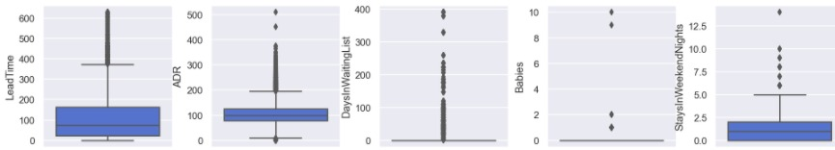

Figure 3.1 – Boxplot for numeric feature before outliers removal.

To remove these outliers, we tested applying five different methods on the entire dataset and using them individually or in combination. However, after testing these different approaches, and realizing that, outliers wise, it did not seem to make a big difference on the box and whiskers plots, we have opted for manually removing the outliers (considering it was feasible to do it for the five features where outliers were found). This way we have removed 2.723 observations, representing 3,45% of the dataset.

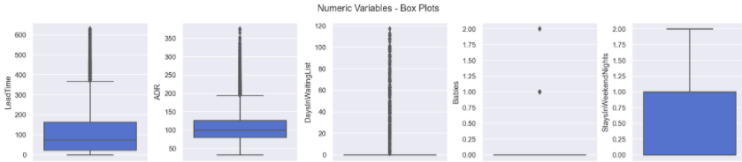

Figure 3.2 - Boxplot for numeric features after outliers removal.

In order to prepare the data for modelling, we have one-hot-encoded categorical variables (to transform in binary values).

## modelling and evaluation

The first stage of this process was to split the dataset into train and test, 80% and 20% of the dataset, respectively. This dataset has entries that are exactly the same and, even though they are real observations, to the model they can be considered as duplicates. Because of this, we had to be especially careful when splitting the dataset, to ensure the same pattern was followed both in the train and test datasets, so we split the repeated values equally between both datasets.

We start this process creating a pipeline to perform a baseline modelling. The pipeline includes two steps: excluding the features with variance low than 10% and running 4 different algorithms (Decision Tree, Random Forest, AdaBoost and Gradient Boosting) with the default parameters. We chose these algorithms based on their ability to predict the positive results (i.e. cancelations) and its ease of interpreting the results. We did not scale the data, because the algorithms chosen don’t need it.

To measure the performance of each algorithm, we used a 10-fold cross validation only on the train set and calculated the average score for each fold. The metrics used were Accuracy, Precision and F1-Score. The results are presented on Table 3.3.

|  |  |  |  |  |  |  |
| --- | --- | --- | --- | --- | --- | --- |
| **Model** | **Mean** | | | **Std** | | |
| ***Accuracy*** | ***Precision*** | ***F1-Score*** | ***Accuracy*** | ***Precision*** | ***F1-Score*** |
| *DT* | *78.77%* | *74.74%* | *74.79%* | *0.52%* | *0.68%* | *0.57%* |
| *GB* | *77.57%* | *93.26%* | *65.30%* | *0.42%* | *1.07%* | *0.99%* |
| *AB* | *76.97%* | *95.79%* | *63.29%* | *0.43%* | *0.84%* | *1.04%* |
| *RFC* | *81.64%* | *81.22%* | *76.87%* | *0.43%* | *0.71%* | *0.64%* |

Table 3.3 - Metrics results for the different algorithms.

The next step was to find the optimal number of features and get their importance; this analysis was made applying the Mutual information coefficient, as most of the variables have non-linear relationships. Features *DepositType_Non Refund, DepositType_No Deposit* and *ADR* stand out as the most relevant features to the target (altogether weighting 57%). The ranking with the features which weight>1% is presented in Figure 3.3.

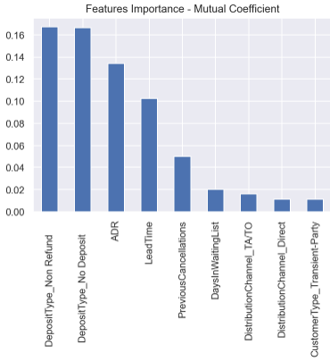

Figure 3.3 - Features importance from Mutual Information Coefficient.

We repeated the process of applying the same algorithms with the default parameters and cross validation on the train set, but now only with the top 9 features selected by mutual coefficient. The results are presented on Figure 3.4.

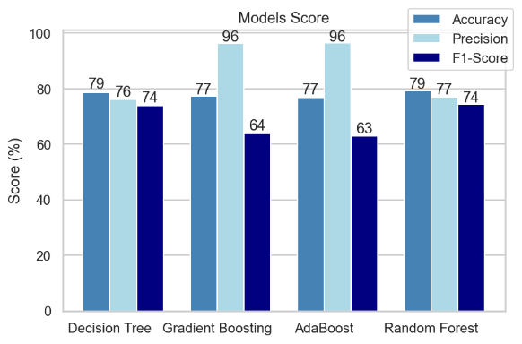

Figure 3.4 - Models score.

Analyzing the results, we chose as our final algorithm the Random Forest Classifier. Although in one hand Gradient Boosting and Adaboost presented very good scores for precision metric, on the other hand they presented low score for F1 metric, so we decided to not use them. Compared to Decision trees, Random Forest presented better accuracy and precision.

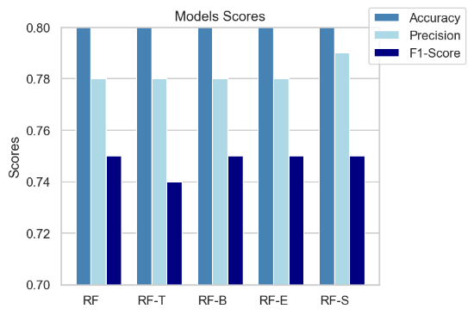The next stage was trying to improve the scores of Random Forest tunning the parameters. At this time, we applied the model in the test set. We tested 6 different types of parameters. The table with the parameters of each model and the graphic with the results are presented below:

|  |  |  |
| --- | --- | --- |
| **Model** | **Parameter changed** | **Value** |
| modelRF | random_state | 5 |
| modelRF_ent | Criterion | Entropy |
| modelRF_10trees | n_estimators | 10 |
| modelRF_b | bootstrap | False |
| modelRF_s | max_samples | 0.7 |

Table 3.5 - Tuning RF parameters and results.

The model with the best performance was the one with the parameter *max_samples = 0.7*. All models have very similar results, but the one chosen has a better precision when compared to the others.

You can see below the ROC curve and the confusion matrix for the final algorithm .

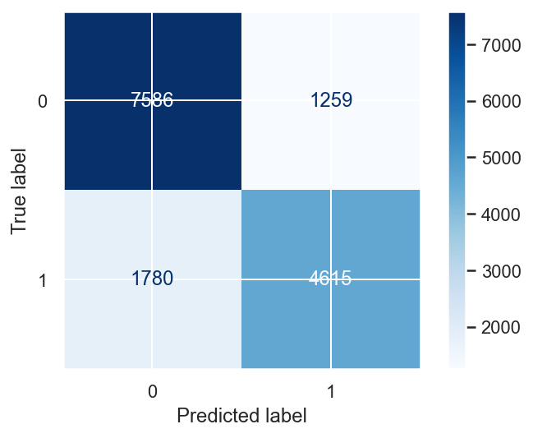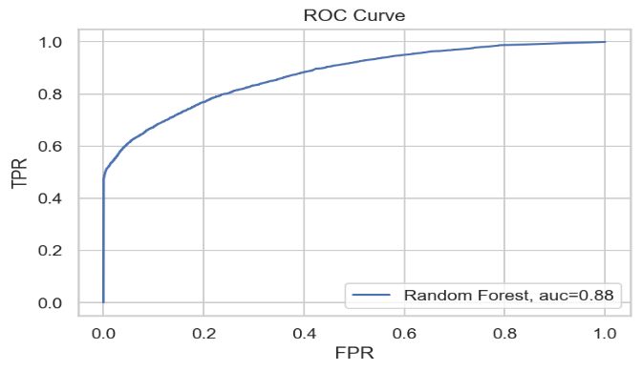

Figure 3.6 – ROC Curve and Confusion matrix to RFC.

The classification report and confusion matrix for all models with Random forest classifier can be found on the notebook.

The features that stood out as the most relevant for the model to predict the target are: *ADR*, LeadTime, *DepositType_No Deposit* and *DepositType_Non Refund*. It is important to note that these four features together weight almost 90%. The full ranking is presented in Figure 3.7.

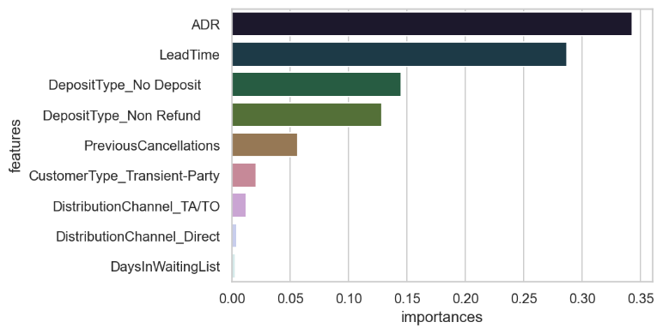

Figure 3.7 - Random Forest Classifier - Features importance.

# RESULTS EVALUATION

The model developed by B4C reached good values on many important measures which will certainly help Hotel Chain C to implement actions to prevent cancellations.

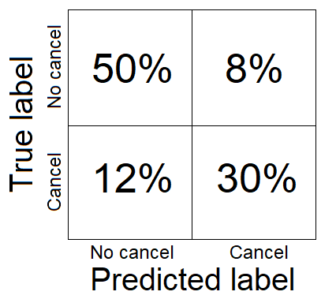Random Forest Classifier predicts cancellation/no cancellation correctly 80% of the times. However, 12% of the bookings will be cancelled but the model will wrongly predict them as not cancelled, which may cause that some rooms are not occupied, leading to loss on revenue. 8% of the bookings will wrongly be labelled as cancelled, however the customer will show up, which may lead to overbooking or extra expense costs on trying to reverse the suppose cancellation.

We could say we found a good balance between the false cancellations and false no-cancellations reducing the costs generated by this.

To conclude, because the model achieves 80% of accuracy, it will probably lead to a reduction on cancellations to a rate of 20%, which was stated as one of the business goals.

# DEPLOYMENT AND MAINTENANCE PLANS

We understand that the process of implementing the model is very critical. Hotel’s market is very dynamic and bookings are changing daily. Every day, there are new bookings on the systems, cancellations or/and changes on the reservations on-the books. So, we understand that it would be very important to implement the model integrated with the hotel reservation system. Integrating both, the results will be generated in a daily basis and the hotel could react faster to the cancellations.

Another important point is the data is that we have some problems of quality in the data. We advise to improve the quality of variables Deposit Type and country. We also find some reservations with no adult guests and believe this might be an issue on the records. Also, on the data provided we found a good percentage of very similar bookings that can reduce the performance of the model.

We are going to monitor the performance of the model after it is implemented for some months and make some adjustments if necessary.

We also suggest updating the model from time to time as the behavior of the customers, and even the market trends, can change, reducing the model performance.

Lastly, considering this model was built with only few thousands of observations, we consider that re-training the model when new data is available would potentially improve its quality.

# CONCLUSIONS

As state in the section 2.2 – Business objectives, the main objective of this project was to implement a predictive model to forecast net demand based on reservations on-the-books.

The model developed by B4C reached good values on many important measures such as 80% of accuracy and 87% of AUC. It would certainly help Hotel Chain C to implement actions to prevent cancellations.

We were also able to describe the key characteristics of bookings to help to identify high cancellation likelihood bookings.

In addition, we set some risks on this project. One of these risks is the model performance, as we have been working with almost 30% of duplicated observations. We implemented some actions to reduce this risk, but the model will have improvement margin if we get additional datasets to test its performance.

We hope Hotel Chain C is satisfied with D4B work and we can continue working together

# REFERENCES

<http://www.ijstr.org/final-print/jan2020/Two-Recommendation-System-Algorithms-Used-Svd-And-Association-Rule-On-Implicit-And-Explicit-Data-Sets.pdf>

<https://medium.com/@teddywang0202/implicit-feedback-recommendation-system-i-intro-and-datasets-eda-eda16764602a>

https://d1wqtxts1xzle7.cloudfront.net/38584474/IJETT-V4I5P132_1_.pdf?1440652038=&response-content-disposition=inline%3B+filename%3DA_Survey_of_Recommendation_System_Resear.pdf&Expires=1619217489&Signature=OWfQlatRbfn2e-ZRmtgwYuoLSF6eO1RmFuSElyl3GMKlffvZCj8gFnPg9ajHqI~NHZNy7ISKHmyPGJZrjiXZj2lLyfPHZZADLfe36M2KxZlNLtlo-JKOKcmwmPY3lVE8bP70dZwzZjIFFMnQU0O3sxGiJSJNyRFvojJt2EvSxPaC58FkZAEgfba74AkIbirMk4VKiaJkkOJ7mt5MP3Bj9jYxGzx~YLMZhzKj9ui36UKUUMT7uldAR2TpH06iT~9KiGQWDHKClF6BUCZ5vnYsdzEaly3egbarB19CNqiXMEMQWTGaLW4S0-U4Wd1z16-Nv0fN~IztdOKcFb7QJaAgQw__&Key-Pair-Id=APKAJLOHF5GGSLRBV4ZA