ClimateSense AI: A Multimodal Attention-Based Deep Learning Framework for Early Detection of Compound Climate Habitability Risk
Debshata Choudhury
Department of Computer Science and Engineering
Amity University, Noida, India
Enrollment No. A2305223104 · Course: Generative AI

Abstract—Dangerous environmental conditions rarely stem from a single variable: heat, humidity, air pollution and dryness often co-occur. This work develops ClimateSense AI, a multimodal attention-based deep learning framework that forecasts a project-defined four-class compound habitability-risk level (Low, Moderate, High, Critical) one day ahead. A harmonised panel of 160,497 site-days for 185 capital cities (2024-05-16 to 2026-10-12) was built from four public Kaggle datasets: the World Weather Repository (meteorology and air quality), World Cities (geography, population), Berkeley Earth (long-term temperature normals) and a US drought dataset (used only for an auxiliary benchmark and transfer learning). Labels combine NWS heat-index categories, WHO 2021 air-quality guideline levels and a vapour-pressure-deficit dryness proxy. The proposed Multimodal Attention Fusion Network (MAF-Net) encodes climate, air-quality and dryness sequences with separate temporal encoders and fuses them, together with static context, through masked modality attention and a gated residual (modality dropout is available as a tuned option). On a strictly held-out future period (2026-06-03 to 2026-10-12) the selected MAF-Net reached a macro-F1 of 0.741 (95% site-block bootstrap CI 0.714–0.762), accuracy 0.807, balanced accuracy 0.744 and macro ROC-AUC 0.941, versus 0.727 macro-F1 for a persistence forecast and 0.734 for gradient boosting. Attention fusion improved on concatenation fusion (0.741 vs 0.738, five-seed means), and ablations show that multimodal input clearly outperforms any single modality. Gains over persistence are small, come from detecting class transitions, and did not carry over to unseen cities. The study also documents important limitations, including the absence of observed soil-moisture, SPEI and vegetation data, an observation-hour bias in the source data, and the circularity of rule-based labels.
Keywords—Climate risk, compound events, multimodal deep learning, attention mechanism, LSTM, GRU, environmental monitoring, air pollution, drought, habitability risk

Introduction
The IPCC Sixth Assessment Report concludes that human influence has increased the frequency of hot extremes and the likelihood of compound extremes such as concurrent heatwaves and droughts [1]. Compound events can cause impacts larger than any constituent hazard alone [2], [3]. The physiological burden of heat depends on humidity, and heat–humidity combinations near proposed tolerance limits have already been observed [4], [5]. Heat frequently coincides with elevated ozone or particulate pollution, which the WHO regards as one of the largest environmental health threats [6], while precipitation deficits and high evaporative demand dry soils and vegetation [7], [9].
Heat warnings, air-quality indices and drought monitors are, however, usually produced separately and at different resolutions, so a system based on any one of them may miss days on which several moderate stresses co-occur. This project therefore asks: can a multimodal deep learning framework integrating meteorological, air-quality and drought-related indicators improve the identification of compound environmental conditions associated with reduced human habitability compared with models based on individual environmental modalities?
The contributions of this work are: (i) a reproducible harmonisation of four public datasets into a leakage-safe daily panel of 185 capital-city sites; (ii) a transparent, sensitivity-tested four-class compound-risk label built from published thresholds; (iii) MAF-Net, a branch-wise architecture with masked modality attention, gated residual fusion and modality dropout; (iv) a fair comparison against naive, classical and tuned recurrent/Transformer baselines on a future held-out period, with multi-seed statistics, ablations, horizon and spatial-transfer tests; and (v) a cross-domain transfer experiment from a US drought benchmark. Throughout, “habitability risk” denotes the degree of combined environmental stress at a place and time; it is not a determination that a location is or will become uninhabitable.

Related Work

Compound events and heat–humidity stress
Compound-event research emphasises that impacts emerge from combinations of drivers [2], [3]. Heat stress is commonly quantified with the heat index derived from Steadman's apparent temperature [20], [19] or with wet-bulb temperature [21]; recent physiological evidence places the limit of compensable heat stress well below the theoretical 35 °C wet-bulb threshold [22], [4].

Air quality and drought monitoring
WHO's 2021 guidelines substantially tightened recommended levels of PM2.5, PM10, O₃ and NO₂ [6]. Drought is typically monitored with indices such as SPEI [7] or expert products like the US Drought Monitor [8]; vegetation stress is observed with satellite indices such as MODIS NDVI/EVI [10], and vapour-pressure deficit is an established driver of plant water stress [9].

Deep learning for environmental time series and multimodal fusion
Deep learning is increasingly used in Earth-system science [11], from recurrent networks (LSTM [15], GRU [16]) to convolutional-recurrent nowcasting [18] and attention-based forecasters [14], [17]. Multimodal learning offers early, late and intermediate fusion strategies [12], [13]; attention allows a model to weight modalities adaptively, although attention weights are not necessarily faithful explanations [31]. Compound-risk classification that jointly models heat, air quality and dryness with modality-level attention appears comparatively unexplored relative to single-hazard prediction.

Problem Formulation
For site s and day t let x_{s,t} ∈ R^{F} denote the daily feature vector and c_{s} ∈ R^{K} static context. Features are partitioned into modalities m ∈ {climate, air, dryness}. Given the look-back window X_{s,t} = (x_{s,t−L+1}, …, x_{s,t}) with L = 14, the task is to predict the compound-risk class at t + h:
ŷ_{s,t+h} = argmax_{k} f_{θ}(X_{s,t}, c_{s})_{k}, k ∈ {0,1,2,3} (1)
with h = 1 as the primary horizon and h ∈ {3, 7} as secondary horizons. No observation later than day t enters the input. The label y_{s,t} is computed from the observed (never imputed) values of day t via hazard scores H (heat), A (air quality) and D (dryness), each in {0,…,3}. With S = H + A + D, m = max(H, A, D) and n₂ the number of hazards ≥ 2, the classes are defined as
y = 3 if S ≥ 6 ∨ (m = 3 ∧ n₂ ≥ 2); 2 if S ≥ 4 ∨ m = 3 ∨ n₂ ≥ 2; 1 if S ≥ 2 ∨ m ≥ 2; else 0 (2)
so that the class reflects both the number and the severity of concurrent stresses (Eq. (2)). Hypotheses: H1 — multimodal models outperform unimodal ones; H2 — attention fusion outperforms plain concatenation; H3 — learned models outperform the persistence forecast ŷ_{s,t+h} = y_{s,t}.

Dataset Description
The study is restricted to four Kaggle datasets (Table 1). The World Weather Repository [32] (version 1105; 170,733 rows, 41 columns) provides one snapshot per capital city per day with temperature, humidity, wind, pressure, precipitation, UV and six pollutants. World Cities [34] (50,250 cities) supplies coordinates, ISO codes and population; Berkeley Earth [35], [36] (8,599,212 monthly city records, 1743–2013) supplies 1961–1990 monthly normals and long-term warming; and the US drought dataset [33] (19,300,680 training rows for 3,108 counties) is used only for an auxiliary benchmark because US counties cannot be aligned with global capitals.
- Datasets used
Dataset | Records | Coverage | Use
World Weather Repository | 170,733 | 2024-05-16 – 2026-10-12 | Inputs + labels
World Cities | 50,250 | global | Geography, population
Berkeley Earth (by city) | 8,599,212 | 1743 – 2013 | Climatology context
US drought (NASA POWER + USDM) | 23,841,468 | 2000 – 2020, US | Auxiliary / transfer

After cleaning, 185 of 279 candidate sites with at least 500 observed days were retained (160,497 site-days; 1,412 unobserved calendar days on the daily grid). The proposal's SPEI, soil-moisture and NDVI sources [7], [37], [10] were not part of the permitted data; no synthetic substitutes were generated, and the drought/soil/vegetation branch is realised as an observed atmospheric dryness proxy. Two properties of the source data matter for interpretation: (i) all snapshots are taken at nearly the same UTC instant, so the local observation hour ranges from roughly 04–06 h in the Americas to about 17 h in East Asia; (ii) cross-site PM2.5 levels shift abruptly around 2024-09 and 2025-10, consistent with changes in the provider's air-quality model.
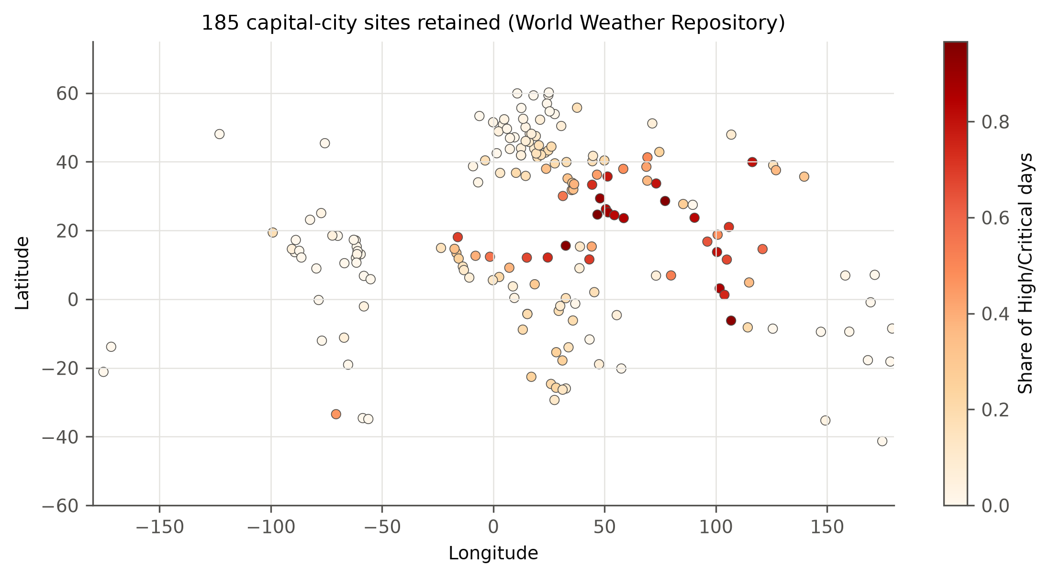
- Retained capital-city sites coloured by the share of High or Critical days.

Data Preprocessing
Cleaning. Sentinel values (−9999) and physically impossible values were set to missing; duplicate rows were removed and multiple same-day records averaged. Because the provider sometimes renames a location, a site is defined by its country and coordinates rounded to 0.1°. Spatial alignment. Sites were matched to World Cities and Berkeley Earth by haversine distance (coordinates decide; names are only a check): 182 of 185 sites matched World Cities within 50 km (median 1.3 km) and 156 matched a Berkeley series within 150 km.
Feature engineering. From temperature T and relative humidity RH the NWS heat index [19], [20], Stull wet-bulb temperature [21], dew point and vapour-pressure deficit were derived:
VPD = 0.6108·exp(17.27T/(T+237.3))·(1 − RH/100) [kPa] (3)
Further features are log-transformed pollutant concentrations, the provider's US-EPA and GB-DEFRA indices, past-only 7- and 30-day precipitation sums and wet-day fractions, days since recorded precipitation, the temperature anomaly relative to the Berkeley normal, the local observation hour, seasonal harmonics and eight static context features (Table 2).
- Model inputs by branch
Branch | # | Features
A Climate | 17 | T, feels-like, RH, dew point, heat index, wet-bulb, wind, gust, pressure, cloud, visibility, UV, T anomaly, obs. hour, sin/cos day-of-year, heat score
B Air quality | 9 | log CO, O3, NO2, SO2, PM2.5, PM10; US-EPA, GB-DEFRA index; air score
C Dryness proxy | 9 | VPD, log precip., wet flag, 7/30-d precip. sums and wet fractions, days since wet, dryness score
D Context | 8 | lat, |lat|, sin/cos lon, log10 population, Berkeley annual normal, seasonal amplitude, 2000–12 warming

Missing data and leakage control. Inputs are forward-filled for at most three days (past information only); remaining gaps are imputed with the training mean after standardisation and flagged by per-modality missingness indicators, and labels are never imputed. Standardisation statistics are fitted on training rows only. The calendar is split chronologically and identically for all sites into training (2024-05-16 to 2026-01-21), validation (2026-01-22 to 2026-06-02) and test (2026-06-03 to 2026-10-12). A sample is admitted only if its first input day and its target day lie in the same split, which embargoes L + h days at each boundary. Class imbalance is handled with class-weighted or focal loss; no oversampling is used.
Label validity. The class distribution over all labelled site-days is Low 52.4%, Moderate 25.8%, High 12.1%, Critical 9.8%. Perturbing heat-index bands by ±1 °C or VPD bands by 25% changes few labels (weighted κ ≥ 0.96), whereas removing the air or dryness hazard changes them substantially (κ = 0.79 and 0.77). Today's class equals tomorrow's on 75.6% of consecutive days, which makes persistence a demanding baseline. The highest High/Critical shares occur in Riyadh, New Delhi, Khartoum, Jakarta and Kuwait City, which is regionally plausible.

Proposed Methodology
MAF-Net (Fig. 2) follows the branch-wise design of the problem statement. Each sequence modality m is encoded by its own temporal encoder E_{m} (GRU, LSTM or Transformer for climate; GRU for air quality and dryness) and static context by an MLP. Representations are projected into a common d-dimensional space and tagged with a learned modality embedding e_{m}:
z_{m} = LayerNorm(W_{m} E_{m}(X^{(m)})) + e_{m} (4)
Modality tokens Z optionally interact through one masked self-attention layer and are then pooled by a learned query q with multi-head cross-attention [14]; a modality missing for the whole window is removed via the key-padding mask 𝓜 rather than replaced by fictitious values:
α = softmax(qW_{Q}(ZW_{K})^{T}/√d + 𝓜), f = αZW_{V}W_{O} (5)
A gated residual combines the attended vector with the masked mean token z̄, and an MLP head outputs class probabilities:
g = σ(W_{g}[f; z̄]), u = g⊙f + (1−g)⊙z̄, p = softmax(MLP(u)) (6)
Two enhancements over plain concatenation fusion are introduced: modality-masked attention and modality dropout, which masks whole modalities with probability p_{md} during training so that the network neither over-relies on one branch nor fails when a modality is absent (p_{md} was a tuned hyper-parameter; the selected configuration uses p_{md} = 0.0, and its effect is examined in the ablation study). Training minimises class-weighted cross-entropy or focal loss [23] with AdamW [24].

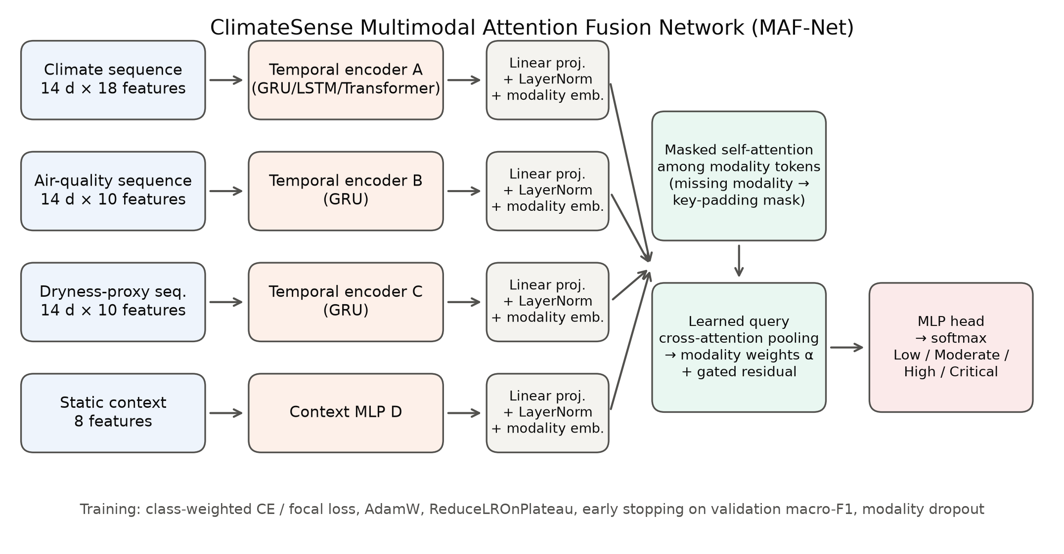
- Architecture of the ClimateSense Multimodal Attention Fusion Network (MAF-Net).

Experimental Setup
Hardware and software. Experiments ran on an Quadro P3200 GPU (6 GB, compute capability 6.1), 12 logical CPUs and 16 GB RAM with Python 3.13.7, PyTorch 2.14.1+cu126 [29], scikit-learn 1.9.1 [28] and Optuna 5.0.0 [25]. Mixed precision was not used because the Pascal GPU has low FP16 throughput.
Baselines. Naive: persistence, majority class and site-month climatology. Classical models on 242 aggregated window features (last, mean, max, min, s.d., trend per feature + context): logistic regression, random forest [26], histogram gradient boosting [27] and an MLP. Sequence models on all features jointly: vanilla RNN, LSTM [15], GRU [16] and a Transformer encoder [14]. The concatenation-fusion variant of MAF-Net isolates the effect of attention.
Tuning and selection. Optuna's TPE sampler with median pruning maximised validation macro-F1 (24 trials for MAF-Net, 10 each for GRU and Transformer; 46 completed and 0 pruned in total; 20 epochs, patience 5). Selected configurations were retrained for up to 40 epochs (patience 6, ReduceLROnPlateau, gradient clipping 1.0) with five seeds (MAF-Net, concat variant, GRU) or three (Transformer, LSTM, RNN). The reported MAF-Net checkpoint is the seed with the highest validation macro-F1; the test split was evaluated once, after all choices were frozen. Table 3 lists the selected MAF-Net hyper-parameters.
- Selected MAF-Net hyper-parameters
Parameter | Value
Look-back / horizon | 14 d / 1 d
Climate encoder | TRANSFORMER, 1 layer(s), hidden 32
Air / dryness encoders | GRU, hidden 16
Token dimension d / heads | 32 / 2
Token self-attention | yes
Dropout / modality dropout | 0.3 / 0.0
Loss | focal (γ = 2)
Optimiser, LR, weight decay | AdamW, 0.001, 0
Batch size / best epoch | 256 / 10
Trainable parameters | 33,268

Metrics. Accuracy, balanced accuracy, macro precision/recall/F1, weighted F1, one-vs-rest macro ROC-AUC and PR-AUC, log-loss, Brier score and quadratic-weighted κ. Macro-F1 is the primary metric because High and Critical are minority classes. Confidence intervals use 1 000 site-block bootstrap resamples; model differences are assessed with paired bootstrap on identical test samples.

Results and Analysis
Table 4 compares all models on the held-out test period (horizon one day). The selected MAF-Net achieved macro-F1 0.741 (95% CI 0.714–0.762), accuracy 0.807, balanced accuracy 0.744, weighted F1 0.808, macro ROC-AUC 0.941 and macro PR-AUC 0.787. Across five seeds MAF-Net obtained 0.741 ± 0.003 test macro-F1, ranking 1 of 13 models; the strongest other model was Transformer encoder (tuned) (0.740).
- Held-out test performance (h = 1; mean ± s.d. over seeds where trained with several seeds)
Model | Params | Val F1 | Acc. | Bal. acc. | Macro-F1 | W-F1 | ROC-AUC | Time (s)
MAF-Net (proposed) | 33,268 | 0.742 | 0.806 | 0.747 | 0.741 ± 0.003 | 0.807 | 0.941 | 327
Transformer encoder (tuned) | 21,860 | 0.744 | 0.810 | 0.738 | 0.740 ± 0.002 | 0.808 | 0.946 | 239
Random forest | 4,016,074 | 0.740 | 0.806 | 0.739 | 0.740 | 0.808 | 0.945 | 63
GRU (tuned) | 49,860 | 0.741 | 0.798 | 0.754 | 0.739 ± 0.003 | 0.804 | 0.944 | 79
MAF-Net w/o attention (concat fusion) | 21,652 | 0.741 | 0.801 | 0.747 | 0.738 ± 0.004 | 0.804 | 0.939 | 171
Vanilla RNN | 11,588 | 0.740 | 0.798 | 0.752 | 0.736 ± 0.004 | 0.803 | 0.942 | 34
Gradient boosting (HistGB) | 30,500 | 0.740 | 0.802 | 0.744 | 0.734 | 0.805 | 0.944 | 117
LSTM | 64,836 | 0.739 | 0.793 | 0.750 | 0.732 ± 0.010 | 0.799 | 0.942 | 105
Logistic regression | 948 | 0.729 | 0.801 | 0.727 | 0.730 | 0.803 | 0.938 | 34
Persistence (today's class) | — | — | 0.798 | 0.727 | 0.727 | 0.798 | 0.822 | 0
MLP (sklearn) | 94,084 | 0.718 | 0.792 | 0.685 | 0.700 | 0.784 | 0.936 | 54
Site-month climatology | — | — | 0.614 | 0.586 | 0.519 | 0.637 | 0.727 | 0
Majority class | — | — | 0.614 | 0.250 | 0.190 | 0.468 | 0.500 | 0

- Parameters of tree ensembles are counted as tree nodes; training time is measured wall-clock time per run.
Against persistence, MAF-Net improved macro-F1 by 0.015 (paired bootstrap 95% CI 0.007 to 0.022), confirming H3. Relative to gradient boosting the difference was +0.008 (CI 0.001 to 0.015), relative to the tuned GRU +0.003 (CI -0.004 to 0.009) and relative to the concatenation-fusion variant +0.005 (CI -0.001 to 0.011). The paired intervals include zero for the random forest, the tuned GRU, the concatenation-fusion variant, the tuned Transformer, so MAF-Net is statistically indistinguishable from these models on this test period. MAF-Net is better than persistence, gradient boosting (intervals above zero), although the margins are small.
Per class (Fig. 3), recall was 0.90 for Low, 0.62 for Moderate, 0.68 for High and 0.78 for Critical, with precision 0.91, 0.62, 0.59 and 0.85. Errors are concentrated between adjacent classes (quadratic-weighted κ = 0.874; mean absolute ordinal error 0.201).
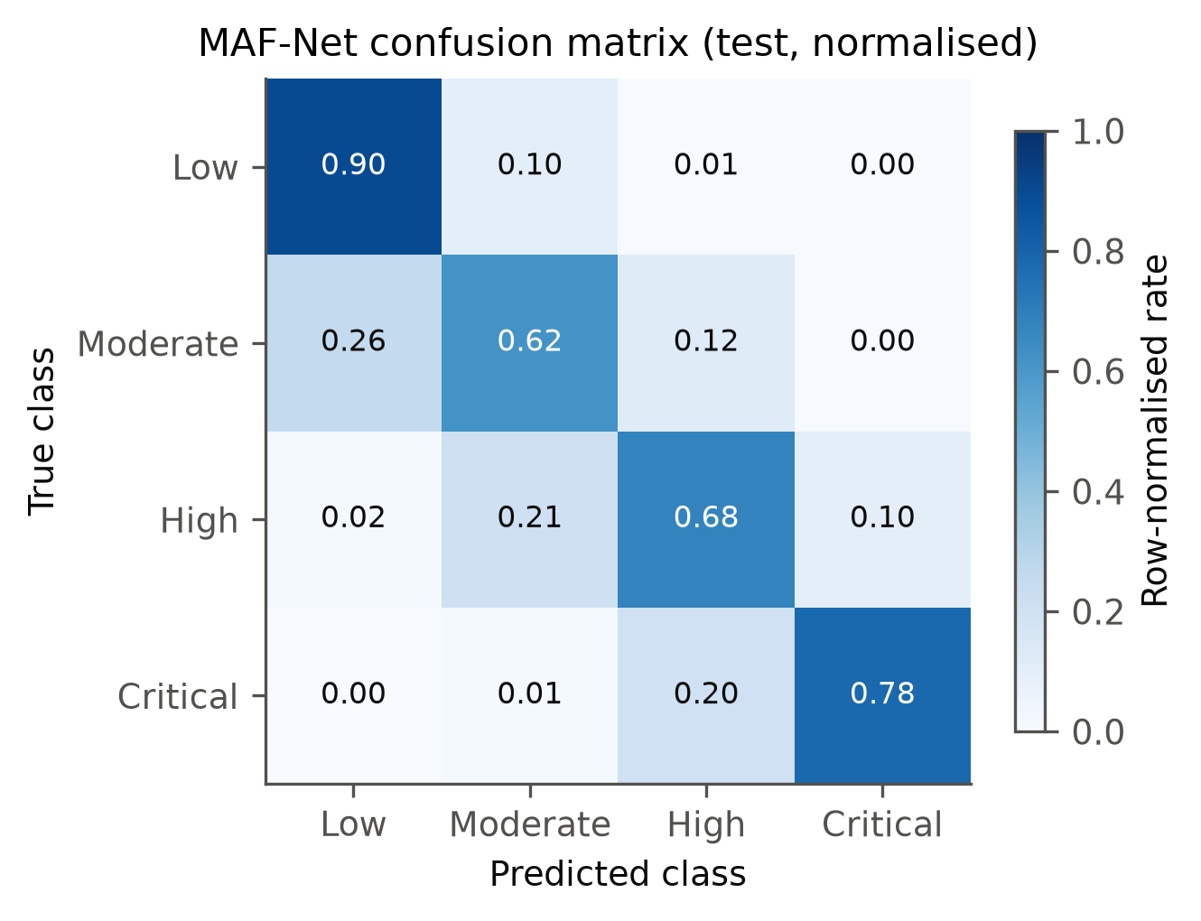
- Row-normalised confusion matrix of the selected MAF-Net on the held-out test period.

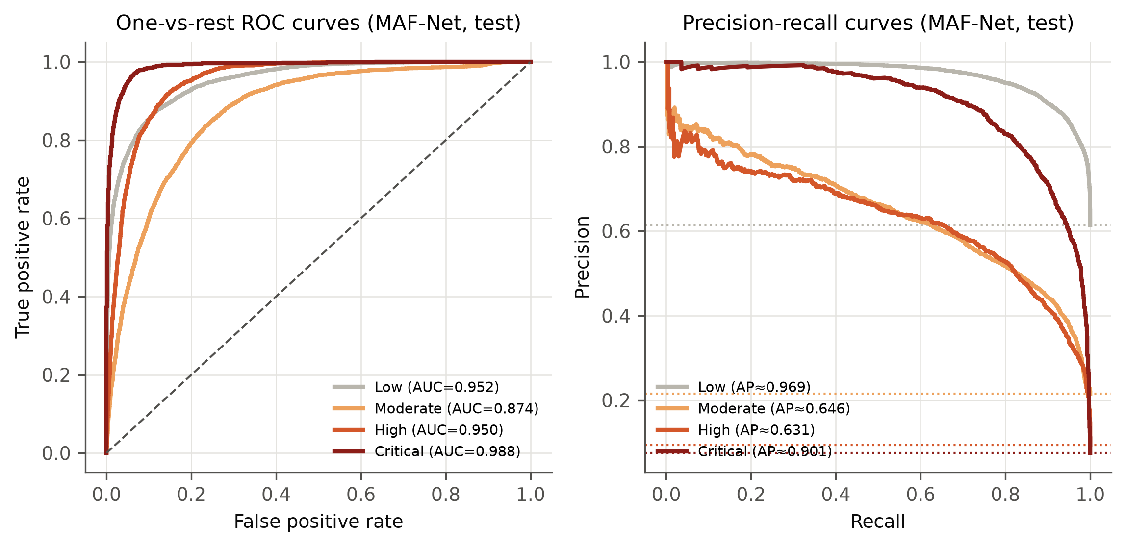
- One-vs-rest ROC (left) and precision–recall (right) curves of the selected MAF-Net on the test period; dotted lines mark class prevalence.

Training dynamics are shown in Fig. 5: validation macro-F1 peaked at epoch 10 and the plateau scheduler reduced the learning rate afterwards. The validation loss is lower than the training loss because the validation period (January–June) contains a larger share of the easier Low class than the training period; validation macro-F1 fluctuates between epochs, which is why early stopping on this metric is used. Fig. 6 summarises the comparison.

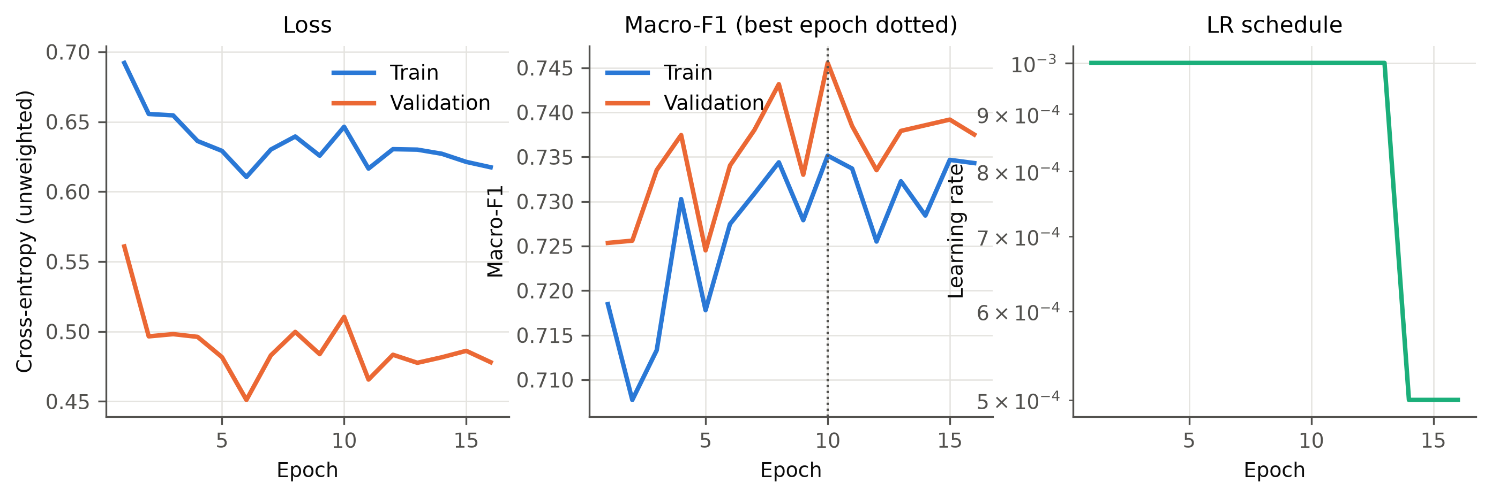
- Training and validation loss, macro-F1 and learning rate of the selected MAF-Net run.

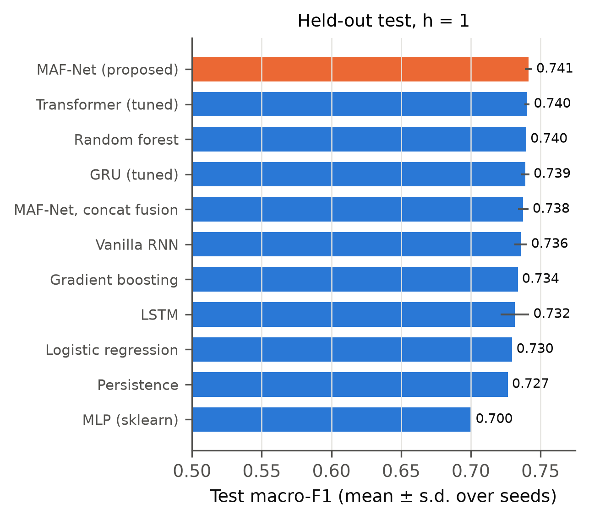
- Test macro-F1 (mean ± s.d. over seeds) of all models (h = 1); site-month climatology and majority class omitted.
Forecast horizon. Skill decays with lead time (Fig. 7): MAF-Net macro-F1 is 0.743 at h = 1, 0.688 at h = 3, 0.666 at h = 7, versus 0.727, 0.655, 0.630 for persistence. The advantage over persistence grows with horizon (+0.035 at seven days).
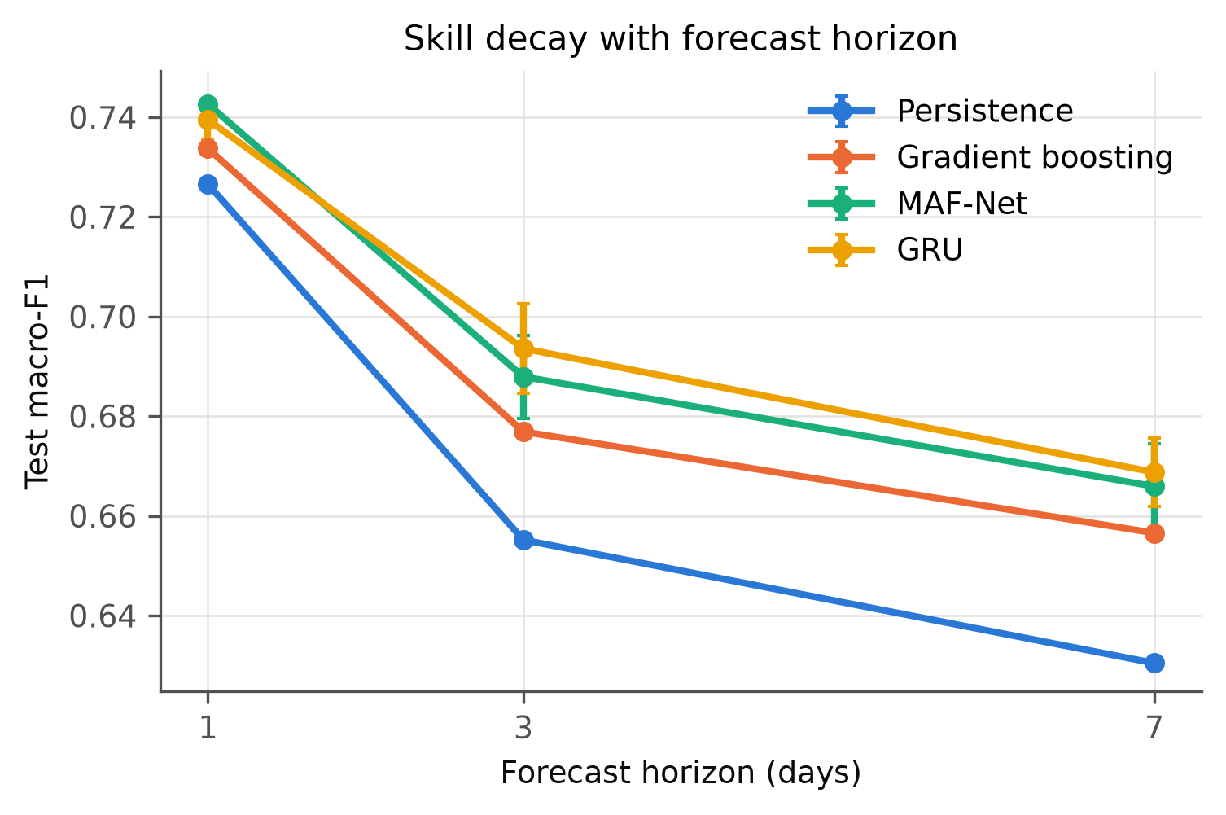
- Test macro-F1 as a function of forecast horizon.

Spatial and temporal robustness
Spatial generalisation. Retraining on 80% of sites and testing on the remaining 20% (unseen cities, test period; three seeds) gave macro-F1 0.706 ± 0.006 for MAF-Net, 0.709 ± 0.003 for the GRU and 0.713 for persistence on the held-out sites, compared with 0.739 for MAF-Net on the training sites (Fig. 8). On unseen cities neither learned model beat persistence, i.e. the learned skill over persistence did not transfer to new locations in this experiment.
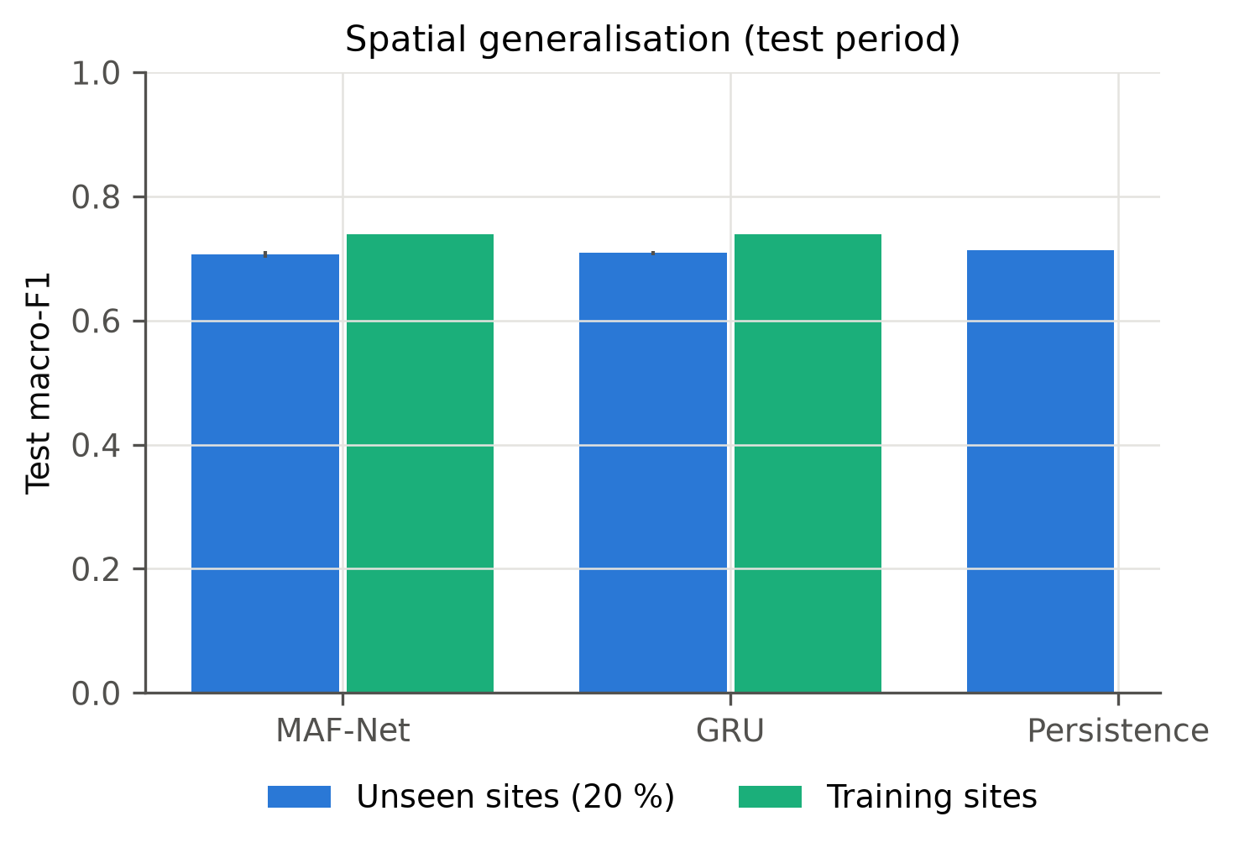
- Macro-F1 on unseen (held-out) sites and on training sites during the test period.
Look-back length. Validation macro-F1 was 0.741 (L = 7), 0.743 (L = 14), 0.739 (L = 30); longer history did not help, and the 14-day window is the best of the three.
Observation-hour bias. The local hour of the snapshot correlates with the label (Spearman ρ = 0.35; with the heat score 0.33). Test macro-F1 of MAF-Net ranged from 0.43 to 0.76 across longitude bands, being highest where High/Critical days are common (western/southern and eastern Asia) and lowest in the Americas and Europe/Africa, where few High/Critical days occur at the sampled local hours (Fig. 9). Per-band results should therefore not be read as regional differences in true risk.
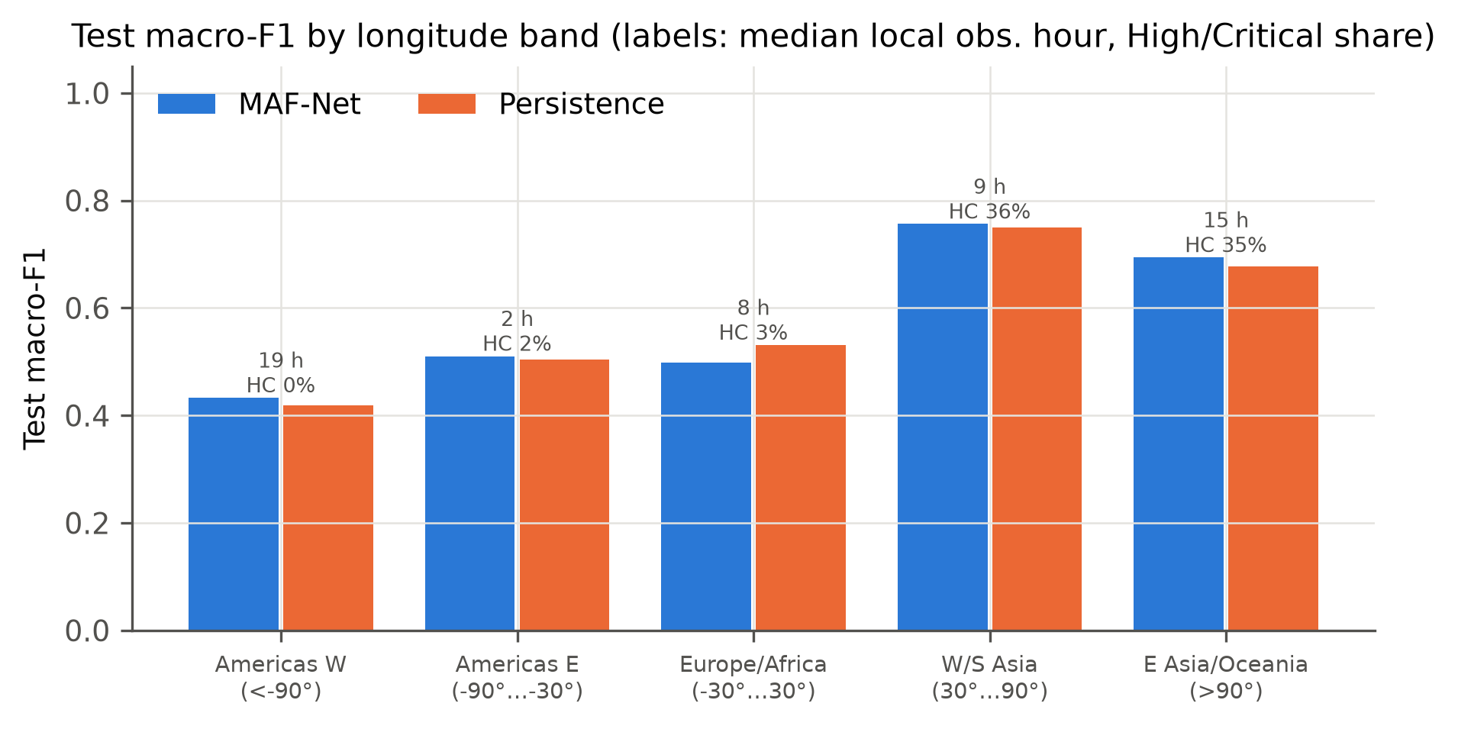
- Test macro-F1 by longitude band; annotations give the median local observation hour and the share of High/Critical days.
Air-quality non-stationarity. The cross-site median PM2.5 differs between the three provider regimes (5.1 µg/m³, 18.5 µg/m³, 11.1 µg/m³; Kolmogorov–Smirnov D = 0.47 and 0.24 between consecutive regimes). Training spans all three regimes, whereas validation and test lie entirely in the last one, so part of the air-quality signal learned in training is shifted at evaluation time; monthly macro-F1 over validation and test is reported in the repository.
Persistence and early warning. On the test period the class is unchanged from the previous day for 79.4% of samples. On these stable days MAF-Net is correct for 93.7% (persistence 100% by construction). On the 4,274 transition days it is correct for 29.3% (gradient boosting 26.6%, persistence 0%), and it anticipates 34.7% of the 606 onsets of High/Critical conditions (gradient boosting 35.1%), at the cost of a false High/Critical alarm on 1.4% of days that stay Low/Moderate. Most of the headline accuracy therefore reflects the persistence of the project-defined classes; the genuine early-warning skill lies in this modest but non-zero detection of transitions.
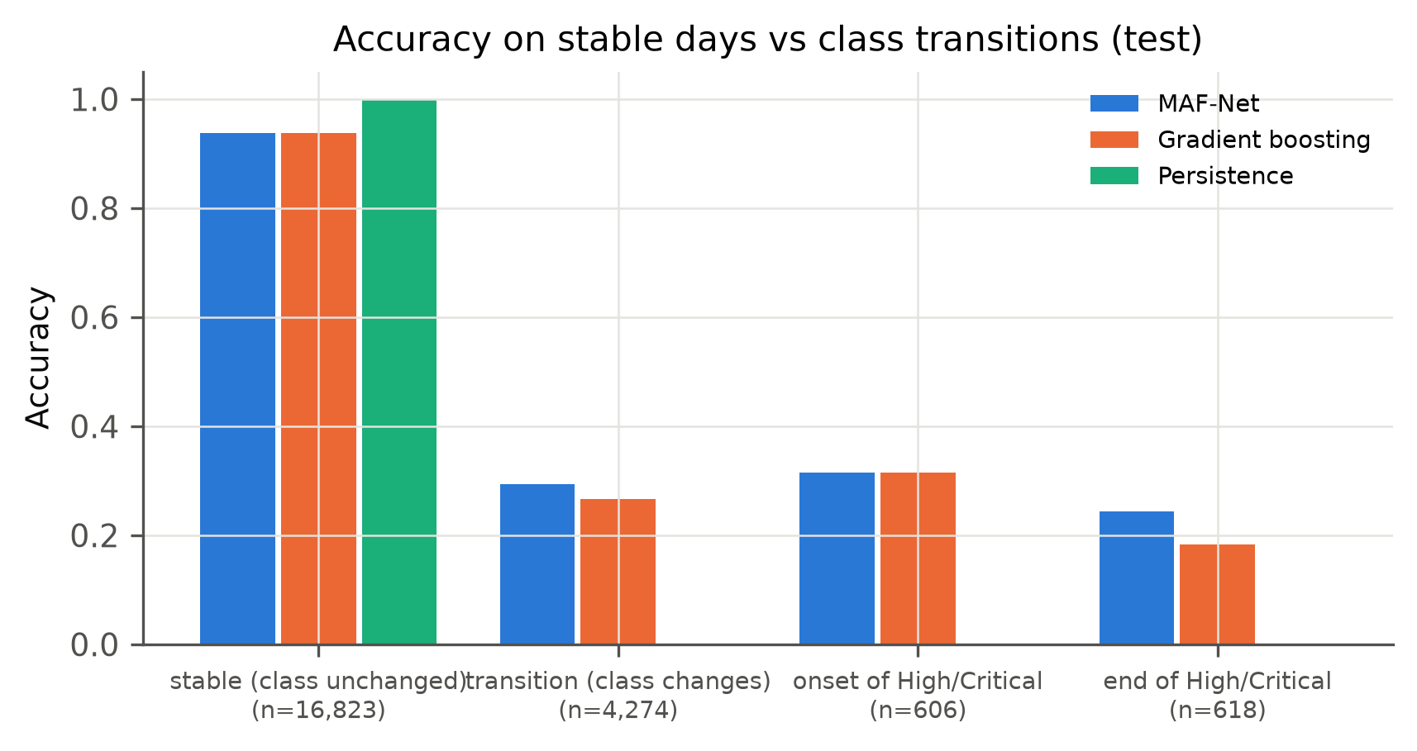
- Accuracy on stable days, class transitions and High/Critical onsets/ends (test).

Ablation Study
Table 5 reports ablations of the selected configuration (three seeds each). Unimodal variants were clearly weaker (climate-only 0.629, air-only 0.520, dryness-only 0.553) than the full model (0.743), supporting H1. Removing air quality lowered test macro-F1 to 0.655 and removing the dryness branch to 0.723; removing all humidity-derived features gave 0.707. Replacing attention by concatenation gave 0.740, so attention provided no measurable benefit over concatenation (H2 not supported). Adding modality dropout (p = 0.1) gave 0.738, removing static context 0.735, and adding the transferred drought features 0.740.
- Ablation study (mean ± s.d., three seeds; C climate, A air, D dryness, ctx context)
Variant | Inputs | Val macro-F1 | Test macro-F1 | Bal. acc. | ROC-AUC
All, attention (full) | C+A+D+ctx | 0.743 ± 0.002 | 0.743 ± 0.001 | 0.748 | 0.941
Full + transferred drought features | C+A+D+ctx+TL | 0.741 ± 0.003 | 0.740 ± 0.004 | 0.743 | 0.940
All, concat (no attention) | C+A+D+ctx | 0.740 ± 0.002 | 0.740 ± 0.003 | 0.748 | 0.939
Full + modality dropout 0.1 | C+A+D+ctx | 0.738 ± 0.002 | 0.738 ± 0.003 | 0.743 | 0.940
All, attention, no context | C+A+D | 0.739 ± 0.001 | 0.735 ± 0.006 | 0.746 | 0.939
Climate + air (= full − dryness) | C+A+ctx | 0.730 ± 0.002 | 0.723 ± 0.002 | 0.728 | 0.931
Full − humidity features | C+A+D+ctx −humidity | 0.731 ± 0.001 | 0.707 ± 0.016 | 0.725 | 0.928
Climate + dryness (= full − air) | C+D+ctx | 0.689 ± 0.016 | 0.655 ± 0.034 | 0.679 | 0.905
Climate only | C | 0.638 ± 0.009 | 0.629 ± 0.006 | 0.635 | 0.876
Dryness proxy only | D | 0.613 ± 0.003 | 0.553 ± 0.002 | 0.590 | 0.825
Air quality only | A | 0.504 ± 0.014 | 0.520 ± 0.015 | 0.544 | 0.825

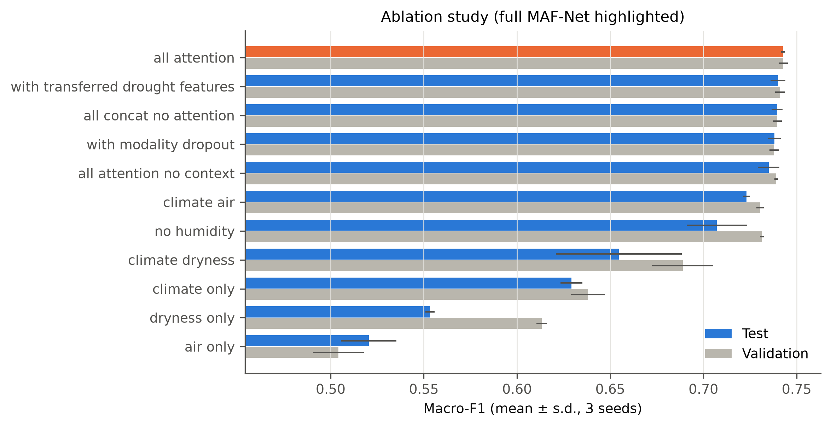
- Ablation results on validation and test (three seeds).
Auxiliary drought benchmark and transfer. On 400 US counties, a two-layer GRU predicting the US Drought Monitor class from 30 days of weather reached test macro-F1 0.348 (majority 0.213), confirming that drought is only weakly predictable from a month of weather. Applied to the capital-city sites, the encoder labelled 50% of site-days as D2 or worse, a sign of domain shift (snapshot versus daily-total precipitation, US versus global climates); its features did not improve MAF-Net.

Discussion
Explainability. Permuting whole modality groups on 8 000 test windows reduced macro-F1 by 0.396 (Humidity-derived), 0.238 (Dryness proxy (all)), 0.200 (Climate (all)), 0.148 (Air quality (all)), 0.007 (Static context). The most important single features were dry_score, heat_score, air_score, vpd_kpa (Fig. 12). Mean attention weights per predicted class are reported in the repository; they describe how the fusion module weighted modality tokens but, as argued in [31], are not causal explanations, and integrated gradients [30] were used as a complementary attribution.
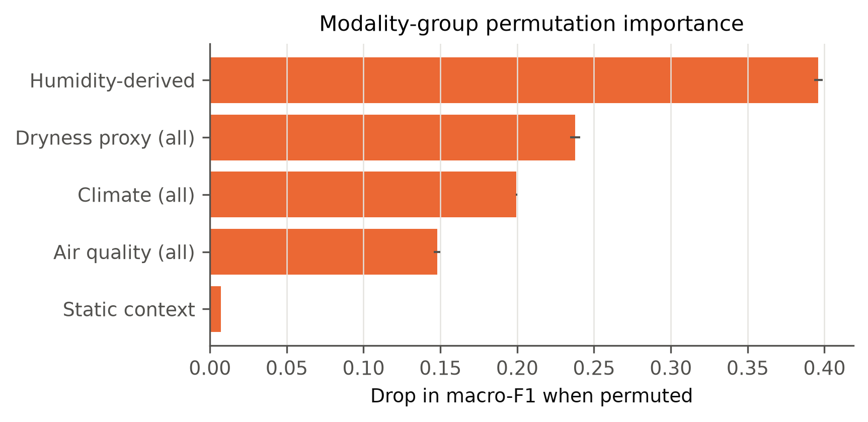
- Drop in test macro-F1 when a modality group is permuted (selected MAF-Net).
Case studies. For Jakarta (Indonesia) on 2026-09-28 the model predicted Critical (P = 0.76) and the observed class was Critical; on the preceding day the heat index was 36.1 °C, PM2.5 53.4 µg/m³ and VPD 2.79 kPa. A failure case is Dhaka on 2026-10-02: predicted High but observed Critical, illustrating that day-to-day changes in pollution or humidity are hard to anticipate from the preceding fortnight.
Strengths and weaknesses. The multimodal models are consistently better than any single modality and, on the training sites, slightly better than persistence; High/Critical days are detected with ROC-AUC above 0.95. Most residual errors are between adjacent classes, and the Moderate and High classes are hardest because they are defined by thresholds that the next day's weather crosses frequently. Because labels persist strongly from day to day, most of the attainable accuracy is already captured by persistence and simple aggregated-feature models; gains from more elaborate fusion are therefore small. The validation period (January–June) and test period (June–October) differ in season and in the provider's air-quality regime, which partly explains differences between validation and test scores.
Label validity. The classes are a deterministic, transparent combination of published thresholds; they are robust to small threshold changes but have not been validated against health or disaster outcomes. The observation-hour bias means heat stress is under-represented for the Americas and over-represented for East Asia, so geographic comparisons of predicted risk must be made with caution.

Limitations and Future Work
- Limited temporal history (about 2.4 years) and a single four-month test period; rolling-origin evaluation across years was not possible.
- Capital-city sampling bias and a single daily snapshot taken at a longitude-dependent local hour.
- No observed SPEI, soil moisture or vegetation index for the capital cities; the dryness branch is a proxy and soil/vegetation ablations were not evaluated.
- The US drought dataset is geographically mismatched; its transferred representation suffers from domain shift.
- Air-quality values are provider estimates with apparent regime shifts; WHO comparisons are approximate.
- Project-defined labels with risk of circular validation; no external validation (e.g., EM-DAT).
- Generalisation beyond the sampled cities was tested with only one held-out-site split.
Future work should add observed NASA POWER soil wetness [37], SPEIbase [7] and MODIS NDVI/EVI [10] through the existing dryness branch, use hourly or daily-maximum observations to remove the observation-hour bias, validate classes against EM-DAT events [38] and health records, and extend the evaluation to several years and climate-zone-stratified spatial splits.

Conclusion
ClimateSense AI provides a reproducible, leakage-safe pipeline and a multimodal attention-fusion network for one-day-ahead forecasting of a transparent four-class compound environmental-risk label for 185 capital cities. On genuinely unseen future data the proposed MAF-Net reached macro-F1 0.741 and macro ROC-AUC 0.941, improving on persistence by 0.015 macro-F1 on the sampled cities (but not on unseen cities) and clearly outperforming unimodal variants, which supports the central hypothesis that integrating heat, air-quality and dryness signals improves compound-risk identification. Attention-based fusion, however, was not clearly superior to concatenation or to strong single-stream and gradient-boosting baselines, and the absence of observed soil, drought-index and vegetation data limits the scope of the conclusions. The results should be read as a screening tool for a project-defined stress index, not as a measure of human habitability.

Acknowledgment
The author thanks Prof. M. K. Dutta, Amity Centre for Artificial Intelligence, for guidance, and the providers of the public datasets used in this study. Code, notebooks and results: https://github.com/Debshata/ClimateSenseAI.

References
- IPCC, “Summary for policymakers,” in Climate Change 2021: The Physical Science Basis. Contribution of Working Group I to the Sixth Assessment Report of the Intergovernmental Panel on Climate Change. Cambridge, U.K.: Cambridge Univ. Press, 2021, pp. 3–32, doi: 10.1017/9781009157896.001.
- J. Zscheischler et al., “Future climate risk from compound events,” Nature Climate Change, vol. 8, no. 6, pp. 469–477, 2018, doi: 10.1038/s41558-018-0156-3.
- M. Leonard et al., “A compound event framework for understanding extreme impacts,” WIREs Climate Change, vol. 5, no. 1, pp. 113–128, 2014, doi: 10.1002/wcc.252.
- C. Raymond, T. Matthews, and R. M. Horton, “The emergence of heat and humidity too severe for human tolerance,” Science Advances, vol. 6, no. 19, Art. no. eaaw1838, 2020, doi: 10.1126/sciadv.aaw1838.
- C. Mora et al., “Global risk of deadly heat,” Nature Climate Change, vol. 7, no. 7, pp. 501–506, 2017, doi: 10.1038/nclimate3322.
- World Health Organization, WHO Global Air Quality Guidelines: Particulate Matter (PM2.5 and PM10), Ozone, Nitrogen Dioxide, Sulfur Dioxide and Carbon Monoxide. Geneva, Switzerland: WHO, 2021.
- S. M. Vicente-Serrano, S. Beguería, and J. I. López-Moreno, “A multiscalar drought index sensitive to global warming: The standardized precipitation evapotranspiration index,” Journal of Climate, vol. 23, no. 7, pp. 1696–1718, 2010, doi: 10.1175/2009JCLI2909.1.
- M. Svoboda et al., “The Drought Monitor,” Bulletin of the American Meteorological Society, vol. 83, no. 8, pp. 1181–1190, 2002, doi: 10.1175/1520-0477-83.8.1181.
- C. Grossiord et al., “Plant responses to rising vapor pressure deficit,” New Phytologist, vol. 226, no. 6, pp. 1550–1566, 2020, doi: 10.1111/nph.16485.
- K. Didan, “MODIS/Terra Vegetation Indices Monthly L3 Global 1km SIN Grid V061 (MOD13A3),” NASA EOSDIS Land Processes DAAC, 2021, doi: 10.5067/MODIS/MOD13A3.061.
- M. Reichstein et al., “Deep learning and process understanding for data-driven Earth system science,” Nature, vol. 566, pp. 195–204, 2019, doi: 10.1038/s41586-019-0912-1.
- T. Baltrušaitis, C. Ahuja, and L.-P. Morency, “Multimodal machine learning: A survey and taxonomy,” IEEE Transactions on Pattern Analysis and Machine Intelligence, vol. 41, no. 2, pp. 423–443, 2019, doi: 10.1109/TPAMI.2018.2798607.
- D. Ramachandram and G. W. Taylor, “Deep multimodal learning: A survey on recent advances and trends,” IEEE Signal Processing Magazine, vol. 34, no. 6, pp. 96–108, 2017, doi: 10.1109/MSP.2017.2738401.
- A. Vaswani et al., “Attention is all you need,” in Advances in Neural Information Processing Systems, vol. 30, 2017, pp. 5998–6008.
- S. Hochreiter and J. Schmidhuber, “Long short-term memory,” Neural Computation, vol. 9, no. 8, pp. 1735–1780, 1997, doi: 10.1162/neco.1997.9.8.1735.
- K. Cho et al., “Learning phrase representations using RNN encoder–decoder for statistical machine translation,” in Proc. EMNLP, 2014, pp. 1724–1734, doi: 10.3115/v1/D14-1179.
- B. Lim, S. Ö. Arık, N. Loeff, and T. Pfister, “Temporal fusion transformers for interpretable multi-horizon time series forecasting,” International Journal of Forecasting, vol. 37, no. 4, pp. 1748–1764, 2021, doi: 10.1016/j.ijforecast.2021.03.012.
- X. Shi et al., “Convolutional LSTM network: A machine learning approach for precipitation nowcasting,” in Advances in Neural Information Processing Systems, vol. 28, 2015, pp. 802–810.
- L. P. Rothfusz, “The heat index ‘equation’ (or, more than you ever wanted to know about heat index),” NWS Southern Region Headquarters, Fort Worth, TX, Tech. Attachment SR 90-23, 1990.
- R. G. Steadman, “The assessment of sultriness. Part I: A temperature-humidity index based on human physiology and clothing science,” Journal of Applied Meteorology, vol. 18, no. 7, pp. 861–873, 1979, doi: 10.1175/1520-0450(1979)018<0861:TAOSPI>2.0.CO;2.
- R. Stull, “Wet-bulb temperature from relative humidity and air temperature,” Journal of Applied Meteorology and Climatology, vol. 50, no. 11, pp. 2267–2269, 2011, doi: 10.1175/JAMC-D-11-0143.1.
- D. J. Vecellio, S. T. Wolf, R. M. Cottle, and W. L. Kenney, “Evaluating the 35°C wet-bulb temperature adaptability threshold for young, healthy subjects (PSU HEAT Project),” Journal of Applied Physiology, vol. 132, no. 2, pp. 340–345, 2022, doi: 10.1152/japplphysiol.00738.2021.
- T.-Y. Lin, P. Goyal, R. Girshick, K. He, and P. Dollár, “Focal loss for dense object detection,” in Proc. IEEE ICCV, 2017, pp. 2980–2988, doi: 10.1109/ICCV.2017.324.
- I. Loshchilov and F. Hutter, “Decoupled weight decay regularization,” in Proc. ICLR, 2019.
- T. Akiba, S. Sano, T. Yanase, T. Ohta, and M. Koyama, “Optuna: A next-generation hyperparameter optimization framework,” in Proc. ACM SIGKDD, 2019, pp. 2623–2631, doi: 10.1145/3292500.3330701.
- L. Breiman, “Random forests,” Machine Learning, vol. 45, no. 1, pp. 5–32, 2001, doi: 10.1023/A:1010933404324.
- J. H. Friedman, “Greedy function approximation: A gradient boosting machine,” The Annals of Statistics, vol. 29, no. 5, pp. 1189–1232, 2001, doi: 10.1214/aos/1013203451.
- F. Pedregosa et al., “Scikit-learn: Machine learning in Python,” Journal of Machine Learning Research, vol. 12, pp. 2825–2830, 2011.
- A. Paszke et al., “PyTorch: An imperative style, high-performance deep learning library,” in Advances in Neural Information Processing Systems, vol. 32, 2019, pp. 8024–8035.
- M. Sundararajan, A. Taly, and Q. Yan, “Axiomatic attribution for deep networks,” in Proc. ICML, PMLR vol. 70, 2017, pp. 3319–3328.
- S. Jain and B. C. Wallace, “Attention is not explanation,” in Proc. NAACL-HLT, 2019, pp. 3543–3556, doi: 10.18653/v1/N19-1357.
- N. Elgiriyewithana, “World Weather Repository (Daily Updating),” Kaggle, 2023. [Online]. Available: https://www.kaggle.com/datasets/nelgiriyewithana/global-weather-repository (version 1105 used).
- cdminix, “Predict droughts using weather & soil data,” Kaggle, 2021 (sources: NASA POWER, U.S. Drought Monitor, Harmonized World Soil Database). [Online]. Available: https://www.kaggle.com/datasets/cdminix/us-drought-meteorological-data
- SimpleMaps, “World Cities Database,” Kaggle mirror by J. Martínez. [Online]. Available: https://www.kaggle.com/datasets/juanmah/world-cities
- Berkeley Earth, “Climate change: Earth surface temperature data,” Kaggle. [Online]. Available: https://www.kaggle.com/datasets/berkeleyearth/climate-change-earth-surface-temperature-data
- R. Rohde et al., “A new estimate of the average Earth surface land temperature spanning 1753 to 2011,” Geoinformatics & Geostatistics: An Overview, vol. 1, no. 1, 2013, doi: 10.4172/2327-4581.1000101.
- NASA Langley Research Center, “POWER: Prediction Of Worldwide Energy Resources — Data Access.” [Online]. Available: https://power.larc.nasa.gov/
- Centre for Research on the Epidemiology of Disasters (CRED), UCLouvain, “EM-DAT: The International Disaster Database.” [Online]. Available: https://www.emdat.be

