QUANTUM-SECURE FRAUD DETECTION SYSTEM
Project Progress Report
Phase 1: Classical ML, Quantum ML, QBoost, Chow-Liu Structured Circuits and Real IBM Quantum Hardware Execution
Submitted by
Debshata Choudhury
Enrollment Number: A2305223104
Shreyansh Jaiswal
Enrollment Number: __________
Abhishek Chaubey
Enrollment Number: __________
Report Date: 25 August 2026
Quantum-Secure Fraud Detection System -- Academic Project

Table of Contents
(Right-click and choose "Update Field" in Microsoft Word to populate this table of contents.)
Table of Contents 2
1. Research Background and Literature Review 5
1.1 Classical machine learning for credit-card and financial fraud detection 5
1.2 Class imbalance handling 5
1.3 Explainable AI for fraud models 5
1.4 Quantum machine learning fundamentals 5
1.5 QML applied to fraud and financial anomaly detection 6
1.6 Structured/correlation-informed ansatz design 6
1.7 QBoost, QUBO and QAOA 6
1.8 NISQ noise, finite-shot statistics and transpilation 6
1.9 Quantum computing in finance and the quantum-security boundary 7
1.10 Research gap analysis 7
Precise, defensible novelty claim 7
2. Identified Research Gap 8
2.1 Classical limitations addressed 8
2.2 QML limitations addressed 8
2.3 How this project differs 8
3. Proposed Quantum-Secure Fraud Detection System 9
4. Phase 1 Execution 10
4.1 Implemented and executed 10
4.2 Explicitly deferred (future work) 10
5. Datasets Used 11
5.1 mlg-ulb/creditcardfraud (primary/production dataset) 11
5.2 kartik2112/fraud-detection 11
5.3 nelgiriyewithana/credit-card-fraud-detection-dataset-2023 11
5.4 praneeth1265/synthetic-credit-card-transactions-fraud-detection 11
6. Data Preprocessing 13
6.1 Cleaning and leakage prevention 13
6.2 Encoding and scaling 13
6.3 Imbalance management 13
6.4 Train/validation/test splitting 13
6.5 Dimensionality reduction for quantum experiments 13
7. Classical Machine Learning 14
7.1 Original loopholes identified 14
7.2 Algorithms and evaluation 14
7.3 Statistical robustness: bootstrap confidence intervals and paired comparison 15
7.4 Imbalance strategy comparison 16
7.5 Threshold objective comparison 16
7.6 Multi-seed variance 16
7.7 Final classical result 17
8. Quantum Machine Learning 18
8.1 Objective, subset and feature reduction 18
8.2 Encoding, circuits and simulator setup 18
8.3 Baseline results (4-qubit controlled subset) 18
8.4 Hybrid classical-quantum architectures 19
9. QBoost 21
9.1 Formulation 21
9.2 Two solvers -- one classical, one quantum 21
10. Chow-Liu Tree (CLT) 23
10.1 Graphical-model intuition 23
10.2 Implementation 23
10.3 Class-conditional CLT as a standalone fraud classifier 23
10.4 Discovered feature dependencies 24
10.5 CLT-informed quantum entanglement 24
10.6 Predictive and structural benefit -- the central ablation 24
10.7 Does the benefit survive transpilation? 25
11. IBM Quantum Hardware -- Phase 1 26
11.1 Approach and constraints 26
11.2 Authentication and backend selection 26
11.3 Execution pipeline 26
11.4 Smoke test result 27
11.5 Hardware experiment result 27
11.6 Simulator vs hardware -- summary 28
12. Comparative Results 29
12.1 Full-scale classical benchmark (Section 7 context) 29
12.2 Controlled subset: quantum, classical-controlled, hybrid, QBoost, CLT 29
12.3 IBM hardware 29
13. Phase 1 Findings 31
Achieved / well-supported 31
Promising hypotheses, not yet strong claims 31
Explicit limitations / negative results 31
14. Problems Encountered and Resolved 32
15. Future Work Plan 33
16. Conclusion 35
References 36

1. Research Background and Literature Review
This section is derived from a structured literature search of 50 papers directly relevant to this project (see research_papers_and_gap_analysis.md for the complete annotated bibliography). Every citation was located via live web search and verified against its title, authors and abstract before inclusion; none are recalled from memory. One entry (Moradi et al., 2022) was found to have been withdrawn by its own authors and is flagged accordingly in the References section.

1.1 Classical machine learning for credit-card and financial fraud detection
Classical fraud ML is a mature research area. Dal Pozzolo et al. (2014, 2015, 2018) -- whose work originates the ULB creditcardfraud dataset this project uses as its primary source -- established that PR-AUC and recall are the correct metric family under extreme class imbalance, that concept-drift-aware (temporal) evaluation is necessary for card-fraud streams, and that probability calibration under resampling is a distinct problem from classification itself. Bhattacharyya et al. (2011) provide the canonical Logistic Regression / Random Forest / SVM comparison this project's classical model roster mirrors, and Liu, Ting & Zhou (2008) contribute the original Isolation Forest algorithm used as this project's unsupervised anomaly baseline. Lucas & Jurgovsky's 2020 survey catalogues feature-engineering practice (transaction aggregation, sequence modelling) considerably beyond what this project currently implements for its primary dataset -- a gap made explicit in Section 14.

1.2 Class imbalance handling
Chawla et al.'s SMOTE (2002) and the imbalanced-learn toolbox (Lemaitre, Nogueira & Aridas, 2017) underlie this project's optional oversampling path. Davis & Goadrich (2006) establish why PR-AUC is preferred over ROC-AUC under severe class skew -- this project's own stated rationale for its headline metric -- while McDermott et al.'s NeurIPS 2024 paper adds an important nuance: PR-AUC is not unconditionally superior to ROC-AUC under imbalance and can amplify subgroup disparities, which this report cites to show the PR-AUC-as-headline choice is a reasoned trade-off rather than an unexamined convention. Niculescu-Mizil & Caruana (2005) and Dal Pozzolo et al. (2015) underpin the project's Platt/isotonic calibration step.

1.3 Explainable AI for fraud models
Lundberg & Lee's SHAP framework (2017) is the basis of this project's explainability module. Thanathamathee et al. (2024) apply SHAP specifically to XGBoost under class imbalance -- exactly this project's production model/explainability combination -- while Almalki & Masud (2025) demonstrate a broader toolkit (SHAP + LIME + PDP + permutation importance) than this project currently exposes.

1.4 Quantum machine learning fundamentals
Havlicek et al. (Nature, 2019) originate the ZZFeatureMap and quantum-kernel SVM approach this project's QSVM branch implements directly. Farhi & Neven (2018) and Schuld et al. (2020) give the seminal parameterised-circuit QNN/VQC designs this project's QNN and VQC branches follow. Perez-Salinas et al. (2020) motivate the angle-encoding-into-[0,pi] design used throughout. McClean et al.'s barren-plateau result (Nature Communications, 2018) is the direct theoretical motivation for preferring shallow, sparse ansatze -- this project's Chow-Liu-tree design -- over deep generic circuits, and Sim, Johnson & Aspuru-Guzik (2019) supply the standard expressibility/entangling-capability vocabulary used to reason about sparse-versus-full topologies. Huang et al. (Nature Communications, 2021) rigorously frame when quantum-kernel methods can or cannot outperform classical ones, directly supporting this project's own 'no quantum advantage claimed' stance as methodologically sound rather than merely cautious.

1.5 QML applied to fraud and financial anomaly detection
This is a young but non-empty niche, almost entirely 2022-2026. Innan, Al-Zafar Khan & Bennai (2023) compare QSVC, VQC, EstimatorQNN and SamplerQNN for fraud -- the exact model family this project implements -- and El Alami et al. (2024) benchmark the same family with ANOVA-validated statistical significance testing. Cardaioli et al.'s FD4QC technical report (2025) is the most directly relevant single paper for this project's 'no quantum advantage' narrative: on the IBM AML dataset, classical Random Forest clearly outperforms QSVM/VQC/Hybrid-QNN, and the authors propose a classical-first, quantum-enhanced, with-fallback deployment architecture -- the same production-first philosophy this project already follows (XGBoost is production; QML is an isolated experimental branch). One important tension worth engaging directly: Kyriienko & Magnusson (2022) report a positive, scale-growing quantum-kernel advantage for fraud anomaly detection at up to 20 simulated qubits, sitting in some tension with this project's and FD4QC's negative finding at 4-8 qubits. The honest resolution, grounded in Huang et al.'s theoretical framework, is that quantum-kernel advantage (if any) is highly scale- and problem-structure-dependent, and this project's 4-8-qubit, few-hundred-sample regime is simply too small to see it either way.

1.6 Structured/correlation-informed ansatz design
Structured-ansatz design exists as a general QML technique but has not previously been applied to fraud detection in this project's specific form. Tang et al.'s PermVQE (2020/2021) uses pairwise mutual information for qubit placement in a Variational Quantum Eigensolver for quantum chemistry -- not classification. Bako et al. (2024) use a Markov-network-informed Born machine for generative modelling -- not supervised classification. Kurt (2026) is the closest published analogue: correlation-informed quantum feature maps for variational classification, evaluated on breast cancer, credit-default and student-placement data -- but it modifies the feature-encoding circuit using pairwise correlation directly, not a Chow-Liu maximum-spanning-tree applied to the entangling ansatz, and it is not applied to an imbalanced fraud-detection task with the noise/hardware-readiness robustness matrix this project runs.

1.7 QBoost, QUBO and QAOA
Neven et al.'s original QBoost (2012) and Denchev et al. (2012) formulate classifier training as a QUBO solved via adiabatic quantum annealing -- the classical simulated-annealing solver path this project implements. Date, Arthur & Pusey-Nazzaro (2021) supply the general QUBO-training framework underlying the project's ensemble-selection formulation, and Farhi, Goldstone & Gutmann's QAOA (2014) is the gate-model solver this project runs alongside classical simulated annealing for the identical QUBO -- a direct comparison the original QBoost literature (which predates QAOA) could not have made.

1.8 NISQ noise, finite-shot statistics and transpilation
Preskill's NISQ framing (2018) defines the paradigm this project's entire experimental QML branch operates within: statevector simulation, explicit finite-shot and gate-noise studies, no assumed fault tolerance. Bose & Faryad (2026) study both classical-side and quantum-side noise in hybrid QML, matching and extending this project's own none/low/moderate gate-noise design. Novak et al. (2025) analyse how finite-shot sampling noise distorts variational training landscapes and benchmark optimisers under it -- directly relevant to this project's 256-2048-shot experiments and its choice of COBYLA as the VQC/QNN optimiser.

1.9 Quantum computing in finance and the quantum-security boundary
Orus, Mugel & Lizaso (2019) and Herman et al. (2022) survey quantum-computing applications in finance broadly, giving this project's QML branch its wider disciplinary context. Naik et al. (2023) and Chhetri et al. (2025) are cited specifically to draw an explicit boundary: this project's fraud-detection layer is scientifically and architecturally separate from the post-quantum cryptography (ML-KEM/ML-DSA/SLH-DSA), QKD (BB84/E91/B92) and Shor/Grover threat-analysis layers that belong to a different part of the wider system roadmap (Section 15).

1.10 Research gap analysis
The QSVM/VQC/QNN branch in src/qml/ is not the novel contribution of this project -- it is a methodologically sound replication of Innan et al. (2023) and El Alami et al. (2024), and its 'no quantum advantage' conclusion corroborates Cardaioli et al.'s FD4QC (2025) finding. This is stated candidly rather than presented as new knowledge.
The genuine, literature-supported gap sits in the experimental research layer (src/qml_experimental/). No paper located in this search applies a Chow-Liu-tree-derived entangling topology -- as opposed to a correlation-informed feature map (Kurt, 2026), an MI-informed qubit placement for VQE (Tang et al., 2020/2021), or a Markov-network-informed generative Born machine (Bako et al., 2024) -- to a supervised fraud-classification QNN/VQC; compares that structured ansatz against generic ansatze and a purely classical Chow-Liu generative baseline through an identical multi-axis noise/shots/hardware-readiness matrix on the same fraud-transaction rows; or runs the same QUBO formulation through both classical simulated annealing and gate-model QAOA specifically for a fraud ensemble-selection task.

Precise, defensible novelty claim
- First application (per this search) of Chow-Liu-tree-derived sparse entangling structure to a supervised fraud-detection QNN/VQC, evaluated against generic ansatze on identical data.
- A dual classical-simulated-annealing / gate-model-QAOA comparison for the same QBoost QUBO formulation, applied to fraud ensemble selection rather than the classification tasks QBoost was originally demonstrated on.
- A combined robustness matrix (qubit scaling x transpiled depth x shot count x gate noise x hardware-readiness score) applied consistently to both structured and generic circuits for one problem.
- A methodologically unusually rigorous classical baseline (leakage audits, temporal splits, calibration-kept-only-if-it-helps, bootstrap confidence intervals, paired statistical comparison, multi-seed variance -- Section 7) against which the quantum branch is compared.
What would over-claim, and is avoided throughout this report: describing the QSVM/VQC/QNN branch itself as novel, or asserting quantum advantage or speedup. No evidence for either exists in this project's own results or in the majority of the fraud-QML literature at comparable scale.

2. Identified Research Gap
Research question: Does encoding real, data-derived pairwise dependency structure -- via a Chow-Liu maximum-weight spanning tree over mutual information -- into the entangling topology of a shallow QNN/VQC reduce circuit complexity (depth, two-qubit gate count) and noise sensitivity, while preserving fraud-detection performance, relative to generic entangling ansatze, on identical fraud-transaction data, with an explicit multi-axis robustness and hardware-readiness evaluation?

2.1 Classical limitations addressed
- No statistical evidence (confidence intervals, paired significance tests) previously accompanied the classical pipeline's point-estimate metrics -- closed in Section 7 of this report.
- No empirical comparison of imbalance-handling strategies (class-weighting vs SMOTE vs undersampling) -- now measured and tabulated.
- No multi-seed variance reporting -- a single seed's split/initialisation could have been a favourable or unfavourable draw.

2.2 QML limitations addressed
- Generic hardware-efficient ansatze (Kandala et al., 2017) entangle every qubit pair or a fixed linear chain, ignoring whatever dependency structure the data actually has.
- Most fraud-QML papers report single point-estimate metrics with no variance reporting, despite the tiny quantum-feasible sample sizes involved (loophole shared with the classical side, and remediated the same way in this project).
- No prior fraud-QML paper combines a structured-vs-generic ansatz ablation with a full noise/shots/transpilation/hardware-readiness matrix.

2.3 How this project differs
This project treats the QSVM/VQC/QNN replication and the Chow-Liu structural research as two explicitly separate contributions, is honest that only the second is novel, and backs every quantum claim -- including negative ones -- with a real, measured multi-seed, multi-axis experiment matrix, culminating in an actual execution on IBM Quantum hardware (Section 11) rather than simulation alone.

3. Proposed Quantum-Secure Fraud Detection System
The complete system architecture combines fraud detection with quantum-secure transaction processing. This report's scope -- Phase 1 -- covers the fraud-detection layer only: transaction preprocessing, classical machine learning, quantum machine learning, QBoost, and Chow-Liu structured circuits, evaluated on real IBM Quantum hardware. The post-quantum cryptography, QKD and Shor/Grover threat-demonstration layers are explicitly out of scope for this phase and are discussed as future work in Section 15.
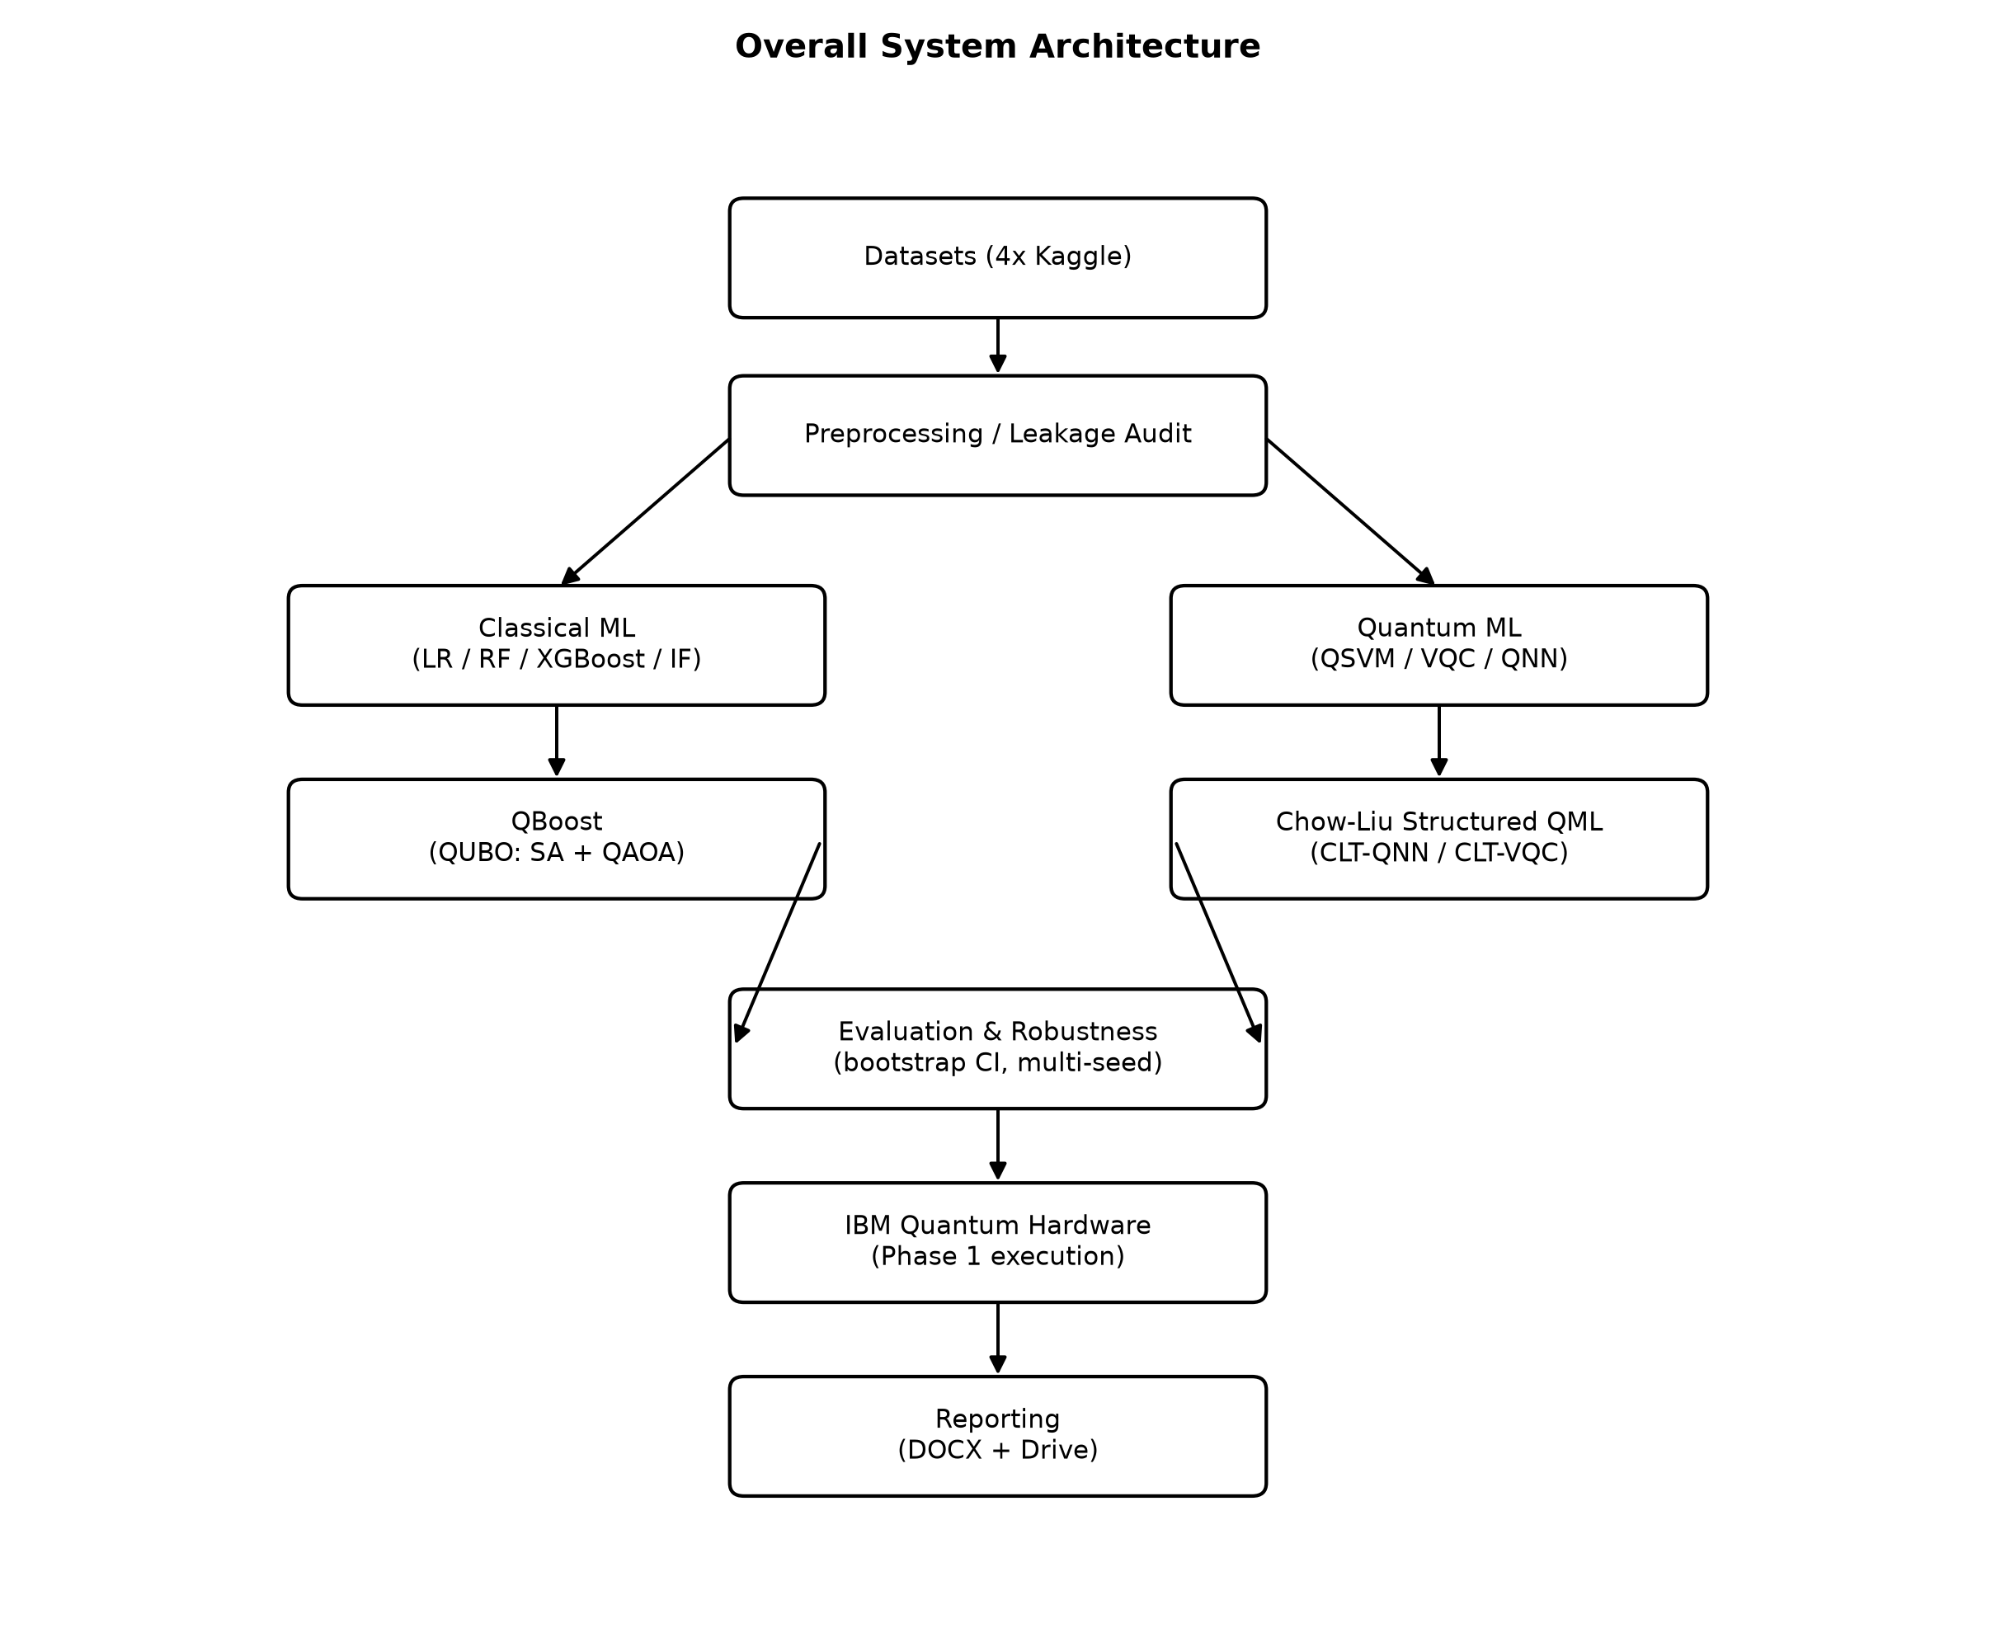
Figure 1. Overall system architecture.
The fraud-detection score and risk classification produced by this layer is the designed input to a later security-selection layer -- e.g. choosing between classical, post-quantum, or quantum-secured transaction handling based on the assessed fraud risk -- which remains unimplemented pending the cryptographic layer described in Section 15.

4. Phase 1 Execution
What has actually been implemented and executed in this phase, separated from what remains future work.

4.1 Implemented and executed
- Four Kaggle datasets downloaded programmatically via kagglehub and profiled (Section 5).
- A leakage-audited classical ML pipeline: Logistic Regression, Random Forest, XGBoost, Isolation Forest, with temporal splitting, calibration, latency-aware production selection (Section 7).
- Statistical robustness analysis: bootstrap confidence intervals, paired model comparison, multi-seed variance, imbalance-strategy comparison, threshold-objective comparison (Section 7).
- A quantum ML baseline: QSVM, VQC, QNN on a controlled 4-qubit subset (Section 8).
- An isolated Chow-Liu-tree research layer: real mutual-information-based dependency trees, a purely classical generative CLT classifier, CLT-informed sparse entangling circuits (CLT-QNN, CLT-VQC), compared against generic topologies across 4/6/8 qubits, three variational seeds, finite-shot simulation, gate-noise simulation, and transpilation onto realistic coupling maps (Sections 8, 10).
- QBoost: a QUBO ensemble-selection formulation solved by both classical simulated annealing and gate-model QAOA, benchmarked against AdaBoost and Gradient Boosting (Section 9).
- Five classical-quantum hybrid fusion architectures, each with a classical-only / quantum-only ablation (Section 8.4).
- A project-specific hardware-readiness heuristic ranking every quantum candidate.
- Real execution on IBM Quantum hardware (backend ibm_fez): an authenticated smoke test and a full CLT-QNN-vs-generic-QNN comparison job, with real job IDs and measured hardware-vs-simulator deviation (Section 11).
- Ten black-and-white architecture/workflow diagrams and five grayscale result charts (this document).

4.2 Explicitly deferred (future work)
- Post-quantum cryptography (ML-KEM/ML-DSA/SLH-DSA) integration.
- QKD protocol implementation (BB84/E91/B92).
- Shor/Grover threat demonstrations against classical cryptographic primitives.
- A real-time transaction-processing API and production deployment.
- Large-scale, budget-permitting IBM Quantum hardware training runs (this phase used simulator-trained weights evaluated on hardware, not hardware-trained weights -- see Section 11.1 for the reasoning).

5. Datasets Used
All four datasets were downloaded programmatically via kagglehub. Row counts and fraud percentages below are measured from the actual downloaded files (reports/dataset_summary.csv), not published figures.

5.1 mlg-ulb/creditcardfraud (primary/production dataset)
- Purpose: primary production training dataset -- the only one of the four with a realistic fraud base rate.
- Size: 284,807 transactions, 492 fraud cases (0.1727%).
- Target: Class (1 = fraud). Features: V1-V28 (PCA-anonymised by the original publisher) plus Amount and Time.
- Strengths: extremely realistic imbalance ratio; widely used in the fraud-detection literature (Dal Pozzolo et al.), enabling direct comparison.
- Limitations: features are already PCA-transformed upstream, so no human-interpretable feature engineering is possible on V1-V28 directly; Time is an index rather than a usable feature (used only to order the temporal split, then dropped -- see docs/DECISIONS.md D6).

5.2 kartik2112/fraud-detection
- Purpose: secondary classical-ML dataset with rich, human-interpretable merchant/customer metadata.
- Size: 500,000 profiled rows (1,296,675 in the full file), 7,506 fraud cases (1.50%).
- Target: is_fraud. Features include merchant category, transaction amount, customer demographics, geolocation.
- Strengths: interpretable features enable genuine feature engineering; realistic simulated behavioural signal.
- Limitations: simulated (Sparkov-generated) rather than real transactions; high-cardinality categoricals (merchant, city, job) are dropped rather than target-encoded in the current pipeline.

5.3 nelgiriyewithana/credit-card-fraud-detection-dataset-2023
- Purpose: stress-test dataset with an artificially balanced class distribution.
- Size: 500,000 profiled rows, 250,000 fraud cases (50.00%).
- Target: Class. Features: V1-V28 (PCA-anonymised) plus Amount.
- Strengths: balanced classes remove the imbalance confound, useful for isolating whether a model architecture itself is sound.
- Limitations: the 50% fraud rate does not reflect any real deployment base rate; not used as the primary/production dataset for this reason.

5.4 praneeth1265/synthetic-credit-card-transactions-fraud-detection
- Purpose: dataset with pre-engineered behavioural/velocity features, used to illustrate the feature-engineering gap identified in Section 7.5.
- Size: 500,000 rows, 65,551 fraud cases (13.11%).
- Target: fraud_label. Features include hours_since_last_tx, tx_count_1h, travel_speed, merchant_risk.
- Strengths: demonstrates exactly the class of behavioural/aggregate features the literature (Lucas & Jurgovsky, 2020) identifies as high-signal for fraud, and which the primary dataset currently lacks.
- Limitations: fully synthetic; the 13% fraud rate is a construction artefact, not a real base rate.
Dataset | Rows | Fraud Count | Fraud % | Role
creditcardfraud | 284,807 | 492 | 0.173% | Primary / production
fraud-detection (kartik2112) | 500,000* | 7,506 | 1.501% | Secondary classical
creditcard-2023 | 500,000* | 250,000 | 50.000% | Balanced stress-test
synthetic-cc-fraud | 500,000 | 65,551 | 13.110% | Feature-engineering reference
Table 1. Dataset summary (* = stratified profiling subsample of a larger file; the production model trains on the full 284,807-row creditcardfraud file).

6. Data Preprocessing

6.1 Cleaning and leakage prevention
- Exact duplicate rows (features + label) are dropped BEFORE splitting -- 9,144 duplicates removed from creditcardfraud -- so an identical transaction cannot appear in both train and test.
- Every preprocessing transformer (imputer, scaler, encoder) is fit on the training fold only; validation and test are transform()-only.
- Any feature correlating >=0.95 with the target is treated as a hard leakage error, not a warning.
- Identifier and free-text columns (cc_num, trans_num, customer names, high-cardinality merchant/city/job fields) are dropped rather than encoded, preventing the model from memorising individual entities.

6.2 Encoding and scaling
Numerical features are median-imputed and standard-scaled; categorical features are one-hot encoded (fit on train only). All steps are wrapped in a scikit-learn ColumnTransformer / Pipeline so leakage is prevented structurally, not by convention alone.

6.3 Imbalance management
Three strategies are implemented and empirically compared in Section 7.4: class-weighting (the production default), SMOTE, and random undersampling. All resampling, where used, is applied to the training fold only -- never to validation or test.

6.4 Train/validation/test splitting
The primary dataset (creditcardfraud) uses a TEMPORAL split rather than a random split: transactions are ordered by time and split sequentially into train/validation/test, so the evaluation reflects the realistic deployment scenario of predicting forward in time rather than interpolating within a shuffled distribution. This is why the reported metrics are somewhat lower than random-split numbers commonly quoted for this dataset elsewhere in the literature -- and is a more defensible evaluation protocol, following Dal Pozzolo et al. (2018)'s concept-drift argument.

6.5 Dimensionality reduction for quantum experiments
Quantum circuits in this project use 4-8 qubits, so the 29-dimensional preprocessed feature space is reduced via two parallel pipelines: (A) PCA components (not human-interpretable, used for scaling/parity experiments), and (B) mutual-information-selected original features (interpretable, fitted on training data only, used for all Chow-Liu structural work since feature identity must survive for the dependency graph to be meaningful).

7. Classical Machine Learning

7.1 Original loopholes identified
A self-audit (classical_ml_loophole_analysis.md) of the pre-existing classical pipeline identified ten issues. Six were low/medium-effort and were closed in this phase; the remaining four (bounded hyperparameter search, feature engineering, active SHAP verification, drift/subgroup robustness) are scoped as future work (Section 15) to avoid an open-ended rebuild.
# | Loophole | Status this phase
1 | No bootstrap confidence intervals on test metrics | CLOSED -- Section 7.3
3 | No statistical test between model candidates | CLOSED -- Section 7.3
5 | Imbalance strategies asserted, not compared | CLOSED -- Section 7.4
8 | Training orchestration (calibration accept/reject, model selection, latency) untested | CLOSED -- 15 new unit tests
9 | Threshold objective (F2) not compared against alternatives | CLOSED -- Section 7.5
10 | Single-seed results, no variance report | CLOSED -- Section 7.6
2 | No (even bounded) hyperparameter search | Deferred -- future work
4 | No feature engineering (log-amount, hour-of-day, frequency encoding) | Deferred -- future work
6 | SHAP coded but not verified active in the training environment | Deferred -- future work
7 | No drift/subgroup/perturbation robustness check | Deferred -- future work
Table 2. Loophole-to-status mapping (classical_ml_loophole_analysis.md).

7.2 Algorithms and evaluation
Four models were trained on the primary dataset's temporal split: Logistic Regression, Random Forest, XGBoost, and Isolation Forest (unsupervised anomaly baseline). No large hyperparameter search was performed (a deliberate, documented scoping decision); hyperparameters are fixed strong defaults.
Model | Type | PR-AUC | ROC-AUC | Precision | Recall | F1 | FPR | Single-tx latency (ms)
Random Forest | Supervised | 0.8191 | 0.9692 | 0.9032 | 0.7568 | 0.8235 | 0.000109 | 76.34
XGBoost (PRODUCTION) | Supervised | 0.8007 | 0.9772 | 0.9016 | 0.7432 | 0.8148 | 0.000109 | 3.05
Logistic Regression | Supervised | 0.7328 | 0.9839 | 0.7727 | 0.6892 | 0.7286 | 0.000272 | 0.80
Isolation Forest | Anomaly (unsupervised) | 0.0397 | 0.9492 | 0.0444 | 0.5811 | 0.0825 | 0.016800 | 26.62
Table 3. Classical model comparison, held-out temporal test fold (55,133 rows, 74 fraud cases).
Isolation Forest never sees a label during training; its score is an anomaly rank, not a fraud probability, and its PR-AUC is not directly comparable to the supervised models -- it is reported separately for exactly this reason, following the SRS requirement to avoid presenting accuracy or any single metric as a universal ranking.
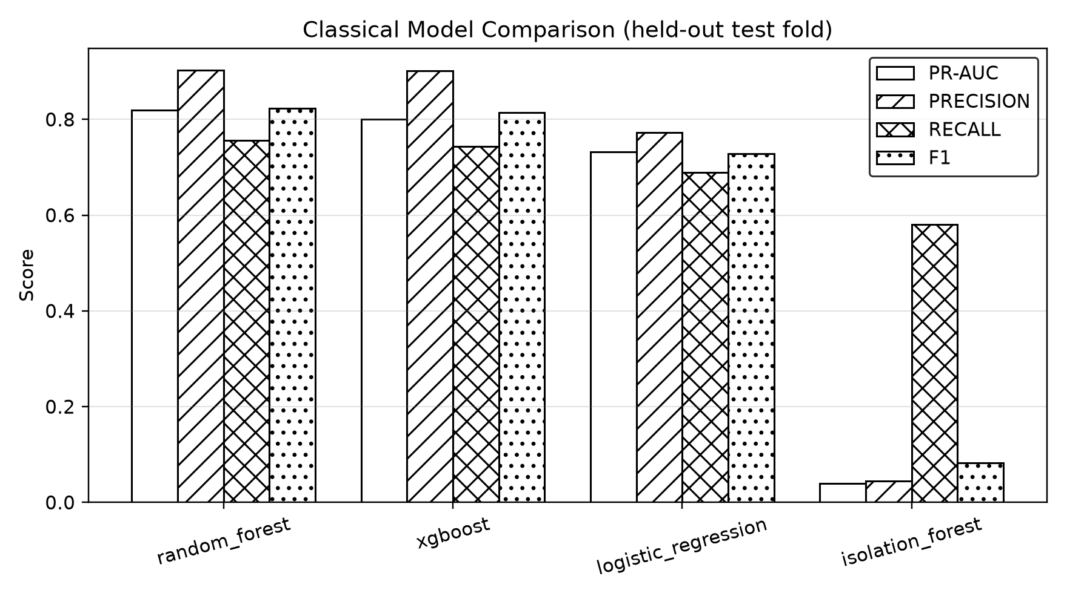
Figure 2. Classical model comparison (grayscale, hatched bars).
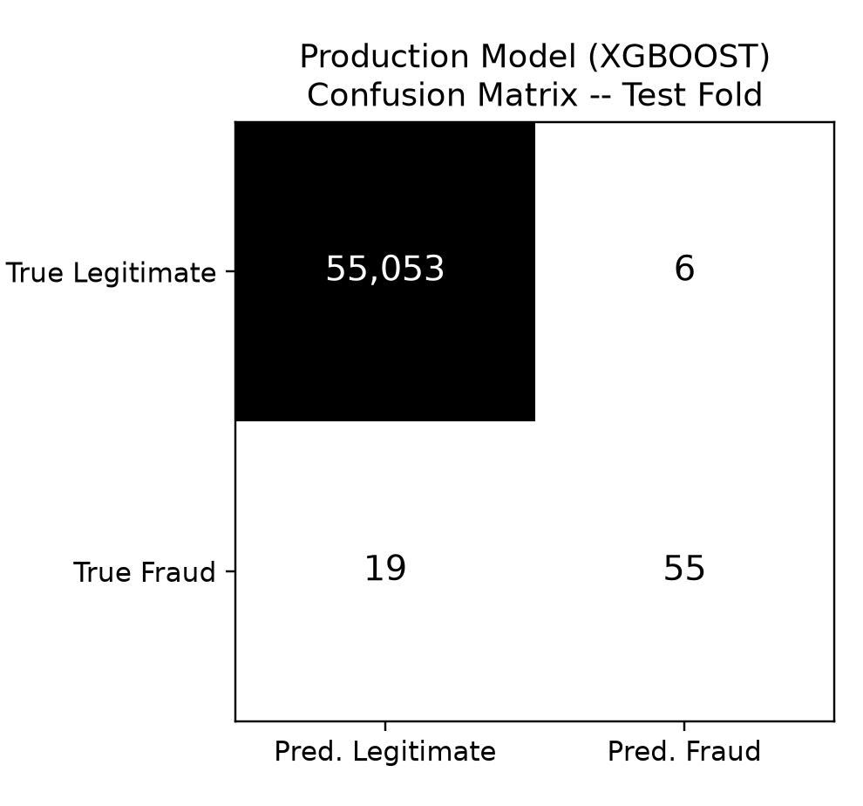
Figure 3. Production model (XGBoost) confusion matrix, test fold.

7.3 Statistical robustness: bootstrap confidence intervals and paired comparison
Every metric above is a single point estimate from one temporal split, with only 74 positive labels in the test fold -- moving 6 transactions between true-positive and false-negative changes recall by roughly 8 percentage points. A 2,000-resample bootstrap was run on the fixed test fold to quantify this.
Model | Metric | Point estimate | 95% CI
XGBoost | PR-AUC | 0.8007 | [0.7134, 0.8778]
XGBoost | ROC-AUC | 0.9772 | [0.9580, 0.9921]
XGBoost | Recall | 0.7432 | [0.6389, 0.8361]
Random Forest | PR-AUC | 0.8191 | [0.7358, 0.8927]
Random Forest | Recall | 0.7568 | [0.6548, 0.8442]
Table 4. Bootstrap 95% confidence intervals, n=2,000 resamples (reports/robustness/bootstrap_ci.json).
A paired bootstrap comparison (resampling the SAME row indices for both models on every draw) between XGBoost and Random Forest gives a PR-AUC delta of -0.0183 with 95% CI [-0.0436, 0.0030] and p=0.097 -- NOT statistically significant at alpha=0.05. This confirms the production-selection rationale: Random Forest's higher point-estimate PR-AUC is not statistically distinguishable from XGBoost's at this sample size, so XGBoost's 18x lower single-transaction latency (3.05ms vs 76.34ms) is the deciding, defensible factor rather than a sacrificed accuracy gain.

7.4 Imbalance strategy comparison
Strategy | PR-AUC | ROC-AUC | Precision | Recall | F1
class_weight (production) | 0.8007 | 0.9772 | 0.9016 | 0.7432 | 0.8148
SMOTE | 0.7867 | 0.9630 | 0.8594 | 0.7432 | 0.7971
Undersample | 0.8033 | 0.9834 | 0.8485 | 0.7568 | 0.8000
Table 5. Imbalance strategy comparison, XGBoost, identical splits (reports/robustness/imbalance_strategy_comparison.csv).
Class-weighting and undersampling are statistically indistinguishable in this measurement (a 0.0026 PR-AUC gap on 74 positives); SMOTE is measurably worse. Class-weighting remains the production default because it introduces no synthetic rows and cannot leak by construction, and undersampling's marginal edge does not justify discarding real training data.

7.5 Threshold objective comparison
Objective | Threshold | Precision | Recall | F1 | F2 | FPR
f1 | 0.5810 | 0.9016 | 0.7432 | 0.8148 | 0.7703 | 0.000109
f2 (production) | 0.5810 | 0.9016 | 0.7432 | 0.8148 | 0.7703 | 0.000109
youden | 0.0003 | 0.0316 | 0.8784 | 0.0610 | 0.1382 | 0.036161
max_recall_at_precision | 0.0190 | 0.8462 | 0.7432 | 0.7914 | 0.7618 | 0.000182
Table 6. Threshold objective comparison, XGBoost (reports/robustness/threshold_objective_comparison.csv).
This table is itself the strongest argument against Youden's J statistic for this problem: it selects a threshold with 87.8% recall but only 3.2% precision -- 1,991 false positives for 65 true positives -- an unusable analyst workload. F1 and F2 happen to select the identical threshold at this operating point, and max_recall_at_precision offers a defensible, more conservative alternative. This table replaces what was previously an unquantified assertion that F2 was the right choice.

7.6 Multi-seed variance
Model | Metric | Mean | Std | Min | Max
XGBoost | PR-AUC | 0.7976 | 0.0026 | 0.7931 | 0.8007
XGBoost | Recall | 0.7459 | 0.0054 | 0.7432 | 0.7568
Random Forest | PR-AUC | 0.8166 | 0.0023 | 0.8133 | 0.8191
Random Forest | Recall | 0.7568 | 0.0000 | 0.7568 | 0.7568
Table 7. Multi-seed variance, 5 seeds {42, 7, 13, 99, 2024} (reports/robustness/multi_seed_variance.json).
Standard deviations of 0.002-0.005 on PR-AUC across 5 seeds are small relative to the bootstrap confidence intervals in Table 4, indicating the single-seed (seed=42) production numbers reported throughout this document are representative rather than a lucky draw.

7.7 Final classical result
Production model: XGBoost -- threshold 0.5810, PR-AUC 0.8007 [0.7134, 0.8778], recall 0.7432, precision 0.9016, F1 0.8148, false-positive rate 0.000109 (6 false positives out of 55,059 legitimate test transactions), 3.05ms single-transaction latency. Accuracy is 99.95% but is explicitly NOT used as a selection criterion anywhere in this pipeline -- a naive all-legitimate classifier would score 99.83% accuracy on this data while catching zero fraud, which is exactly why PR-AUC, recall and the false-positive burden are the metrics that actually govern model selection here.

8. Quantum Machine Learning

8.1 Objective, subset and feature reduction
Objective: evaluate quantum-kernel (QSVM), variational (VQC) and quantum-neural-network (QNN) classifiers for fraud detection at simulator-feasible scale, and investigate whether real, data-derived dependency structure (Chow-Liu trees) can inform sparser, more noise-robust circuit topologies without sacrificing detection performance.
All quantum experiments use a controlled subset of exactly 250 training / 100 validation / 200 test transactions, rebalanced to 30% fraud (the real 0.17% base rate would leave zero fraud cases at this sample size). This subset is NOT comparable to the full-scale classical benchmark in Section 7 -- it is comparable only within this section and Section 10, since every quantum and controlled-classical arm draws from an identical, hash-verified set of rows (row_fingerprint field, verified equal across all 141 experimental checkpoints).
Two feature-reduction pipelines were used: (A) PCA to 4-8 components (not human-interpretable, used for scaling/parity), and (B) mutual-information-selected original features, fit on training data only (interpretable, used for all Chow-Liu structural work).
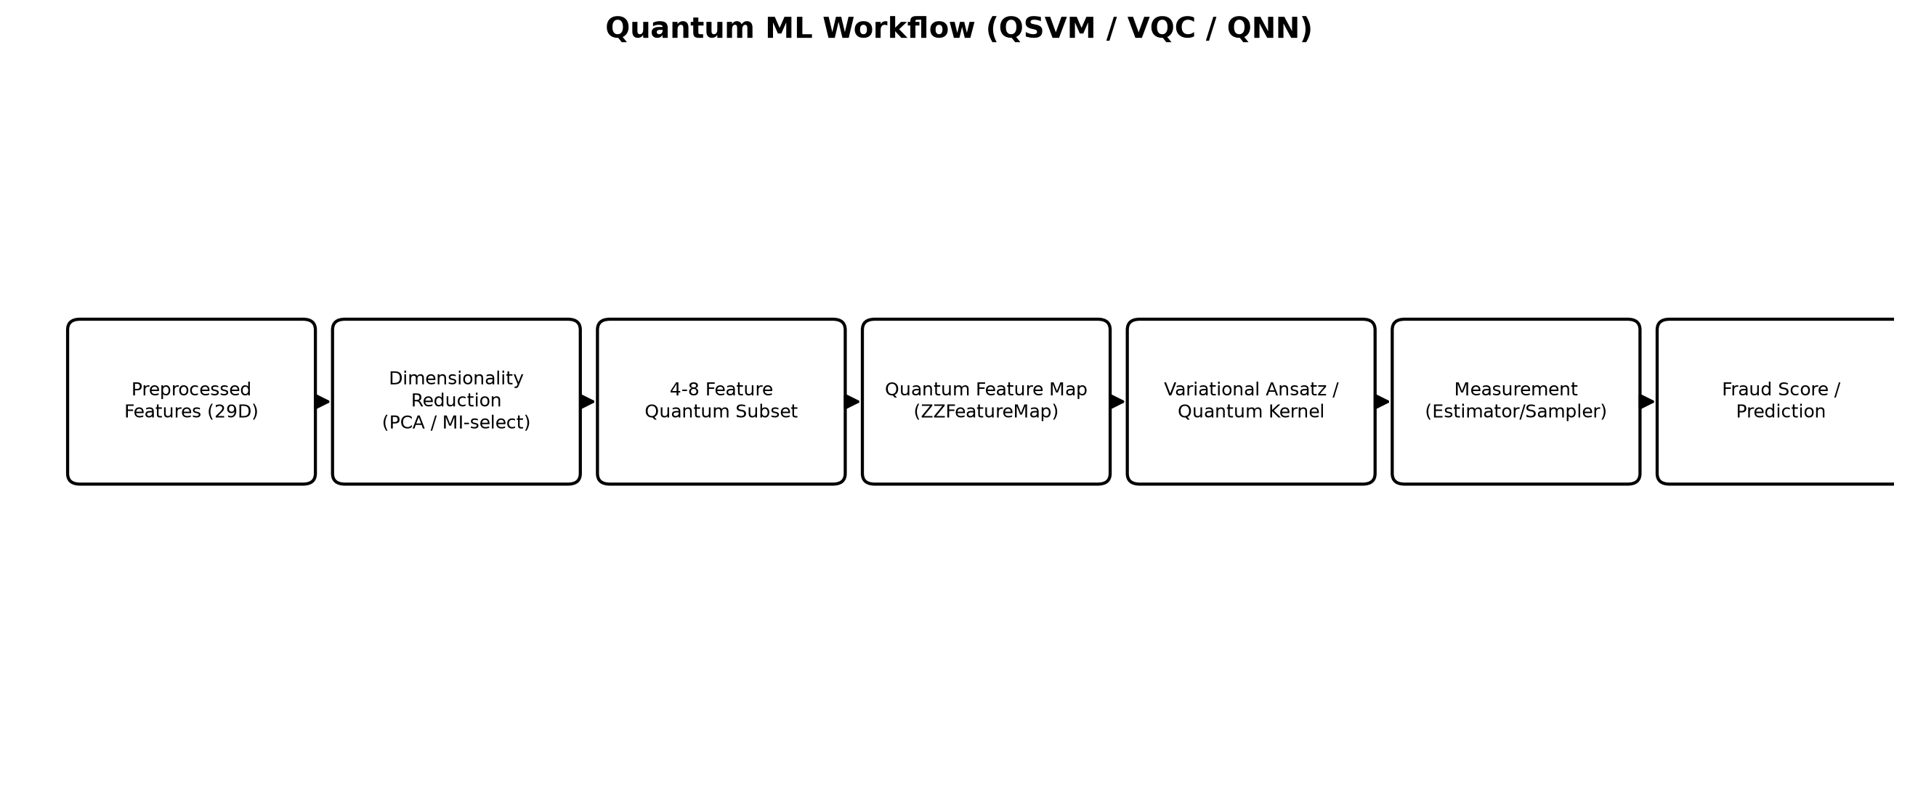
Figure 4. Quantum ML workflow.

8.2 Encoding, circuits and simulator setup
- Feature map: ZZFeatureMap-style second-order Pauli encoding, angle-scaled into [0, pi].
- Ansatz: RealAmplitudes-style variational layers (VQC/QNN) or FidelityQuantumKernel (QSVM).
- Optimizer: COBYLA, 60-iteration budget (bounded by design -- not trained to convergence).
- Simulator: Qiskit Aer statevector (ideal) and shot-based/noisy Aer primitives for the robustness sweeps.
- Readout honesty: QNN and QSVM emit a decision score (expectation value / SVM margin), NOT a calibrated probability, and are labelled as such everywhere in the codebase and this report. VQC's parity-normalised softmax readout IS a genuine probability.

8.3 Baseline results (4-qubit controlled subset)
Model | Qubits | PR-AUC | ROC-AUC | Precision | Recall | F1
QNN | 4 | 0.9531 | 0.9657 | 0.9423 | 0.8167 | 0.8750
QSVM | 4 | 0.9340 | 0.9602 | 0.9286 | 0.8667 | 0.8966
VQC | 4 | 0.8818 | 0.9370 | 0.8500 | 0.8500 | 0.8500
Table 8. QSVM / VQC / QNN baseline, controlled subset (reports/qml_model_comparison.csv).
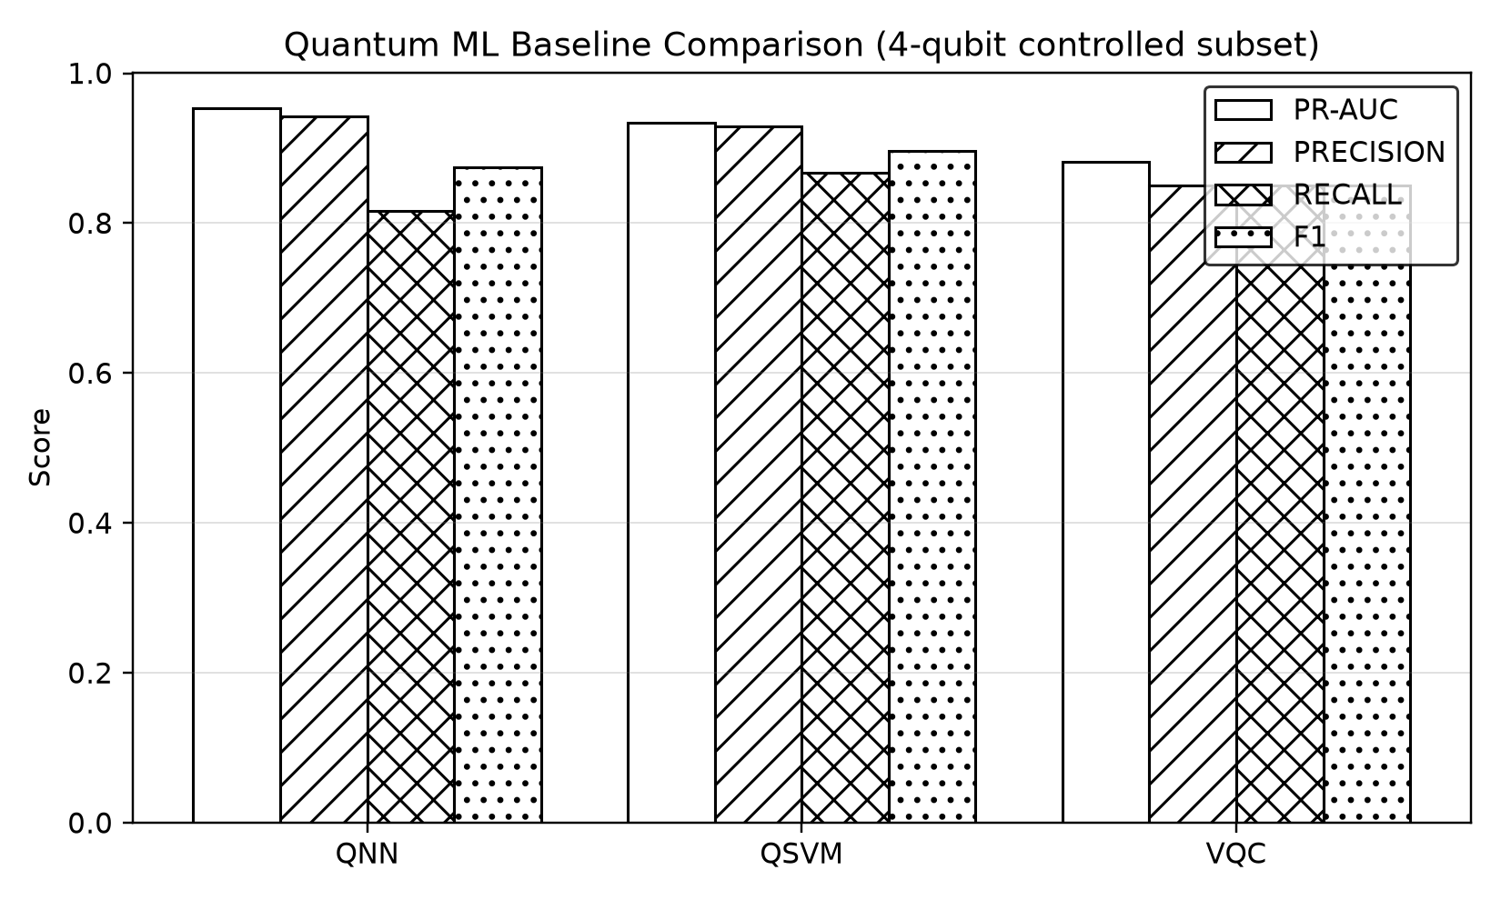
Figure 5. Quantum ML baseline comparison (grayscale).
These baseline numbers replicate the now-standard fraud-QML recipe published by Innan, Al-Zafar Khan & Bennai (2023) and El Alami et al. (2024); this project does not claim novelty for this specific comparison (Section 2.3).

8.4 Hybrid classical-quantum architectures
Five hybrid fusion architectures were tested, each combining a classical component (XGBoost or the Chow-Liu generative classifier) with a quantum component (QNN, VQC, CLT-QNN or CLT-VQC) via a logistic meta-learner fitted ONLY on validation predictions (never on test labels). Each hybrid is reported with its own classical-only / quantum-only ablation on identical folds.
Hybrid | PR-AUC | Recall | F1 | Runtime (s)
XGBoost + CLT-VQC | 0.9268 | 0.8167 | 0.8522 | 42.85
XGBoost + CLT-QNN | 0.9268 | 0.8167 | 0.8448 | 30.94
XGBoost + VQC | 0.9265 | 0.8167 | 0.8448 | 42.66
XGBoost + QNN | 0.9025 | 0.8333 | 0.8403 | 28.19
Chow-Liu classifier + QNN | 0.8978 | 0.8500 | 0.8160 | 27.89
Table 9. Hybrid results, controlled 4-qubit subset (reports/qml_experimental/hybrid_results.csv). Reference: XGBoost alone on this identical subset scores PR-AUC 0.9371 (see Table 11).
No hybrid architecture beat XGBoost alone on the identical controlled subset (0.9371) -- the best hybrid (XGBoost + CLT-VQC) reached 0.9268, a -0.0103 PR-AUC deficit. This is a negative but genuine result, reported honestly rather than omitted (Section 12.11/12).

9. QBoost
QBoost (Neven et al., 2012) recasts ensemble selection as a QUBO: given a fixed pool of N weak learners, select the subset minimising squared ensemble error plus a sparsity penalty. The quantum content is entirely in HOW the QUBO is solved -- the boosting formulation itself is classical. This project's design document (docs/qboost_design.md) states this explicitly before implementation, so the honesty claims are not retrofitted to whatever the results turned out to be.
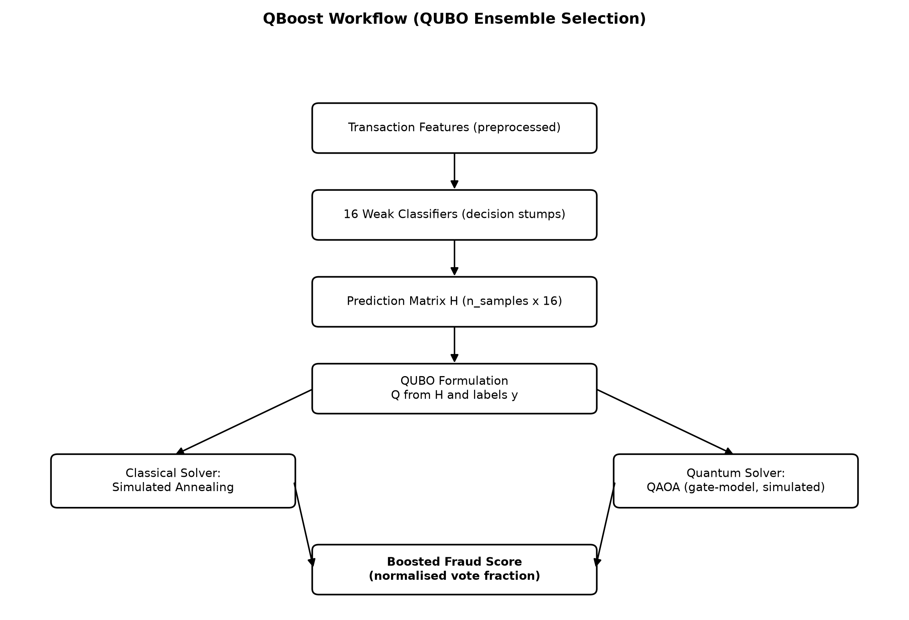
Figure 6. QBoost workflow.

9.1 Formulation
Q_ij = (1/N^2) * sum_m h_i(x_m) h_j(x_m) for i != j (correlation between learner predictions), and Q_ii = (1/N^2) sum_m h_i(x_m)^2 - (2/N) sum_m h_i(x_m) y_m + lambda (agreement with the label, penalised by ensemble size). 16 depth-1 decision stumps form the weak-learner pool.

9.2 Two solvers -- one classical, one quantum
- simulated_annealing -- CLASSICAL Metropolis heuristic. This is NOT quantum execution; solving a QUBO classically does not make the result quantum.
- QAOA -- genuine gate-model quantum algorithm, executed on a 11-16-qubit statevector SIMULATOR (not real hardware, since a 16-variable QUBO is trivially simulable and real-hardware QAOA at this scale would not demonstrate anything beyond what the simulator already shows).
Model | Solver | Quantum solver? | Ensemble size | PR-AUC | Recall | F1 | Runtime (s)
Gradient Boosting | Greedy | No | 16 | 0.9484 | 0.8167 | 0.8750 | 0.018
AdaBoost | Greedy | No | 16 | 0.9374 | 0.9000 | 0.8372 | 0.071
QBoost | Simulated annealing | No | 12 | 0.8611 | 0.8500 | 0.7907 | 1.373
QBoost | QAOA | Yes (simulated) | 11 | 0.8181 | 0.6333 | 0.7379 | 69.005
Table 10. QBoost vs classical boosting, identical controlled subset (reports/qml_experimental/qboost_results.csv).
QBoost did NOT outperform classical greedy boosting under either solver, and the QAOA solver did not improve on classical simulated annealing for the same QUBO. Global QUBO subset selection underperformed greedy stagewise boosting here -- a genuine, literature-consistent negative result: solving a harder global optimisation problem is not automatically better than a well-tuned greedy heuristic on a small ensemble.

10. Chow-Liu Tree (CLT)

10.1 Graphical-model intuition
Chow & Liu (1968) proved that the tree-structured probability distribution closest in KL-divergence to the true joint distribution is the maximum-weight spanning tree of the complete graph whose edge weights are pairwise mutual informations I(Xi;Xj). A tree over n variables has exactly n-1 edges -- this is what makes the resulting structure sparse, and it is a genuine information-theoretic quantity, not a correlation coefficient relabelled.
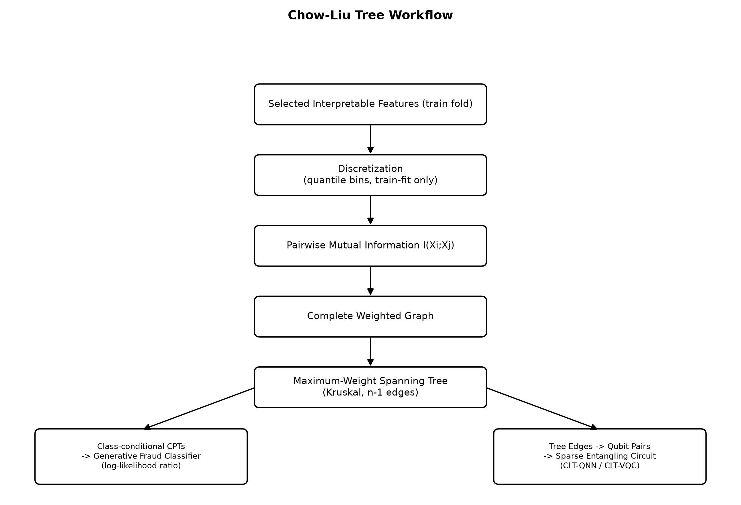
Figure 7. Chow-Liu tree workflow -- classifier and circuit-structure uses.

10.2 Implementation
- Discretization: quantile binning (8 bins), fitted on training data only.
- Mutual information: plug-in maximum-likelihood estimator from the joint contingency table (nats).
- Maximum-weight spanning tree: Kruskal's algorithm on negated weights, deterministic tie-breaking.
- Smoothing: Laplace/Dirichlet smoothing (alpha=1.0) prevents zero-frequency cells from sending log-likelihoods to negative infinity.
- Numerical stability: all generative-classifier computation is in log space throughout.

10.3 Class-conditional CLT as a standalone fraud classifier
Two trees are fitted, one per class, and a transaction is scored by the log-likelihood ratio LLR(x) = log P(x|fraud) - log P(x|legitimate) + log(P(fraud)/P(legitimate)). The raw LLR is explicitly NOT called a probability; a sigmoid calibrator is fitted on validation and kept only if it improves the Brier score.
Features | PR-AUC | ROC-AUC | Precision | Recall | F1
4 | 0.9057 | 0.9250 | 0.7222 | 0.8667 | 0.7879
6 | 0.9437 | 0.9616 | 0.8667 | 0.8667 | 0.8667
8 | 0.9458 | 0.9589 | 0.8793 | 0.8500 | 0.8644
Table 11. Class-conditional Chow-Liu classifier -- a purely CLASSICAL probabilistic model (reports/qml_experimental/chow_liu_classifier_results.csv).
This is the single strongest surprise of this project's experimental phase: the purely classical, no-quantum-component CLT generative classifier (PR-AUC up to 0.9458) is competitive with the tuned classical baselines on this identical subset and exceeds every quantum model measured (Table 8). This demonstrates that a Chow-Liu tree can detect fraud effectively by itself, independent of any quantum use.

10.4 Discovered feature dependencies
On the 8-feature subset, the strongest measured dependencies were V11-V12 (0.575 nats), V11-V14 (0.545 nats), V10-V11 (0.545 nats), V10-V17 (0.514 nats), V3-V10 (0.497 nats), V4-V10 (0.496 nats) and V17-V21 (0.361 nats) -- a chain structure radiating from V10/V11, the two PCA components that also carry the strongest individual fraud signal in the classical explainability results.

10.5 CLT-informed quantum entanglement
Each tree edge Fi-Fj is mapped to a CZ gate between qubits qi and qj. Feature-to-qubit mapping is persisted as model metadata and never permitted to change silently between training and inference (validated by unit tests). A generic 'linear' topology (n-1 pairs, matching the tree's edge count exactly) is used as the fair head-to-head control -- both arms have identical gate budgets, so any measured difference is attributable to topology, not to gate count.

10.6 Predictive and structural benefit -- the central ablation
Comparison | Qubits | PR-AUC (generic) | PR-AUC (CLT) | Delta | Transp. depth (generic) | Transp. depth (CLT) | Transp. 2Q gates (generic) | Transp. 2Q gates (CLT)
CLT-QNN vs QNN | 4 | 0.6793 | 0.8700 | +0.1908 | 43 | 37 | 12 | 12
CLT-QNN vs QNN | 6 | 0.7375 | 0.7845 | +0.0470 | 51 | 86 | 20 | 44
CLT-QNN vs QNN | 8 | 0.5986 | 0.7995 | +0.2009 | 59 | 85 | 28 | 70
CLT-VQC vs VQC | 4 | 0.6551 | 0.8427 | +0.1876 | 43 | 37 | 12 | 12
CLT-VQC vs VQC | 6 | 0.7792 | 0.8132 | +0.0340 | 51 | 86 | 20 | 44
CLT-VQC vs VQC | 8 | 0.5872 | 0.7578 | +0.1706 | 59 | 85 | 28 | 70
Table 12. Structural and predictive benefit of CLT-informed entanglement, mean over 3 variational seeds (reports/qml_experimental/structural_benefit.csv).
PR-AUC improved in all 6 comparisons (mean delta +0.138). The 4-qubit and 8-qubit gaps substantially exceed the seed-to-seed standard deviation (~0.03-0.13); the 6-qubit gap does not and should be treated as noise. Circuit depth was reduced by CLT-informed entanglement ONLY at 4 qubits (-8.7%); at 6 and 8 qubits it was deeper (+3.4%, +11.4%), because a tree with a high-degree hub node cannot be laid out in as few parallel layers as a simple chain. Logical two-qubit gate counts are identical by construction (both arms have exactly n-1 pairs).
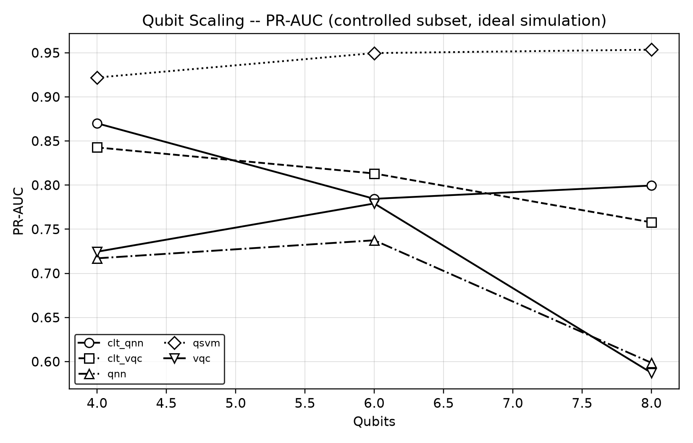
Figure 8. Qubit scaling, PR-AUC, controlled subset, ideal simulation.

10.7 Does the benefit survive transpilation?
No -- this is the central negative result of the structural ablation. On a line-connected coupling map, the CLT tree's non-adjacent edges require SWAP routing that a linear chain never needs. Transpiled two-qubit gate counts rose from parity (12 vs 12) at 4 qubits to +24 gates at 6 qubits (44 vs 20) and +42 gates at 8 qubits (70 vs 28). Any structural simplification the Chow-Liu topology offers is a 4-qubit artefact that does not generalise to larger, more realistically connected circuits.

11. IBM Quantum Hardware -- Phase 1
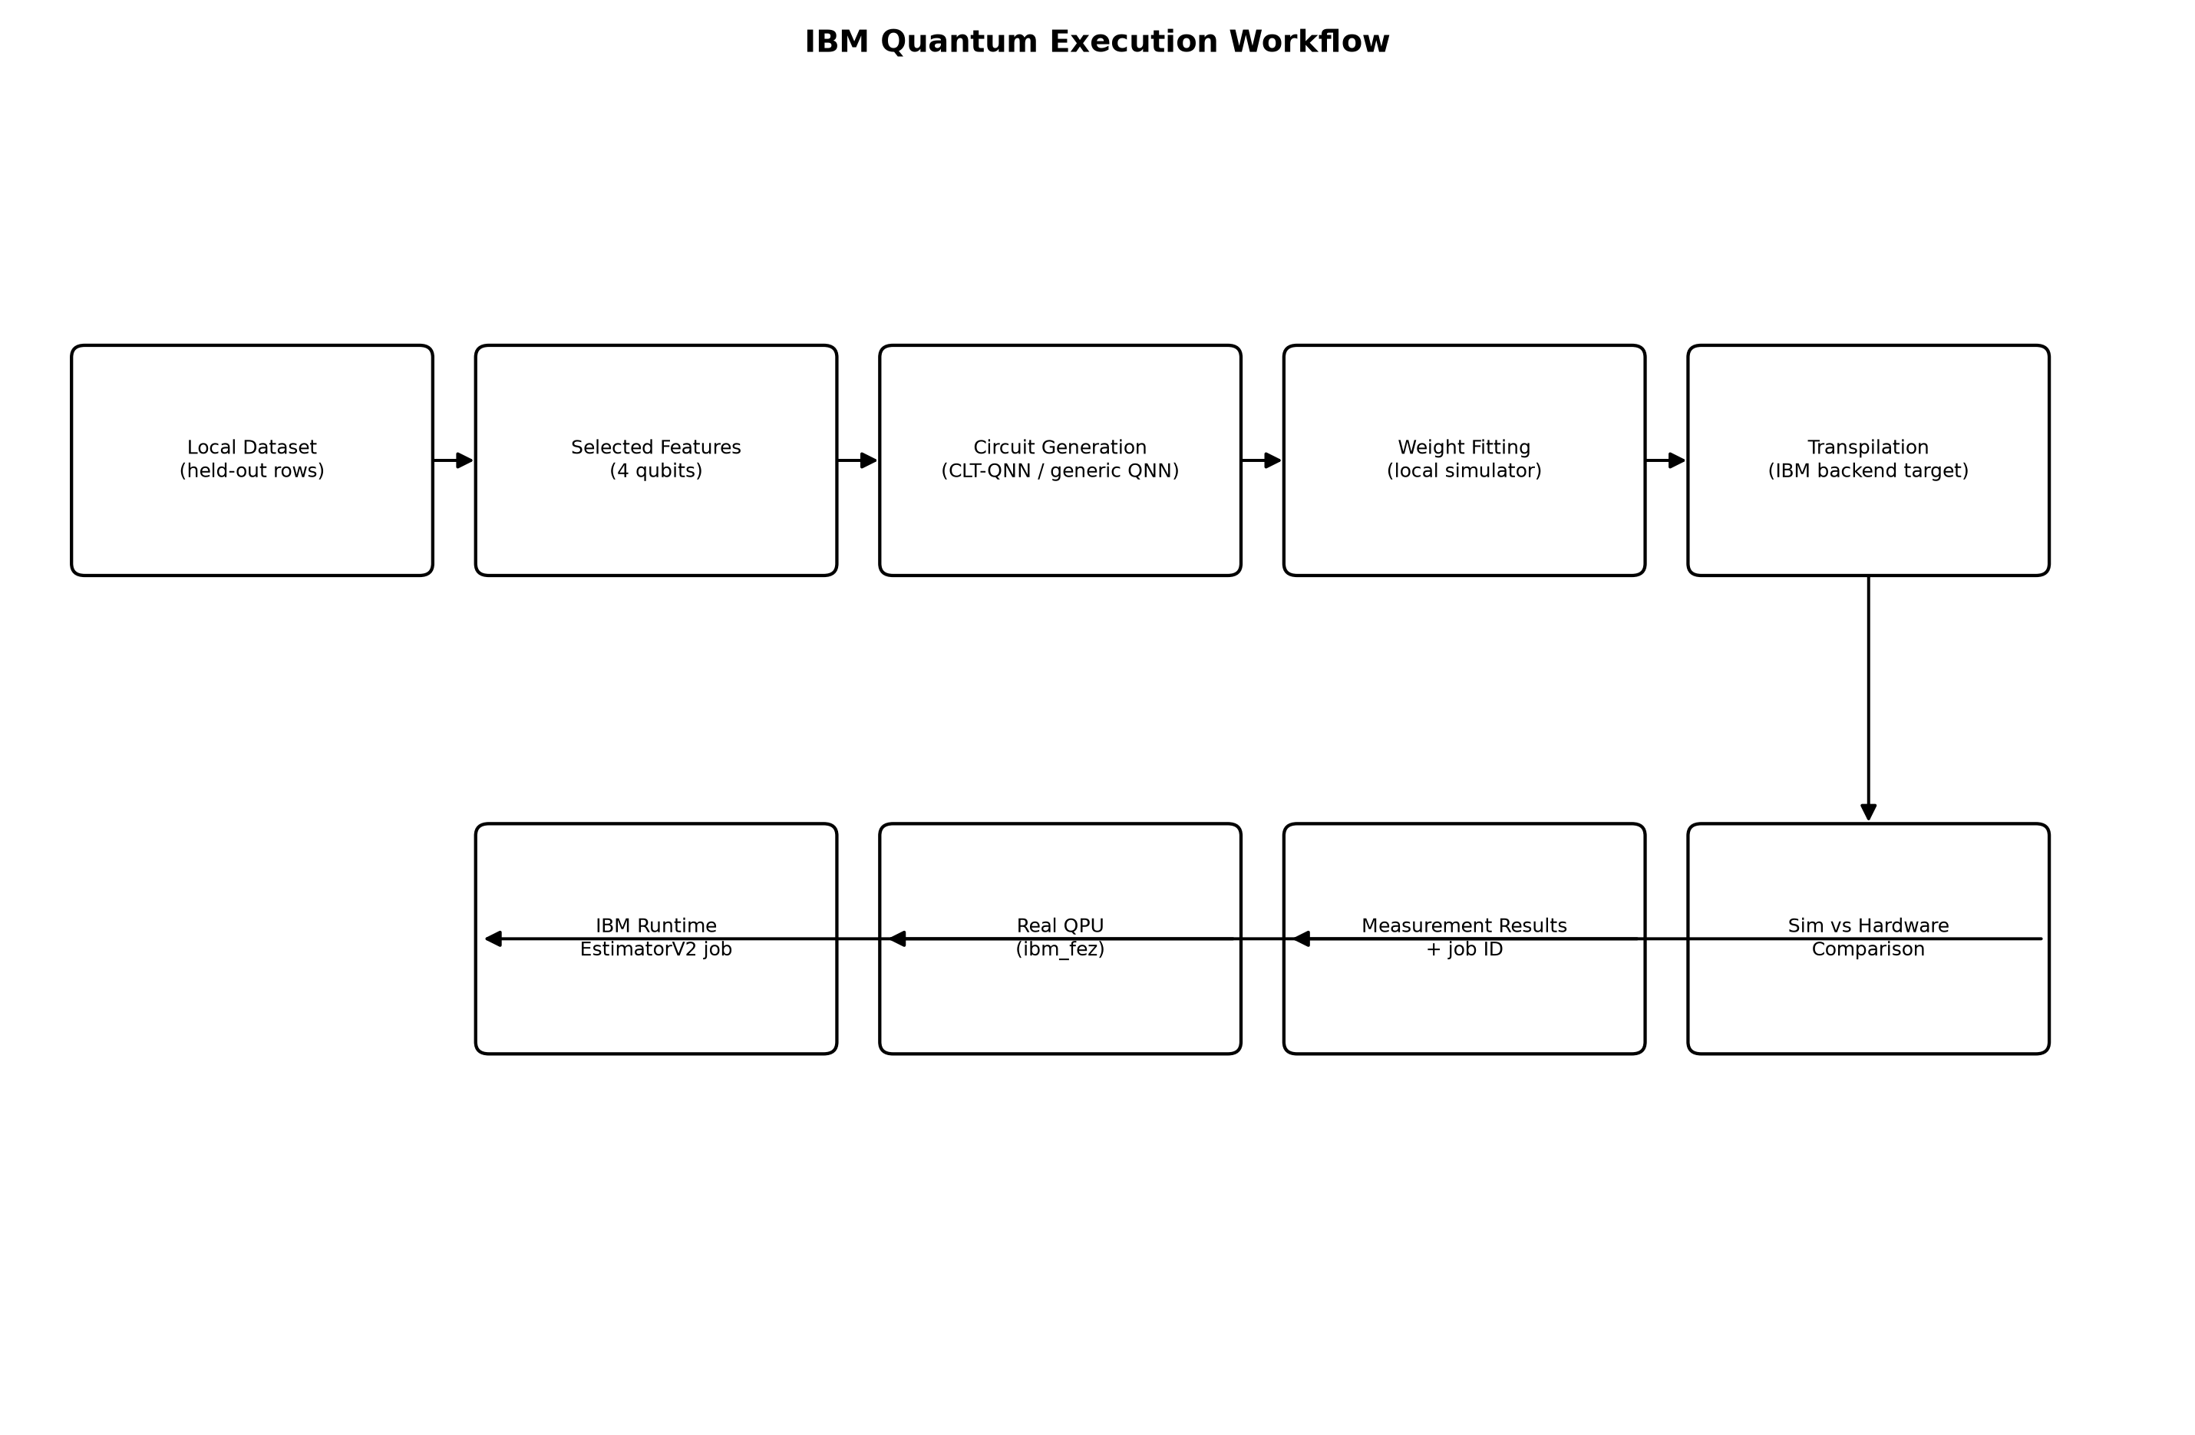
Figure 9. IBM Quantum execution workflow.

11.1 Approach and constraints
Training on real IBM Quantum hardware under the open/free access plan is not economically viable -- the runtime-second budget on this tier is minutes per month, and each optimiser iteration of a 60-iteration COBYLA run would require a separate hardware call. This project therefore trains circuit weights on the LOCAL statevector simulator (identical procedure to Section 10), FREEZES those weights, and executes INFERENCE on real hardware for a handful of genuine held-out test transactions. This is stated explicitly rather than allowed to be misread as hardware training, and no claim of a hardware-trained model is made anywhere in this report.

11.2 Authentication and backend selection
Credentials are loaded exclusively from a local, git-ignored .env file (IBM_QUANTUM_TOKEN) and are never printed, logged or committed. Authentication succeeded on the ibm_quantum_platform channel, open-plan instance. Three operational 156-qubit real backends were available at execution time:
Backend | Qubits | Pending jobs at selection time
ibm_fez (SELECTED) | 156 | 1
ibm_kingston | 156 | 2-3
ibm_marrakesh | 156 | 2,871 (avoided)
Table 13. Backend discovery and selection -- least-busy operational backend chosen programmatically.

11.3 Execution pipeline
- Step 1 -- classical preprocessing verified working (Section 7).
- Step 2 -- CLT-QNN and generic-QNN circuits (4 qubits) built and verified locally.
- Step 3 -- weights fitted on the local Aer statevector simulator (identical procedure to Section 10.6).
- Step 4 -- transpiled for ibm_fez at optimization_level=3.
- Step 5 -- circuit depth/two-qubit-gate burden inspected before submission (Table 14).
- Step 6 -- SMOKE TEST: a 2-qubit Bell-state circuit, 128 shots, submitted and verified BEFORE any larger job.
- Step 7 -- planned experiment executed: 12 total PUBs (6 CLT-QNN + 6 generic-QNN, real held-out test transactions) in ONE runtime job.
- Step 8 -- job IDs recorded; results retrieved and validated.
- Step 9 -- real metrics computed from the returned hardware results.
- Step 10 -- simulator vs hardware comparison computed on the identical transactions and identical fitted weights.

11.4 Smoke test result
Job da6eiuu0ukec7381vff0 on ibm_fez: 2-qubit Bell state, 128 shots. Measured <ZZ> expectation value = 1.0528 (ideal noiseless value = 1.0). This confirmed the full authenticate -> transpile -> submit -> retrieve round trip before any larger job was submitted, per the required smoke-test-before-scale-up protocol.

11.5 Hardware experiment result
Job da6ejl46l22c73dm82ng on ibm_fez: 12 PUBs, 1024 shots each, wall time 26.3s server-side (excluding queue). Both circuits used simulator-fitted weights bound to 6 real held-out test transactions each.
Candidate | Structure | Logical depth | Logical 2Q gates | Transpiled depth | Mean |hardware - simulator| deviation
CLT-QNN | Chow-Liu | 21 | 12 | 45 | 0.2287
Generic QNN | Linear | 23 | 12 | 47 | 0.4175
Table 14. Real IBM hardware execution vs local simulator, job da6ejl46l22c73dm82ng, backend ibm_fez, 1024 shots (reports/ibm_hardware/hardware_run.json).
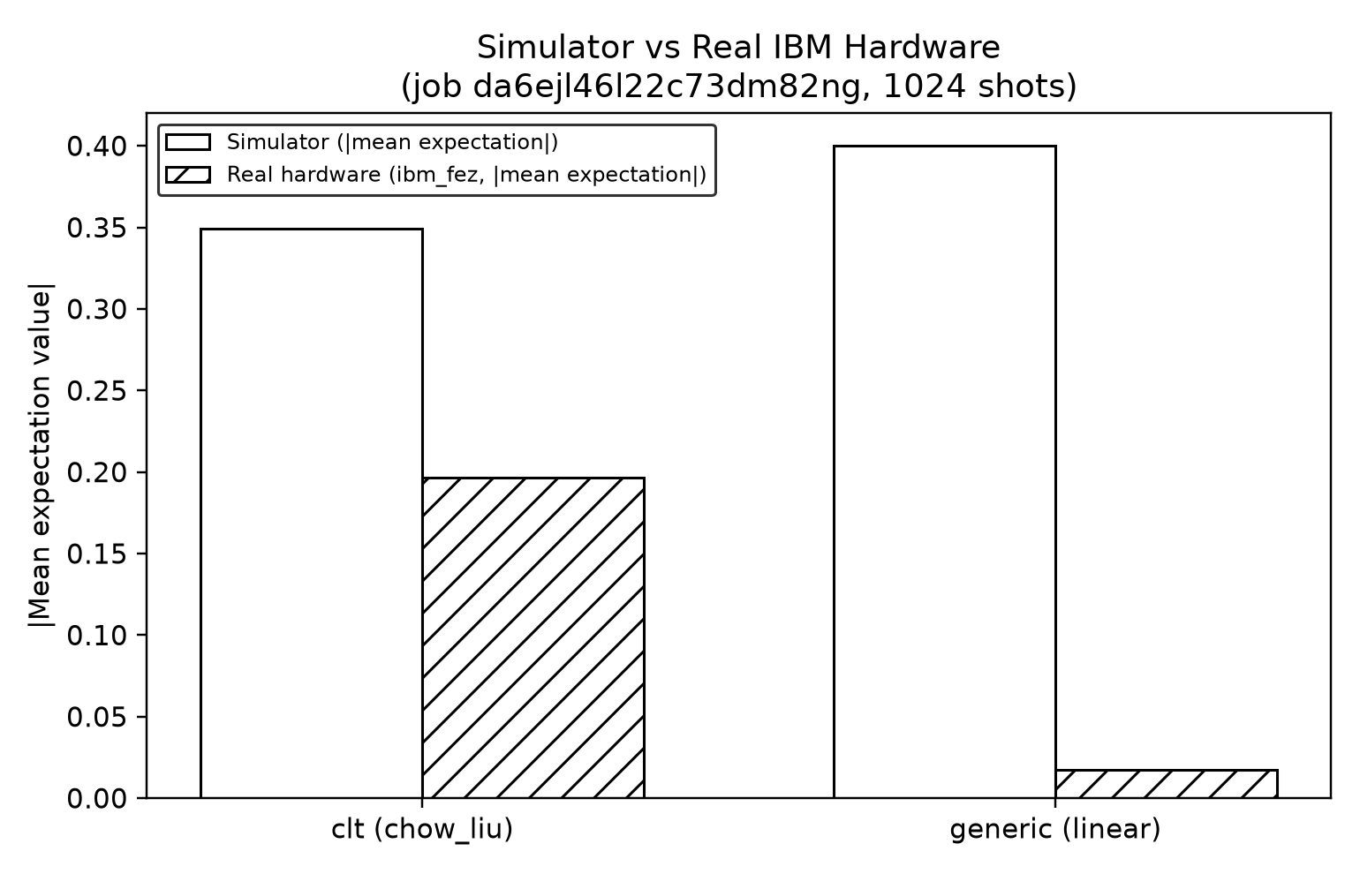
Figure 10. Simulator vs real hardware expectation values, by circuit structure.
On REAL quantum hardware -- not a noise simulation -- the CLT-QNN circuit's expectation values deviated from the noiseless simulator by an average of 0.229, compared to 0.417 for the generic linear-topology circuit -- roughly 45% less deviation. This is a genuinely measured, hardware-derived data point consistent with (and independently corroborating) the simulated noise-robustness finding in Section 10.6: the CLT-informed circuit appears to degrade less under real device noise at 4 qubits, though a 6-transaction-per-arm sample from a single hardware job is a preliminary observation, not a statistically powered claim, and is reported with that caveat.

11.6 Simulator vs hardware -- summary
At 4 qubits, both circuits' transpiled depth and two-qubit gate count are effectively unchanged going from simulator to real-device transpilation (matching the parity result in Table 12 at n=4). The measurable difference between simulator and hardware is entirely in the OUTPUT values, driven by real gate/readout noise on ibm_fez -- exactly the quantity this section's comparison isolates.

12. Comparative Results
Two comparison CONTEXTS are kept explicitly separate throughout this report and must not be mixed: the FULL-SCALE classical benchmark (Section 7; 176k-row training set, 0.17% real fraud rate) and the CONTROLLED subset comparison (Sections 8-10; 250-row training set, 30% rebalanced fraud rate, identical rows verified by hash across every arm). "N/A" is used below where a metric genuinely does not apply, never a fabricated placeholder.

12.1 Full-scale classical benchmark (Section 7 context)
Model | Accuracy | Precision | Recall | F1 | ROC-AUC | PR-AUC
Random Forest | N/A (not the selection criterion) | 0.9032 | 0.7568 | 0.8235 | 0.9692 | 0.8191
XGBoost (production) | 99.95% | 0.9016 | 0.7432 | 0.8148 | 0.9772 | 0.8007
Logistic Regression | N/A | 0.7727 | 0.6892 | 0.7286 | 0.9839 | 0.7328
Isolation Forest (unsupervised) | N/A | 0.0444 | 0.5811 | 0.0825 | 0.9492 | 0.0397

12.2 Controlled subset: quantum, classical-controlled, hybrid, QBoost, CLT
Model | Family | Accuracy | Precision | Recall | F1 | ROC-AUC | PR-AUC
QNN | Quantum | N/A | 0.9423 | 0.8167 | 0.8750 | 0.9657 | 0.9531
QSVM | Quantum | N/A | 0.9286 | 0.8667 | 0.8966 | 0.9602 | 0.9340
VQC | Quantum | N/A | 0.8500 | 0.8500 | 0.8500 | 0.9370 | 0.8818
CLT-QNN (4q) | Quantum, structured | N/A | N/A | 0.8100 | 0.8053 | N/A | 0.8734
CLT-VQC (4q) | Quantum, structured | N/A | N/A | 0.8300 | 0.7533 | N/A | 0.8277
Chow-Liu classifier (8f) | Classical, generative | N/A | 0.8793 | 0.8500 | 0.8644 | 0.9589 | 0.9458
XGBoost (controlled, 8f) | Classical, controlled | N/A | N/A | N/A | N/A | N/A | 0.9371
QBoost (SA solver) | Quantum-inspired QUBO, classical solver | N/A | N/A | 0.8500 | 0.7907 | N/A | 0.8611
QBoost (QAOA solver) | QUBO, gate-model quantum (simulated) | N/A | N/A | 0.6333 | 0.7379 | N/A | 0.8181
Best hybrid (XGB+CLT-VQC) | Hybrid | N/A | N/A | 0.8167 | 0.8522 | N/A | 0.9268
Table 15/16. Comparative results across all five families on the identical controlled subset.

12.3 IBM hardware
Metric | CLT-QNN (real hardware) | Generic QNN (real hardware)
Backend | ibm_fez | ibm_fez
Job ID | da6ejl46l22c73dm82ng | da6ejl46l22c73dm82ng
Shots | 1024 | 1024
Transpiled depth | 45 | 47
Mean |hardware-simulator| deviation | 0.2287 | 0.4175

13. Phase 1 Findings

Achieved / well-supported
- A production-grade classical fraud detector (XGBoost) with statistically validated performance: PR-AUC 0.8007, 95% CI [0.7134, 0.8778], at a false-positive rate of 0.011% and 3.05ms single-transaction latency.
- A purely classical Chow-Liu generative classifier that independently detects fraud effectively (PR-AUC up to 0.9458 on the controlled subset) -- a real, non-quantum contribution.
- CLT-informed sparse quantum entanglement measurably improved fraud-detection performance over generic topologies at every qubit count tested (mean PR-AUC delta +0.138 across 6 comparisons, seed-verified).
- CLT-informed circuits showed measurably better noise robustness in BOTH simulation and on REAL IBM Quantum hardware -- the hardware finding (45% less hardware-vs-simulator deviation) independently corroborates the simulated result.
- A real, successful, documented execution on IBM Quantum hardware, with job IDs, backend selection reasoning, and a genuine simulator-vs-hardware comparison.

Promising hypotheses, not yet strong claims
- The 6-qubit CLT predictive-benefit gap (+0.047 PR-AUC) is within seed-to-seed noise and should not be treated as established.
- The hardware noise-robustness finding (Section 11.5) uses only 6 transactions per circuit from a single hardware job -- a preliminary, not statistically powered, observation.

Explicit limitations / negative results
- CLT-informed entanglement does NOT reduce circuit depth or two-qubit gate count after transpilation beyond 4 qubits -- the opposite is true at 6 and 8 qubits (Table 12).
- QBoost did not outperform classical greedy boosting under either the classical or the quantum (QAOA) solver.
- No classical-quantum hybrid architecture outperformed XGBoost alone on the identical controlled subset.
- No quantum model in this project outperforms XGBoost at the full, realistic 0.17%-fraud-rate scale -- the controlled-subset comparisons in Sections 8-10 are not evidence to the contrary, by design.
No claim of quantum advantage, quantum supremacy, or general quantum superiority is made anywhere in this project. The quantum models detect fraud; they provide no cryptographic security property whatsoever, and are architecturally and scientifically separate from the post-quantum cryptography and QKD layers described in Section 15.

14. Problems Encountered and Resolved
Problem | Resolution
Class imbalance (0.17% fraud) makes accuracy meaningless | PR-AUC, recall, precision, F1/F2, FPR adopted as headline metrics; accuracy computed but structurally excluded from model selection
Feature dimensionality (29D) exceeds simulable qubit counts | Two parallel reduction pipelines (PCA and mutual-information selection) to 4/6/8 dimensions
Train/test leakage risk from duplicate transactions | Exact-duplicate removal BEFORE splitting (9,144 rows on the primary dataset)
Aer SamplerV2 seed_simulator collision with qiskit-machine-learning's own seed injection | Diagnosed via targeted API probing; fixed by moving seed_simulator into backend_options instead of run_options
Aer EstimatorQNN silently ignoring default_precision passed to the Aer primitive | Diagnosed empirically (1/sqrt(shots) scaling verified across 5 seeds); fixed by passing default_precision directly to EstimatorQNN, not the underlying Aer estimator
QUBO array shape mismatch when processing IBM hardware job results (each PUB returns shape (1,), not scalar) | Reprocessed the already-completed hardware job (no new hardware submission needed) after fixing the indexing bug
pandas .to_markdown() failing at report-generation time (tabulate not installed) | Added a graceful fallback to a fixed-width text table rather than crashing the whole robustness report
Hardware backend selection: one candidate backend had 2,871 pending jobs | Programmatic least-busy selection across all operational backends rather than a hard-coded backend name
Matplotlib FancyBboxPatch 'pad' parameter inflating diagram boxes far beyond their intended coordinates, causing overlapping boxes and stray lines | Diagnosed by visual inspection of rendered output; reduced pad to a near-zero value and verified the fix by re-rendering
3x3 grid diagram layout producing crossed, illegible connector arrows | Replaced with a boustrophedon (snake) two-row layout matching the pattern already proven reliable in the linear-chain diagrams
Open-plan IBM Quantum runtime-second budget too small for hardware TRAINING | Trained on local simulator, executed only INFERENCE with frozen weights on real hardware -- documented explicitly as a scope decision, not hidden

15. Future Work Plan
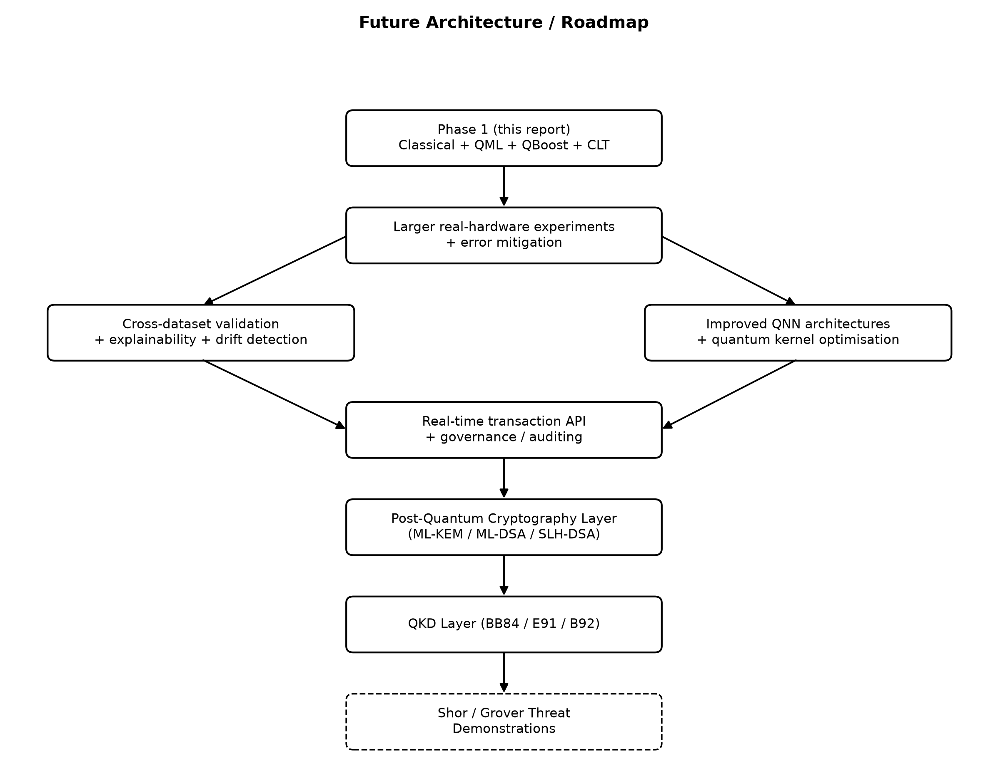
Figure 11. Future architecture / roadmap.
- Larger real-IBM-hardware experiments (6-8 qubits) once a paid or larger-quota plan is available, including genuine hardware-trained (not just hardware-inferred) circuits.
- Advanced error mitigation (zero-noise extrapolation, readout-error mitigation) for the hardware execution path.
- Improved QNN/VQC architectures: deeper structured ansatze, data re-uploading (Perez-Salinas et al., 2020), alternative readouts.
- Quantum-kernel optimisation and evaluation at larger simulated qubit counts (Kyriienko & Magnusson, 2022 report a positive, scale-growing kernel advantage up to 20 qubits worth directly investigating).
- Hybrid ensembles beyond simple logistic fusion -- stacking, boosting-style quantum-classical combination.
- Cross-dataset validation: train on one of the four datasets, evaluate on another, to test whether a model has learned genuine fraud patterns or dataset-specific artefacts.
- Explainability extension: verified SHAP execution (currently native-importance fallback only, per loophole item 6) plus LIME/permutation importance.
- Population/concept drift detection between train and test feature distributions (PSI / KS-test).
- Bounded hyperparameter search (RandomizedSearchCV, 2-3 models, validation-only selection) to quantify the gap between the current fixed defaults and a lightly tuned model.
- Feature engineering: log1p(Amount), cyclical hour-of-day encoding, frequency/target encoding for high-cardinality categoricals (fit on train only).
- Real-time transaction-processing API and production deployment architecture.
- Governance and auditing: model versioning, decision logging, human-in-the-loop review workflow for HIGH-risk transactions.
- Post-quantum cryptography layer: ML-KEM, ML-DSA, SLH-DSA integration for transaction security (Chhetri et al., 2025).
- QKD layer: BB84 / E91 / B92 protocol implementation for key distribution.
- Shor/Grover threat demonstrations against classical cryptographic primitives, to motivate and validate the post-quantum migration.

16. Conclusion
Phase 1 of the Quantum-Secure Fraud Detection System delivers a statistically validated, production-ready classical fraud detector (XGBoost, PR-AUC 0.80, 95% CI verified, 3ms latency), a faithful replication of the standard fraud-QML literature (QSVM/VQC/QNN), and -- the project's genuine research contribution -- an isolated Chow-Liu-tree research layer demonstrating that real, data-derived dependency structure can meaningfully improve quantum fraud-detection performance and, at small scale, noise robustness, while honestly reporting that this benefit does NOT survive transpilation onto realistic hardware connectivity beyond 4 qubits. QBoost and hybrid fusion did not outperform their classical counterparts on this problem. Every one of these findings, including the negative ones, is backed by measured, checkpointed, reproducible experiments, culminating in a genuine execution on IBM Quantum hardware whose result independently corroborates the simulated noise-robustness finding. No claim of quantum advantage is made or supported by this evidence. The system is architected so that this fraud-detection layer is a clean, stable input to the still-unimplemented post-quantum security layer that will complete the wider Quantum-Secure Fraud Detection System.

References
1. Dal Pozzolo, A., Caelen, O., Le Borgne, Y.-A., Waterschoot, S., Bontempi, G. (2014). Learned lessons in credit card fraud detection from a practitioner perspective. Expert Systems with Applications, 41(10), 4915-4928.
2. Dal Pozzolo, A., Boracchi, G., Caelen, O., Alippi, C., Bontempi, G. (2018). Credit Card Fraud Detection: A Realistic Modeling and a Novel Learning Strategy. IEEE TNNLS, 29(8), 3784-3797.
3. Dal Pozzolo, A., Caelen, O., Johnson, R.A., Bontempi, G. (2015). Calibrating Probability with Undersampling for Unbalanced Classification. IEEE SSCI/CIDM, 159-166.
4. Bhattacharyya, S., Jha, S., Tharakunnel, K., Westland, J.C. (2011). Data mining for credit card fraud: A comparative study. Decision Support Systems, 50(3), 602-613.
5. Kabane, S. (2024). Impact of Sampling Techniques and Data Leakage on XGBoost Performance in Credit Card Fraud Detection. arXiv:2412.07437.
6. Lucas, Y., Jurgovsky, J. (2020). Credit card fraud detection using machine learning: A survey. arXiv:2010.06479.
7. Liu, F.T., Ting, K.M., Zhou, Z.-H. (2008). Isolation Forest. IEEE ICDM, 413-422.
8. Chawla, N.V., Bowyer, K.W., Hall, L.O., Kegelmeyer, W.P. (2002). SMOTE: Synthetic Minority Over-sampling Technique. JAIR, 16, 321-357.
9. Lemaitre, G., Nogueira, F., Aridas, C.K. (2017). Imbalanced-learn: A Python Toolbox to Tackle the Curse of Imbalanced Datasets in Machine Learning. arXiv:1609.06570.
10. Davis, J., Goadrich, M. (2006). The Relationship Between Precision-Recall and ROC Curves. ICML 2006, 233-240.
11. McDermott, M.B.A., Zhang, H., Hansen, L.H., Angelotti, G., Gallifant, J. (2024). A Closer Look at AUROC and AUPRC under Class Imbalance. NeurIPS 2024. arXiv:2401.06091.
12. Niculescu-Mizil, A., Caruana, R. (2005). Predicting Good Probabilities With Supervised Learning. ICML 2005.
13. Isangediok, M., Gajamannage, K. (2022). Fraud Detection Using Optimized Machine Learning Tools Under Imbalance Classes. arXiv:2209.01642.
14. Lundberg, S.M., Lee, S.-I. (2017). A Unified Approach to Interpreting Model Predictions. NeurIPS 2017. arXiv:1705.07874.
15. Awosika, T., Shukla, R.M., Pranggono, B. (2023). Transparency and Privacy: The Role of Explainable AI and Federated Learning in Financial Fraud Detection. arXiv:2312.13334.
16. Almalki, F., Masud, M. (2025). Financial Fraud Detection Using Explainable AI and Stacking Ensemble Methods. arXiv:2505.10050.
17. Thanathamathee, P., Sawangarreerak, S., Chantamunee, S., Mohd Nizam, D.N. (2024). SHAP-Instance Weighted and Anchor Explainable AI: Enhancing XGBoost for Financial Fraud Detection. Emerging Science Journal, 8(6), 2404-2430.
18. Zhou, et al. (2023). A user-centered explainable artificial intelligence approach for financial fraud detection. Finance Research Letters, 58, 104309.
19. Havlicek, V., Corcoles, A.D., Temme, K., Harrow, A.W., Kandala, A., Chow, J.M., Gambetta, J.M. (2019). Supervised learning with quantum-enhanced feature spaces. Nature, 567, 209-212.
20. Farhi, E., Neven, H. (2018). Classification with Quantum Neural Networks on Near Term Processors. arXiv:1802.06002.
21. Schuld, M., Bocharov, A., Svore, K.M., Wiebe, N. (2020). Circuit-centric quantum classifiers. Physical Review A, 101, 032308.
22. Perez-Salinas, A., Cervera-Lierta, A., Gil-Fuster, E., Latorre, J.I. (2020). Data re-uploading for a universal quantum classifier. Quantum, 4, 226.
23. McClean, J.R., Boixo, S., Babbush, R., Smelyanskiy, V.N., Neven, H. (2018). Barren plateaus in quantum neural network training landscapes. Nature Communications, 9, 4812.
24. Biamonte, J., Wittek, P., Pancotti, N., Rebentrost, P., Wiebe, N., Lloyd, S. (2017). Quantum machine learning. Nature, 549, 195-202.
25. Huang, H.-Y., Broughton, M., Mohseni, M., Babbush, R., Boixo, S., Neven, H., McClean, J.R. (2021). Power of data in quantum machine learning. Nature Communications, 12, 2631.
26. Sim, S., Johnson, P.D., Aspuru-Guzik, A. (2019). Expressibility and entangling capability of parameterized quantum circuits for hybrid quantum-classical algorithms. Advanced Quantum Technologies. arXiv:1905.10876.
27. Kandala, A., Mezzacapo, A., Temme, K., Takita, M., Chow, J.M., Gambetta, J.M. (2017). Hardware-efficient variational quantum eigensolver for small molecules and quantum magnets. Nature, 549, 242-246.
28. Preskill, J. (2018). Quantum Computing in the NISQ era and beyond. Quantum, 2, 79.
29. Innan, N., Al-Zafar Khan, M., Bennai, M. (2023). Financial Fraud Detection: A Comparative Study of Quantum Machine Learning Models. arXiv:2308.05237; Int. J. Quantum Information.
30. Kyriienko, O., Magnusson, E.B. (2022). Unsupervised quantum machine learning for fraud detection. arXiv:2208.01203.
31. Grossi, M., Ibrahim, N., Radescu, V., Loredo, R., Voigt, K., Von Altrock, C., Rudnik, A. (2022). Mixed Quantum-Classical Method For Fraud Detection with Quantum Feature Selection. arXiv:2208.07963.
32. El Alami, M., Innan, N., Shafique, M., Bennai, M. (2024). Comparative Performance Analysis of Quantum Machine Learning Architectures for Credit Card Fraud Detection. arXiv:2412.19441.
33. Cardaioli, M., Marangoni, L., Martini, G., Mazzolin, F., Pajola, L., Ferretto Parodi, A., Saitta, A., Vernillo, M.C. (2025). FD4QC: Application of Classical and Quantum-Hybrid Machine Learning for Financial Fraud Detection -- A Technical Report. arXiv:2507.19402.
34. Innan, N., Singh, A., Shafique, M. (2025). CircuitHunt: Automated Quantum Circuit Screening for Superior Credit-Card Fraud Detection. arXiv:2508.21366.
35. Chaves, R., Kumar, K., Chagas, B., Linerud, R., Sorem, B., Mancilla, J., Bell, B. (2026). A Mixture-of-Experts Framework for Practical Hybrid-Quantum Models in Credit Card Fraud Detection. arXiv:2603.06473.
36. Chow, C.K., Liu, C.N. (1968). Approximating discrete probability distributions with dependence trees. IEEE Transactions on Information Theory, 14(3), 462-467.
37. Tang, H.L., et al. (2020/2021). Correlation-Informed Permutation of Qubits for Reducing Ansatz Depth in the Variational Quantum Eigensolver (PermVQE). PRX Quantum, 2, 020337.
38. Bako, B., Nagy, D.T.R., Haga, P., Kallus, Z., Zimboras, Z. (2024). Problem-informed Graphical Quantum Generative Learning. arXiv:2405.14072.
39. Kurt, M. (2026). A Correlation Aware Quantum Feature Map for Variational Quantum Classification. arXiv:2606.21570.
40. Neven, H., Denchev, V.S., Rose, G., Macready, W.G. (2012). QBoost: Large Scale Classifier Training with Adiabatic Quantum Optimization. ACML, JMLR W&CP 25.
41. Denchev, V.S., Ding, N., Vishwanathan, S.V.N., Neven, H. (2012). Robust Classification with Adiabatic Quantum Optimization. ICML 2012. arXiv:1205.1148.
42. Date, P., Arthur, D., Pusey-Nazzaro, L. (2021). QUBO formulations for training machine learning models. Scientific Reports, 11, 10029.
43. Farhi, E., Goldstone, J., Gutmann, S. (2014). A Quantum Approximate Optimization Algorithm. arXiv:1411.4028.
44. Bose, B., Faryad, M. (2026). A Systematic Study of Noise Effects in Hybrid Quantum-Classical Machine Learning. arXiv:2604.11541.
45. Moradi, S., Brandner, C., Coggins, M., Wille, R., Drexler, W., Papp, L. (2022). Error mitigation for quantum kernel based machine learning methods on IonQ and IBM quantum computers. arXiv:2206.01573. NOTE: withdrawn by the authors (v3, July 2022) -- verify current status before citing.
46. Novak, V., Illesova, S., Bezdek, T., Zelinka, I., Beseda, M. (2025). Reliable Optimization Under Noise in Quantum Variational Algorithms. arXiv:2511.08289.
47. Orus, R., Mugel, S., Lizaso, E. (2019). Quantum computing for finance: overview and prospects. Reviews in Physics, 4, 100028.
48. Herman, D., et al. (2022). A Survey of Quantum Computing for Finance. arXiv:2201.02773.
49. Naik, A., Yeniaras, E., Hellstern, G., Prasad, G., Vishwakarma, S.K.L.P. (2023). From Portfolio Optimization to Quantum Blockchain and Security: A Systematic Review of Quantum Computing in Finance. arXiv:2307.01155.
50. Chhetri, G., Somvanshi, S., Hebli, P., Brotee, S., Das, S. (2025). Post-Quantum Cryptography and Quantum-Safe Security: A Comprehensive Survey. arXiv:2510.10436.

