A detailed study on Feedback, PID and Internal Model Control Strategies

Debsurya Roy(117EI0448)
Department of Electronics & Instrumentation Engineering
National Institute of Technology, Rourkela
Rourkela-769008, India
debsurya1999.roy@gmail.com

Abstract - In today’s modern industries, due to numerous changes in process parameters and product requirements, control issues and control strategy implementation is a major concern.These changes might be occur since the process characteristics are connected with linear behaviour, limitation of process variable and manipulated variable values during continuation of the operation. Liquid level control in tanks and between tanks are elementary industrial difficulty and also most essential needs since often tanks might be connected in series or parallel according to process requirements. Due efforts have been made to solve the issue by implementing various kind of control strategies to automate different kind of plant processes like feedback, feed-forward, IMC(Internal Model Control). In this paper, we will be talking about feedback and IMC strategies, two widely used control strategies and attempt to perform a comparative study between them.
Keywords—Industrial, feedback, Internal Model Control, Process Automation

Introduction
The process industries and manufacturing industries require control methods for liquid level maintenance and desired flow rate. In various oil and chemical plants, various process like level maintenance, mixing and separation of components in specific proportions, maintaining fluid temperature and all this in multiple connected tanks be it connected in series or parallel connection has always been a primary objective. For these various processes, two commonly used control strategies are feedback control and IMC based strategy. These techniques are used so that with the help of an array of sensors, controllers and valves, a process can be automated and no manual labour be needed.

Feedback control has been an important and commonly used control strategy. The process output is subtracted from the input and fed back to the controller. The controller measures this difference(error value), compares it with a pre-defined value at which the parameter is to be maintained and sends instructions to the final control element according to the error value.A high error value means more control action will be required and a low error value means some little control action will be enough. A PID(Proportional Integral Differential) controller is used to improve the smoothness and response of the automatic process. Tuning techniques like Ziegler-Nichols method are used to find the suitable coefficients for the PID algorithms used. They ultimately reduce the overshoot time of the process, or fasten the response time, etc. There are many such characteristics through which a feedback control system can be analyzed, some of them being Transfer functions, poles and zeroes, stability of a system, state space representation, inital and final values, Routh Hurwitz criterion, time response of first and second order system, root locus and bode plot. These criterions like stability tells a system is stable or not.

Another popularly used control technique is Internal Model Control(IMC), In processindustries, often it is required to store some fluid in a tank at a certain level and temperature, and then transfer it tp another connected tank at a certain rate. For such complicated processes, obviously manually controlling them can be quite troublesome. So, some predictive control techniques like IMC is used. It is mostly used when in practical we can’t determine the actual transfer function corresponding to the process(which happens in most practical cases). In that case, we take an approximate plant transfer function and compare it with a closest achievable process transfer function, and subtract the two responses and send it as feedback. The best part of an IMC is that it provides a transparent framework for control system design and tuning. As we will soon find out, the IMC control structure can be formulated in the standard feedback control structure.

Literature Survey

The following are some of the studies that have been done on different industrial process control strategies :

Feed-Forward Control: Unlike traditional feedback control system, this technique measures deviations in the disturbance sources and the manipulating variable(steam for a boiler). It sends the deviations directly to the controller before it’s transmitted to the whole process. So before the deviation is transmitted, the manipulated variable is controlled to it’s set point by correcting the deviations of the disturbances.

Internet Of Things: A popular automation and control technique nowadays, gaining rapid popularity. A micro-controller lie a R-Pi is connected with an array of sensors and computer system to control some automation processes. But while considering heavy bulky: This techn cases like tonnes of fluid flow, where a more robust system is required, IoT is not generally a very commonly used choice.

Large Mobile Robots: Mobile robots, having servo mechanisms are quite commonly used in control techniques nowadays. They are used for various purposes like automated grinding of pipes, loading and unloading of goods, cleaning and galvanizing substances, etc. Though very useful, these robots are very expensive to manufacture and don’t come into much play while handling fluids.
- Automatic tuning of PID controllers: As we know, tuning of PID coefficients is detrimental for a smooth feedback control process. But in general case, those coefficients remain fixed throughout. But very recently, the same can be auto-tuned with some algorithms, and they change overtime as per the process requirement, which gives a more superior and flexible control output.

Proposed Model(Feedback)
Here, we consider a simple feedback structure imitating a simple plant process. We take a sample transfer function :
G(s) = 1/(3s^2 + 5s +8)
This here is the open loop transfer function. Now as there is a feedback path with unity gain, the closed loop transfer function
Gc(s) = G(s)/(1+G(s))

This feedback structure also has a PID controller, tuning whose coefficients we get an optimum response. Various tuning techniques like Ziegler-Nichols method along with our own intuitive factor was used in finding the proper tuning parameters. The PID transfer function as used by the simulink system is :

P + I/s + D.N/(1+N/s)

Where P,I,D are the proportional, Integral and Differential coefficients respectively.
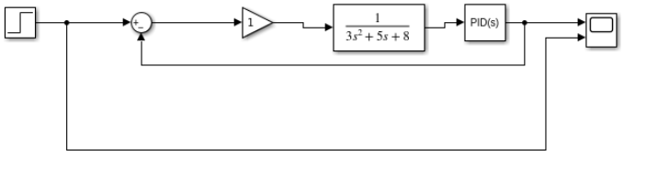
Feedback block diagram
Here, we will compare a un-tuned response with a proper parameter tuned response, to observe how changing parameters affect a system.
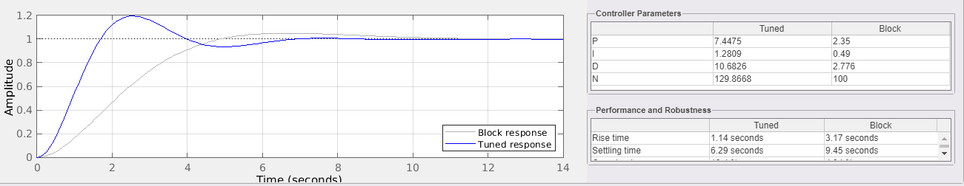

Response plots for feedback system

Here we can clearly observe differences between the efficiency and smoothness of the two systems.
The tuned one has a rise time of 1.14 sec and settling time 6.29 sec against 3.17 sec and 9.45 sec of the un-tuned one. So the response is not only faster but also settles down quicker.

Proposed model(IMC)
Here, we take a plant model:
G(s) = (-9s +1)/(15s+1)(3s+1)

Now we assume this to be a perfect system for ease of simulation and tuning, so we take the same transfer function for our process model :
Gp(s) = (-9s+1)/(15s+1)(3s+1)

A step comes where the transfer function becomes improper. To make it proper, we add a filter to it
f(s)= 1/(As+1)

Here, A is the main tuning parameter with the help of which the response is smoothened.
q(s) = (Gp-(s))f(s)
= (15s+1)(3s+1)/(9s+1)(As+1)

The output transfer function thus stands for a perfect model like this :
y(s) = Gp+(s)f(s)r(s)
= (-9s+1)/(9s+1)(As+1) *r(s)
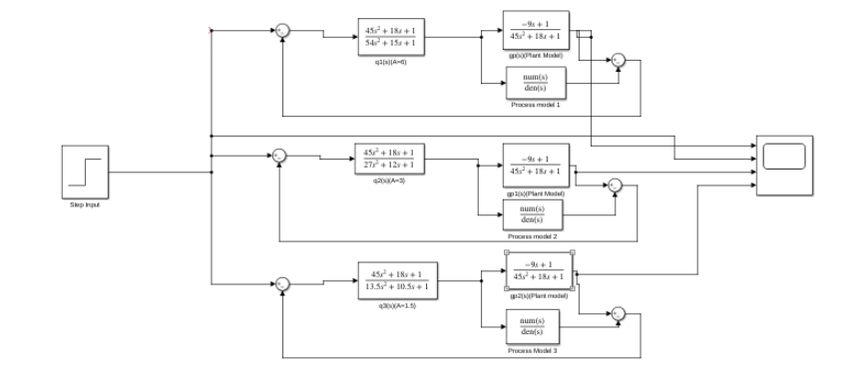

IMC block diagram

Here, for tuning of the process, we vary the value of A over 6, 3 and then 1.5 .
We will clearly be able to see through carrying out some simulink simulations that as we keep on reducing the value of A from 6 to 1.5, though the process improves it’s response time, but the overshoot increases. So there is basically a trade-off between peak overshoot and response time which we need to take care of. This control strategy is a bit convenient because rather than controlling 3 parameters in PID tuning, we will have to control just the one parameter A(filter coefficient) to control the response of the process.

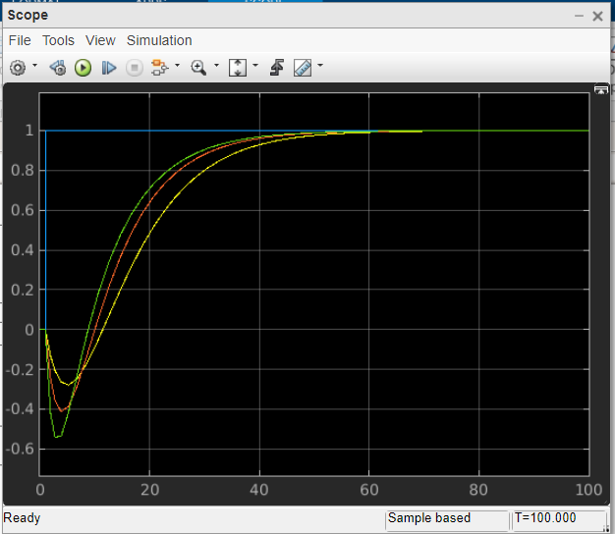

Unit step response of IMC with varying parameters

The green line represents A=1.5, the red line for A=3 and the yellow line for A=6.

Future Work
.For future work in this field, we can use a PID controller in our IMC control strategy. Not only will it be a very efficient combination but also we can get better tuning and thus lower overshoots and faster responses that their individual counterparts. After achieving this, we can implement the algorithms of auto-tuning of PID and filter parameters of IMC, such that during a process along with change in process conditions, these parameters get auto-tuned in accordance to the best performance of the process. In this way no manual labour and no manual calculation will be required at all to find the parameters and the process will run by itself smoothly.

Conclusion
Manufacturing has been a major source of economy boost for our country. And the more efficiently the manufacturing of goods are carried out in our country, the more effectively will the country be able to grow. Efficient manufacturing includes lower production cost and better quality products, which also includes leaning towards automation more and leaning away from manual labour. The process control startegies like feedback, PID, IMC come into play right here. For efficient manufacturing, it is not only detrimental that these strategies be implemented properly but advance research, improvement and smart improvisation be also carried out, so as to keep on improving the standard of the material and the processes to be at par with the outside world.

References

- George Stephanopoulos, Chemical Process Control, Prentice Hall, NJ, 1984.
- Rajesh, Arunjayankar.S, Siddharth.S.G ,“Design and implementation of IMC based PID controller for conical tank level control process” for international journal of innovative research in electrical, electronics, instrumentation and control engineering, vol 2 issue 9,September 2009.
- Y. LEE, GS-Caltex Corp., Yeochon, Korea; S. PARK, KAIST, Daejon, Korea; and M. LEE, Yeungnam University, Kyongsan, Korea , “Consider the generalized IMC-PID method for PID controller tuning of time-delay processes”, Hydrocarbon Processing January 2006
- Mohammad Shahrokhi and Alireza Zomorrodi, “Comparison of PID Controller Tuning Methods”, Department of Chemical & Petroleum Engineering Sharif University of Technology
- Indirapriyadharshini. J,P.Dhivya, Elayabharathi.V, Gowtham.T, V.Lokeshkannan,“ Analysis of PID controller for interacting and noninteracting system using Lab VIEW” for international journal of applied engineering research, January 2015.
- Miss. Londhe P, Prof. Kadu C, Prof. Parvat B,“ IMC-PID controller designing for fopdt&sopdt systems”, international journal of innovative research in electrical, electronics, instrumentation and control engineering Vol. 4, Issue 5, May 2016
- V.R.Ravi, T.Thyagarajan, M.Monika Darshini“A Multiple Model Adaptive Control Strategy for Model Predictive controller for Interacting Non Linear Systems”, International Conference on Process Automation, Control and Computing (PACC),July 2011.pp:1 – 8

