SALES PERFORMANCE ANALYSIS
Transforming Sales Data into Actionable Business Insights Using Power BI

Why I Selected This Project
Sales performance is one of the most important indicators of business success. This project demonstrates how business intelligence tools can transform raw sales transactions into meaningful insights for management decision-making.
The project involved importing raw sales data, cleaning and modelling the dataset, creating DAX measures for KPIs, and designing interactive visualizations that communicate trends and opportunities clearly.

Keywords
Power BI | Data Analytics | Business Intelligence | Sales Analysis | KPI Tracking | Dashboard Design | DAX | Profit Analysis | Trend Analysis

Target Audience
• Sales Managers
• Business Executives
• Marketing Teams
• Financial Analysts
• Students and Academic Evaluators

Requirement Gathering
• Total Sales and Year-over-Year Growth.
• Total Profit and Profit Margin.
• Total Orders and Average Order Value.
• Sales by Region, Category, and Customer Segment.
• Monthly Sales Trend Analysis.
• Top Products Analysis.
• Regional Sales Distribution.

Data Preparation and Modelling
• Removed duplicates and missing values.
• Standardized categories and regions.
• Created Date Table for time intelligence calculations.
• Established relationships between tables.
• Validated the data model before creating visuals.

Step-by-Step Build Process
• Imported data into Power BI.
• Performed transformations in Power Query.
• Created DAX measures for KPIs.
• Developed KPI cards and trend charts.
• Added interactive filters and slicers.
• Designed the final dashboard layout.

Key DAX Measures
Total Sales = SUM(train[Sales])
Total Orders = DISTINCTCOUNT(Sales[Order ID])
Total Customer = COUNTA(train[Customer ID])
Average of Value = DIVIDE(train[total sales],train[Total Customer])

Dashboard Visuals
• KPI Cards
• Monthly Sales Trend Chart
• Category-wise Sales Chart
• Region-wise Map
• Customer Segment Analysis
• Top Products Table

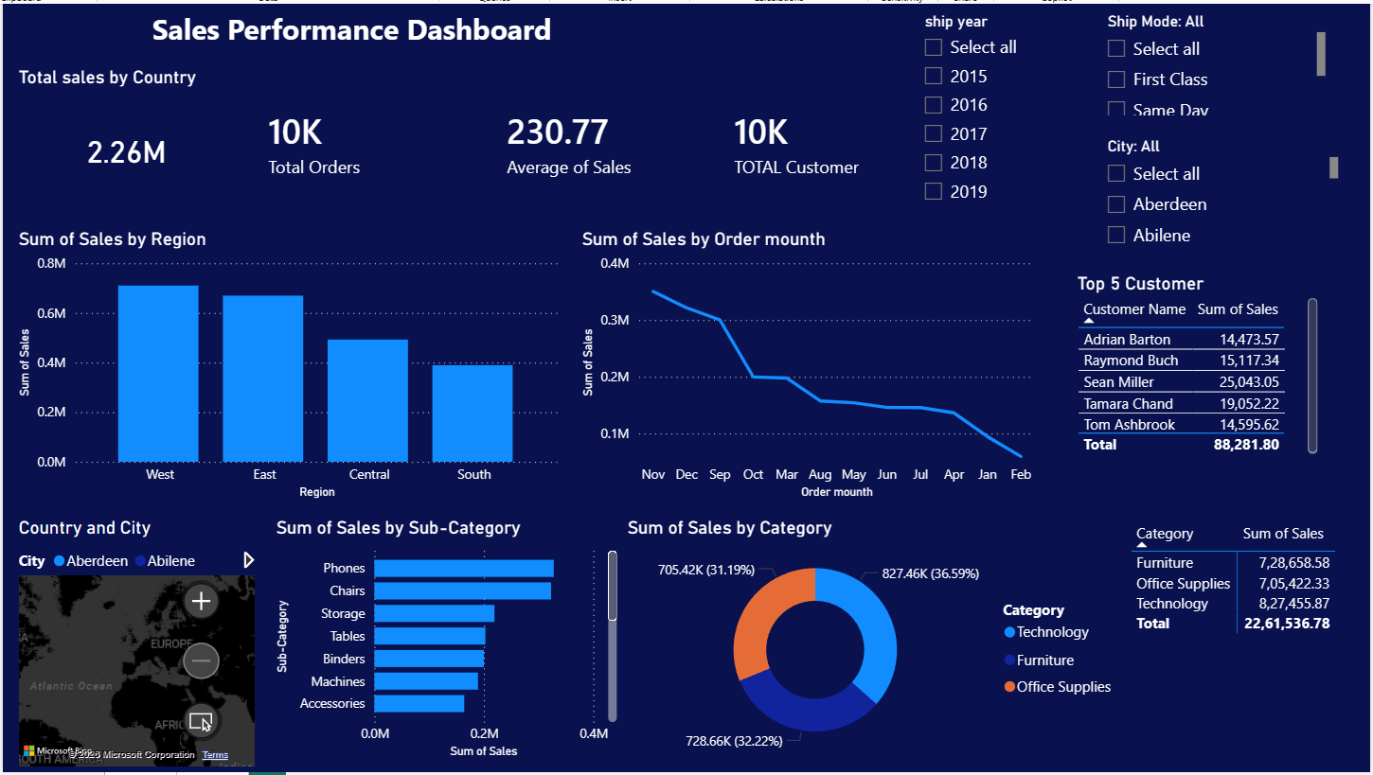

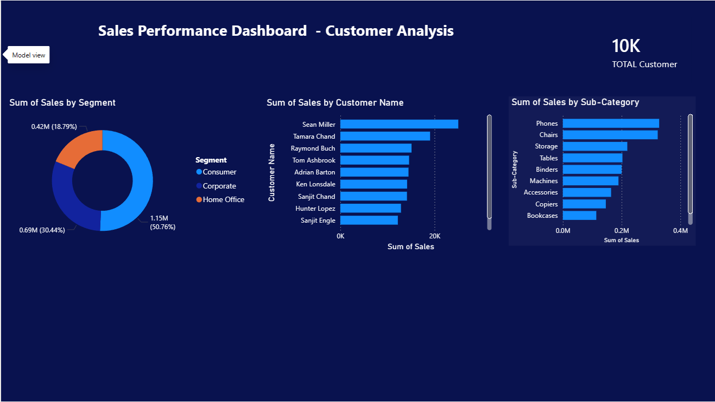

Executive Recommendations
1. Increase focus on high-performing regions.
2. Improve margins in low-profit categories.
3. Expand investment in top-performing products.

Conclusion
The dashboard provides a centralized and interactive platform for monitoring sales performance and supporting data-driven business decisions.

