# INTERNSHIP TASK

TASK

Red light Detection and Recognition

You are required to make an classifier/model which can detect traffic lights and then recognize the light which is shown by the traffic light. And you are not supposed to use tensorflow API directly

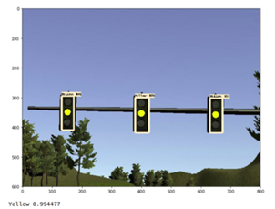

APPROACH

1. I collected data for green light, yellow light and red light separately.
2. Converted all the images in grayscale using opencv.
3. Resized all the images in 100X100.
4. Used Keras which works on top of tensorflow and trained my model using convolutional neural network which can classify the image based on red yellow and green.
5. Used following layers to train my model.
6. used this model to predict other images and classify them as green,red and light.

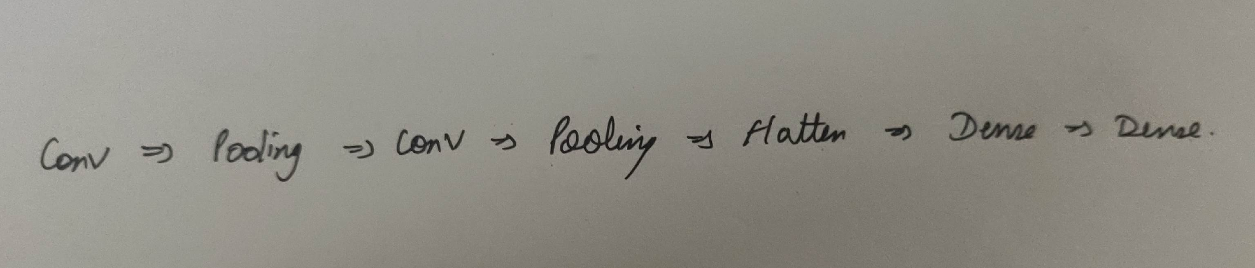

1. Got accuracy upto 84%
2. Used Avtivation layer of ReLU (Rectified Linear Unit) , most commonly used activation function . (avtivation functions are used for non linearity)

ALGORITHM USED

I used Convolution Neural Network which  is a class of deep neural networks, most commonly applied to analyzing visual imagery.

CNNs are regularized versions of multilayer perceptrons.

Multilayer perceptrons usually refer to fully connected networks, that is, each neuron in one layer is connected to all neurons in the next layer. The "fully-connectedness" of these networks makes them prone to overfitting data.

Typical ways of regularization include adding some form of magnitude measurement of weights to the loss function.

However, CNNs take a different approach towards regularization: they take advantage of the hierarchical pattern in data and assemble more complex patterns using smaller and simpler patterns.

TERMS (LAYERS) USED:

{ Convolution layer, Image Features(kernel size, Depth, Stride Padding), Feature Map, Activation function(ReLU, Softmax), Pooling(max,sum,average), Fully Connected Layer(Dense layer)}

WHY CNN?

1. Neural Networks acts as a “Black-Box” brain that takes input and predicts an output.
2. Neural Network is different and better than most traditional Machine Learning algorithms because it learns complex nonlinear mapping to produce far more accurate output classification results.
3. But CNN, they form the foundation of deep learning image classification.
4. Neural Network don’t scale well to images data. Suppose the input size to our NN would be 64X64X3 (3 for colored image) = 12,288 which is very large number as an input.
5. CNN are easy to learn and implement as model can be trained by simply adding the layers using model.add() function.
6. The more the layers used the more dense(deep) will be the CNN resulting in more validation and test accuracy.

PROBLEMS FACED:

As I am new in performing and implementing such algorithms it took so much time to find and resolve errors.

There was not any material related to this problem statement so I find it very challenging.

The images in google search for traffic lights were not up to the mark after gray scaling and resizing it was very hard to differentiate if the light is on or not majorly all the color from the lights disappeared(1) .

Still managed to got an accuracy of upto 84% which is a good start. Currently working more on adding more layers to my model thus making it more dense, to get an accuracy of more than 90%.

This classifier can not work on arrowed(2) images and not for the horizontal(3) traffic lights.

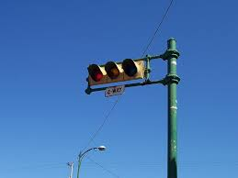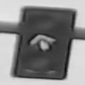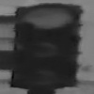

Image result for 1

It was a great time working on this project. Looking forward to work live under professionals to enhance the skillset and gain some experience and knowledge.

Thank You

Vedant Mehta

[mehtavedant7498@gmail.com](mailto:mehtavedant7498@gmail.com)

+91 8800755121