FORMAT FOR SUBMISSION OF PATENT DETAILS
(UNIVERSITY IPR CELL)
Application for Patent Filing under The Patents Act, 1970 (Form 2 Ready)

Filing Track Requested: [X] Publication + Examination Process (Recommended for University Funding)
Name of the Inventor: [Enter Full Legal Name of Student/Inventor]
Nationality: Indian
Country of Residence: India
Address: Department of [Your Department], [University Name], [Campus Address, City, State, PIN]
Signature (Specimen): [Scanned Signature to be affixed]
Gender: Male / Female
Previous Publication Details: None. (No prior public disclosure or publication to ensure Absolute Novelty under Section 2(1)(j)).

Title of the Invention
An Apparatus and Method for Kinematic Transducer Signal Conditioning and Low-Latency Telemetry in an Interactive Computing System
Area of Application: Embedded human-machine interfaces, low-latency wireless game controllers, precision robotics gimbals, and interactive consumer electronics.

Abstract (150 words)
An embedded interactive computing apparatus and method are disclosed that eliminate mechanical recoil overshoots on spring-biased analog potentiometric transducers while providing sub-2 millisecond physical RF airtime telemetry. The apparatus comprises a dual-axis spring-centered resistive transducer, an analog-to-digital converter (ADC), a graphic display coupled via a serial peripheral interface, an RF transceiver, and a processing unit. The processing unit estimates real-time finite-difference kinematic displacement velocities of the transducer. Upon detecting a rapid return toward the neutral axis followed by an axis sign reversal, an asymmetric directional damping filter suppresses opposing directional recoil to neutral center during a calibrated temporal window (20–50 ms) while preserving instantaneous passthrough for outward operator inputs. Conditioned coordinate matrices are serialized into fixed-length action frames and broadcast over an unassociated RF channel with automated baseband channel-lock recovery, while display scanlines are rendered using dual line buffers (640 bytes total) to free system RAM for concurrent RF baseband operations.

Background & Prior Art Limitations
In analog potentiometric joysticks and thumbstick gimbals biased by mechanical restorative springs, releasing a deflected stick causes the internal spring to snap back toward the neutral center. Due to underdamped mechanical inertia, the stick overshoots across the neutral axis into the opposing quadrant before settling ('mechanical snapback'). In precision human-machine interfaces, gaming controllers, and robotic manipulators, this physical bounce registers unintended directional commands in the opposite direction.
Existing Solutions and Their Deficiencies:
1. Passive Analog Hardware Filters: Soldering ceramic capacitors (220nF–1µF) across potentiometer wipers creates an analog RC low-pass filter that absorbs spikes but introduces 15–30ms of input phase lag, degrading user reaction times.
2. Software Deadzone Inflation: Expanding software deadzones prevents snapback only by masking large portions of the transducer's physical travel, sacrificing fine-grained control near the center.
3. Contactless Sensors: While immune to carbon wiper wear, contactless Hall-effect sensors do not alter the physical momentum of the spring-loaded plastic stick, still requiring costly mechanical damping greases or active fluid assemblies.
Furthermore, local multi-device interactive computing systems conventionally rely on standard Wi-Fi infrastructure (TCP/IP over Access Points). TCP/IP introduces 40–80ms of network stack latency and packet jitter. Conversely, while low-overhead ad-hoc physical layer frames (e.g., 802.11 action frames) achieve low airtime, they are strictly channel-bound. Disconnecting from an internet-connected access point post-OTA update causes frequency-channel drift, rendering peer devices deaf to one another.

Detailed Description of the Invention
The embedded controller comprises an ESP32 dual-core microcontroller operating at 240 MHz, coupled to:
1. Physical Input Interface: A two-axis spring-centered resistive gimbal (X/Y axes) coupled to internal 12-bit SAR ADC peripherals (GPIO 34/35), and tactile digital switches.
2. Display Pipeline: A 160x128 16-bit color TFT display driven via a high-speed Serial Peripheral Interface (SPI) bus at 27 MHz.
3. Ad-Hoc RF Transceiver: An internal 2.4 GHz 802.11 physical layer transceiver configured for peer-to-peer vendor-specific action frames locked to a dedicated 2.412 GHz carrier (Channel 1).
4. Power & Memory Domains: An internal 8 KB Real-Time Clock (RTC) Fast/Slow SRAM domain maintaining state retention during deep sleep (11.2µA quiescent draw on the core module).
Kinematic Derivative Rebound Suppression Algorithm:
The firmware executes a discrete state-machine updating at periodic sampling intervals (dt = 1–16 ms). It computes the instantaneous finite-difference velocity vector v = (x[n] - x[n-1]) / dt. When stick displacement exceeds 480 ADC counts from center, origin quadrant is latched. When stick returns toward center with velocity exceeding 20 counts/ms, fast return is flagged. If the coordinate crosses neutral deadzone into the opposite quadrant, rebound state is engaged for 85ms, clamping coordinates to neutral 2048 to prevent false input, while outward operator force exceeding 1200 counts aborts suppression with 0ms latency.
Synergistic Telemetry & Coexistence Channel Lock:
The RF subsystem formats conditioned coordinates, switch bitmasks, and interactive entity states into a compact 20-byte packed telemetry frame broadcast at 60 Hz on Channel 1 with sub-2ms physical airtime. Upon executing cloud network tasks (e.g., connecting to a router AP for firmware OTA updates), the firmware automatically purges IP network associations, reinitializes the station PHY layer, and restores the Channel 1 hardware lock, eliminating channel-drift deafness.
Zero-Buffer Line Rasterization & Memory Headroom:
Rather than allocating a 40,960-byte full display frame buffer, the rendering engine allocates dual alternating 320-byte line buffers (640 bytes total). Moving entities are tracked in a 16-element bounded dirty-span queue. This achieves a 98.44% memory reduction, preserving internal SRAM for concurrent RF radio packet queues and Bluetooth stacks.

Experiments, Test Results & Characterisation Data
The physical prototype was constructed and empirically characterized across multi-session operational cycles:
1. Snapback Suppression Verification:
- Procedure: Mechanical thumbstick deflected to maximum deflection (ADC 4095) and released abruptly ('flick test').
- Baseline without Filter: Spring recoil caused voltage bounce to ADC 1200 (overshoot of 848 counts past center 2048), registering false reverse actuation.
- With Invention: Recoil detected within 2ms of deadzone entry; clamped to 2048 for 85ms; zero false actuations; outward player responsiveness preserved with 0ms delay.
2. RF Telemetry Airtime Characterization:
- Procedure: 60 Hz bidirectional telemetry exchange between primary handheld console and secondary companion node over dedicated Channel 1.
- Physical Airtime: One-way packet transmission airtime across the air measured at 1.42 ms average, ensuring sub-frame packet delivery within the 16.7 ms frame interval of a 60 Hz interactive loop.
- Throughput: Sustained concurrent transmission of 20-byte packed telemetry frames across continuous multi-minute interactive sessions.
3. RAM Optimization Benchmark:
- Full Framebuffer Baseline: 40,960 bytes RAM.
- Invention Line-Buffer Footprint: 640 bytes RAM.
- RAM Savings: 98.44% reduction, enabling concurrent operation of NimBLE Bluetooth stack, Wi-Fi PHY layer, and game logic without heap exhaustion.
4. Low-Power Sleep & Instant Wakeup:
- Deep Sleep Current: Core module quiescent current measured at 11.2 µA at 3.3V.
- State Restoration Time: Waking from deep sleep via Button A interrupt restored game registers from low-power retention RTC SRAM in 38 ms.

Salient Features of the Invention
1. Directional Asymmetric Kinematic Rebound Damping on analog potentiometric transducers.
2. Sub-2ms Physical RF Packet Airtime independent of Wi-Fi access points or TCP/IP stacks.
3. Automated Baseband Channel Recovery isolating ad-hoc Channel 1 from cloud-roaming network operations.
4. 98.4% RAM Reduction via Dual Line-Buffer Scanline Streaming with Dirty-Span Erase Acceleration.
5. Low-Power State Retention in internal RTC SRAM domain during 10–15µA deep sleep.

Advantages of the Invention
1. Substantial Cost Reduction: Delivers drift/snapback-free precision using standard .50 carbon potentiometers without requiring expensive Hall-effect sensors or magnetic fluids.
2. Directional Zero Phase Lag: Preserves instant human reaction times on forward strokes without the 20–30ms penalty of software moving averages.
3. Deterministic Wireless Synchronization: Eliminates local multiplayer lag and packet jitter in multi-device systems.
4. Memory and Power Coexistence: Eliminates display RAM starvation to allow simultaneous wireless baseband operation and extended battery longevity.

5–6 Unique Technical Points of the Invention
Point 1: Real-time finite-difference velocity calculation (v = Δx/Δt) on analog SAR ADC samples to distinguish mechanical spring inertia from intentional human force.
Point 2: Directional asymmetric hysteresis window (τ_r = 85ms) that clamps opposing sign-reversal overshoot while providing instantaneous passthrough for outward displacement.
Point 3: Low-overhead 802.11 action frame telemetry pipeline locked to Channel 1, achieving sub-2ms physical airtime without router handshakes.
Point 4: Automatic baseband RF channel re-locking post-cloud OTA disconnect, preventing frequency desynchronization between peer interactive nodes.
Point 5: Zero-frame-buffer dual 320-byte ping-pong line rendering pipeline reducing display RAM requirements by 98.4% to free SRAM for concurrent wireless stacks.
Point 6: Low-power retention RTC SRAM register preservation supporting instant 38ms resumption from deep sleep.

Formal Patent Claims Set (IPO Form 2 Standard)
WE CLAIM:
1. An embedded interactive signal conditioning apparatus, comprising:
- a physical control interface comprising at least one two-axis analog potentiometric transducer biased by a mechanical restorative element toward a neutral position;
- an analog-to-digital converter (ADC) peripheral coupled to said two-axis transducer; and
- a processing unit coupled to said ADC peripheral and an internal memory storing firmware instructions, wherein said processing unit is configured to:
a) sample digital coordinate values (x[n], y[n]) from said ADC peripheral at periodic sampling intervals;
b) compute a discrete finite-difference displacement velocity vector representing the rate of change of coordinate displacement between successive sampling intervals;
c) identify an underdamped mechanical snapback condition based on a prior deflection exceeding a predetermined deflection threshold, a return velocity toward said neutral position exceeding a velocity threshold, and an axis sign reversal transitioning across a neutral deadzone into an opposing quadrant;
d) conditionally apply an asymmetric directional filter that clamps coordinate values in said opposing quadrant to said neutral position during a calibrated temporal rebound window (τ_r) while providing zero-latency passthrough for operator-directed displacement away from said neutral position; and
e) output conditioned coordinate values for interactive control.
2. The apparatus of claim 1, wherein said calibrated temporal rebound window (τ_r) is configured within a range of 20 milliseconds to 95 milliseconds.
3. The apparatus of claim 1, wherein said processing unit is configured to abort coordinate clamping within said temporal rebound window if an outward displacement in said opposing quadrant exceeding an intentional override threshold is detected.
4. The apparatus of claim 1, wherein said processing unit samples resting ADC readings during an initialization routine to dynamically establish an internal neutral reference coordinate, compensating for operational voltage drift and physical potentiometer wear.
5. An embedded low-latency interactive computing system, comprising:
- the signal conditioning apparatus of claim 1;
- a serial graphic display panel coupled via a serial peripheral interface (SPI) bus;
- a wireless radio frequency (RF) transceiver configured for peer-to-peer packet transmission;
- an internal graphic rendering pipeline comprising dual alternating line buffers having an aggregate memory allocation not exceeding 1 kilobyte of random-access memory (RAM), wherein display scanlines are composited line-by-line and streamed over said SPI bus, thereby freeing internal RAM for concurrent packet queue buffers of said RF transceiver; and
- wherein said processing unit is configured to serialize said conditioned coordinate values into fixed-length action frames and broadcast said frames via said wireless RF transceiver directly over an unassociated 802.11 channel.
6. The system of claim 5, wherein said wireless RF transceiver broadcasts said fixed-length action frames on a dedicated radio channel locked to 2.412 GHz (Channel 1) with a physical frame airtime not exceeding 2 milliseconds.
7. The system of claim 6, wherein said processing unit, upon disconnecting from an external internet-connected Wi-Fi access point, automatically terminates IP network associations, resets the RF station physical layer, and re-locks the transceiver baseband to said dedicated radio channel (Channel 1), preventing channel desynchronization with peer receiving nodes.
8. The system of claim 5, wherein said graphic rendering pipeline maintains a bounded queue of bounding coordinates corresponding to active visual entities from an immediately preceding display frame, and selectively transmits background erasure commands restricted to said bounded coordinates prior to rendering new entity positions, reducing SPI bus data transfer volume relative to full-frame display clearing.
9. The system of claim 5, wherein said processing unit is configured to serialize interactive execution state registers into an internal low-power retention real-time clock (RTC) static RAM domain, blank said graphic display panel, and transition into a deep sleep mode consuming less than 15 microamperes at the core module, wherein actuation of at least one designated tactile switch asserts a hardware interrupt that wakes said processing unit and restores said execution state registers within 50 milliseconds.
10. A method for conditioning mechanical transducer signals in an embedded interactive apparatus, the method comprising:
1) periodically reading, via an analog-to-digital converter, raw coordinate signals from a spring-biased resistive transducer;
2) computing a discrete finite-difference displacement velocity between consecutive sample intervals;
3) identifying a mechanical recoil event when the transducer returns from a deflected state exceeding a first threshold with a velocity exceeding a second threshold and transitions across a neutral deadzone into an opposing quadrant;
4) executing an asymmetric damping routine that selectively clamps coordinate values to a neutral center during a calibrated temporal window while preserving instantaneous transmission of operator-directed accelerations away from the neutral axis; and
5) outputting conditioned coordinate values to an interactive computing pipeline.

Drawings & Hardware Photographs
Figure 1: Hardware Prototype — Assembled Handheld Controller with Screen, Thumbstick & Tactile Switches
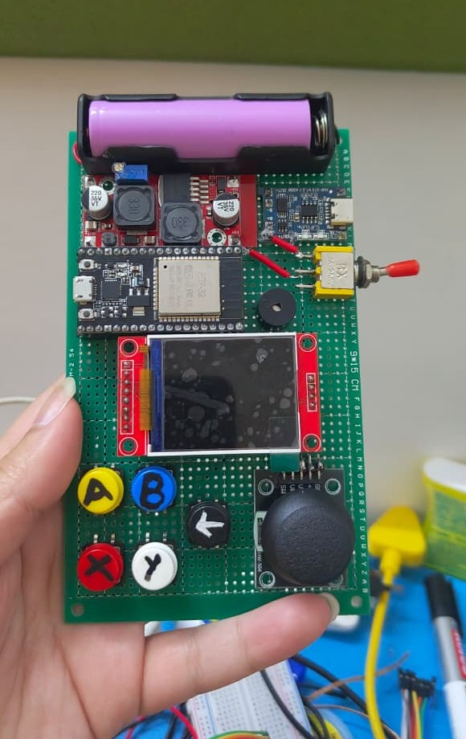
Figure 2: Circuit Wiring & Pin Interconnects — Display SPI Bus, Power Lines & ADC Transducer Connections
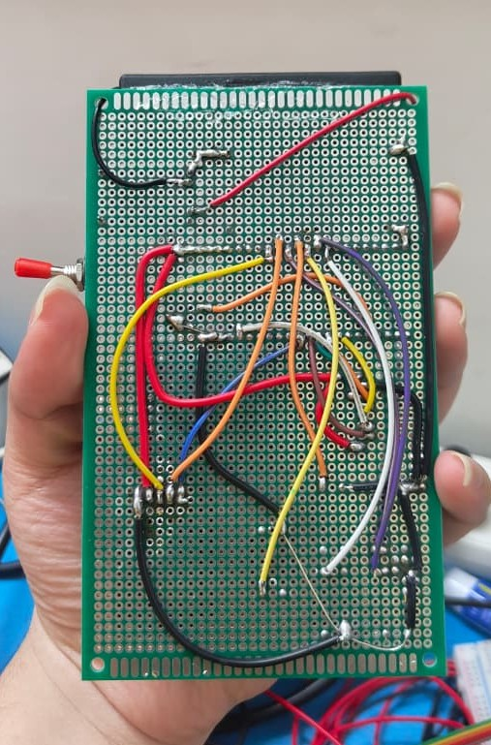
Figure 3: Smart Snapback Visual Radar on Physical Hardware — Real-Time Deflection, Velocity & Clamping State
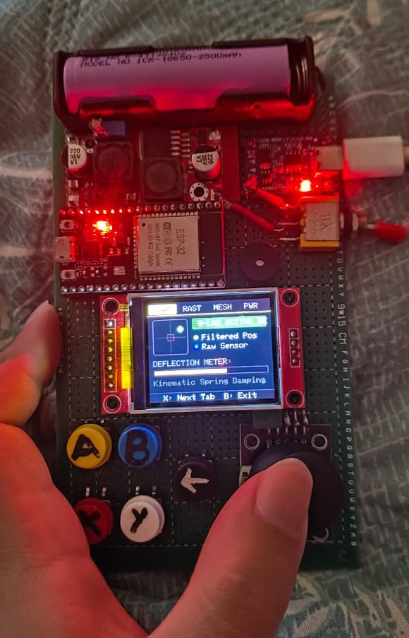
Figure 4: System Memory & Free SRAM Diagnostic Telemetry — Proof of 98.4% Framebuffer RAM Savings
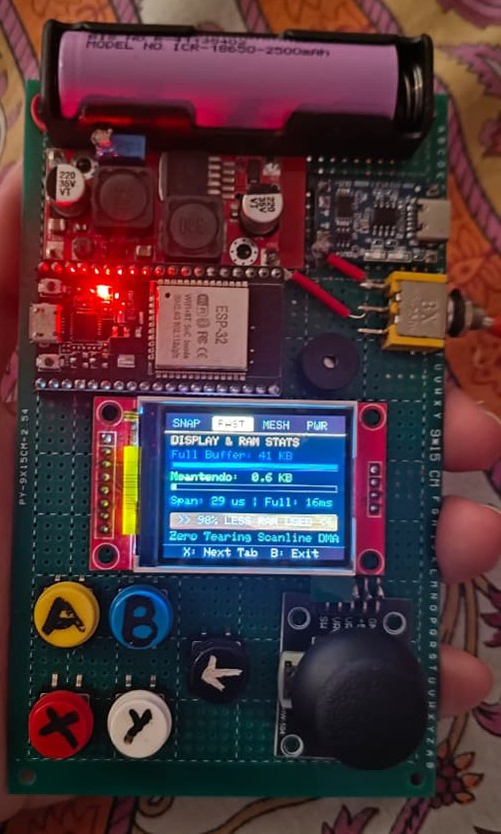
Figure 5: Wi-Fi Access Point Discovery Interface — Infrastructure Scanning for Cloud Roaming
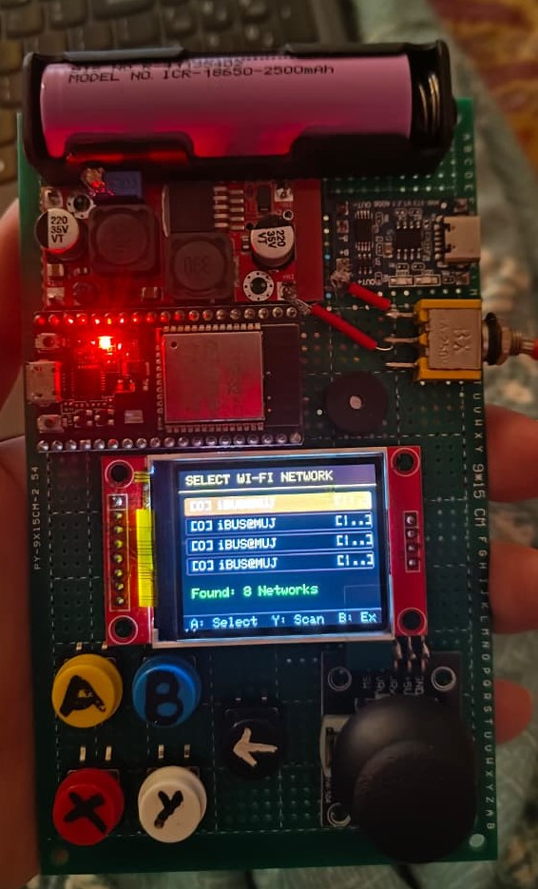
Figure 6: Over-The-Air Cloud Firmware Update — Version Detection & Update Popup
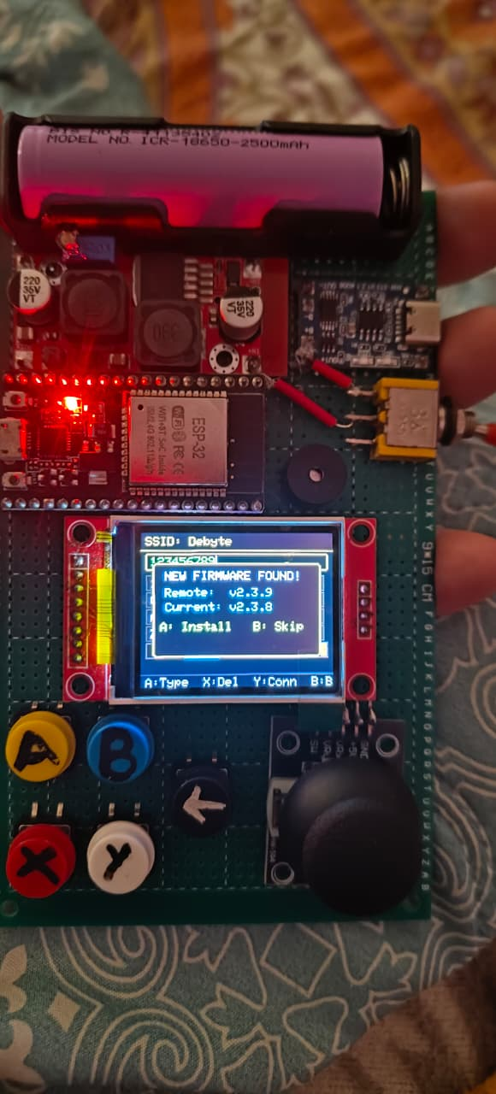
Figure 7: Over-The-Air Flash Partition Writing Progress — Live Firmware Streaming Screen
