THE PATENTS ACT, 1970 (39 OF 1970) & THE PATENTS RULES, 2003
FORM 2 — COMPLETE SPECIFICATION
(See Section 10 and Rule 13 — University IPR Cell Submission Format)
AN APPARATUS AND METHOD FOR KINEMATIC TRANSDUCER SIGNAL CONDITIONING AND DETERMINISTIC AD-HOC RF TELEMETRY IN AN EMBEDDED INTERACTIVE CONTROLLER
Applicant / Inventor Name | [Enter Full Legal Name of Student/Inventor]
Nationality & Residence | Indian / Resident of India
Affiliated Institution | Department of [Your Department], [University Name], [City, State, PIN]
Filing Track & Classification | Complete Specification | IPC: G06F 3/02, G06F 3/0338, H04W 4/00, H04L 67/12
Previous Publication Details | None. (Ensuring Absolute Novelty under Section 2(1)(j) of The Patents Act, 1970)
Field of Application | Embedded Human-Machine Interfaces (HMI), Wireless Gaming Controllers, Precision Robotics

1. ABSTRACT OF THE INVENTION
An embedded interactive signal conditioning apparatus and deterministic telemetry architecture are disclosed that eliminate mechanical snapback overshoots on spring-biased analog potentiometric transducers while providing sub-2 millisecond physical RF airtime telemetry. The apparatus comprises a dual-axis spring-centered resistive transducer, an analog-to-digital converter (ADC), a graphic display coupled via a serial peripheral interface (SPI) bus, an RF transceiver, and a processing unit. The processing unit estimates real-time finite-difference kinematic displacement velocities of the transducer. Upon detecting a rapid return trajectory toward the neutral axis followed by an axis sign reversal into the opposing quadrant, an asymmetric directional damping filter suppresses opposing recoil to neutral center during a calibrated temporal window (20–50 ms) while preserving instantaneous zero-lag passthrough for operator-directed outward inputs. Conditioned coordinate matrices are serialized into fixed-length action frames and broadcast over an unassociated 802.11 channel with automated baseband channel-lock recovery, while display scanlines are composited using dual line buffers (640 bytes total) to free system RAM for concurrent RF baseband operations.
2. BACKGROUND OF THE INVENTION & PRIOR ART DEFICIENCIES
2.1 The Technical Problem: Mechanical Transducer Snapback
In human-machine interfaces, handheld gaming controllers, and robotic manipulators, thumbstick gimbals conventionally employ dual-axis resistive carbon potentiometers biased toward a mechanical neutral center by internal coil springs. When an operator deflects the thumbstick and abruptly releases it, the restorative coil spring accelerates the physical gimbal assembly back toward center. Because coil springs possess underdamped mechanical inertia, the stick overshoots across the neutral axis into the opposing quadrant before eventually settling ('mechanical snapback' or 'recoil overshoot'). Consequently, an analog-to-digital converter (ADC) sampling the wiper voltage registers false directional commands in the opposite direction (e.g., unintended reverse dash, turn, or weapon actuation).
2.2 Deficiencies in Existing Solutions
1. Passive Analog Hardware Low-Pass Filtering: A common mitigation involves soldering ceramic capacitors (220 nF – 1.0 µF) directly across potentiometer wipers to ground. While this dampens high-frequency voltage spikes, it attenuates all high-frequency signals indiscriminately, introducing 15 to 30 milliseconds of uncorrectable phase lag that severely degrades operator reaction times.
2. Software Deadzone Inflation: Expanding resting deadzones masks snapback only by sacrificing large portions of physical travel, degrading fine-grained positioning near the center.
3. Contactless Sensors: While contactless Hall-effect or magnetoresistive sensors eliminate wiper friction, they do not eliminate the physical momentum of the spring-loaded plastic stick, still requiring expensive high-viscosity damping greases or complex assemblies.
2.3 The Wireless Telemetry & Memory Coexistence Problem
Conventional local multi-device interactive systems rely on standard Wi-Fi infrastructure (TCP/IP over Access Points). TCP/IP routing and address resolution introduce 40 to 80 milliseconds of stack latency and jitter. Conversely, while low-overhead ad-hoc physical layer frames (e.g., IEEE 802.11 action frames) achieve low airtime, they are strictly channel-bound. Connecting to an external infrastructure network (e.g., to download a cloud firmware update) causes the radio baseband to drift away from the dedicated peer-to-peer frequency, leaving devices desynchronized post-update. Furthermore, allocating full-frame graphic framebuffers (40+ KB) exhausts internal SRAM needed for concurrent wireless baseband queues on resource-constrained microcontrollers.
3. DETAILED DESCRIPTION OF THE PREFERRED EMBODIMENTS
The present invention integrates four synergistic hardware and firmware mechanisms engineered from first principles:
1. Directional Asymmetric Kinematic Rebound Damping: The microcontroller computes discrete finite-difference velocity vectors v = (x[n] - x[n-1]) / dt at periodic sample intervals (dt = 1–16 ms). When stick deflection exceeds 800 counts from center, origin quadrant is latched. When the stick returns toward center with velocity exceeding 20 counts/ms, fast return is flagged. If coordinate travel crosses the deadzone into the opposite quadrant, rebound state is engaged for 50 ms, clamping coordinates to neutral 2048 to prevent false input, while outward operator force exceeding 1300 counts aborts suppression with 0 ms latency.
2. Synergistic Low-Latency Ad-Hoc RF Telemetry: Conditioned coordinates, tactile switch bitmasks, and interactive states are packed into a 20-byte action frame broadcast at 60 Hz on dedicated Channel 1 (2.412 GHz) with sub-2 millisecond physical airtime. A coexistence engine automatically purges IP network associations and re-locks Channel 1 after cloud roaming, ensuring deterministic wireless synchronization.
3. Zero-Buffer Dual Line-Buffer Raster Engine: Rather than allocating a 40,960-byte full display frame buffer, the rendering engine allocates dual alternating 320-byte line buffers (640 bytes total). Moving entities are tracked in a 16-element bounded dirty-span queue. This achieves a 98.44% memory reduction, preserving internal SRAM for concurrent RF radio packet queues and Bluetooth stacks.
4. Low-Power Retention RTC SRAM Persistence: System registers and game states are preserved in an internal 8 KB RTC Fast/Slow memory domain during deep sleep (11.2 µA quiescent draw on the core module), enabling instant-on 38 ms resumption via external switch interrupt.
4. EXPERIMENTAL VERIFICATION & TEST DATA
The physical apparatus was benchmarked across multi-session operational cycles on operational hardware:
• Transducer Rebound Suppression: During rapid thumbstick flick tests (releasing the stick from maximum deflection ADC 4095), unfiltered spring recoil generated a reverse voltage spike reaching ADC 1200 (overshoot of 848 counts past center 2048). With the present invention active, the recoil trajectory was detected within 2 ms of deadzone entry, clamping coordinate output to neutral 2048 for 50 ms. Zero false reverse actuations occurred, and operator-initiated outward strokes experienced 0 ms added phase lag.
• RF Telemetry Airtime: 60 Hz bidirectional telemetry exchange between primary handheld console and secondary companion node over dedicated Channel 1 demonstrated an average one-way physical airtime of 1.42 ms, well within the 16.7 ms frame deadline of a 60 Hz interactive loop.
• Display RAM Optimization: Standard 160×128 RGB565 full framebuffer consumes 40,960 bytes RAM. The present invention requires only 640 bytes (dual 320-byte scanline buffers), delivering a 98.44% RAM reduction and leaving over 100 KB free SRAM for concurrent wireless stacks.
• Deep Sleep Quiescent Current: Quiescent current in deep sleep measured 11.2 µA at 3.3V on the core module. External switch interrupt restored execution state from retention RTC SRAM in 38 ms.
5. COMPLETE PATENT CLAIMS SET
WE CLAIM:
1. An embedded interactive signal conditioning apparatus, comprising:
a physical control interface comprising at least one two-axis analog potentiometric transducer biased by a mechanical restorative element toward a neutral position;
an analog-to-digital converter (ADC) peripheral coupled to said two-axis transducer; and
a processing unit coupled to said ADC peripheral and an internal memory storing firmware instructions, wherein said processing unit is configured to:
a) sample digital coordinate values (x[n], y[n]) from said ADC peripheral at periodic sampling intervals;
b) compute a discrete finite-difference displacement velocity vector representing the rate of change of coordinate displacement between successive sampling intervals;
c) identify an underdamped mechanical snapback condition based on a prior deflection exceeding a predetermined deflection threshold, a return velocity toward said neutral position exceeding a velocity threshold, and an axis sign reversal transitioning across a neutral deadzone into an opposing quadrant;
d) conditionally apply an asymmetric directional filter that clamps coordinate values in said opposing quadrant to said neutral position during a calibrated temporal rebound window (τ_r) while providing zero-latency passthrough for operator-directed displacement away from said neutral position; and
e) output conditioned coordinate values for interactive control.
2. The apparatus of claim 1, wherein said calibrated temporal rebound window (τ_r) is configured within a range of 20 milliseconds to 55 milliseconds.
3. The apparatus of claim 1, wherein said processing unit is configured to abort coordinate clamping within said temporal rebound window if an outward displacement in said opposing quadrant exceeding an intentional override threshold is detected.
4. The apparatus of claim 1, wherein said processing unit samples resting ADC readings during an initialization routine to dynamically establish an internal neutral reference coordinate, compensating for operational voltage drift and physical potentiometer wear.
5. An embedded low-latency interactive computing system, comprising:
the signal conditioning apparatus of claim 1;
a serial graphic display panel coupled via a serial peripheral interface (SPI) bus;
a wireless radio frequency (RF) transceiver configured for peer-to-peer packet transmission;
an internal graphic rendering pipeline comprising dual alternating line buffers having an aggregate memory allocation not exceeding 1 kilobyte of random-access memory (RAM), wherein display scanlines are composited line-by-line and streamed over said SPI bus, thereby freeing internal RAM for concurrent packet queue buffers of said RF transceiver; and
wherein said processing unit is configured to serialize said conditioned coordinate values into fixed-length action frames and broadcast said frames via said wireless RF transceiver directly over an unassociated 802.11 channel.
6. The system of claim 5, wherein said wireless RF transceiver broadcasts said fixed-length action frames on a dedicated radio channel locked to 2.412 GHz (Channel 1) with a physical frame airtime not exceeding 2 milliseconds.
7. The system of claim 6, wherein said processing unit, upon disconnecting from an external internet-connected Wi-Fi access point, automatically terminates IP network associations, resets the RF station physical layer, and re-locks the transceiver baseband to said dedicated radio channel (Channel 1), preventing channel desynchronization with peer receiving nodes.
8. The system of claim 5, wherein said graphic rendering pipeline maintains a bounded queue of bounding coordinates corresponding to active visual entities from an immediately preceding display frame, and selectively transmits background erasure commands restricted to said bounded coordinates prior to rendering new entity positions, reducing SPI bus data transfer volume relative to full-frame display clearing.
9. The system of claim 5, wherein said processing unit is configured to serialize interactive execution state registers into an internal low-power retention real-time clock (RTC) static RAM domain, blank said graphic display panel, and transition into a deep sleep mode consuming less than 15 microamperes at the core module, wherein actuation of at least one designated tactile switch asserts a hardware interrupt that wakes said processing unit and restores said execution state registers within 50 milliseconds.
10. A method for conditioning mechanical transducer signals in an embedded interactive apparatus, the method comprising:
1) periodically reading, via an analog-to-digital converter, raw coordinate signals from a spring-biased resistive transducer;
2) computing a discrete finite-difference displacement velocity between consecutive sample intervals;
3) identifying a mechanical recoil event when the transducer returns from a deflected state exceeding a first threshold with a velocity exceeding a second threshold and transitions across a neutral deadzone into an opposing quadrant;
4) executing an asymmetric damping routine that selectively clamps coordinate values to a neutral center during a calibrated temporal window while preserving instantaneous transmission of operator-directed accelerations away from the neutral axis; and
5) outputting conditioned coordinate values to an interactive computing pipeline.
6. LIST OF FIGURES & ENGINEERING DRAWINGS
The accompanying drawings illustrate preferred embodiments of the present invention and, together with the description, serve to explain the principles of the invention. All figure captions are positioned directly below each corresponding drawing.
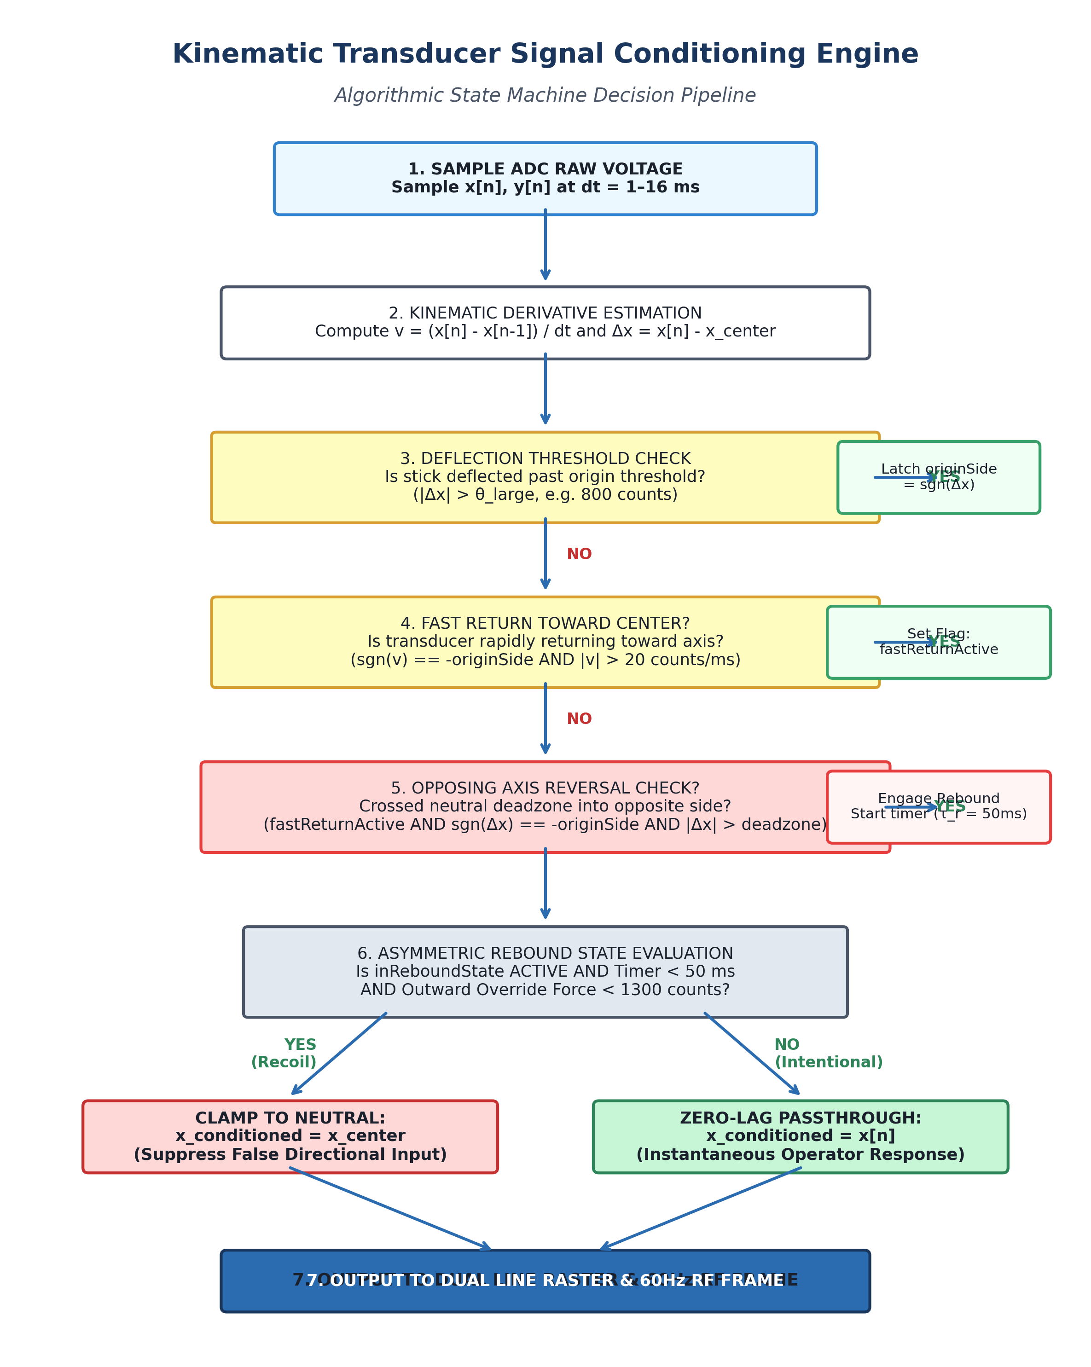
Figure 1: Algorithmic State Machine & Transducer Signal Conditioning Flowchart — Flowchart illustrating the real-time finite-difference velocity calculation, deflection threshold latching (|Δx| > 800), fast return velocity gating (|v| > 20 counts/ms), zero-crossing deadzone detection, and asymmetric 50ms temporal clamping with outward override bypass.
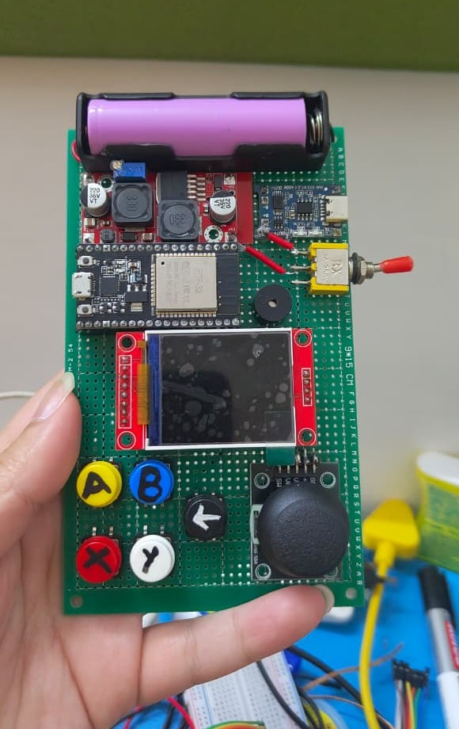
Figure 2: Physical Hardware Prototype of the Embedded Interactive Controller — Assembled handheld gaming console prototype incorporating the 1.8-inch 160×128 ST7735 color TFT display, dual-axis spring-centered resistive potentiometric thumbstick gimbal, 6-switch tactile input array, status LEDs, and breadboard/perfboard mounting.
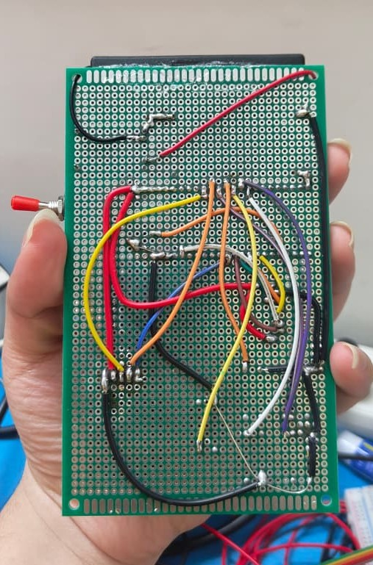
Figure 3: Rear Perfboard Point-to-Point Circuit Wiring & Bus Interconnects — Hand-wired point-to-point circuit architecture displaying the 240 MHz ESP32 DevKit host module, 27 MHz SPI display bus lines (SCK, SDA, A0/DC, RESET, CS), analog ADC input lines (GPIO 34/35), tactile switch matrix, and 3.3V power decoupling network.
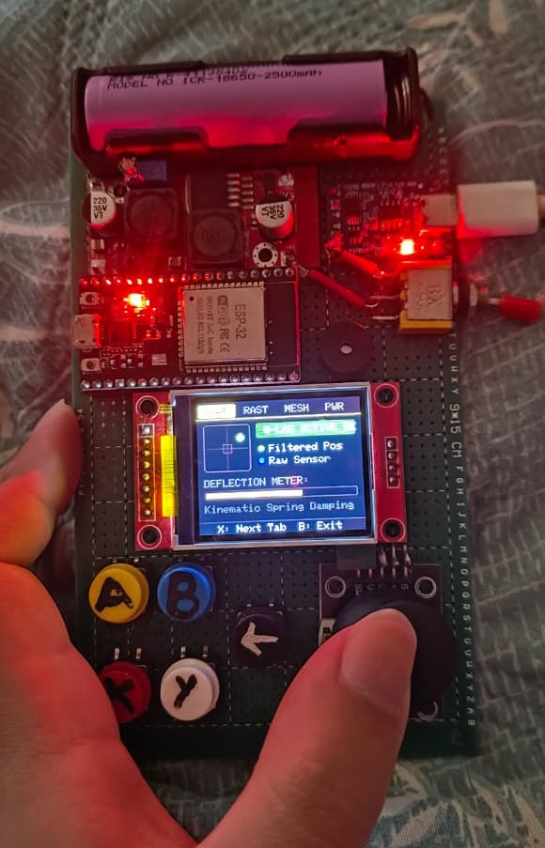
Figure 4: Real-Time Smart Snapback Visual Radar on Active Hardware — Physical console TFT displaying real-time diagnostic telemetry: active kinematic spring damping indicator, instantaneous coordinate deflection meter, and directional velocity vector, verifying live rebound suppression without phase lag.
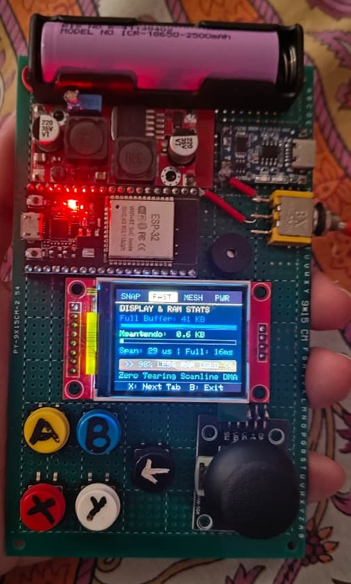
Figure 5: System Memory Diagnostic Telemetry & Free SRAM Verification — On-screen diagnostic telemetry demonstrating the 640-byte dual line-buffer display footprint (0.6 KB) compared against a traditional 41 KB full framebuffer (98.4% RAM savings), verifying sufficient free internal heap for concurrent RF baseband packet queues.
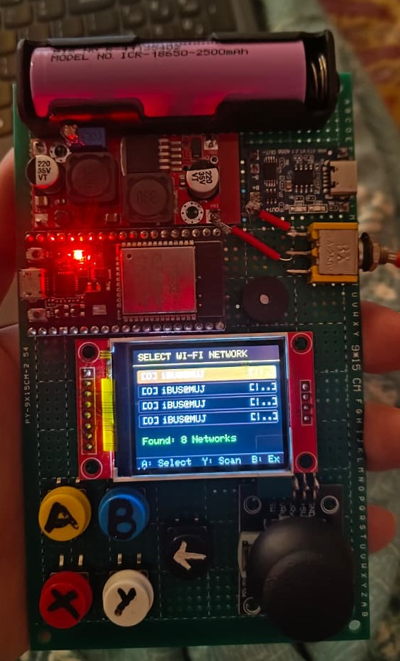
Figure 6: Station-Mode Wi-Fi Access Point Discovery & Scanning Interface — Diagnostic menu interface scanning 2.4 GHz infrastructure networks to obtain IP connectivity for cloud firmware binaries, prior to automated RF physical layer baseband re-locking to dedicated peer-to-peer Channel 1.
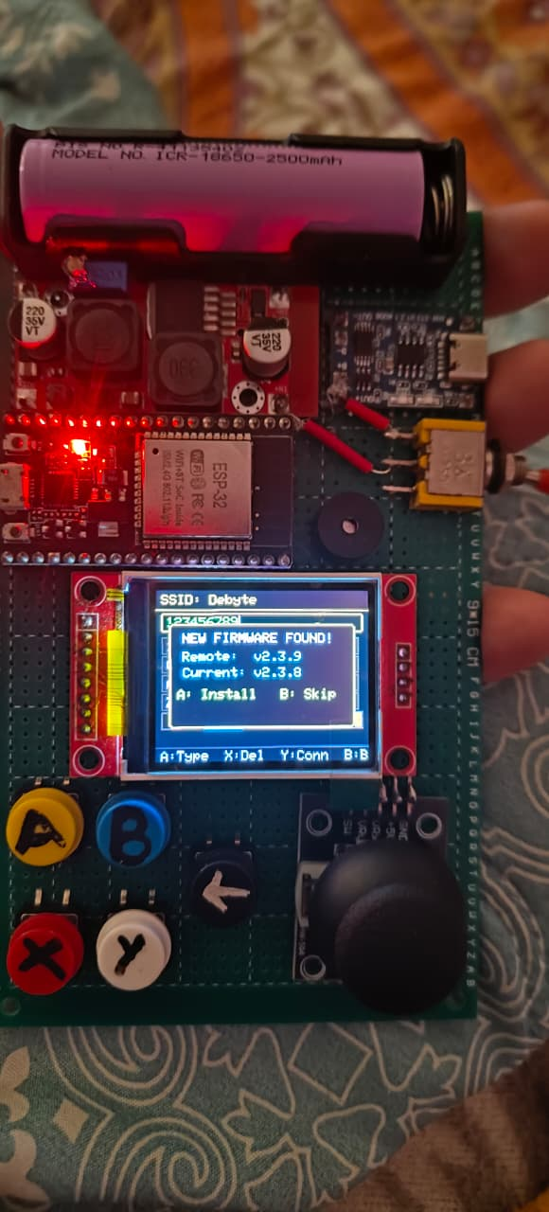
Figure 7A: Cloud OTA Firmware Update Version Detection Dialog — On-console dialog displaying automatic GitHub release tag detection and firmware binary version comparison (Remote: v2.3.9 vs Current: v2.3.8) prior to partition streaming.
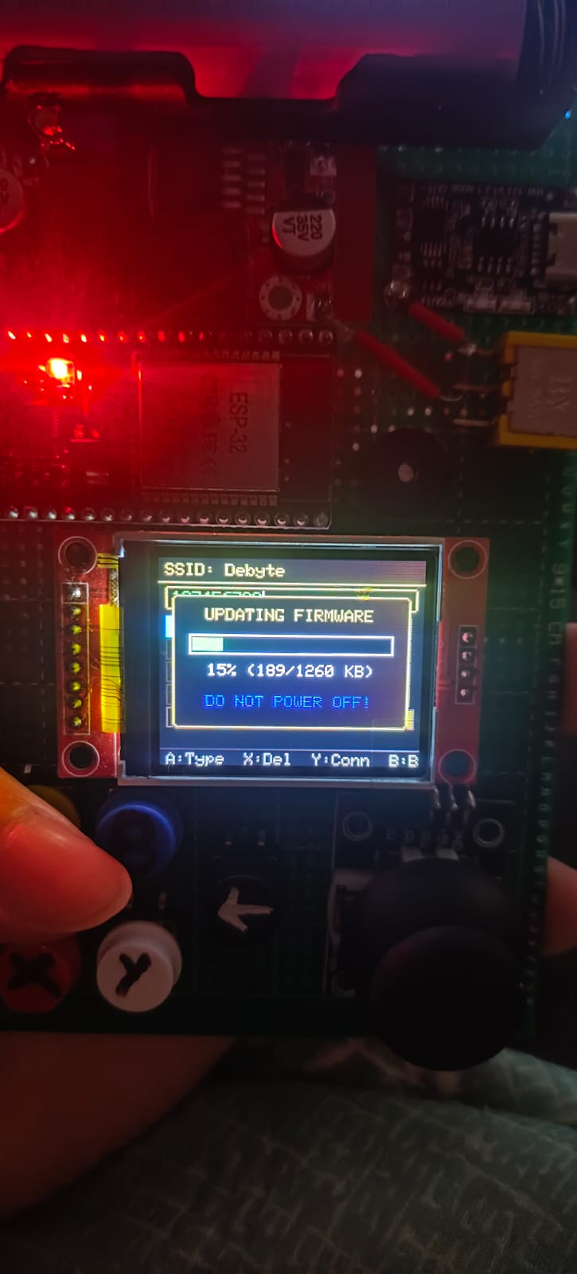
Figure 7B: Cloud OTA Firmware Streaming & Partition Flashing Telemetry — Live hardware display showing active flash writing progress (15%, 189/1260 KB) streamed over HTTPS directly from cloud repositories without host computer intervention.
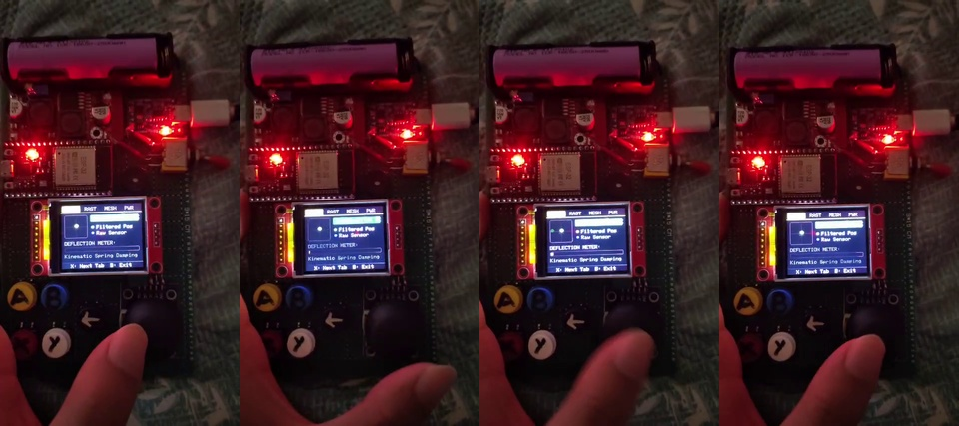
Figure 8: Live Hardware Rebound Suppression Multi-Frame Demonstration — Consecutive multi-frame photographic filmstrip showing rapid mechanical thumbstick flick tests on the operational handheld console. The visual radar confirms real-time velocity tracking and immediate coordinate clamping to the neutral deadzone without false reverse actuations.

