# MOODLITE

### HARDWARE

Power box for 3d model is for smaller Nodecmu, larger fit but need adj screw holes   
<https://moodlite.co.uk/index.php?topic=35.0>  
Stl with bot screw holes <https://moodlite.co.uk/index.php?action=dlattach;topic=35.0;attach=170>

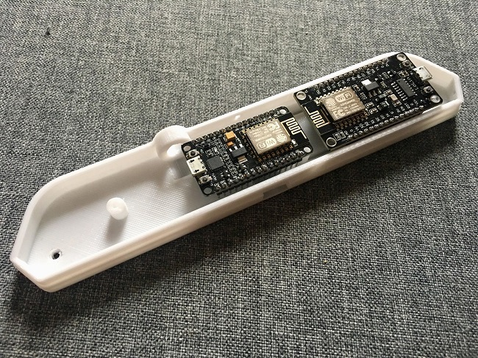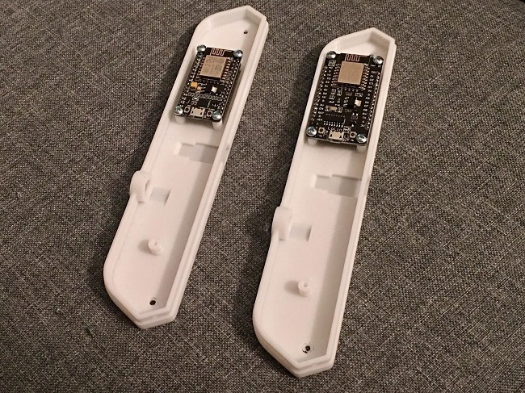

Add buffer capacitor to protect strips chip from brown outs resets  
<https://electronics.stackexchange.com/questions/374922/why-would-i-need-a-capacitor-in-front-of-a-led-strip/374924#374924>

<https://learn.adafruit.com/adafruit-neopixel-uberguide/best-practices>

### 

### SOFTWARE

Github repo for v2 and v3: <https://github.com/spigotx/Moodlite>

Wiki: <https://github.com/spigotx/Moodlite/wiki>

### BUILDS

3d print files: <https://www.thingiverse.com/thing:3317203>

**V2 design** (solo online!) https://moodlite.co.uk/index.php?action=downloads;sa=view;down=2

CdRsKull user: <https://moodlite.co.uk/index.php?topic=4.0>

Spigot user, con 3led e Wemos: <https://moodlite.co.uk/index.php?topic=40.0>

New moodlite design release: <https://moodlite.co.uk/index.php?topic=97.msg838#msg838>

### DEBUG

Fix for 3.0 brightness control? <https://moodlite.co.uk/index.php?topic=143.msg1112#msg1112>

EEPROM e SPPIFF erase

<https://moodlite.co.uk/index.php?topic=149.0>

.Ino compiling issues - revert to 2.5.0 ESP8266 on arduino board manager ( i had to use 2.4.2) <https://moodlite.co.uk/index.php?topic=146.msg1131#msg1131>