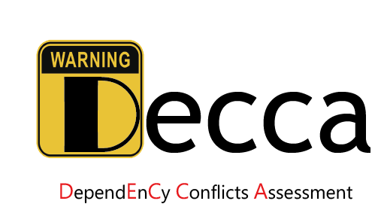

**How to use Decca**

Decca can take a Maven based project (it should contain the complete Maven built project directory and file pom.xml) as input for analysis. The expected running environment is 64-bit Window operating system with JDK 1.8, or Linux operating system with Docker platform. **As Maven built projects need to download dependencies from Maven Central Repository, Decca cannot work offline.**

You can run Decca on the subjects based on the following steps:

**Step 1**: Unzip the plugin-decca-Linux.zip to local directory. Recommended directory structure is:

plugin-decca-Linux

├─Decca

├─decca-3.0.jar :

├─decca-3.0.pom

├─soot-1.0.jar

├─soot-1.0.pom

├─Dockerfile

├─maven_3_5_4.tar

├─testProject

├─result

*Note: To facilitate testing, please keep the unzip directory to be consistent with the above example. It should be noted that the location of data (e.g, /usr/local/plugin-decca-Linux) is not hardcoded, it can be replaced with user's actual unzip directory in the install commands.

**Step 3**: Copy the project under test into directory testProject (e.g. petstore-vertx-json-rx-server)

**Step 4:** load docker images

docker load < busybox.tar.gz

**Step 5:** build docker

docker build -f ./ -t decca

**Step 6**: Install Decca.

Execute the following command to install Decca:

docker run -v /usr/local/plugin-decca-Linux/testProject:/usr/local/decca/testProject --env MAVEN_OPTS=-Xmx???m -it decca /bin/bash

**Step 7**: Detect and assess the dependency conflict issues.

Execute the following command to analyze the project:

mvn -f=/usr/local/decca/testProject/petstore-vertx-json-rx-server/pom.xml -DresultPath=/usr/local/decca/testProject/result/ -DsubdivisionLevel=false -DfromHostSearch=true -Dmaven.test.skip=true neu.lab:decca:1.0:printRiskLevel -e

Command explanation:

1. -f=pom.file : Specify the project under analysis;
2. -DresultFilePath=output issue report directory : Output the issue report to the specified file;
3. -Dappend=Boolean : Specify the result output mode (whether in append mode or not);
4. -DsubdivisionLevel= Boolean : Specify the assessment mode. (True: MODE 1; False MODE 2);
5. -DDfromHostSearch= Boolean : Specify the assessment mode. (False: MODE 3).

Then you can get the dependency issue report in your specified directory (e.g., /usr/local/decca/testProject/result/\ petstore-vertx-json-rx-server.xml).