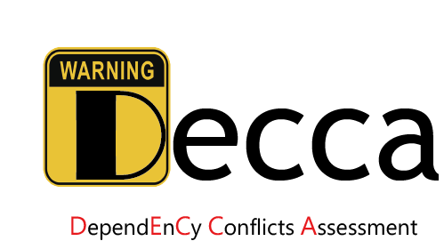

**How to use Decca**

Decca can take a Maven based project (it should contain the complete Maven built project directory and file pom.xml) as input for analysis. The expected running environment is 64-bit Window operating system with JDK 1.8, or Linux operating system with Docker platform. **As Maven built projects need to download dependencies from Maven Central Repository, Decca cannot work offline.**

You can run Decca on the subjects based on the following steps:

**Step 1**: Unzip the plugin-decca.zip to local directory. Recommended directory structure is:

D:\plugin-decca

├─Decca

├─decca-3.0.jar :

├─decca-3.0.pom

├─soot-1.0.jar

├─apache-maven-3.2.5

├─soot-1.0.pom

├─testProject

├─result

├─petstore-vertx-json-rx-server

*Note: To facilitate testing, please keep the unzip directory to be consistent with the above example. It should be noted that the location of data (e.g, D:\plugin-decca) is not hardcoded, it can be replaced with user's actual unzip directory in the install commands.

**Step 2**: Install Decca.

1. Execute the following Windows CMD command to install soot:

D:\plugin-decca\apache-maven-3.2.5\bin\mvn.bat install:install-file -Dfile=D:\plugin-decca\soot-1.0.jar -DgroupId=neu.lab -DartifactId=soot -Dversion=1.0 -Dpackaging=jar

1. Execute the following Windows CMD command to install Decca:

D:\plugin-decca\apache-maven-3.2.5\bin\mvn.bat install:install-file -Dfile=D:\plugin-decca\decca-3.0.jar -DgroupId=neu.lab -DartifactId=decca -Dversion=1.0 -Dpackaging=maven-plugin -DpomFile=D:\plugin-decca\decca-1.0.pom

**Step 3**: Detect and assess the dependency conflict issues.

Execute the following Windows CMD command to analyze the project:

D:\plugin-decca-windows\Decca\apache-maven-3.2.5\bin\mvn.bat -f=D:\plugin-decca-windows\testProject\petstore-vertx-json-rx-server\pom.xml -DresultFilePath=D:\plugin-decca-windows\testProject\result -DsubdivisionLevel=false -DfromHostSearch=true -Dmaven.test.skip=true neu.lab:decca:3.0:printRiskLevel -e

Command explanation:

1. -f=pom.file : Specify the project under analysis;
2. -DresultFilePath=output issue report directory : Output the issue report to the specified file;
3. -DdetectClass=Boolean : Specify the tool whether reports the class level conflicts or not;
4. -Dappend=Boolean : Specify the result output mode (whether in append mode or not);
5. -DsubdivisionLevel = Boolean : Specify the assessment mode. (True: MODE 1; False MODE 2);
6. -DfromHostSearch = Boolean : Specify the assessment mode. (True: MODE 3).

Then you can get the dependency issue report in your specified directory (e.g., D:\Report\resultFile.xml).