Module 9
Advanced Protocol Features
Sampling • Elicitation • Roots • Newer Additions • Lab
Deccansoft Software Training Institute
AI Integration with MCP | Day 2 · Hour 1

Overview — The Direction Flips
Earlier modules we have covered one direction: the Client calls the Server — to list tools, read resources, and get prompts. This Module introduces the reverse direction: capabilities the Client exposes so the Server can call back into it.

There are three such client-side capabilities:
- Sampling — server asks the client to run an LLM completion
- Elicitation — server asks the user for structured input
- Roots — client tells the server which folders to focus on
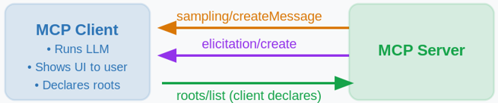

1. Sampling
Sampling lets a server request a language model completion through the client. The server does not need its own API key or model subscription — the client, which already has model access, does the inference on the server's behalf.

Why is this useful?
Imagine you are building an MCP tool that needs to generate a product description. Without sampling:
- The server would need its own OpenAI/Anthropic key
- Every deployment would need its own billing and key management
- The server author must decide which model to use

With sampling:
- The server just asks: "please generate this for me"
- The client runs the LLM using its own key and model
- The user stays in control — they can review or deny the request

The Flow
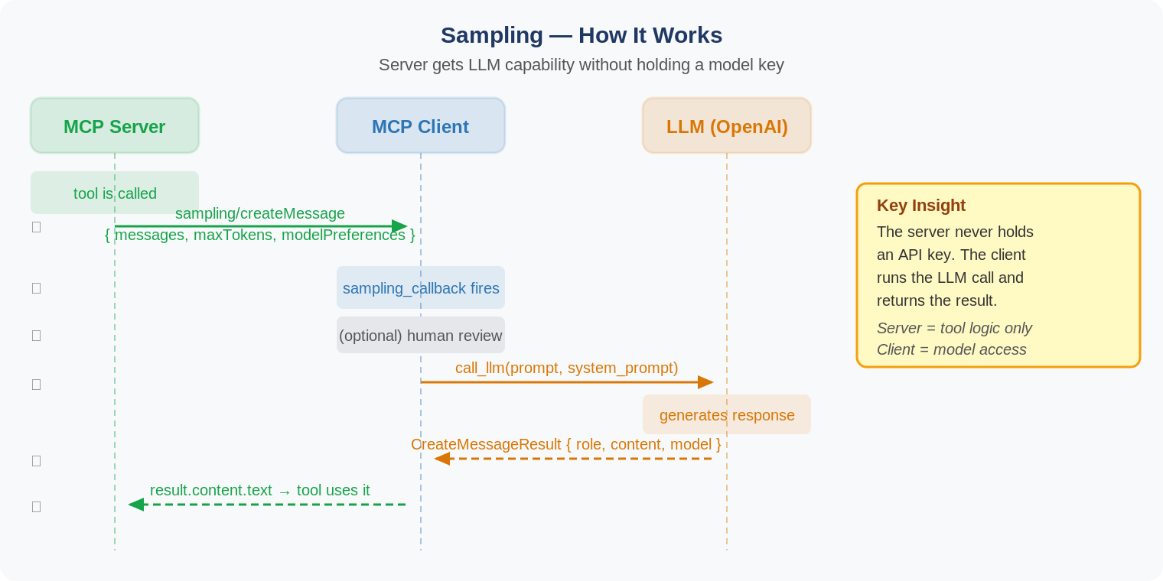

The Sampling Request
When the server calls ctx.session.create_message(), it sends a request like this:

{
"messages": [
{
"role": "user",
"content": "Analyze these flight options and recommend the best choice:\n
[47 flights with prices, times, airlines, and layovers]\n
User preferences: morning departure, max 1 layover"
}
],
"modelPreferences": {
"hints": [{ "name": "claude-sonnet-4" }],
"costPriority": 0.3,
"speedPriority": 0.2,
"intelligencePriority": 0.9
},
"systemPrompt": "You are a travel expert...",
"maxTokens": 1500
}

modelPreferences — the three priority weights
Priority | What it means | Example value
costPriority | How much to minimise API cost | 0.3 (not a major concern)
speedPriority | How much to prioritise fast responses | 0.2 (can wait for thoroughness)
intelligencePriority | How much to prioritise reasoning quality | 0.9 (complex analysis needed)

The hints field suggests a preferred model by name, but the client is free to choose the actual model.

Human-in-the-Loop
User Control
Sampling requests may require explicit user consent. The client can show the exact prompt,
model, and token limit before forwarding to the LLM. Users can approve, deny, or modify.

Clients should also rate-limit sampling requests and validate message content.

2. Elicitation
Elicitation lets a server ask the user for specific information mid-interaction, instead of requiring everything upfront or failing when data is missing. The server sends a JSON schema; the client renders a form; the user fills it in or declines.

Elicitation was added in protocol version 2025-06-18.

The Flow
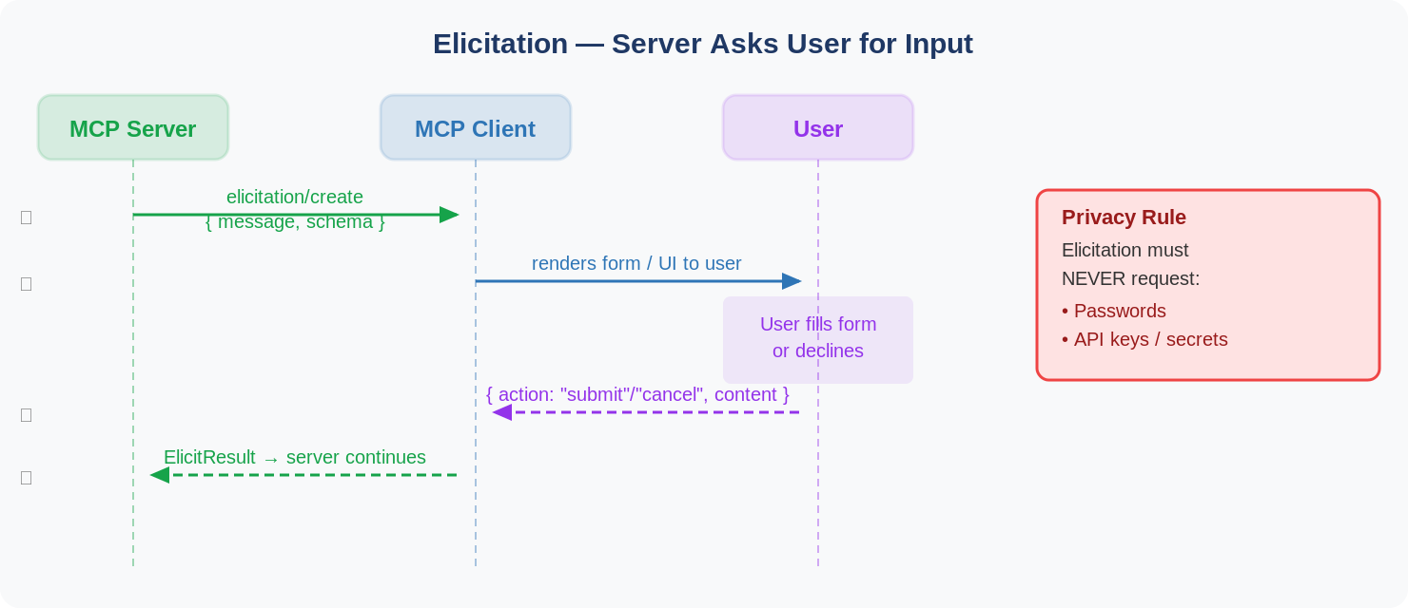

Example — Barcelona Booking Confirmation
The server sends an elicitation request like this:

{
"method": "elicitation/create",
"params": {
"message": "Please confirm your Paris vacation booking details:",
"schema": {
"type": "object",
"properties": {
"confirmBooking": {
"type": "boolean",
"description": "Confirm the booking (Flights + Hotel = $3,000)"
},
"seatPreference": {
"type": "string",
"enum": ["window", "aisle", "no preference"]
},
"roomType": {
"type": "string",
"enum": ["sea view", "city view", "garden view"]
},
"travelInsurance": {
"type": "boolean",
"default": false,
"description": "Add travel insurance ($150)"
}
},
"required": ["confirmBooking"]
}
}
}

The Response
The client returns one of three actions:
action value | Meaning
submit | User filled the form and confirmed
cancel | User explicitly cancelled
decline | User chose not to provide the information

Privacy Rule — Critical
Elicitation must NEVER request passwords, API keys, or other secrets.
Clients must warn users about suspicious requests and let them review data before submitting.

3. Roots
Roots are how a client communicates which directories a server should focus on. They are file:// URIs that the client declares to help the server understand the relevant workspace.

How it looks
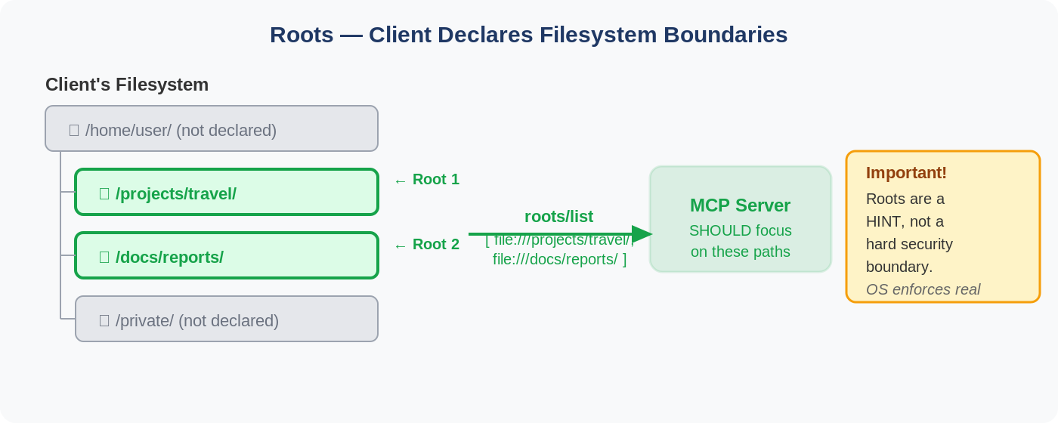

Example Root
{
"uri": "file:///Users/agent/travel-planning",
"name": "Travel Planning Workspace"
}

Key Facts about Roots
- Always file:// URIs — roots always point to local filesystem paths, never HTTP URLs.
- Dynamic updates — if the user opens a new folder, the client sends a roots/list_changed notification so the server knows.
- Coordination, not security — the spec says servers SHOULD respect root boundaries, not MUST enforce them.

4. Hands-On Lab — Sampling Server + Client
This lab builds a product creation tool where the server generates a product description by asking the client to run an LLM. The client supplies a sampling_callback that calls GitHub Models via the OpenAI SDK.

Lab Architecture
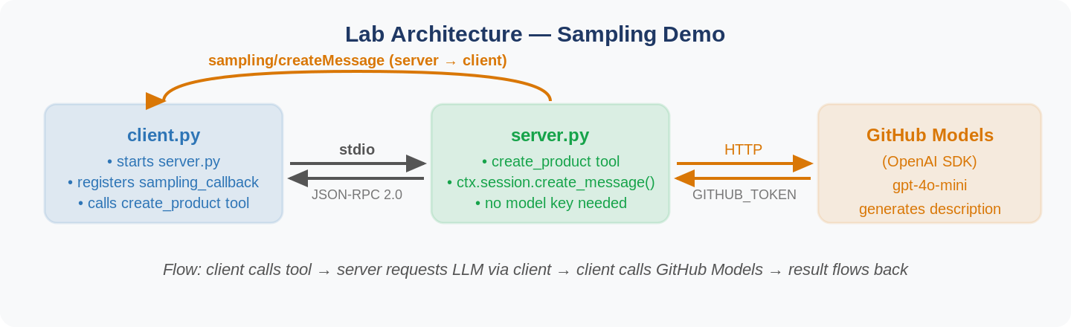

Setup
uv init mcp-sampling
cd mcp-sampling
uv venv
uv add "mcp[cli]" openai

# Set your GitHub token (fine-grained PAT)
export GITHUB_TOKEN=ghp_your_token_here # macOS / Linux
$env:GITHUB_TOKEN = "ghp_your_token_here" # Windows PowerShell

server.py — The Key Part
The tool calls ctx.session.create_message() — this is how the server initiates sampling back to the client:

@mcp.tool()
async def create_product(
product_name: str,
keywords: str,
ctx: Context[ServerSession, None]
) -> str:
"""Create a product and generate description using LLM sampling."""

# Build the prompt
prompt = f"Create a product description about {product_name} described as {keywords}"

# Ask the CLIENT to run the LLM — server has no model key
result = await ctx.session.create_message(
messages=[
SamplingMessage(
role="user",
content=TextContent(type="text", text=prompt),
)
],
max_tokens=100,
)

# Use the LLM-generated text as the product description
product.description = result.content.text
return json.dumps({ "name": product.name, "description": product.description })

client.py — The Key Part
The client registers a sampling_callback when creating the session. This callback fires whenever the server requests an LLM completion:
async def handle_sampling_message(
context: RequestContext[ClientSession, None],
params: types.CreateMessageRequestParams
) -> types.CreateMessageResult:

message = params.messages[0].content.text

# Client calls GitHub Models (OpenAI SDK)
response = await call_llm(
message,
system_prompt="You are a helpful assistant. Create a compelling product description."
)

return types.CreateMessageResult(
role="assistant",
content=types.TextContent(type="text", text=response),
model="gpt-4o-mini",
stopReason="endTurn",
)

# Register the callback when creating the session
async with ClientSession(
read, write,
sampling_callback=handle_sampling_message # ← this is all you need
) as session:
await session.initialize()

Two Defects in the Reference Code
The lab code from the course repository has two known issues you must fix:

Defect | Symptom | Fix
Defect 1 — client calls get_products which does not exist | Error: Unknown tool: get_products on the second call | Delete the two get_products lines from client.py — they are leftover commented-out code
Defect 2 — server prints to stdout | Connection closed / JSON parse error on startup | Change print("Starting server...") to print("Starting server...", file=sys.stderr)

How to Run
The client launches the server automatically — run only the client:

uv run python client.py

Expected Output
Sampling request: [SamplingMessage(role='user', content=...)]

result: {
"id": 1,
"name": "paprika",
"description": "Paprika is a vibrant, red, juicy vegetable known for its
bold flavor and rich color, perfect for adding depth..."
}

What just happened:
1. client.py called create_product(paprika, red juicy vegetable)
2. server.py executed the tool and called ctx.session.create_message()
3. MCP sent sampling/createMessage to the client
4. client.py's sampling_callback fired and called GitHub Models (gpt-4o-mini)
5. The LLM generated a product description
6. The result flowed back through MCP to the server tool
7. The server returned the complete product JSON

The server produced AI-generated content without ever holding a model key.

