Module 14: Spec-Driven Development
Lab: an expense-approval feature, built from a written spec
An agent is only as good as the instructions it works from. "Add approval for large expense claims" will be understood ten different ways by ten people, or ten agents.
A spec is a short reviewable document that says what "right" means before anyone writes code. A spec: approved by a human, read by a subagent, traced to by a test.
Think of the drawing of a house before the construction. The builders, the electrician and the owner all look at the same drawing. If it is only in the architect's head, each one builds a different house.

Why write a spec?
A spec gives three benefits.
- A small change to the spec steers a large change to the code: one sentence about the look of a page can become hundreds of lines of CSS.
- The spec survives the session: the context window fills up and the agent makes more mistakes, but the spec carries over to a new session, or to a different agent.
- Intent is clearer, because you must name the problem, the success criteria and the limits before code is written.

Another way to see it:
A compiler turns source code that people can read into machine code. Spec-driven development moves this one level up: the agent turns the spec into source code. The spec is written in plain language, so the product owner can review it too. Put shortly: the agent is the muscle, and the spec is the brain.

Vibe Coding | Spec-driven Development
- Prompt, accept, repeat  - Requirements live in chat history  - Works for throwaway prototypes  - Review happens after the code exists  - Hard to tell intended from assumed | - Intent agreed first and written down  - Spec, plan and tasks are reviewable  - Tests derive from acceptance criteria  - Human gates between stages  - Evidence ties the result to the spec
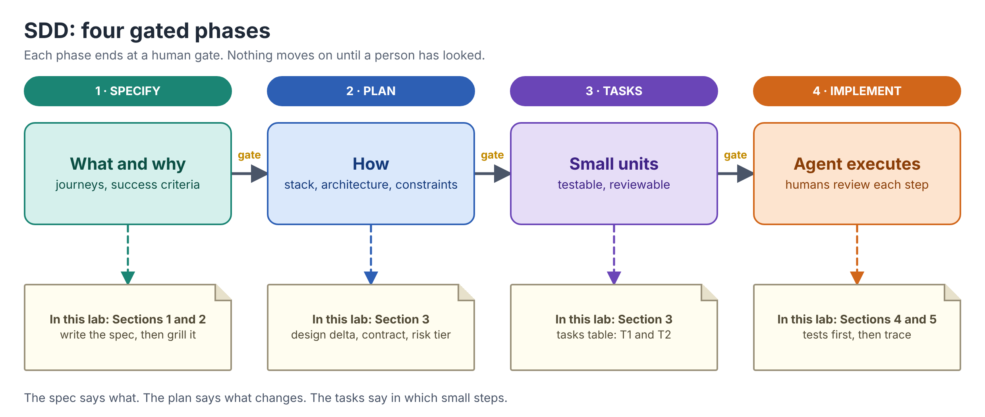

Walkthrough - What we are building
Let’s build one small feature from its spec, one section at a time: write the spec, grill it, describe the change, split it into packages, add the gates, trace it, and then build it.
- The first slice of TaskFlow, a team task tracker: a team member adds a task with a title, moves it between three statuses (Todo, InProgress, Done) and lists the tasks that have one status.
- That is all: one small Python module and its pytest tests, with no web API, no database and no login.
- It is small, but it has what a spec needs: a boundary (is a 100-character title allowed?), a rule (what is a valid title?), a state (which statuses exist?) and an error case (an unknown status).
- It handles no money and no personal data, so it is risk tier 2.
File | Who writes it
docs/spec.md | You. The spec: problem, stories, criteria, answers. Claude only drafts the plan section, and you review it.
taskflow.py | Claude, from your spec (about 40 lines)
test_taskflow.py | Claude, from your spec (one test per criterion)
pyproject.toml, uv.lock | uv, when you set up the project

Section 1: The spec and EARS criteria
A spec for one feature has these parts:
- Problem - what is wrong today, for whom, at what cost? No solution yet. 2 to 4 sentences.
- User stories - who wants what, and why. One line each: As a (role), I want (goal), so that (benefit).
- Acceptance criteria - how do we know it works? Each one is testable. One row each, with an id.
- Open questions - what do we not know yet?
- Build and approve - design delta, contracts, work packages, risk and gates.

Five sentence patterns for Acceptance Criteria:
- Write acceptance criteria in EARS form. EARS (Easy Approach to Requirements Syntax) has five sentence patterns.
- Each one has a trigger and a response, and SHALL marks a promise, not a wish.
Pattern | Form | Example from this lab
Always true | The (system) SHALL (response) | TaskFlow SHALL store the title without spaces at the start or end
Event | WHEN (trigger), the (system) SHALL (response) | WHEN the title is exactly 100 characters, TaskFlow SHALL accept it
State | WHILE (state), the (system) SHALL (response) | WHILE a task is Done, the board SHALL show it in the Done column
Optional feature | WHERE (feature is present), the (system) SHALL (response) | WHERE due dates are switched on, TaskFlow SHALL refuse a due date in the past
Unwanted behaviour | IF (condition), THEN the (system) SHALL (response) | IF a status is not Todo, InProgress or Done, THEN TaskFlow SHALL refuse it with an error

Hands-On Lab: Section 1
Step 1: Scaffold the project
Windows (PowerShell)
mkdir taskflow-starter
cd taskflow-starter
git init
uv init --bare --name taskflow
uv add --dev pytest
mkdir docs
Set-Content .gitignore "__pycache__/"

macOS / Linux
mkdir taskflow-starter
cd taskflow-starter
git init
uv init --bare --name taskflow
uv add --dev pytest
mkdir docs
echo "__pycache__/" > .gitignore

Step 2: Write the first half of the spec
Create docs/specs/expense-approval.md. This is the whole of sections 1 to 3: the problem, the stories and seven criteria. Notice that each criterion already names its test and its package, and starts as todo.
docs/spec.md
# Spec: TaskFlow starter (add, move and list tasks)

Status: draft
Risk tier: 2

## 1. Problem

Our team tracks its work in a chat thread. Tasks get lost, and nobody can see at a glance what is still to do, what is in progress and what is done.

## 2. User stories

- As a team member, I want to add a task with a short title, so that the work is written down.
- As a team member, I want to move a task to In progress or Done, so that others see where it stands.
- As a team lead, I want to list the tasks that have one status, so that I can see what is left.

## 3. Acceptance criteria

| ID | Criterion (EARS) | Status |
|---|---|---|
| AC-1 | WHEN a task is added with a valid title, TaskFlow SHALL store it with status Todo and a new id | todo |
| AC-2 | TaskFlow SHALL store the title without spaces at the start or end | todo |
| AC-3 | WHEN the title is exactly 100 characters, TaskFlow SHALL accept it | todo |
| AC-4 | IF the title is empty or longer than 100 characters, THEN TaskFlow SHALL refuse it with an error and store nothing | todo |
| AC-5 | WHEN a task is moved to Todo, InProgress or Done, TaskFlow SHALL change its status | todo |
| AC-6 | WHEN tasks are listed with a status, TaskFlow SHALL return only the tasks with that status, in the order they were added | todo |
| AC-7 | IF a status is not Todo, InProgress or Done, THEN TaskFlow SHALL refuse it with an error | todo |

Check it against this list: one trigger and one response per row, something you can assert (a status, a length, an error), no "fast", "easy" or "properly", and the boundary (AC-3) is its own row.
Checkpoint: Section 1
- A project with no code yet, and a spec with a problem, three user stories and seven EARS criteria.
- Status is draft. Nothing may be built until a person approves it (Section 3)

Section 2: Grill the spec

Concepts
- A first draft always hides questions. Grilling means being questioned one question at a time, with each answer written into the spec, before any code exists.
- Every open question has three fields:
  - Question (a specific choice, not "any concerns?"
  - Owner (a role that can decide, such as finance or security, never "the team")
  - Answer (a decision in a sentence). "TBD" means the spec is not ready.
- Where questions hide:
  - Boundaries (is "above 10000" strict?)
  - Scope (per claim, or a running total?)
  - Who (which role approves, and how does the system know?)
  - State (what does "pending" mean for the rest of the system?).
- Three ways to run a grill:
  - Ask Claude to interview you. In plan mode: one question at a time, with a recommended answer to accept or reject. It reads the code first, so questions can point at lines that contradict your draft.
  - Use a grilling skill. Skills that interview you about a plan exist in the ecosystem (grill-me on the community-skills slide). Lab 3 builds one. None is required.
  - Have a human grill it. In review. The cheapest bug is the one a colleague finds in a table.

Important: An answer that lives only in the chat is lost at the next /clear. Edit it into the spec. The spec is the project's memory.

Think of it like this: a building inspector reading the drawings before the concrete is poured. A mistake found in a table costs minutes. The same mistake found in production costs a bad week.
Hands-On Lab: Section 2
Step 1: Start Claude Code in plan mode
Windows and macOS
claude --permission-mode plan

Step 2: Run the grilling prompt
Prompt
Read docs/spec.md. Interview me about gaps in it, one question at a time.
For each question give your recommended answer and why. Do not edit any file.
After each answer I give, say whether it contradicts an earlier answer.
When I say "done", in markdown format list the questions and answers as rows for an Open questions table.

Answer each question yourself, as the owner would. The grill should reach at least these four gaps: is a title of exactly 100 characters allowed (a boundary), do tasks have an assignee (scope), is the status case-sensitive (state), and who may add tasks (who). Claude may ask more. Keep any extra answers too.
Step 3: Edit the answers into the spec
Add section 4 at the end of the spec, by hand or by asking Claude (leave plan mode with Shift+Tab first). Every row has an owner that is a role and an answer that is a decision.
docs/spec.md (add at the end)
## 4. Open questions

| ID | Question | Owner | Answer |
|---|---|---|---|
| Q-1 | Is a title of exactly 100 characters allowed? | Product owner | Yes. Only titles longer than 100 are refused (AC-3, AC-4) |
| Q-2 | Can tasks have an assignee in this version? | Product owner | No. Assignees come with the full TaskFlow backlog in M14 |
| Q-3 | Is the status case-sensitive? | Product owner | Yes. Only Todo, InProgress and Done are valid. "todo" is refused (AC-7) |
| Q-4 | Who may add tasks? | Security | Deferred: there is no login yet. Login is a later story |

Note: Q-4 shows what an honest answer looks like when you cannot decide yet: the owner defers it in a sentence, with the reason. That is a decision. "TBD" is not.
Checkpoint: Section 2
- Four open questions, each with a role as owner and a written answer.
- The answers are in the file, so a /clear cannot lose them.

Section 3: Plan, risk tier and approval

Concepts
- The spec says what. The plan says what changes in the system (the design delta), what each part promises the next (the contract), and in which small steps it is built (the tasks). List only the changes. A reviewer sees the blast radius in thirty seconds, and a later diff that touches something the plan never mentioned is a red flag.
- A contract is the exact thing one task hands to the next: a method signature, an HTTP route, a data shape, and the errors. If task T2 needs something that T1 has not promised, that is a new line in the spec, not a guess.
- A task (a work package) is a slice small enough for one agent to finish and one person to review.
  - A good one has a one-sentence goal, names the criteria it delivers, and has an observable "done when" (its tests pass).
  - A bad one says "backend stuff" or is done "when it looks right".
  - In bigger projects each package also owns its own files, so packages can be given to separate subagents and run in parallel. Our two tasks share two small files, so they run one after the other.
- A task row is a delegation prompt, prepared in advance: goal, criteria, contract, done-when. You will paste it into Claude in Section 4.
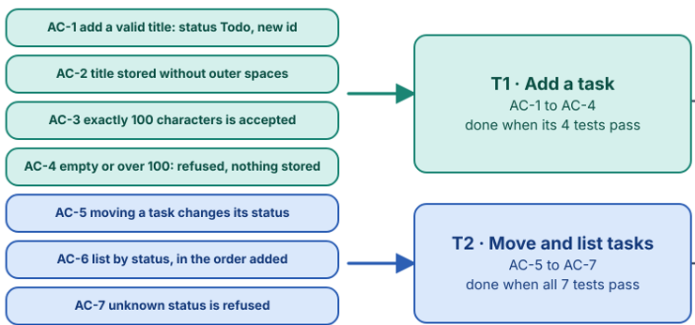

Risk Tier:
Choose the risk tier from the worst thing the change can do. The tier decides how much human attention the change gets.
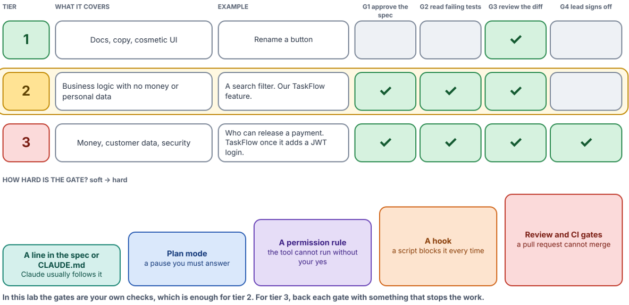
- Our feature is tier 2. It is business logic with no money, no personal data and no login, so it gets three gates:
  - G1 approve the spec before any test or code
  - G2 read the failing tests before the code is written
  - G3 review the diff before it is committed and merged
- When TaskFlow adds login with a JWT, that change is tier 3 and adds G4: a lead signs off before release.
- Gates can be enforced from soft to hard:
  - a line in the spec or CLAUDE.md (Claude usually follows it)
  - plan mode (a pause you must answer)
  - a permission rule (the tool cannot run without your yes)
  - a hook (a script blocks it every time)
  - review and CI gates (a pull request cannot merge).
Note: In this lab the gates are your own checks, which is enough for tier 2. For tier 3, back each gate with something that stops the work.
Hands-On Lab: Section 3
Step 1: Ask Claude to draft the plan
Claude is good at the plan. You are the one who checks it. In Claude Code (plan mode is fine to leave now), run:
Prompt
Read docs/spec.md. Add two sections at the end and change nothing else.
5. Plan: the design delta (only the files that change), the contract (the class, its
method signatures and the errors they raise) and a tasks table with the columns ID, Goal,
Criteria, Done when.
Use one Python module, taskflow.py, and one pytest file,
test_taskflow.py. Tasks are kept in memory: no database, no web API, no login.
Task T1 is adding a task (AC-1 to AC-4), task T2 is moving and listing (AC-5 to AC-7).
6. Risk and gates: risk tier 2, and a table of three gates: G1 approve the spec,
G2 read the failing tests, G3 review the diff.
Do not write any code.

Claude's wording will differ from the reference below, and that is fine.
Sample content of extended docs/spec.md
## 5. Plan

Design delta:

- `taskflow.py` (new): a `Task` (id, title, status) and a `TaskBoard` that keeps the tasks in memory.
- `test_taskflow.py` (new): one pytest test per criterion, named `test_ac<n>_...`.
- Nothing else. No database, no web API and no login in this version.

Contract:

- `TaskBoard.add(title) -> Task`. Raises `ValueError` if the title is not valid.
- `TaskBoard.move(task_id, status) -> Task`. Raises `ValueError` for an unknown status.
- `TaskBoard.list(status) -> list[Task]`. Raises `ValueError` for an unknown status.
- A `Task` has `id` (int, starting at 1), `title` (str) and `status` ("Todo", "InProgress" or "Done").

Tasks:

| ID | Goal | Criteria | Done when |
|---|---|---|---|
| T1 | Add a task | AC-1 to AC-4 | its 4 tests pass |
| T2 | Move and list tasks | AC-5 to AC-7 | all 7 tests pass |

## 6. Risk and gates

Risk tier 2: business logic only. No money, no personal data and no login.

| Gate | A person must... | How |
|---|---|---|
| G1 | approve this spec before any test or code is written | You change Status to approved and commit the spec |
| G2 | read the failing tests before the code is written | The build prompt stops after the tests |
| G3 | review the diff before it is committed | `git diff`, then commit |

Step 2: Review the plan
Accept Claude's plan only if all of these are true. If one is not, ask Claude to fix that one thing.
- Every criterion appears in exactly one task.
- The contract is exact: method names, what they return, and which error each one raises. T2 should never have to guess.
- The delta names only taskflow.py and test_taskflow.py. Nothing else changes.
- Each task is done when its tests pass, not "when it looks right".
Step 3: Approve the spec (gate G1)
Now act as the approver. Open the spec yourself, change the second line to Status: approved, and commit it. Only a person approves the spec: do not ask Claude to do this.
docs/spec.md (edit by hand)
Status: approved

Windows and macOS
git add -A
git commit -m "Approved spec"

Checkpoint: Section 3
- The spec has all six sections: criteria, answers, plan, contract, two tasks, risk tier 2 and three gates.
- You approved it and committed it. Building can start.

Section 4: Build it tests-first

Concepts
- The build rhythm is the "tests first" loop, one task at a time: the agent writes failing tests from the criteria, you read them (G2) and commit them, the agent writes the code until they pass, you review the diff (G3) and mark the criteria done.
- Why tests first: a test written before the code is written from the spec, not from the code. If the code is wrong, the test says so. A test written after the code tends to check whatever the code already does.
- Done is a list someone can check, not "the agent said so". Every criterion of the task has a passing test, the full suite is green, no file outside the plan changed, and no open question is left.
Clear before you build: Before you start a task, run /clear. If the build still works after a clear, the intent lives in the spec and not in the chat history, and the agent can spend its limited context on the work.
Watch for cognitive debt: Green tests are not the same as understanding. If you accept changes you have not read, you build up cognitive debt: code in your project that nobody on the team can explain. Small tasks keep each review short enough to actually do, and reading the tests is a quick way to check you understand the change.
Hands-On Lab: Section 4
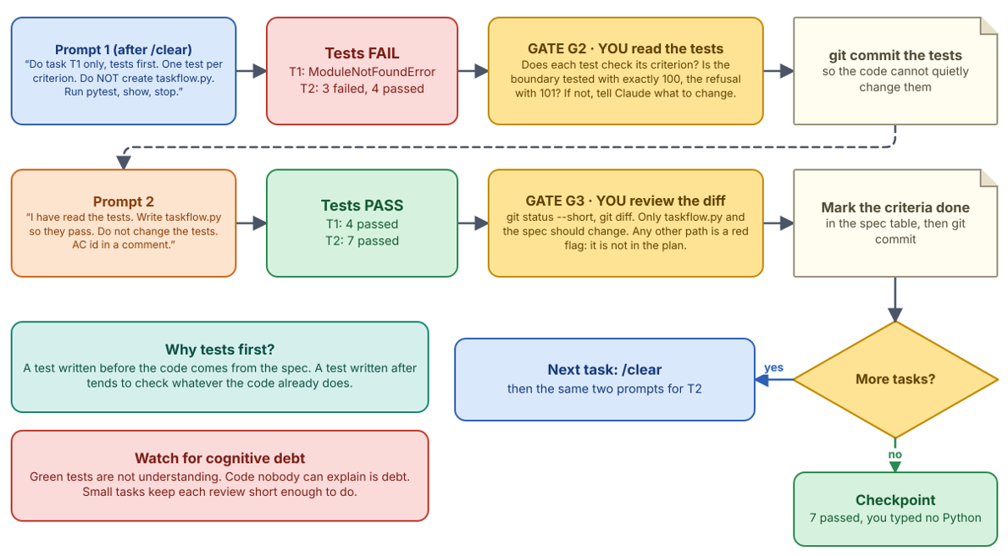
Step 1: Task T1, the failing tests
Run claude in the project folder (normal mode), type /clear, then:
Prompt
docs/spec.md is approved. Do task T1 only, tests first.
Write test_taskflow.py with pytest: one test per criterion, AC-1 to AC-4, named
test_ac<n>_<what it checks>. Use the contract in section 5.
Do not create taskflow.py yet. Run uv run pytest -q, show me the result, and stop.

Expected result (shortened): the tests fail because taskflow.py does not exist yet
E ModuleNotFoundError: No module named 'taskflow'
...
1 error in 0.07s
...

This is gate G2. Open test_taskflow.py and read the four tests. Does each one check what its criterion says? Is the boundary tested with exactly 100 characters, and the refusal with 101? If not, tell Claude what to change. Then commit the tests, so the code cannot quietly change them:
Windows and macOS
git add test_taskflow.py
git commit -m "T1: failing tests for AC-1 to AC-4"

Step 2: Task T1, the code
Prompt
I have read the tests. Now write taskflow.py so they pass. Follow the contract in
section 5 of the spec and do not change the tests. Put the AC id in a comment where
each criterion is handled. Run uv run pytest -q and show me the result.

Expected result (the time differs)
.... [100%]
4 passed in 0.01s

This is gate G3. Review the change, then mark AC-1 to AC-4 as done in the criteria table (by hand, or ask Claude to change only those four rows) and commit:
Windows and macOS
git status --short
git diff
git add -A
git commit -m "T1: AC-1 to AC-4 done"

git status --short should list only taskflow.py and the spec. Any other path is a red flag: it is not in the plan.
Step 3: Task T2, the same rhythm
Type /clear, then give the same two prompts for task T2:
Prompt
docs/spec.md is approved and T1 is done. Do task T2 only, tests first.
Add tests for AC-5 to AC-7 at the end of test_taskflow.py, one per criterion, named
test_ac<n>_<what it checks>. Use the contract in section 5. Do not change taskflow.py
yet. Run uv run pytest -q, show me the result, and stop.

Expected result (shortened)
E AttributeError: 'TaskBoard' object has no attribute 'move'
...
3 failed, 4 passed in 0.03s

Read the three new tests (G2) and commit them. Then:
Prompt
I have read the tests. Now add move and list to taskflow.py so all tests pass.
Follow the contract in section 5 and do not change the tests. Put the AC id in a
comment where each criterion is handled. Run uv run pytest -q and show me the result.

Expected result
....... [100%]
7 passed in 0.01s

Review the diff (G3), mark AC-5 to AC-7 done and commit, exactly as for T1.
Checkpoint: Section 4
- taskflow.py and test_taskflow.py, both written by Claude from your spec, and 7 passed.
- Every test was read and committed before its code. You typed no Python.

Section 5: Traceability
- Follow a requirement in both directions. The spec row has an id, the test carries the id in its name (test_ac3_...), and the code mentions the id in a comment. A criterion is done only when its test exists and passes.
- What traceability gives you. Three things:
  - A review you can finish. The reviewer reads criteria, then the tests, then the code, and asks of each: does this match?
  - Orphan detection. Code with no criterion is scope creep; a criterion with no test is a promise nobody checks.
  - Impact analysis. Change the criterion and you know which tests and functions move.
- It is a habit, not a tool. Ids in test names and comments, plus one question to Claude ("map each criterion to its test"), are enough for a small project. You do not need to write a checker script. Larger teams add one to CI later.
Think of it like this: the tracking number on a parcel. From the order you can find the parcel, and from the parcel you can find the order.
Hands-On Lab: Section 5
Step 1: Ask Claude for the trace
Prompt
Read docs/spec.md, test_taskflow.py and taskflow.py. Do not edit any file.
Run uv run pytest -v. Then give me a table with one row per criterion: the id,
the test that covers it, the code that handles it, and PASSED or FAILED.
After the table, list anything the code does that no criterion covers,
and any criterion that has no test.

Expected result (Claude's wording and names will differ)
| AC | Test | Code | Result |
|------|-------------------------------------------------------|--------------------|--------|
| AC-1 | test_ac1_valid_title_is_stored_as_todo_with_new_id | TaskBoard.add | PASSED |
| AC-2 | test_ac2_title_is_stored_without_outer_spaces | TaskBoard.add | PASSED |
| AC-3 | test_ac3_title_of_exactly_100_chars_is_accepted | TaskBoard.add | PASSED |
| AC-4 | test_ac4_empty_or_too_long_title_is_refused | TaskBoard.add | PASSED |
| AC-5 | test_ac5_move_changes_the_status | TaskBoard.move | PASSED |
| AC-6 | test_ac6_list_returns_only_that_status_in_added_order | TaskBoard.list | PASSED |
| AC-7 | test_ac7_unknown_status_is_refused | _check_status | PASSED |

Not covered by any criterion: move() with a task id that does not exist.
Id 99 raises IndexError, and id 0 quietly moves the last task.
Criteria with no test: none.

Check two rows yourself: open the test and the code for AC-3 and AC-7 and confirm they say what the table says. The table is Claude's claim. The test run is the evidence.
Step 2: Close the gap the spec way
Claude found behaviour that no criterion covers, and one case is a real bug (id 0 moves the wrong task). If your table does not mention it, ask Claude: "What does move() do with task id 0 or 99?" Do not just ask for a fix. A gap goes into the spec first, then into a test, then into the code. Add one question row and one criterion row to the spec by hand:
docs/spec.md (add the first row to section 4 and the second to section 3)
| Q-5 | What does moving a task with an id that does not exist do? | Product owner | Refuse it with an error and change nothing (AC-8) |

| AC-8 | IF a task is moved with an id that does not exist, THEN TaskFlow SHALL refuse it with an error and change no task | todo |

Prompt
I added AC-8 to the spec. Add a failing test for AC-8 only at the end of
test_taskflow.py, run uv run pytest -q and stop. Then, after I say go, change
TaskBoard.move so it passes, without changing any other test.

Expected result after the test (shortened)
E Failed: DID NOT RAISE ValueError
...
1 failed, 7 passed in 0.02s

Read the test, say go, and check the result:
Expected result after the fix
........ [100%]
8 passed in 0.01s

Mark AC-8 done, run the trace prompt once more (every row PASSED, nothing uncovered), and commit.
Step 3: The done checklist
Before you call the feature done, tick every line yourself:
Check | How you know
Every criterion has a test with its id in the name | The trace table
The whole suite passes | uv run pytest -q shows 8 passed
No code without a acceptance criterion | The "not covered" list is empty
Only planned files changed | git status --short and git log --stat
Every criterion is marked done in the spec | Section 3 of the spec

Checkpoint: Section 5
- A feature built from its spec: 8 criteria, 8 tests, all passing, and a trace table with nothing uncovered.
- You saw a gap found by the trace go into the spec before it went into the code.

