BMAD-METHOD lab: the refund approval change, built by an AI team

What is BMAD?
- BMAD-METHOD (Breakthrough Method for Agile AI-Driven Development) is a free, open-source agentic framework for spec driven development that turns Claude Code into a small agile team.
- The official docs site now uses “Build More Architect Dreams” instead, and the acronym also refers to its creator, Brian Madison.
- You use a set of role-based agents that hand documents to each other. It aims to stop context getting lost between planning and implementation by defining specialized roles such as Analyst, PM and Dev. The agents include a Product Manager (John), an Architect (Winston), a Developer, a UX Designer, a Scrum Master and a QA Engineer, among others.
You install it into your project, and it adds two things:
- Skills: commands such as /bmad-prd or /bmad-build.
- Agents: named personas, each with a short menu of codes and each own one phase of the work.
- Mary the analyst
- John the product manager
- Winston the architect
- Sally the UX designer
- Amelia the developer

How it works:
The framework splits AI-assisted development into four phases: analysis, planning, solutioning and implementation
- Analyst helps you brainstorm and write a project brief.
- PM turns that brief into a PRD.
- Architect writes the architecture document.
- Scrum Master breaks the work into small, self-contained story files.
- Dev agent implements one story at a time, and QA reviews the result.
The big idea is simple: every phase writes a file, and the next phase reads it. The brief feeds the PRD, the PRD feeds the architecture, the architecture feeds the stories, and the stories feed the build.

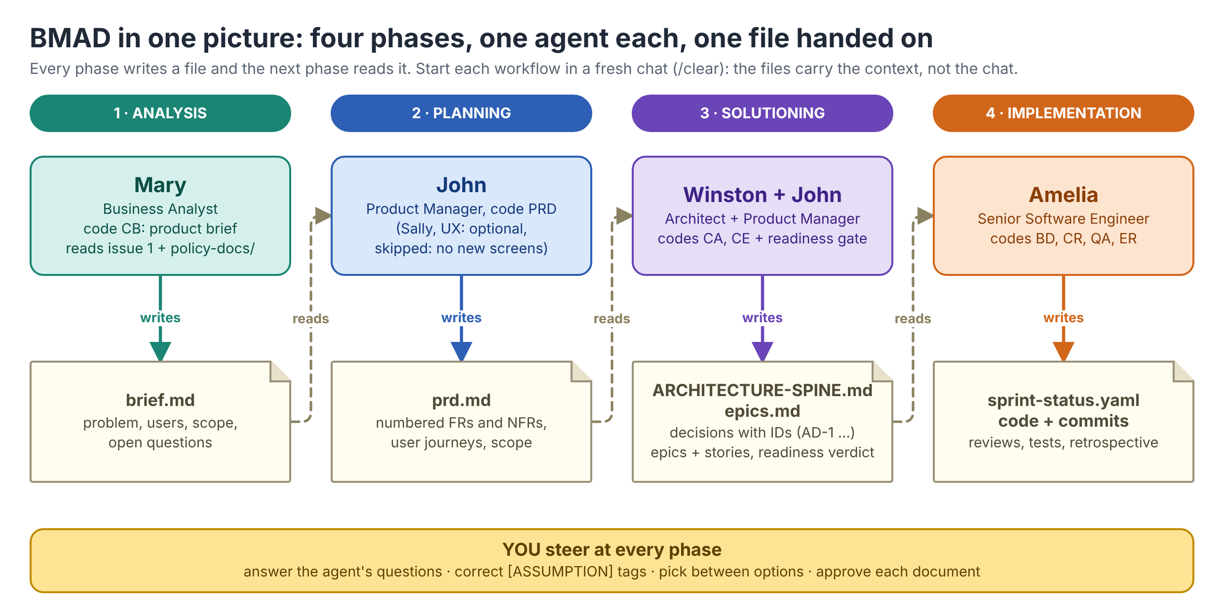

How BMAD differs from spec-driven development (SDD)
Both approaches share a principle: write down what you mean before an agent writes code, and keep it in the repository. They differ in how much structure they bring and who does the writing.
 | Spec-driven lab (what you did) | BMAD (this lab)
Core idea | One short, human-written spec is the source of truth | A chain of files, one per phase, each written with an agent and read by the next
What you install | Nothing extra. A template file and Claude Code's built-in features | BMAD: about 29 skills, 5 agents, a _bmad/ config folder
Documents produced | One spec with six sections | Brief, PRD, architecture spine, epics and stories, sprint status, reviews, retrospective
Who writes the text | You write the spec; Claude only drafts the plan section for you to review | The agents draft each document; you steer, correct and approve
Where the human decides | Three gates: approve the spec, read the failing tests, review the diff | At every phase: answer the agent's questions, correct [ASSUMPTION] tags, pick between options, approve plans
How the work is split | Tasks in the plan section, built tests first | Epics and stories, each built in its own fresh Build session
Review | Built-in /code-review and /security-review | /bmad-code-review in a fresh chat, plus an epic retrospective
Best fit | A single, well-understood change | A new product or a change large enough for several stories and several decisions
Main risk | A thin spec that misses a case | More documents to review, so review overload; a small change can get a heavy process

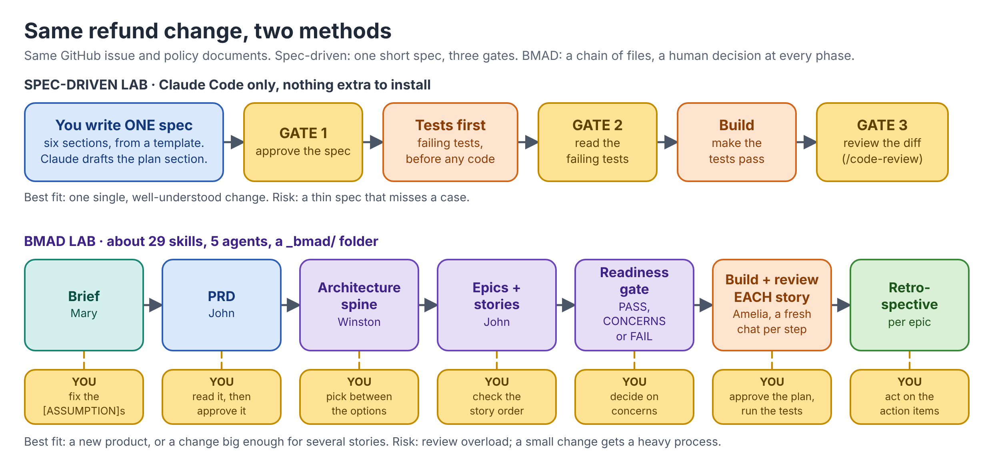

How much BMad process to use:
BMAD is scale-adaptive. BMad has a full path (brief → PRD → architecture → stories → implement → review) and lighter shortcuts. “Choose the smallest path that safely fits” means you pick the lightest path that still covers the risk in the change. You don’t run the whole ceremony every time.
Each example is one step up that scale.
- A one-line fix needs NO PRD. If you’re fixing a typo or an off-by-one, writing a requirements document costs more than the fix. You just make the change and test it.
- One clear goal can go straight to bmad-build. If the task is a single, well-understood goal with no open design questions, you skip planning and give it straight to the build/implementation step.
- A refund approval change needs the full path. That change touches several risky areas at once:
  - Authorization: who is allowed to approve.
  - Duplicates: the same refund must not be paid twice.
  - Audit: every approval has to be recorded.
Think of it like this. A wedding planner's file. The caterer, the decorator and the photographer are different people, but they all read the same file, and nobody asks the family the same question twice. BMAD's artifacts are that file and each agent is one of the vendors.

BMAD works with many AI tools, not only Claude Code.
Run npx bmad-method install --list-tools to see the current list.

1. What you are building
The repository is a small to-do app: a FastAPI + SQLite backend and a React 19 + Vite frontend. GitHub issue 1 asks for priority levels:
- A to-do can be created with a priority of low, medium or high. The default is medium.
- Each to-do in the list shows its priority as a small badge.
- The list can be filtered by priority.
- Existing to-dos keep working and count as medium.
The approved documents are docs/PRD.md and docs/TRD.md. Some of the PRD is out of date compared with the code (it says there is no persistence and no delete, but the code uses SQLite and has a delete endpoint). The agents must record such disagreements as open questions and never pick a side silently.
What is BMAD? A free, open-source framework that turns Claude Code into a small agile team. Role agents (Mary the analyst, John the product manager, Winston the architect, Amelia the developer) each own one phase and hand a file to the next. The brief feeds the PRD, the PRD feeds the architecture, and the architecture and PRD feed the build.

The four roles and the one skill each runs
Role | Agent | The one skill | File it writes
Analyst | Mary | bmad-product-brief (menu code CB) | brief.md
Product Manager | John | bmad-prd (menu code PRD) | prd.md
Architect | Winston | bmad-architecture (menu code CA) | ARCHITECTURE-SPINE.md
Developer | Amelia | bmad-build (menu code BD) | Code, tests and a commit

Why this path? The change is small enough for one build, but it still has real decisions (can priority change after creation, what is the sort order). The brief, PRD and architecture spine are where those decisions are made once and written down. A one-line fix would need none of this; a new product would need the epics and stories steps listed in the Notes.

2. How to use this list
- Work top to bottom. Tick each box only when its "Your check" line is true.
- One workflow per chat. Type /clear before each todo item. The files carry the context, not the chat.
- You approve, not the agent. Read each file and correct every [ASSUMPTION] tag against docs/PRD.md and docs/TRD.md.
- Always start claude from the project folder, so it sees CLAUDE.md and the skills.
The project CLAUDE.md ends with "Standing answers for BMAD questions", so BMAD normally does not ask routine questions. If a skill still asks one, answer from this table:
BMAD asks | Answer
Fast path or coaching path? | Fast path.
Architecture: spine only, or spine plus an explainer? | Spine only.
Keep the new open questions? | Keep them all. Never decide them.
Keep inferred requirements? | Keep them, each naming the document it is inferred from.
Run the wording pass or finalize steps? | Yes.
Approve this document / mark it final? | Not yet. Read it first and approve it yourself.
Anything not listed | Answer only from the approved documents. If none decides it, answer "defer" so it is recorded as an open question.

3. The to-do list
☐ T0 Set up the project (no agent)
What you do | Clone the repository, make a working branch, run the baseline tests, and install BMAD.
Commands | git clone https://github.com/DeccansoftAITeam/bmad-todo-priority-lab.git  cd bmad-todo-priority-lab  git checkout -b my-bmad-run  cd backend  uv sync  uv run pytest -q  cd ../frontend  npm install  cd ..
Install BMAD | Run the installer from the project root. Interactive:  npx bmad-method install  Answers: module BMad Method (bmm); custom modules No; AI tool Claude Code; project name Todo App; English; output folder _bmad-output; Express configuration. Or non-interactive:  npx bmad-method install --yes --modules bmm --tools claude-code --user-name "Your Name"
Then commit | git add -A  git commit -m "chore: install BMAD"
Connect GitHub | Mary reads issue 1 through the GitHub MCP server. Check that it is connected:  claude mcp list  If github is missing, add it once with a read-only token:  claude mcp add github --scope user --transport http https://api.githubcopilot.com/mcp/ --header "Authorization: Bearer YOUR_TOKEN"
Your check | "32 passed" from pytest. .claude/skills/ holds 29 bmad-* folders and _bmad/ exists. claude mcp list shows github connected.

☐ T1 Mary, Analyst: write the product brief
Skill | bmad-product-brief (menu code CB)
Why | The brief is the first file in the chain. It turns issue 1 into a problem, users and scope that the PRD will read.
Command | /clear  /bmad-agent-analyst  Mary greets you and shows her menu. Then paste:  CB  Build the product brief for the priority levels change. Use the GitHub MCP server to read issue 1 of DeccansoftAITeam/bmad-todo-priority-lab, then read docs/PRD.md and docs/TRD.md and the code in backend/app/.  Approved decisions are in docs/PRD.md and docs/TRD.md. The PRD is partly out of date compared with the code (it says no persistence and no delete, but the code uses SQLite and has a delete endpoint): record each disagreement as an open question, do not pick a side. The PRD says editing a to-do after creation is out of scope, so priority is set at creation only unless the owner decides otherwise: record that as an open question. Use the fast path. Out of scope for v1: custom priority names, colours, reminders, automatic sorting beyond the filter.
Shortcut | You can skip loading the agent and run the skill directly: /bmad-product-brief followed by the same text (without the leading CB). The result is the same.
You should see | A draft brief in _bmad-output/planning-artifacts/briefs/brief-<project>-<date>/brief.md, plus a .memlog.md. It has status: draft, scope and out-of-scope lists taken from issue 1, one [ASSUMPTION] (priority is set at creation only), about six inferred requirements that each name their source, and a table of open questions with an owner role. In a real run it found three disagreements: the PRD says no persistence and no delete, the TRD says no DELETE endpoint, and the code has all of them. It may say it did the review pass itself instead of running a separate reviewer; that is acceptable here.
Your check | Every [ASSUMPTION] is checked against the PRD or TRD. The brief lists the open questions and does not decide them. Then commit: git add -A && git commit -m "BMAD: product brief"

☐ T2 John, Product Manager: write the PRD
Skill | bmad-prd (menu code PRD)
Why | The PRD turns the brief into numbered requirements (FR) and quality requirements (NFR) that the architecture and the build can cite.
Command | /clear  /bmad-agent-pm  PRD  Create a PRD for the priority levels change from the product brief. Every requirement must trace to docs/PRD.md, docs/TRD.md or issue 1. Keep the open questions open.
Shortcut | Or run the skill directly: /bmad-prd create followed by the same text (without the leading PRD).
You should see | prd.md and .memlog.md in _bmad-output/planning-artifacts/prds/prd-<project>-<date>/. The PRD starts with status: draft and has numbered functional requirements (about 15, in groups: values, create, badge, filter, existing to-dos) and about 4 non-functional requirements (the R8 logging rule, database-enforced values, no regressions, test coverage). Requirements that are inferred say so and name their source. The brief's Q1 to Q8 are carried over, and a new one usually appears (for example, whether the filter runs on the server or in the browser). Keep every open question.
Your check | Read prd.md. Each requirement cites a source. Open questions are still open. Change the status line at the top to status: approved yourself, then commit: git add -A && git commit -m "BMAD: approved PRD"

☐ T3 Winston, Architect: write the architecture spine
Skill | bmad-architecture (menu code CA)
Why | The spine records only the decisions that would clash if two people made them separately, so the build does not invent them.
Command | /clear  /bmad-architecture Create the architecture for the priority levels change from the PRD. Keep the stack already in the repository: FastAPI, sqlite3, React 19 and pytest. Record decisions for: where the allowed priority values live, how the database column is added and how existing rows become medium, how the API filters by priority, and what the UI shows. Follow the existing layering (rules.py, schemas.py, main.py, db.py) and the logging rule R8. Write the spine only, with no explainer.
You should see | ARCHITECTURE-SPINE.md in _bmad-output/planning-artifacts/architecture/architecture-<project>-<date>/, with a .memlog.md and a reviews/ folder. In a real run there were six decisions, AD-1 to AD-6: the allowed values and the default defined once in rules.py (schemas.py and db.py derive from it); an idempotent ensure_schema() that adds the column with ALTER TABLE so old rows read as medium; server-side filtering with GET /api/todos?priority= (422 for a bad value); the UI (select, badge, "All" filter); priority set at creation only; and priority never logged. It tags its own choices for open questions as [ASSUMPTION]. It may suggest bmad-spec and epics as the next step; skip them.
Your check | Every decision has an ID such as AD-1. The spine keeps the existing layers and says that priority is never logged. Open the file and change status: draft to status: approved yourself (the build checks this). Then commit: git add -A && git commit -m "BMAD: architecture spine"

☐ T4 Amelia, Developer: build the change
Skill | bmad-build (menu code BD)
Why | Build reads the PRD and the spine first, so only what it cannot settle from them becomes a question. It plans, implements, reviews its own work and commits.
Command | /clear  /bmad-build Implement the priority levels change from the approved PRD and the architecture spine
Watch out | bmad-build runs commands through uv and runs the tests. Claude Code asks permission for each: read the command and approve it. If you refuse, the skill stops or reports that it could not run the tests. In that case run them yourself (T5) and tell Amelia the result.
You should see | Build does not start coding straight away. It reads the PRD and spine, then writes a short spec, _bmad-output/implementation-artifacts/spec-gh-1-priority-levels.md (status draft), and stops with three choices:  - Approve and continue: it implements in this chat.  - Approve and stop: it marks the spec ready-for-dev; a fresh /bmad-build picks it up.  - Review spec: a separate review first.  The spec lists what will be built, any step that cannot be undone (here: the schema change to an existing todos.db), and the open questions it deferred. Read it, then choose Approve and continue. Amelia writes the code and tests, runs them, reviews her own work and commits.
Your check | Read the spec before you approve it. Note which open questions it deferred and which it settled from the spine. After the build, run the checks yourself (T5).

☐ T5 Verify with evidence (no agent)
What you do | A summary from an agent is a claim. The commit, the test run and the running app are evidence.
Commands | git log --oneline -5  Backend:  cd backend  uv run pytest -q  uv run uvicorn app.main:app --port 8000 --no-access-log  Frontend:  cd frontend  Npm run dev
Your check | All of these are true. In a real run pytest went from 32 passed to 40 passed, npm run lint exited 0 and npm run build succeeded:  - A to-do created without a priority comes back as medium.  - A priority outside low, medium and high is rejected with a 422.  - The filter returns only to-dos with that priority.  - A to-do that existed before the change shows as medium.  - test_titles_never_logged still passes, and priority appears in no log line.

☐ T6 Wrap-up (no agent)
What you do | Fill the table in your own words. If you also did the spec-driven lab on the refund change, compare the two.
Questions | - How many documents did I read and approve?  - Where did a wrong assumption get caught?  - What did the method ask of me that I could not skip?  - What slowed me down?  - For a change this size, would I use this path or one bmad-build? For a new product?
Your check | You can say in one line what a skill, an agent and an artifact are.

Useful commands
Command | What it does
npx bmad-method install | Install, update or reconfigure BMAD
/bmad-help <question> | Recommend the next skill
/bmad-product-brief | Product brief (Mary, CB)
/bmad-prd create, /bmad-prd validate | Write or check the PRD (John, PRD)
/bmad-ux | UX design (Sally, CU)
/bmad-spec <intent> | A short spec for a clear intent; can break it into stories
/bmad-architecture | Architecture spine (Winston, CA)
/bmad-create-epics-and-stories | Epics and stories (John, CE)
/bmad-sprint-planning | Readiness gate and sprint tracking
/bmad-build <story>, /bmad-build-auto <story> | Build one story (Amelia, BD)
/bmad-code-review <target> | Review a PR, commit or branch (Amelia, CR)
/bmad-qa-generate-e2e-tests | API and end-to-end tests (Amelia, QA)
/bmad-correct-course | Handle a big change mid-sprint (John, CC)
/bmad-retrospective | Close an epic (Amelia, ER)
/bmad-customize | Override an agent or workflow safely
/bmad-party-mode | Several agents discuss one topic
/clear | Start a fresh chat
/mcp | Show MCP servers and their status

References. Repository: github.com/bmad-code-org/BMAD-METHOD (branch V6.12 for the stable docs, main for v7). Docs: docs.bmad-method.org. npm package: bmad-method. Licence: MIT.

