I’m assuming you already have python installed.

Note: you can run flask from Jupiter notebook without using this.

1 – create env

py -m pip install --user virtualenv

2 – second, activate the virtual environment

.\env\Scripts\activate



3 – install the requirements files

Pip install –r requirments.txt

3 – flask run

Note: make sure you’re in the environment



4 – open the host and then send your parameters

Ex: /?jobtitle='full stack developer, oxfordshire, Â£40k'

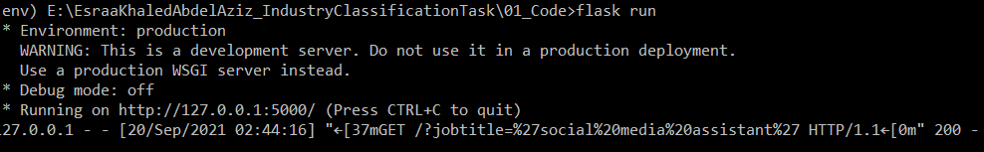

5 – use postman or from the browser itself.

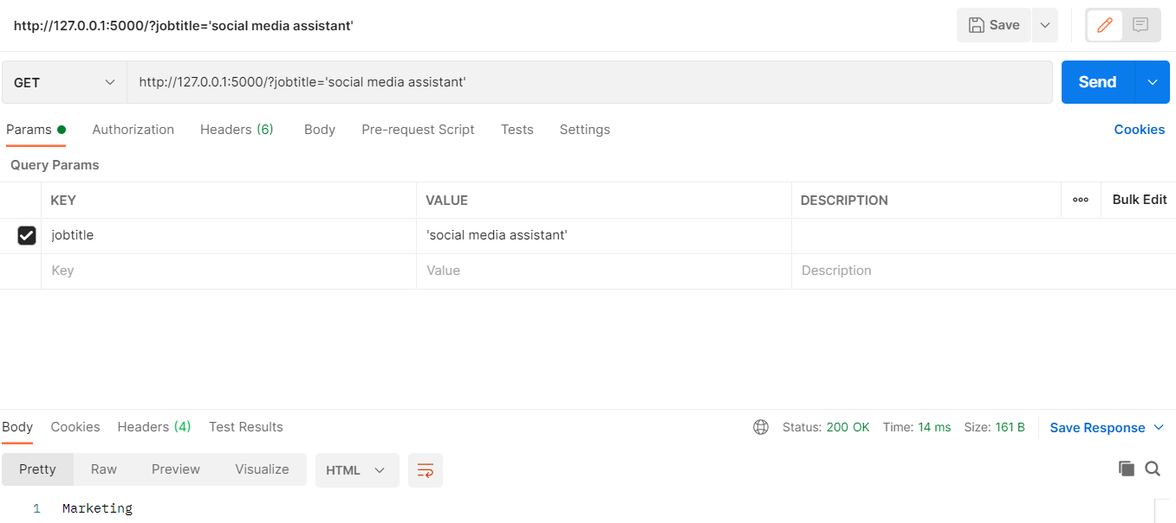

6 – to stop flask ctrl+c then deactivate the env