


COMMUNITY-BASED NATURAL RESOURCE MANAGEMENT (CBNRM) IN AFRICA -

A REVIEW

Henri P. Josserand, ARD, Inc

April 2001

For

Rural and Agricultural Incomes with a Sustainable Environment (RAISE)
Contract No. PCE-I-00-99-00001-00, Task Order 002

ARD-RAISE Consortium
1601 N. Kent Street., Suite 800
Arlington, VA 22209, USA
Tel: 703-807-5700, Fax: 703-807-0889
gkerr@ardinc.com

The ARD-RAISE Consortium:
ARD, Inc., Cargill Technical Services, Associates for International Resources and Development
CARANA Corporation, A.P. Gross & Company, International Programs Consortium, Land O’ Lakes,
Purdue University, and Technoserve.

ACKNOWLEDGMENTS

The CBNRM experience in Africa is highly dynamic, so that an assessment is either quickly outdated or useful mostly as “work in progress”. Nevertheless, we hope this synthesis and the analytical tools provided on this disk will contribute to the ongoing quest for more sustainable and equitable natural resource management.

The author of the Synthesis Report and other Working Group members have benefited from the expert opinion, comments and cooperation of many friends and colleagues. Special thanks go to Jamie Thomson, Steve Dennison, Rebecca Butterfield, Ramzy Kanaan, Ryan Roberge and Tracy Simmons, at ARD, Inc.; Asif Shaikh and Bob Winterbottom, of the International Resources Group (IRG); David Gibson of Chemonics International; Yves Prévost, of the World Bank, Roy Hagen, and Lars Soeftestad, CBNRM Net Webmaster.

Henri P. Josserand
April 2001

EXECUTIVE SUMMARY

The Working Group on Community-Based Natural Resource Management (CBNRM) in Africa was convened by the Africa Bureau’s Office of Sustainable Development (AFR/SD) as part of their Environmental Management and Information Systems (EMIS) portfolio. At USAID, leadership was provided by Paul Bartel, Technical Advisor for Environmental Information and Mike McGahuey, Technical Advisor for Environment and Natural Resources. Other members included Henri Josserand from ARD, Inc.; Max McFadden, Bruce Miller, J. Kathy Parker and Michael Saunders from the Heron Group; and John Woodwell, of the University of Maryland.

The purpose of this work was to characterize the nature of CBNRM experiences, their evolution over time, and to develop analytical tools on determinants of success, uptake, and expansion. The purpose also included an assessment of resource valuation approaches, of the potential impact of CBNRM, and suggesting some implications for USAID personnel and their partners.

Final products include a synthesis report, an annotated bibliography, a collection of reports and case studies, Web site references, and two analytical models concerning

- macroeconomic implications of environmental actions, and
- an analysis of micro- and macro-level factors in CBNRM initiation.

1. The Concept of CBNRM and its Evolution over Time

The concept of CBNRM has gradually shifted from a relatively narrow focus on local communities and their biophysical milieu, to a broader view of CBNRM as an integral part of forces at work in the environment/natural resources (ENR) sector. There is now wide agreement that CBNRM cannot be understood and assessed in isolation. Another way of putting it is that just as one cannot imagine a ten-story building without a third floor, one cannot conceive of the third floor without the rest of the ten-story building. CBNRM, as the third floor of the ENR building, may have a different color, may have different uses, but it is inseparable from the rest of the structure. This fundamental notion has pervaded all aspects of this work.

Among many possible definitions, the following fits well with the wide variety of existing CBNRM cases:

"CBNRM is the management of natural resources under a detailed plan developed and agreed to by all concerned stakeholders. The approach is community based in that the communities managing the resources have the legal rights, the local institutions, and the economic incentives to take substantial responsibility for sustained use of these resources. Under the natural resource management plan, communities become the primary implementers, assisted and monitored by technical services.”

In slightly different terms, CBNRM is also defined as:

“Joint management of resources by a community, based on a community strategy, done in partnership with other legitimate stakeholders. This implies that the community plays an active role in the management of natural resources, not because it asserts sole ownership over them, but because it can claim participation in their management and benefits for practical and technical reasons.”

The notion of community-based natural resource management seems most appropriate when one wishes to focus on the community level aspects of the micro-macro continuum. The closely related concept of co-management of natural resources on the other hand, may be more appropriate when one wishes to emphasize more evenly the various components of the micro-macro continuum, including noncommunity-based stakeholders.

CBNRM does not take place in a vacuum; communities operate within policy and legal frameworks, and can exert some influence upon it. The notion of vertical linkages repeatedly appears in the Working Group’s analysis, through enabling conditions and via direct and indirect effects from CBNRM, for example. Communities also share the management of natural resources with other stakeholders at the local level (traditional authorities, local government agencies, private sector operators); horizontal linkages thus appear in the analysis of determinants of success, and of potential impact and implications for USAID and partners.

The Group believes the connections between the various forms of CBNRM and other segments of society are very strong. Hence, there cannot be significant progress in CBNRM activities unless ENR work at the macro level is also successful. Conversely, an accurate indicator of progress in the ENR policy and legislative areas at the macro level is a healthy CBNRM sector.

CBNRM activities may apply to limited areas, to a relatively small number of persons, but they are one of the points where critical processes come together; the place where "the rubber meets the road". In a very real sense, the success of CBNRM is a test of whether countries are striving for progress in a critical area: the rights and responsibilities of indigenous people.

Finally, this overview of the evolving concept of CBNRM and its manifestations highlights an overarching issue in ENR: the dichotomy between ‘modern’ legal frameworks and the multitude of customary systems of tenure and resource use at the local level. This is why most significant CBNRM and other ENR activities find themselves — and may remain for a long time — on the fringes of strictly defined legality.

2. Enabling Conditions and Key Variables in Adoption

Because CBNRM is not an isolated phenomenon, determinants of success span the macro and micro levels. They also pertain to the nature and efficiency of linkages between stakeholders, such as the ability of communities to negotiate with private sector operators.

The Group designed a model to identify enabling factors of CBNRM initiation from the macro to the community levels, and to express interactions between these factors. Critical determinants of initiation fell into four areas: political, economic, social and biophysical. Successful CBNRM activities clearly need to satisfy minimum requirements in each of the four areas. Beyond a minimum level, however, tradeoffs within and between areas can take place, depending on local conditions and environment. For instance, once basic preconditions are met, a community can rely on particularly strong characteristics in one area (e.g., social or technical) to overcome constraints in another (e.g., political or institutional). The original model was created with NetWeaver™; a Microsoft® Excel illustration is also available.

Constraints to ENR and CBNRM activities do not only pertain to community characteristics and to poor policy or legal frameworks. Communities and their partners are also limited by the nature of investments in infrastructure. With recurrent costs usually beyond the means of national institutions, and little regard for traditional resource use systems, they can rule out efficiency in co-management of natural resources. Common examples include deep boreholes in pastoral zones, dams and large irrigation schemes.

3. Trends in Uptakes, Effects

Because CBNRM is integrated with other aspects of the ENR sector, and connected to many parts of the economy, trends reflect evolving legal and policy frameworks as well as changes in activities at the local levels. Complexity and "noise-to-signal ratio" are high. However, a review of country cases, from policy to community levels, highlights recent trends. At the community level, they include:

- a demonstrated willingness by rural communities to invest in the future at the expense of more immediate benefits, especially when this involves individual and joint actions on community lands or ‘terroirs’ rather than more remote common property resources (Not surprisingly, the issue of security of tenure is fundamental, and plays a greater role as the time horizon expands.);

- quite a few cases of CBNRM profitability for communities and other legitimate stakeholders (This suggests progress in co-management capacity, and progress in working for ‘congruence of objectives’ among interested parties.);

- mixed results in terms of community participation, especially for women, although trends point to greater diversification and wider participation (Relations with other traditional resource users also vary; some communities have used CBNRM schemes at the expense of groups which had traditionally shared the same resources.); and

- knowledge, attitudes and practices with respect to NRM are changing, but communities need continued support in the areas of training (organization, literacy, financial management), and for technical inputs, credit.

At the macro level, although legal and policy frameworks are becoming more favorable to ENR and CBNRM, they are not yet strictly consistent with them. Many community initiatives have been well received (e.g., Malawi’s lake Malombe and Senegal’s Kayar fisheries) but only by “bending" formal laws or rules. Acceptance is thus counterbalanced by the inconsistency or arbitrariness of official support for CBNRM, and by the weakness of its legal basis. Still, changes in policy and legal frameworks have taken place, for instance:

- Guinea – stronger co-management of the Nyalama classified forest. Formal agreements exist between the national Forest Service and about 30 local communities. Joint training of Forest Service and communities will extend this practice to other parts of the country.

- Madagascar – enactment of the National Park Act; mining permits rescinded in areas adjacent to national parks.

- Senegal – first instances of local leaders (about 600) being actively involved in defining options for feasible land reform in all ten regions.

- Tanzania – parliamentary approval of the National Environmental Policy (1997).

- Uganda – establishment of the Bwindi Trust, the first of its kind in sub-Saharan Africa. Designed for the long-term conservation of afromontane ecosystems (Bwindi impenetrable Park, Mgahinga Gorilla National Park), the Trust now has a $5.5 million endowment for grants program, administration and research.

- National environmental impact assessments (EIAs) are becoming more common for investments with sizeable environmental implications. Results are definitely mixed (rejection of an EIA on a prawn farm in the Rufiji River delta by the Government of Tanzania, for example) but the principle of providing public scrutiny; input and media coverage is gaining currency.

The influence exerted by micro-level actors upon the macro processes of policy orientation and implementation is slowly growing. Community advocacy for local NRM is rising, especially where communities work together rather than singly. There are also a few instances of CBNRM being supported through specialized associations at the national level, and even of co-management of natural resources across national borders. Still, little is happening in such closely related sectors as training, industry, commerce and tourism, and further diversification is needed, especially in southern Africa where CBNRM activities tend to be more narrowly focused than in other regions.

4. Economic Analysis of Resource Valuation

Since CBNRM and other parts of the ENR sector are closely connected, resource valuation issues directly or indirectly span the macro and micro levels. At both levels, a fuller recognition of the value of natural resources is a fundamental condition for efficient resource management, but it is very much a matter of perception, capacity to realize the full value of the environmental services from the resources, and of equity in distribution.

At the macro level, common property resources tend to remain systematically undervalued to favor a specific constituency, or because they represent politically sensitive commodities. Most people have witnessed some form of ‘tragedy of the commons’ process whereby a fishery, public forest or open rangeland are overexploited. The resource can have considerable value, but, because this value cannot be ‘integrated’ into the strategy of a single controlling individual or entity, it is frittered away in ever decreasing returns to competing users. In fact, the higher the original value of the resource, the faster the process tends to unfold. National governments are increasingly aware of the degradation of the environment, they realize that ‘things cannot go on like this forever’. At the same time, they still have a vague sense of the scale of potential benefits from better NRM, and hesitate to entrust the realization of some of these benefits to a combination of decentralized units and autonomous rural communities and other stakeholders. Indeed, while there is a consensus on the need to improve the overall management of natural resources, it is hard to show in specific terms what this might amount to, for the average economy of sub-Saharan Africa. To address this question, the author has developed a simple Excel-based model showing the direct macroeconomic impact of various changes in the efficiency of resource use. It turns out that for a ‘typical’ African country with population growing at 2.6 percent per year it takes a significant overall improvement (about 100 percent) in returns from natural resources to maintain per capita income over time.

At the community level, the perceived value of the resource to be managed must be large enough for communities to go through organization, mobilization, planning, management and implementation for the activity, not to mention dialogue and negotiations with a potentially large set of legitimate stakeholders. Communities must also perceive that benefits from the activity represent a net gain; they will not make large investments if the returns from their work end up as a mere substitute for investments in public services and infrastructure that they would normally expect the government (or perhaps, donors) to provide.

The value of natural resources which may come under co-management has to be assessed and expressed as clearly as possible, so that all relevant parties may perceive that the benefits from co-management are greater than revenues derived from alternative uses of resources extracted from these systems. This does not require that all parties eventually come to have exactly the same perception of value from natural resources; they cannot. Still, they must all perceive that co-management is a superior strategy than most alternatives. This also implies that relevant stakeholders can draw on this information to mobilize institutional and political mechanisms for appropriate co-management. In the final analysis, the value derived by society from natural resources in a given area depends on the extent to which relevant stakeholders (communities, tribes, local and central governments, private companies) can negotiate informed and manageable agreements to reach the most beneficial among alternative uses of natural resources.

Our review of the CBNRM experience in sub-Saharan Africa suggests that this may well be one of its main deficiencies. As essential as it may be for successful and significant co-management of natural resources, the need to work jointly with communities and other stakeholders on their perceptions of the value of resources, including potential benefits from co-management has received relatively little attention.

5. Potential/Constraints for the Expansion of CBNRM, Impact

There is great potential for the expansion of CBNRM; it must be envisioned at several related levels. Further work at the community level is needed, of course, but one must also emphasize the extent and quality of linkages, both horizontal and vertical. In other words, while activities at the community level need to progress, and expand spatially, it is equally crucial to strengthen the linkages between communities and other stakeholders. These two approaches are not mutually exclusive; on the contrary: more successful community-level actions are consistent with greater benefits from increased integration with larger processes.

In terms of expansion over space, CBNRM potential partly depends on practical factors. These include the extent to which communities can co-manage resources from the borders of strictly defined community lands up to areas where they cease to be viable partners, because of distance, the overwhelming scale of resources to be managed, etc. The theoretical potential for CBNRM is large, because it involves many types of resources (farmland, forest, pasture, fishing grounds) and a combination of these. The chief constraint is less the availability of resources to be co-managed than access by communities to the skills and information needed for shared responsibility in resource management.

Monitoring the geographic expansion of CBNRM on the basis of biophysical change is an essential part of the task of tracking progress at the local level. The development of horizontal linkages is another critical element of ‘CBNRM expansion’. Horizontal linkages depend on the extent to which communities can associate with proximate communities and other stakeholders for co-management. The potential size of a CBNRM activity thus depends on the size of the "consortium" assembled to share the management of resources. A single community working with Forest Service agents may be able to co-manage a given area of forest. A set of communities, working together with the Forest Service, plus a number of private sector operators, can efficiently manage a much larger area.

A critical mass of successful CBNRM activities can use vertical linkages to inform and influence the ENR policy environment. When joint actors of CBNRM activities help improve the national policy and legal frameworks, for instance, the ‘fallout’ from CBNRM can potentially reach all activities affected by national ENR policies. There is no simple and clear-cut definition of a ‘critical mass’ of CBNRM activities. However, critical mass may be reached when the implications from successful CBNRM experiences, on the one hand, and current ENR policy, on the other, are so clearly at odds that pressure for change becomes very real. The size of this critical mass also depends on the receptivity of central authorities to pressure from below and on the efficiency of vertical linkages.

The potential for expansion of, and benefits from, CBNRM often runs into countervailing factors. Successful CBNRM implementation indicates that economic value and benefits from natural capital are more fully realized than was previously the case. Short- and long-term returns to resource use are bound to rise in such areas. In most cases, the former practices of inefficient resource use have not disappeared altogether; they have just been displaced, possibly toward more marginal or environmentally fragile areas. By raising the value of resources, CBNRM raises the economic stakes and incentives for resource protection, helping fend outside pressure. Pressure, however, will remain or increase because the population keeps growing. Increasingly destitute populations ‘on the outside’ also perceive areas implementing successful CBNRM as a way out of their poverty. This is obviously not a case against CBNRM, but another reason to work for expansion, not only in a spatial sense, but also in terms of impacts on policy processes.

6. Implications for USAID and Partners

At headquarters, and in countries where USAID has environmental strategic objectives, operating units design and support a wide variety of ENR activities, from the macro to community levels. They may not explicitly refer to ‘vertical and horizontal linkages,’ but USAID personnel and their partners recognize the connections between discrete components of ENR sector activities at all levels. For instance, over its ten-year life, the Botswana Natural Resource Management Plan (NRMP) intervened at many related levels:

- introduced the CBNRM process,
- organized, created and supported a large number of pilot community-based organizations (CBOs),
- initiated CBNRM network and outreach processes,
- assisted national agencies to develop community-oriented extension approaches,
- worked on nationwide environmental education,
- supported NGOs, and
- reviewed and revised key CBNRM policies of the government.

The implications from this work for USAID and partners can be summarized into five areas for action:

- Establishing a more explicit joint understanding of interactions at the macro level, as a basis for such macro-level work as country strategy and strategic objective (SO) definition.
- Gaining a better understanding of macro-micro linkages in the ENR sector, and of approaches to resource valuation. CBNRM is one of several good point of departure.
- Applying a better grasp of interactions, analytical tools and information technologies to institutional obstacles to more efficient NRM at various levels.
- Retaining flexibility within a wide portfolio of supporting activities.
- Seeking a closer fit between strategies and programs which are necessarily limited in time, and a vision consistent with the long-term nature of ENR work in Africa.

(a) A Shared Vision of Interactions at the Macro Level

Paradoxically, the Working Group on CBNRM started with a simplified, consensual analysis of national-level interactions among processes pertaining to economics, health, population, democracy and governance, as well as education. The purpose was not to derive a detailed model of such interactions, but to place thinking on ENR issues squarely on the basis of a shared view of the their broader context. USAID Missions often go through a similar process. This process, which involves contrasting and reconciling different views of the world and objectives, stands to gain from being more open, explicit, structured and systematic. A number of process-oriented analytical tools are available to facilitate knowledge-based exchanges and consensus building. They require neither advanced modeling skills or large investments in time and data collection and analysis. They do, however, greatly facilitate the kind of mutual understanding and shared visions without which it is very difficult to design (let alone implement) a set of coherent sectoral initiatives.

(b) Understanding Macro-Micro Linkages in the ENR sector, Approaches to Resource Valuation

Understanding, and working to strengthen, vertical and horizontal linkages is a fundamental principle in work on CBNRM. The greatest potential for future benefits from CBNRM lies in stronger and more efficient linkages between communities and other stakeholders. The analysis of macro- and micro-level factors determining success and impact from CBNRM can be a convenient point of departure for USAID officers and their partners. The Working Group also encourages them to use process-oriented analytical tools to examine jointly the efficiency of current linkages, and to find means to improve them. Another potential benefit from a better understanding of linkages is that it can help express the economic benefits from CBNRM at various levels and for various stakeholders, in more telling and convincing ways.

(c) Reducing Institutional Obstacles to Efficient NRM

Since environmental issues and policies cut across institutional lines, the implementation of such a policy may involve several national institutions: Ministries of Agriculture, Livestock, Forestry, Territorial Administration, etc. Each of these institutions has its own objectives, agenda, and institutional culture, so that crosscutting policies are often viewed as attempts to interfere with the self-defined mandate of these institutions. They are frequently ignored or rejected because they don’t fit the institution’s own master plan. A combination of better information and of analytical tools can help institutions perceive more clearly which aspects of an environmental policy actually correspond to, or help fulfill, their own objectives.

Neither central government agencies nor other institutions should have exclusive rights to policy analysis. Analytical tools appropriate for use by interest groups (including those tested) can ‘democratize’ the process of policy analysis. By making information and analytical tools available to other groups, such as university researchers, NGOs, trade, professional and even producers’ associations, USAID can promote a more open debate on resource management issues and the adoption of local resource management techniques. This can weaken the undivided hold national institutions may be trying to maintain on parts of the ENR sector.

(d) Retaining Flexibility within the ENR Portfolio

Since CBNRM and other parts of the environmental portfolio are closely connected and complementary, an appropriate balance must be struck. An overemphasis on policy-level action at the expense of community-level work, or vice versa, could be inefficient. Yet, USAID works — along with many other actors at any point in time — in a complex and changing environment. Some operating units explicitly state their intention to address whatever happens to be the ‘weakest link’ in the ENR chain, for instance:

"In areas where the national tenure laws and enabling environment are inappropriate, we will support legislative and policy change. In areas where the policy environment is right, we will support capacity building and sustainable resource enterprise development. In areas where alternative land use is firmly established, we will promote more biodiversity-friendly production systems."

A good understanding of connections between the community and other levels can help USAID personnel best use the flexibility built into their environmental programs not only to strengthen the connections between links, but also to focus on the weakest ones when necessary.

(e) Short-term Strategies and Programs vs. Long-term Visions of ENR

Sub-Saharan Africa still constitutes a vast reservoir of natural resources, but widespread resource loss and degradation are so rapid that urgent action is needed. The time span required to mediate or reverse negative environmental trends stretches over the long term. For many reasons, however, most human institutions (governments, donor agencies, NGOs, rural communities) tend to operate within a much shorter timeframe. The first step toward a practical compromise is to recognize this divergence explicitly. The next step is to develop a vision of long-term processes, and to visualize how short-term strategies and programs can best contribute to these long-term processes. This, in turn, requires two things:

- striking a proper balance between the achievement of quick results and ‘planting the seeds’ of longer-term processes, and
- being more open to what others are doing (and planning), in order to seek coherence and continuity not only in one’s ideas and actions, but also in those of other actors.

TABLE OF CONTENTS

ACKNOWLEDGMENTS i
EXECUTIVE SUMMARY ii
LIST OF FIGURES xii
ACRONYMS AND ABBREVIATIONS xiii
CHAPTER ONE. THE CONCEPT OF CBNRM AND ITS EVOLUTION OVER TIME 1
CHAPTER TWO. ENABLING CONDITIONS AND KEY DETERMINANTS IN 6
THE ADOPTION OF CBNRM 6
2.1 The Notion of Comparative Advantage as Applied to CBNRM 12
2.2 Public Investments and Flexibility in Resource Use for CBNRM Implementation 12
2.3 Enabling Conditions, Key Variables 13
2.3.1 Overview of Factors Influencing Success/Failure of CBNRM 13
2.3.2 Reasoning Behind the Choice of Each Factor 14
2.4 Structure of the Knowledge- based Model, Substitutability between Closely Related Factors, Tradeoffs 22
2.4.1 Social Factors: 23
2.4.2 Political Factors 25
2.4.3 Economic Factors 26
2.4.4 Biophysical Factors 26

CHAPTER THREE. TRENDS IN UPTAKE, EFFECTS 28
CHAPTER FOUR. CBNRM - ECONOMIC ANALYSIS OF RESOURCE VALUATION 34
4.1 Model Results with a Stagnating Economy, 2.6 Percent and 2 Percent Population Growth 37

CHAPTER FIVE. PROJECTIONS OF POTENTIAL IMPACT 41
5.1 Direct Local Effects and Constraints 41
5.2 Local Indirect Effects and Constraints 42
5.3 Scope for Expansion 43
5.4 Macro-Level Effects, Scope for Expansion 43

CHAPTER SIX. IMPLICATIONS FOR USAID AND PARTNERS 45
(a) A Shared Vision of Interactions at the Macro Level 45
(b) Understanding Macro-Micro Linkages in the ENR Sector, Approaches to Resource Valuation 48
(c) Reducing Institutional Obstacles to Efficient NRM 49
(d) Retaining Flexibility within the ENR Portfolio 50
(e) Short-term Strategies and Programs vs. Long-term Visions of ENR 50

LIST OF FIGURES

Figure 2.1 Main Types of Factors for CBNRM 8
Figure 2.2 Summary of Enabling Conditions as of February 2001 (n = 98) 9
Figure 2.3 Summary of Stakeholders rank (February 2001) 9
Figure 2.4 Initiatives by regions (February 2001) 9
Figure 2.5 Minimum Conditions for CBNRM Initiation 11
with Shortcomings in Social Area 11
Figure 2.6 Minimum Conditions for CBNRM Initiation with Tradeoffs 11
Figure 2.7 The Four Type of Factors Influencing the Success/Failure of CBNRM 13
Figure 2.8 Ability to Manage CBNRM Activities 23
Figure 2.9 Social Factors in CBNRM Initiation 24
Figure 2.10 Social Factor Scores 25
Figure 2.11 Political Factors in CBNRM Initiation 25
Figure 2.12 Economic Factors in CBNRM Initiation 26
Figure 2.13 Biophysical Factors in CBNRM Initiation 27

Figure 3.1 Evolution of Total Community Income from Natural Resource-based Activities in Namibia from 1995 through 1999 31
Figure 3.2 Evolution of the Extent of Natural Habitats in Officially Protected Areas, in Madagascar 31

Figure 3.3 Evolution of the Value of CAMPFIRE Benefits in Zimbabwe, 1989-1997 32

Figure 3.4 Number of Beneficiary Households among Participating Communities, Zimbabwe CAMPFIRE Project 32

Figure 4.1 Economic Growth = 0, Population Growth = 2 Percent 38
Figure 4.2 Model Results with a Slow Growing Economy, Lower Population Growth 38

Figure 6.1 Major Ecological-Economic Relationships 46
Figure 6.2 Effects on Income over Time 47
Figure 6.3 Macro-Micro Linkages 48

ACRONYMS AND ABBREVIATIONS

AFR/SD Africa Bureau’s Office of Sustainable Development
CBNRM Community-Based Natural Resource Management
CBO Community-Based Organization
CDCS Centre for Development Cooperation Services, Vrije University - Amsterdam, Netherlands
CILSS Permanent Interstate Committee for the Fight Against the Drought in the Sahel
CR communautés rurales
EIA Environmental Impact Assessment
EMIS Environmental Management and Informational Systems
ENR Environment/Natural Resources
GDP Gross Domestic Product
MSY Maximum Sustainable Yield
NGO Nongovernmental Organization
NR Natural Resources
NRM Natural Resource Management
NRMP Natural Resource Management Plan
ODA Official Development Assistance
p.a. per annum
PADLOS Project to Support Local Development in the Sahel
SO Strategic Objective
USAID United States Agency for International Development

CHAPTER ONE

THE CONCEPT OF CBNRM AND ITS EVOLUTION OVER TIME

Strictly speaking, Community-Based Natural Resource Management (CBNRM) refers to one of the most fundamental forms of production-oriented social organization. A chronology of CBNRM might, in fact, start with Old Testament references to group use of, and conflict over, resources.

Luckily, the approach to the historical analysis of factors related to CBNRM does not hark back to the days of Genesis. Rather, it takes the position that exploring historical processes is not a matter of following a single line of chronological events. Understanding the evolution of CBNRM over time is more like uncoiling a rope whose main strands represent various processes. The Group views these intertwined strands as representing processes in three main domains:

- the biophysical domain, expressed as environmental trends;
- the political/institutional domain, including changes in the nature and role of state institutions; and
- the socioeconomic domain, where demographic and economic trends, popular movements are at work.

Some events, such as periods of generalized drought in a particular region of Africa, e.g., the Sahel in the late 1960s and mid-1980s, or southern Africa in the early 1990s, stand out on a single strand. Single strands may also represent long-term processes, such as climate and ecological changes. Other events, however, seem to fit at the junction of processes from the various strands. The 1989 Ségou Meeting, for instance, may be considered an important stage in environmental, socioeconomic and political processes.

Processes that would figure prominently in a political/institutional strand might include the colonial period, the post-independence period, the changing nature and role of State institutions and evolving relations between the State and civil society.

In terms of natural resources, the colonial period could be characterized as one of imposition by conquest of an alien legal system on top of customary rules for managing people and natural capital. Centuries of established and functional resource tenure and use systems were usurped, often by the single stroke of a colonial administrator’s pen. In many fundamental ways, the colonial period also laid the foundation for neo-colonial practices by newly independent states. Oftentimes, the rulers of new nation states established systems of political supremacy and resource extraction reminiscent of colonial strategies, although they relied on different mechanisms, such as vesting the trusteeship of natural capital in various State administrations. This strategy formed the basis of political power and patronage, but it was clearly at odds with State’s real capacity to manage natural resources.

The broad application of the principle of ‘eminent domain,’ establishing the State’s preeminent authority over the nation’s natural capital had important consequences with respect to CBNRM. For instance, it effectively sanctioned only two forms of tenure: private property and state property. Common property regimes and attendant rights based on custom were thus largely ignored. In many cases, it meant that local communities lost the right to exercise traditional rules and regulations on the use of local resources. This was detrimental not only to communities but also to central governments, because the State thus lost the opportunity of relying on traditional customs to help enforce resource management in the cases when mutually advantageous settlements could have been reached. As Toulmin and Quan point out, “there are considerable merits in customary systems for land rights management since they provide a relatively secure means for those who are members of the community, at a lower cost and with greater fairness than state-run administrative structures.”

Here and there, traditional authority, customs and knowledge have remained strong enough to provide central or local governments with a reasonable option for the co-management of natural resources, especially when combined with ‘modern’ skills and techniques. In most other instances, however, local communities remain ‘in limbo’ between customary resource use entitlements that are no longer recognized, and the modern legal rights they have yet to win.

The failure of the politically centralized approach has become increasingly patent. While ready and workable political alternatives are by no means always available, the late 1980s and early 1990s have seen a number of critical trends gather momentum, at different rates here and there in sub-Saharan Africa. In several countries, popular discontent with its various forms combined with natural hardships to create political pressure for change. One of the extreme manifestations of rising democratic pressure was the popular coup d’état that took place in Mali in 1991. The last decade or so has also seen a sharp decrease in the central governments’ capacity to intervene. Political currency and financial resources have been eroded, direct bilateral support by donors has shrunk, and the international economic environment has been unfavorable overall. Under a combination of internal and external pressure, many governments have gradually come to accept the principle of allowing local populations to co-manage resources for which the State could no longer pose as a credible custodian. As shown in subsequent chapters, this phenomenon has followed a number of different paths, whereby arrangements between interested parties have taken various and sundry forms.

Although the trend toward co-management of natural resources is positive, a number of critical constraints remain. For one thing, even though central governments may be more willing to allow the co-management of natural resources, CBNRM is almost never given full and official legal status. There are two main reasons for this. First, there is a distinct lack of enthusiasm for this policy on the part of central governments. Secondly, one must not underestimate the undeniable, indeed considerable, difficulty of integrating a multitude of local customary rules and practices into a nationwide legal framework. In the mid-1980s, Niger embarked upon an ambitious scheme to provide a more appropriate legal framework for the assorted modes of local resource tenure and use. It soon became obvious that such an undertaking would take many years and require huge amounts of resources; certainly much more than anyone at the time would have been willing to commit to the full exercise.

Therefore, an important feature of CBNRM chronology and trends is that there is, and will be for quite some time, a ‘disconnect’ between:

- customary or traditional practices which remain the historical, cultural and social heritage of populations, and their main frame of reference in the management of local resources; and
- attempts to establish a basis for modern legislation pertaining to natural resource management.
Inconsistencies between traditional and modern systems are significant and not nearly resolved. In virtually all cases where significant CBNRM activities take place, they do so only because the various stakeholders work out formal or tacit agreements whereby ‘rules are bent’ up to the point where a modus vivendi becomes mutually acceptable. Such agreements are typically reached when all parties recognize that

- There are practical constraints to what the State can reasonably hope to accomplish in areas where local knowledge, expertise and management capacity (as well as a legitimate claim to a share of the benefits from resource use) happen to be available.

- Recognition of the role of local communities in resource management does not mean that all can be solved at the local level. For one thing, relevant scientific information and technical knowledge can supplement traditional natural resources management (NRM) skills. The State may provide some form of legal recognition, and help deal with resources shared by different communities. Secondly, many resource management issues relate to national decisions about the path of national development and resource allocation.

- They would clearly be better off if they reach an agreement on NRM, including shared benefits from resource use, than if they were to pursue separate strategies.

Unfortunately, the transaction costs involved in reaching such agreements remain considerable, so that central and local governments continue to show little propensity to work out agreements with communities over the management of natural resources. In addition, historical experience and habits still weigh heavily on public institutions and communities. In the words of the PADLOS assessors of CBNRM experiments in countries of the Sahel, “the weakness of local organizations stems from the history of centralized, top-down, non transparent and often overly technical approaches by State agencies and projects… this is not terribly consistent with expectations to see the emergence of a local capacity to organize, and plan and manage complex activities.”

Because of its close interactions with larger processes, the notion of CBNRM has evolved over time. To a large extent, it has followed the political and institutional strands defining over time what local communities are allowed to do, or take upon themselves to initiate, in the area of NRM and co-management. At the same time, the forces of socioeconomic change affect the social and economic viability of many rural communities. These include the effects of migration, new rural settlement patterns, changing production distribution or marketing systems and shifting structures of authority. As discussed below, there are a bewildering variety of CBNRM experiments, spanning a multitude of ecosystems and institutional arrangements. The general trend, however, is that the notion of CBNRM has become both deeper, with respect to the degree of authority they have over local resources and over relations with other stakeholders, and broader in terms of the range of NRM activities communities can take up at any point. To illustrate how the general concept of CBNRM has become deeper and broader, one could contrast a set of early experiences where communities relied mostly on some project to carry out some NRM activities in a narrow technical area, with more “advanced” cases where communities fully assume inventory, control and enforcement over local resources, and carry out a diversified portfolio of resource-based activities involving various community groups.

Although the concept of CBNRM has become rich and diverse, one should clarify key aspects. As shown in Chapter Five, which deals with potential impacts from CBNRM, four types of resource use activities can take place within a community:

- resource use activities by an individual, that have an impact on that person’s household only;
- resource use activities by an individual, that have an impact on the households of other individuals in the community, through positive or negative externalities;
- NRM activities undertaken by members of a community, with the agreement or active collaboration of other community members, that have an impact solely on the individuals directly involved; and
- NRM activities undertaken by members of a community, with the agreement or active collaboration of other community members, that have a direct or indirect impact on other members of the community.

Obviously, Type 3 and 4 activities, because they require some level of conscious community decision or involvement, are included in this definition of CBNRM. This does not mean that the community should not have outside partners. On the contrary, as shown in Chapter Two, CBNRM is impossible or trivial without ‘vertical and horizontal integration’. CBNRM requires collaboration or cooperation with other stakeholders, so that the concept of CBNRM is not restricted to individual or joint management of local resources falling within the narrow purview of a community, such as village cropland management, or gestion de terroir. A broader and more relevant definition of CBNRM must refer to joint management of resources by a community, based on a community strategy, done in partnership with other legitimate stakeholders. This implies that the community plays an active role in the management of natural resources not because it asserts sole ownership over them, but because it can claim participation in their management and benefits for practical and technical reasons.

Although there are many ways to define CBNRM in accordance with the above concept, the language suggested by Heermans and Otto provides a convenient illustration:

“CBNRM is the management of natural resources under a detailed plan developed and agreed to by all concerned stakeholders. The approach is community based in that the communities managing the resources have the legal rights, the local institutions, and the economic incentives to take substantial responsibility for sustained use of these resources. Under the natural resource management plan, communities become the primary implementers, assisted and monitored by technical services.”

CHAPTER TWO

ENABLING CONDITIONS AND KEY DETERMINANTS IN

THE ADOPTION OF CBNRM

The range of CBNRM experiments is very wide. Some activities are implemented on a large scale, while others are quite small. Some have a narrow focus, concentrating mainly on one type of resource, while others are more diversified. CBNRM activities are also carried out under a variety of institutional arrangements with other stakeholders, including government agencies. The distribution of benefits can also take many forms. At first sight, it is difficult to discern trends or to reach broad conclusions. There are many instances of success or failure pertaining to fisheries, forestry, livestock, and other systems. Some activities succeed because of a favorable political and legal environment, while others fail under apparently ideal conditions. Finally, quite a few even manage to succeed in the face of open adversity.

In theory, it is relatively easy to spell out the conditions or prerequisites for complete success. An ideal CBNRM experiment should involve a well-educated, socially harmonious community, armed with detailed knowledge of local environment and resources, applying a well-planned and efficiently managed effort to resources within a clear legal and institutional framework. Such a community should also have access to credit, realize substantial benefits and share them equitably with all relevant (and active) stakeholders. Needless to say, there are few, if any, such cases in the common experience of the development community. In fact, there are probably few industrialized countries where local communities can operate under more favorable conditions.

F. van Bussel suggests a list of factors thought to be critical in the successful implementation of CBNRM. These are quite unobjectionable, but likely to be jointly satisfied only in the rarest of cases:

- Generation of income and employment opportunities;
- Development and maintenance of cultural identity;
- Transfer of management responsibilities from government to the community through a functioning, representative and transparent CBO, thereby increasing access to and control over resources, as well as enhancing decentralization;
- Capacity-building through training and the development of relevant skills, and ensuring that in all stages of the project there is sufficient management capacity, and that the project is at a scale appropriate to the capabilities and human resources within the community;
- Existence of a market for the project’s products;
- Involvement of an organization such as a local NGO or government department as a partner in project development and who is committed to providing continued support; and
- That the environment is protected, and that the project is at a scale appropriate to the sustainable use of available natural resources.

In a CDCS study on “Successful Natural Resource Management in Southern Africa”, sustainable CBNRM reportedly requires that

- Incentives for users to govern and manage natural resources in sustainable ways, including a recognized capacity to control access and membership;
- Management of natural resources capitalize on local knowledge, or on an effective blend of scientific and local knowledge;
- Self-governing institutions exist, and members have a voice in natural resources management decision making;
- Low-cost, fair mechanisms for conflict resolution be available;
- Resource governance and management institutions take account of diverse, legitimate interests; and
- National and regional policies and institutions create an enabling environment.

Finally, Murphree (1993) suggests the following “five optimal principles for CBNRM”
- Giving the resource a focused value to determine whether the benefits of management exceed the costs;
- The size of benefits to the community must be proportional to the size of its investments;
- There must be a positive correlation between the quality of management and the magnitude of derived benefits;
- The decision-making unit of proprietorship should be the same as the unit of production, management and benefit; and
- The unit of proprietorship should be as small as practicable, within ecological and sociopolitical constraints.

There are both differences and similarities between these series. All stress the importance of economic returns to communities, two raise the question of scale of operation, and one heavily underscores the importance of national policies and institutions and local conflict resolution mechanisms. In the above lists, necessary conditions are expressed in absolute terms, and implicitly given the same weight. One might represent them, as in Figure 2.1 below, as falling into four broad categories: legal, economic/financial, social and political/institutional. The vertical dotted line representing an arbitrary chosen ‘minimum’ level.

Figure 2.1 Main Types of Factors for CBNRM
Legal Framework
Political conditions
Social conditions
Economic/financial
conditions
Minimum level

The conditions listed above for CBNRM successfully embody the knowledge acquired by experts over time. A more systematic review of empirical evidence is also available through the USAID-sponsored NRM Tracker system. This Web-based tool allows CBNRM practitioners in Africa to contribute information on their own experience and lessons learned and to learn in turn from the experience of others. As of February 2001, there were nearly one hundred entries into the system. The NRM-Tracker was designed for the purpose of information exchange rather than research, but the information it contains can be analyzed to some extent, and it makes for very interesting comparisons with the separate analysis carried out by the Working Group in the elaboration of its own knowledge-based model of determinants of CBNRM success. The Tracker allows one to do frequency analysis on explanatory factors ranked by respondents on the site’s questionnaire. Enabling conditions refer to social and economic characteristics of the communities, and include the issue of security of tenure. The political, legal and institutional frameworks, and the nature of interactions with other stakeholders are expressed through the relative ranking of the importance of the role played by various groups, inside and outside of the community.

The current summary statistics for all CBNRM initiatives entered into the NRM-Tracker are presented in Figures 2.2-2.4.

Figure 2.2 Summary of Enabling Conditions as of February 2001 (n = 98)
Enabling Condition | Barely Existing | Important | Very Important | Not Answered/Not Applicable
Participation | 1.02% | 35.71% | 48.98% | 14.29%
Knowledge | 1.02% | 46.94% | 33.67% | 18.37%
Organizational Capacity | 3.06% | 28.57% | 30.61% | 37.76%
Decentralized authority | 11.22% | 21.43% | 17.35% | 50.00%
Resource Security | 13.27% | 38.78% | 18.37% | 29.59%
Partnership | 17.35% | 29.59% | 20.41% | 32.65%
Access to capital | 29.59% | 18.37% | 2.04% | 50.00%
Access to markets | 17.35% | 28.57% | 13.27% | 40.82%
Dispute Resolution | 11.22% | 22.45% | 10.20% | 56.12%
Entrepreneurship | 14.29% | 43.88% | 6.12% | 35.71%
Availability of sufficient labor | 16.33% | 24.49% | 15.31% | 43.88%

Figure 2.3 Summary of Stakeholders rank (February 2001)
Stakeholder | 1 (Most) | 2 | 3 | 4 | 5 (Least) | N/A
Local reps. of national agencies | 15.3% | 31.6% | 14.29% | 0.00% | 1.02% | 37.76%
Local/national NGOs | 6.12% | 9.18% | 8.16% | 3.06% | 1.02% | 72.45%
Elected community leaders | 29.59% | 12.24% | 1.02% | 3.06% | 1.02% | 53.06%
Local women | 42.86% | 16.33% | 8.16% | 1.02% | 3.06% | 28.57%
Local men | 64.29% | 10.20% | 8.16% | 0.00% | 2.04% | 15.31%
Business interests | 4.08% | 9.18% | 1.02% | 3.06% | 1.02% | 81.63%
International donors / etc | 8.16% | 14.29% | 8.16% | 8.16% | 3.06% | 58.16%

Figure 2.4 Initiatives by regions (February 2001)
Region name | Initiative count
Central Africa | 3
Southern Africa | 23
Horn of Africa | 11
Sahel West Africa | 61
Total | 98

Although one can obtain a general understanding of the relative importance of various factors, it is difficult to see how they interact, either as mutually reinforcing characteristics, or as potential substitutes. As shown below, the CBNRM model developed by the Working Group specifically addresses the issue of tradeoffs between characteristics beyond the point of minimum requirements.

As pointed out in the introduction to this chapter, success or failure in CBNRM, and its determinants, defy narrow categorization. There are success and failure stories in all main resource areas: agriculture, livestock, fisheries and forestry. Nor does it seem that a single factor such as size of community or social organization categorically makes or breaks an experiment. The complex reality may be better represented by combining (a) a set of minimum requirements or conditions, with (b) tradeoffs between positive characteristics beyond the minimum level required. This is the logical foundation for the knowledge-based model of CBNRM implemented by the Working Group.

Minimum conditions might include:
- enabling or ‘permissive’ political, legal, and institutional environments;
- a minimum level of social cohesion within the community (necessary for labor mobilization, capacity to negotiate with other stakeholders);
- control over resource(s) with substantial value (security of tenure); and
- some access by the community to technical, managerial and market information, and to financial resources to ‘jump-start’ the activity.

The Working Group’s opinion is that a successful CBNRM activity clearly needs to satisfy minimum requirements in each of the four areas depicted above. However, beyond this minimum level, tradeoffs within and between areas can take place, depending on local conditions and the nature of their environment. There are quite a few cases in the CBNRM literature, where, once basic preconditions were met, a community was able to rely on one or several particularly strong characteristics in one area (e.g., social or technical) to overcome constraints in another (e.g., political or institutional).

Senegal’s Kayar fisheries provide a good example. Decentralized institutions such as communautés rurales (CR) should be playing a positive role in CBNRM. In this case, the CR’s participation proved of little use, although the local office of the Fisheries Department was in favor of community action. Local fishermen overcame the institutional weakness of the CR by drawing on their strengths: a sophisticated understanding of issues surrounding ecological sustainability, including the complex interactions between various demersal and pelagic species, and between artisanal and industrial fleets. Even though they were dealing with a mobile resource to be captured over a territory difficult to define spatially, local fishermen were able to establish and enforce a set of regulations consistent with long-term stock management. In addition, these local regulations on type and level of effort were flexible enough to reflect changes in fish stocks and market conditions. In this case, the community’s strong organization and technical skills more than offset the constraint posed by institutional weakness in a potentially key stakeholder.

By the same token, a community with relatively good financial resources may be able to overcome rather forbidding commercial or institutional circumstances. In the case of a community-based experiment involving irrigated agriculture in Nagnassoni (Mali), two villages located in an ecologically favorable setting were able to make sizable and long-term financial investments. This has allowed them to overcome the weakness of their own start-up resource management and accounting systems. At some point, the problem will have to be fixed, but tradeoffs have enabled the experiment to start under relatively good auspices.

The case of the Kelka forest experiment in Mali provides another example. This forest management activity has involved 13 villages, about 6,500 persons, and four main ethnic groups. At the community level, there were definitely some problems in the areas of social cohesiveness, breadth of representation and distribution of benefits. Paradoxically, single and grouped villages have been generally successful in managing forest resources by drawing on their strengths in inter-community conflict resolution. This does not imply that imperfections at the community level should be left unattended. On the contrary, there may be good opportunities to address them on the basis of the changes brought about by a nascent or functioning CBNRM activity.

Figure 2.5 Minimum Conditions for CBNRM Initiation

with Shortcomings in Social Area

Legal Framework
Social conditions
Economic/financial
Political/institutional
Minimum
Tradeoff

Figure 2.5 illustrates a case where minimum conditions for CBNRM initiation are satisfied in all areas, and where the community’s relatively good economic or financial situation allows it to overcome shortcomings in the social area (e.g., cohesion, participation).

Figure 2.6 Minimum Conditions for CBNRM Initiation with Tradeoffs
Legal Framework
Economic/financial
Social conditions
Political/institutional
Minimum
Tradeoff
Tradeoff

In the case shown in Figure 2.6, all minimum levels are satisfied. A relatively well off community with particularly strong social characteristics succeeds by drawing on its social capital to overcome constraints in the legal and political areas. Internal tradeoffs also take place within the economic/financial area; for instance, income flows from migrant workers help overcome distance to markets.

2.1 The Notion of Comparative Advantage as Applied to CBNRM

In a way, the notion of tradeoffs is a CBNRM variation on the theme of comparative advantage for a community. The combinations of community strengths and weaknesses in the four main areas depicted above are many and varied. They are determined by many factors related to the historical, social and cultural makeup of the community, and its biophysical and institutional environments. The nature of resources to be used and modes of resource management being attempted further determine the comparative advantage of each community. The implication for all who assess, design and monitor CBNRM activities, is clear; while any community would benefit from gains in the four main areas determining success or failure, the most efficient approach for them and their partners is to identify which areas are most critical. Critical areas may be weak characteristics where no compensating tradeoff is possible; in such a case, weaknesses must be addressed directly. In other instances, the community and its partners may find that some of their strong characteristics lend themselves well to substitution for weak areas. This would argue for further reinforcement of existing strengths, to compensate for weaknesses more difficult to remedy.

Since communities are all different, groups interested in supporting them (donors, NGOs, local government units) can only ensure that support is available in all determinant areas, and then work with individual communities on the strongest and weakest links, readjusting emphasis over time as necessary. In such cases, the CBNRM model developed by the Working Group can be a valuable analytical tool because it specifically helps highlight strong and weak areas, and potential tradeoffs.

2.2 Public Investments and Flexibility in Resource Use for CBNRM Implementation

The literature provides several examples where certain types of public investments can hinder or preclude CBNRM implementation. There are cases where investments with recurrent costs much beyond the means of national agencies and users (e.g., large irrigation infrastructures, deep-bore water infrastructure in pastoral areas) severely reduce options available for community-based resource use. M. Niamir quotes an apt example relating to the tenure for grazing land and control of water points. Over a period of time, the Government of Niger established a number of boreholes in pastoral areas. In many instances, traditional ownership of water points endured, but because of government intervention, individual clans could no longer control grazing lands surrounding these points. The breakdown in traditional systems of resource use induced by this investment thus became a major threat to the overall pastoral system in these areas. In addition, the maintenance of such investments was beyond the financial and technical means of either local groups or government agencies. Certain tribes, such as the Illabakan Twareg, eventually forced the government to close down various boreholes in order to regain some control over areas they had traditionally shared with other users. This shows that even if communities have the necessary attributes for CBNRM, the extent to which they can actually bring them to bear is not to be taken for granted. The constraints imposed by infrastructures and other fixed investments can often be obvious, sometimes subtle, but very real nonetheless.

2.3 Enabling Conditions, Key Variables

The Working Group went through a number of iterations to identify enabling conditions and key variables for successful CBNRM initiation. A set of discussions, based on a review of the literature and on expertise of Group members, allowed increasingly precise definitions of a general list of factors. Hypothesized interactions and substitutions between these factors were then used as input into the NetWeaver™ knowledge-based expert system, to model these relationships. The resulting list of factors, was then submitted, with the reasons why each factor had been chosen, to several expert panels, in person or via the administration of a questionnaire sent to managers or supervisors of CBNRM activities in Africa. The responses to the questionnaire were then used to validate, calibrate and refine the original model.

Provided below is a quick overview of all factors thought to be relevant and important in CBNRM initiation. These fall into four broad categories: social, political, economic and biophysical. The reasoning behind the selection of each factor follows. Many of these factors are closely related, somewhat interdependent and can, to some extent, be substituted one for the other. Substitution is how the model handles the notion of tradeoffs between closely related factors. The model also requires that the user assess the relative weight of each factor, or the extent to which it is relevant, depending on the specific CBNRM case being investigated. We provide below a quick overview of factors influencing the success/failure of CBNRM.

2.3.1 Overview of Factors Influencing Success/Failure of CBNRM

Figure 2.7 The Four Type of Factors Influencing the Success/Failure of CBNRM

Social Factors | Political Factors
Community cohesiveness | a. Legal Factors
Clear Leadership within the community | Legal framework
Leadership responsiveness to community members | Security of Tenure
Breadth of participation | Authority of communities
Labor Mobilization | Risk of conflict
Quality of labor pool | Competition over resources
Training (extent, availability of) | b. Institutional Factors
Experience in forms of community organization | Decentralization
Level of innovation | Linkage to national policy
Extent of ability to negotiate
Economic Factors | Biophysical Factors
Perceived benefit/cost of CBNRM | Resource Manageability
Distribution of benefits among stakeholders
Infrastructure
Financial resources
Substitution for public investments

2.3.2 Reasoning Behind the Choice of Each Factor
Social Factors

Community Cohesiveness
(The extent to which a community, or small set of communities, is socially cohesive.)

Community cohesiveness is assumed to be a critical determinant of success for a CBNRM activity. CBNRM requires that the community members act jointly to identify or consider a CBNRM opportunity; decide to act, organize and mobilize their efforts to manage the resources; and agree on the sharing and distribution of benefits. This requires both leadership and a certain amount of cohesiveness and balance between components of the community. If certain social or age/gender-specific groups are left out or slighted, for instance, chances of significant and long-term success will be slim. Cohesiveness is not synonymous with homogeneity; some communities are ethnically or socially homogeneous but not very cohesive, while others are cohesive in spite of greater social diversity. A community does not have to be very egalitarian to be cohesive, but wide disparities in access to basic resources, such as land or water, and sharp differences in social status suggest that a community would have difficulty managing a CBNRM activity and sharing its benefits broadly. A possible indicator of cohesiveness is whether access to basic education, training and extension services are accessible to members of the community’s various ethnic, social, and gender or age-specific classes.

Clear Leadership within the Community
(The extent to which there is a consensus on leadership within the community.)

Effective communities tend to have clearly defined leadership. This does not imply that there is necessarily only one leader, but that leadership is clearly identified and broadly accepted as such. The clarity of leadership with respect to access to, and use of, natural resources may be a key determinant of success in CBNRM initiation. A community may have a clear leader, with strong authority in the area of religion, but this person is not necessarily the best community leader for resource management. In all likelihood, clear leadership also has a positive influence on a community’s capacity to manage CBNRM activities and to negotiate access rights, management plans and sharing of benefits with other relevant stakeholders.

Leadership Responsiveness to Community Members
(The extent to which community leadership is perceived as responsive to the needs or aspirations of its members.)

The hypothesis is that the distribution of benefits from CBNRM is more likely to accrue to most community members rather than a select few if the leadership is responsive to several resource-dependent constituencies within the community. Responsiveness tends to broaden the leadership base of support, and facilitate the participation of various community groups in main and ancillary schemes of natural resource management. The question is, therefore, whether the leadership is responsive at all, and equally responsive to the needs of various community groups as defined by social status, gender or age.

Breadth of Participation
(This determinant relates to the issue of whether certain community members are either prohibited or actively discouraged from participating in activities associated with CBNRM.)

In other words, the issue is whether the intended CBNRM design includes various types of resource users and resource groups, such as women, youth, elders, within the community.

Labor Mobilization
(The extent to which labor can be mobilized when it is needed for CBNRM activities.)

The community’s choices on the types of natural resources to be managed, and for what ends, strongly determine the type and quantity of labor to be mobilized. It is often possible to combine several types of uses from the same resource base. For instance, women and/or children may be gathering wild forest products while adult males concentrate on a woodlot or fuelwood activity. The choice of CBNRM activities must also be consistent with the timing of peak labor requirements for various groups engaged in production for their households. One cannot expect a community group to be very active in a CBNRM activity taking place precisely when there is the highest demand for their labor elsewhere. Other things being equal, the fact that a high proportion of community labor can be mobilized for a CBNRM activity suggests a willingness to ensure a broad rather than narrow distribution of benefits among community groups.

Quality of Labor Pool
(The extent to which a community has the expertise to manage a CBNRM activity.)

The community must be able to manage the labor, technical, and managerial requirements of a CBNRM activity. Requirements depend on the nature of the resource, and on the degree of sophistication of resource management methods. However, one would expect that communities which have received training and manage other types of enterprises are more likely to successfully manage a CBNRM activity.

Training (extent, availability of)
(The extent to which community members have benefited from, or could have access to training appropriate to CBNRM.)

Related to the concept of quality of labor pool cited above, is the extent and appropriateness of training received by a community. Other things being equal, one should expect that appropriate training is a positive factor of successful CBNRM. This is especially so if the training has been relevant in terms of the type of resource(s) to be managed by the community and if it has been available and extended to those community members likely to play a role in CBNRM. Certain groups, such as women, youths, are often underrepresented in training activities,

Experience in Forms of Community Organization
(The extent to which a community has effective, formal organizations.)

Central or local governments often require that communities have some form of legal status before devolving to them the authority to manage natural resources and enter into agreements with various parties. Formal status may be expressed as a cooperative organization, a producers’ association or economic interest group, a conservancy organization, etc. Formal organization may not, in itself, enhance the community’s capacity to manage resources, but it may facilitate relations with other stakeholders. In many cases, however, communities with some formal organization tend to have more enterprise management skills and experience.

Level of Innovation
(The extent to which the community has demonstrated a capacity to innovate, or to learn from and adapt innovations introduced by other communities.)

A community’s capacity to innovate could be taken as an indicator of the extent to which they meet some of the conditions listed above; it is difficult to imagine that a community could innovate to any extent without some degree of cohesiveness, good leadership, and a broadly mobilized, trained labor pool. A community’s demonstrated capacity to innovate can thus be considered a proxy for some of these characteristics.

Extent of Ability to Negotiate
(The extent to which a community is able to negotiate joint resource use and benefits with other communities and relevant stakeholders.)

This is an important and often overlooked determinant of success for CBNRM. The co-management of natural resources implies a capacity to initiate and sustain a dialogue with a variety of stakeholders: neighboring communities, local government offices, central government agencies, traditional authorities, private operators, NGOs, etc. Negotiations must rest on a good information base, and deal with complex and sensitive issues: management plans, sharing of responsibilities and benefits, exclusion of nonmembers, etc.

Political Factors

These are divided into two main areas: legal and institutional factors.

a) Legal Factors

Legal Framework Regulating Community Rights over Local Resources
(The extent to which CBNRM experiences fall within the legal framework and within acceptable bounds of national policy or tolerance.)

With few exceptions, current legal frameworks for access to and use of natural resources do not explicitly grant NRM rights or authority to community organizations. This is changing, but only at a slow pace. In most countries, the legal framework also includes a number of complex and often contradictory legal and legislative instruments governing access to and use of land, forest, wildlife, aquatic and other natural resources. Legal and legislative frameworks are still based on colonial and state-centered visions, so that many CBNRM activities result from an explicit or tacit agreement to ‘bend the rules’ slightly. In other words, CBNRM activities often fall between what is legal from the viewpoint of the state, and what is legitimate from the traditional perspective of rural communities. Even when there is a willingness to be flexible, there are two further issues. One is the remaining element of arbitrariness on the part of government officials in allowing CBNRM activities to take place in one instance while they oppose them in another. The other, related, issue is one of consistency: why allow it for community A and not for community B, since both fall outside of the strict definition of what is legal? At some point, however, the pressure from communities and from donors to widen the national CBNRM experience induces gradual, incremental changes in the legal and legislative frameworks.

Security of Tenure
(The extent to which perceived security of tenure over resources enables CBNRM.)

This is one of the areas where the literature is quasi unanimous; unless people perceive that they have secure tenure rights over the entire set of related resources that they need to manage for their livelihood, they cannot invest in their long-term use or sustainability. This applies both to privately and commonly held resources. In the case of common property resources, it is well known that lack of tenure induces a strategy of mining the resources as much and as fast as possible before a competing user does so for his own benefit.

Authority of Communities
(The extent to which a government has granted to this community or set of communities the legal right to manage local natural resources.)

The right of communities to manage natural resources, and their responsibilities in doing so, has to be worked out with local and central governments. Although the authority granted to communities is supposed to lie within the bounds of national laws and regulations, these are often inadequate when issues and disputes arise. For instance, effective CBNRM requires that communities in charge of the management of a defined set of resources have the capacity to exclude or control resource use by other groups. This authority to exclude others is essential, and has to be sanctioned by a clear agreement, even though this agreement may be somewhat informal or ad hoc. Communities must also be able to enforce resource use among their own members, and the exclusion of nonmembers, or of stakeholders who are not part of the resource management plan or agreement.

Risk of Conflict
(The extent to which conflict is a relevant issue in CBNRM initiation.)

Most widespread conflicts stem from fights over control of natural resources. Conflicts revolve most sharply around mined resources such as diamonds, valuable ores, oil or natural gas. To a lesser but frequent extent, social groups also oppose each other over renewable resources like land, pastureland, certain forested areas or water points. Conflicts between powerful élites create insecurity over large areas, and make it difficult or impossible to manage natural resources efficiently. New conflicts between social groups over renewable resources, on the other hand, are a sign that customary systems of communication, negotiation and sharing of resources are dysfunctional or breaking down. The latter are often bred by a combination of population pressure and economic depression. In all cases, resource use becomes increasingly inefficient in both public and private senses. Obviously, conflict conditions make CBNRM more difficult to emerge, and less likely to be successful.

Competition over Resources
(The extent to which a community competes with other interested parties in the planned implementation of CBNRM.)

The introduction of a community-based scheme of NRM often implies that the respective roles of, and benefits derived by, various local stakeholders are going to change. Obviously, CBNRM is more likely to succeed if channels of communication, and mechanisms for negotiation of joint resource management, are available. However, there are cases where a group sees the resource as so strategic to its vested interests that there are few or no incentives to modify the pattern of resource use, and to negotiate over the new distributions of benefits. A central government, for instance, may not want to relinquish its already shaky control over a resource that play a key role in export earnings. Similarly, private sector or institutional interests will resist giving control over a resource that is a major input into a complex chain of economic activities.

b) Institutional Factors

Decentralization
(The extent to which a process of decentralization has devolved authority from the central to lower levels of government.)

This is closely related to the point above on the authority given to communities. Through the process of decentralization, local governments must have the authority from the central government to establish linkages with local stakeholders, especially if some of the resource management mandate is shifted to, or shared with, local communities.

Linkage to National Policy Process; Efficiency of Linkages, Relevance of National Policies
(The extent to which a CBNRM initiative can be linked to various stages of the national policy process.)

One of the main conclusions from the review of the literature is that CBNRM experiences do not take place in a vacuum: successful CBNRM activities must be both horizontally and vertically integrated. Horizontal integration refers to relationships established between a community and other communities, local traditional or government authorities, or local private sector operators. Vertical integration refers to the linkages between local initiatives and various elements of the legal, political and policy apparatus at higher levels. These may include provincial and national governments, national environmental action plans and policies, and macroeconomic policies.

The literature on CBNRM further suggests that good vertical linkages between communities and higher national levels must operate in both directions. For example, macroeconomic events and national environmental policies, as well as political processes, such as decentralization represent a ‘downward’ linkage to CBNRM. When communities undertaking CBNRM are well integrated vertically, flows go in both directions: downwards and upwards. For instance, good vertical integration allows for downward communication from governments to communities on environmental policies, legislation, and technical information. Conversely, the social, political, economic and environmental results of aggregated CBNRM experiences at the national level are upward linked to national processes, often inducing incremental changes in policies and their implementation.

The strong vertical linkages necessary for successful CBNRM can also influence donor and country environmental strategies. For instance, it is not unusual to see an environmental program focusing mostly on CBNRM to include environmental policy reform, legislative processes, environmental education campaigns, and support to local government units as well.

Economic Factors

Perceived Benefit/Cost of CBNRM
(The extent to which community members, individually and as a group, perceive that CBNRM can provide greater benefits than costs.)

One of the strongest recurring themes in the literature on CBNRM is that the perceived value of the resource to be managed must be large enough for the community to go through the considerable trouble of community organization, mobilization, planning, management, and implementation for the activity, not to mention dialogue and negotiations with a potentially large set of legitimate stakeholders. The perceived value of the resource to the community also has to do with the extent to which the community has access to a market (if the resource is a tradable), to market information, or even to processing facilities. However, the perception of the benefit/cost from CBNRM is not always straightforward. Communities are often unaware of the potential value of their local resources, once adequately processed, and given good access to markets. Techniques for qualitative improvement are often ignored or discounted because of difficult access to key inputs, including information. This is particularly true in cases where natural resources have elements of biodiversity or endemism. The perception of relative benefits and costs also depends on how the community assesses or values the effort by, and benefits to, certain social groups. In addition, some communities tend to have high discount rates; they would much rather have small benefits now than larger ones in a distant future. Others do not, and tend to accept short-term sacrifices for long-term gains. Finally, the composite assessment of a community’s benefits/costs of CBNRM is often at odds with that of other stakeholders or potential partners, making negotiations difficult.

Distribution of Benefits among Relevant Stakeholders
- The extent to which benefits of CBNRM can be acceptably distributed among community members [closely related to community cohesiveness, breadth of participation].)

Successful CBNRM usually requires a sizable investment in time, effort and financial resources on the part of certain members of the community. The community members who are to do the ‘heavy lifting’ may not do so unless they can expect that a good share of the benefits will accrue to them, as well as to other members of the community. Conversely, there may not be broad support for a CBNRM activity if there is a perception that most or all of the benefits will be entirely captured by a small élite. This is closely related to the question of the community, as such, decides how to distribute benefits from CBNRM between ‘active’ and ‘nonactive’ members of the community.

(b. The extent to which community can share benefits from CBNRM with noncommunity stakeholders.)

The distributional issue also concerns noncommunity or ‘outside’ stakeholders. These are the groups that have a ‘legitimate’ claim on some of the benefits from the use of resources. This may be either because they participate in enterprise management, such as private sector operators. They may also be staff from a local government agency, because they provide relevant technical services. In some cases, the central government considers that taxing benefits derived from the use of national resources is legitimate. The literature clearly suggests that formal or informal mechanisms must be established for negotiating the sharing of CBNRM benefits within the community and with outside stakeholders.

Infrastructure
(The extent to which infrastructure can facilitate realizing the value of the resources.)

Depending upon the case, the availability of infrastructure can enhance or reduce benefits from more efficient resource management and use. Roads, for example, can facilitate access to the resource and to input or product markets. Infrastructure can also take the form of equipment for processing, storage, refrigeration/freezing, or include means of communication, such as mail, telephone or fax services and access to new technologies. There are, however, cases where infrastructure reduces the number of options for efficient resource use. Some communities, for instance, may find themselves "boxed" in by the patterns of irrigation schemes or livestock water points imposed by outside actors.

Financial Resources
(The extent to which financial resources constitute a factor in CBNRM initiation.)

According to this assumption, communities need to have access to a minimum of financial resources to undertake a CBNRM activity. Access can be relatively direct, as when the community can draw on its own (local or migrant) resources. It can also be indirect, as when the community has the skills and knowledge allowing it to secure financial resources from private lenders or through grants.

Substitution for Public Investment
(The extent to which expected revenues from CBNRM are seen as a possible substitute for public investments.)

For communities to go through the effort and trouble of organizing themselves for efficient CBNRM, they must perceive that benefits from the activity represent a net gain. They will not do so if benefits from their work are a mere substitute for investments in public services and infrastructure that they would normally expect the government (or perhaps, donors) to provide. A community may decide to invest in a local school or clinic, but this is seen as a net gain only if the community members are reasonably sure that such an investment would not have been made by the government or some other group.

Biophysical Factors

Resource Manageability
(From a biophysical point of view, the extent to which resources lend themselves to management by the community [Biophysical suitability])

This is the reciprocal of a community’s capacity to carry out CBNRM. Because of the type of access or tenure (e.g., common property as opposed to open access resource), certain resources are easier to manage than others. Scale can be a factor (e.g., a large pond rather than a sizable lake, or watershed), the extent to which the resource is mobile (marine fishery, wildlife) can also be important, relative to the size of the community or groups or communities. Sometimes, changes in NRM practices require significantly different modes of resource management and use (this relates to the social concepts of quality of labor pool, and capacity for innovation). In some cases the shift from the previous pattern of resource use to a more sustainable CBNRM approach is relatively simple. In other instances, the state of resources or other constraints force the community to undertake a major shift in knowledge, practices, mentality and patterns of resource use.

2.4 Structure of the Knowledge- based Model, Substitutability between Closely Related Factors, Tradeoffs

The CBNRM Working Group believes that necessary conditions pertain in each of the four main areas; this is why an “AND” operator links social, economic, political and biophysical factors. In other words, necessary conditions have to be met in each of the four main areas.

Other posited tradeoffs between variables are more complex. Although they are somewhat subjective, they represent a consensus based on literature review and personal experience. In addition, once the original knowledge base was modeled, the selection of variables was submitted by questionnaire to a number of CBNRM practitioners in Africa, who were asked to judge the relevance of each factor, and to give them a ranking as an explanatory variable. The results were integrated into the model, in order to validate its main lines and refine its specification. This rather lengthy process is described in detail in the report by Parker et al. (..\Bibliography\CBNRM Annotated Bibliography.doc - Parker_1999).

Suppose one was to work with a community on a CBNRM design exercise, or on an assessment of the viability of an ongoing CBNRM activity. The list of factors, and their modeled relationships, would be the starting points. The model is structured like a decision tree, with flows following the paths with the highest scores. Let us take a somewhat complex structure as an example: the community ability to manage a CBNRM activity, which is one of the two required conditions in the social area.

There are three necessary conditions (with equal weights, each weighing a maximum of 25 percent) to be combined with one of four factors, any of which could fulfill the remaining 25 percent. Necessary conditions are as follows:

- breadth of participation, AND
- labor mobilization, AND
- ability to negotiate.

While any one (or several) of the OR conditions include:

- quality of labor pool, OR
- extent of training received or available, OR
- presence of community organizations, OR
- level of innovation.

Figure 2.8 Ability to Manage CBNRM Activities

AND
OR
- Breadth of Participation
(25%)
And
- Labor Mobilization (25%)
And
- Ability to Negotiate (25%)
- Quality of Labor (25%)
Or
- Extent of Training (25%)
Or
- Presence of Community Organizations
(25%)
Or
- Level of Innovation (25%)
Ability to Manage CBNRM Activities

The extent to which each factor is satisfied, can be graded by the CBNRM activity assessor (with community participation, to all the extent possible) on a scale of 0 to 10, ranging from no participation to something approaching ideal conditions.

2.4.1 Social Factors:

The model specifies that a number of conditions have to be met in two main social areas: community cohesiveness AND ability to manage a CBNRM activity. Figure 2.9 is extracted from the MS Excel implementation of the model; it shows an example where weights and scores are assigned to the various social factors influencing the extent of CBNRM success for a sample community.

Figure 2.9 Social Factors in CBNRM Initiation

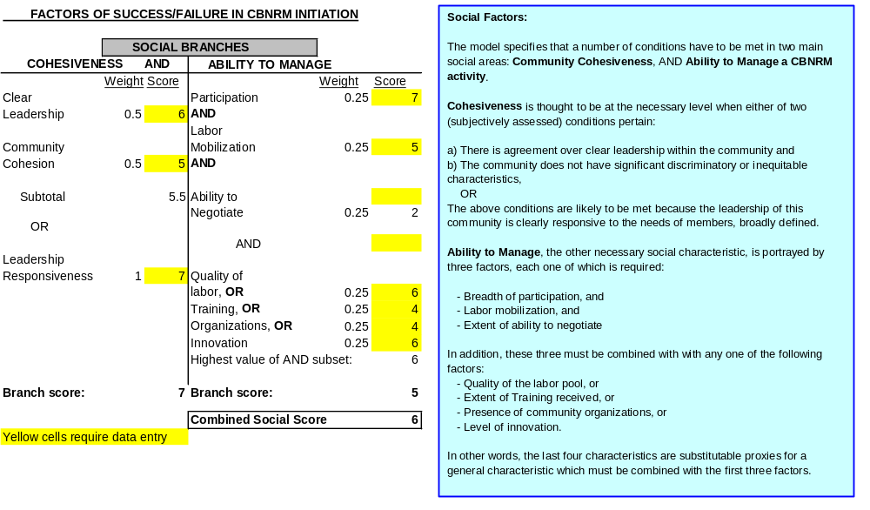
The sum of scores multiplied by their relative weights provides the overall grade for the cohesiveness branch. It can be compared with the other AND branch of the social factors, which deals with ability to manage. In the example above, the two social branches are assessed for a hypothetical community. The cohesiveness branch yields a global score of 7, the highest of two OR scores (5.5 and 7), while the ability to manage branch yields a global score of 5. Depending on how the users set subjective criteria for the model, this may not be enough to qualify this community as being potentially successful in the social area, since high scores in both social branches are needed. On the other hand, the model suggests that corrective action would best be aimed at training, especially if it can improve the community’s ability to negotiate with other stakeholders.

An Excel version of this model is available on this disk. It does not compare in flexibility and ease of use with the NetWeaver package, but it does provide a good basis for analysis of, and experimentation with, the determinants of CBNRM success listed above. The users only need to enter appropriate weights and scores for each factor; the Excel model generates scores and graphs for each of the four areas and an overall assessment of a community’s suitability for CBNRM. Sample pages are included below. The model is in ..\Analytical Tools\NW_Version4\NW Implementation2.`xls - Title_page Please enable Excel Macros! A shorter version is in ..\Analytical Tools\NW_Version4\NW Implementation blue.xls - Title_page

Figure 2.10 shows scores for this community in the area of Social Factors.

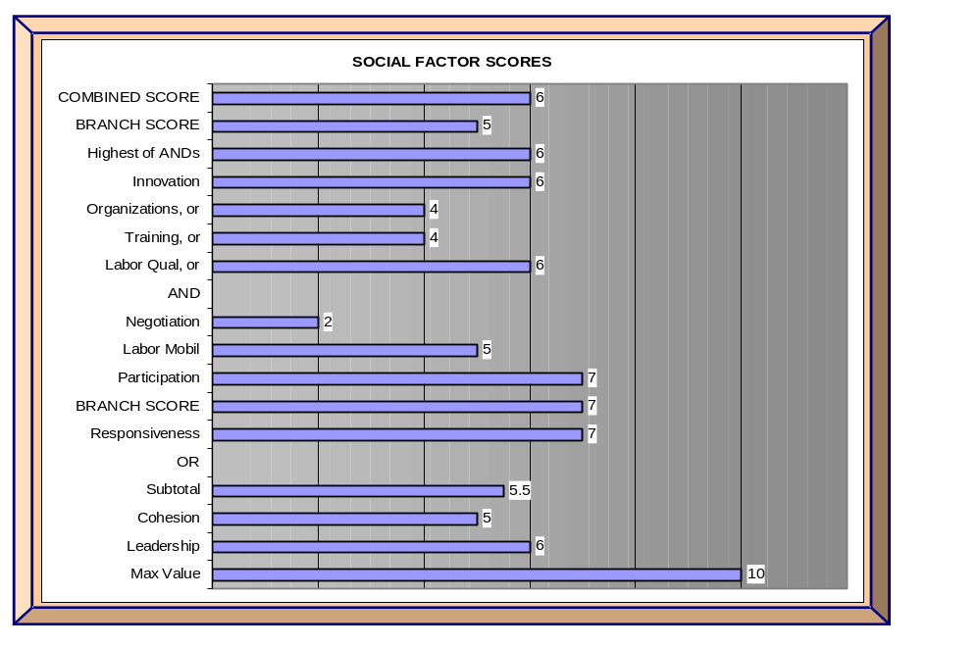
Figure 2.10 Social Factor Scores

2.4.2 Political Factors

Political factors are of two main types, both necessary: legal and institutional factors. The Excel implementation of this area is as follows:

Figure 2.11 Political Factors in CBNRM Initiation
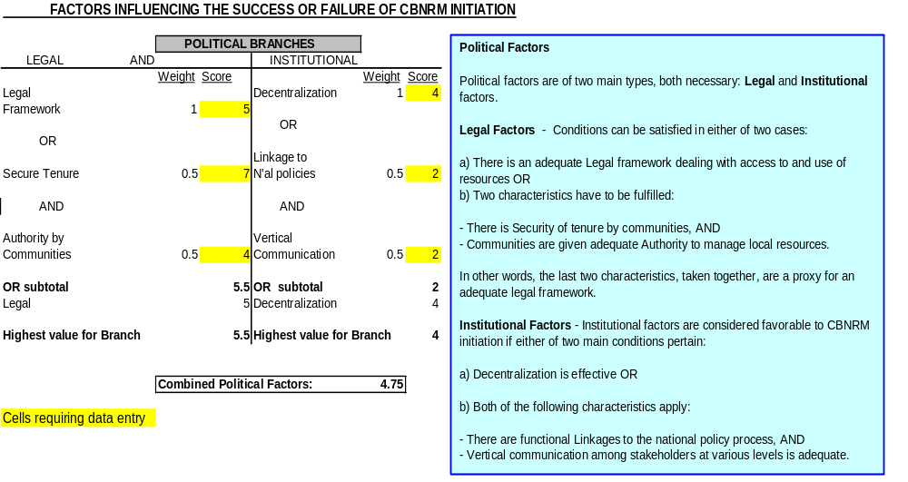

2.4.3 Economic Factors

Three conditions are necessary, and they must be combined with either of two other characteristics. Necessary conditions are:

- perceived benefits from the activity, AND
- relatively equitable distribution of benefits among stakeholders, AND
- benefits from CBNRM are not expected to substitute for public investments.

These must be combined with either one of the following:

- local infrastructure is adequate for CBNRM purposes, OR
- the community has or can have access to relatively substantial financial resources.

Figure 2.12 Economic Factors in CBNRM Initiation
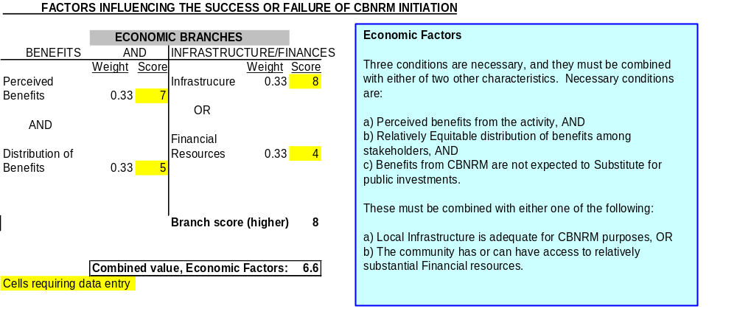

2.4.4 Biophysical Factors

Only one main characteristic is relevant but, as explained above, it may have multiple dimensions, some of which are related to the community’s capacity to manage CBNRM. The assessment of biophysical suitability of local resources for CBNRM should, therefore, be done with an appreciation of social as well as biophysical conditions.

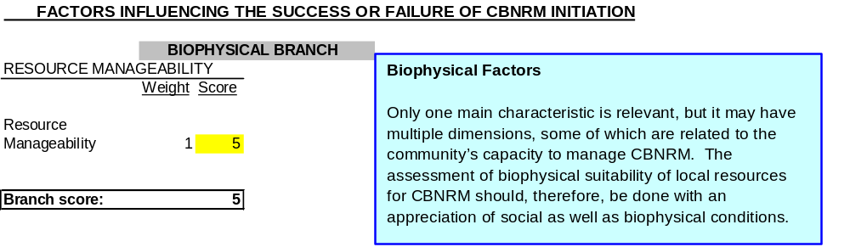
Figure 2.13 Biophysical Factors in CBNRM Initiation

A powerful computer-based analytical tool, NetWeaver allows the user(s) to rank each factor in order of relevance, or weight in influencing CBNRM success or failure. It allows the user to quickly identify inconsistencies between the way the basic model is specified, and the subjective ranking of factors entered by the user on the basis of one or several CBNRM experiences. In other words, users can repeat the process of design, testing and calibration undertaken by the Working Group. It also allows for fast computation and visualization of sensitivity of success to various factors, which can be invaluable in CBNRM activity assessment or implementation. Finally, data on the relevance and relative importance of various factors for a number of CBNRM experiments in a given country, should allow the users to synthesize a large number of cases, and establish relationships between factors on the basis of a sample population. NetWeaver is available through the Heron Group (http://www.herongroupllc.com/).

The knowledge base used to design the NetWeaver model, as tested and calibrated with the help of the program, may be used without using this sophisticated program. A ‘manual’ approach is more cumbersome, and does not lend itself to the analysis of multiple cases. One also loses the benefit of fast and accurate calculations based on the numerical value assigned to the relevance or weight of each factor. Finally, the idea of doing repeated manual simulations can be daunting. However, the knowledge base, embodied in the tested relationships among factors presented above, can be used as a convenient analytical reference or checklist. The Excel version of the model makes this easier and lends itself well to work in small groups.

CHAPTER THREE

TRENDS IN UPTAKE, EFFECTS

The previous chapter presented the Working Group’s view of the factors that determine the degree of success in CBNRM initiation. Overall, the Group has a good understanding of basic conditions and of the extent to which strengths in one area can offset weaknesses in another. This chapter addresses the question of trends in CBNRM, at the micro and macro levels. Examples illustrate these trends, and a few graphs summarize the combined effects of micro- and macro-level actions supported by USAID. Addressing trends in uptake also raises the issue of sustainability; obviously, uptake is significant only if there is a reasonably good likelihood of long-term viability, with or without external support. In the latter part of this chapter, the notion of sustainability as it applies to CBNRM is examined.

Trends in uptake, or the extent to which communities and their partners initiate and implement CBNRM activities, have two main dimensions. First, they are closely connected to broader trends in such areas as the environment and governance at the national level. Secondly, trends reflect the more internal dynamics of the CBNRM process. Complexity and ‘noise to signal-ratio’ are high at both levels, and sub-Saharan Africa provides a confusingly wide array of cases which complicates the task of drawing broad conclusions. Part of the difficulty in assessing the true extent of uptake also lies in the definition of what is meant by uptake and finding which cases correspond to that definition so that accurate trends can be portrayed. For instance, should one lump together communities undertaking CBNRM at their sole initiative and with their own resources, and those which would stop right away if outside support were withdrawn?

The southern Africa experience suggests that CBNRM can take place within a wide variety of institutional arrangements among stakeholders. Botswana and Namibia tend to follow an enterprise approach, whereby CBOs are registered and can contract directly with the private sector. Under this system, communities are legal owners of the assets and can act either as active or passive businesses; they can run their own harvesting or ecotourism programs, or can lease the assets to entrepreneurs. Zambia, Zimbabwe and Malawi, on the other hand, tend to follow a revenue-sharing approach, whereby government authorities act as contracting agent, collect and redistribute revenues generated to communities. According to one author: “both the revenue-sharing and enterprise models have had nearly the same positive effect on resource utilization or conservation and on income generation”. However, as seen below, the rights of proprietorship over wildlife devolved to rural district councils have rarely filtered down to lower administrative levels. The Group’s view is that rather than being equally valid options, the revenue-sharing and enterprise approach are different stages in CBNRM development. Other things being equal, an enterprise approach is more likely to succeed in the long term than a revenue-sharing approach.

At the regional level, the combination of political, social and environmental factors also produces fundamental differences in approaches to CBNRM. For instance, there are big differences between the southern and west Africa experiences in terms of type and economic value of natural resources, and of political processes. CBNRM in the southern Africa region is very different in terms of the absolute and relative size of the resources at stake; for example, there are very large game parks in Zambia, Zimbabwe and Botswana. Some of these large expanses are contiguous and even straddle national borders. Under such conditions, it makes sense to focus on resources that command interest (and effective demand for environmental services in the form of ecotourism) at the national, regional and world levels. Many wildlife areas are also relatively well connected to existing market mechanisms. Yet, one of the main challenges in southern Africa is to move toward more diversified CBNRM activities.

From a scientific point of view, the identification of trends on the basis of hand-picked examples drawn from very diverse populations containing successful and failed cases is a questionable exercise. The fact that failures tend to be much less widely reported and documented than ‘successes’ is also an issue; one has to make do with instances where obstacles were overcome, and lessons learned from cases where constraints remain binding. This being said, the CBNRM experience is rich enough to extract a few trends in key areas.

The first general trend is that, where possible, people have reacted to the increasing pressure on resources, and the degradation of their productive environments. They have done so because they came to realize that (a) the situation has become increasingly serious and a direct threat to their survival, and (b) the extent to which other actors can intervene (governments, donors) is limited, compared to the scale of the problem. They have done so both at the individual and community levels. As reported in the Assessment of CBNRM in Southern Africa, for example, “the dependent users of NR on common lands respond positively and effectively to the needs to manage and conserve those resources when they acquire the authority and responsibility to act for the enhancement of their benefits”. What has been happening in CBNRM is part of the trends involving the larger environmental context in Africa, where continued degradation coexists with conservation initiatives.

The second widespread phenomenon is the growing expression of a popular desire for greater autonomy in the management of natural resources at the local level. This came about both as a necessity, and as part of the long-term process whereby local populations have started to claim autonomy in selected matters as a political right. Again, the expression of this phenomenon in the CBNRM area is a natural extension of a broader phenomenon from which CBNRM sometimes benefits, and which it reinforces in certain instances.

At the community level, key trends include:

- a demonstrated willingness by rural communities to invest in the future at the expense of more immediate benefits, especially when this involves individual and joint actions on community lands or ‘terroirs’ rather than more remote common property resources (Not surprisingly, the issue of security of tenure is fundamental, and plays a greater role as the time horizon expands.);

- quite a few cases of CBNRM profitability for communities and other legitimate stakeholders (This suggests progress in co-management capacity, and progress in working for ‘congruence of objectives’ among interested parties.);

- mixed results in terms of community participation, especially for women, although trends point to greater diversification and wider participation (This is an area where results are definitely mixed. Some communities have taken steps to minimize the negative impact a CBNRM strategy was expected to have on certain groups, such as women, who gather most of the firewood. On the other hand, there are many instances where CBNRM is used by some at the expense of others, both within the community and outside. In a paper assessing benefits from CBNRM programs for certain population groups in Botswana, for example, the authors conclude that women, children, the elderly and disabled are slighted. These groups reportedly have (a) lower access to benefits than adult males of politically powerful groups, (b) less access to positions of authority on boards of community trusts, and (c) heavier workloads resulting from the reallocation of male labor to CBNRM activities. Relations with other traditional resource users also vary; some communities have used CBNRM schemes at the expense of groups that had traditionally shared the same resources.); and
- knowledge, attitudes and practices with respect to NRM are changing, but communities need continued support in the areas of training (organization, literacy, financial management), and for technical inputs and credit. It is very difficult to ascertain to what extent a change in practice is due to greater access to information and technology, and to what extent improved access had to be combined with a change in perceptions regarding natural resources and the environment. Most of the evidence suggests that attitudes to the environment itself are easier to modify than gender bias in access to capital and information, so that the benefits of changed attitudes with respect to natural resources can be selective and partial. In any case, changes in practices (combined or not with a change in attitudes) most often require other measures, such as:
- extension visits by government or NGO representatives, and
- continued investments in labor-saving farm animals such as donkeys and oxen. Labor constraints are still widespread, and often appear more binding than capital constraints.
At the macro level, although legal and policy frameworks are becoming more favorable to ENR and CBNRM, they are not yet strictly consistent with them. Many community initiatives have been well received (e.g., Malawi’s lake Malombe and Senegal’s Kayar fisheries) but only after ‘bending’ formal laws or rules. Acceptance is thus counterbalanced by the inconsistency or arbitrariness of official support for CBNRM, and by the weakness of its legal basis. Still, changes in policy and legal frameworks have taken place, for instance:

- Guinea – stronger co-management of the Nyalama classified forest. Formal agreements exist between the national Forest Service and about 30 local communities. Joint training of Forest Service and communities will extend this practice to other parts of the country.

- Madagascar – enactment of the National Park Act; mining permits rescinded in areas adjacent to national parks.

- Senegal – first instances of local leaders (about 600) being actively involved in defining options for feasible land reform in all ten regions.

- Tanzania – parliamentary approval of the National Environmental Policy (1997).

- Uganda – establishment of the Bwindi Trust, the first of its kind in sub-Saharan Africa. Designed for the long-term conservation of afromontane ecosystems (Bwindi impenetrable Park, Mgahinga Gorilla National Park), the Trust now has a $5.5 million endowment for grants program, administration and research.

- National environmental impact assessments (EIAs) are becoming more common for investments with sizeable environmental implications. Results are definitely mixed (rejection of an EIA on a prawn farm in the Rufiji River delta by the Government of Tanzania, for example) but the principle of providing public input and media coverage is gaining currency.

The following graphs provide examples of trends in benefits from a combination of ENR and CBNRM activities supported by USAID in southern Africa.
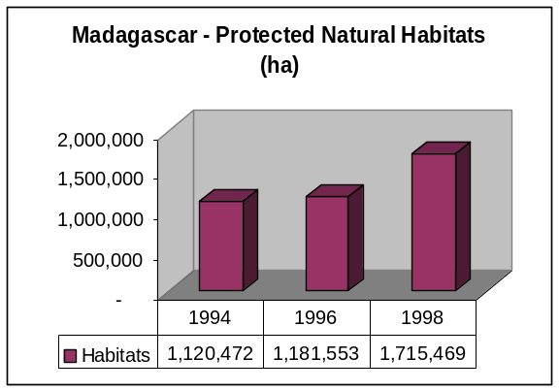

Figure 3.2 Evolution of the Extent of Natural Habitats in Officially Protected Areas, in Madagascar
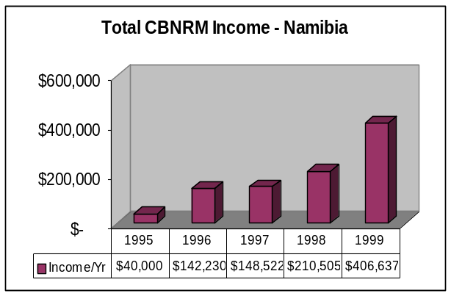

Figure 3.1 Evolution of Total Community Income from Natural Resource-based Activities in Namibia from 1995 through 1999

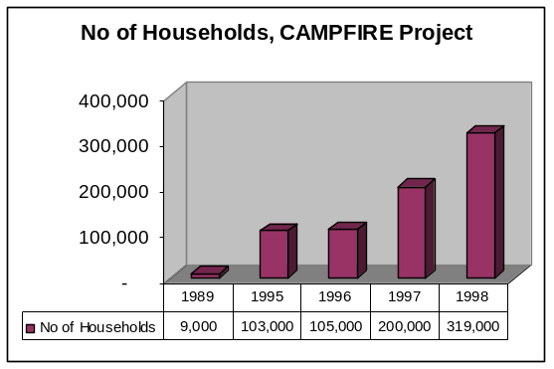
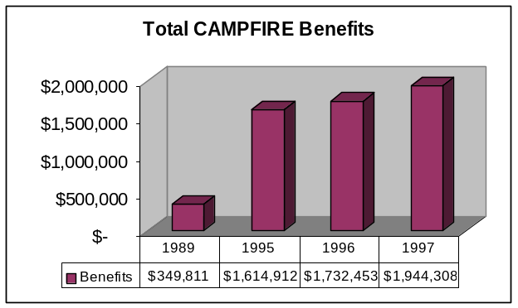

Figure 3.3 Evolution of the Value of CAMPFIRE Benefits in Zimbabwe,

1989-1997

Figure 3.4 Number of Beneficiary Households among Participating Communities, Zimbabwe

CAMPFIRE Project
The influence exerted by micro-level actors upon the macro processes of policy orientation and implementation is slowly growing. Community advocacy for local NRM is rising, especially where communities work together rather than singly. There are also a few instances of CBNRM being supported through specialized associations at the national level, and even of co-management of natural resources across national borders. Still, little is happening in such closely related sectors as training, industry, commerce and tourism, and further diversification is needed, especially in southern Africa where CBNRM activities tend to be more narrowly focused than in other regions.

Although they are rooted in the past, trends are also about the future. One of the key issues in the future of CBNRM is the question of sustainability. In other words, to what extent are current CBNRM experiments sustainable, and thus, replicable on a wider scale?

The concept of sustainability is sometimes treated as the ultimate goal, or hallmark of success in project activities, very much in the ecological sense of resource use consistent with a maximum sustainable yield (MSY). In fact, even the concept of MSY tends to apply only to relatively short-term, partial equilibrium situations. It may be useful as a first conceptual approach, such as the MSY in a capture fishery, but its limitations readily appear. Most analyses of sustainable resource use are expressed in terms of the search for an ‘evolving’ equilibrium over time, an unstable balance between resource use and renewal as a process of dynamic optimization over time. Actual examples of perfect dynamic optimization are rare; human systems of resource use do not anticipate or deal very well with sudden and complex changes in the dynamics of the resource (supply side). Neither do they foresee demand side changes very accurately.

Again, because of the micro and macro dimensions of CBNRM, the question of sustainability may be viewed from several perspectives. As far as the micro level is concerned, the concept of CBNRM sustainability can usefully be divided up into several component dimensions; ecological, socioeconomic, financial, and institutional.

- Ecological sustainability implies extracting a natural resource in a manner that does not reduce its robustness or at a higher rate than its natural replacement rate, and without altering ecosystems in ways that cause their resilience to deteriorate.

- Socioeconomic sustainability involves the continued demand for the goods and services produced by an activity, the degree of vulnerability to market changes and the flow of economic and social benefits well into the future.

- Financial sustainability is a matter of obtaining adequate financing to support activities well into the future as well as avoiding short-term collapse due to cash-flow inadequacies.

- Institutional sustainability concerns the managerial capacity and performance incentives, policy support, legal rights and social values of participatory organizations and groups whose actions affect the continuation and nature of the activity.

This perspective on sustainability is comprehensive and deals with interconnected issues at the local level. Promoting more sustainable use of resources by applying more appropriate and efficient patterns of resource use, in a socially acceptable way, within a favorable institutional context is definitely ‘the way to go’. However, the CBNRM phenomenon is really significant only if horizontal and vertical linkages are most efficiently built and used, so that the notion of sustainability also applies in a larger, macro sense. As shown in Chapter Five, in the final analysis, the impact of a collection of successful, sustainable CBNRM experiences is limited unless they also inform and impact the broader ENR policymaking and implementation processes in a significant way.

CHAPTER FOUR

CBNRM - ECONOMIC ANALYSIS OF RESOURCE VALUATION

The price of a good or service is determined by a process of negotiation, in the marketplace or in a political forum on the basis of two main factors: relative scarcity and the perception of the resource’s worth or usefulness by would-be resource users. The concept of value, on the other hand, has a much deeper dimension, which involves broader social perceptions. After all, one often speaks of a society’s values. Although specific natural resources can be given a price, the concept of value, even expressed in monetary terms, seems more appropriate in the case of natural resources, sometimes also defined as ‘natural capital’.

Since CBNRM and other parts of the ENR sector are closely connected, resource valuation issues directly or indirectly span the macro and micro levels. At both levels, a fuller recognition of the value of natural resources is a fundamental condition for efficient resource management, but it is very much a matter of perception, capacity to realize the full value of the environmental services from the resources, and of equity in distribution.

At the macro level, common property resources tend to remain systematically undervalued to favor a specific constituency, or because they represent politically sensitive commodities. Common examples include users of water resources on large irrigated schemes or in industry, and traditional energy products. Most people have witnessed some form of ‘tragedy of the commons’ process whereby a fishery, public forest or open rangeland are overexploited. The resource can have considerable value, but, because this value cannot be ‘integrated’ into the strategy of a single controlling individual or entity, it is frittered away in ever-decreasing returns to competing users. In fact, the higher the original value of the resource, the faster the process tends to unfold.

National governments are increasingly aware of the degradation of the environment, they realize that "things cannot go on like this forever". At the same time, they still have a vague sense of the scale of potential benefits from better NRM, and hesitate to entrust the realization of some of these benefits to a combination of decentralized units and autonomous rural communities and other stakeholders.

Although there is a broad consensus on the need to improve the overall management of natural resources, one is hard put to show in specific terms what this might amount to, for the average economy of sub-Saharan Africa. For example, suppose one were to take sweeping policy measures ensuring significant increases in sustainable returns from natural resources (in agriculture, fishing, forestry, animal husbandry), what would be the direct economic impact of such measures? This seems to be a rather basic question; for one thing it gives a sense of returns to investments in NRM and thus, of the rough scale of public expenditures one could justify to support wide-ranging changes in environmental practices. In the course of this work, the Working Group did not find straightforward answers to this question. And yet, it is possible to get some useful insights even in the absence of economy-wide environmental accounting methods and data, and without investing person-years in sophisticated modeling. To illustrate this, the author has developed a simple Excel-based model showing the direct macroeconomic impact of various changes in the efficiency of resource use and, conversely, of the increases in NRM efficiency required to maintain per capita income at some level, other things being equal. It turns out that for a typical African country with population growing at 2.6 percent per year it takes a significant overall improvement (about 100 percent) in returns from natural resources to maintain per capita income over time. This model is described in greater detail below, and is available in Excel format on the CBNRM CD-ROM: Simulating the Effects of Environmental Policy Change via Gains in the Efficiency of Natural Resource Use- A Simple Model of an African Economy Please enable Macros in Excel! A faster version of this file is available in: ..\Analytical Tools\3-Sector Model\Env_Econ_Model blue.xls - Title_Page

Although the quest for better environmental policies and natural resource use is universal, little or no information is available on what such changes might imply, or on the scale of change needed for significant progress. For example, if an African country were to raise efficiency in the use of its renewable resources by the equivalent of 25 or 50 or 100 percent overall; what would this mean in terms of trends of natural capital use? What would be the impact of doubling the current area in managed forests by substituting managed forest areas for natural forest and woodland areas? Conversely, what change in resource use efficiency would it take to stabilize typical trends in the mining of renewable resources, for an ‘acceptable’ level of depletion of non renewable resources?

The economy is simply specified, by main sector of activity, with population, resource endowments and returns to resources combined with labor and other inputs. Depending on the assumptions made on gains in the efficiency of resource use, a range of net domestic resource gains is attained. These gains are then expressed as trends in income per capita, or of a reduction in the rate of loss of natural capital (for a fixed, given level of per capita consumption). In effect, the model is mostly driven by the hypotheses that

- environmental policies and practices change in response to pressure (both endogenous and exogenous);
- environment-related policy reforms, including wide CBNRM application, can induce significant changes in the allocation of factors and resources, and a higher level of efficiency in the use of certain types of natural resources, within a span of five years;
- such changes have a positive impact which can be measured as higher returns to the combination of labor, capital and natural resources — this higher return can also induce domestic resource savings because of lower food or energy imports requirements (holding total or per capita consumption constant); and
- the impact on the rate of depletion natural capital, for a given level of annual consumption, can be estimated.

Constructing the simulation model involved the following steps:

- Specifying a basic input-output, or mass-balance model highlighting sectors which are sensitive to environmental policy change, and where gains in resource efficiency can be measured in terms of domestic resource savings by main type of tradables (in this case, food, energy products).
- Specifying basic economic and environmental parameters and assumptions, consistent with the range of African country datasets.
- Choosing levels of discrete change in the efficiency of NRM practices (e.g., 25, 50, 100 percent).
- Assuming a set of economic outcomes for each discrete level of change in the efficiency of allocation and use of natural resources.
- Expressing the outcomes in terms of changes in per capita income over time.
- For the resulting rates of efficiency in resource use and per capita consumption, estimating the impact of the gains in domestic resource savings on the annual change in the country’s stock of natural capital.

The country is first assumed to have a certain population size at t = 0, growing at 2.6 percent per annum (p.a.), the average for sub-Saharan Africa. Another set of runs is done with population growth at 2 percent p.a., equivalent to the rate of economic growth. Gross Domestic Product (GDP) per capita at t = 0 is set at $580, a value within the range prevailing among African nations.

The structure of the economy is expressed in the simplest terms: a stock of natural capital and three main sectors: food, energy and manufacturing/services. Resources are originally allocated among sectors on the basis of relative factor and product prices, consistent with ex-ante economic and environmental policies; that is, before the policy changes and CBNRM have fully taken effect. Natural capital includes both nonrenewable (geological) and renewable (biological) resources. Labor, capital and renewable resources are combined to generate a certain level of domestic product and consumption in food, energy, manufactured goods and services. The remainder of labor, capital and natural resources are allocated to the export sector.

Total consumption is increased by recourse to the trade sector. In the simplest of cases, the current level of domestic production and consumption is maintained by (a) using renewable resources beyond a sustainable level (given current technology) and (b) mining part of the nonrenewable natural capital (e.g., iron ore, oil, gold, diamonds). For the desired total level of per capita consumption, export earnings from the depletion of nonrenewable resources finance imports complementing the output of the three domestic sectors. Import substitution is possible, but only to a point, beyond which the allocation of resources to domestic production is woefully inefficient. Conversely, for a given level of total consumption, more efficient domestic production allows for a decrease in export requirements, and thus, in the mining of natural capital. It is assumed that any additional increases to output and consumption from other transfers such as Official Development Assistance (ODA) are constant and given, and are not taken into account here.

Assumptions about the domestic and trade sectors, and the size of the stock of natural capital define the number of years before total collapse. Since both geological and biological capital are being mined, tradeoffs are possible: for example, if the country pushes the use of renewable capital beyond a critical level of diminishing returns, higher import requirements can be met (for a while) out of increased exports of non renewable capital. Some renewable resources, exploited beyond the maximum sustainable yield, may be treated much like geological ones (harvested up to complete collapse and depletion) — marine fisheries off the coast of some west African countries may be an example. Finally, all countries are price-takers from a mercifully stable world market for tradables, although the impact of a major devaluation could easily be integrated into the model.

The model tries to reflect the reality that energy production in Africa is relatively low (6.2 percent of world production). Continent-wide, production outpaces consumption, but that is only because consumption is very low (2.6 percent of world consumption), and because a lot of that production is from a few countries with relatively large liquid and gaseous fuels production, such as Nigeria, Algeria, Lybia, and Angola. Most of the officially recorded energy consumption is accounted for by the industrial and transportation sectors, which use up about two-thirds of available energy resources. Agriculture and residential use make up about five percent of total consumption. However, countries that don’t produce oil, traditional sources of energy such as fuelwood and charcoal provide a very large share of total domestic energy consumption, ranging from 91 percent in Ethiopia, to well over half in Kenya, Côte d’Ivoire and Senegal. The model is also based on the fact that a typical land use pattern for an African country is such that 6.5 percent of total land area is cropland, permanent pasture accounts for 30 percent, forest and woodland for 24 percent, and ‘other’ for 39.5 percent. The four country cases show a range of values around these averages. Finally, the declining productivity of agricultural and range lands is included in the modeled through a yield reduction factor, which can be offset by conservation measures.

Because of its simplicity, the model assumes no flexibility in the structure of the economy; that is, the relative shares of the labor force in each main sector do not change in response to a change in returns to labor by sector. The consequences of four scenarios in environmental actions are considered, under various economic and population growth assumptions. The four scenarios of environmental actions (to be implemented within a period of five years at the outset of the simulations) are:

- no gain in NRM efficiency, no soil conservation, no managed forest expansion,
- 25% gain in NRM efficiency, full conservation (no soil erosion), no forest expansion,
- 50% gain in NRM efficiency, full conservation, no forest expansion, and
- 100% gain in NRM efficiency, full conservation, doubling of managed forest area.

4.1 Model Results with a Stagnating Economy, 2.6 Percent and 2 Percent Population Growth

To sustain per capita consumption, the country needs to increase the efficiency of NRM use up to Scenarios 3 or 4. Even so, initial gains in income per capita are slowly eroded by population growth. After about ten years, unless there is a sharp increase in the mining of geological resources, per capita income starts to fall rather sharply. After 15 years of careful resource management, the $580/capita/yr goal can only be maintained by a rapid increase in the mining of geological resources.

With anything less than the drastic changes in the efficiency of resource use implied by Scenario 4, the situation deteriorates even further and very quickly. With no increase in NRM efficiency, for example, the path of per capita consumption falls immediately and ends at about half of the original value after 25 years, if the rate of geological resources depletion is held constant. If population growth is reduced from 2.6 percent to 2 percent per year, all income curves are shifted up to some extent.

Figure 4.1 Economic Growth = 0, Population Growth = 2 Percent
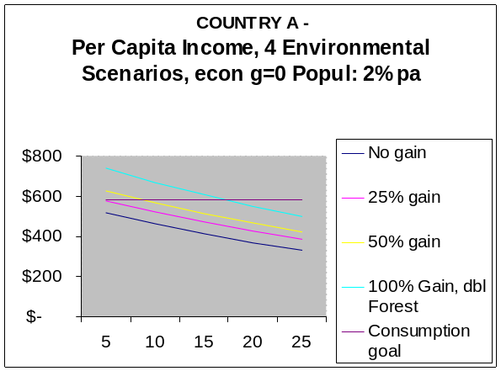
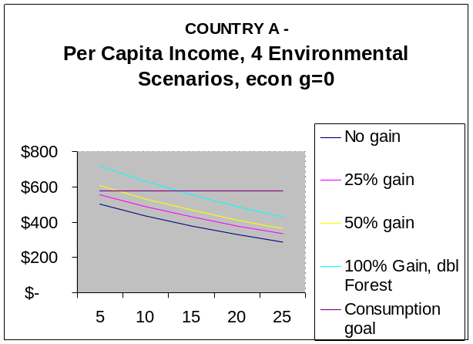

Figure 4.2 Model Results with a Slow Growing Economy, Lower Population Growth
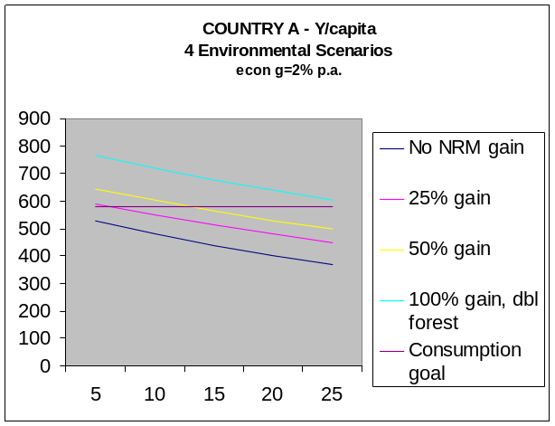
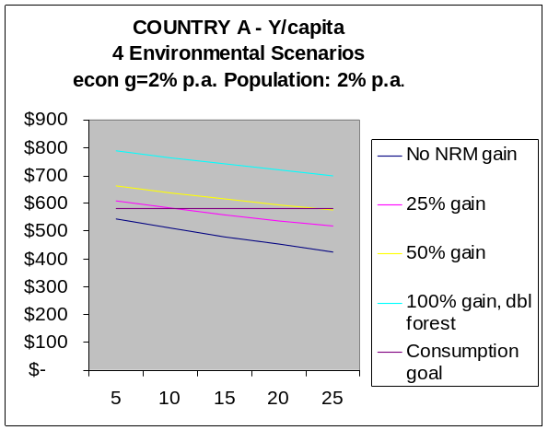

If the economy grows at an overall 2 percent per year, a 25 percent increase in the efficiency of NRM will sustain per capita income only for a few years. It takes a 50 percent increase in efficiency of use of all natural resources to keep per capita income over the goal of $580, at least for 12 years or so after the effects of policy change. After that, the effects of population growth start cutting into per capita income again. The most favorable case is Scenario 4: 100 percent increase in resource use efficiency, combined with 2 percent economic growth per year. Even so, income per capita decreases somewhat, because even quantum changes in environmental policy coupled with modest economic growth are eventually eroded by population growth.

As described in Chapter Two, the perception of benefits and costs from CBNRM is a major determinant of CBNRM initiation at the community level. The perceived value of the resource to be managed must be large enough for communities to go through organization, mobilization, planning, management and implementation for the activity, not to mention dialogue and negotiations with a potentially large set of legitimate stakeholders. Communities must also perceive that benefits from the activity represent a net gain. They will not make large investments if the benefits from their work end up as a mere substitute for investments in public services and infrastructure that they would normally expect the government (or perhaps, donors) to provide.

The perception of the benefit/cost from CBNRM, however, is not always straightforward. Communities are often unaware of the potential value of their local resources, once adequately processed, and given good access to markets. Techniques for qualitative improvement are often ignored or discounted because of difficult access to key inputs, including information. This is particularly true in cases where natural resources have elements of biodiversity or endemism, as is the case for some of the ‘hotspots’ of west Africa and Madagascar. The perception of relative benefits and costs also depends on how the community assesses or values the effort by, and benefits to, certain social groups. In addition, some communities tend to have high discount rates; they would much rather have small benefits now than larger ones in a distant future. Others do not, and tend to accept short-term sacrifices for long-term gains. Finally, the composite assessment of a community’s benefits/costs of CBNRM is often at odds with that of other stakeholders or potential partners, making negotiations difficult.

We recognize that clear information on the economic impact of environmental action remains difficult — and expensive — to obtain. Most project-related benefits from CBNRM are expressed as quantified results, expected to increase over time. This is critical for monitoring progress with respect to plans, but it endows the information with absolute rather than comparative value. It shows that ‘this is good’ but does little to help various parties visualize ‘how much better it is than would otherwise be the case’. This makes it harder to garner broad support for environmental action through a ‘congruence in objectives’ between various private and public stakeholders. As one of USAID’s R4 self-assessments points out, "we’re not very good at expressing benefits and using information to make the case that CBNRM has broad benefits".

And yet, the value of natural resources which may come under co-management has to be assessed and expressed as clearly as possible, so that all relevant parties may perceive that the benefits from co-management are greater than revenues derived from alternative uses of resources extracted from these systems. This does not require that all parties eventually come to have exactly the same perception of value from natural resources; they cannot. Still, they must all perceive that co-management is a superior strategy than most alternatives. This also implies that relevant stakeholders can draw on this information to mobilize institutional and political mechanisms for appropriate co-management. In many ways, these factors (access to information, existence of mechanisms for negotiated co-management) set the practical limits of natural resource valuation and thus on the likelihood of successful CBNRM. In the final analysis, the value derived by society from natural resources in a given area depends on the extent to which relevant stakeholders (communities, tribes, local and central governments, private companies) can negotiate informed and manageable agreements to reach the most beneficial among alternative uses of natural resources.

The Working Group’s review of the CBNRM experience in sub-Saharan Africa suggests that this may well be one of its main deficiencies. As essential as it may be for successful and significant co-management of natural resources, the need to work jointly with communities and other stakeholders on their perceptions of the value of resources, including potential benefits from co-management, has received relatively little attention.

CHAPTER FIVE

PROJECTIONS OF POTENTIAL IMPACT

The impact from CBNRM activities, and the potential for expansion, must be seen at several levels: local and national (micro and macro), direct and indirect. These are discussed in turn below. Here too, the notion of horizontal and vertical linkages is critical to analyzing the related notions of impact and potential for expansion.

5.1 Direct Local Effects and Constraints

At the local level, direct benefits are expressed in terms of biophysical impact on natural resources and of the stream of current and future incomes for rural households and other local stakeholders. Given the variety of CBNRM experiences, direct benefits are expressed in a multitude of ways. The main issue has been less the actual size of benefits, than the relative distribution of returns from investment into CBNRM among members of rural communities and other stakeholders.

Zimbabwe’s long-running CAMPFIRE Project provides good examples of complex distribution and impact issues. The total value of benefits from CAMPFIRE increased from $349,811 in 1989 to $1,732,452 in 1996. By 1996, the project had generated a cumulative $7.85 million of benefits, and over $13 million by 2000. Over the 1989-1996 period, the value of benefits devolved directly to participating communities increased from $186,268 to $906,400. The absolute numbers are impressive, but the whole story, as usual, is more complex. The distribution of benefits among participating districts is highly skewed: seven out of 27 account for 86 percent of all revenues. Because the project reaches a large and rapidly growing population, average benefits per household, after rising for many years, have fallen sharply. This probably reflects an unavoidable pattern of CBNRM expansion; even with declining benefits per household, CAMPFIRE is certainly better than the null hypothesis (no project). The real question is whether the same investments could have generated larger long-term benefits. Part of the answer lies in the evolving nature of relations between communities and other stakeholders, district rural councils, in particular. The project remains more akin to the devolution by the central government of revenue raising and spending authority to the districts, resting on controlled community actions, than to a set of genuinely CBNRM activities.

In addition to intra-community distribution issues, gauging the impact of CBNRM at the local level must account for such factors as the commingling of effects and exclusionary practices.

The close integration of CBNRM and other environmental activities, from the household to the macro levels, can also complicate the reckoning of direct benefits. Governments, donors and NGOs recognize this integration, and their support to CBNRM activities almost always comes as part of a broader ENR package. In Senegal, for instance, USAID’s CBNRM program combines various agricultural and NRM technologies: composting, improved seed, windbreaks, stone lines, improved stoves, nitrogen-fixing trees, etc. The program also provides infrastructure, such as anti-salt dikes. Although each component is an integral and essential part of the whole package, it is hard to allocate the share of benefits in increased yields or higher incomes among each of the components, including CBNRM activities.

The fact that some communities are now exercising exclusionary rights raises more questions. For example, are they helping institute local system which exclude other communities more effectively than previously did the state and other stakeholders? There seem to be some cases where CBNRM involves the exclusion from resource use of groups that had traditionally been sharing them with a community. In Lesotho, for instance, "range management, livestock productivity and herd owner incomes have been enhanced by the establishment of clearly defined Range Management Areas. The plan has been successful, although neighboring communities have suffered from their loss of access to the Sehlabathebe RMA…”

5.2 Local Indirect Effects and Constraints

There are a number of indirect effects at the local level, both biophysical and sociopolitical.

Again, the variety of CBNRM cases makes it difficult to capture all effects, but among the indirect biophysical effects of CBNRM at the local level, one may cite:

- protection of biodiversity, because raising the value of natural resources provides greater incentives to maintain the integrity and viability of particular ecosystems with unique combinations of species of flora and fauna;
- maintenance of ecosystems, such as watersheds, for their multiple service functions of benefit to communities, regions, nations and the world; and
- preservation of global cultural diversity, where the identity and values of certain communities are linked to living in, and extracting resources from, particular ecosystems.

In the case of CBNRM applied to forestry, there are also indirect contributions to health, agriculture and livestock:
- Health - forests as source of emergency food supplies and traditional medicines.
- Agriculture – well-managed forests have a positive effect on groundwater levels and proximate watersheds.
- Livestock - forests as sources of grass, forbs and fodder trees for various species. Forested areas are especially important when agriculture has taken over pastureland, when crop patterns restrict livestock movements, and when open range resources have dried up.

There are also some significant indirect local effects in the socio-political area, mostly through the dynamics of participation. As Inges et al. point out, the dynamics of participation have effects on the community itself, and therefore, on its ability to manage increasingly complex activities and outside relations:

“Participation can be seen primarily as a means to achieve specific goals such as building a better management structure, obtaining improved goods and services, and getting natural resources into a ‘good condition’. Participation to achieve specific purposes more efficiently requires that judgements be made about what represents ‘better management’, ‘improved services’ and ‘good condition’. The efficiency argument draws attention to the fact that participation is all about negotiating goals. Alternatively, the most important feature of participation can be seen as its potential to enhance the power of resource users to influence things. In this case, the purpose of the participatory process is seen as increasing the skills, knowledge, confidence and self-reliance of resource users to collaborate and engage in sustainable development. Participation becomes an end in itself rather than just a means to an end.”

5.3 Scope for Expansion

In terms of expansion over space, CBNRM potential partly depends on practical factors. These include the extent to which communities can co-manage resources from the borders of strictly defined community lands up to areas where they cease to be viable partners, because of distance, the overwhelming scale of resources to be managed, etc. The theoretical geographic potential for CBNRM is large, because it involves many types of resources (farmland, forest, pasture, fishing grounds) and a combination of these. The chief constraint is less the availability of resources to be co-managed than access by communities to the information and skills needed for shared responsibility in resource management.

Monitoring the geographic expansion of CBNRM on the basis of biophysical change is an essential part of tracking progress at the local level. The development of horizontal linkages is another critical element of ‘CBNRM expansion’. Horizontal linkages depend on the extent to which communities can associate with proximate communities and other stakeholders for co-management. The potential size of a CBNRM activity thus depends on the size of the ‘consortium’ assembled to share the management of resources. A single community working with Forest Service agents may be able to co-manage a given area of forest. A set of communities, working together with the Forest Service, plus a number of private sector operators, can efficiently manage a much larger area.

Further work at the community level is needed, of course, but one must also emphasize the extent and quality of linkages, both horizontal and vertical. In other words, while activities at the community level need to progress and expand spatially, it is equally crucial to strengthen the linkages between communities and other stakeholders. These two approaches are not mutually exclusive; on the contrary, more successful community-level actions are consistent with greater benefits from increased integration with larger processes.

5.4 Macro-Level Effects, Scope for Expansion

A critical mass of successful CBNRM activities can use vertical linkages to inform and influence the ENR policy environment. When joint actors of CBNRM activities help improve the national policy and legal frameworks, for instance, the ‘fallout’ from CBNRM can potentially reach all activities affected by national ENR policies. There is no simple and clear-cut definition of a ‘critical mass’ of CBNRM activities. However, a critical mass may be reached when the implications from successful CBNRM experiences on the one hand, and current ENR policy on the other, are so clearly at odds that pressure for change becomes very real. The size of this critical mass also depends on the receptivity of central authorities to pressure from below, and on the efficiency of vertical linkages. These are critical factors, and while the potential fallout from successful CBNRM activities is enormous, one must acknowledge that the requisite conditions are hard to fulfill. As one example among many, the observations of Trenchard et al. on relations between CBOs and the Government of Botswana is cited:

“Time is required to overcome uncertainty and vested interests in establishing independent and self-sufficient CBOs: The initiation of each CBO has been linked to changes in peoples’ attitudes and perceptions. These changes have manifested themselves in new relationships among community members, communities, communities and the GOB, and communities and the private sector. But, regardless of demonstrated benefits from trusts, there seems to be a certain inertia against these new relationships that may be related to uncertainty about what the new relationships will bring, especially in a country such as Botswana where the Government of Botswana, as a generous benefactor, meets many of the basic needs of rural communities. For whatever reason, the resistance to change allows self-interest to play against the establishment of CBOs and extends the time required for a CBO to become self-sufficient and independent."

The potential for expansion of, and benefits from, CBNRM often runs into yet another set of countervailing factors. Successful CBNRM implementation indicates that the economic value and benefits from natural capital are more fully realized than was previously the case. Short- and long-term returns to resource use are bound to rise in such areas. In most cases, however, the former practices of inefficient resource use have not disappeared altogether; they have just been displaced, possibly toward more marginal or environmentally fragile areas. By raising the value of resources, CBNRM raises the economic stakes and incentives for resource protection, helping fend off outside pressure. Pressure, however, remains because the population keeps growing. Increasingly destitute populations ‘on the outside’ also perceive areas implementing successful CBNRM as a way out of their poverty. This is obviously not a case against CBNRM, but yet another reason to promote its further expansion, not only in a spatial sense, but also in terms of impacts on policy processes.

CHAPTER SIX

IMPLICATIONS FOR USAID AND PARTNERS

At headquarters, and in countries where USAID has environmental strategic objectives (SOs), operating units design and support a wide variety of ENR activities, from the macro to community levels. They may not explicitly refer to ‘vertical and horizontal linkages’, but USAID personnel and their partners recognize the connections between discrete components of ENR sector activities at all levels. In Botswana, for example, the Natural Resource Management Plan (NRMP) Project has intervened sequentially or simultaneously at many related levels. Its managers have:

- introduced the CBNRM process,
- organized, created and supported a large number of pilot CBOs,
- initiated CBNRM network and outreach processes,
- assisted national agencies to develop community-oriented extension approaches,
- worked on nationwide environmental education,
- supported NGOs, and
- reviewed and revised key CBNRM policies of the government.

The implications from this work for USAID and partners can be summarized into five areas for action:

(a) Establish a more explicit joint understanding of interactions at the national or policy level, as a basis for such macro-level work as country strategy and SO definition.

(b) Gain a better understanding of macro-micro linkages in the ENR sector, and of approaches to resource valuation. CBNRM is one of several good point of departure.

(c) Apply a better grasp of interactions, analytical tools and information technologies to institutional obstacles at various levels.

(d) Retain flexibility within a wide portfolio of supporting activities.

(e) Seek a closer fit between strategies and programs which are necessarily limited in time, on the one hand, and a vision consistent with the long-term nature of ENR work in Africa on the other hand.

(a) A Shared Vision of Interactions at the Macro Level

Paradoxically, the Working Group on CBNRM started with a simplified, consensual analysis of national-level interactions among macro-level processes pertaining to economics, health, population, democracy and governance, as well as education. The purpose was not to derive a detailed model of such interactions, but to place thinking on ENR issues squarely on the basis of a shared view of their broader context.

Because the macro context strongly influences the range of effectiveness of specific activities, it deserves, and has received, a lot of attention. At both macro and micro levels, many factors intervene, and ‘things get complicated’. However, the vastly greater scale of the macro context makes the analysis relatively more difficult.

First, intervening factors may facilitate or nullify ENR activities and the results of policy changes at the macro level. Such factors may include major economic disruptions and changes, adverse weather patterns, or widespread epidemics. Secondly, policy changes in nonenvironmental areas can have substantial impacts on the environment. In economic policy, a sharp fall in the value of a national currency can, for instance, lead to changes in farming practices (lower use of imported fertilizer and other inputs, import substitution for food products, or changes in the composition of agricultural exports). Conversely, gains in primary education, especially if they reach many boys and girls in rural areas, can have positive impact on the current use of resources, or on the degree of success of environmental programs.

Finally, even as policy reform-induced changes take place in environmental policy, or in the legal or institutional frameworks, they have many direct and indirect effects. Examples include the positive externalities from more harmonious interactions between agriculture and pastoralism, or benefits in soil conservation and flood control from actions primarily aimed at forests as sources of energy and reservoirs of biodiversity.

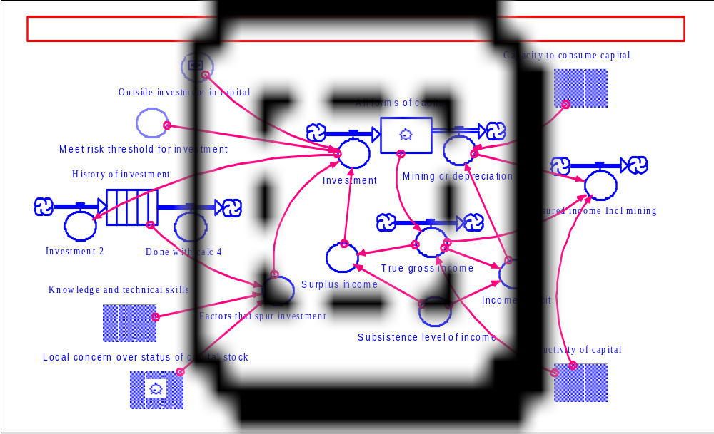USAID Missions often go through a similar process of contrasting and reconciling different views of the macro environment, and diverse SOs. Such exercises can often gain from being more open, explicit, structured and systematic. A number of process-oriented analytical tools are available to facilitate knowledge-based exchanges and consensus building. They require neither advanced modeling skills or large investments in time and data collection and analysis. They do, however, greatly facilitate the kind of mutual understanding and shared visions without which it is very difficult to design (let alone implement) a set of coherent sectoral initiatives.

Figure 6.1 Major Ecological-Economic Relationships
For example, Group members developed a knowledge-based, intuitive reasoning model to represent, discuss and analyze their conceptual understanding of logical relationships between such factors as the stocks of natural and human capital of a nation, the effects of strategies on mining natural capital, investment in natural and human capital through education, the impacts of changes in technology, etc.

The first application, illustrated in Figure 6.1, explored major ecological and economic relationships. Several sub-models were also developed to examine more closely such areas as the effects of knowledge and skills, the opportunity cost of labor under various conditions, attitudes toward risk or lack of secure tenure over resources, and demographics, including the effects of the AIDS-HIV pandemic. The model is described in greater detail in a paper by Working Group member John Woodwell. While it is knowledge-based and more intuitive than quantitative, the model allows for the specification of assumed mathematical relationships, so that the results of various scenarios can be expressed in terms of their effects on income over time.

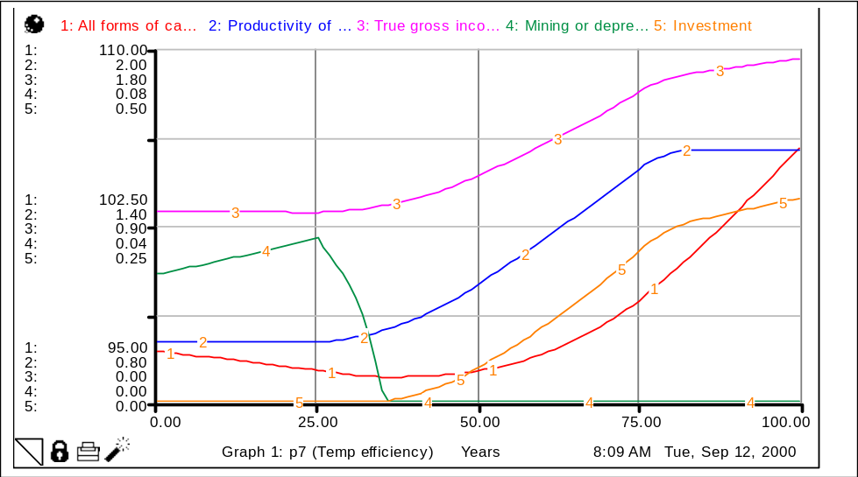
Figure 6.2 Effects on Income over Time

This kind of analysis allows groups, such as SO teams, to ‘pick the brains’ of experts who have much knowledge and experience, but little hard data. It also allows for a dynamic process of thinking and discussing issues which is usually more fruitful than other options, such as starting from a blank sheet, or with a complex and ponderous formal model. It can also help clarify the process of specifying development hypotheses and critical assumptions. For example:

- Is it reasonable to expect gains in the development and adoption of NRM-oriented technologies given the current levels of investment in education?
- Is the opportunity cost of labor in rural areas likely to change if conditions for migration to urban areas or the degree of risk in rain-fed agriculture evolve over time?

In addition, this tool lends itself well to discussions between SO teams on broader country development strategy issues. Finally, the simplicity and transparency of this approach makes it easier to broaden discussions by SO teams to national technicians, researchers, or decision-makers.

Understanding Macro-Micro Linkages in the ENR Sector, Approaches to Resource Valuation

The most obvious link between macro and micro levels owes to the fact that the macro context partly defines the general parameters or specific conditions under which any micro-level activity can take place, and thus, its potential for relative success. The diagram below illustrates the types of influences on the macro context, from donor and national programs, exogenous factors, and the fact that the resulting, complex, macro context defines a number of political, economic and social trends that set the bounds of potential success at the local level. Within such bounds, local activities may be more or less successful, given the intrinsic characteristics of local systems, although these are also subject to influence by other, localized factors.

Figure 6.3 Macro-Micro Linkages
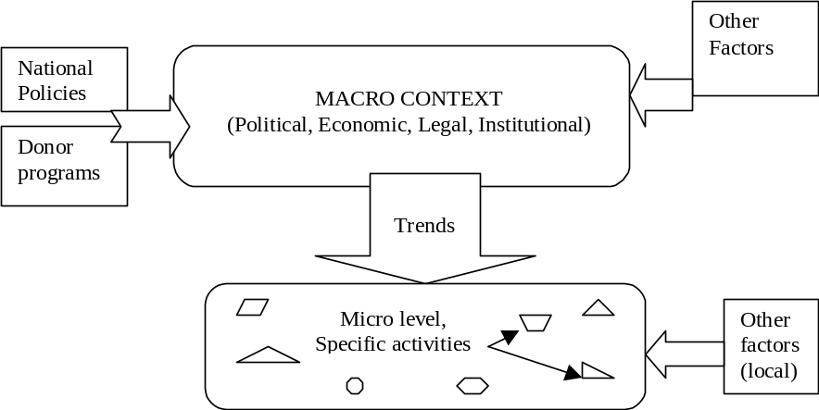

For example, the extent to which a community-based forest management activity may be initiated and become successful depends partly on the political, legal, and institutional conditions prevailing in the country. At the micro level, there are also many intervening factors, and some activities doubtless take place regardless, or in spite of, the state of the macro context.

Just as there are intervening factors at the macro level, there are some at the micro level, but the scale of complexity is much more manageable, and it is possible to express progress in terms of current and longer-term benefits from a specific CBNRM activity. In fact, the assessment of effectiveness, or the returns to investment in ENR and CBNRM activities, does assume a change in local environmental trends; otherwise, streams of benefits over time cannot be anticipated. However, since trends reflect the evolution of indicators over time, the extent to which local activities fundamentally affect anything depends on their scope and sustainability.

At the micro level, benefit-cost analysis is not just practical, it is essential. Micro-level analysis first reveals the extent of absolute progress. For example, in Namibia, over 2.5 million hectares have been placed under the management of communities since 1995, with 26,800 beneficiaries and $406,000 of income generated from community enterprises. In Zambia, more women than men participate in finance and agroforestry programs, nearly half of the CARE village management teams consist of women, and programs are being tailored to address the problem of persons made widows and orphans by the AIDS epidemic. Secondly, micro-level analysis of benefits and costs helps make choices among activities competing for limited resources.

Although one can measure and compare potential returns to investments, such comparisons across activities are only valid for a given state of macro environment. It would be improper to compare the returns to specific ENR activities in two countries, or at two points in time, without taking into account differences in macro contexts. One might, for example, reach the conclusion that central heating in house A is less energy efficient than open fireplaces in house B without taking into account the fact that house A is located in Alaska, while house B is in downtown Honolulu…

As SO team members and/or partners focus on ENR and CBNRM issues at the micro level, they should consider various questions, including:

- Do we have a good understanding of the current macro context and of the limitations it places on various types of micro-level activities?
- Are we using the best tools available to assess the characteristics of potentially successful communities, and ranking them in order of likelihood of success?
- Can we measure the potential returns to competing micro-level activities?
- Can we predict the requirements for horizontal and vertical linkages between communities and other stakeholders?

Understanding, and working to strengthen, vertical and horizontal linkages is a fundamental principle in work on CBNRM. We believe the greatest potential for future benefits from CBNRM lies in stronger and more efficient linkages between communities and other stakeholders. The Group’s analysis of macro- and micro-level factors determining success and impact from CBNRM can be a convenient point of departure for USAID officers and their partners. The Group encourages them to use process-oriented analytical tools to examine jointly the efficiency of current linkages, and to find means to improve them. Another potential benefit from a better understanding of linkages is that it can help express the economic benefits from CBNRM at various levels and for various stakeholders in more telling and convincing ways.

(c) Reducing Institutional Obstacles to Efficient NRM

Since environmental issues and policies cut across institutional lines, the implementation of such a policy may involve several national institutions: Ministries of Agriculture, Livestock, Forestry, Territorial Administration, etc. Each of these institutions has its own objectives, agenda, and institutional culture, so that crosscutting policies are often viewed as attempts to interfere with the mandate these institutions have defined for themselves. They are frequently ignored or rejected because they don’t fit the institution’s own master plan. A combination of better information and of analytical tools can help institutions perceive more clearly which aspects of an environmental policy actually correspond to, or help fulfill, their own objectives.

Neither central government agencies nor other institutions should have exclusive rights to policy analysis. Analytical tools appropriate for use by interest groups (including those tested) can ‘democratize’ the process of policy analysis. By making information and analytical tools available to other groups, such as university researchers, NGOs, trade, professional and even producers’ associations, USAID can promote a more open debate on resource management issues and the adoption of local resource management techniques. This can weaken the undivided hold national institutions may be trying to maintain on parts of the ENR sector.

(d) Retaining Flexibility within the ENR Portfolio

Since CBNRM and other parts of the environmental portfolio are closely connected and complementary, an appropriate balance must be struck. An overemphasis on policy-level action at the expense of community-level work, or vice versa, could be inefficient. Yet, USAID works — along with many other actors at any point in time — in a complex and changing environment. Some operating units explicitly state their intention to address whatever happens to be the ‘weakest link’ in the ENR chain; for instance:

"In areas where the national tenure laws and enabling environment are inappropriate, we will support legislative and policy change. In areas where the policy environment is right, we will support capacity building and sustainable resource enterprise development. In areas where alternative land use is firmly established, we will promote more biodiversity-friendly production systems."

A good understanding of connections between the community and other levels can help USAID personnel best use the flexibility built into their environmental programs not only to strengthen the connections between links, but also to focus on the weakest ones when necessary.

The notion of flexibility should be seen not only as a willingness to shift emphasis among ‘classic’ options as needed, but also as a willingness to adopt less-than-conventional approaches. For example, contempt of customary law remains common in many countries. Even where registration of customary land use is underway, as part of a larger process including CBNRM, establishing private title to land often remains the underlying purpose of land reform. This can precipitate land grabbing, exacerbate latent disputes and systematize or worsen inequities. Yet, the registration of collective rights can be a simpler, cheaper and potentially far more equitable process. The experience from Mozambique in this respect is interesting: the semi-formal approach used in this case relied on mapping of village or community boundaries, and attribution of rights and responsibilities for land management to a village body. A francophone country variation on this theme may take the form of ‘conventions locales pour gestions de terroirs’.

(e) Short-term Strategies and Programs vs. Long-term Visions of ENR

Sub-Saharan Africa still constitutes a vast reservoir of natural resources, but widespread resource loss and degradation are so rapid that urgent action is needed. The time span required to mediate or reverse negative environmental trends stretches over the long term. The implementation of certain major policy changes, such as land reforms, may itself require several decades (e.g., work on a new Rural Code for Niger started in 1986, it was tested on a pilot model basis in 2000…).

Governments have been forced to recognize the relatively limited role they can play in direct allocation and management of land and other natural resources. Nevertheless, they retain an important set of tasks concerning the framework of law and underlying principles. They must establish the authority of those institutions given the powers to manage natural resources and resolve conflicts. The appropriate legal and legislative frameworks need to draw upon the values and aspirations held by society, and cannot be drafted in a vacuum. Hence, widespread consultation processes are needed to permit effective engagement by a broad range of actors, in discussion of proposed legal reforms and the institutional options for implementation. All this is bound to take a great deal of time (and resources).

For many reasons, however, most human institutions (governments, donor agencies, NGOs, rural communities) tend to operate within a much shorter timeframe. The first step toward a practical compromise is to recognize this divergence explicitly. The next step is to develop a vision of long-term processes, and to visualize how short-term strategies and programs can best contribute to these long-term processes. This, in turn, requires two things:

- striking a proper balance between the achievement of quick results and ‘planting the seeds’ of longer-term processes, and
- being more open to what others are doing (and planning), in order to seek coherence and continuity not only in one’s ideas and actions, but also in those of other actors.

Adapted from Heermans and Otto, 1999.
1997 USAID/RCSA Concept Paper on CBNRM.
The story of Cain and Abel, or Kabil and Habil in the Moslem tradition, has taken many popular forms and interpretations. It is interesting to note that the incipient competition or conflict between herders and tillers figures in most popular tales based on this text.
A CILSS workshop where farmers from many countries of the Sahel addressed land and natural resource issues, and started to reestablish the role of rural populations in the management of natural capital at the national and regional levels.
For an interesting discussion of NRM issues in pre-colonial, colonial and post-colonial periods, see ..\Bibliography\CBNRM Annotated Bibliography.doc - Murombedzi_1998.
See ..\Bibliography\CBNRM Annotated Bibliography.doc - Toulmin_Quan_2000. See also ARD, 1992 ..\Bibliography\CBNRM Annotated Bibliography.doc - ARD_1992.
The literature provides many examples of traditional authority and customary rules being replaced by ineffective modern instruments. See for instance ..\Bibliography\CBNRM Annotated Bibliography.doc - Githitho_1998.
..\Bibliography\CBNRM Annotated Bibliography.doc - PADLOS_1997
This does not imply that all CBNRM experiments are equally successful. Although the “average has been pulled up”, so to speak, real control over resources remains elusive. Referring to the CAMPFIRE Project, I. Bond points out, “These people are not managing their wildlife yet. These people are managing benefits which are passed on to them by the District Council. So until people are actively participating in wildlife management, it will still be something out of their control.”
Stakeholders: individuals, groups or institutions with a directly related and lawful interest in a CBNRM activity. They can include private sector operators, local or central government units, donor agencies or nongovernmental organizations (NGOs).
..\Bibliography\CBNRM Annotated Bibliography.doc - Heermans_Otto_1999
The Africa Bureau’s NRM Tracker web site provides access to many CBNRM experiences in Africa (http://www.nrm-tracker.org)
..\Bibliography\CBNRM Annotated Bibliography.doc - Rozenmeijer_1999
http://www.nrm-tracker.org
See PADLOS/CILSS, 1997.
Ibid.
ibid.
in ..\Bibliography\CBNRM Annotated Bibliography.doc - IFAD_1995
For an excellent brief on conflict assessment and management in CBNRM, see Warner and Jones, 1998.
"Assessment of CBNRM in Southern Africa July 1998 - ADC, Inc."
The emphasis on wildlife is understandable, but other opportunities (marula fruit, mopane worms, thatching grass, palm fronds, crafts, etc) can provide significant additional revenues, and benefit groups like women, who are less involved in game management.
ADC, Inc. 1998.
See for example: PADLOS, 1997 on acacia albida in Koulouck’s farming system.
..\Bibliography\CBNRM Annotated Bibliography.doc - Hitchcock_2000
McCormick and Honadle.
See Murphree, M. 1998 on Zimbabwe's CAMPFIRE, for example.
See also Gujadhur, 2000, on controlled hunting areas in Botswana.
After Uphoff, 1998.
Inges, A.W., A. Musch, H. Qwist-Hoffman, 1999.
Trenchard, P. et al. 1997.
The interpretation of satellite imagery, and geographic information systems, as well as the joint use of knowledge-based, intuitive reasoning modeling tools have been used very effectively for this purpose.
1997 USAID/RCSA Concept Paper on CBNRM
See Toulmin and Quan, 2000.

