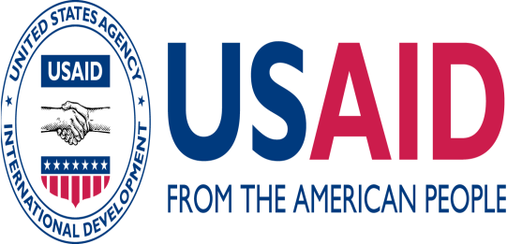
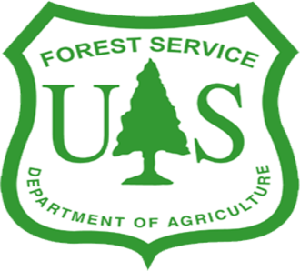


Sustainable & Thriving Environments for West African Regional Development (STEWARD)

STEWARD FORUM
The United States Forest Service – International Programs
Programs in Africa, with a general overview of the STEWARD Program for the Upper Guinea Forest Ecosystem
By
Jason Ko
(Africa Program Specialist, US Forest Service, International Programs, Washington, DC)

International Programs of the US Forest Service, Department of Agriculture, promotes sustainable forest management and biodiversity conservation internationally. By linking the skills of the field-based staff of the US Forest Service with partners overseas, the Agency can address the most critical forestry issues and concerns. International Programs regularly taps into the agency's wide range of expertise. Wildlife biologists, forest economists, hydrologists, disaster and fire management specialists, and policy makers are among those who comprise the staff of over thirty thousand employees.

The Technical Cooperation unit works on collaborative projects on a wide range of topics, many of which are co-funded by USAID, with a variety of partners including the FAO, the World Bank, the Center for International Forestry, The Nature Conservancy, WWF, the Wild Life Conservation Society, and other environmental nongovernmental organizations. Our collaborators tap the Technical Cooperation staff to manage field programs, contribute specialized technical assistance to existing projects, conduct training, facilitate research, and publish technical guides to promote sustainable forest management and biodiversity conservation worldwide.

Forests and wildlife in Africa are recognized for their ability to protect water supplies, and play a prominent role in many cultural and spiritual traditions. Some of the world's most spectacular and unique wildlife-like the lemur in Madagascar, the endangered mandrill in the Congo Basin, and the impalas of Lake Manyara-depend on forests for their home and survival.

Africa's forests, however, are threatened by slash and burn agriculture, desertification, illegal logging and bushmeat hunting. In many parts of Africa, this forest loss is continuing at an alarming rate, threatening the people and the wildlife that depend on such valuable resources.

For a number of years, the US Forest Service has worked in Africa to address these threats and promote sustainable forest management. Working with many African land management agencies, the US Forest Service focuses on building local capacity on the continent to improve natural resources management. The agency taps upon its expertise to promote the principles of sustainable use of natural resources, land-use planning, and biodiversity conservation. From Angola to Zambia, the US Forest Service and its in-country partners work on various technical issues, including forest concession management, land-use planning, watershed management, development of information systems for decision making, and protected area management through training, policy reform and other forms of technical assistance in order to advance sustainability of natural resources in Africa and across the globe.

The Upper Guinea ecosystem of West Africa is a high priority globally for biodiversity conservation and is of strategic importance in terms of peace building, extractive industries and other important commodities such as rubber, cocoa and oil palm. USAID and the US Forest Service have already made significant investments in biodiversity and community-based natural resource management in Liberia, Guinea, Ghana and Sierra Leone. Sustainable and Thriving Environments for West African Regional Development (STEWARD) is an opportunity to produce a more coherent regional program that will address regional threats to biodiversity as well as capitalize on regional opportunities to spread best practices, harmonize policies and improve regional markets.

STEWARD will focus on key regional concerns: 1) harmonizing forest, wildlife and conservation policies to mitigate illegal movement and unsustainable use of natural resources; 2) promoting improved markets and management for high value tree crops that provide benefits to smallholders and help governments diversify extractive-industry based economies; 3) developing a regional presence in global flora for conservation, sustainable development and trade; 4) assisting the region to more effectively manage and capitalize on influxes of investment and trade in natural resources; 5) developing regional strategies for coastal and fisheries management, and (6) accelerating the flow of knowledge and experiences about best practices.

Mr. Jason Ko will speak in more detail about the work of the US Forest Service around the world, on the African continent, and in West Africa and Sierra Leone specifically.

Thursday, December 17th 2009
2:00 PM
Place: Forestry Division Conference Room, Youyi Building
Freetown, Sierra Leone

