1. Go to **Settings**

1. Select **Sim Cards and Traffic Management**

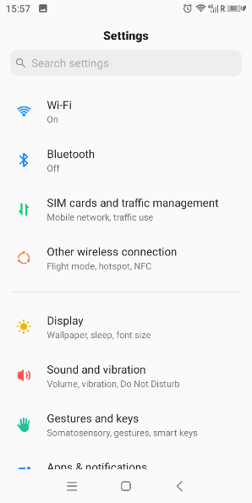

1. Select your card (example Movistar)

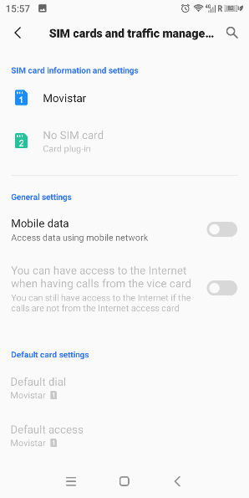

1. Scroll down select **Network Operator**

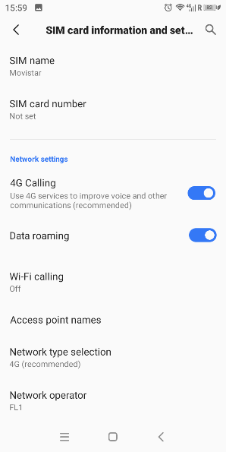

1. Disable **Automatic Selection**

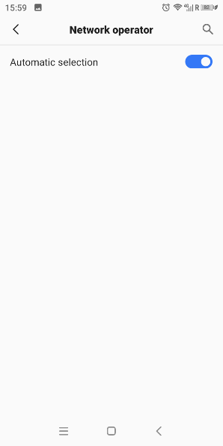

1. Select **FL1**

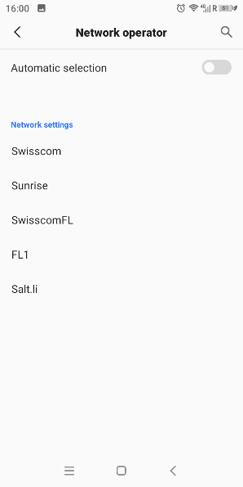

1. Go back now it should display **FL1**

