Decoder
A decoder takes n input bits and produces 2ⁿ output lines, where only one output is active for any input combination.
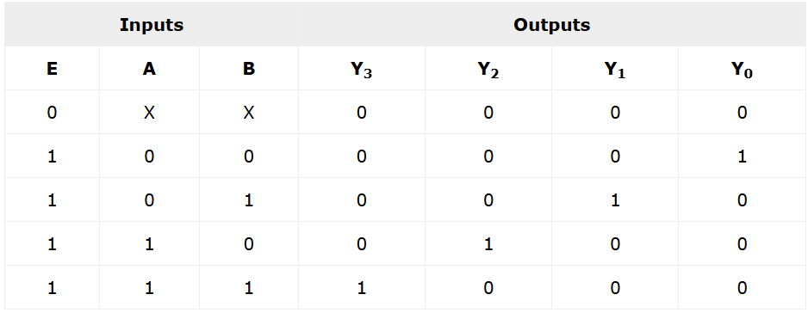

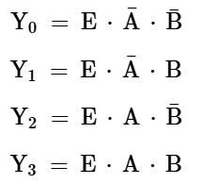
Direct Decoder

A direct decoder implements each output using a single AND gate that includes all input bits (or their complements).

Example: Direct 3:8 Decoder
Characteristics
- Each output uses a 3-input AND gate
- Simple logic
- Easy to code
- Works well for small decoders
Limitations
- AND gate fan-in increases with input size
- Higher delay due to stacked transistors
- Increased power and area
- Poor scalability for large decoders
Pre-Decoded (Hierarchical) Decoder
A pre-decoded decoder splits the decoding into multiple smaller stages to reduce complexity.
Example: Pre-Decoded 3:8 Decoder
- First stage:
  - Decode (A, B) using a 2:4 decoder
  - Decode C using a 1:2 decoder
- Second stage:
  - Combine outputs using 2-input AND gates
Fan-in = number of inputs to a logic gate
Decoder Type | AND Gate Fan-In
Direct 3:8 | 3
Pre-decoded 3:8 | 2
Large decoders | Reduced from N → 2 or 3

Even with two stages, pre-decoded is often faster because:
- No high fan-in gates
- Better transistor sizing
- Less RC delay
Pre-decoding does not reduce the number of AND operations; it reduces AND-gate fan-in, which lowers series transistor stacks, improving delay and power.
Large decoders are implemented using pre-decoding to reduce fan-in and improve timing and power.

Fan In
Fan-in of a logic gate is the number of inputs that the gate has.
Fan-in is not just a logic concept — it directly affects speed, power, and layout in VLSI.
AND Gate Fan-In at Transistor Level
CMOS AND Gate Implementation
An AND gate is usually built as:
- NAND gate + inverter
NAND gate pull-down network:
- NMOS transistors in series
- Number of series NMOS = fan-in
2-input AND → fast
3-input AND → slower
4-input AND → much slower

