Encoder
An encoder is a combinational circuit that converts 2ⁿ input signals into an n-bit coded output.
Types of encoders
- Binary encoder
- Priority encoder (handles multiple active inputs)
- Decimal to BCD encoder
- Octal to binary encoder
2-to-1-bit binary
A 2-to-1-bit binary encoder has two inputs and one output. The encoder assigns a binary code to the active input signal.
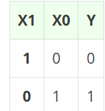
4-to-2 Bit Binary Encoder
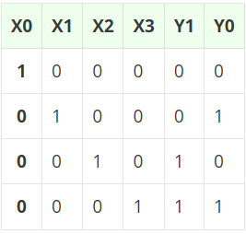
Y1 = X1 + X3
Y0 = X2 + X3
Octal to Binary Encoder
- An octal to binary encoder is an 8 to 3-bit binary encoder which takes eight inputs (X0 to X7) and produces three outputs (Y2 Y1 Y0).
- It is used to convert an octal digit to its binary equivalent. Each input terminal corresponds to an octal digit and three output terminals produce its binary code.
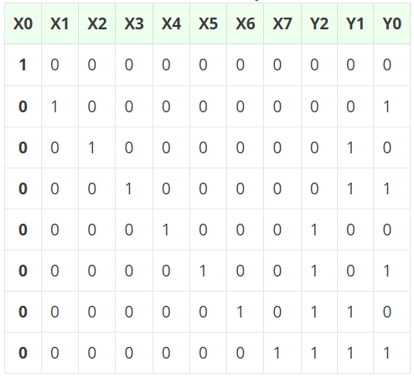
Decimal to BCD Encoder
A decimal-to-BCD encoder converts decimal digits (0-9) into 4-bit binary-coded decimal (BCD) format. This type of encoder is commonly used in calculators and digital displays
