KOGI STATE POLYTECHNIC LOKOJA
KOGI STATE
SCHOOL OF APPLIED SCIENCES
DEPARTMENT OF COMPUTER SCIENCE
HIGHER NATIONAL DIPLOMA II

SEMINAR PRESENTATION

TOPIC: AN E-COMMERCE WEBSITE FOR SALES OF HAIR EQUIPMENT

SUPERVISOR: Mrs Audu, L.H
BY

NAME | OJO SILIFAT CHRISTIANA
MATRIC NO. | 2023/HND/CPS/018

1.0 INTRODUCTION
1.1 BACKGROUND OF THE STUDY
In the digital age, e-commerce has revolutionized the way businesses operate and how consumers interact with goods and services. It enables companies to showcase their products, receive payments, manage inventories, and communicate with customers over the internet (Laudon & Traver, 2020). In particular, the beauty and hair care industry has experienced significant growth globally through online platforms, allowing businesses to reach wider markets, reduce overhead costs, and operate efficiently.
Hair equipment, including hair dryers, straighteners, clippers, curling irons, and professional salon tools, are essential in both personal grooming and professional hair care services. Traditionally, businesses such as Tiana Empire, a fast-growing beauty enterprise based in Nigeria, have relied on physical stores and face-to-face marketing to sell these products. However, the limitations of this model became increasingly evident with the rise of digital competitors, urban mobility challenges, and the evolving purchasing behavior of modern consumers who prefer convenience, variety, and instant access to products (Ndukwe & Eze, 2019).
  - PROBLEM STATEMENT
Despite the proliferation of digital platforms in Nigeria’s retail landscape, many small and medium-scale enterprises (SMEs), including Tiana Empire, continue to face significant challenges in adopting e-commerce systems for product sales. Currently, Tiana Empire relies heavily on manual methods of transaction processing, inventory tracking, and customer management. This approach presents numerous issues, including:
• Limited Customer Reach: The absence of an online platform restricts Tiana Empire to walk-in customers, limiting its market potential and geographical reach.
• Manual Inventory Errors: Manual stock management often results in errors, leading to stockouts or overstocking, and in some cases, loss of revenue due to poor record-keeping (Ibrahim & Mustapha, 2020).
1.3 AIM AND OBJECTIVES OF THE STUDY
The aim of this study is to develop an e-commerce system for Tiana Empire to facilitate the online sales of hair equipment. The specific objectives include:
- To develop an online platform where customers can view and purchase hair equipment.
- To design a user-friendly administrative dashboard for inventory and sales management.
- To provide a system for tracking customer orders and generating sales reports.
  - SIGNIFICANCE OF THE STUDY
This study is significant in several ways. Firstly, it offers Tiana Empire an opportunity to transition from traditional to digital business operations, enhancing scalability and competitiveness. Secondly, it provides a model for other small businesses in Nigeria's beauty sector looking to leverage technology for growth. Academically, the project serves as a case study for the practical application of e-commerce principles in local business contexts. Additionally, it contributes to the broader discourse on digital transformation among SMEs in developing economies.

LITERATURE REVIEW
2.1 THEORETICAL FRAMEWORK
E-commerce, short for electronic commerce, refers to the buying and selling of goods and services through electronic means, primarily over the internet. It encompasses a wide range of online business activities, including retail shopping, online banking, electronic payments, online auctions, and internet marketing (Laudon & Traver, 2020). The essence of e-commerce lies in leveraging digital technologies to conduct commercial transactions without the constraints of physical location or traditional business hours.
E-commerce can be broadly classified into several categories based on the nature of transactions and participants involved: Business-to-Consumer (B2C), where businesses sell directly to consumers; Business-to-Business (B2B), where transactions occur between companies; Consumer-to-Consumer (C2C), involving transactions between individuals; and Consumer-to-Business (C2B), where individuals offer products or services to businesses (Turban et al., 2018).
E-Commerce in the Beauty and Haircare Industry
The beauty and haircare industry has witnessed significant transformation due to the rapid adoption of e-commerce platforms. Traditionally, consumers purchased beauty and haircare products through physical stores such as salons, beauty shops, and department stores. However, the digital revolution has introduced new buying behaviors where consumers prefer the convenience, variety, and accessibility that online shopping provides (Kim & Park, 2020).
E-commerce in the beauty and haircare sector allows businesses to showcase a wide range of products, including hair equipment, styling tools, hair care products, and accessories to a global audience. Online platforms enable consumers to compare brands, read reviews, and access detailed product information, thereby empowering informed purchase decisions (Kumar & Garg, 2019).
2.2 REVIEW OF RELATED WORK
Mark (2021), This research identifies the critical factors of online service delivery of electronic commerce (e-commerce) websites, including website attractiveness, website functionality, website security and consumer fulfillment during an unprecedented Coronavirus (COVID-19) pandemic. Design/methodology/approach: A structured questionnaire was used to gather data from 430 online respondents, who were members in popular social media groups. The survey instrument relied on valid and reliable measures relating to electronic service quality (e-SERVQUAL), to better understand the participants’ satisfaction with shopping websites as well as their loyal behaviors and word-of mouth activities. Findings: The findings reported that consumers valued the e-commerce websites’ features and their consumer order fulfillment capabilities. These factors increase the consumers’ satisfaction with online shopping experiences, generate repeat business as well as positive reviews in social media. Originality: This contribution posits that e-commerce websites ought to be appealing, functional and offer secure transactions. More importantly, it suggests that online merchants should consistently deliver a personalized service in all stages of an online purchase, including after the delivery of the ordered products. Research implications / limitations: This study addresses a knowledge gap in academia. To date, little research has focused on the consumer order fulfillment aspect of e-commerce transactions and on the after-sales services of online businesses.
Vipin (2021), The world economy is witnessing a transition. All companies are transformed into information-based operations through online technologies. The pace of technical transition is so exponential that modern electronic commerce is now making significant shifts in the economic environment, impacting all areas of industry. The Web has expanded companies' scope. The vast quantity of business information made accessible by the global network that facilitates the gathering of information between firms, a corporation, its clients and the various divisions of a business is increasing exponentially. The information-based virtual value chains for any company cannot be overlooked operationally or strategically. This review article discussed the aspects of electronic commerce including its importance, facilitators, benefits, challenges and scope in the Indian market.
Sohyun and Keumsook (2021), E-commerce has dramatically expanded its sales, with people being increasingly customed to online shopping. This study aimed to examine changes in the distribution of retail stores that provide fashion and beauty products and services in terms of the number of online shopping transactions and their spatial characteristics in Seoul. For this purpose, we analyzed location data concerning relevant newly opened and closed offline stores from four subgroups between 2015 and 2019. Though more offline stores were newly opened than closed in that period, the number of stores had overall significantly decreased apart from stores providing beauty services, with significant differences in subgroup spatial distribution patterns. We identified local geographic factors affecting retail stores by applying spatial regression models, and we found that the growth of e-commerce was associated with the related to the survival and closure of fashion and beauty stores. While retail store locations are not immediately responsive to changes due to COVID-19, we expect the prolonged COVID-19 outbreak will further facilitate the spatial transformation that has been stimulated by rise of online retailing.
3.0 METHODOLOGY
3.1 PROPOSED METHODOLOGY
In this project, prototyping methodology is chosen, because prototyping methodology is one of the most important software developments models, it’s the process of building prototype (which is the first design of the system).
3.2 ANALYSIS OF THE EXISTING SYSTEM
Tiana Empire, a growing business specializing in the sale of hair equipment, currently operates without a fully automated e-commerce system. The business relies primarily on social media platforms such as WhatsApp, Instagram, and Facebook to interact with customers, showcase products, and complete sales transactions. While these platforms provide visibility and engagement, they are not structured to function as complete e-commerce solutions. Orders are typically received through direct messages, followed by manual responses from the business owner or staff. Customers are then required to manually transfer payments via bank accounts and send proof of payment as a screenshot or receipt, after which delivery arrangements are made, also through chat.
3.4 DATA COLLECTION TECHNIQUES
To gather information on the existing business operations and customer experience at Tiana Empire, both primary and secondary data collection methods were employed. Primary data was collected through interviews and oral discussions with the business owner and staff members involved in order processing, inventory management, and customer service. These discussions provided firsthand insight into the challenges faced under the current system.
Additionally, questionnaires were distributed to regular customers to understand their buying experience, preferences, and expectations for an online store. The feedback obtained was instrumental in identifying key features for the proposed system. Secondary data was gathered by studying existing e-commerce platforms and reviewing literature on e-commerce best practices. This helped in understanding standard system components such as shopping carts, secure checkout, user registration, product categorization, and customer feedback mechanisms.
3.5 ANALYSIS OF THE PROPOSED SYSTEM
The proposed system is a fully functional e-commerce website specifically designed to streamline and automate the sales process of hair equipment for Tiana Empire. The primary objective of this system is to replace the existing manual and semi-digital methods with a centralized online platform that enhances user experience, simplifies business operations, and supports scalability. This web-based platform will serve as a virtual storefront where customers can conveniently browse, select, and purchase various hair-related products from the comfort of their homes using their mobile devices or computers.
One of the core features of the proposed system is an intuitive and well-structured product catalog. Customers will be able to view product images, prices, specifications, and availability in real time. Products will be organized into categories (e.g., hairdryers, straighteners, curlers, accessories) to enhance searchability and navigation. A search bar and filtering options will enable users to quickly find what they need based on product type, price range, popularity, or availability. This significantly improves the user experience compared to scrolling through social media posts or status updates.

3.6 SYSTEM FLOWCHART
System Flowchart
Start

Landing page

Enter login page

No
Display Products List
If login details is correct?

Yes
Display Dashboard

Yes
Display Products List
If option = Product List?

No
Yes

Display inventory List
If option = Inventory List?
No
Yes
If option = Order List?

Display Order List
No

Yes
Display Client List

If option = Client List?
No

Yes

Display Sales Report
If option = Sales Report?
No
Yes
Display Category List

If option = Category List?

No
Display Settings

Yes
If option = Settings?

No
Stop

Fig.3.1: System Flowchart

IMPLEMENTATION AND EXECUTION
4.1 SYSTEM IMPLEMENTATION
I implemented the system using Apache web server, Mysql database server, Hypertext Pre-processor (PHP) for business logic and Hypertext markup language (HTML), Cascading style sheets (CSS), JavaScript for system interfaces.
4.2 SYSTEM REQUIREMENTS
This is the minimum requirements of a computer system to be able to run the proposed system very well. The system requirements shall be broken down into two, namely: hardware and software requirements.

4.2.1 SOFTWARE REQUIREMENTS
- Operating System:
- Deep Learning Frameworks: TensorFlow
- Libraries and Packages: NLP Libraries
- Visual Studio Code Editor

4.2.2 HARDWARE REQUIREMENT
For the effective and efficient implementation of this application, there are some minimum hardware requirements that are necessary for the program to function without problems. For a smooth computer execution, the program requires.
- High-Performance GPUs
- A minimum of 16 GB VRAM is recommended for handling large batches of data and complex models.
- High-Speed SSDs
- The computer should be equipped with a memory (RAM) not less than 512 MB.
- 16 inches monitor
- UPS [uninterruptable Power Supply]

4.3 SYSTEM INTERFACE
System interface is the font-end application view through which users interact with the computer. Users can manipulate and control the program by common instructions through a program interface. A good User interface is an attribute of a good program as it makes the operation of the program very easy.
INPUT INTERFACE
The system interface for the system shall compose of both input interface and output interface. They are respectively the medium through which all the user input and output are being supplied and stored in the system.
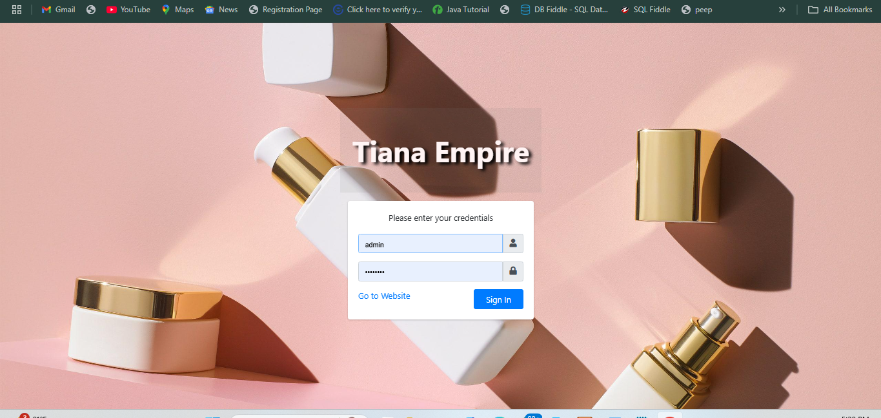
Fig.4.1: Login Interface
4.3.2 OUTPUT INTERFACE
After supplying the input to the system the system stores the information. Form these information output can be generated based on some specified instructions.
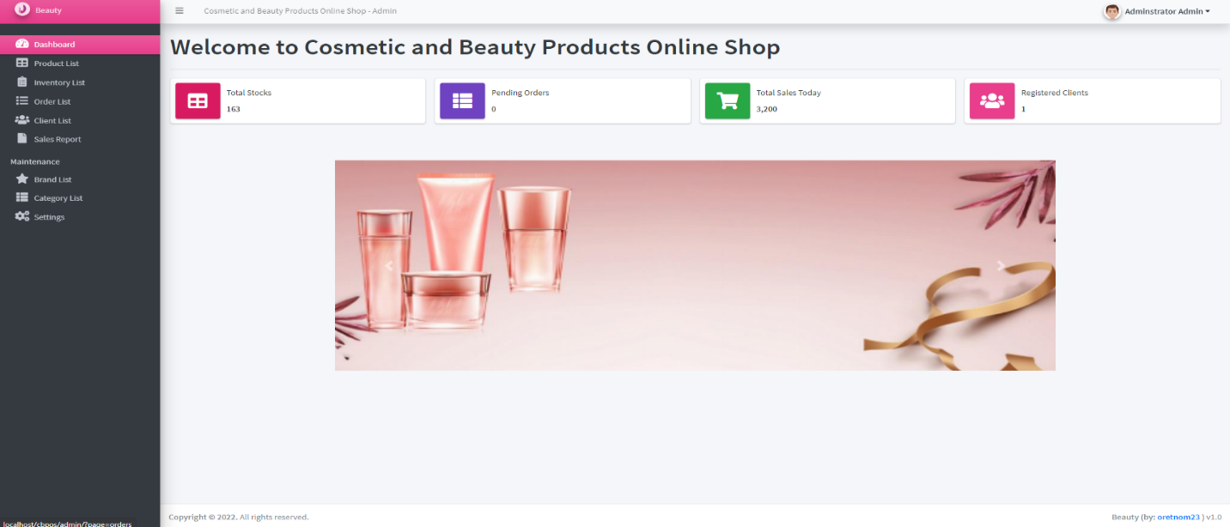
Fig.4.4: Dashboard for admin
SUMMARY, RECOMMENDATIONS AND CONCLUSION

5.1 SUMMARY

This project focused on the design and implementation of an e-commerce website tailored to the specific needs of Tiana Empire, a business that specializes in the sale of hair equipment. The goal was to develop a digital platform that automates the entire process of selling products—ranging from product display and customer ordering to inventory tracking and payment processing. The motivation for this project arose from the limitations of the existing system, which heavily relied on manual processes and informal platforms such as WhatsApp and Instagram for handling inquiries, confirming payments, and managing orders.

5.2 RECOMMENDATIONS

In light of the successful implementation of the e-commerce system, several recommendations are proposed to enhance its functionality and long-term sustainability. First, it is advisable for Tiana Empire to host the website on a reliable and secure web server with sufficient bandwidth and uptime guarantees. Cloud-based hosting services with built-in security features should be considered to ensure consistent access and data protection.

5.3 CONCLUSION
In conclusion, the development of an e-commerce website for Tiana Empire represents a significant transformation from traditional sales methods to a modern, efficient, and scalable online business model. The system not only addresses the weaknesses of the previous manual approach but also provides a foundation for future growth and digital innovation. With its user-friendly interface, automated operations, and secure transaction flow, the platform enhances customer satisfaction while reducing the workload on business staff.
This project has demonstrated that a well-structured e-commerce system can empower small and medium enterprises like Tiana Empire to compete effectively in the digital marketplace. It bridges the gap between product availability and customer access, making it easier for buyers to explore, purchase, and receive products without physical limitations. Overall, the implementation of this system marks a critical step toward digital transformation, improved efficiency, and increased revenue generation for the business.

REFERENCES
Amisha, M., Malik, P., Pathania, M., & Rathaur, V. K. (2019). "Overview of artificial intelligence in medicine." Journal of Family Medicine and Primary Care, 8(7), 2328.
Bodenreider, O. (2004). "The Unified Medical Language System (UMLS): integrating biomedical terminology." Nucleic acids research, 32(suppl_1), D267-D270.
Bresnick, J. (2019). How AI in healthcare is making a difference. HealthITAnalytics. Retrieved from https://healthitanalytics.com/features/how-ai-in-healthcare-is-making-a-difference
Esteva, A., Robicquet, A., Ramsundar, B., Kuleshov, V., DePristo, M., Chou, K., ... & Dean, J. (2019). "A guide to deep learning in healthcare." Nature medicine, 25(1), 24-29.
Fadhil, A., & Gabrielli, S. (2017). "Addressing challenges in promoting healthy lifestyles: the AI chatbot approach." Proceedings of the 11th EAI International Conference on Pervasive Computing Technologies for Healthcare, 261-265.
Fitzpatrick, K. K., Darcy, A., & Vierhile, M. (2017). "Delivering cognitive behavior therapy to young adults with symptoms of depression and anxiety using a fully automated conversational agent (Woebot): a randomized controlled trial." JMIR mental health, 4(2), e19.
Garg, A. X., Hackam, D., & Tonelli, M. (2020). "Systematic review and meta-analysis: when one study is just not enough." Clinical Journal of the American Society of Nephrology, 15(2), 217-219.
Hamet, P., & Tremblay, J. (2017). "Artificial intelligence in medicine." Metabolism, 69, S36-S40.
Jha, A., Lin, L., Savio, A., & Lu, X. (2019). A survey of chatbot systems in healthcare. arXiv preprint arXiv:1904.04609.
Jurafsky, D., & Martin, J. H. (2020). "Speech and Language Processing." Pearson.
Krittanawong, C., Johnson, K. W., Rosenson, R. S., Wang, Z., Aydar, M., & Halperin, J. L. (2017). "Deep learning for cardiovascular medicine: a practical primer." European heart journal, 40(25), 2058-2073.
LeCun, Y., Bengio, Y., & Hinton, G. (2015). "Deep learning." Nature, 521(7553), 436-444.
Morley, J., Machado, C. C. V., Burr, C., Cowls, J., Joshi, I., Taddeo, M., & Floridi, L. (2020). "The ethics of AI in health care: A mapping review." Social Science & Medicine, 260, 113172.
Shafqat, S., Tariq, A., Nisa, Z. U., & Mehmood, Z. (2020). "The rise of chatbots in health care: A case study of Babylon health." Journal of medical Internet research, 22(8), e20769.
Shortliffe, E. H. (1976). "Computer-based medical consultations: MYCIN." Elsevier.

