

WASTE To WOW

Home Waste Management Recommendation System - Recycling or Upcycling

Team 7

## Table of contents.

01 | Abstract and Introduction

03 | Methodology

02 | Related Work

04 | Experiments

05 | Limitations and Future Work

06 | Conclusion





# Abstract and Introduction

Sonali Arcot





## Abstract

This project addresses the critical issue of improper household waste disposal, focusing on categorizing household items to promote recycling and safe disposal.

Leveraging a diverse dataset, including annotation and augmentation, models such as YOLOv8 and MobileNetv2 are employed for accurate identification and categorization.

The integration of a Language Model (LLM) provides personalized recommendations for waste management. Key deliverables include classification and object detection models, a real-time user interface, and integration with the Google Maps API. Technical evaluation metrics, such as top 1 accuracy and F1 score, assess system performance, with YOLOv8-s showing the best results (F1-score: 0.93, 94% accuracy).

## Introduction



Introduction to Waste Management Challenge:

* Growing concern about waste management, particularly household waste.
* Environmental, health, and aesthetic issues due to improper waste disposal.
* Lack of knowledge on segregating recyclables, organics, and non-recyclables.

Project Mission and Dataset:

* Mission to classify household waste types and provide disposal information.
* Meticulously curated dataset from diverse sources: Mendeley, TrashBox, etc.
* Representation of 11 waste categories, addressing class imbalance.





## Introduction

Dataset Challenges and Solutions:

* Varying image counts for each waste category.
* Annotation challenges for accurate classification.
* Training models on a massive and diverse dataset.
* Models include MobileNetV2, InceptionNetV3, Xception, ResNet50, and YOLOv8.

Model Selection and Architectural Strengths:

* MobileNetV2 and InceptionResNetV2 for balance between efficiency and accuracy.
* Xception for improved feature representation.
* ResNet50 for addressing challenges in training deep neural networks.
* YOLOv8 for real-time object detection, speed, and accuracy.





## Introduction

Multi-Model Approach:

* Leveraging diverse architectural strengths for superior waste classification.
* Commitment to maximizing each model's advantages collectively.

Project Goals and Impact:

* Empowering individuals with knowledge for informed waste disposal decisions.
* Fostering a sustainable and environmentally conscious society.
* Meaningful contribution to improving household waste management practices.





# Related Work

Sonali Arcot



|  |  |  |  |
| --- | --- | --- | --- |
| Title | Author(s) | Model(s) Used | Results |
| A Domestic Trash Detection Model Based on Improved YOLOX | Liu et al. (2022) | A new trash detection model, i-YOLOX | The i-YOLOX model improved mAP by 1.47%, increased FPS by 40.4%, and reduced parameters by 23.3% compared to the baseline. |
| Garbage detection and classification using a new deep  learning-based machine vision system as a tool for sustainable waste recycling | Jin et al. (2023) | MobileNetV2 with convolutional attention module and transfer learning | MobileNetV2: original 71.4%  (770ms), improved 90.7% (600ms); on Raspberry PI: 89.26%, enhanced with GAN: 91.98%. |
| Hybrid approach of garbage classification using computer vision and deep learning | Tatke et al. (2021) | Simple CNN, VGG16, ResNet50, HOG+SVM. | Simple CNN (Adadelta): 93.56%, VGG16: 75.6%,  ResNet50 (Adadelta): 95.93%,  HOG+SVM: 47.25% |
| MWaste: A Deep Learning Approach to Manage Household Waste | Kunwar (2023) | Inception V3, MobileNet V2, Resnet 50, and others | InceptionResNetV2 and Xception scored 92% accuracy; MWaste, a  real-time waste classification app, uses these for six categories and includes gamified leaderboards for motivation. |

Related Work



|  |  |  |  |
| --- | --- | --- | --- |
| Title | Author(s) | Model(s) Used | Results |
| "TALLRec: An Effective and Efficient Tuning Framework to Align Large Language Model with Recommendation" | Bao et al. (2023) | Alpaca-LoRA, Text-Davinvi-002, Text-Daviniv-003 etc. | TALLRec excels in few-shot settings, outdoing both traditional and LLM-based methods, rapidly recommends with under 50 samples, and shows  cross-domain strength, such as training on movies and testing on books. |
| An On-Device Deep Learning Framework to Encourage the Recycling of Waste | Ekundayo et al. (2021) | MobileNetV2, VGG19, DenseNet201, ResNet152V2, or InceptionResNetV2 | InceptionResNetV2 had 90% accuracy and 1000ms latency; MobileNetV2 and DenseNet201 balanced accuracy, latency, and size optimally. |
| Grounding DINO: Marrying DINO with Grounded  Pre-Training for Open-Set Object Detection | Liu et al. (2023) | Transformer-based detector DINO (used for open-set object detection) | Grounding DINO achieves a 52.5 AP on the COCO detection  zero-shot transfer benchmark, setting a new record on the ODinW zero-shot benchmark with a mean 26.1 AP. The model performs remarkably well on benchmarks, including COCO, LVIS, ODinW, and RefCOCO/+/g. |

Related Work





# Methodology

Siddharth Solanki



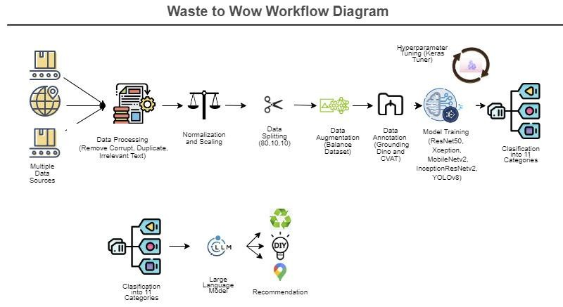

## Methodology



Data Collection

* Aimed to create a comprehensive dataset for household waste.
* Primarily sourced data from Trashbox and Mendeley datasets.
* Identified gaps in categories like "Furniture" and introduced new categories.
* Enriched datasets to handle a wider range of waste items.

Data Preprocessing

* Removed corrupt images and handled unsupported types.
* Used pytesseract package to remove images with text.
* Removed duplicate images using ImageHash.
* Processed over 1200 corrupt images from various categories.

## Methodology



Data Transformation

* Normalizing and Scaling Images:
  + Inherent variability in image data due to different sources.
  + Standardized through normalization and scaling.
  + Converted to RGB mode; pixel values normalized to [0,1].
  + Initial scaling: 416x416; adjusted for different models:
    - Xception and InceptionResnetv2: 299x299.
    - Resnet50 and Mobilenetv2: 224x224.
    - YOLOv8: 640x640.

## Methodology

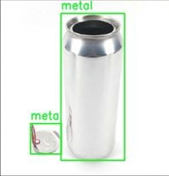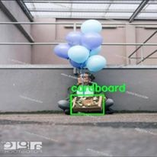

Data Transformation

* Data Annotation:
  + State-of-the-art object detection model combining grounding and DINO.
  + Two encoders, one decoder architecture for effective NLP and computer vision.
  + Self-attention mechanism for global context understanding.
  + Powerful zero-shot detector with semantic embeddings.
  + Cross-Modality Decoder refines box predictions using textual and visual features.
  + Effective in detecting over 1200 images/class; although e-waste detections was not up to the mark.
  + To mitigate bias, E-waste images were manually labeled using CVAT tool.

## Methodology



Data Transformation

* Data Augmentation Techniques:
  + Diversified and increased dataset size for effective model training.
  + Techniques applied for all classes:
    - Horizontal flipping, rotating by 90 degrees, Gaussian Blur, Zooming (110% to 150%).
  + YOLOv8 configuration for augmentation:
    - Hue (0.015), Saturation (0.7), Brightness (0.4), Scaling (0.5),

Translation (0.1), Horizontal Flip (0.5), Mosaic (1.0).

## Methodology



Modeling

* YOLOv8:
  + Released by Ultralytics in January 2023, a one-stage object detector.
  + Introduces five scaled versions for diverse applications.
  + Architecture includes Backbone, Neck, and Head components.
  + Utilizes C2f module for contextual information integration.
* MobileNetV2:
  + Designed for mobile and embedded devices.
  + Balances computational efficiency and accuracy.
  + Incorporates depth wise separable convolutions, reducing computational cost.
  + Memory-efficient design suitable for systems with limited resources.

## Methodology



Modeling

* ResNet-50:
  + 50-layer deep Convolutional Neural Network (CNN).
  + Addresses challenges in training deeper networks through residual learning.
  + Introduces shortcut connections for identity mapping.
  + Effectively mitigates the degradation problem.
* Xception:
  + Convolutional neural network for image classification tasks.
  + Uses depthwise separable convolutions to reduce parameters.
  + Achieves a balance between accuracy and computational efficiency.
  + Leverages transfer learning for diverse garbage image classification.

## Methodology



Modeling

* InceptionResNetV2:
  + Integrates features from Inception and ResNet for training very deep networks.
  + Includes Inception modules, residual connections, and reduction blocks.
  + Utilizes auxiliary classifiers for intermediate predictions.

Evaluation Metrics

## Methodology

* Classification Model Metrics:
  + Confusion Matrix:
    - Visualizes algorithm performance with instances in predicted and actual classes.
    - Columns represent predicted class instances; rows represent actual class instances.
    - Powerful tool indicating correctness and types of errors.
  + Basic Terms in Confusion Matrix:
    - True Positives (TP): Predicted yes, and event occurred.
    - True Negatives (TN): Predicted no, and no event occurred.
    - False Positives (FP) or Type I error: Predicted yes, but no event occurred.
    - False Negatives (FN) or Type II error: Predicted no, but event occurred.

## Methodology



Evaluation Metrics

* Derived Metrics for Classification Report:
  + Accuracy
    - Measures how often the classifier makes correct predictions.
    - Ratio of correct predictions to the total number of predictions..
  + Precision
    - Proportion of positive identifications that were actually correct.
    - Metric for classifier accuracy.
  + Recall (Sensitivity or True Positive Rate)
    - Proportion of actual positives identified correctly.
    - Metric for classifier comprehensiveness.
  + F1 Score
    - Communicates harmony between recall and precision.

## Methodology



Evaluation Metrics

* Object Detection Model Metrics:
  + mAP50 (Mean Average Precision at 50%):
    - Used for YOLO object detection.
    - Calculates average precision of predicted bounding boxes at IoU threshold of 50%.

Deployment

* Intuitive system design for real-time waste classification.
* Features include image upload, waste categorization, recommendation system, and location integration.
* Recommendations based on a Large Language Model for efficient waste disposal and recycle.





# Experiments

Vidushi Bhati

## Classification Models

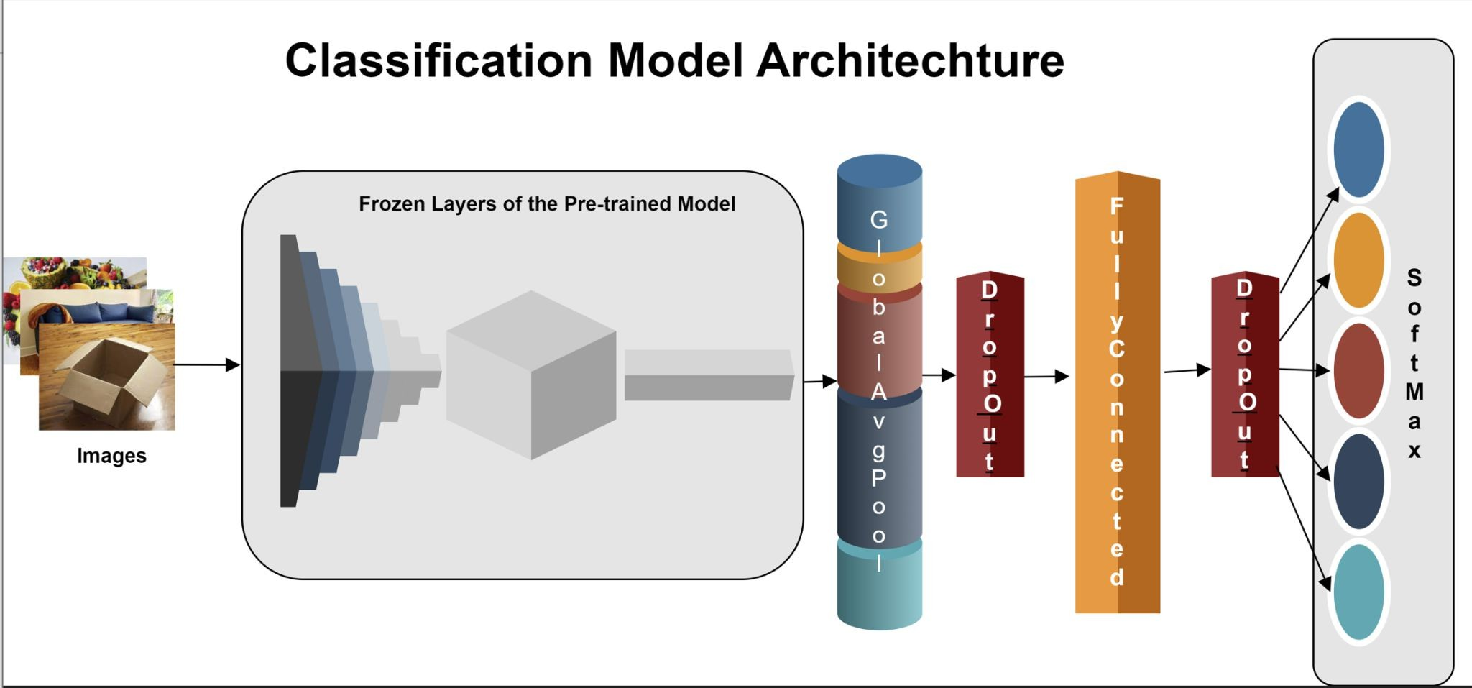

Classification Models



* Dropout rate was 20%
* Dense Layer was set to 32 units with ReLU activation function
* Batch size was chosen as 32
* Output Softmax layers contained 11 units for 11 classes.
* Optimizer used was Adam and Categorical cross entropy as the loss function.
* Keras Tuner was used to tune the model
* Dense Layer started with 32 units till 512 units with the step size of 32
* Learning rate was changed from 1e-2 to 1e-4 with the step size of 1e-1
* Callbacks -
  + EarlyStopping with Patience Level 5
  + Reduce Learning Rate on Plateau while monitoring Validation loss with Patience level of 2
  + Saved ModelCheckPoints while monitoring Validation Loss

## Classification Models



* + - Keras Tuner Random Search ran for 10 trails for 10 epochs

|  |  |
| --- | --- |
| Model | F-1 Score |
| ResNet50 | 0.91 |
| Xception | 0.87 |
| MobileNetv2 | 0.87 |
| InceptionResnetv2 | 0.88 |
| YOLOv8-n | 0.92 |
| YOLOv8-s | 0.93 |

* + - Total time taken by different models were different.
      * InceptionResNetv2 took one Day, 13 hours, 36 minutes, and 34 Seconds.
      * MobileNetv2 took 14 hours, 19 minutes, and 3 seconds
    - YOLOv8-n nano and YOLOv8-s small flavors of YOLOv8 models were trained for classification task for 100 epochs
    - Classification Report was generated for all the models and weighted avg F1-Score compared.

## YOLOv8



Classification Model

|  |  |  |  |
| --- | --- | --- | --- |
| Model | Top1 | Top5 | Inferenc e Speed |
| YOLOv8-n | 93.1% | 99.6% | 0.6 |
| YOLOv8-s | 94% | 99.6% | 1.0 |

* YOLOv8-n nano model took 5.5 hours to train on 100 epochs
* YOLOv8-s small took 7.3 hours to train on 100 epochs
* YOLOv8-s small performed the best with highest accuracy of 94%

## YOLOv8 Classification Samples

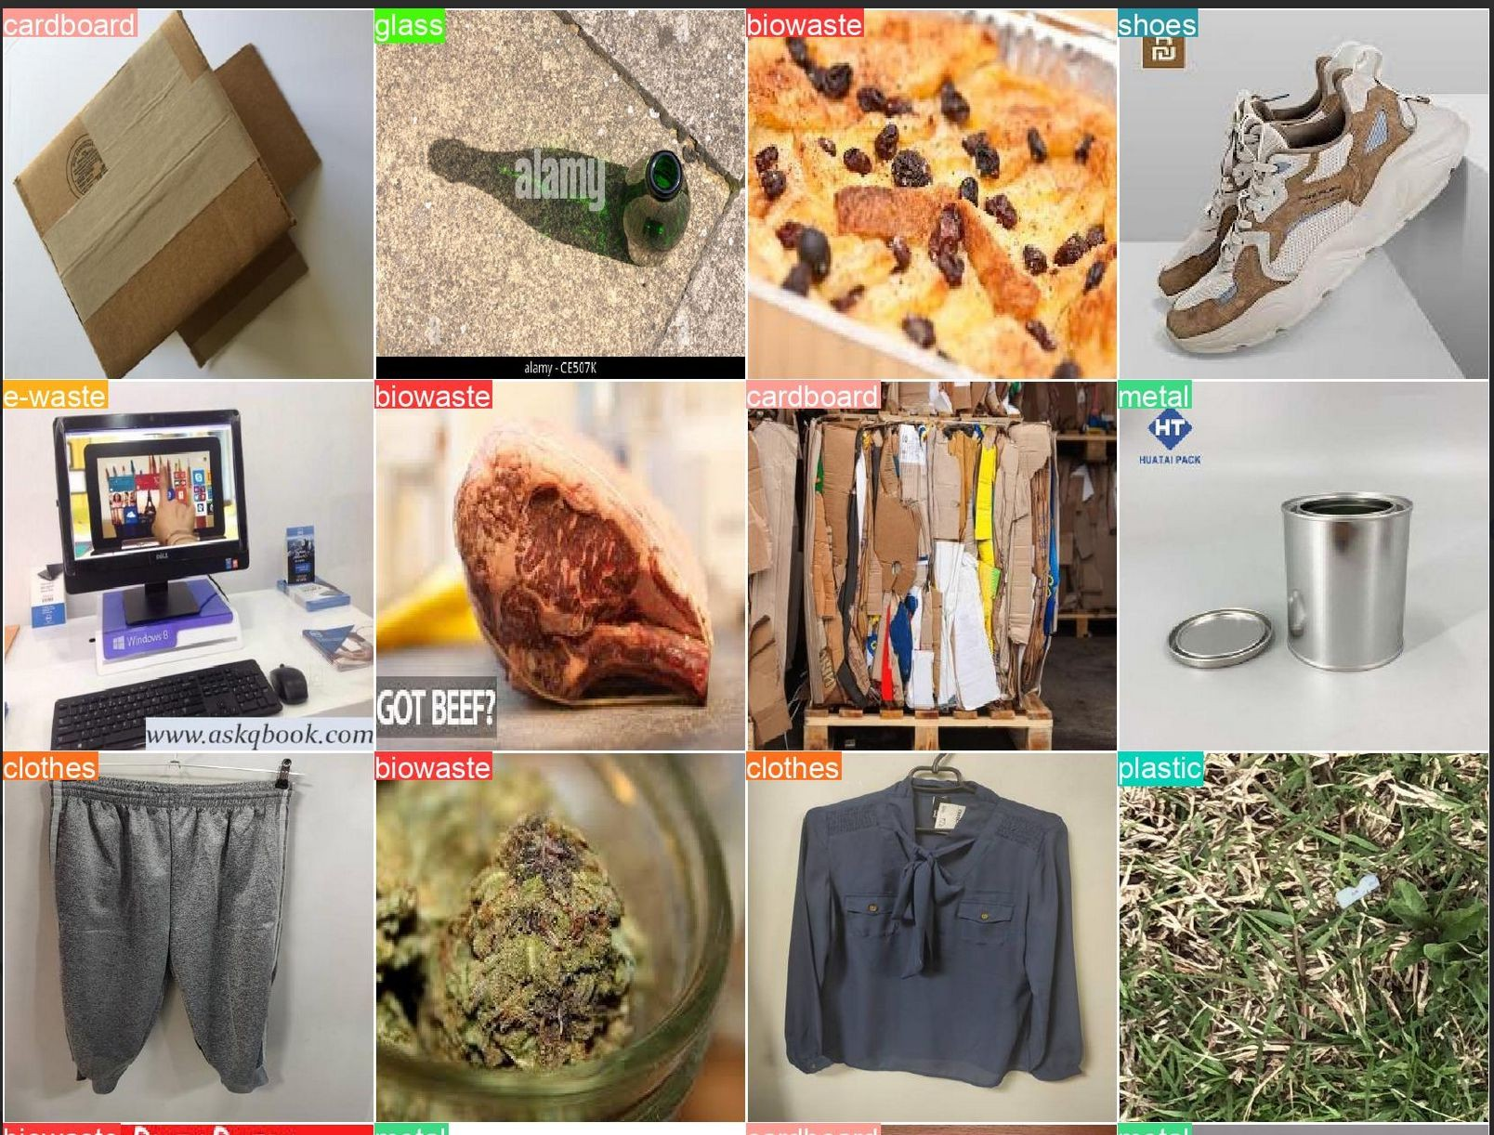

YOLOv8 Object Detection



* Initially YOLOv8 medium(295 layers) model trained for 25 epochs on 1100 images annotated with CVAT tool

|  |  |  |  |
| --- | --- | --- | --- |
| Model | mAP50 | mAP 50-95 | Inference Time (ms) |
| YOLOv8-m (1100  images) | 0.579 | 0.409 | 0.6 |
| YOLOv8-m | 0.745 | 0.699 | 1.7 |
| YOLOv8-l | 0.863 | 0.862 | 4.6 |

* Training took 0.055 hours
* Annotated images through Grounding DIno, more than 1100 images per class got detected.
* Trained on YOLOv8-medium again for 100 epochs.. e-waste category performed really badly.
* After working on the dataset again

re-trained the model on YOLOv8’s large variant for 400 epochs.

* The model performed consistently across all the thresholds.

YOLOv8 Object Detection

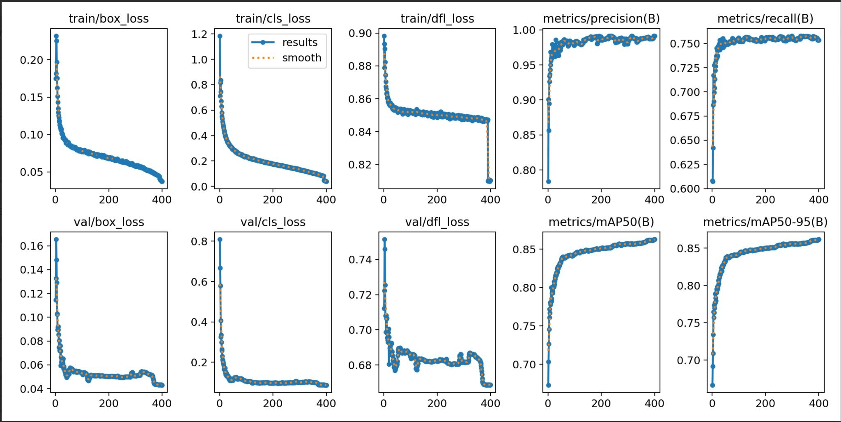

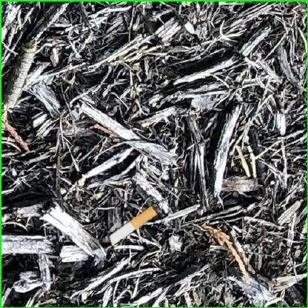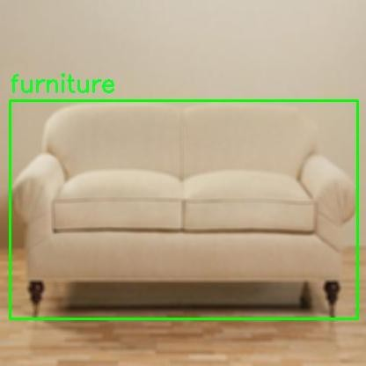GroundingDino Annotation samples

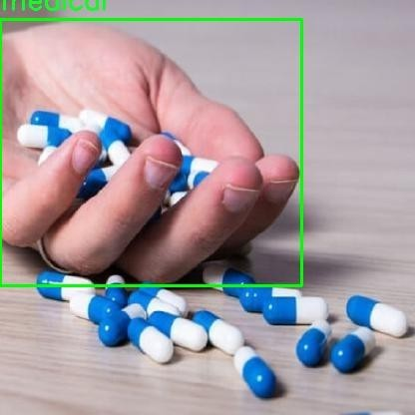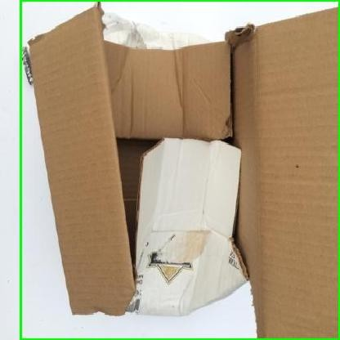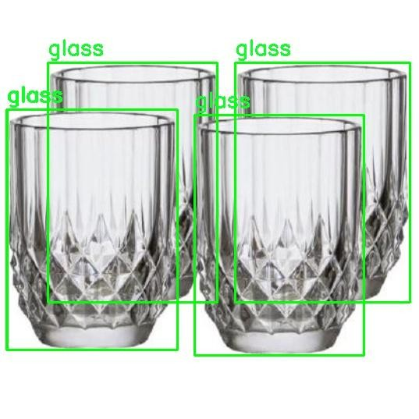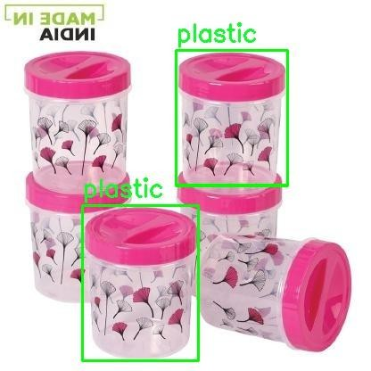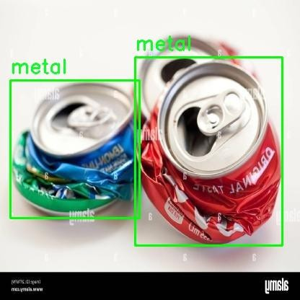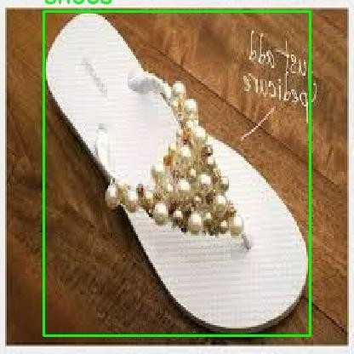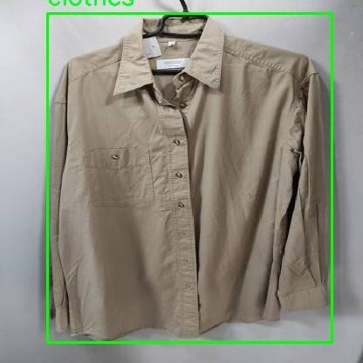

Yolov8 Prediction Samples

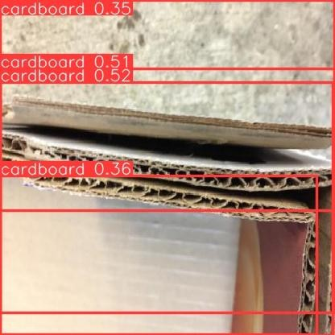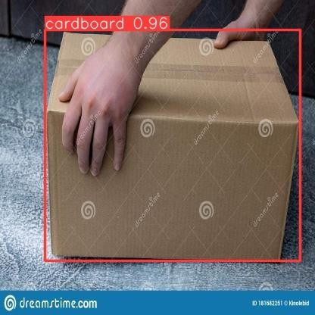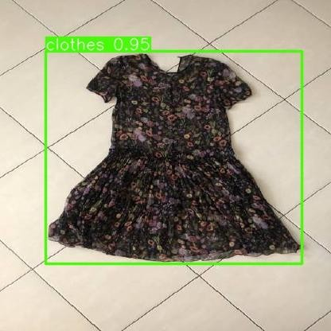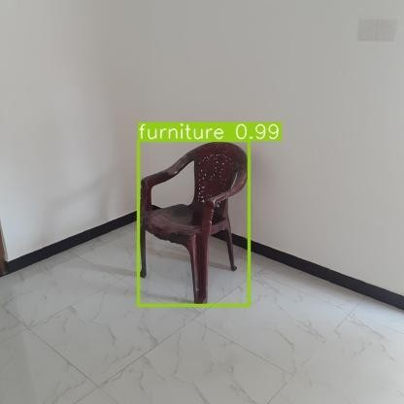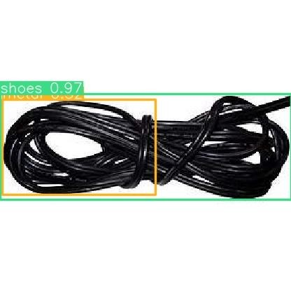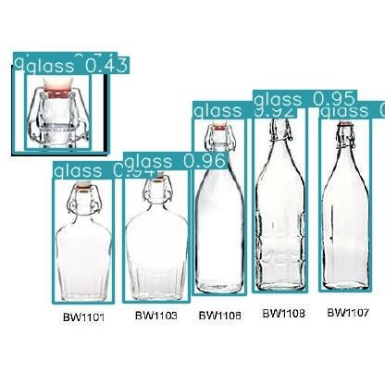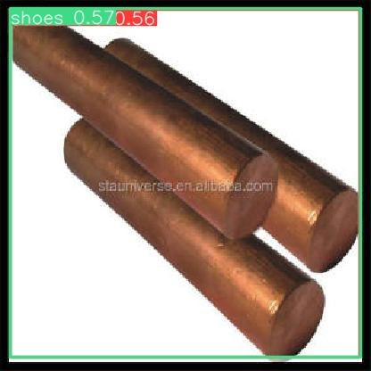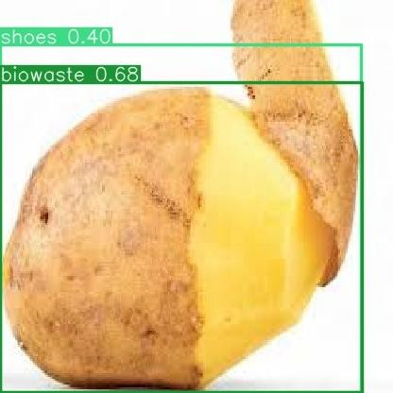





# Limitations and Future Work

Krishna Sameera Surapaneni

## Limitations and Future Work



Dataset Enhancement:

* Real-life photos can be added to enhance the dataset.
* Improved infrastructure and processing resources for enhanced model performance.
* Varied environments will enable better model generalization and accurate waste classification.
* Aim to capture subtle visual properties of different garbage items for real-world effectiveness.





## Limitations and Future Work

Business Connection Feature:

* Promoting a sustainable ecosystem through innovative connections.
* Connect household-generated waste to businesses selling relevant items.
* Provide businesses with a strategic avenue for targeted advertising.
* Altering traditional waste management boundaries for a dynamic and adaptive system.
* Responding to changing consumer needs and encourages sustainable purchasing habits.





# Conclusion

Krishna Sameera Surapaneni





## Conclusion

In conclusion, the project addresses the critical issue of inadequate domestic waste management, tackling environmental challenges like landfill congestion and increased carbon emissions.

By focusing on household trash and employing advanced models for precise identification, the system serves as a valuable tool, promoting responsible waste disposal practices. The overarching goal is to foster an ecologically conscious society by advocating widespread adoption of proper trash disposal practices. The project not only aims to minimize environmental impact but also presents a viable model for holistic waste management, contributing to global efforts for a sustainable and

eco-friendly future.

## IEEE Conference



* **2nd International Conference on Data Science and Network Security**
* [**https://icdsns.co.in/dates.php**](https://icdsns.co.in/dates.php)

|  |  |  |  |
| --- | --- | --- | --- |
| Paper Submission 30 April 2024 | Acceptance Notification 30 May 2024 | Author Registration 15 June, 2024 | Conference  26-27 July 2024 |

* 1st International Conference on Computing, Sciences and Communications.
* <https://iccsc.abes.ac.in/index.php>

❖

|  |  |  |  |
| --- | --- | --- | --- |
| Paper Submission 15 May 2024 | Acceptance Notification 15 July 2024 | Author Registration 20 Sept 2024 | Conference  24-25 Oct 2024 |



Thank you!

Do you have any questions?