**ER Diagram:**

**Initial ER Diagram:**

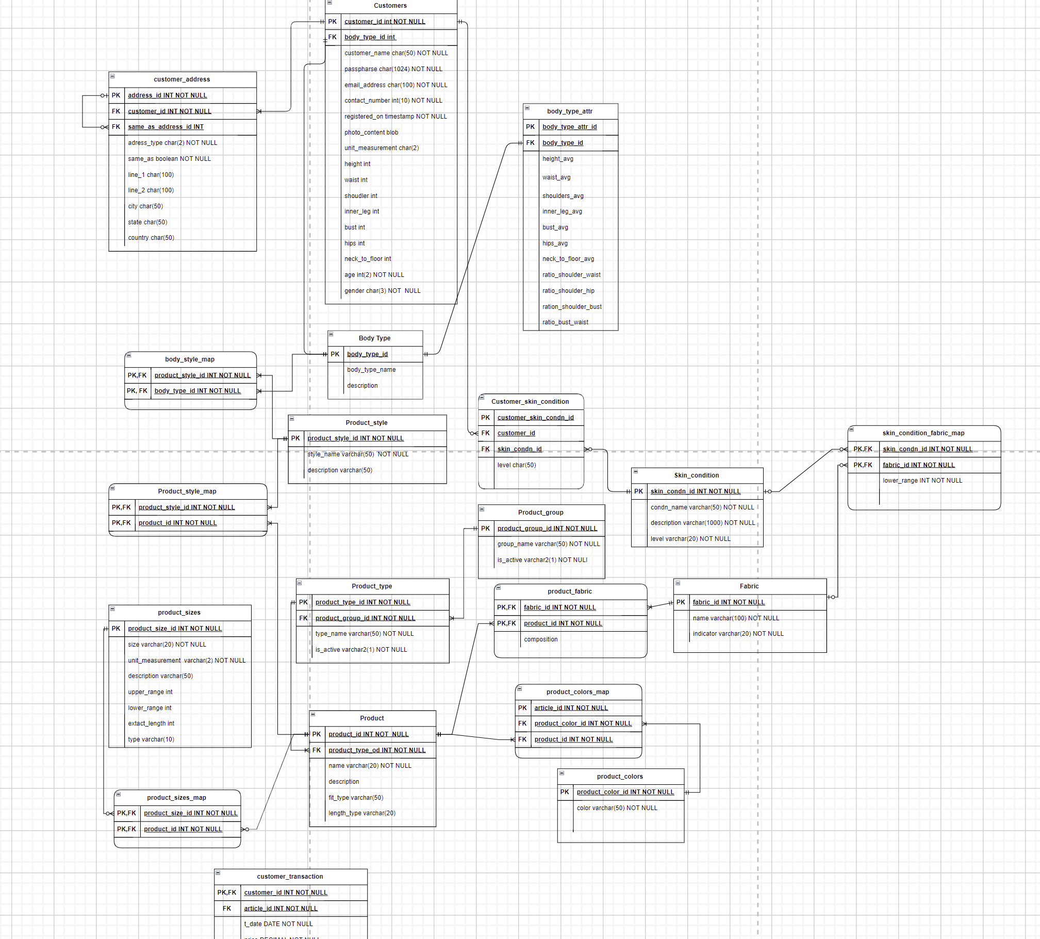

**After removing the size feature as its data was not available in our dataset and removing skin condition granularity feature as this may attract legal compliance issues and removing specifics skin conditions would also improve the performance as less tables will be joined.**

**Modified ER diagram with a View**

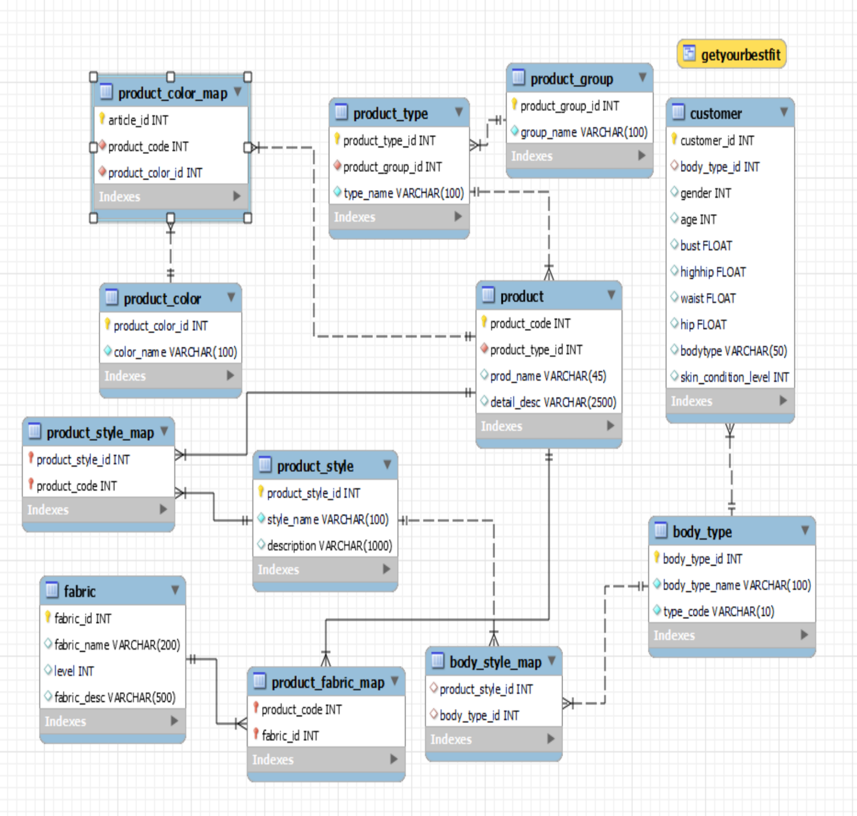

1. Product available in online store to its customers.
   1. Each product is divided into three categories
      1. Garment Upper Body
      2. Garment Lower Body
      3. Garment Full Body
   2. Each Product type is a part of one Product group. Product type can be Top, Blouse, Trouser, Skirt, Cardigan etc. (1-1)
   3. Each product can be of one product type. (1-1)
   4. Each product may have one or more colors associated with it. Also, each color may be associated with one or more products.(M-M)
   5. A product can compose of multiple fabrics. Also, multiple products can be made from each fabric. (M-M)
   6. Each product may have one or more styles associated with it. Also, each style can be found in one or more products. (M-M)
   7. A style for particular body should match the style associated with the product type.
   8. Each fabric should have a level indicating:
      1. Fabric level 1: Highest quality (skin-level 1 can wear these)
      2. Fabric level 2: Medium quality (skin-level 2 can wear these + fabric level 1)
      3. Fabric level 3: Lowest quality (skin-level 3 can wear these + fabric level 1 + fabric level 2)