**BODY SHAPE**

**Apple**

**How to tell if you’re an apple:** “Your shoulders and hips are around the same size,” Roché says. “Apple-shaped ladies have little difference between the measurements of their chest, waist and hips.. You as an apple-shaped girl have chest and waist measurements that are fairly close, but your hips are about six inches smaller than your chest.”

**Apple body shape traits:**

* Hips and shoulders have the same width; waistline has the same width or is wider.?
* You gain weight mainly around the waist, at least in proportion to the other parts of your body.?
* You probably have slender lower legs and arms.?
* Your high hip is wider than your lower hip.
* Your bust and/or midriff are larger than your hips.
* You might be short-waisted.?
* Your thighs or hips are probably the narrowest part of your body.?

**How to tell if you’re a pear:** “Your hips are wider than your shoulders,” Roché says, “They are also wider than your bust, making them the widest area of your body. In numbers, your hip measurement is more than five percent bigger than your shoulder or bust measurements. With a pear figure, one of your best assets is you slim midriff, which many women envy you for. Make sure to show off your killer waist and balance your wider lower half. These basic items should be the foundation of a great wardrobe.”

**Pear body shape traits:**

* Your hips are wider than your shoulders.?
* You have round, sloping shoulders.?
* You have a well-defined waistline (and might even have killer abs).?
* Your buttocks and thighs are full and round.?
* Pear body shapes gain weight on their thighs.?

**How to tell if you’re an hourglass:** “Your shoulders and hips are around the same size,” Roché says. “Your waistline is significantly smaller. The rule of thumb here is about 75 percent: Your shoulder and hip measurements are within five percent of each other. Your waist is at least 25 percent smaller than your shoulder, hip and bust measurements. Your waist is eight to 12 inches smaller than your hip or bust measurement.”

**Hourglass body shape traits:**

* Your hips and shoulders have about the same width.?
* You have round and sloping shoulders.?
* You have a well-defined waistline.?
* Did we mention cleavage?
* You buttocks are rather round.?
* Your lower hips are wider than your high hips.?
* Your thighs are full but narrower than the lower hips.?
* Hourglass body shapes gain weight through the hips and above the waist.?

**How to tell if you’re a rectangle:** “Rectangles have a very athletic frame,” Roché says. “That allows them to wear boyish clothes as well as a wide range of feminine ones. Your shoulders, waistline, bust and hips are around the same size. Your shoulder, bust and hip measurements are within five percent of each other. Your waist is less than 25 percent smaller than your shoulder or bust measurements. Waist measures from one to eight inches (2.5 cm – 20 cm) smaller than the bust.”

**Rectangle**[**body shape**](https://www.sheknows.com/tags/body-shape/)**traits:**

* Your hips, waistline and shoulders have about the same width.
* Rectangles gain weight evenly, but may gain some more through the upper back or neck.
* You have rather straight shoulders.
* Your buttocks are flat.
* You have an athletic build and a small bustline.

**How to tell if you’re an inverted triangle:** “Your shoulders are wider than your hips,” Roché says. “They are the widest part of your body. Your shoulders are more than five percent bigger than your hip measurement.”

**Inverted body shape traits:**

* You have prominent and broad straight shoulders — wider than your waistline or hips.
* You have an athletic build.?
* You probably have rather flat buttocks.?
* You might have a larger chest and fuller back than rectangles.?
* When inverted triangles gain weight, they usually gain it through the torso and back area.?
* **Rectangle, straight, or “banana”**
* If your waist measurements are about the same as your hip or bust, and your shoulders and hips are about the same width, you have what’s called a “banana” or rectangle body type.
* Stylists will probably point you toward off-the-shoulder tops, tube dresses, and belted waists.
* **Triangle or “pear”**
* With this shape, your shoulders and bust are narrower than your hips.
* You probably have slim arms and a fairly defined waist. Your waist most likely slopes out to your hips.
* Stylists often recommend clothing that shows off the waistline.
* **Spoon**
* The spoon body type is pretty similar to the triangle or “pear” shape.
* Your hips are larger than your bust or the rest of your body and may have a “shelf”-like appearance.
* You likely have a defined waist. You may also carry some weight in your upper arms and upper thighs.
* You may be told to look for dresses that have classic “baby doll” cuts or other items with an empire waist.
* **Hourglass**
* If your hips and bust are nearly equal in size and you have a well-defined waist that’s narrower than both, you have an hourglass shape.
* Your legs and upper body are probably considered proportionate.
* Your shoulders may be slightly rounded, and you most likely have a rounded buttocks.
* Form-fitting or tailored clothing have traditionally been designed with this body type in mind.
* **Top hourglass**
* As a [top hourglass](https://www.researchgate.net/publication/238103641_Female_Figure_Identification_Technique_FFIT_for_apparel_part_II_Development_of_shape_sorting_software), you have the general hourglass shape, but your bust measurements are slightly larger than your hips.
* Boot cut or slightly flared pants probably fit you well, as do full or A-line skirts and tailored jackets.
* 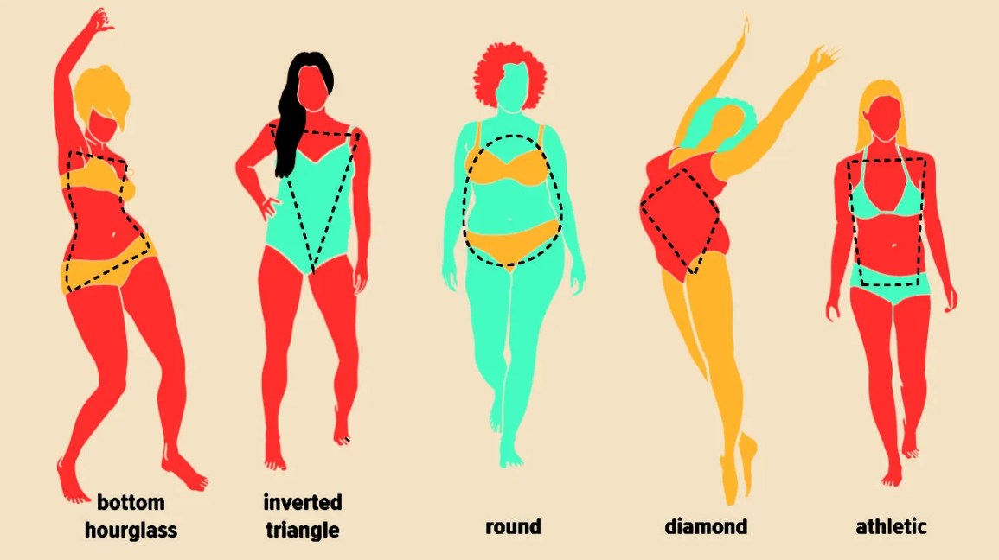Share on Pinterest
* **Bottom hourglass**
* As a [bottom hourglass](https://www.researchgate.net/publication/238103641_Female_Figure_Identification_Technique_FFIT_for_apparel_part_II_Development_of_shape_sorting_software), you have the general hourglass shape, but your hip measurements are slightly larger than your bust.
* Stylists probably point you toward form-fitting knits and dresses.
* **Inverted triangle or “apple”**
* If your shoulders and bust are larger than your relatively narrow hips, you have what’s known as an inverted triangle or “apple” shape.
* Stylists may recommend tops that have some shaping around the waist and more open necklines, or clothing that shows off your legs.
* **Round or oval**
* If your bust is larger than the rest of your body, your hips are narrow, and your midsection is fuller, you have what’s usually called a round or oval body type.
* Stylists usually point people with this body type toward tops that flare at the top or that have vertical details.
* **Diamond**
* If you have broader hips than shoulders, a narrow bust, and a fuller waistline, you have what’s called a diamond body shape.
* With this type, you may carry a little more weight in your upper legs. You may also have slender arms.
* Flowy off-the-shoulder or boat-neck tops are usually recommended for this body type.
* **Athletic**
* If your body is muscular but isn’t particularly curvy, you might have an athletic body type.
* Your shoulder and hip measurements are about the same.
* Your waist is narrower than your shoulder and hips, but it isn’t overly-defined and looks straighter up and down.
* Stylists often point to halter, strapless, and racerback styles.

**What is my body shape?**

The female body shapes are based on societal standards that are subjective and are different in different cultures. The algorithm used in this calculator is based on a study published in the International Journal of Clothing Science and Technology, which breaks down the body shapes of women into 7 categories1. There are very wide ranges of actual sizes within each shape. Also, some body shapes may not fit into any of the shapes listed below.

**Hourglass**

If (bust - hips) ≤ 1" AND (hips - bust) < 3.6" AND (bust - waist) ≥ 9" OR (hips - waist) ≥ 10"

**Bottom hourglass**

If (hips - bust) ≥ 3.6" AND (hips - bust) < 10" AND (hips - waist) ≥ 9" AND (high hip/waist) < 1.193

**Top hourglass**

If (bust - hips) > 1" AND (bust - hips) < 10" AND (bust - waist) ≥ 9"

**Spoon(Pear)**

If (hips - bust) > 2" AND (hips - waist) ≥ 7" AND (high hip/waist) ≥ 1.193

**Triangle**

If (hips - bust) ≥ 3.6" AND (hips - waist) < 9"

**Inverted triangle (Apple)**

If (bust - hips) ≥ 3.6" AND (bust - waist) < 9"

**Rectangle**

If (hips - bust) < 3.6" AND (bust - hips) < 3.6" AND (bust - waist) < 9" AND (hips - waist) < 10"

**Waist-hip ratio**

Waist-hip ratio (WHR) is defined as the ratio of waist circumference to hip circumference. The value is calculated by dividing waist measurement by hip measurement. A person with a 34" waist and 40" hip would therefore have a waist-hip ratio of 34/40, or 0.85. Waist-hip ratio is sometimes used as an indicator of certain health conditions. Research has shown that people with more weight around their waist, or who have "apple-shaped" bodies, are at higher risk than those with more weight around their hips, or who have "pear-shaped" bodies. According to the National Institute of Diabetes, Digestive and Kidney Diseases (NIDDK), women with WHRs above 0.8 and men with WHRs above 1.0 have higher health risks as a result of their fat distribution.

WHR is also used as a measurement of obesity. The World Health Organization (WHO) defines males with a WHR above 0.90 and females with a WHR above 0.85 as obese. This corresponds to a body mass index (BMI) above 30. Obesity can be an indicator of a number of serious health conditions such as hypertension, coronary heart disease, diabetes, some cancers, and more. WHR has been found to be more effective than both waist circumference and BMI for predicting mortality in people above the age of 75; WHR has also been found to be a better predictor of cardiovascular disease than both these measures. According to a study by Yusuf S, et al.2, were obesity to be re-defined based on WHR rather than BMI, the proportion of people who would be categorized as being at risk of heart attack would increase three times.

Abdominal fat (which corresponds to people with "apple-shaped" bodies) has been found to result in higher health risks than other peripheral fat. A higher WHR indicates more abdominal fat, and the higher the ratio, the higher the risk of potential health complications. Refer to the Body Fat Calculator for more information regarding different types of fat and the risks associated with being overweight or obese.

WHR is also correlated with fertility, with different values being optimal for males and females. Females with WHRs above 0.80 have been found to have significantly lower pregnancy rates than those with WHRs between 0.70 and 0.79. Studies have also shown that men with WHRs around 0.9 are more fertile, tend to be healthier, and also have a lower chance of both prostate and testicular cancer.

Aside from the associated health risks, WHR has also been studied in relation to cognitive ability, as a measure of female attractiveness, and even in relation to food composition in a diet.

1. Lee, J.Y., Istook,C.L., Nam, Y. J., and Park, S. M.,, "Comparison of body shape between USA and Korean women", International Journal of Clothing Science and Technology, Vol.19, No.5, 2007, pp.374-391.
2. Yusuf S, Hawken S, Ounpuu S, Bautista L, Franzosi MG, Commerford P, Lang CC, Rumboldt Z, Onen CL, Lisheng L, Tanomsup S, Wangai P, Razak F, Sharma AM, Anand SS (November 2005). "Obesity and the risk of myocardial infarction in 27,000 participants from 52 countries: a case-control study". Lancet. 366 (9497): 1640-9.
3. When measuring, be sure to stand straight with arms to the side. Make sure the tape is snug against the body, but not too tight such that it compresses the body (making the measurement inaccurate).
4. **Bust size**—the circumference measured around the chest over the fullest part of the breasts, while wearing a properly fitted bra.
5. **Waist size**—the smallest circumference measured around the natural waist, just above the belly button.
6. **High hip size**—the circumference of the upper swell of the hip over the pelvic region. It is around 7 inches (18 cm) below the natural waist.
7. **Hip size**—the largest circumference measured around the hips over the largest part of the buttocks.

### Female body shapes in the fashion industry

1. In the fashion industry, body shapes are often categorized into four classes.
2. **Apple, or inverted triangle**
3. This body shape describes a person who has broader shoulders and bust than they do hips.
4. **Banana, straight, or rectangle**
5. This body shape describes a person who typically has waist measurements that are less than 9 inches smaller than the hip or bust measurements.
6. **Pear, spoon, bell, or triangle**
7. This body shape describes a person who has hip measurements greater than their bust measurements.
8. **Hourglass, X shape, triangles opposing, or facing inwards**
9. This body shape (typically presented as the "ideal") describes a person with hip and bust measurements nearly equal in size, with a narrower waist measurement.
10. 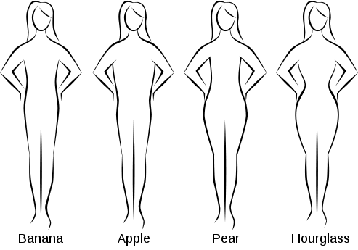
11. A study of more than 6,000 women conducted at North Carolina State University in 2005 revealed that 46% of women were banana-shaped; just over 20% were pear-shaped; just under 14% were apple-shaped; and only 8% were hourglass-shaped.