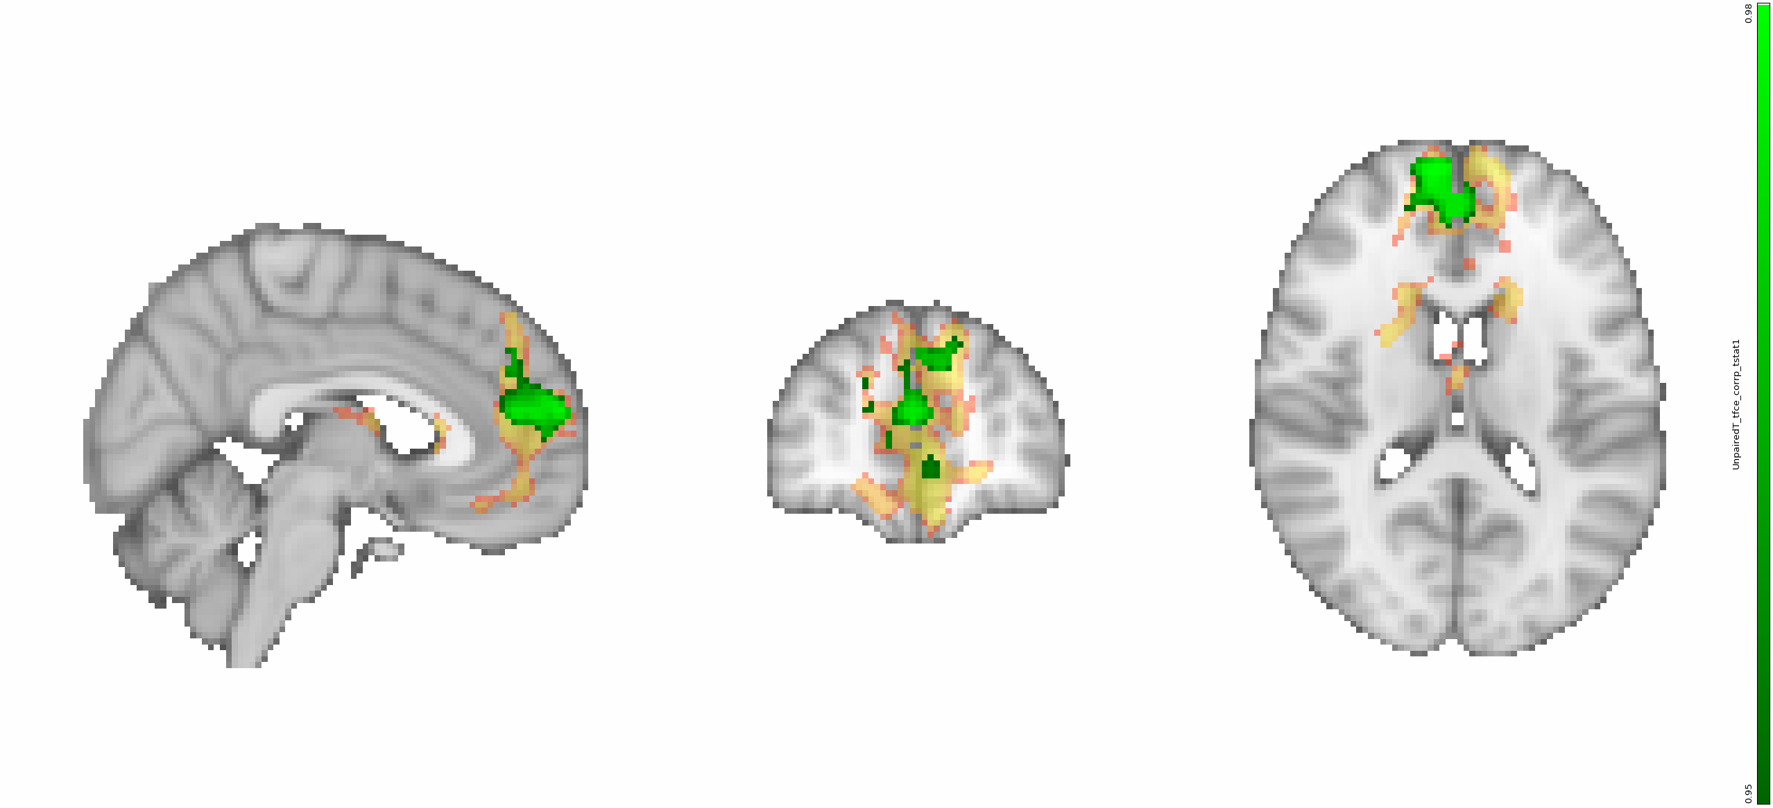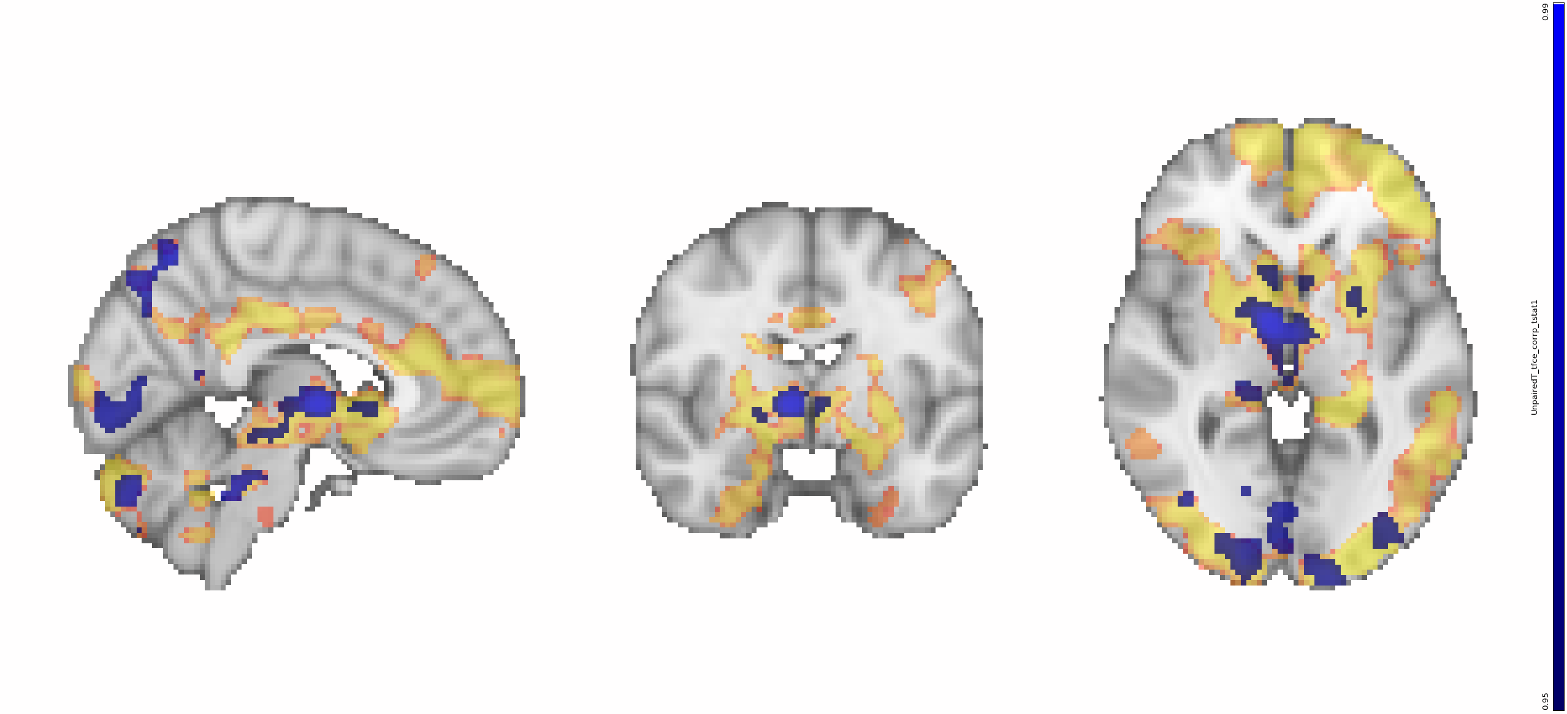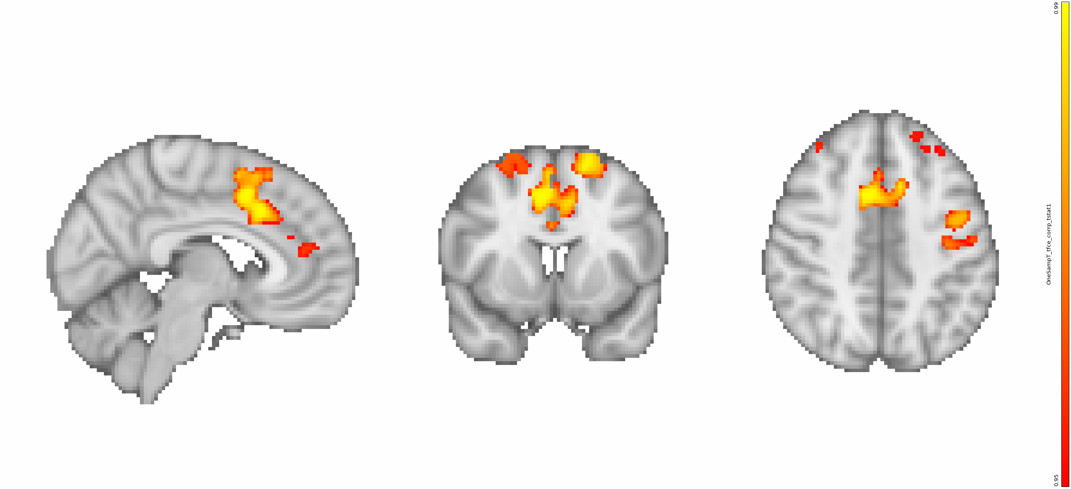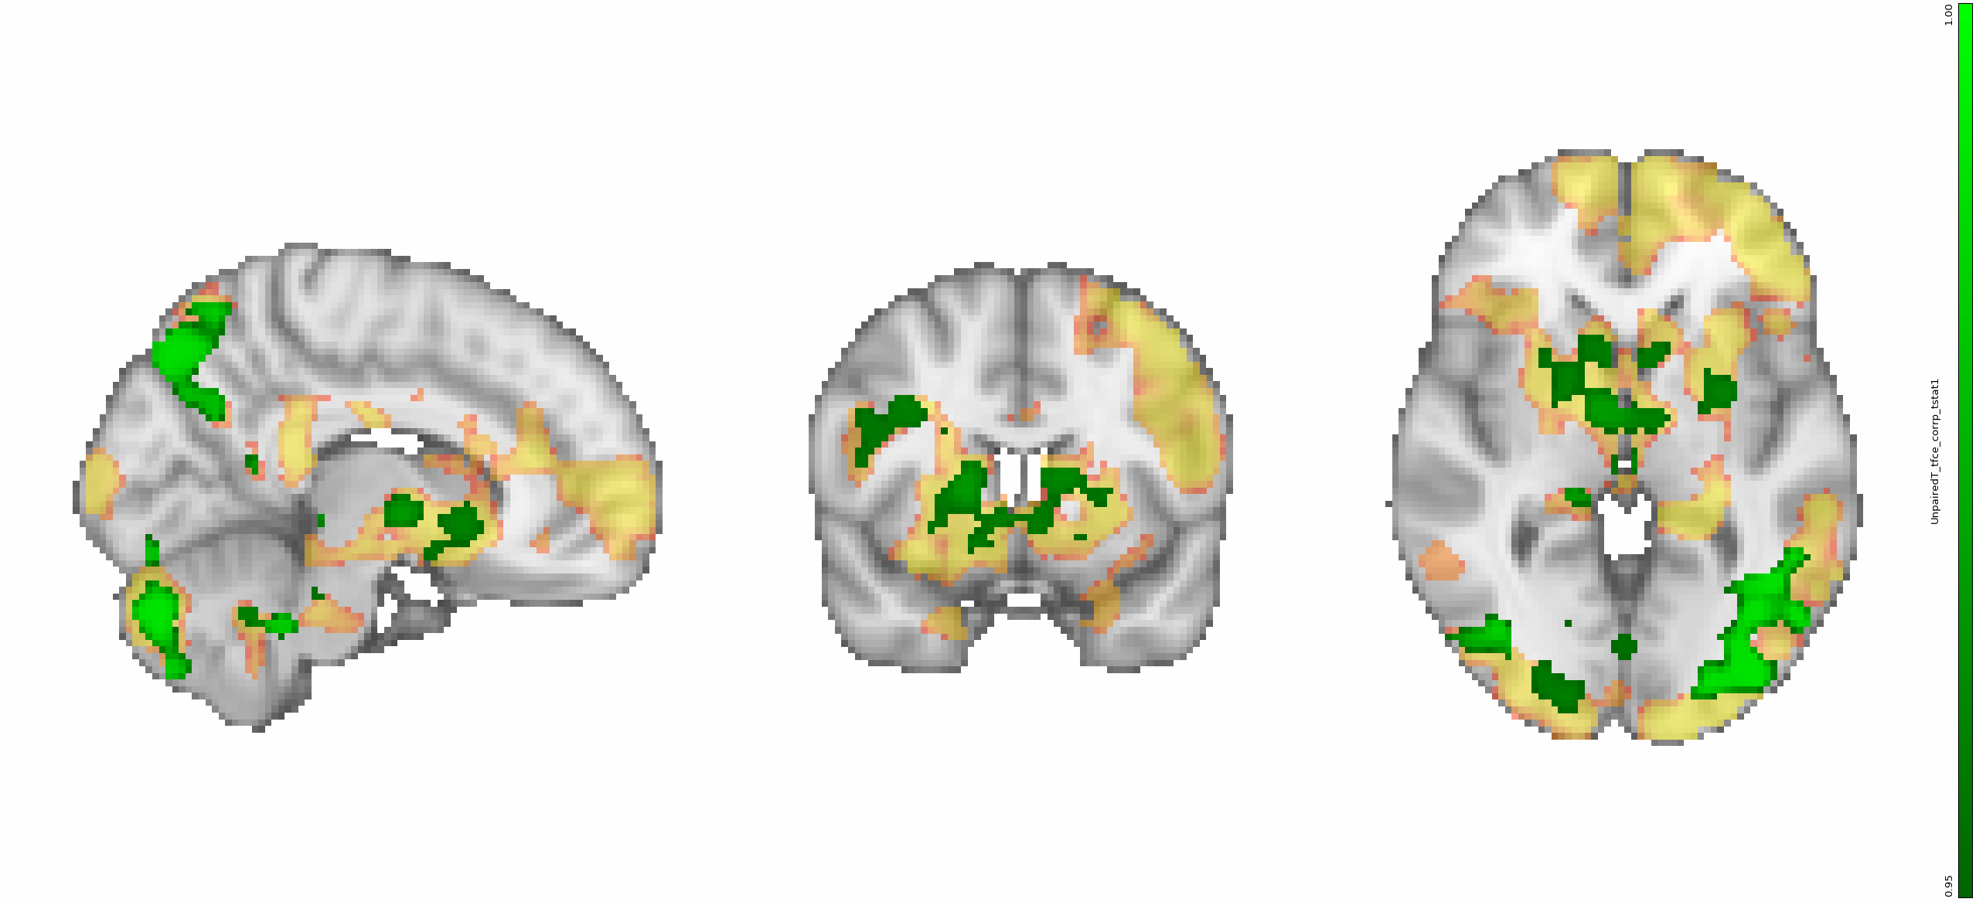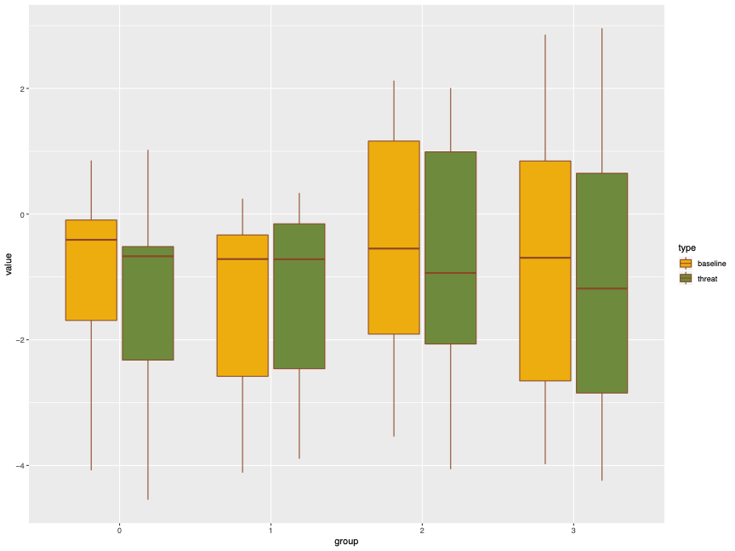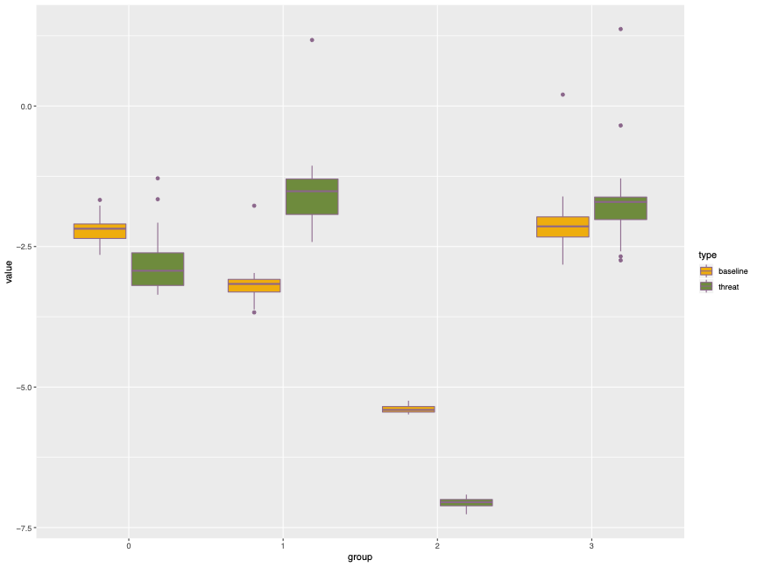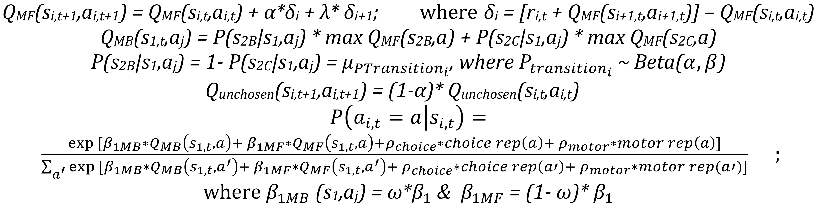

Healthy Control

Healthy Control > Depressed

Healthy Control > Attempter

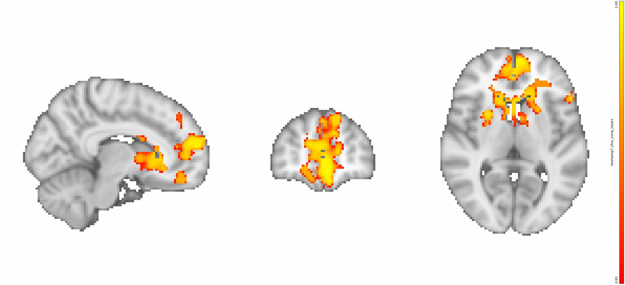

-7.5

-5.0

HC

DEP

IDE

ATT

0

-2.5

Model-Base weight parameter value in gaussian space



Without Threat

With Threat

**Model-based Weight (**𝜔**)**

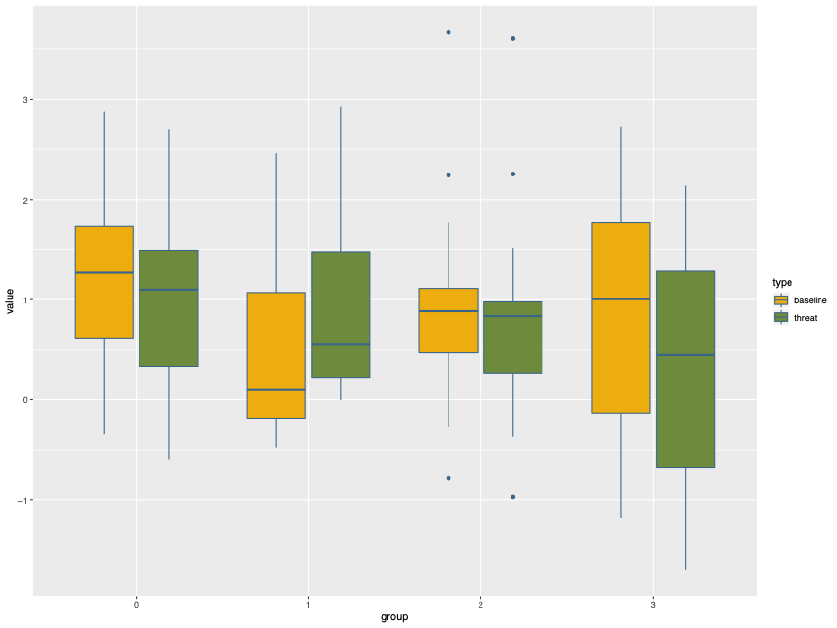

-1

0

1

2

3



Without Threat

With Threat

HC

DEP

IDE

ATT

Choice stochasticity parameter value in gaussian space

**Choice Stochasticity (**𝛽**1)**

**Learning Rate (**𝛼**)**

Jiazhou Chen B.S. B.A., Vanessa M Brown Ph.D., Katalin Szanto M.D., Alexandre Y. Dombrovski M.D.

*Department of Psychiatry, University of Pittsburgh Medical Center*

Introduction

Method

Conclusion & Limitations

References

Funding & Acknowledgement

**Sample:** N=84, age 50+, suicide attempters (ATT, n = 28), ideatiors (IDE, 20), depression without suicidal behavior (DEP, 14), and controls (HC, 22). MDD assessed with SCID. 3 subjects did not complete MRI scan.

**Two-Step Decision Task:** Learning task assessing model-based versus model-free learning (Illustration 1). Each first stage choice (spaceships) is more likely to lead to one of two second stage states (planets). Outcome (reward/no reward) occurs probabilistically after selecting a second stage option (aliens).

Blocks of trials (total blocks = 2) alternated between non-threat and threat of punishment conditions. A visual cue signals the threat condition. Participants are told that a punishment may occur at any time during the threat block, but punishment (monetary loss [-$25], fearful image, and fearful auditory stimulus of a ‘shark attack’) only occurs once, during the first threat block.

**Analysis:** We analyzed behavioral data with:

1. Logistic mixed effects regression predicting first stage choice staying as a function of reinforcement, transition type (common/rare), and interaction;
2. Linear mixed effects regression predicting first stage reaction times (RT) with reinforcement, transition type, group and interactions; and
3. By fitting a reinforcement learning model to choices.

Regressors entered into the first level fMRI GLM included: at the first stage decision, reward prediction error, presence of reinforcement (reward/omission), transition type (common/rare), and reinforcement by transition type from previous trial ; at second stage onset, current trial’s transition type. Unpaired t-tests assessed differences between groups.

Declines in learning and decision-making ability are associated with aging and suicidality. Older adults with suicidal behavior have difficulty navigating stressful and complicated situations.[1]

In particular, suicide attempters have difficulty exploiting desirable outcomes and avoid tasks requiring deliberation or cognitive demands. [2]

Model-Based learning (MBL) is a form of learning that relies on a cognitive map of the environment, rather than a history of rewards. MBL is more cognitively demanding than model-free learning and is reduced under acute stress. [3]

In the present study, we assessed MBL and the effects of a stress/threat manipulation on MBL in older adults with and without a history of suicide attempts.

**H1:** All groups will show altered model-based learning during the with threat condition.

**H2:** Compared to healthy control participants, ideators and attempters but not depressed controls will show lower MBL.

**H3:** Attempters will show additional decreases in MBL under the threat condition.

We found evidence for MBL in our sample. Compared to previous studies, our sample was less model-based, which could be due to older age and a more demanding paradigm.

In healthy controls, threat of punishment decreased MBL. This effect was abolished in attempters. Those results are only found in reaction time analyses, not in choice analysis, congruent with previous studies that showed reaction time is more sensitive to cognitive processes with high demand.

Both MBL and the effect of threat of punishment on MBL are blunted behaviorally and neurally in attempters, possibly reflecting impairment with cognitively demanding tasks.

To further investigate the aims of the study, additional analyses will refine the reinforcement learning model, examine neural signals in regions of interest, and combine neural signals and model parameters to predict choices and reaction times. We will also investigate if model-baseness is correlated with personality traits, such as cluster-b traits, or suicidal behavior onset.

1. Jollant  F, Bellivier  F, Leboyer  M,  et al.  Impaired decision making in suicide attempters. *Am J Psychiatry*. 2005;162(2):304-310.
2. Dombrovski AY, Szanto K, Clark L, Reynolds CF, Siegle GJ. Reward Signals, Attempted Suicide, and Impulsivity in Late-Life Depression. JAMA Psychiatry. 2013;70(10):1020–1030.
3. Otto, A. R., Raio, C. M., Chiang, A., Phelps, E. A., & Daw, N. D. (2013). Working-memory capacity protects model-based learning from stress. Proceedings of the National Academy of Sciences, 110(52), 20941-20946.

We thank our funding sources: NIMH R01 Supplement. Special thanks to Michelle Perry, Mandy Collier, Laura Keneally and Morgan Buerke for their roles in the data collection and participant recruitment; and to Anna Szüecs and Thandi Lyew for writing and analysis advice. Thanks mom, dad and all the friends. We would also like to express our gratitude for our participants.

Results

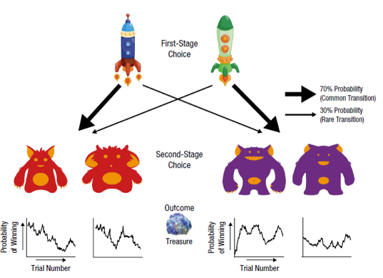

Illustration 1:

*Left:*

Task Overview;

*Right:*

Stress

Manipulation; ***Bottom:***

MRI Block Design

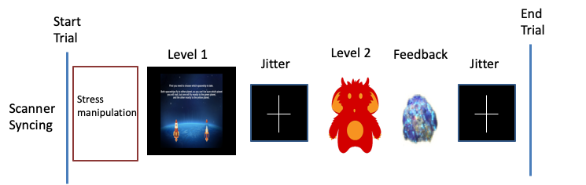

**Figure 1:** Effect of previous transition type * reward type interaction on first stage choice switching

**Cluster method:** threshold free cluster enhancement (tfce), 1-P > 0.95

Threat of Punishment and Model-Based Learning in Late-Life Depression and Suicidal Behavior

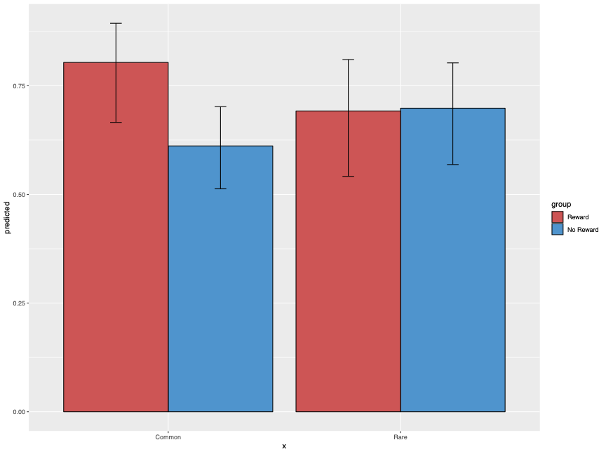

Predicted Probability of Choice Switching

0

0.25

0.50

0.75

Common

Reward

Omission

Rare

Reward

Omission

Predicted Reaction Time

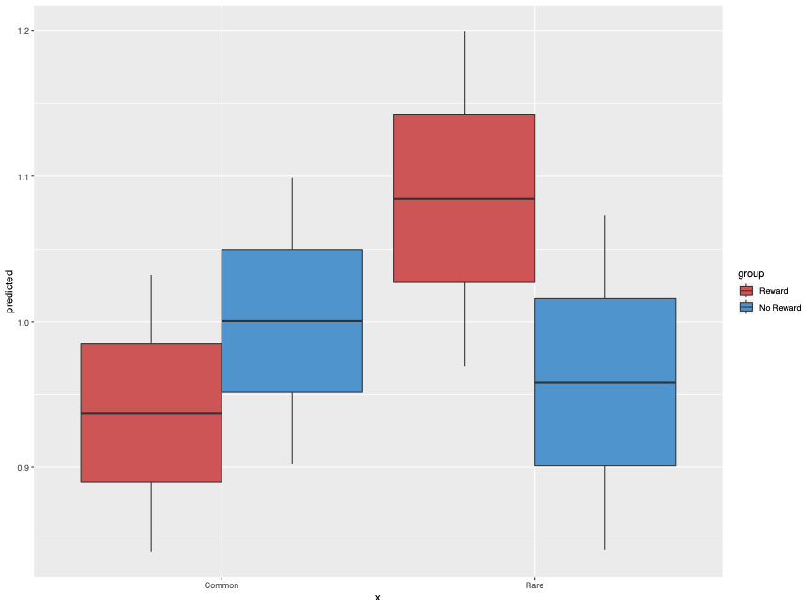

0.9

Common

Reward

Omission

Rare

Reward

Omission

1.0

1.1

**Figure 2:** Effect of previous transition type * reward type on first stage RT

**Figure 3:** Effect of the transition type * reward type * block type on first stage RT

**Figure 4:** Effect of the previous transition type * reward type * group on first stage RT

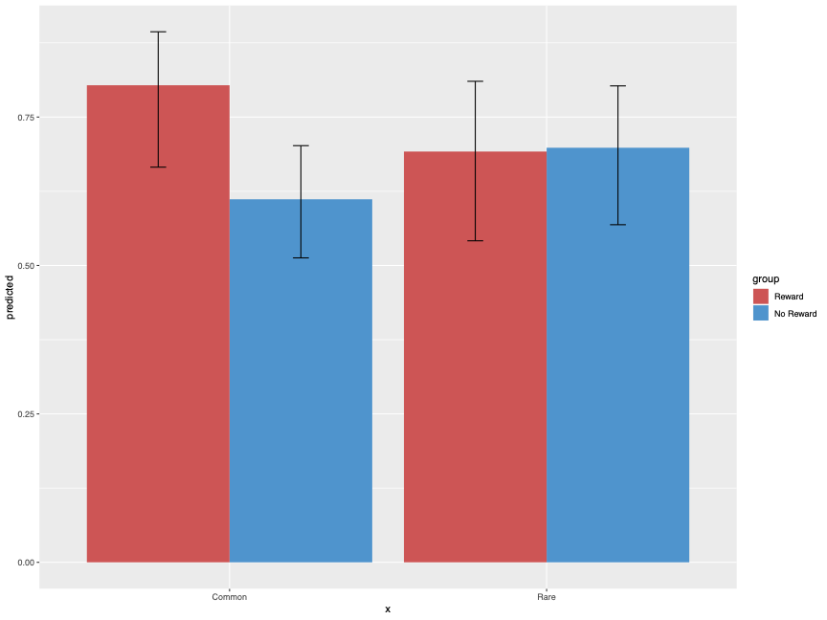

Reward

Omission



Reward

Omission

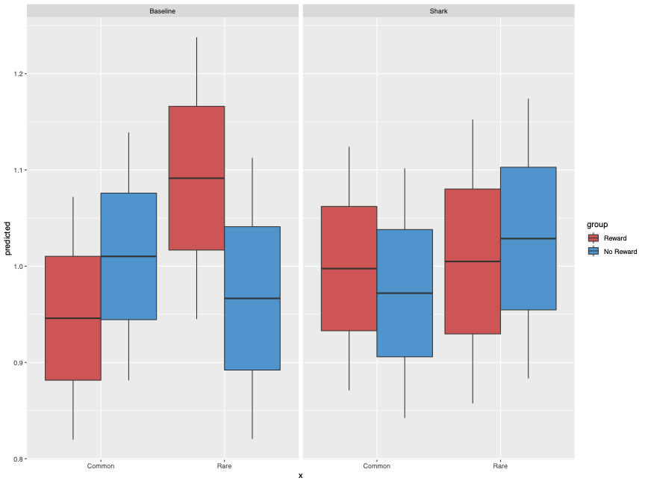

Common

Rare

Common

Rare

Without Threat

With Threat

0.9

0.8

1.0

1.1

1.2

Predicted Reaction Time

Common

Rare

Common

Rare

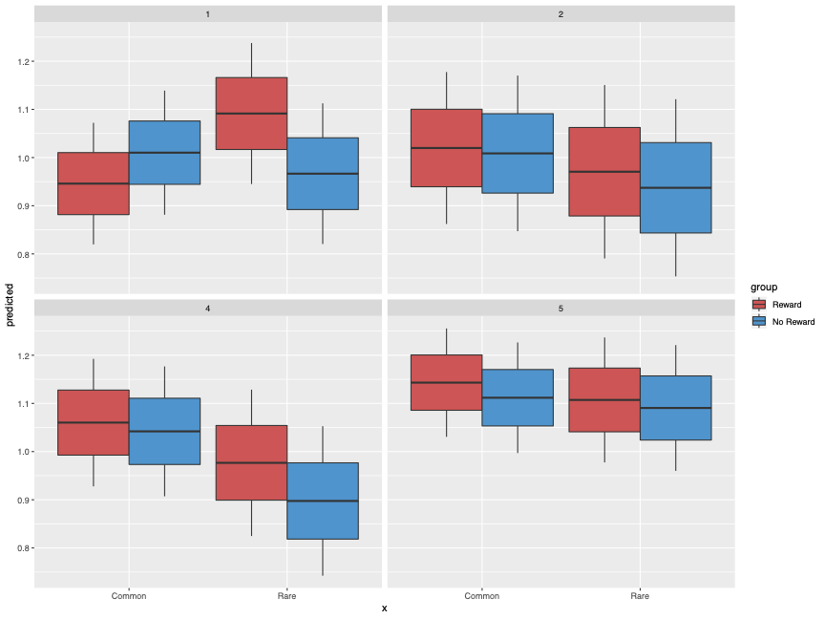

HC

DEP

IDE

ATT

Predicted Reaction Time

0.8

0.9

1.0

1.1

1.2

0.8

0.9

1.0

1.1

1.2

**Figure 5:** Neural effect of threat of punishment (With Threat > Without Threat) in healthy control

**Figure 6:** Neural effect of previous reward type at first decision time (Reward > No Reward)

**Figure 7a:** Neural effect of the second stage prediction error with Control > Depressed contrast

**Figure 7b:** Neural effect of the second stage prediction error with Control > Attempter contrast

**0.95**

**1.00**

Learning rate parameter value in gaussian space

-4

-2

0

2

HC

DEP

IDE

ATT

**Figure 8 (Top Left):** Posterior of model-based weight (𝜔) parameter in Gaussian space.

**Figure 9 (Top Right):** Posterior of learning rate (𝛼) parameter in Gaussian space.

**Figure 10 (Bottom Left):** Posterior of choice stochasticity (𝛽1) parameter in Gaussian space.

**Figure 11 (Bottom Right):** Model Equations



Without Threat

With Threat