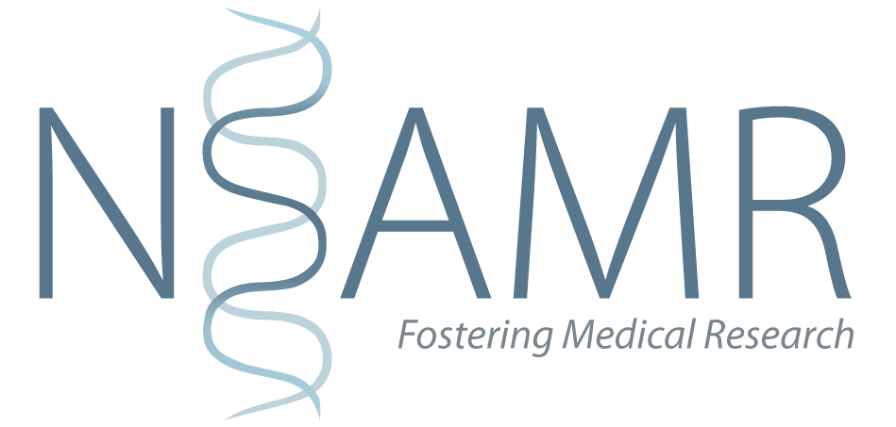

Your Guide to Applying to Medical School – *Part 3: UKCAT*

The United Kingdom Clinical Aptitude Test (UKCAT) is one of the two entrance exams for medical schools in the UK. It is used by many medical schools although they all differ in how they use your score. The other test is the [BMAT](http://www.admissionstestingservice.org/for-test-takers/bmat/), Biomedical Admission Test, which is used by the following schools: Oxford, Cambridge, Brighton and Sussex Medical School, Imperial College London, Lancaster, Leeds and UCL. You only need to sit the BMAT if you are applying to one of those schools.

# Costs

The test costs money and the fees vary depending on when you sit the test (ranging between £65 and £80). Fortunately, there are [bursaries](http://www.ukcat.ac.uk/registration/bursaries/) available to help you with the cost of the test – more info on the UKCAT website.

# Our views on how to prepare for the UKCAT

The UKCAT will be different to many of the other tests you have sat so far. There is some evidence which suggests that your UKCAT score will reflect how well you do at medical school but the reality is that you are able to increase your UKCAT score through practice. Equally an average score doesn't mean you can't be a great doctor.

Everyone applying to medicine is academically achieving high grades so Medical Schools need some way of separating out the people they are going to give offers.  Unfortunately, this does mean that you will need to sit the exam and make sure you do well in it because it will affect your application. If you struggle with the UKCAT exam it is woth researching with universities give less weight to the UKCAT and more weight on your exam results for example.

There is no score which guarantees you a place and the ranges change year on year so it can be hard to predict how well you need to do.

There is plenty of advice regarding the content of the UKCAT available in the **UKCAT Official guide.** In terms of when to actually sit the exam, it is up to you, but we would recommend that you get it out the way as early as you can – sit it by the end of August at the latest. Come September, you will need to focus on your school work and your personal statement. Having said that, you need to make sure you have done all the preparation you can.

**The best way to prepare is to practice.**

Practice questions over and over again until you develop your own system of working through the different forms of questions. You should do the practice tests timed and in exam conditions to get a feeling for what you’ll have to do. On the day, make sure you’re well rested and that you know how to get to the test centre.

Frankly, some of the questions are strange and you need to familiarise yourself with them to give yourself the best chance. It is inevitable that you will find some sections more difficult than others but aim to get the highest overall score. You can do terribly on the Verbal Reasoning section but still do very well on the UKCAT overall if you do reasonably well on the other sections so don't panic if you're struggling with one section. Most people have stronger and weaker areas when it comes to apititude tests - that's the nature of humans!

# FAQ: Should I go to a UKCAT course?

Many UKCAT courses cost money and not all students will be able to afford that. These courses can cost up to £200 for a two-day course. Most people who sit the exam won't attend a course. There are many free resources out there. There are also lots of books out there with practice questions. Members of the NSAMR Outreach team have managed to get into medical school without attending any UKCAT courses.

You will face similar situations when you reach medical school. *Should I attend an SJT course to apply for my first job as a doctor?* In the opinion of one of the authors of this guide, going to such courses often adds nothing more than what you can do from practice yourself. There are no magic solutions to tests like the UKCAT or the SJT (for foundation job applications); no one is going to tell you the secret because there is no secret. If you find that people who have attended the courses think that they have benefited from them, it might solely be because they paid for it!

# What UKCAT book should I buy?

Again, no magic answers here. Some of the books used by the members of NSAMR Outreach Team when we applied to medical school include:

* "Get into Medical School" do a series of books not only on UKCAT but also interview prep and personal statements. Their UKCAT book has 4.3 stars on Amazon. They used to do a 600 UKCAT question book when we applied; this has subsequently been updated to 1000 UKCAT questions.
* The Kaplan guide to UKCAT also has a 4.3-star rating on Amazon.
* There is also an official app by Pearson Vue who host the exam which has practice questions and useful tips which can be purchased from the App Store.