Gabriel Morrison

Professor Dmitri Koustas

Household Finance: Theory and Applications

29 May 2022

Replication Exercise: Shiller Was Right

**Abstract**

In this replication exercise, I build on Robert Shiller’s (2006) prescient prediction that America’s housing market would crash. Shiller’s correct forecast was massively important because it explained a key driver to the Great Recession, one of the country’s worst financial crises. Much of Shiller’s analysis relies on theory suggesting that housing and rental prices should track each other but the reality that they do not. In this work, I build on Shiller’s analysis by updating his key figure with the most up-to-date national data on changing trends in housing and rental prices. This demonstrates how Shiller’s forecast was correct and also reveals that growth in housing prices outpaced rents in the 2010s, continuing to conflict with economic theory. I then use a univariate regression to assess the association of the ratio of a housing price index to a rental price index in 2006 with changes in housing net worth between 2006 and 2009 at the metropolitan scale. I find strong evidence that areas with larger ratios had greater declines in housing net worth. Finally, I explore the metropolitan-level heterogeneity in rental and housing price trends, determining that housing prices in cities on the West Coast have exploded in the last decade. I subsequently offer some explanations and analyses of these trends.

Organization

I begin by explaining Shiller’s research and describing the importance of housing net worth to the American economy. I subsequently introduce my three research questions. I then describe my data sources, analysis, and results. I conclude by discussing these findings, offering two explanations for the increases in housing prices, describing the limitations of the housing to rent index as a predictor of recessions, and outlining general weaknesses to the analysis presented here.

**Background**

Paper Being Replicated:

In 2006, Shiller published a paper studying the boom in housing in the late 1990s and early 2000s. He wrote of the “possibility of an irrational overpricing today and a huge fall in home prices in the coming years.” Shiller reached this conclusion by marshalling evidence comparing real housing prices internationally and considering changes in real American rent and housing indices. He also rejected the idea that interest rates drove the increase in housing price and highlighted the geographic patterning in of price increases.

To begin, Shiller assessed at least century-old data on housing prices from Amsterdam, Norway, and the United States. While there were fluctuations across all countries, Shiller found the increase in American housing prices between 1997 and 2005 to be “practically unique in history.” This analysis is illustrated in Figure 1.

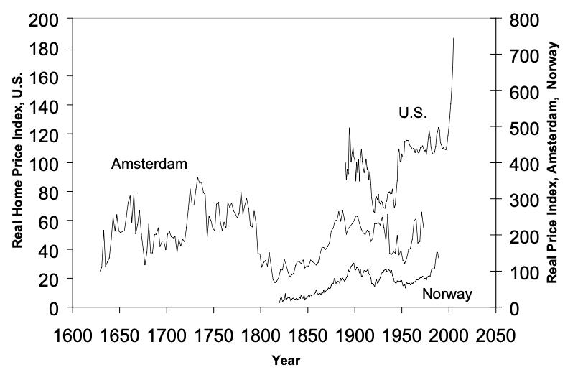

Figure 1: Figure 1 from Shiller (2006)

Second, Shiller considered both the theory and empirical evidence about changes in real housing and rent price over time. Shiller noted that “[i]n theory, real rents and real home prices might be expected to track each other” because people can move between renting and owning “with relative ease.” However, Shiller found major growth in housing prices in the 1940s and even more so in the late 1990s and early 2000s. He also observed a long-term decrease in real rent prices (see Figure 2 below).

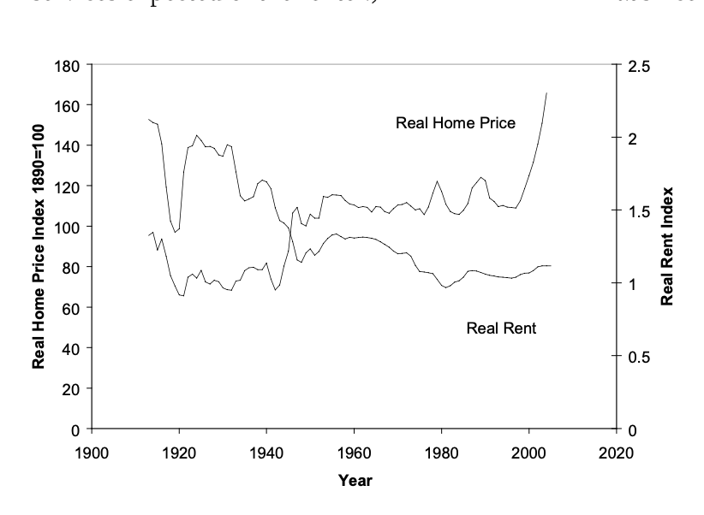

Figure 2: Figure 3 from Shiller (2006)

Shiller considers interest rates as a possible explanation for the growth in housing prices. He found that real interest rates did not track the rent/housing ratio over time. Shiller showed this in his Figure 4 which I replicate below.

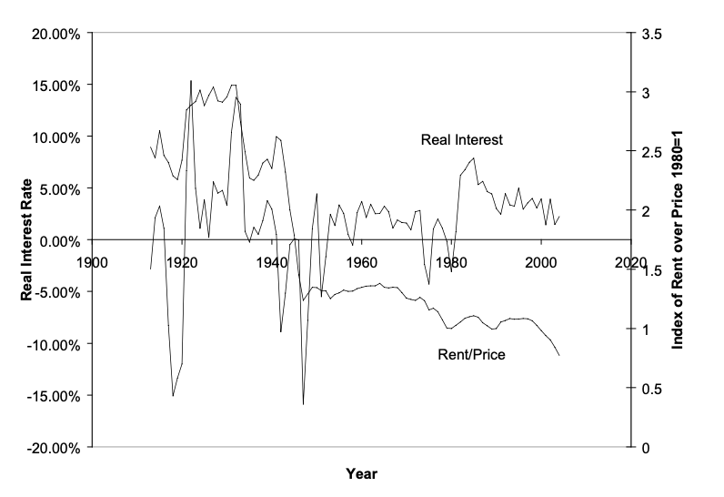

Figure 3: Figure 4 from Shiller (2006)

Finally, Shiller assessed where housing prices were increasing. Schiller found that between 1997 and 2005, there was a 71% increase in real home prices. Using his Case-Shiller Index, Shiller found even larger increases in “glamor cities” and regions like Boston (93%) and Los Angeles (151%).

In other words, Shiller’s (2006) analysis identified that the price increase between 1997 and 2006 was unprecedented both domestically and internationally. He found that this growth could not be explained by interest rates, and it departed dramatically from economic theory. Finally, he found that the growth in prices was driven mainly by desire for homes in major cities. This combination of evidence led Shiller to believe in an “irrational exuberance” in housing prices that he correctly predicted would decline.

Importance

The Great Recession was one the worst financial crises in American history. The economy lost 8.6 million jobs between 2007 and 2009 (Mian and Sufi, 2014). America has experienced similarly devastating levels of job losses only during the Great Depression and at the start of the COVID-19 recession (Ansell and Mullins 2021). Thus, understanding the causes of the Great Recession are massively important.

Mian and Sufi (2014) argue that declines in housing value drove job losses in the Great Recession. More specifically, Mian and Sufi sought to assess the impact of declining housing net worth on the employment. They broke employment into two sectors. “Non-tradable” employment relies on local demand whereas “tradable” sectors depend upon national or global demand. Mian and Sufi found a 10 percentage point decline in housing net worth at the county level to be associated with a 3.7 percentage point decline in non-tradable employment, thus supporting the idea that declines in a region’s housing net worth was tied to the area’s job losses (Mian and Sufi 2014). This finding provides strong motivation to further analyze housing market trends given their direct importance to and association with one of America’s worst financial crises.

**Methodology:**

Research Questions and how they respond to Shiller’s work

To build on Shiller’s research, I sought to answer the following questions:

1. Did real housing price trends realign with those of real rents after the start of the Great Recession, and how have these trends changed in the ensuing years?
2. Did regions with larger differences in rental and home price changes experience greater declines in housing values during the Great Recession?
3. Is there heterogeneity in real housing and rental price trends by city, and has this pattern changed over time?

The first question seeks to assess both Shiller’s prediction of a “huge fall” in housing prices and the economic theory that housing and rental prices should track each other. The second builds on this analysis and specifically delves more deeply into Shiller’s claims of the spatial heterogeneity of the changes in housing prices. The third question seeks to explore Shiller’s observation of some “glamor cities” experiencing notably large growth in housing prices by assessing their unique real rent and housing and trends over time.

Research Approach and Data:

To answer the questions described above, I collected, cleaned, and analyzed data from a variety of sources using R. My code is open source, replicable, and can be seen at the following github repository: <https://github.com/Deckart2/hh_final>.

I list my data and its sources in Table 1.

Table 1:

|  |  |  |
| --- | --- | --- |
| **Name** | **Source** | **Method Accessed** |
| Case-Shiller Housing Index | S&P CoreLogic | *fredr* R package |
| CPI Real Rent of Primary Residence | Bureau of Labor Statistics | *fredr* R package |
| Change in Housing Net Worth ’06 – ’09 | Sufi and Mian (2014) | Mian’s website:  <https://scholar.princeton.edu/atif> |
| 2005-2009 Housing Units by County | 5-year American Community Survey | *tidycensus* R package |
| County CBSA Delineation Files | U.S. Census Bureau | Census Bureau Website |

To answer the first question, I follow Shiller (2006) in plotting the Case-Shiller Housing Index (“S&P Dow Jones Indices…”) and the Bureau of Labor Statistics’ (BLS) Real Rent of Primary Residence (“U.S. Bureau of Labor Statistics…”) through 2021. In doing so, I replicate his Figure 3 (shown here in Figure 2) but extend it through the most recently available (annual) data.

To assess regional differences in rental and home price trends and their association with declines in housing values, I again use the Case-Shiller Housing Index and the BLS Real Rent of Primary Residence data but this time at the metropolitan region scale. The Federal Reserve Economic Data website (FRED) has data for both the housing index and real rent for 18 metropolitan areas. I collected this data. I also used data created by Mian and Sufi (2014).

Mian and Sufi’s data is at the county scale, but the housing and rent indices are at the metropolitan region scale (MSA or CBSA). Moreover, some metropolitan areas cover multiple counties. To map counties to metropolitan areas, I downloaded a County-CBSA Delineation File from the Census Bureau’s website. This dataset provides a linkage between county and metropolitan region. I also downloaded the number of housing units by county according to the 2005-2009 5-year American Community Survey. To estimate the percentage point change in housing values between 2006 and 2009 by metropolitan area, I took the average of all counties in a metropolitan area weighted by the number of housing units in that county.

With the data at the metropolitan region scale, I created an Ordinary Least Squares regression with the metropolitan region level change in housing net worth ($ΔHNW_{2009-2006}$) as the dependent variable and the ratio of the 2006 Case-Shiller Housing Index ( $Housing Index_{2006})$ to the 2006 BLS Real Rent of Primary Residence Index ($Rent Index_{2006}$) as the independent variable. This regression can be specified as follows:

$$ΔHNW_{2009-2006} =β_{0}+β_{1}\frac{Housing Index_{2006} }{Rent Index_{2006}}+ϵ$$

The BLS Real Rent of Primary Residence Index has index years of 1982-1984 (“U.S. Bureau of Labor Statistics…”), and Case-Shiller Housing Index uses 2000 as an index year (“S&P Dow Jones Indices…”). I consequently ran the regression specified above two ways: once with the data with the index years provided and subsequently with the data reindexed to the first year in which both metropolitan regions have data. Note that the exact year varies by metropolitan region but tends to be around 1990.

To answer the third question, I plotted reindexed Case-Shiller and BLS real-rent data at the metropolitan scale. These plots are thus similar to Shiller’s (2006) Figure 3 but for a metropolitan area and with reindexed data.

**Results**

Question 1:

I created the extension of Shiller’s Figure 3 (replicated in my Figure 2) in Figure 4 below. It shows that housing and rental price changes track each other between 1987 and 1997. As in Shiller’s Figure 2, the housing index grew far faster than the rent index in the early and mid-2000s. As Shiller predicted, the housing index fell dramatically between 2007 and 2012, declining back to the same level as the rent index. After 2012, however, the housing index grew at a faster rate than the rent index.



Figure 4

Question 2:

The table below shows the result from the univariate regression with data reindexed to the first year in which there was both BLS and Case-Schiller data for the metropolitan area. It shows that the ratio of the Case-Shiller Housing Index to BLS Real Rent of Primary Residence Index is strongly statistically significant and negative. The magnitude of the coefficient is .11. One can interpret this coefficient as meaning, on average, for each 1 unit increase in the ratio of Case Schiller Housing Index to BLS Real Rent of Primary Residence Index in 2006, the metropolitan region saw an 11-percentage point decline in housing net worth between 2006 and 2009. The results for the regression without re-indexing data are not show, but the coefficient of the ratio term is about -11.5 and is again strongly statistically significant. This suggests the reindexing has little impact on the results.

|  |  |
| --- | --- |
| Table 2: | |
|  | *Dependent variable:* |
|  |  |
|  | Metro. Weighted ${ΔHNW}_{2009-2006}$ |
|  | |
| $$\frac{Housing Index_{2006} }{Rent Index_{2006}}$$ | -0.110*** |
|  | (0.034) |
|  |  |
| Constant | 0.058 |
|  | (0.060) |
|  |  |
|  | |
| Observations | 18 |
| R2 | 0.391 |
| Adjusted R2 | 0.353 |
| Residual Std. Error | 0.055 (df = 16) |
| F Statistic | 10.274*** (df = 1; 16) |
|  | |
| *Note:* | *p<0.1; **p<0.05; ***p<0.01 |

Question 3:

Figure 3, which plots the Case-Shiller Housing and BLS Real Rent of Primary Residence indices for 18 metropolitan areas demonstrates substantial regional heterogeneity. Some sunbelt cities like Atlanta, Dallas, Tampa, and Phoenix, show that housing and rent prices have tracked each other closely, except for perhaps during the peak of the housing bubble in the mid-2000s. Also interestingly, many West Coast cities, including San Diego, Los Angeles, San Francisco, Portland, Seattle, and Denver, show massive housing price increases above the growth in rental prices. Notably, the trends in these cities do not follow the economic theory outlined by Shiller (2006).



Figure 5

**Discussion**

Potential Explanations for Housing Price Increases

While beyond the scope of the replication exercise to fully explore how and why housing prices grew both in the mid-2000s and during the 2010s, I describe Mian and Sufi’s (2015) explanation of the price increases in the lead-up of the Great Recession from their book *House of Debt*. I also offer one supply-side theory for the disparate housing and rent trends seen in West Coast cities in the last decade.

Mian and Sufi (2015) suggest expansion of debt caused the housing price increase in the mid-2000s. They argue that the increase in spending on housing could stem from consumers believing that their incomes would increase. However, they find this unlikely, in large part because new borrowers in the early 2000s had declining incomes and because this income growth was never realized. Instead, Mian and Sufi observe that there was a major expansion in loans to homeowners with low credit scores between 2002 and 2006. They contend that consumers behaved “myopically” when provided the opportunity to borrow more than was financially prudent. In other words, they find that “the lending boom fueled house-price growth” (48).

One alternative explanation for the growth in housing prices above rental prices in many West Coast cities in the last decade could have to do with rental markets’ inability to respond to increased demand. As Shiller (2006) has noted, Americans in the 21st century have increasingly moved to central cities. Thus, one would expect an at-least short-term increase in demand for both rental and housing prices in metropolitan areas. One reason why Shiller’s (2006) theory about rent and housing prices could be false is if the rental market could not adequately respond to demand.

At least one city, San Francisco, bears out this explanation. According to regional policy organization SPUR, San Francisco only added about 1500 rental units annually between 1994 and 2014, far fewer than the 5000 they estimated would be necessary to keep prices constant (Metcalf et al., 2014). Additionally, more than 60% of San Francisco rental units are rent-controlled, meaning that their ability to increase rent is limited (“Rent Control…”). Consequently, increased demand to live in the San Francisco cannot be met by the rental market both because it expanded too slowly, and prices on many apartments are capped. This combination could force more newcomers into the housing market and thus increase prices.

In other words, Mian and Sufi (2015) convincingly describe increases in speculatory lending as a reason for the boom in housing prices in the 2000s. The more recent increase is unclear and beyond the scope of paper but could possibly be explained by Mian and Sufi’s demand-side credit expansion or by the rental markets’ inability to respond to demand for urban living.

Policy Response

The meaningful increases in housing and rental prices everywhere suggests a need for increased supply. Each of the 18 cities shown and the United States as a whole has experienced increases in real rent and housing prices, and as noted, housing prices have been particularly explosive in the past decade. This increase in prices everywhere suggests that expanding the housing supply is crucial. One policy lever accessible to regional policymakers is the restriction of single-family zoning. Many cities are almost exclusively zoned for single family homes (Badger and Bui 2019), so allowing denser development could permit apartment buildings to ease the demand for new housing.

Using indices to predict future recessions

One potential direction for analysis in this replication exercise could have been to predict areas with future housing declines based on their current housing index to rent index ratio. Researchers have studied this question. Notably, one analysis plotted the home to rent index ratio since 1975 and assessed whether it declined in the lead-up to recessions (see Figure 6). While the ratio declined in the lead up of the Great Recession and another recession in 1981, it did not shift dramatically before recessions in the early 1990s and early 2000s. Thus, while preliminary, this research suggests a home-rent indicator, at least at the national level, has not been historically effective at predicting recessions (Mather and Schlagenhauf 2018).

Figure 6: Mather and Schlagenhauf’s home index-rent index analysis

Limitations

This analysis is not without limitations. To begin, the regression used only 18 observations, one for each metropolitan area studied. This small sample size is sub-optimal. I also attempted to use ACS data at the county level. However, county level ACS data only began in 2005, too soon before the Great Recession to study. Third, while reasonable, my mapping between metropolitan areas and counties is not exact. Finally, some city-level data ended before 2022, making full analysis limited.

Conclusion

The work done in this replication exercise confirms Shiller’s (2006) prediction of a large crash in housing prices. Trends in housing prices reverted, at least for a time to the trend for rental prices. These findings also validate the work of Mian and Sufi (2014) in that they show regions with larger disparities between housing and rental price growth on average tended to have larger 2006 to 2009 housing price falls. Lastly, as hinted at by Shiller, there is material heterogeneity in the change in rent and housing prices by city. Many West Coast cities showed massive housing price increases in the 2010s whereas sunbelt cities tended to have less rapid housing price increases that were in line with rental price growth. Mian and Sufi (2014) explain the housing price increases in the mid-2000s through a massive expansion of debt, particularly to Americans with low credit scores. I present an alternative explanation for housing price increases in the 2010s centered around rental markets’ inability to respond to increased demand, thus forcing newcomers to buy expensive houses. Finally, I offer one alternative, to move away from single-family zoning to allow denser apartments, to respond to these price increases.

Work Cited Page:

Ansell, Ryan, and John P. Mullins. “Covid-19 Ends Longest Employment Recovery and Expansion in CES History, Causing Unprecedented Job Losses in 2020 : Monthly Labor Review.” *U.S. Bureau of Labor Statistics*, U.S. Bureau of Labor Statistics, June 2021, https://www.bls.gov/opub/mlr/2021/article/covid-19-ends-longest-employment-expansion-in-ces-history.htm.

Badger, Emily, and Quoctrung Bui. “Cities Start to Question an American Ideal: A House With a Yard on Every Lot.” *The New York Times*, 18 June 2019.

Mather, Ryan, and Don Schlagenhauf. “Is the Housing Price-Rent Ratio a Leading Indicator?” *FRED Blog*, FRED, 10 Sept. 2018, https://fredblog.stlouisfed.org/2018/09/is-the-housing-price-rent-ratio-a-leading-indicator/.

Metcalf, Gabriel, et al. “How to Make San Francisco Affordable Again.” *SPUR*, SPUR, 9 Mar. 2016, https://www.spur.org/publications/urbanist-article/2014-02-11/how-make-san-francisco-affordable-again.

Mian, Atif, and Amir Sufi. *House of Debt: How They (and You) Caused the Great Recession, and How We Can Prevent It from Happening Again*. Chicago University Press, 2015.

Mian, Atif, and Amir Sufi. “What Explains the 2007-2009 Drop in Employment?” *Econometrica*, vol. 82, no. 6, 2014, pp. 2197–2223., https://doi.org/10.3982/ecta10451.

“Rent Control in San Francisco: Everything You Need to Know.” *Bungalow*, Bungalow, 1 Feb. 2022, https://bungalow.com/articles/rent-control-in-san-francisco-everything-you-need-to-know.

Shiller, Robert J. “Long-Term Perspectives on the Current Boom in Home Prices.” *The Economists' Voice*, vol. 3, no. 4, Mar. 2006, <https://doi.org/10.2202/1553-3832.1145>.

S&P Dow Jones Indices LLC, S&P/Case-Shiller U.S. National Home Price Index [CSUSHPISA], retrieved from FRED, Federal Reserve Bank of St. Louis; https://fred.stlouisfed.org/series/CSUSHPISA, May 28, 2022.

U.S. Bureau of Labor Statistics, Consumer Price Index for All Urban Consumers: Rent of Primary Residence in U.S. City Average [CUSR0000SEHA], retrieved from FRED, Federal Reserve Bank of St. Louis; https://fred.stlouisfed.org/series/CUSR0000SEHA, May 22, 2022.