Full swap example under Windows

For example we have KMD and wanna receive 1 REVS. The necessary steps are described below (correct me plz, if i wrong somethere). Here all described in terms of Windows-specific dexscripts, so, do not put atterntion to their names, also, they have .cmd extension under Windows.

1. We should come up with secret passphrase to generate smartaddress and start markemaker: put our passphrase in passphrase file and start marketmaker via 1-client.cmd. Ok, it's started.
2. Now we should grab userpass, we can do it two ways - from marketmaker output windows from step 1, or using 2-getuserpass.cmd script. Running this we have userpass output on screen — 7a3372c6a3a1d28c02986e0d5cdce97c02a38b8f9c3341b5db77aa050a84aa08 and also it stored it in userpass for future use in other scripts. So, if we get userpass by executing 2-getuserpass.cmd we don't need anything else. It's already stored. If we grab it from marketmaker output window manyally, we should put it into userpass file also, because it will used it next steps.
3. Now we get the orderbook with the orderbook.cmd script. But first we should clearly understand some things.

Let see on Bittrex market for example (BTC-KMD):

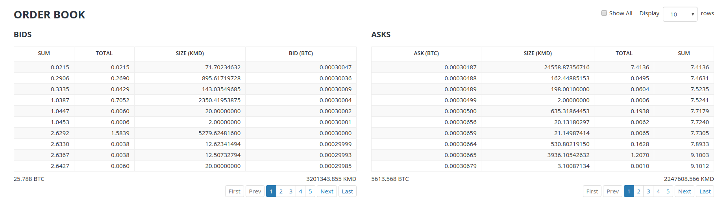
Orderbook have BIDS (buy orders) and ASKS (sell orders). Bids means that somebody have BTC and wants to buy KMD, asks means that somebody have KMD and wanna sell it to receive BTC. This is a simple thing that everyone understands. All operations (buy and sell) here is base coin related, base coin here is a KMD. If we say buy order - we assume that we buy KMD, if we say sell order - we assume that we sell KMD. rel coin here is a BTC. So on screen we see KMD/BTC (base/rel) market. Just remember this, it's important.

According this to buy REVS we should request orderbook where the base = REVS and rel = KMD.

4. Let's request it via 3-orderbook.cmd script with the following parameters:

curl --url "http://127.0.0.1:7783" --data "{\"userpass\":\"%USERPASS%\",\"method\":\"orderbook\",\"base\":\"REVS\",\"rel\":\"KMD\"}"

Answer is:

{"bids":[{"coin":"KMD","address":"RVPcbafNSi6uMaKDyss9epGpHCHbbzUFMd","price":2.03033788,"numutxos":46,"minvolume":0.00008298,"maxvolume":960,"pubkey":"e1d9ff940bd7fb30954e0d9297053457eb7f766e66da6c198e75c06b7d982124","age":82}, {"coin":"KMD","address":"RDoMmoCM5AcEH6Yf5vqKbqRjD1fLcQHuWb","price":2,"numutxos":4,"minvolume":0.08800000,"maxvolume":10.01440000,"pubkey":"8bec3a71f63b24adf1d4a2c865a0921847ef4b7b138c102a20784357651b4070","age":17941}, {"coin":"KMD","address":"RNyBS6ryQtPPQnJhavKn9o94U2RNExLZon","price":1.51801196,"numutxos":32,"minvolume":0.00008238,"maxvolume":960,"pubkey":"25a491638a815a6e669319532270b616124aab4bfd7e466fc08606ab46d48931","age":20}, {"coin":"KMD","address":"RXUF132uyPVTVUdLn16zCgvYoFXya3pyVb","price":1.34097978,"numutxos":36,"minvolume":0.00008088,"maxvolume":960,"pubkey":"825d0e1355117f6b76e7b3741f51c1827e72e25ddc688c0b20ad5b1ec7b28b4f","age":32}, {"coin":"KMD","address":"RMdjuxKBhyr87yhKp6BLUg2p9673NMcPAu","price":1.27305610,"numutxos":58,"minvolume":0.00008154,"maxvolume":900.23273873,"pubkey":"040f1d2d5d12027afa2cec30477312e225b0d24c77cc4aa08d3fffe51277b904","age":31}, {"coin":"KMD","address":"RMfQwu5ey23eWJ4as2ckd8dqsQJwo836ny","price":1.17393765,"numutxos":9,"minvolume":0.16440658,"maxvolume":0.79984000,"pubkey":"9468f3d40fed3a5220d26c0f7efd43fd818fffdc7ce71c48dcfae7da9f476101","age":52}, {"coin":"KMD","address":"RUPX5RWQL1qurMLmF4fFB4JAgRfwcNww4b","price":1.09860370,"numutxos":64,"minvolume":0.00008267,"maxvolume":960,"pubkey":"bb99c7042e092692191b7b4a636c7da28aeb36497ad038601cd599f356274051","age":17}, {"coin":"KMD","address":"RAzheh3L7QtBL7oNKByVa43CtgALht6bbT","price":1.07003092,"numutxos":45,"minvolume":0.00008203,"maxvolume":960,"pubkey":"50959696e9d954d5853b113b54bfd695f7dd1a272f01700b13d6cd7e4b9bc704","age":79}],"numbids":8,"asks":[{"coin":"REVS","address":"RKDQbQy9A9mqRVGCZreGRLGLZyEvSgR43E","price":1.09000000,"numutxos":0,"minvolume":0,"maxvolume":0,"pubkey":"883d46f6452e17efc8da638de7476f214bb274650e657e583cd484cb53f0952f","age":49}, {"coin":"REVS","address":"RUPX5RWQL1qurMLmF4fFB4JAgRfwcNww4b","price":1.11224634,"numutxos":30,"minvolume":0.00017795,"maxvolume":0.10262493,"pubkey":"bb99c7042e092692191b7b4a636c7da28aeb36497ad038601cd599f356274051","age":17}, {"coin":"REVS","address":"RQzkkncY8ehpRg8M4kvKmDMcbFxcJvohgk","price":1.11234000,"numutxos":20,"minvolume":0.00079106,"maxvolume":0.99892565,"pubkey":"30eb3d952f66eba2df0100b97d6707257cf91dc8c8b0237cfb7c3aa70dc52d4d","age":37}, {"coin":"REVS","address":"RAzheh3L7QtBL7oNKByVa43CtgALht6bbT","price":1.23755243,"numutxos":22,"minvolume":0.00079203,"maxvolume":1.18805033,"pubkey":"50959696e9d954d5853b113b54bfd695f7dd1a272f01700b13d6cd7e4b9bc704","age":79}, {"coin":"REVS","address":"RMfQwu5ey23eWJ4as2ckd8dqsQJwo836ny","price":1.25583400,"numutxos":4,"minvolume":1.00466720,"maxvolume":1.20560064,"pubkey":"9468f3d40fed3a5220d26c0f7efd43fd818fffdc7ce71c48dcfae7da9f476101","age":52}, {"coin":"REVS","address":"RMdjuxKBhyr87yhKp6BLUg2p9673NMcPAu","price":1.29051134,"numutxos":14,"minvolume":0.00010324,"maxvolume":1.23889088,"pubkey":"040f1d2d5d12027afa2cec30477312e225b0d24c77cc4aa08d3fffe51277b904","age":31}, {"coin":"REVS","address":"RXUF132uyPVTVUdLn16zCgvYoFXya3pyVb","price":1.31132340,"numutxos":13,"minvolume":0.00020981,"maxvolume":1.25887046,"pubkey":"825d0e1355117f6b76e7b3741f51c1827e72e25ddc688c0b20ad5b1ec7b28b4f","age":32}, {"coin":"REVS","address":"RNyBS6ryQtPPQnJhavKn9o94U2RNExLZon","price":1.76975634,"numutxos":13,"minvolume":0.00129192,"maxvolume":1.69896608,"pubkey":"25a491638a815a6e669319532270b616124aab4bfd7e466fc08606ab46d48931","age":20}, {"coin":"REVS","address":"RVPcbafNSi6uMaKDyss9epGpHCHbbzUFMd","price":2.00752886,"numutxos":11,"minvolume":0.00166626,"maxvolume":1.92722770,"pubkey":"e1d9ff940bd7fb30954e0d9297053457eb7f766e66da6c198e75c06b7d982124","age":82}],"numasks":9,"base":"REVS","rel":"KMD","timestamp":1508180167}

Or in human readable form (in small GUI which i plan to release in near future):

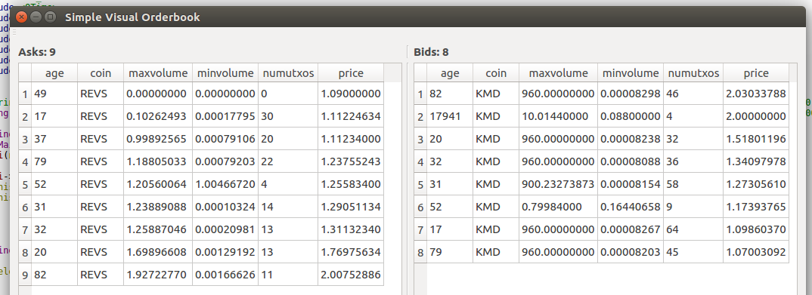
Recall that here base=REVS, and rel=KMD. Base/rel asks means someone with base wants rel for it at the price. Let's see on second ask string:

{"coin":"REVS","address":"RUPX5RWQL1qurMLmF4fFB4JAgRfwcNww4b","price":1.11224634,"numutxos":30,"minvolume":0.00017795,"maxvolume":0.10262493,"pubkey":"bb99c7042e092692191b7b4a636c7da28aeb36497ad038601cd599f356274051","age":17}

Price and volumes here is in a rel-coin. So, this string means that somebody wants to sell REVS for 1.11224634 KMD. 1 REVS = 1.11224634 KMD. As i said above. minvolume here and maxvolume is also in rel-coin (KMD in our example). We have maxvolume = 0.10262493 KMD. It means that this seller have 0,092268166 REVS.

Buy orders fill asks using relvolume. So, let's try to fill this ask order.

5. For making a swap we'll need to deposit KMD on a special smartaddress (!) It already generated for us via using our passphrase. Let's see how we can see it, there is a two ways:

We can use portfolio.cmd for this. Output:

{"result":"success","kmd_equiv":0,"portfolio":[{"coin":"KMD","address":"RTgUV3QgJTHeAN58VsvFmvByn3F51Fn3Mm","amount":0,"price":1,"kmd_equiv":0,"perc":0,"goal":0,"goalperc":0,"relvolume":0,"force":0,"balanceA":0,"valuesumA":0,"balanceB":0,"valuesumB":0,"balance":0}, {"coin":"REVS","address":"RTgUV3QgJTHeAN58VsvFmvByn3F51Fn3Mm","amount":0,"price":1.38283764,"kmd_equiv":0,"perc":0,"goal":0,"goalperc":0,"relvolume":0,"force":0,"balanceA":0,"valuesumA":0,"balanceB":0,"valuesumB":0,"balance":0}]}

Or we can use getcoin method for this:

{"result":"success","enabled":2,"disabled":1,"coin":{"coin":"KMD","height":538498,"status":"active","smartaddress":"RTgUV3QgJTHeAN58VsvFmvByn3F51Fn3Mm","rpc":"127.0.0.1:7771","pubtype":60,"p2shtype":85,"wiftype":188,"txfee":10000}}

Our smartaddress is RTgUV3QgJTHeAN58VsvFmvByn3F51Fn3Mm.

How much KMD we need to deposit for bying 1 REVS? Let's proceed from 1 REVS = 2,03 KMD. So for bying 1 REVS we need minimum 2,04 KMD and 1/777 «alice fee». Let's transfer 2.04 KMD and 0.003 KMD in 2 different (!) tx to this address and wait for 10 confirmations:

https://kmd.explorer.supernet.org/address/RTgUV3QgJTHeAN58VsvFmvByn3F51Fn3Mm

Let's use inventory.cmd to see Alice balance:

{"result":"success","coin":"KMD","timestamp":1508167935,"alice":[{"gui":"nogui","coin":"KMD","iambob":0,"address":"RTgUV3QgJTHeAN58VsvFmvByn3F51Fn3Mm","txid":"7f251434172086c75e032bba496a812904eeae0373db56ff9c120da1ada69f7a","vout":0,"value":"204000000","satoshis":"203990000","txid2":"f81644de62dcc60b1b981c98a4507c429f86bcbf0b8a152af323691f8d536154","vout2":0,"value2":"300000","desthash":"07ac67536c6735df813e4f77b7c050ecb49769fda3cfc92526c28173407bff23","session":1508164543}]}

As we are see, we have two txid. And Alice now have a balance.

6. Now we can place a buy order to fill first ask in table. Format of calling buy method is:

curl --url "http://127.0.0.1:7783" --data "{\"userpass\":\"$userpass\",\"method\":\"BUY\",\"base\":\"NAME_OF_BASE_COIN",\"rel\":\"NAME_OF_REL_COIN\",\"relvolume\":VOLUME_OF_REL_COIN,\"price\"PRICE_OF_BASE_COIN}"

shossain in his «barterDEX API Summery by Category» perfectly describe a buy method:

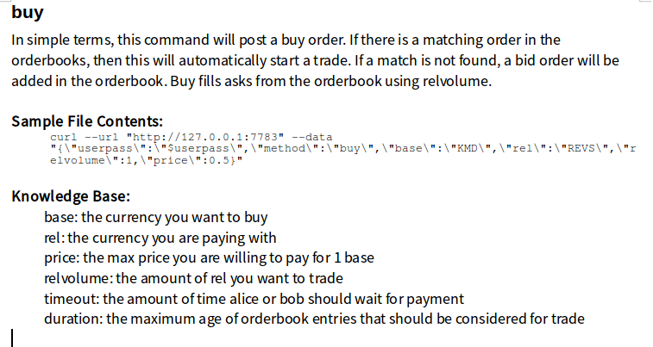
So, let's execute our buy:

curl --url "http://127.0.0.1:7783" --data "{\"userpass\":\"%USERPASS%\",\"method\":\"buy\",\"base\":\"REVS\",\"rel\":\"KMD\",\"relvolume\":1.5777,\"price\":1.5777}"

This means that we want to want to trade 1.5777 KMD (relvolume) to get REVS at price 1.5777. So, finally we will receive 1 REVS. Right?

Answer:
{"result":"success"}

Check status:
curl --url "http://127.0.0.1:7783" --data "{\"userpass\":\"%USERPASS%\",\"method\":\"swapstatus\"}"
Answer:
{"result":"success","swaps":[{"status":"realtime","requestid":1512311463,"quoteid":513028283}]}
Check status by requestid and quoteid:
curl --url "http://127.0.0.1:7783" --data "{\"userpass\":\"%USERPASS%\",\"method\":\"swapstatus\",\"requestid\":1512311463,\"quoteid\":513028283}"
Answer:
{"requestid":1512311463,"quoteid":513028283,"iambob":0,"bob":"REVS","srcamount":0.53610817,"bobtxfee":0.00010000,"alice":"KMD","destamount":0.66339475,"alicetxfee":0.00010000,"sentflags":["alicespend", "bobpayment", "alicepayment", "bobdeposit", "myfee"],"values":[0.53600817, 0, 0.53610817, 0.66349475, 0.60312169, 0, 0.00095378, 0, 0, 0, 0],"result":"success","status":"finished","bobdeposit":"914c0be36421af742ebac8618d6e553049f07f8b31150611e3d7e90790ee67e0","alicepayment":"9b4357a6fa6f7f4903e1c99e1e464cf83c1a48b4d371189c1764493094df9a5c","bobpayment":"5b179b0a05af0b9adf06e5c6d55bef915e2df1eb639374f90f8050446bd86c96","paymentspent":"2099b64fdf8816f887d05336763aaf2cbf7569c389d96d406cc41a136074b935","Apaymentspent":"0000000000000000000000000000000000000000000000000000000000000000","depositspent":"0000000000000000000000000000000000000000000000000000000000000000"}

komodo-cli.exe -ac_name=REVS getbalance
0.61687443

Orderbook status after our buy:
{"bids":[{"coin":"KMD","address":"RVPcbafNSi6uMaKDyss9epGpHCHbbzUFMd","price":2.03033788,"numutxos":0,"minvolume":0,"maxvolume":0,"pubkey":"e1d9ff940bd7fb30954e0d9297053457eb7f766e66da6c198e75c06b7d982124","age":80}, {"coin":"KMD","address":"RNyBS6ryQtPPQnJhavKn9o94U2RNExLZon","price":1.51801196,"numutxos":32,"minvolume":0.00008238,"maxvolume":960,"pubkey":"25a491638a815a6e669319532270b616124aab4bfd7e466fc08606ab46d48931","age":51}, {"coin":"KMD","address":"RXUF132uyPVTVUdLn16zCgvYoFXya3pyVb","price":1.34097978,"numutxos":36,"minvolume":0.00008088,"maxvolume":960,"pubkey":"825d0e1355117f6b76e7b3741f51c1827e72e25ddc688c0b20ad5b1ec7b28b4f","age":57}, {"coin":"KMD","address":"RMdjuxKBhyr87yhKp6BLUg2p9673NMcPAu","price":1.27305610,"numutxos":58,"minvolume":0.00008154,"maxvolume":900.23273873,"pubkey":"040f1d2d5d12027afa2cec30477312e225b0d24c77cc4aa08d3fffe51277b904","age":85}, {"coin":"KMD","address":"RTgUV3QgJTHeAN58VsvFmvByn3F51Fn3Mm","price":1.23755243,"numutxos":2,"minvolume":0.00155698,"maxvolume":1.10112420,"pubkey":"07ac67536c6735df813e4f77b7c050ecb49769fda3cfc92526c28173407bff23","age":608}, {"coin":"KMD","address":"RMfQwu5ey23eWJ4as2ckd8dqsQJwo836ny","price":1.17393765,"numutxos":0,"minvolume":0,"maxvolume":0,"pubkey":"9468f3d40fed3a5220d26c0f7efd43fd818fffdc7ce71c48dcfae7da9f476101","age":12}, {"coin":"KMD","address":"RUPX5RWQL1qurMLmF4fFB4JAgRfwcNww4b","price":1.09860370,"numutxos":58,"minvolume":0.00008267,"maxvolume":960,"pubkey":"bb99c7042e092692191b7b4a636c7da28aeb36497ad038601cd599f356274051","age":31}, {"coin":"KMD","address":"RAzheh3L7QtBL7oNKByVa43CtgALht6bbT","price":1.07003092,"numutxos":43,"minvolume":0.00008203,"maxvolume":960,"pubkey":"50959696e9d954d5853b113b54bfd695f7dd1a272f01700b13d6cd7e4b9bc704","age":2}],"numbids":8,"asks":[{"coin":"REVS","address":"RUPX5RWQL1qurMLmF4fFB4JAgRfwcNww4b","price":1.11224634,"numutxos":30,"minvolume":0.00017795,"maxvolume":0.10262493,"pubkey":"bb99c7042e092692191b7b4a636c7da28aeb36497ad038601cd599f356274051","age":31}, {"coin":"REVS","address":"RQzkkncY8ehpRg8M4kvKmDMcbFxcJvohgk","price":1.11234000,"numutxos":20,"minvolume":0.00079106,"maxvolume":0.99892565,"pubkey":"30eb3d952f66eba2df0100b97d6707257cf91dc8c8b0237cfb7c3aa70dc52d4d","age":28}, {"coin":"REVS","address":"RAzheh3L7QtBL7oNKByVa43CtgALht6bbT","price":1.23755243,"numutxos":22,"minvolume":0.00079203,"maxvolume":0.59093456,"pubkey":"50959696e9d954d5853b113b54bfd695f7dd1a272f01700b13d6cd7e4b9bc704","age":2}, {"coin":"REVS","address":"RMfQwu5ey23eWJ4as2ckd8dqsQJwo836ny","price":1.25583400,"numutxos":4,"minvolume":1.00466720,"maxvolume":1.20560064,"pubkey":"9468f3d40fed3a5220d26c0f7efd43fd818fffdc7ce71c48dcfae7da9f476101","age":12}, {"coin":"REVS","address":"RMdjuxKBhyr87yhKp6BLUg2p9673NMcPAu","price":1.29051134,"numutxos":14,"minvolume":0.00010324,"maxvolume":1.23889088,"pubkey":"040f1d2d5d12027afa2cec30477312e225b0d24c77cc4aa08d3fffe51277b904","age":85}, {"coin":"REVS","address":"RXUF132uyPVTVUdLn16zCgvYoFXya3pyVb","price":1.31132340,"numutxos":13,"minvolume":0.00020981,"maxvolume":1.25887046,"pubkey":"825d0e1355117f6b76e7b3741f51c1827e72e25ddc688c0b20ad5b1ec7b28b4f","age":57}, {"coin":"REVS","address":"RNyBS6ryQtPPQnJhavKn9o94U2RNExLZon","price":1.76975634,"numutxos":0,"minvolume":0,"maxvolume":0,"pubkey":"25a491638a815a6e669319532270b616124aab4bfd7e466fc08606ab46d48931","age":51}, {"coin":"REVS","address":"RVPcbafNSi6uMaKDyss9epGpHCHbbzUFMd","price":2.00752886,"numutxos":0,"minvolume":0,"maxvolume":0,"pubkey":"e1d9ff940bd7fb30954e0d9297053457eb7f766e66da6c198e75c06b7d982124","age":80}],"numasks":8,"base":"REVS","rel":"KMD","timestamp":1508186202}

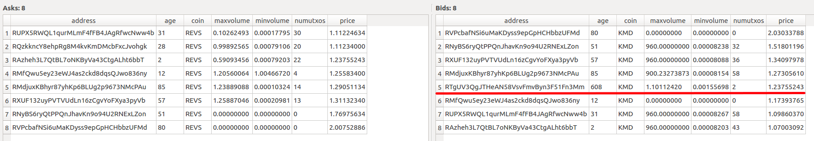
0.66349475 KMD → 0.53600817 REVS (price = 1,237844472???)

