RUNEVINE STUDIOS
Portfolio Website
Assessment 4: Project Report
Declan Bannerman
Student ID: 11851989
Charles Sturt University
June 2026
This report documents the design and development of an eight paged portfolio website that I’ve themed around RUNEVINE STUDIOS. This company is a fictional online games developer. The site demonstrates my competency in HTML5 as well as in CSS3 and JS.

b. Concept Map
The concept map I’ve constructed below illustrates the overall structure of the Runevine studios portfolio website. This map shows how all of the four HTML pages constructed function and how they relate to each other through to the shared CSS; as well as to the asset files.
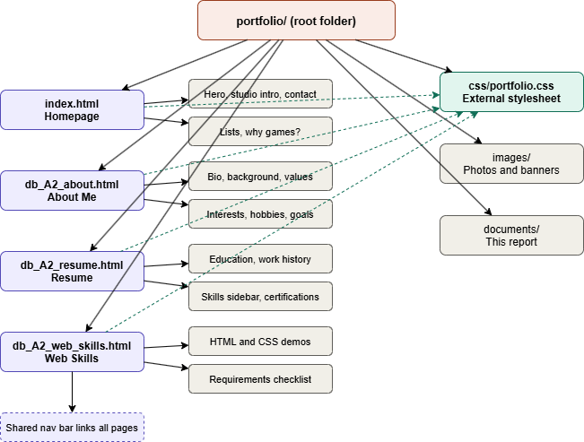
RUNEVINE STUDIOS | PORTFOLIO WEBSITE

index.html Homepage | db_A3_about.html About Me | db_A3_resume.html Resume | db_A3_web_skills.h tml Web Skills
The hero, studio intro, and the contact | The bio, my personal background interests and values | My education and work experience. My certifications and my skills | The HTML and CSS demos. The skills grid and the checklist

SHARED ASSETS | css/portfolio.css External stylesheet | images/ Photos and banners | documents/ This report

c. Storyboard

I’ve created an individual storyboard for each of the features pages before I began development. This was done so as to plan out the layout as well as the content of each page before any work began. This prevented any errors or scope issues from occurring sand it also demonstrates how everything links together.

index.html

index.html - Homepage
Header: Logo in the top left. Home (active), about, resume, and web skills.
Hero: Contains my name as the heading with a tagline paragraph to go with it. Also carries the enter button
Studio intro: Talks all about runevine studios and what the company does in the games space. In that card will be the genre tags of the games that we make to advise the reader of the general company atmosphere.
What we make: Will showcase the three main pillars of our studio. Those being survival horror, historical combat and online worlds
Navigate: This will be an unordered list of all the portfolio pages. Just below that will be an ordered list of all the reasons to hire me and why I will be a good fit.
Why games?: Holds two main paragraphs that elaborate on why I’m attracted to the games industry with a bit of backstory. Simultaneously showing off left and right alignment
Contact: Contains my email and phone for contacting purposes. Also has an external link to CSU if employers want to know more about the university that I attend
Footer: The copyright notice to prevent plagiarism. As well as another email link
Links to: db_A3_about.html, db_A3_resume.html, db_A3_web_skills.html, contact

db_A3_about.html

db_A3_about.html - About Me
Header: Logo in top left. Home, about (active), resume, and web skills
Hero: About me heading with the below subtitle paragraph.
Who I am: A two column layout with a profile photo left in the top left. Not of me, but of a fitting image, due to my not having the equipment nor capacity to shoot professional photos. Bio paragraphs as well as the skill tags are to the right.
My background: two paragraphs here that cover both my personal and my professional background
Interests: An unordered list of hobbies accompanied by my list of goals for 2026 that have been ordered
My Values: A 2x2 grid of value cards with brief descriptions of each major professional value that I hold.
Contact: An email and a phone link for reaching out to me. Also an internal link to my resume page.
Footer: Contains a copyright notice and another email link
Links to: index.html, db_A3_resume.html, db_A3_web_skills.html

db_A3_resume.html

db_A3_resume.html - Resume
Header: Logo in top left. Home, about, resume (active), and web skills
Hero: My resume heading as well as a subtitle paragraph below.
Main column: Contains the summary and a timeline covering my education. Shows off my work experience and industry certifications as well. Under that will be the small references table.
Sidebar: Showcases my skill proficiency through varying percentages cast onto bars with inline widths. Will also contain a list of my soft skills. Towards the bottom will be more contact and site nav buttons
Footer: Copyright notice as well as another email link
Links to: index.html, db_A3_about.html, db_A3_web_skills.html

db_A3_web_skills.html

db_A3_web_skills.html - Web Skills
Header: Logo in top left. Home, about, resume and web skills (active)
Hero: Contains the web skills heading and a small subtitle paragraph just underneath.
Checklist: this will be a two column grid that descends and showcases all of my relevant technical skills as well as clarifying how these meet industry qualifications and requirements
HTML techniques: These will be demo cards with headings, lists, links, character references. Demonstrates my coding abilities.
CSS techniques: These will be demo cards with colours, typography, text decorations and selectors, div and span. Also demonstrates more of my coding abilities.
Skills grid: A grid that now specifically outlines very briefly all of my technical abilities for prospective employers
Continue: Internal links that lead right back to all of the other pages from before. Also will have two external links to validators
Footer: The copyright notice and the email link for contacting
Links to: index.html, db_A3_about.html, db_A3_resume.html, validator.w3.org, jigsaw.w3.org/css-validator

d. index.html

Overview
index.html is the homepage for the entire site that I’ve constructed. This page serves to introduce the fictional game developer that I’ve created, that being runevine studios, and it contains various technical elements throughout it as well. Things like inline styles, an internal stylesheet, the external stylesheet link, a horizontal navigation bar, paragraphs that contain three different alignments, ordered and unordered lists, headings, an image, internal and external links, email links and phone links, and lastly character references are included as well.

Code Highlights

<!-- head: doctype, charset, title, external and internal stylesheets -->
<!DOCTYPE html>
<head>
<meta charset="UTF-8">
<title>Declan Bannerman | RUNEVINE STUDIOS Portfolio</title>
<link rel="stylesheet" href="css/portfolio.css">
<style>
.hero-label { font-family: 'Courier New', monospace; color: #6a2a2a; }
</style>
</head>
<!-- inline style -->
<span class="hero-label" style="font-size: 0.72rem;">Portfolio 2026</span>
<!-- character references -->
<p>&copy; 2026 Declan Bannerman &amp; RUNEVINE STUDIOS</p>
<!-- email, phone and external links -->
<a href="mailto:declan.bannerman04@outlook.com">Email</a>
<a href="tel:+61422414399">Phone</a>
<a href="https://www.csu.edu.au" target="_blank">Charles Sturt University</a>

Validation
index.html has been validated using the W3C markup validation service online. The address for that site being at https://validator.w3.org wherein it provides back an error check. As seen below the index html file returned 0 errors and 0 warnings.

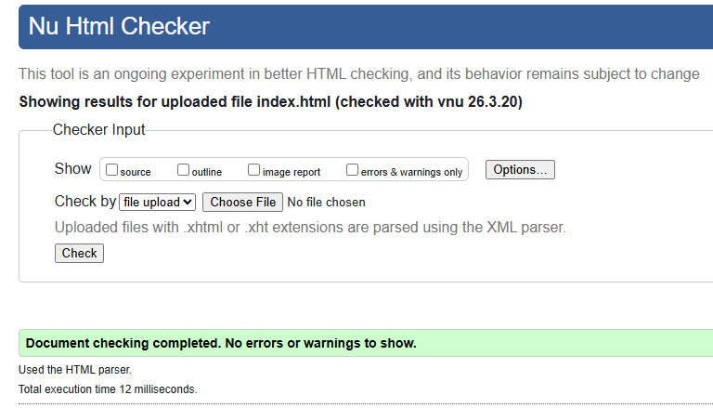

Personal Reflection
The homepage for this site was certainly the most important page for me to get right. It was the most important page on account of it setting the the tone for everything else to come across the site, given this is a users first introduction. Therefore, I had set out on using an internal style block for the page specific styles which I felt was most appropriate, this was conducted alongside the external stylesheet kept portfolio.css being kept both clean and reusable. Personally, I do believe that the dark and atmospheric theme of the site fits the specific games industry focus quite well.

e. db_A3_web_skills.html

Overview

The db_A3_web_skills.html page demonstrates every required HTML and CSS technique displayed clearly across the entire page. I’ve made it with a requirements checklist at the very top and there are demo panels underneath for each and every technique. These include techniques like lists with square bullets or roman numerals. Furthermore there is a show of all link types, of images, of colour and typography demos, and also of selectors. This page shows off everything that I am capable of.

Code Highlights

<!-- unordered list with square bullets (set in portfolio.css) -->
<ul class="content-list">
<li>HTML5 semantic structure</li>
</ul>
<!-- ordered list with Roman numerals (set in portfolio.css) -->
<ol class="content-list">
<li>Plan the page structure</li>
</ol>
<!-- div wrapper and inline span -->
<div class="demo-panel">
<span class="accent">RUNEVINE STUDIOS</span>
</div>
/* portfolio.css */
ul.content-list { list-style-type: square; }
ol.content-list { list-style-type: upper-roman; }

Validation

db_A3_web_skills.html has also been personally validated and confirmed to be without error by using the W3C validation service online at https://validator.w3.org via file upload. With there being a warning offering a small suggestion for a non critical change. Therefore, with the file returning 0 errors and only 1 small warning, it is entirely functional.

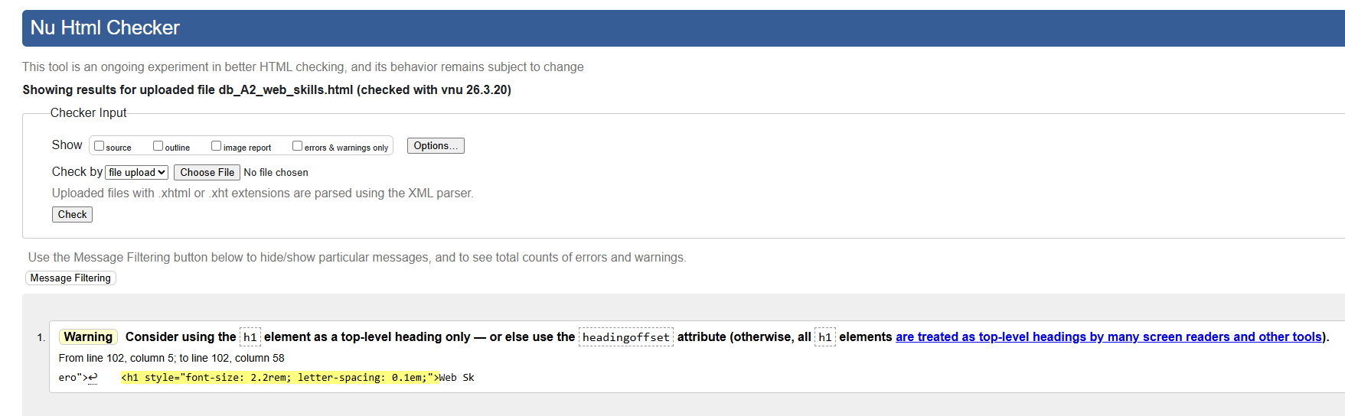Personal Reflection

Having built this page has made me think carefully and specifically about each technique that I’ve had to employ. This has been helpful for my individual coding capacity, much more so than using them by accident or chance elsewhere on the thought of being potentially helpful for a UI but not having familiarity with its implementation. Having the checklist that i’ve placed at the top has also made it much easier to track the coverage as well as to give any prospective viewer a clear overview of what has been demonstrated on the site.

f. db_A3_resume.html

Overview
The page for my resume, db_A3_resume.html , uses a CSS grid layout featuring two major prominent columns. It lists both my education and my work history timeline on the left. To better illustrate my abilities even further, it also has the skills sidebar on the right. The proficiency bars located within the sidebar itself make use of inline styles for their individual widths too. The page also includes a references table, which is small and invites the viewer to contact me for more information which helps involve prospective viewers in my application just that extra bit rather than making it mundane like many other may be through sheer repetition of volume. There are also my certifications that are structured as an ordered list, with my email and phone links providing a contact method accompanied by more internal site navigation buttons.

Code Highlights

<!-- timeline entry -->
<div class="timeline-entry">
<p class="timeline-date">Current</p>
<h3>Bachelor of Computer Science</h3>
<span class="accent">Charles Sturt University</span>
</div>
<!-- skill bar width set inline per skill -->
<div class="prof-bar-fill" style="width:90%;"></div>
<!-- references table -->
<table>
<thead><tr><th>Available Upon Request</th></tr></thead>
<tbody><tr><td>References available on request.</td></tr></tbody>
</table>

Validation

This file, the db_A3_resume.html file has been entirely validated using the W3C markup validation service which I’ve accessed at https://validator.w3.org and used the file upload feature. The file here has once more returned 0 errors and 0 warnings.

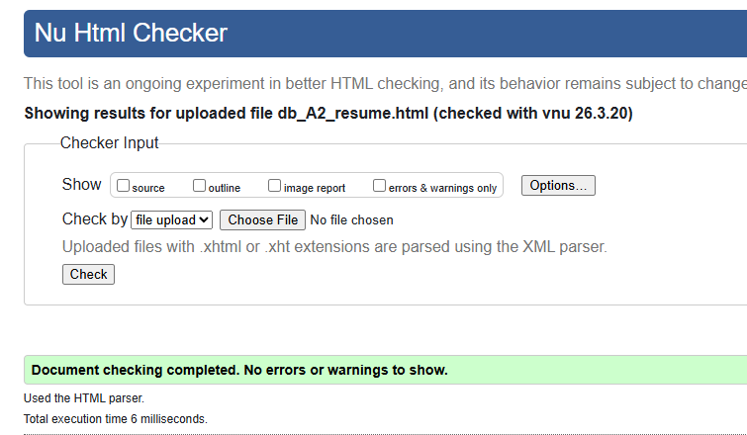

Personal Reflection
This page in its construction has been particularly useful for expanding my understanding of when it is that inline styles make practical sense to implement. Having completed it, in hindsight it is very much evident that setting each skill bar width inline was the right approach to developing these since each value is different. This is in contrast to everything else that stayed normalised within the external stylesheet. By using a table for the references section I was also able to experiment with that design features, and it certainly felt appropriate given that it is genuinely tabular data.

g. portfolio.css

Overview

portfolio.css is the shared external stylesheet that I’ve used for all four of the html pages. This file covers all of the required CSS and includes a variety of techniques to do so. This has been the backbone of the other documents, and the techniques that it showcases span the following: a universal selector reset, multiple type selectors, class and ID selectors, two different text colours, two different background colours, font weights, font styles and font sizes. These have helped construct the site in its entirety. Below is a further in depth examination of how every required metric has been met.

Requirements Met
CSS Requirement | Met
At least two different text colours | Yes
At least two different background colours with one applied to the entire webpage | Yes
At least two different font weight values | Yes
At least two different font style values | Yes
At least two different font size values | Yes
At least one font family with four typefaces | Yes
Three differently aligned paragraphs | Yes
At least two different text decorations | Yes
At least one class selector and one ID selector | Yes
Unordered list bullet type changed to squares | Yes
Ordered list numbers changed to Roman numerals | Yes
At least one div and one span used | Yes
Comments provided throughout the CSS code | Yes

Code Sample

/* reset */
* { box-sizing: border-box; margin: 0; padding: 0; }
/* body - font family (4 typefaces), background and text colour */
body {
font-family: 'Georgia', 'Times New Roman', Times, serif;
background-color: #0a0a0a; /* page bg */
color: #ddd8d0; /* body text */
font-weight: 400;
}
/* ID selector */
#hero-cta { color: #c0392b; font-weight: 700; text-decoration: none; }
/* class selector */
.highlight { color: #c0392b; font-style: italic; }
/* list bullet and numbering overrides */
ul.content-list { list-style-type: square; }
ol.content-list { list-style-type: upper-roman; }

Validation

portfolio.css has also been thoroughly validated by using the online W3C CSS validation service to confirm its efficacy and lack of faults, this was accessed via https://jigsaw.w3.org/css-validator wherein the file itself was uploaded, scanned and confirmed to return zero errors.

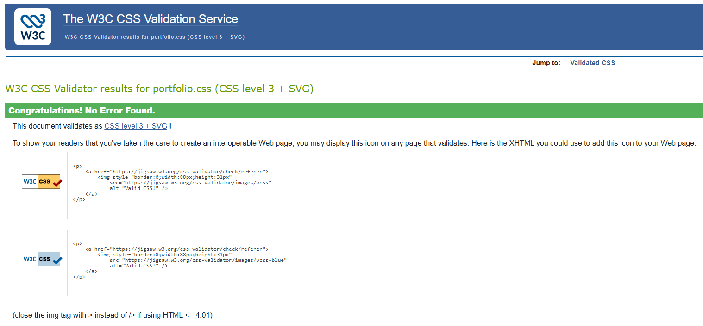

Personal Reflection
Having written one shared stylesheet to be utilised for all four of the site pages has most definitely made the importance of certain aspects like naming conventions and CSS specificity very clear to me early on as in many ways these elements are foundational and having to revise them can cause many undesirable second order effects, so getting them complete properly for the first time is very important. Also worth noting is that keeping the inline styles to a minimum as well as putting as much as possible in the external file itself has certainly made the HTML much cleaner. I do believe that the dark theme accompanied by the red accents, which I’ve chosen to match the tone of the games industry focus, was a good design decision; so much so that a similar theme is repeated in this report. Overall, developing these has been a unique and informative experience.

h. Validations

To reiterate earlier sections, all of the HTML files have been validated and confirmed to retain full functionality without errors. This has been completed using the w3c service that can be accessed at https://validator.w3.org and files uploaded to be scanned. As for the external CSS file, that was validated separately using the specific w3c CSS service which is found at https://jigsaw.w3.org/css-validator and operates similarly. All five of these files have returned no errors and work perfectly.
This can be seen here with the last needed validation, that being for the about me page:
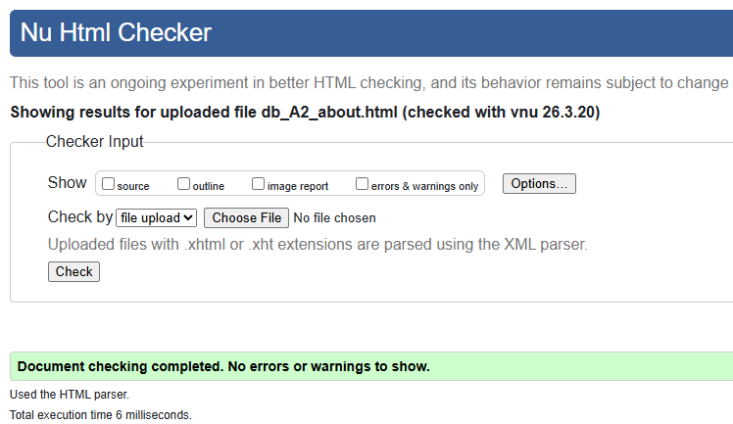

File | Validator | Errors | Warnings | Result
index.html | W3C HTML Validator | 0 | 0 | Pass
db_A3_about.html | W3C HTML Validator | 0 | 0 | Pass
db_A3_resume.html | W3C HTML Validator | 0 | 0 | Pass
db_A3_web_skills.html | W3C HTML Validator | 0 | 1 | Pass
css/portfolio.css | W3C CSS Validator | 0 | 0 | Pass

i. A3 Requirements Met
This table below documents each A3 requirement and confirms whether or not it has been met in this submission.
A3 requirement | Met
HTML files copied over from A2 and renamed to the db_A3_ prefix | Yes
External CSS file only, meaning no internal or inline CSS. | Yes
Navigation bar that properly utilises CSS buttons | Yes
Print friendly CSS that is applied to all of the pages | Yes
Identical navigation bar added onto each and every page | Yes
Logo/favicon added up the top on each page | Yes
Home page has my contact details as well as the copyright notice in the footer using © symbol | Yes
Resume page contains a table with at minimum the 4 rows and the 3 columns | Yes
All HTML pages and all of the CSS files validate | Yes
Comments have been provided throughout all of the code | Yes

j. What has been changed since A2
I have made the following changes to the site between the A2 and the A3 versions:
All of the internal and the inline CSS has been removed. Each of the three A2 pages had at the time contained page specific internal stylesheets as well as several other inline style attributes. I’ve improved this by making it so that all of these rules have now been consolidated into portfolio.css. No internal <style> blocks or style=“” attributes remain in any of the four HTML files at this point after the changes.
The navigation bar has been converted to CSS buttons. It used to be that the nav links previously were using a rather plain underline hover effect when the cursor was positioned on them. But now I’ve construed it so that they have been restyled with border and padding, and a new background colour so that they render properly as buttons. The active page also now gets a filled red background so as to indicate the current page.
Print friendly CSS has now been added in. An @media print block has also been added to the portfolio.css. This one applies to all of the four site pages and it removes the navigation bar. It strips all of the background colours and textures and converts all of the text to black. Furthermore, it increases the base font size now to 12pt, collapsing the multi column grids into a single column which I think makes for much better readability on paper.
The logo has been added to the top of each tab. It’s an SVG logo because that is the standard for the open web and it has been added to the images/ folder with the other images. It is referenced withing as a favicon via the <link rel=“icon”> that’s in the head of each of the pages which means that it appears on the browser tab. It also is thus able to appear as an image in the navigation bar on every one of the pages.
The copyright notice has now been added to every page footer. I’ve also included a second paragraph that has been added to the footer on all four of the pages. It currently contains the © symbol and it states that all content is original work owned by me and that its used with permission.
Proper table has been added onto the resume page. The A2 resume page in its last condition only had a single cell references table and that did not meet the A3 requirement so it has been altered. I’ve replaced it with a proper table that lists all the current subjects from my bachelor of computer science degree. The table has its required three columns and data rows.
I’ve renamed the files from db_A2_ to the db_A3_ prefix. All three of the inner pages have also been renamed accordingly and the internal links updated to match.

k. Navigation Map (Logical)
This table below showcases the logical navigation setup between the pages. Every page currently links to every other page via the shared navigation bar. There are additional internal links that are noted separately.
Page | Links to (via nav bar) | Additional internal links
index.html | About, Resume, Web Skills | About (CTA button), #contact anchor, mailto, tel
db_A3_about.html | Home, Resume, Web Skills | Resume (inline link), mailto, tel
db_A3_resume.html | Home, About, Web Skills | About and Web Skills (sidebar buttons), mailto, tel
db_A3_web_skills.html | Home, About, Resume | #css-section anchor, About and Resume (inline links), external validator links, mailto

l. Structure Chart (Physical)
This following table also shows how the physical folder and the file structure work within the portfolio
Folder | File | Description
portfolio/ | index.html | Home page
portfolio/ | db_A3_about.html | About Me page
portfolio/ | db_A3_resume.html | Resume page
portfolio/ | db_A3_web_skills.html | Web Skills page
portfolio/css/ | portfolio.css | Shared external stylesheet for all pages
portfolio/images/ | logo.svg | Site logo used as favicon and in nav bar
portfolio/images/ | profile.png | Profile photo used on About page
portfolio/images/ | runevine-banner.png | Studio banner used on Web Skills page
portfolio/documents/ | declan_bannerman_A3_report.docx | This design documentation report

m. Testing Plan
The table here outlines all of what was tested, as well as how it was tested, and the expected result for each test.
What was tested | How it was tested | Expected result | Result
HTML validation (all 4 pages) | W3C Nu HTML Checker (validator.w3.org) | No errors or warnings | 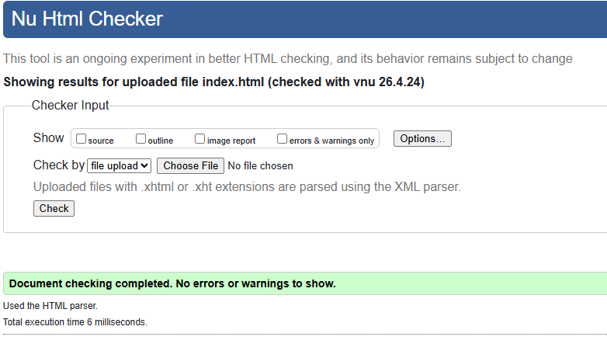
CSS validation (portfolio.css) | W3C CSS Validator (jigsaw.w3.org) | No errors found | 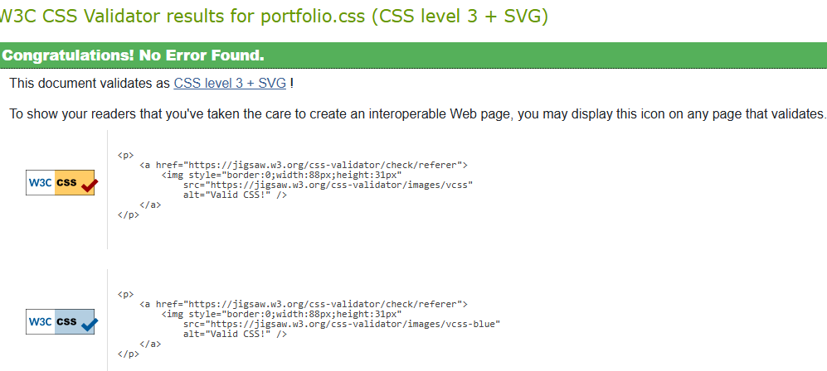
Navigation bar links on all pages | Click each nav button on each page in the browser | Correct page loads, active button highlights | Confirmed to work on all pages.  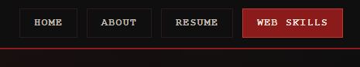
All internal links | Click every inline link and anchor across all pages | No broken links, correct destinations | All internal links confirmed to work.  
External links | Click external links (CSU, W3C validators) while connected to the internet | Opens in a new tab, correct site loads | All external links are also confirmed to work  
Images display correctly | Open each page in the browser and visually confirm images load | Logo, profile photo and banner all display | Images are all confirmed functional  
Favicon appears on browser tab | Open each page and inspect the browser tab | RV logo icon visible on all four tabs | Favicon confirmed to work  
Print friendly output | Press Ctrl+P on each page and inspect the print preview | Nav bar hidden, black text, no backgrounds | Print mode confirmed to be operational  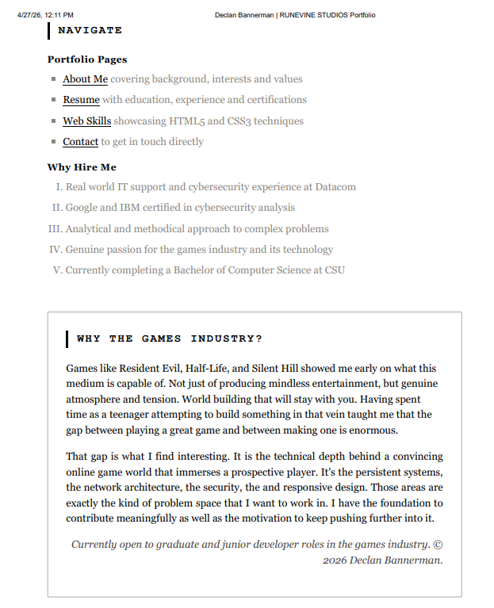
Copyright notice in footer | Scroll to the bottom of each page | © symbol and permissions statement visible on all four pages | Confirmed to be at the footer of all pages successfully.

n. A4 Changes and New Features
This section documents all of the changes that I’ve made in place between A3 and A4. All of the new pages and the features that I’ve added to it. It shows the updated requirements table, the navigation map, the structure chart, and the A4 testing plan.

What Has Changed Since A3
The following changes have been made to the portfolio between the versions of A3 and A4:
All of the files have been renamed from db_A3_ to db_A4_ convention. All three existing inner pages (About, Resume, Web Skills) have been renamed to the db_A4_ prefix and all of the internal cross references have also been updated to match this change for the new version of the assignment.
Three new skills pages have been added to the portfolio now. db_A4_cybersecurity_skills.html, db_A4_problem_solving_skills.html, and db_A4_communication_skills.html have been created and are now sitting alongside the web skills page to complement it. Each contains two reference tables, a values grid, a skills grid, and contextually relevant content to further highlight those skill capacities that I am seeking to demonstrate. This brings the total site page count from four all the way up to eight.
Newsletter signup form added. The db_A4_newsletter_form.html and db_A4_newsletter.js have been created for this new version. The form includes all of the required fields, the onload welcome alert, the POST method submission, and the JavaScript validation that is preventing submission when the case occurs that either name field has been left empty. The JS is fully external for the sake of having code reusability.
Navigation bar expanded on all pages. All eight pages that are in place now carry the full seven item navigation bar at the top with all the relevant links. Users can navigate using these buttons between Home, About, Resume, Web Skills, Cyber Skills, Troubleshooting Skills, and Communication Skills.
Newsletter footer link added to all pages. A styled link to the newsletter signup form for my site has been added to the footer of all of the main pages and when clicked on it opens up in a new tab. This also satisfies the requirement that the form should be accessible from the Web Skills page itself.
Hobbies and Interests section added to resume. A hobbies and interests section has been added to db_A4_resume.html to satisfy the explicit resume requirement that lists hobbies as a required field. This is a smaller addition but an important one nonetheless.
CSS extended for form styling. Additional rules appended to portfolio.css to style the newsletter form. These rules needed fieldsets, labels, text inputs, radio buttons, checkboxes, textarea, and submit and reset buttons. These have all been satisfied now, and they all use the existing dark red design language. No inline styles were introduced.

A4 Requirements Table
A4 Requirement | Met
At least 6 pages are on the website | Yes. 8 pages total
A Home page (index.html) that introduces the applicant | Yes
A Resume page with personal details, education, experience, qualifications, hobbies | Yes. All sections present
At least four skills pages, one being Web Development | Yes. Web Skills, Cyber Skills, Troubleshooting Skills, Communication Skills
Form opens in a new window/tab from the Web Skills page | Yes. footer link on all pages, target=_blank
Form styled using pure CSS code only | Yes. portfolio.css, zero inline styles
Form data submitted using POST method | Yes. method=post on the form element
Welcome alert displayed via onload when signup page loads | Yes. fires on window.onload in db_A4_newsletter.js
Form includes instructive information about required data | Yes. * required labels and hint text on each field
First Name text box, maximum size 60 | Yes. type=text, maxlength=60
Last Name text box, maximum size 60 | Yes. type=text, maxlength=60
Email address box, maximum size 60 | Yes. type=email, maxlength=60
5 radio buttons for age ranges: 15-25, 26-35, 36-45, 46-55, 55+ | Yes. all five present with correct values
5 checkboxes for service areas | Yes. Survival Horror, Historical Combat, Online Multiplayer, Immersive Sim, Dev Updates
Text area minimum 60 cols and 3 rows | Yes. cols=60 rows=3
Submit button | Yes
Reset button | Yes
onsubmit validates First Name not empty - alert and prevent submit if empty | Yes. event.preventDefault() and return false
onsubmit validates Last Name not empty - alert and prevent submit if empty | Yes. checked after First Name passes
Sufficient comments throughout the code | Yes. 23 HTML comments, 19 JS comments
External stylesheet for all pages (CSS reusability) | Yes. portfolio.css linked on all 8 pages
External JavaScript file (code reusability) | Yes. db_A4_newsletter.js, no inline JS
At least 2 type selectors and a universal selector in CSS | Yes. universal selector *, plus 10+ type selectors
HTML5 doctype on all pages | Yes. all 8 pages
Responsive viewport meta on all pages | Yes. all 8 pages
Print-friendly CSS | Yes. two @media print blocks in portfolio.css

A4 Navigation Map
Page | Links to (via nav bar) | Additional links
index.html | About, Resume, Web Skills, Cyber Skills, Troubleshooting Skills, Communication Skills | About (CTA button), newsletter footer link, mailto, tel
db_A4_about.html | Home, Resume, Web Skills, Cyber Skills, Troubleshooting Skills, Communication Skills | Newsletter footer link, mailto, tel
db_A4_resume.html | Home, About, Web Skills, Cyber Skills, Troubleshooting Skills, Communication Skills | Newsletter footer link, mailto, tel
db_A4_web_skills.html | Home, About, Resume, Cyber Skills, Troubleshooting Skills, Communication Skills | Newsletter footer link, #css-section anchor, validator links, mailto
db_A4_cybersecurity_skills.html | Home, About, Resume, Web Skills, Troubleshooting Skills, Communication Skills | Newsletter footer link, Continue section links
db_A4_problem_solving_skills.html | Home, About, Resume, Web Skills, Cyber Skills, Communication Skills | Newsletter footer link, Continue section links
db_A4_communication_skills.html | Home, About, Resume, Web Skills, Cyber Skills, Troubleshooting Skills | Newsletter footer link, Continue section links
db_A4_newsletter_form.html | Home, About, Resume, Web Skills (via nav) | Opened from footer newsletter link on all pages

A4 Structure Chart
Folder | File | Description
portfolio/ | index.html | Home page
portfolio/ | db_A4_about.html | About Me page
portfolio/ | db_A4_resume.html | Resume page
portfolio/ | db_A4_web_skills.html | Web Skills skills page
portfolio/ | db_A4_cybersecurity_skills.html | Cyber Skills page (new in A4)
portfolio/ | db_A4_problem_solving_skills.html | Troubleshooting Skills page (new in A4)
portfolio/ | db_A4_communication_skills.html | Communication Skills page (new in A4)
portfolio/ | db_A4_newsletter_form.html | Newsletter signup form page (new in A4)
portfolio/ | db_A4_newsletter.js | External JS for form validation (new in A4)
portfolio/css/ | portfolio.css | Shared external stylesheet for all pages
portfolio/images/ | logo.svg | Site logo used as favicon and in nav bar
portfolio/images/ | profile.png | Profile photo used on About page
portfolio/images/ | runevine-banner.png | Studio banner used on Web Skills page
portfolio/documents/ | db_A4_report.docx | This design documentation report

A4 Testing Plan
What was tested | How it was tested | Expected result | Result
HTML validation - all 8 pages | W3C Nu HTML Checker (validator.w3.org) - each file uploaded and scanned | Zero errors on all pages | Confirmed on all pages. Images are shown in section R.
CSS validation - portfolio.css | W3C CSS Validator (jigsaw.w3.org) - file uploaded and scanned | Zero errors | Confirmed in section R as well.
Navigation bar on all 8 pages | Click each of the 7 nav links on every page in the browser | Correct page loads, active button highlighted, all 7 links visible | The button works on all pages.
Newsletter footer link on all pages | Scroll to footer on each of the 7 main pages, click the link | Opens db_A4_newsletter_form.html in a new tab | The newsletter link works on all pages.
Form: onload welcome alert | Open db_A4_newsletter_form.html in the browser | Alert fires immediately with the welcome message | Has been confirmed as functional.
Form: submit with empty First Name | Leave First Name blank, fill all other fields, click Subscribe | Alert shown, form does not submit to server | Certified as correctly working.
Form: submit with empty Last Name | Fill First Name, leave Last Name blank, fill others, click Subscribe | Alert shown, form does not submit to server | Yes, works as intended.
Form: submit with all fields filled | Complete all fields correctly and click Subscribe | Confirmation alert shown, form submits | Confirmed to work.
Form: reset button | Fill in several fields then click Reset Form | All fields return to empty/default state | The reset button works properly.
Form: radio buttons (age range) | Click each of the 5 age range radio buttons | Only one can be selected at a time | Yep, the result was as predicted.
Form: checkboxes (interests) | Click multiple interest checkboxes | Multiple can be selected simultaneously | This works as needed.
Print friendly output - all pages | Ctrl+P on each page, inspect print preview | Nav hidden, black text, no backgrounds, readable layout | Confirmed functionality.
Responsive layout at different screen sizes | Resize browser window and inspect layout at mobile, tablet, desktop widths | Content reflows, no horizontal overflow, readable at all sizes | Yes, this is in correct operation.
All images display correctly | Open each page and visually confirm all images load | Logo, profile photo and banner all display | Certified to be working.
Favicon on all tabs | Open each page and inspect the browser tab | RV logo icon visible on all 8 tabs | Tested and confirmed as functional.
All internal links | Click every inline link and anchor across all pages | No broken links, correct destinations load | Yes, the inline ink is there on all pages.
External links open correctly | Click validator links and any external references | Opens in new tab, correct site loads | Confirmed to open new tab when clicked.
New skills pages content and layout | Open each of the 3 new skills pages and visually review | Tables, grids, and text render correctly with consistent styling | Yes, confirmed to be working.

o. Interface Design and Navigation
This section addresses the interface design, the navigation design, and also the organisation of information criteria for A4.

Interface Design
The portfolio uses a consistent dark red and black visual identity derived from RUNEVINE STUDIOS, a fictional independent games studio. All pages share a single external stylesheet (portfolio.css) which defines the full design system: colour palette, typography, spacing, and component classes. This means no page carries any inline styles, and any visual change made to portfolio.css propagates instantly across all eight pages.
The three new skills pages added in A4 (Cyber Skills, Troubleshooting Skills, Communication Skills) each follow the same internal layout pattern: a hero-inner section, two or more section-block content areas containing cards, tables, and grids, a skills-grid tag cloud, a continue navigation list, and a footer. This visual consistency means a user arriving on any page of the site can immediately orient themselves without learning a new layout.
The newsletter form page shares the same header, hero-inner, and footer components. It uses fieldset and legend elements to group related inputs visually and semantically. Form controls are styled to match the portfolio colour scheme: dark backgrounds, red accent borders on focus, and the same monospace typeface used throughout the site. The submit button is filled red to establish visual hierarchy over the ghost-style reset button.

Navigation Design
Navigation in A4 has been extended to accommodate the three new skills pages. The sticky top navigation bar now contains seven links: Home, About, Resume, Web Skills, Cyber Skills, Troubleshooting Skills, and Communication Skills. The bar appears identically on all eight pages. The currently active page is highlighted using an .active CSS class applied to the corresponding nav link, giving the user a persistent location indicator.
In addition to the top navigation, each page includes a Continue section at the bottom of the main content area with inline links to related pages. This provides a secondary navigation path for users who reach the bottom of a page and want to continue browsing without scrolling back to the top. The footer on all seven main pages also carries a direct link to the newsletter signup form, opening in a new tab.

Organisation of Information
The site is organised around a simple employer-facing hierarchy. The home page introduces the candidate and provides a clear call to action. The resume page provides complete professional history. The four skills pages each demonstrate a specific competency with direct relevance to RUNEVINE STUDIOS framed at the top of the page. The newsletter form sits outside this hierarchy as a utility page accessed via the footer link rather than through the main content flow.
Within each skills page, information is organised from general to specific: an introductory section frames the skill in the employer context, reference tables or grids present the technical detail, and a skills tag cloud at the bottom provides a quick summary for a reader who is scanning rather than reading in depth.

p. HTML Form and JavaScript
This section documents the design and implementation of the newsletter signup form and its associated JavaScript validation, satisfying the HTML Form and JavaScript criterion.

Form Structure
The form is contained in db_A4_newsletter_form.html and is opened in a new browser tab via the footer newsletter link present on all seven main pages. The form uses method="post" and is organised into four fieldsets: Personal Details (First Name, Last Name, Email), Age Range (five radio buttons), Areas of Interest (five checkboxes), and Additional Comments (textarea). A submit button and a reset button sit below the fieldsets.
All text inputs use maxlength="60" as specified. The email field uses type="email" which provides browser-native format validation in addition to the JavaScript validation. The textarea is set to cols="60" rows="3" as the minimum required dimensions, with resize:vertical in the CSS allowing the user to expand it if needed. Required fields are clearly labelled with a "* required" indicator and hint text beneath each input.

JavaScript Validation
All JavaScript is contained in the external file db_A4_newsletter.js, loaded at the bottom of the body element so the DOM is fully parsed before the script runs. No inline JavaScript or event handler attributes appear in the HTML. The file uses two main handlers:
window.onload: fires immediately when the page finishes loading and displays the welcome alert: "Welcome to the RUNEVINE STUDIOS Corporation - Newsletter Signup". It also retrieves DOM references to the form and both name fields so they are available to the submit handler.
form.onsubmit: runs when the user clicks the submit button. It trims whitespace from both name fields using .trim(), then checks each in turn. If First Name is empty an alert is shown, focus is moved back to that field, and event.preventDefault() plus return false prevent the form from submitting to the server. The same check runs on Last Name if First Name passes. If both fields contain content a confirmation alert is shown and the form submits normally via POST.

q. Code Reusability and Readability
Code reusability is achieved at three levels in the A4 portfolio. First, all visual styling is centralised in a single external stylesheet (portfolio.css) shared across all eight pages. Adding a new page requires only linking this one file to get the full design system. Second, all JavaScript for the newsletter form is in a single external file (db_A4_newsletter.js) rather than inline in the HTML, meaning the validation logic is defined once and could be reused or updated without touching the HTML. Third, structural patterns are reused consistently: every page uses the same header, nav, hero-inner, section-block, card, and footer components, which are CSS classes defined once in portfolio.css.
Readability is maintained through consistent indentation (two spaces throughout), descriptive class and ID names (form-fieldset, form-radio-group, category-badge rather than div1, box, red-thing), and inline HTML comments on every significant structural element explaining what it does and why it is structured that way. The JavaScript file uses block comments to separate the two main functions and inline comments on every non-obvious line.

r. A4 Validation Table
The following table documents the validation status of all files added or modified in A4. HTML files were checked using the W3C Nu HTML Checker (validator.w3.org) and the CSS was checked using the W3C CSS Validator (jigsaw.w3.org/css-validator). Results should be confirmed after the site is hosted and the live URLs are submitted to the validators.
File | Type | Validator Used | Result
index.html | HTML5 | W3C Nu HTML Checker | 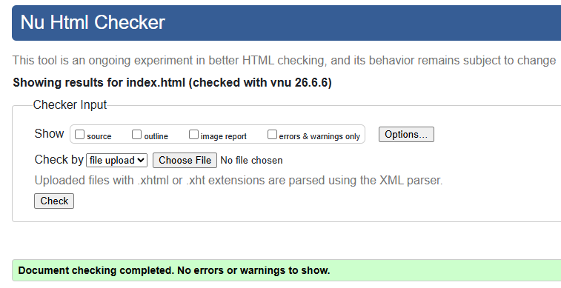
db_A4_about.html | HTML5 | W3C Nu HTML Checker | 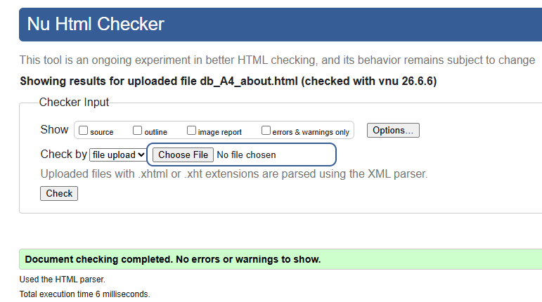
db_A4_resume.html | HTML5 | W3C Nu HTML Checker | 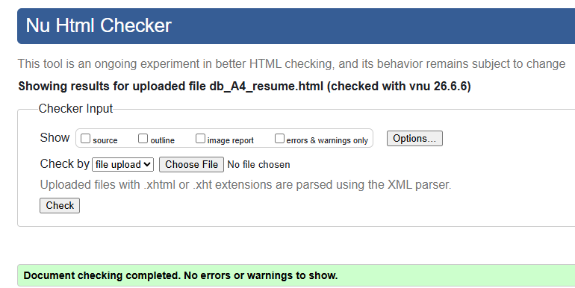
db_A4_web_skills.html | HTML5 | W3C Nu HTML Checker | 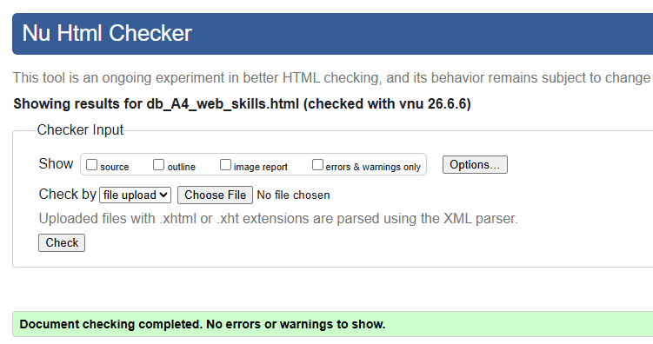
db_A4_cybersecurity_skills.html | HTML5 (new in A4) | W3C Nu HTML Checker | 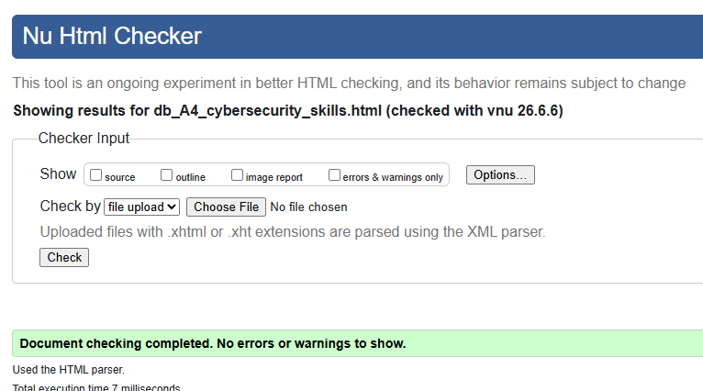
db_A4_problem_solving_skills.html | HTML5 (new in A4) | W3C Nu HTML Checker | 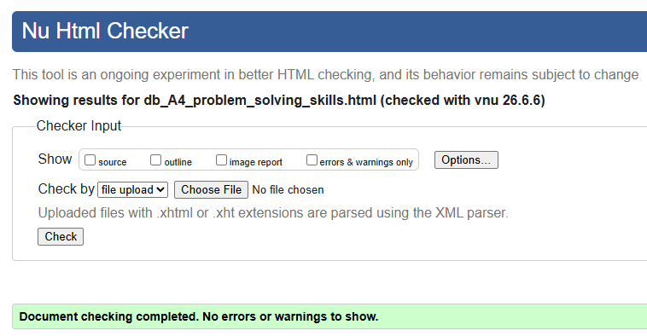
db_A4_communication_skills.html | HTML5 (new in A4) | W3C Nu HTML Checker | 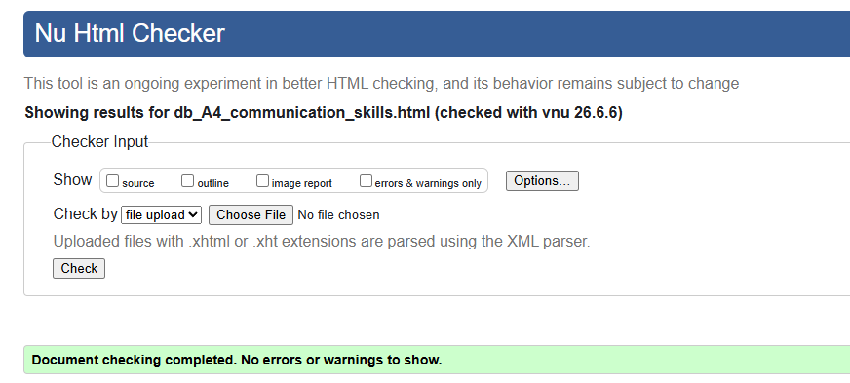
db_A4_newsletter_form.html | HTML5 (new in A4) | W3C Nu HTML Checker | 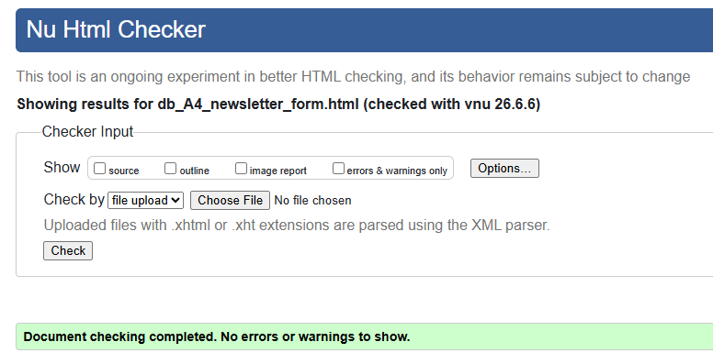
css/portfolio.css | CSS3 | W3C CSS Validator | 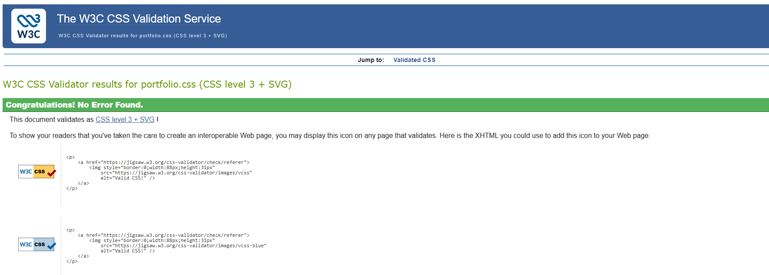

s. File sizes and naming
All files used follow the db_A4_ naming prefix that has been established in this submission. File names use lowercase letters and hyphens as word separators within the descriptive part. They also have no spaces. The naming convention is consistent across all HTML, JS, and the report document within the project portfolio. The CSS file retains the name portfolio.css as a shared asset that is not specific to any one assessment iteration.
File sizes are also kept minimal. HTML pages range from approximately 10 to 16 KB each. The CSS file is approximately 35 KB including the A4 form additions. The JavaScript file is under 3 KB. Images are the only files within this project that actually have any significant size. Though the profile photo and banner are standard web resolution JPEGs or PNGs. No unoptimised or excessively large assets are present in the portfolio whatsoever.

