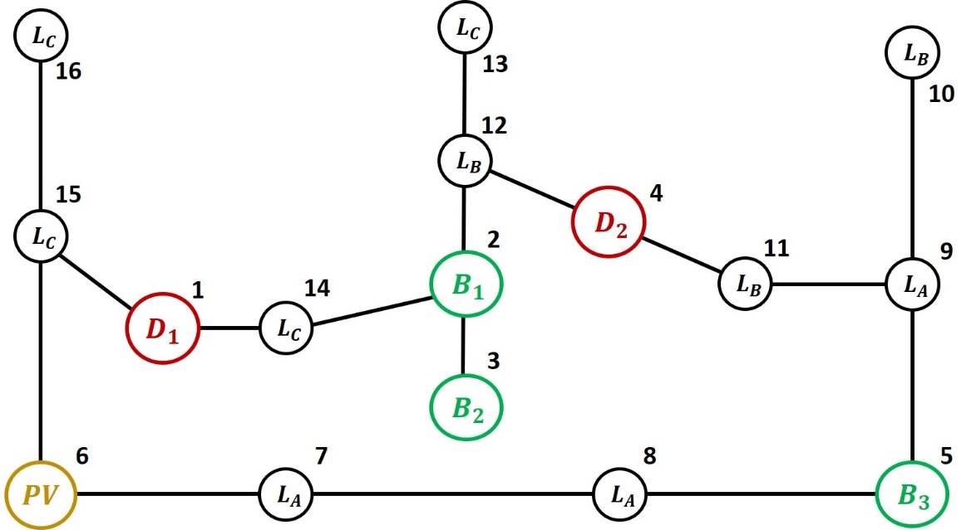

Benchmark taken from: Steven Low – Optimal Power Flow   
in Stand-Alone DC Microgrids (Stand-alone meshed configuration)

Run *plotmain.m* to see all the graphs.

Comments :

* **There are three types of ZIP loads**: A, B, C. These have different trends and they are placed in different position in the mG (see benchmark). If you run *plotmain.m* in the first two figures you find the trends of **nominal current and power**.   
  The impedance of the tree types of load is: Y_L_a = 0.7, Y_L_b = 0.6, Y_L_c = 0.8
* In the file *Initialization.m,* you find all the parameters of the simulation and the units characteristics. As you can see from the pictures there are 3 batteries, 2 dispatchable generator e 1 pv system.
* You find two sets of data: *data_HMPC_LoadMeasure.mat* and *data_HMPC_NoMeasure.mat*.  
  In the first it is assumed that the HMPC is able to measure the nominal load at the current time instant (as it is for the OPF) and it uses forecasts for the future time instants. In the second it is assumed that the HMPC relies on the forecasts also for the current time instant (i.e. open loop). Plotting the graphs it is noticeable that the voltages show smaller deviation with respect to the nominal value when the load is measurable at the current time instant.

**I would just plot in the paper the case where the load is measured at the current time instant and then forecasts are used** (*data_HMPC_LoadMeasure.mat).* Indeed, the OPF has to measure the load to compute the voltage references so also the HMPC can (and moreover the plots are nicer 😉).

Two parts are missing in the summary, in section 2.1

* The HMPC sends to the **OPF** not only the power references but also the **power constraints for the slack variables**.

For the dispatchable generators:

$ΔP_{D}^{max}\left(k\right) = P_{D}^{max} -P_{D}^{ref}(k)$ $ΔP_{D}^{min}\left(k\right)=P_{D}^{min} -P_{D}^{ref}\left(k\right)$

For the batteries:

$ΔP_{B}^{max}\left(k\right) =\min\left( P_{B}^{max}, η_{dh} \frac{C_{B } \left( S_{B}\left(k\right) -S_{B}^{min} \right)}{τ} \right) - P_{B}^{ref}\left(k\right)$

$ΔP_{B}^{min}\left(k\right) =\max\left( P_{B}^{min}, \frac{1}{η_{ch}} \frac{C_{B} \left( S_{B}\left(k\right) - S_{B}^{max } \right)}{τ } \right) - P_{B}^{ref}\left(k\right)$

For the PV system (when it is a voltage-controlled generator):

$ΔP_{PV}^{max}\left(k\right) = ΔP_{PV}^{ref}(k)$ $ΔP_{D}^{min}\left(k\right)=ΔP_{PV}^{ref}(k) -{\overline{P}}_{PV}(k)$

where $ΔP_{PV}^{ref}(k)$ is the pv power reduction committed by the HMPC.

* **The condition on the connectivity of the graph at the HMPC level**. We must state the condition using the adjacency matrix with the Boolean variables saying that it can be converted in a set of linear inequalities using Bemporad Morari approach.

Then we can say that, based on the topology of the network, also simpler conditions can be stated.

For instance, for our benchmark I stated that the both dispatchable generators cannot be switched off at the same time instant.