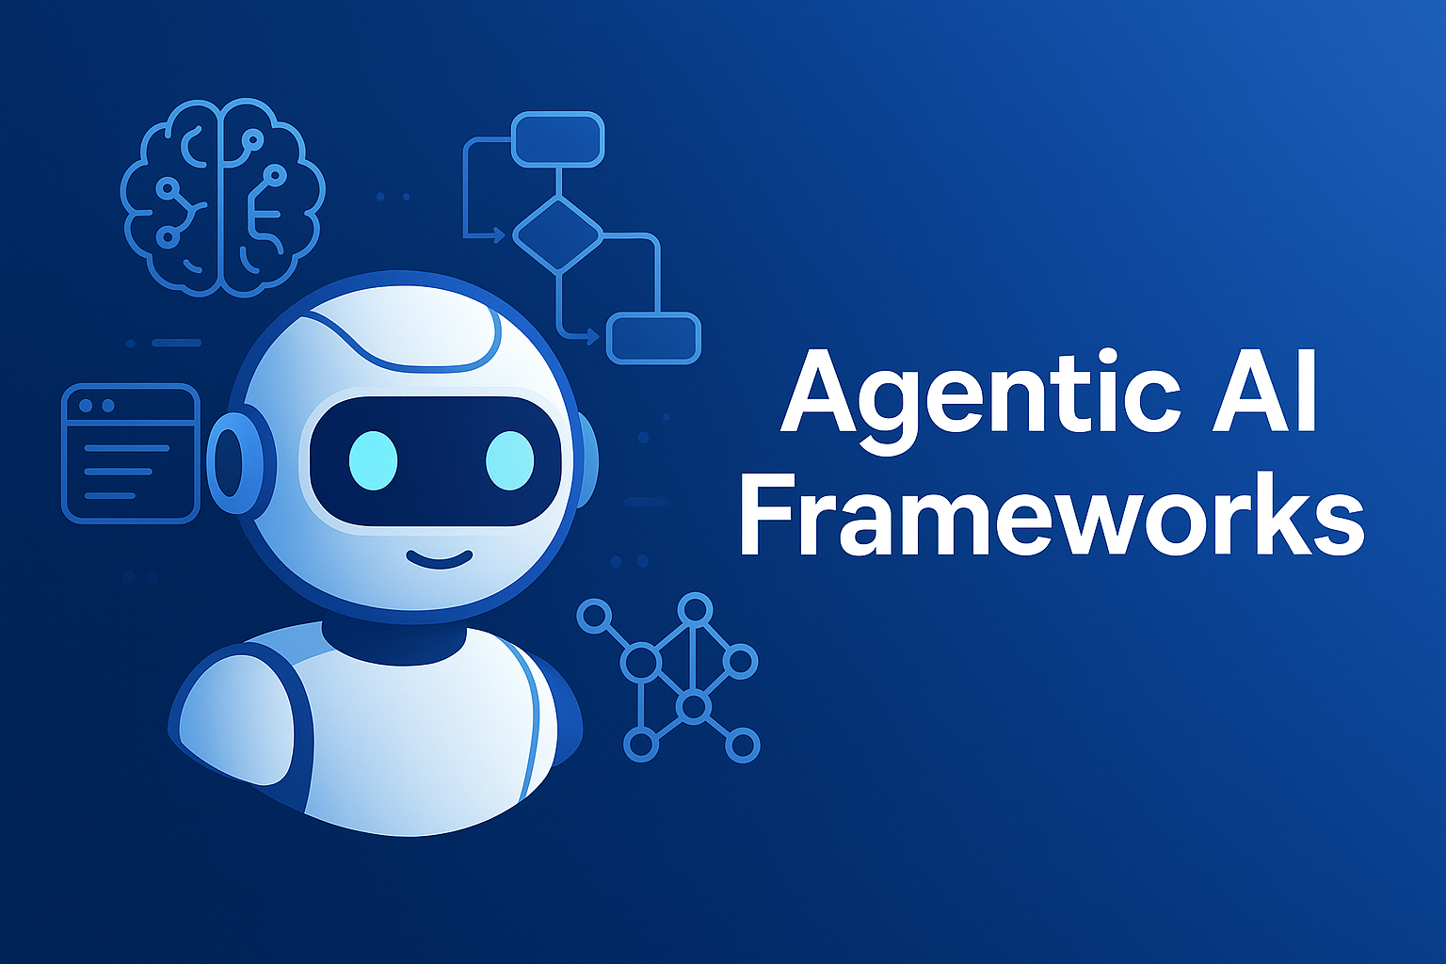

🧠 Agentic AI Frameworks:

Building Next-Gen Autonomous Agents
By Moiz Lokhandwala

Agentic AI frameworks are revolutionizing how we build intelligent systems-empowering software agents that perceive their environments, reason over tasks, call tools, and act with minimal human intervention. This blog post dives into the core architectures, leading frameworks, and best practices, complete with diagrams and real-world examples you can copy and paste.

🤔 What Is Agentic AI?
Agentic AI refers to systems designed to act autonomously, making decisions, perceiving environments, and executing tasks without human oversight. At their core are agentic frameworks, which provide:
- 🧭 Structure for perception, reasoning, planning, action, reflection
- 🔌 Integration with tools, APIs, knowledge bases
- 💾 Stateful memory and context handling
- 👥 Multi-agent orchestration for collaboration
These frameworks allow developers to channel powerful LLMs into robust, end-to-end intelligent systems.

🧩 Fundamental Architectures & Patterns
Let's explore four key architectural patterns:

1. Single-Agent Loop (ReAct Pattern)
A loop of Reason → Act → Observe → Reflect, enabling chain-of-thought reasoning mixing with tool calling.

2. Graph-Based Workflow (e.g., LangGraph)
Tasks are represented as nodes in a graph. Workflow logic flows through edges, enabling branching, agent state, and dynamic execution.

3. Multi-Agent Systems (CrewAI, AutoGen, Swarm)
A manager agent orchestrates worker agents, each handling specialized subtasks. They share insights via messaging or shared memory.

4. Hierarchical “Master-Agent” Architecture
A top-level agent delegates specialized tasks (classification, forecasting, etc.) to sub-agents, then consolidates results.

🛠️ Leading Frameworks (Spring 2025)
Framework | Focus | Highlights
LangChain / LangGraph | Graph-based single/multi workflows | Flexible tool integration, stateful logic
CrewAI | Multi-agent orchestration | Role-based agents, 700+ integrations
AutoGen (Microsoft) | Conversational multi-agent | Assistant/Proxy pattern, Docker support
OpenAI Swarm | Lightweight multi-agent | Collaboration with minimal orchestration
AutoGPT | Goal-driven autonomous loops | Iterative task decomposition
Semantic Kernel | Enterprise orchestration | Memory + function planners

✅ When to Choose Which?
- Need structured workflows + tool calls? → LangGraph, LangChain
- Building collaborative agents? → CrewAI, AutoGen, Swarm
- Want full autonomy? → AutoGPT
- Enterprise-focused? → Semantic Kernel
“CrewAI is really simple but pretty black box! I like using AutoGen with the ReAct design pattern…”

🌐 Agentic Design Patterns
According to Analytics Vidhya, the four main design patterns are:
- Reflection Pattern – Agents review and refine outputs
- Tool Use Pattern – Agents call external APIs/tools
- Planning Pattern – Break down tasks into substeps
- Multi-Agent Pattern – Multiple agents collaborate

🚧 Best Practices & Tips
- ReAct prompting: Use chain-of-thought + tool calls for accuracy
- Define exit criteria: Avoid infinite loops, enable safe stopping
- Embed memory: Use vector stores or databases for long-horizon tasks
- Start small: Prototype with a single agent + simple tools, then scale
- Human-in-the-loop: Add supervision where high risks exist

🚀 Real-World Use Cases
- Fraud detection: agents monitor transactions and adapt in real-time
- Personalized assistants: Retain preferences, access APIs and tools dynamically
- Team coordination: Manager + worker agents collaborate on complex projects

🔮 The Road Ahead
- Interoperability: Agents connecting across ecosystems—IoT, blockchain
- Explainability & Ethics: Frameworks embedding transparency
- Adaptive learning: Agents evolving with self-learning patterns
- Developer tools: IDEs and libraries like LangGraph Studio, AgentLite

Conclusion
Agentic AI frameworks turn LLMs into structured, autonomous agents capable of complex tasks. By leveraging standard patterns—ReAct, workflows, multi-agent—and choosing the right tool (LangGraph, CrewAI, AutoGen, etc.), developers can rapidly build scalable, intelligent systems. Whether you're automating workflows or building next-gen assistants, agentic frameworks are the key to operationalizing AI safely and effectively.

Author Bio



Solutions Architect | .NET & Cloud-Native Solutions | RabbitMQ, Distributed Systems, Messaging Pipelines | Helping Enterprises Scale | Engineer First, Architect Always
I'm a Solutions Architect with deep expertise in the Microsoft technology stack, specializing in .NET, C#, and scalable enterprise applications. With over 8 years of experience, I've led the design and implementation of robust, high-throughput systems across industries, focusing on distributed processing, API development, and cloud-native architectures using Azure.
Currently, I'm expanding my skillset in AI and Machine Learning, exploring how intelligent systems can be integrated into modern enterprise solutions. I’m passionate about bridging traditional software engineering with emerging AI capabilities to build smart, future-ready applications.

