**Practical -1**

**Aim:** **Perform below mentioned experiments**

**1. Creating Tables in HTML  
2. Types of Lists in HTML  
3. Working of div Tag in HTML**

**HTML Code:**

<!DOCTYPE html>

<html lang="en">

<head>

<meta charset="UTF-8">

<meta http-equiv="X-UA-Compatible" content="IE=edge">

<meta name="viewport" content="width=device-width, initial-scale=1.0">

<title>Document</title>

<style>

table,

th,

td {

border: 1px solid blue;

}

#first {

text-decoration: underline;

border: 2px solid blueviolet;

}

</style>

</head>

<body>

<h2>Table</h2>

<table>

<tr>

<th>name</th>

<th>enrollment</th>

<th>age</th>

</tr>

<tr>

<td>Elon Musk</td>

<td>25</td>

<td>20</td>

</tr>

<tr>

<td>Ronaldo</td>

<td>34</td>

<td>20</td>

</tr>

<tr>

<td>Virat Kohli</td>

<td>511</td>

<td>22</td>

</tr>

</table>

<div id="first">

<h2>ordered list</h2>

<ol type="A">

<li>Elon Musk</li>

<li>Ronaldo</li>

<li>Virat Kohli</li>

<li>Decostar Sharma</li>

<h2>unordered list</h2>

<ul type="square">

<li>Elon Musk</li>

<li>Ronaldo</li>

<li>Virat Kohli</li>

<li>Decostar Sharma</li>

</ul>

</div>

</body>

</html>

**Output Screenshot:**

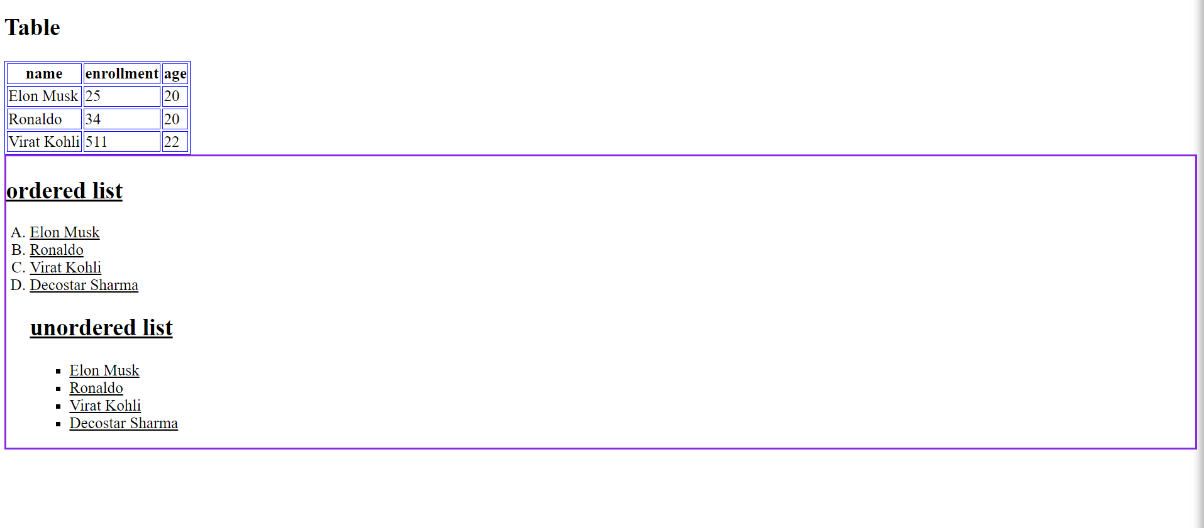

**Practical -2**

**Aim: Develop the following Program Using HTML5 CANVAS   
1. Develop the Different basic Graphical Shapes using HTM5 CANVAS  
2. Develop the Different Advanced Graphical Shapes using HTM5 CANVAS**

**HTML Code:**

<!DOCTYPE html>

<html lang="en">

<head>

<meta charset="utf-8">

<title>Drawing a Circle on the Canvas</title>

<style>

canvas {

border: 1px solid #000;

}

</style>

<script type="text/javascript">

function round() {

var canvas = document.getElementById("myCanvas1");

var context = canvas.getContext("2d");

context.arc(150, 100, 70, 0, 2 * Math.PI, false);

context.stroke();

canvas = document.getElementById("myCanvas2");

context = canvas.getContext("2d");

context.lineWidth = 10;

context.strokeStyle = "orange";

context.lineCap = "round";

context.arc(150, 150, 80, 1.2 * Math.PI, 1.8 * Math.PI, false);

context.stroke();

canvas = document.getElementById("myCanvas3");

context = canvas.getContext("2d");

context.moveTo(50, 150);

context.lineTo(250, 50);

context.stroke();

canvas = document.getElementById("myCanvas4");

context = canvas.getContext("2d");

context.rect(50, 50, 200, 100);

context.stroke();

canvas = document.getElementById("myCanvas5");

context = canvas.getContext("2d");

context.rect(50, 50, 200, 100);

context.fillStyle = "#FB8B89";

context.fill();

context.lineWidth = 5;

context.strokeStyle = "black";

context.stroke();

canvas = document.getElementById("myCanvas6");

context = canvas.getContext("2d");

context.arc(150, 100, 70, 0, 2 * Math.PI, false);

context.fillStyle = "#FB8B89";

context.fill();

context.lineWidth = 5;

context.strokeStyle = "black";

context.stroke();

canvas = document.getElementById('myCanvas7');

context = canvas.getContext('2d');

context.fillStyle = 'gray';

var points = [[0, 85], [75, 75], [100, 10], [125, 75],

[200, 85], [150, 125], [160, 190], [100, 150],

[40, 190], [50, 125], [0, 85]];

var len = points.length;

context.beginPath();

context.moveTo(points[0][0], points[0][1]);

for (var i = 0; i < len; i++) {

context.lineTo(points[i][0], points[i][1]);

}

context.fill();

canvas = document.getElementById('myCanvas8');

context = canvas.getContext('2d');

context.lineWidth = 3;

context.fillStyle = 'gray';

context.beginPath();

context.arc(90, 90, 60, 0, 2 * Math.PI);

context.stroke();

context.beginPath();

context.arc(120, 150, 60, 0, 2 * Math.PI);

context.stroke();

context.beginPath();

context.arc(150, 100, 60, 0, 2 * Math.PI);

context.stroke();

context.globalCompositeOperation = 'destination-out';

context.beginPath();

context.arc(90, 90, 60, 0, 2 * Math.PI);

context.fill();

context.beginPath();

context.arc(120, 150, 60, 0, 2 * Math.PI);

context.fill();

context.beginPath();

context.arc(150, 100, 60, 0, 2 * Math.PI);

context.fill();

};

</script>

</script>

</head>

<body onload="round()">

<h1>Basic Shapes</h1>

<canvas id="myCanvas1" width="300" height="200"></canvas>

<canvas id="myCanvas2" width="300" height="200"></canvas>

<canvas id="myCanvas3" width="300" height="200"></canvas>

<canvas id="myCanvas4" width="300" height="200"></canvas>

<h1>Advance Shapes </h1>

<canvas id="myCanvas5" width="300" height="200"></canvas>

<canvas id="myCanvas6" width="300" height="200"></canvas>

<canvas id="myCanvas7" width="300" height="200"></canvas>

<canvas id="myCanvas8" width="300" height="200"></canvas>

</body>

</html>

**Output Screenshot:**

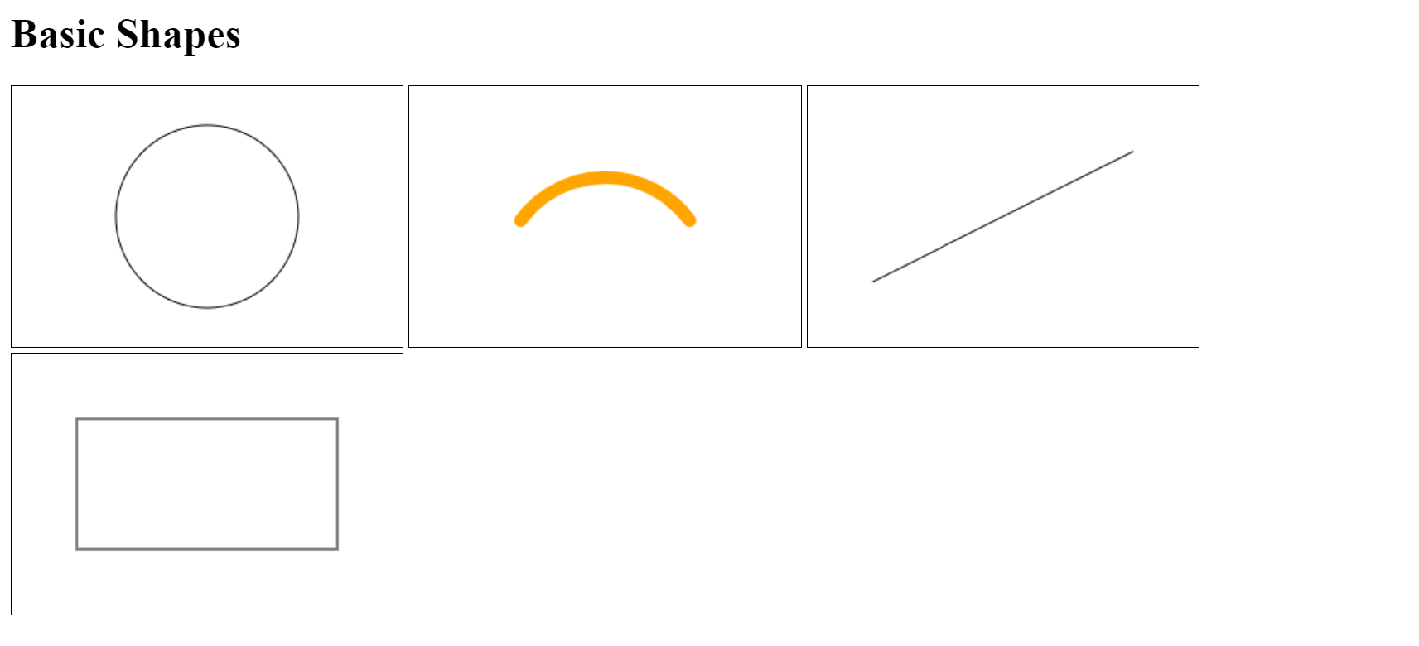

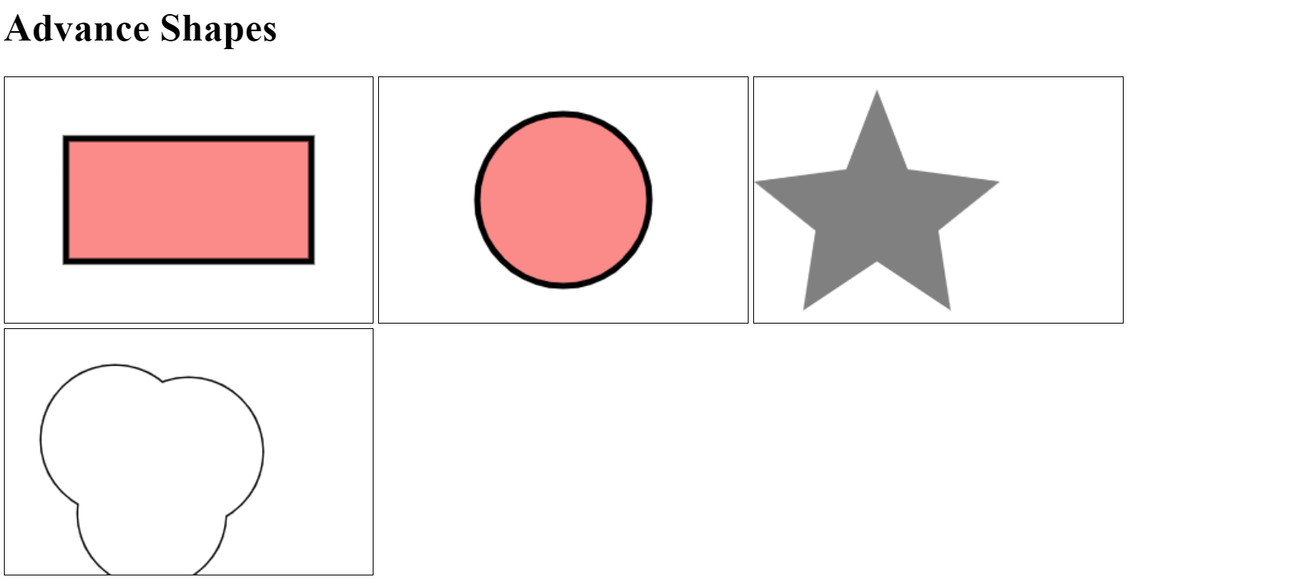

**Practical -3**

**Aim:** **Develop the following Program Using HTML5 SVG TAG  
1. Develop the Different basic Graphical Shapes using HTM5 SVG  
2. Develop the Different Advanced Graphical Shapes using HTM5 SVG**

**HTML Code:**

<!DOCTYPE html>

<html>

<body>

<div>

<h1>Basic Graphical Shapes</h1>

<svg width="100" height="100" style="margin-left:50px">

<circle cx="50" cy="50" r="40" stroke="green" stroke-width="4" fill="yellow" />

</svg>

<svg width="500" height="100" style="margin-left:50px">

<rect width="400" height="100" style="fill:rgb(0,0,255);stroke-width:10;stroke:rgb(0,0,0)" />

</svg>

<svg height="140" width="500">

<ellipse cx="200" cy="80" rx="100" ry="50" style="fill:yellow;stroke:purple;stroke-width:2" />

</svg>

<svg height="210" width="210" style="margin-left:50px; margin-top:20px">

<line x1="0" y1="0" x2="200" y2="200" style="stroke:rgb(255,0,0);stroke-width:2" />

</svg>

</div>

<div>

<h1>Advance Graphical Shapes</h1>

<svg width="300" height="200">

<polygon points="100,10 40,198 190,78 10,78 160,198"

style="fill:blue;stroke:gold;stroke-width:5;fill-rule:evenodd;" />

</svg>

<svg height="180" width="500" style="margin-left:50px">

<polyline points="0,40 40,40 40,80 80,80 80,120 120,120 120,160"

style="fill:white;stroke:red;stroke-width:4" />

</svg>

<svg style="margin-top:50px">

<polygon points="50,5 100,5 125,30 125,80 100,105

50,105 25,80 25, 30" style="stroke:#660000; fill:#cc3333; stroke-width: 3;" />

</svg>

</div>

</body>

</html>

**Output Screenshot:**

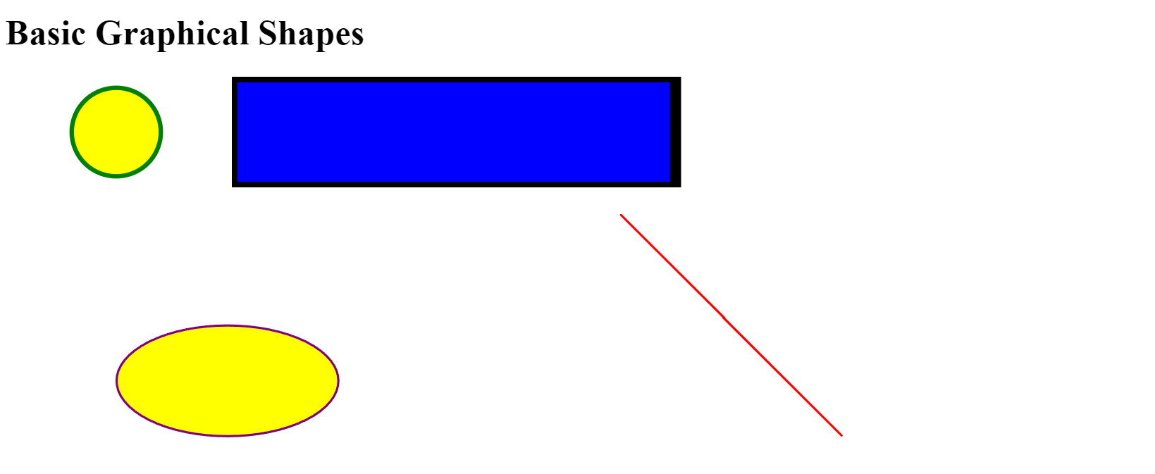

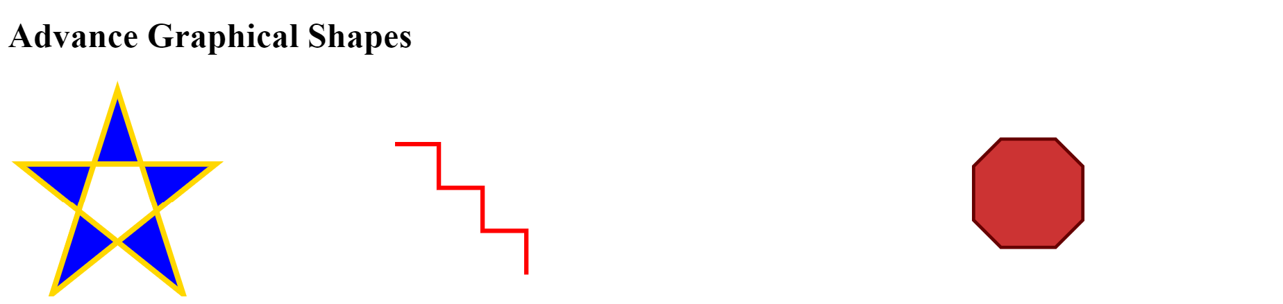

**Practical -4**

**Aim:** **Write a JavaScript and html code for performing below mentioned tasks:  
1. Read a local .txt file using html code and JavaScript and display using alert.  
2. Read the data .txt file and draw unordered list  
3. Read the data .txt file and draw Data Table**

**HTML Code:**

<!doctype html>

<html>

<head>

<meta charset="UTF-8">

<script src="http://code.jquery.com/jquery-latest.js"></script>

<style>

table {

border: 2px solid black;

}

td {

border: 1px solid black;

}

</style>

</head>

<body>

<div>

<ul id="DataUL"></ul>

<table id="Datatable"></table>

</div>

</body>

<script>

$(document).ready(function () {

$.get('sample.txt', function (theData) {

console.log(theData)

theItems = theData.split('\n');

var theList = '';

var theListItem;

for (i = 0; i < theItems.length; i++) {

theListItem = '<li>' + theItems[i] + '</li>';

theList = theList + theListItem;

};

alert(theData)

$('#DataUL').html(theList);

});

});

$(document).ready(function () {

$.get('sample.txt', function (data) {

theItems = data.split('\n');

var t = '<tr><th>Name</th><th>Country</th</tr>';

var tItem;

for (i = 0; i < theItems.length; i++) {

t += '<tr>';

tItem = '<td>' + theItems[i] + '</td>';

t += tItem;

if (i == 0) {

t += '<td>' + 'America' + '</td>';

} else if (i == 1) {

t += '<td>' + 'Portugese' + '</td>';

} else {

t += '<td>' + 'India' + '</td>';

}

t += '</tr>';

};

$('#Datatable').html(t);

});

});

</script>

</html>

**Output Screenshot:**

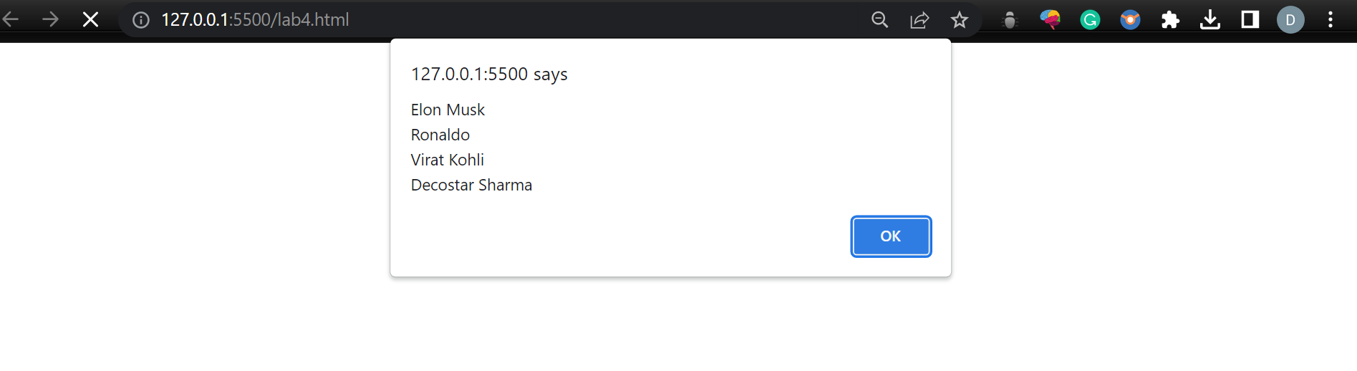

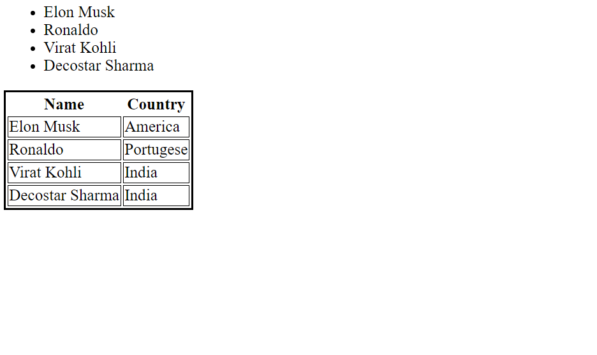

**Practical -5**

**Aim:** **Write a JavaScript, jQuery and html code for performing below mentioned tasks:  
1. Read a local .csv file and display content using alert  
2. Read the data .csv file and create a query for drawing a Data Table, display the query using alert and finally display the table on your webpage**

**HTML Code:**

<!DOCTYPE html>

<html lang="en">

<head>

<meta charset="UTF-8">

<style>

body {

background-color: linen;

}

table {

border: 2px solid green;

}

td {

border: 1px solid black;

}

</style>

<!-- for jquery -->

<script src="https://ajax.googleapis.com/ajax/libs/jquery/3.6.3/jquery.min.js"></script>

<!-- for rading csv files -->

<script src="https://cdnjs.cloudflare.com/ajax/libs/jquery-csv/0.71/jquery.csv-0.71.min.js"></script>

</head>

<body>

<table id="hellocsv" height="500" width="500"></table>

<script>

$(document).ready(function () {

$.ajax({

type: "GET",

url: "local.csv",

dataType: "text",

success: function (response) {

console.log(response, typeof (response))

var contentObj = $.csv.toArrays(response);

console.log(contentObj);

alert(response);

$("#hellocsv").append(createTable(contentObj));

}

})

})

function createTable(data) {

var html = "";

for (var item in data) {

html += "<tr>";

for (var row in data[item]) {

html += "<td>" + data[item][row] + "</td>";

}

html += "</tr>"

}

return html;

}

</script>

</body>

</html>

**Output Screenshot:**

