***20BAI1155 (L43-44)***

**CSE3002**

**LAB Week 1 – HTML Basics**

**HTML Code:**

<!DOCTYPE html>

<html lang="en">

<head>

    <meta name="viewport" content="width=device-width, initial-scale=1.0">

    <title>This is my first webpage</title>

</head>

<body style="background-color: rgb(131, 39, 39);">

    <br>

    <p style="color: whitesmoke;">

        <img ali src="D:\Pics\Me\Terminal 1 (edit) - Copy - Copy.jpg" alt="no image found" width="100" height="125">

        Hello, I'm <u>Tirtha Sankar Nandy</u> and I'm a college sophomore. Due to my interests in the <em>digital field</em> I've been pursuing <strong>Computer Science</strong> degree.

        I live in <em> Tinsukia, Assam</em> and my mother tongue is <em>bengali.</em> My family consists of 6 members.

        My personal interests vary from solving puzzles to reading <strong>thriller stories</strong>. I also like to play <strong>table tennis</strong> and I'm a fan of <strong>football</strong>.

    </p>

    <h2 style="color: rgb(172, 206, 179);font-family: Tahoma;">Tirtha Sankar Nandy</h2>

    <p style="color: whitesmoke;">

        Cristiano Ronaldo <br>

        Son Hyung <br>

        Mohammed Salah <br>

        Thiago Alcântara <br>

        Mason Mount <br>

        Kevin De Bruyne <br>

        Virgil van Dijk <br>

        Trent Alexander-Arnold <br>

        João Cancelo <br>

        Jürgen Klopp

    </p>

    <pre style="color: whitesmoke;">

        W             W   EEEEEEEEE   EEEEEEEEE   K     KK      11

         W     W     W    E           E           K  KK        111

          W   W W   W     EEEEEE      EEEEEE      KK             1

           W W   W W      E           E           K  KK          1

            W     W       EEEEEEEEE   EEEEEEEEE   K     KK     11111

    </pre>

    <p style="color: whitesmoke;">Some interesting websites I usually visit: <br>

        <a style="color: whitesmoke;" href="https://towardsdatascience.com/" target="_blank">To find articles</a> <br>

        <a style="color: whitesmoke;" href="https://colorhunt.co/" target="_blank">To find colors</a> <br>

        <a style="color: whitesmoke;" href="https://b-ok.asia/?signAll=1" target="_blank">To find books</a>

    </p>

    <img src="C:\Users\Tirtha\Downloads\html_tag_bg.jfif" alt="no image found" width="300" height="300">

</body>

</html>

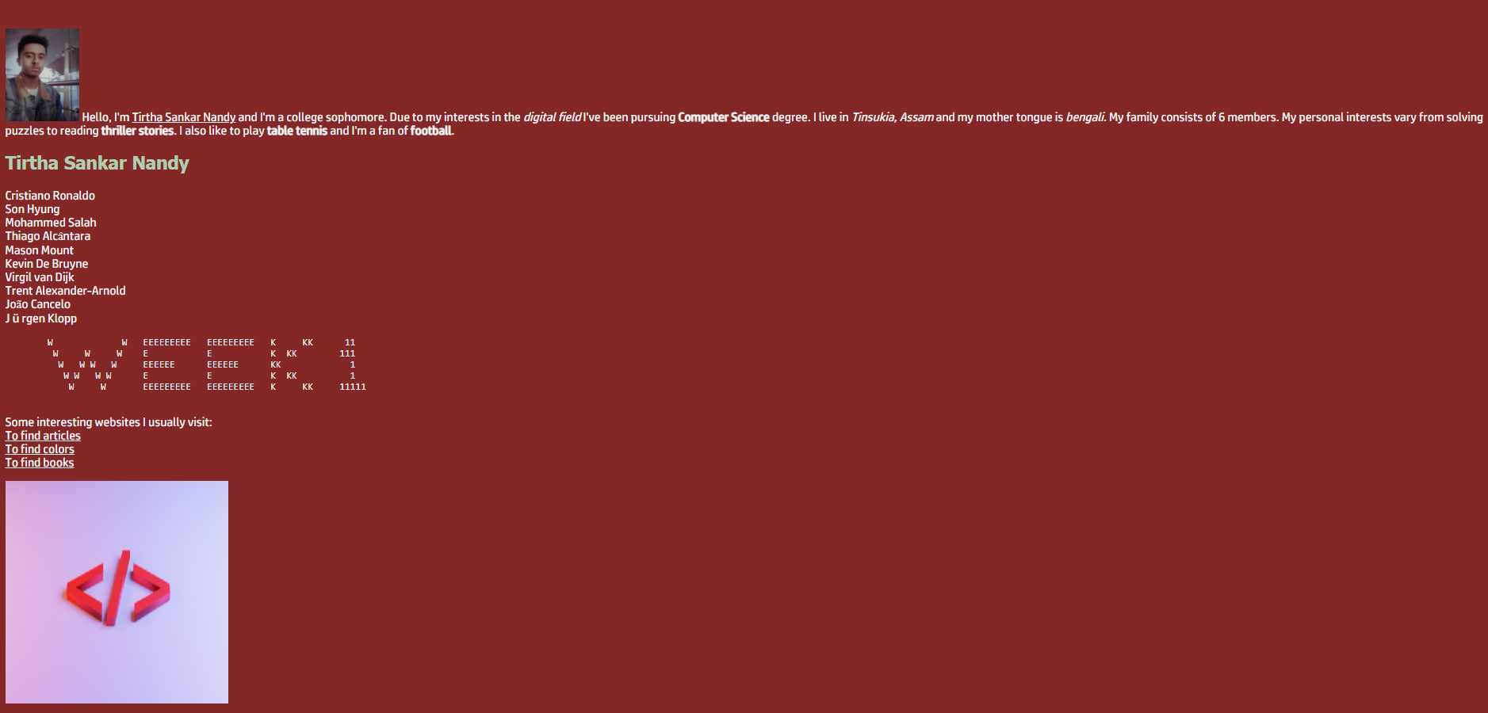**OUTPUT**

