***20BAI1155 (L43-44)***

**CSE3002**

**LAB Week 2 – HTML Basics cont.**

**HTML Code:**

<!DOCTYPE html>

<html lang="en">

<head>

    <meta charset="UTF-8">

    <title>Apple</title>

    <style>

        p {

            padding: 0%;

            margin: 1%;

            text-align: center;

            font-family: Trebuchet MS;

        }

        a {

            color: steelblue;

            text-decoration: none;

            font-style: italic;

        }

        hr {

            margin-top: 40px;

            margin-bottom: 40px;

        }

        span {

            color: black;

            font-weight: bold;

        }

        map {

            display: inline;

        }

        .centre {

            margin-left: auto;

            margin-right: auto;

        }

        td {

            font-family: Trebuchet MS;

        }

        button {

            background-color: grey;

            border: none;

            color: whitesmoke;

            padding: 8px 12px;

            border-radius: 10px;

            text-align: center;

            text-decoration: none;

            font-family: Trebuchet MS;

            display: inline-block;

            font-size: 100%;

            margin: auto;

            cursor: pointer;

        }

    </style>

</head>

<body style="background-color: whitesmoke;">

    <table>

        <tr>

            <td style="width: 100%; text-align: center; text-indent: 151.8px;"><p style="font-size: 350%; font-weight: bold;">Apple Store</p></td>

            <td><img src="D:\~ STADEE ~\Sem 4\CSE3002 Lab - IWP\Week 2 - HTML\pics\shopping_bag.png" alt="Apple logo" height="61.2px" width="60px" usemap="#store"></td>

            <td><img src="D:\~ STADEE ~\Sem 4\CSE3002 Lab - IWP\Week 2 - HTML\pics\apple_logo.png" alt="Shopping Bag" height="61.2px" width="91.8px" usemap="#apple"></td>

        </tr>

    </table>

    <p style="color: grey; font-size: 200%; font-weight: bold; margin-top: 0%; padding: 0%;"><span>Store.</span> The best way to buy the products you love.</p>

    <br><br>

    <p style="color: grey; width: 70%; margin: auto;"><span>Apple</span> is one of the leading branding companies in the world. Apple was founded in 1976 by <span><a href="https://en.wikipedia.org/wiki/Steve_Jobs" target="_blank">Steve Jobs</a></span>, <span><a href="https://en.wikipedia.org/wiki/Steve_Wozniak" target="_blank">Steve Wozniak</a></span> and <span><a href="https://en.wikipedia.org/wiki/Ronald_Wayne" target="_blank">Ronald Wayne</a></span>. The iPhone is a smartphone created by Apple that was announced on January 9, 2007.</p>

    <hr style="color: grey; text-align: center; width: 10%; border: none; border-top: dotted 15px; margin-top: 40px;">

    <p style="color: grey; font-size: 150%; font-weight: bold;">Get to know your new <span style="font-size: 120%;"><a href="https://www.apple.com/in/shop/buy-iphone" style="color: black; font-style: normal;" target="_blank">iPhone</a></span></p>

    <table class="centre" style="border-spacing: 40px; width: 80%;">

        <tr>

            <td><img src="D:\~ STADEE ~\Sem 4\CSE3002 Lab - IWP\Week 2 - HTML\pics\13pro.jpg" alt="iPhone 13 Pro" usemap="#13pro"></td>

            <td><img src="D:\~ STADEE ~\Sem 4\CSE3002 Lab - IWP\Week 2 - HTML\pics\13.jpg" alt="iPhone 13" usemap="#13"></td>

            <td><img src="D:\~ STADEE ~\Sem 4\CSE3002 Lab - IWP\Week 2 - HTML\pics\12.jpg" alt="iPhone 12" usemap="#12"></td>

            <td><img src="D:\~ STADEE ~\Sem 4\CSE3002 Lab - IWP\Week 2 - HTML\pics\SE.jpg" alt="iPhone SE" usemap="#SE"></td>

        </tr>

        <tr>

            <td>

                <table style="border-collapse: separate; border-spacing: 10px;">

                    <tr>

                        <td>From &#8377 119900</td>

                        <td><button class="button" onclick="document.location='https://www.apple.com/in/shop/buy-iphone/iphone-13-pro'">Buy</button></td>

                    </tr>

                </table>

            </td>

            <td>

                <table style="border-collapse: separate; border-spacing: 10px;">

                    <tr>

                        <td>From &#8377 69900</td>

                        <td style="text-align: right;"><button class="button" onclick="document.location='https://www.apple.com/in/shop/buy-iphone/iphone-13'">Buy</button></td>

                    </tr>

                </table>

            </td>

            <td>

                <table style="border-collapse: separate; border-spacing: 10px;">

                    <tr>

                        <td>From &#8377 59900</td>

                        <td><button class="button" onclick="document.location='https://www.apple.com/in/shop/buy-iphone/iphone-12'">Buy</button></td>

                    </tr>

                </table>

            </td>

            <td>

                <table style="border-collapse: separate; border-spacing: 10px;">

                    <tr>

                        <td>From &#8377 39900</td>

                        <td><button class="button" onclick="document.location='https://www.apple.com/in/shop/buy-iphone/iphone-se'">Buy</button></td>

                    </tr>

                </table>

            </td>

        </tr>

    </table>

    <map name="apple">

        <area shape="circle" coords="30,30,20" href="https://www.apple.com/in/" alt="Apple India" target="_blank">

    </map>

    <map name="store">

        <area shape="rect" coords="1,1,90,60" href="https://www.apple.com/in/store" alt="Apple Store" target="_blank">

    </map>

    <map name="13pro">

        <area shape="rect" coords="2,2,178,250" href="https://www.apple.com/in/iphone-13-pro/" alt="Apple Store" target="_blank">

    </map>

    <map name="13">

        <area shape="rect" coords="2,2,167,244" href="https://www.apple.com/in/iphone-13/" alt="Apple Store" target="_blank">

    </map>

    <map name="12">

        <area shape="rect" coords="2,2,164,242" href="https://www.apple.com/in/iphone-12/key-features/" alt="Apple Store" target="_blank">

    </map>

    <map name="SE">

        <area shape="rect" coords="2,2,148,235" href="https://www.apple.com/in/iphone-se/" alt="Apple Store" target="_blank">

    </map>

</body>

</html>

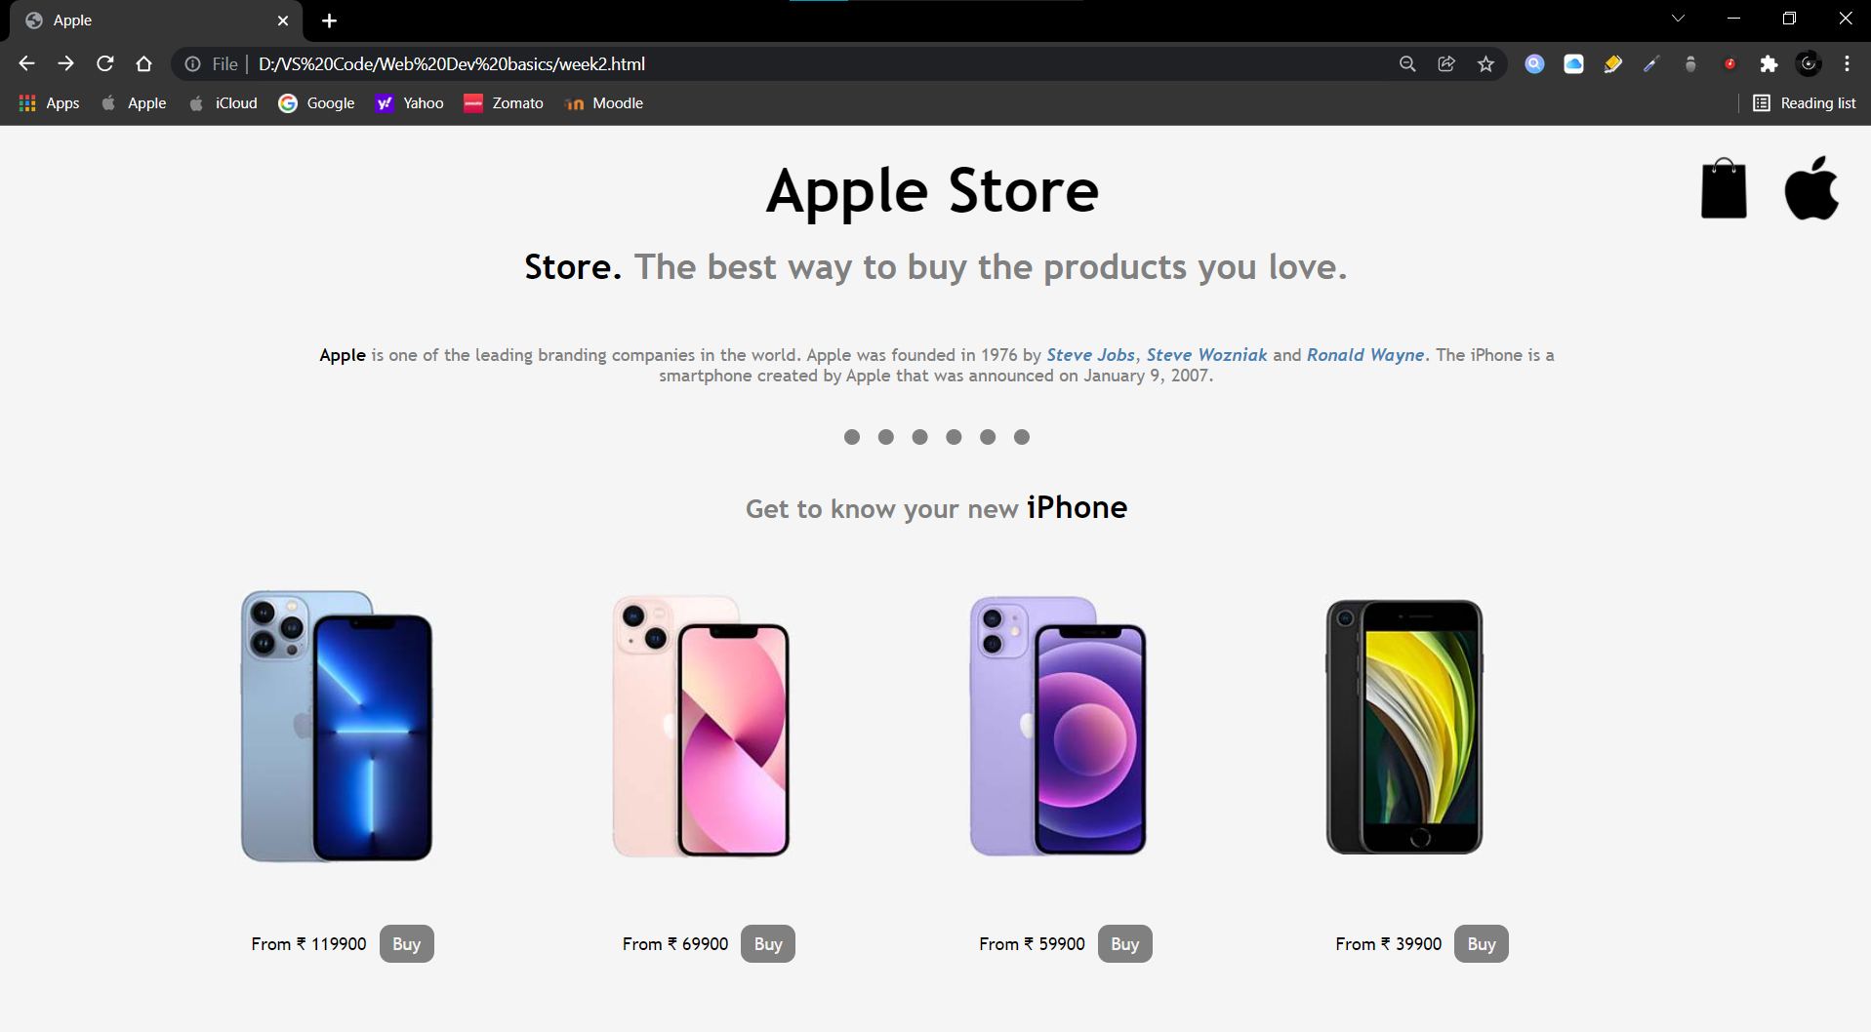**OUTPUT:**

**Note: The two logos on the top right, italicized names with blue color in the paragraph, the text ‘iPhone’, all the iPhone pictures and ‘buy’ buttons are functional and lead to their corresponding websites when clicked.**