***20BAI1155 (L43-44)***

**CSE3002**

**LAB Week 3 – HTML cont.**

**HTML Code:**

**Registration Page**

<!DOCTYPE html>

<html lang="en">

<head>

    <meta charset="UTF-8">

    <title>Himalaya Cycling 2022</title>

    <style>

        body {

            background-color: rgb(20, 20, 20);

        }

        p {

            color: whitesmoke;

            text-align: center;

            font-family: Trebuchet MS;

            margin: fit-content;

        }

        br {

            line-height: 120;

        }

        fieldset {

            border: none;

            text-align: center;

            font-size: 25px;

            font-family: Trebuchet MS;

            color: whitesmoke;

        }

        input[type=text] {

            background-color: transparent;

            color: whitesmoke;

            font-size: 25px;

            border: none;

            border-bottom: 2px solid rgb(240, 240, 240);

        }

        input[type=submit] {

            background-color: rgb(151, 230, 33);

            border: none;

            border-radius: 5%;

            color: rgb(46, 46, 46);

            font-size: 20px;

            font-weight: bold;

            font-family: Trebuchet MS;

            padding: 10px 20px;

            text-decoration: none;

            margin: 4px 2px;

            cursor: pointer;

        }

    </style>

</head>

<body>

    <p style="font-size: 70px; margin-top: 25px; margin-bottom: 10px;"> <span style="color: orange;">Republic</span> <span style="color: white;">Day</span> <span style="color: greenyellow;">Challenge</span></p>

    <p style=" font-size: 60px; margin-top: 5px; margin-bottom: 50px;">2022</p>

    <p style="font-size: 15px; font-style: italic; font-weight: 100;">In this winter of new year, get ready to participate in Republic Day Challenge. Get <span style="color: orange;">"Netaji Subhas Chandra Bose Tribute Medal"</span>.</p>

    <br>

    <p style="font-size: 25px; font-weight: bold;">If you are daring to compete, then register below.</p>

    <!-- &emsp; -->

    <form method="POST" action="week3.5.html">

        <fieldset>

            <label for="fname">First Name &emsp;&emsp;</label>

            <input type="text" id="fname" value="" name="fname"> <br><br>

            <label for="lname">Last Name &emsp;&emsp;</label>

            <input type="text" id="lname" value="" name="lname"> <br><br><br>

            <label for="sport">Choose your sport:&emsp;&emsp;</label>

            <input list="sports" id="sport" value="" name="sport">

            <datalist id = "sports">

                <option value="Marathon">

                <option value="Biking">

                <option value="Climbing">

            </datalist> <br><br>

            <label for="button"></label>

            <input type="submit" value="Register">

        </fieldset>

    </form>

    <br><br>

    <p style="font-size: 10px; font-style: italic; font-weight: 100;"><span style="color: orange;">Venue:</span> ABC Park, New Delhi &emsp; <span style="color: orange;">Timing:</span> 26th Jan 2022, 10 a.m. to 2 p.m.</p>

</body>

</html>

**Redirect Page (containing sample video)**

<!DOCTYPE html>

<html lang="en">

<head>

    <meta charset="UTF-8">

    <meta http-equiv="X-UA-Compatible" content="IE=edge">

    <meta name="viewport" content="width=device-width, initial-scale=1.0">

    <title>Himalaya Cycling 2022</title>

    <style>

        body {

            background-color: rgb(20, 20, 20);

        }

        video {

            width: 70%;

        }

    </style>

</head>

<body>

    <video>

        <source src="C:\Users\Tirtha\Downloads\Boat_13.mp4" type="video/mp4">

    </video>

</body>

</html>

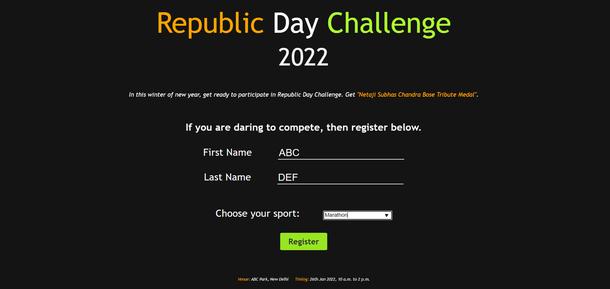**OUTPUT:**

