***20BAI1155 (L43-44)***

**CSE3002**

**LAB Week 6 – Javascript (Strings, arrays)**

**HTML Code:**

<!DOCTYPE html>

<html lang="en">

<head>

    <meta charset="UTF-8">

    <title>Week 6</title>

</head>

<body>

    <p style="font-size: 20px;">1.</p>

    <p>Enter number:</p>

    <input id=number></input>

    <button type="button" onclick="add_asteriks()">OK</button>

    <p id="*"></p>

    <script src = "asterisk.js">

    </script>

    <br>

    <p style="font-size: 20px;">2.</p>

    <p>Enter values:</p>

    <input id="name"></input>

    <br><br>

    <button type="button" onclick="add_array()">Get Value</button>

    <br><br>

    <button type="button" onclick="display_array()">Show array</button>

    <p id="show"></p>

    <button type="button" onclick="display_second_largest()">Show 2nd largest</button>

    <p id="second"></p>

    <script src="second_largest.js">

    </script>

    <br>

    <p style="font-size: 20px;">3.</p>

    <p>Enter a string:</p>

    <input id="string"></input>

    <button type="button" onclick="get_string()">Get string</button>

    <br><br>

    <p>Enter end character:</p>

    <input id="char"></input>

    <button type="button" onclick="get_char()">Get character</button>

    <br><br>

    <p>Words ending with end character: </p>

    <button type="button" onclick="find_words()">See words</button>

    <p id="words"></p>

    <script src="end_words.js">

    </script>

</body>

</html>

**JS Code:**

**1.**

function add_asteriks() {

    var n, res;

    n = parseInt(document.getElementById("number").value);

    const str = n.toString();

    res = str[0];

    for(let x=1; x<str.length; x++) {

        if((str[x-1]%2 === 1) && (str[x]%2 === 1)) {

            res += "*" + str[x];

        }

        else {

            res += str[x];

        }

    }

    document.getElementById("*").innerHTML = res;

}

**2.**

var array = new Array();

var x=0;

function add_array() {

    array[x] = parseInt(document.getElementById("name").value);

    x++;

    document.getElementById('name').value = '';

}

function display_array() {

    var text = "";

    for (var i=0; i<array.length; i++) {

        text += array[i] + ", ";

    }

    text = text.substring(0, text.length - 2);

    document.getElementById("show").innerHTML = text;

}

function display_second_largest() {

    var m = Math.max(...array);

    array = array.filter(e => e != m);

    document.getElementById("second").innerHTML = Math.max(...array);

}

**3.**

var str, c;

function get_string() {

    str = document.getElementById("string").value;

}

function get_char() {

    c = document.getElementById("char").value;

}

function find_words() {

    var words = str.split(" "), res = [], x = 0, r = "";

    for (var i = 0; i < words.length; i++) {

        if (words[i].endsWith(c)) {

            res[x++] = words[i];

        }

    }

    for (var i = 0; i < res.length; i++) {

        r += res[i] + ", ";

    }

    r = r.substring(0, r.length - 2);

    document.getElementById("words").innerHTML = r;

}

**Output format:**

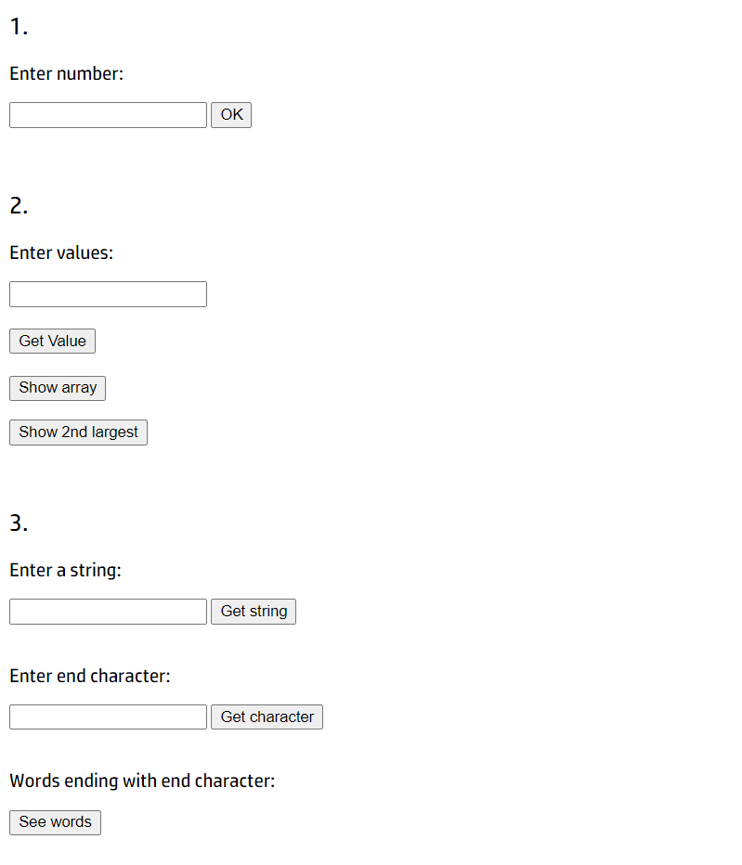

**Outputs (with inputs):**

