***20BAI1155 (L43-44)***

**CSE3002**

**LAB Week 7 – JavaScript**

**HTML Code:**

**<!DOCTYPE *html*>**

**<html *lang*="en">**

**<head>**

**<meta *charset*="UTF-8">**

**<link *rel*="stylesheet" *href*="D:\VS Code\Web Dev basics\css\week7.css">**

**<title>Week 7</title>**

**</head>**

**<body>**

**<h4>Form validation</h4>**

**<form *action*="">**

**<table *style*="background-color: skyblue;">**

**<tr>**

**<td><label *for*="card">Card ID</label></td>**

**<td><input *id*="card"></td>**

**<td *id*="num"></td>**

**</tr>**

**<tr>**

**<td><label *for*="nameoncard">Card name</label></td>**

**<td><input *id*="nameoncard"></td>**

**<td *id*="n"></td>**

**</tr>**

**<tr>**

**<td><label *for*="price">Price</label></td>**

**<td><input *id*="price"></td>**

**<td *id*="pr"></td>**

**</tr>**

**<tr>**

**<td><label *for*="mfg">Mfg Date</label></td>**

**<td><input *id*="mfg"></td>**

**<td *id*="manufac"></td>**

**</tr>**

**<tr *style*="padding-right: 1px;" *id*="1">**

**<td><label *for*="engine">Engine</label></td>**

**<td><input *type*="radio">Petrol</td>**

**<td><input *type*="radio">Diesel</td>**

**</tr>**

**</table>**

**</form>**

**<br>**

**<button *type*="button" *onclick*="validate()">Validate</button>**

**<br><br>**

**<div *id*="o" *style*="color: green;"></div>**

**<script *src*="validationCheck.js">**

**</script>**

**</body>**

**</html>**

**CSS Code:**

**table {**

**padding: 8px 12px 12px;**

**border: none;**

**border-radius: 10px;**

**}**

**td {**

**padding-top: 3px;**

**padding-bottom: 3px;**

**}**

**tr[id="1"] {**

**width: 20px;**

**}**

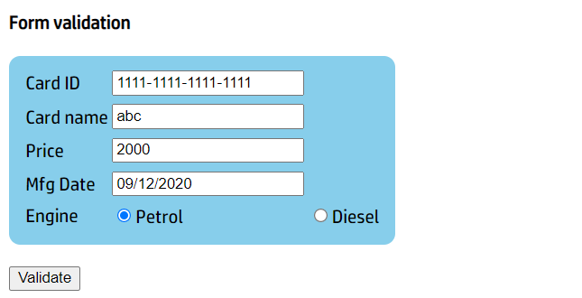**Output**

