***20BAI1155 (L43-44)***

**CSE3002**

**LAB Week 9 – AJAX (Data requesting using localhost)**

**HTML Code:**

**<html *lang*="en">**

**<head>**

**<title>Searching a substring using AJAX</title>**

**</head>**

**<body>**

**<?php**

**$conn = mysqli_connect("localhost:3307");**

**?>**

**<h1>Data request using AJAX</h1>**

**<p *style*="font-size: 25px;">Enter a string you request to search:</p>**

**<input *type*="text" *id*="str">**

**<button  *type*="button" *onclick*="createReq()">Request</button>**

**<br><br><br>**

**<div *id*="print_text"></div>**

**<div *id*="search"></div>**

**<div *id*="length"></div>**

**<script *src*="string_search.js">**

**</script>**

**</body>**

**</html>**

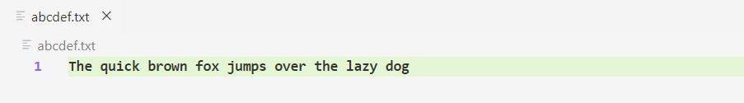**Text File:**

**JS Code:**

**var hReq;**

**function createReq() {**

**hReq = new XMLHttpRequest();**

**if (!hReq) {**

**alert('Cant make an object of XMLHTTP');**

**return false;**

**}**

**hReq.onreadystatechange = alertUser;**

**hReq.open('GET','abcdef.txt');**

**hReq.send();**

**}**

**function alertUser() {**

**if (hReq.readyState == 4) {**

**if (hReq.status == 200) {**

**alert(hReq.responseText);**

**response_msg = "Text in file:\n" + hReq.responseText;**

**document.getElementById("print_text").innerHTML = response_msg;**

**searchString();**

**}**

**else {**

**alert('There was a problem with the request.');**

**}**

**}**

**}**

**function searchString() {**

**var str = document.getElementById("str").value;**

**var text = hReq.responseText, result, pos;**

**result = text.includes(str);**

**pos = text.indexOf(str);**

**stringLength();**

**if(result) {**

**document.getElementById("search").innerHTML = "String '" + str + "' found at position " + pos;**

**}**

**else {**

**document.getElementById("search").innerHTML = "String '" + str + "' not found in the text file";**

**}**

**}**

**function stringLength() {**

**var len = document.getElementById("str").value.length;**

**document.getElementById("length").innerHTML = "String length: " + len;**

**}**

**OUTPUT:**

